**Using Computer Management (Local Users and Groups)**

1. **Open Computer Management**:
   * Press Windows + R, type compmgmt.msc, and press **Enter** to open **Computer Management**.

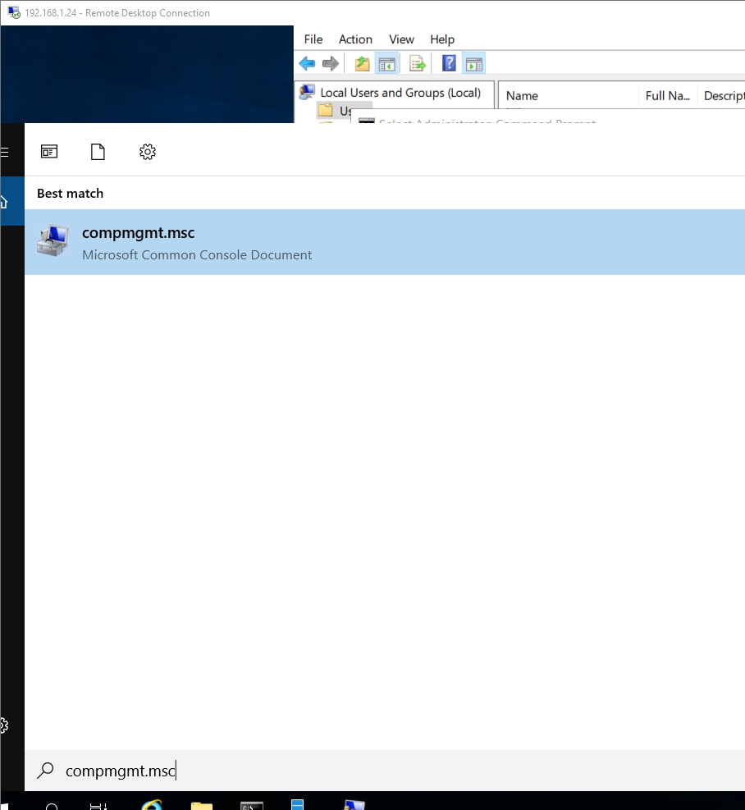

* + Alternatively, you can right-click on the **Start** button and select **Computer Management**.

1. **Navigate to Local Users and Groups**:
   * In **Computer Management**, expand **Local Users and Groups** on the left pane.
   * Click on the **Users** folder.

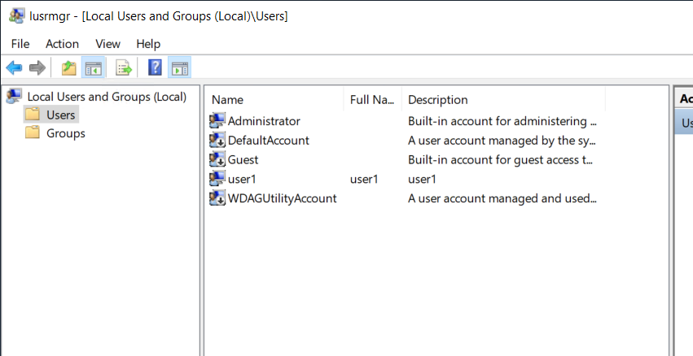

1. **Create a New User**:
   * Right-click the **Users** folder and select **New User**.

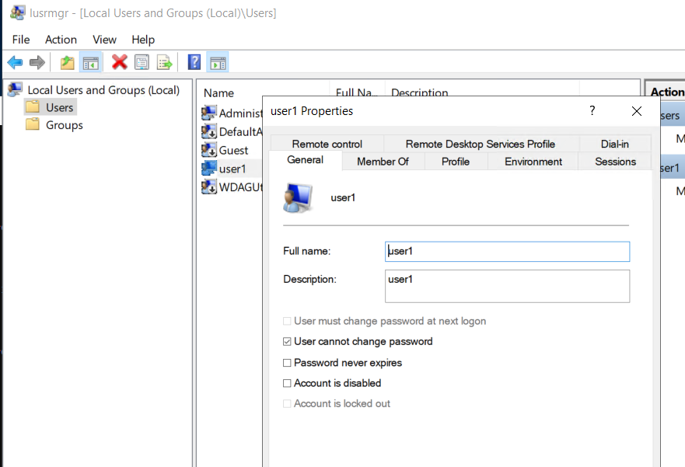

1. **Enter User Details**:
   * In the **New User** dialog, enter the username, full name, description, and password for the new user.
   * You can also configure the password settings, such as forcing the user to change the password at the next logon or preventing the user from changing the password.
   * Click **Create** and then **Close**.
2. Using the new user , access remote using the “rdp” on your laptop

Rdp to 127.0.0.1:3330 ( as configured on the virtual box)

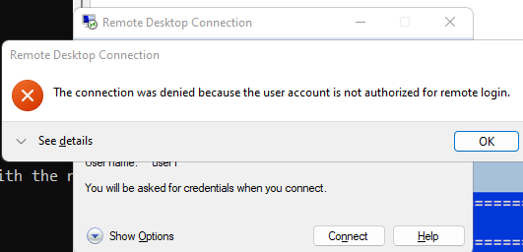

We are getting error, because the new user is not part of the remote desktop group, as below can been seen in the “member of” option

Default member

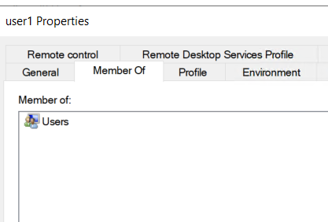

1. Add the user to remote desktop user.

Add the user to ‘remote desktop users”

Click on the “add” button

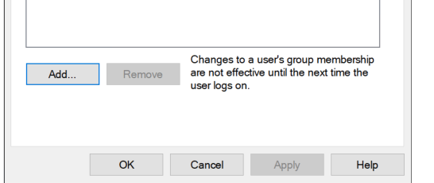

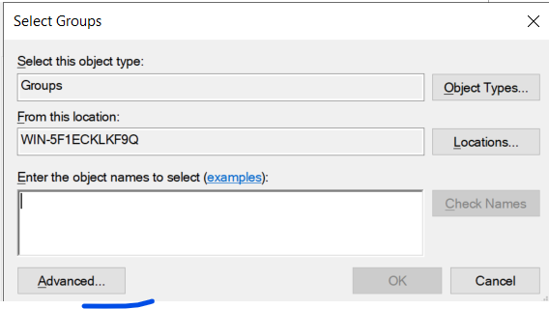

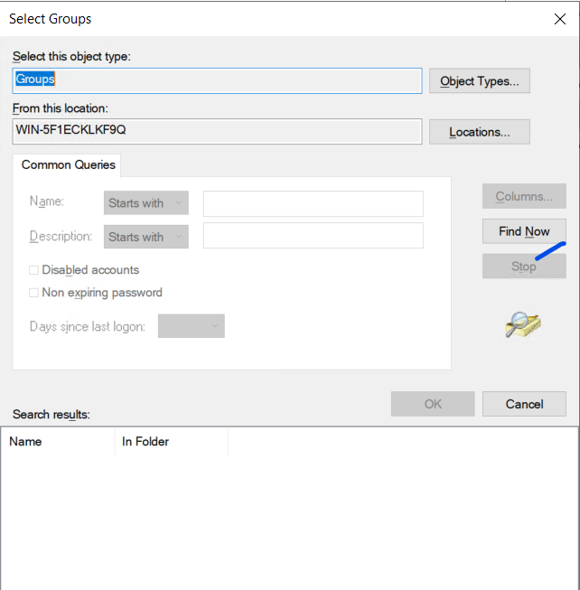

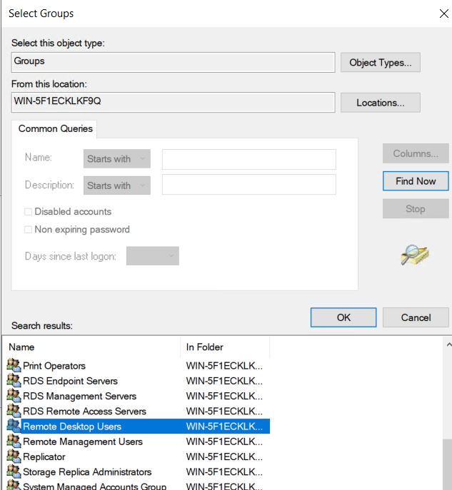

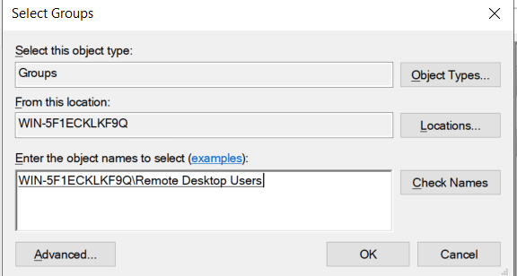

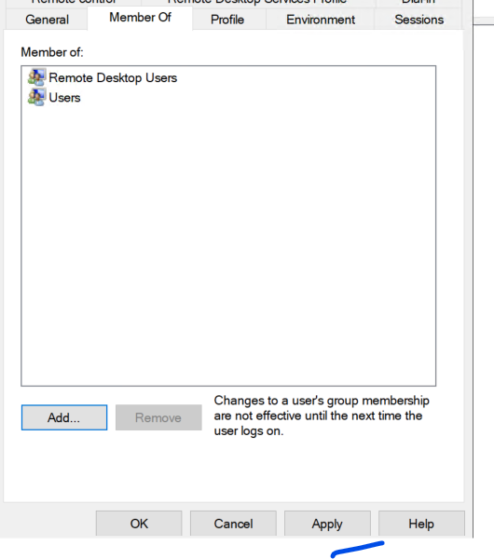

1. Test it again

