**VistA Adaptive Maintenance VAEC Security**

**(VAM2)**

Monthly Progress Report  
CLIN 0001AB



Department of Veterans Affairs

Office of Information & Technology

Contract No: VA118-16-D-1009

task Order: 36C10B19F10090015

Deliverables: CLIN0001AB

Date: April 03, 2019

Version 1.1

.

PAGE INTENTIONALLY LEFT BLANK

Revision History

Note: The revision history cycle begins when changes or enhancements are requested after the document has been baselined.

| Date | Version | Description | Author |
| --- | --- | --- | --- |
| March 04, 2019 | 1.0 | Initial Monthly Progress Report Template | AbleVets |
| April 03, 2019 | 1.1 | Monthly Progress Report for month of March 2019 | AbleVets |
|  |  |  |  |
|  |  |  |  |
|  |  |  |  |
|  |  |  |  |
|  |  |  |  |
|  |  |  |  |
|  |  |  |  |
|  |  |  |  |
|  |  |  |  |

Table of Contents

1. Introduction 1

2. Work Completed During Reporting Period 1

Diagram 1: VAM2 – Architectural Diagram 2

3. Work Planned for Subsequent Reporting Period 2

4. Issues and Risks 3

5. Itemized List of All Electronic and Information Technology (EIT) Deliverables 4

# Introduction

This report covers the Period of Performance (POP) from March 01, 2019 through March 31, 2019.

# Work Completed During Reporting Period

* Completed the technical deep dive on 03-21-2019 at the AWS Herdon Office.
* Facilitatedmultiple VistA Adaptive Maintenance VAEC Security (VAM2) Weekly Project Meetings to discuss status of management and technical team’s progress. The link to the meeting minutes is below: <https://github.com/vistadataproject/VAM2ProjectManagement/tree/master/Documents/weekly_meeting_minutes>
* Delivered the Basic Definition of User and Application (Client) Types on March 15, 2019.
* Updated Risk Vision profile for VAM2; started updating the details for the new scope and adding new team members to old profile and dropping old team members from the new profile etc.
* Reviewed Risk Vision Templates and Controls questions and submitted to ISSO for her review.
* Updated the following documents:
  + CLIN 0001AA – Contractor Project Management Plan (CPMP)
  + CLIN 0001AB – Monthly Progress Report
  + CLIN 0001AC – VA Privacy and Information Security Awareness
  + CLIN 0001AD – Contract Rules of Behavior
  + CLIN 0001AE – VA HIPAA Certificates
  + CLIN 0001AF – Weekly Onboarding Status Report
  + CLIN0003AA – Master Test Plan
* Created a New Architecture Diagram on 03-29-2019 depicting the system boundary and the data flow, as a result of the 03-21-2019 Technical Deep Dive Meeting (See Diagram Below). Created the System Boundaries and Data Flow Document for ATO, based on the New Architecture

Diagram 1: VAM2 – Architectural Diagram

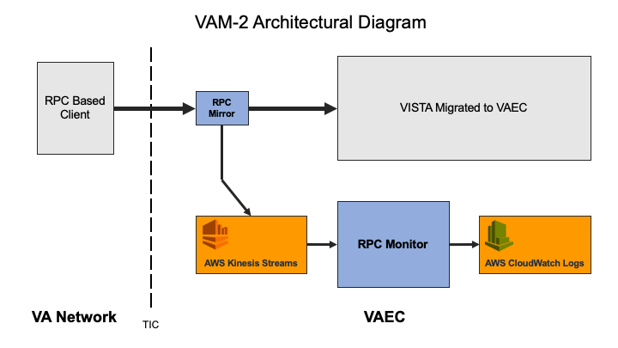

# Work Planned for Subsequent Reporting Period

* Continue technical tasks as outlined during the deep dive meeting that occurred on 03-21-2019 at AWS, Herndon Office.
* Continue to work on updating the Risk Vision in accordance to the scope of VAM2.

# Issues and Risks

The following issues must be resolved prior to delivery of the Dev-Int Build 4:

|  |  |  |  |  |  |
| --- | --- | --- | --- | --- | --- |
| Issue Category | Issue Description | Issue Number | Due  Date | Risk Identified | Mitigation Plan |
| Technical | Receive ATO | VAM2-R10 (ATO Dashboard) | 8/30/2019 | ATO will be required before we go to IOC Production | Risk Vision instance for VAM2 will be updated with VAM VAEC Security scope (VAM2).  AbleVets team is meeting with Bobbi (ISO) and Cheryl ( VA PM) on a weekly basis to meet the date. |
| Technical | Obtain / Configure VAEC IOC Environnements | VAM2-R17(IOC Dashboard) | 10/31/2019 | Need Configured VAEC IOC prior to Delivery of Dev-Int Build 4 | Valley Coastal, TX and Omaha Vista identified on 03-21-2019 meeting for VAM. We will get the identified IOC VistA environments migrated to VAEC and establish connectivity |
| Release Process | Identify a release manager and process using GitHub | VAM2-R18(PWS Dashboard) | 06/06/2019 | As per the PWS, we are using GitHub for releasing VAM2. | Need to identify the release Manager  Setup meeting to discuss the release process using GitHub. |

# Itemized List of All Electronic and Information Technology (EIT) Deliverables

* + CLIN 0001AA – Contractor Project Management Plan (CPMP)
  + CLIN 0001AB – Monthly Progress Report
  + CLIN 0001AC – VA Privacy and Information Security Awareness
  + CLIN 0001AD – Contract Rules of Behavior
  + CLIN 0001AE – VA HIPAA Certificates
  + CLIN 0001AF – Weekly Onboarding Status Report
  + CLIN0003AA – Master Test Plan