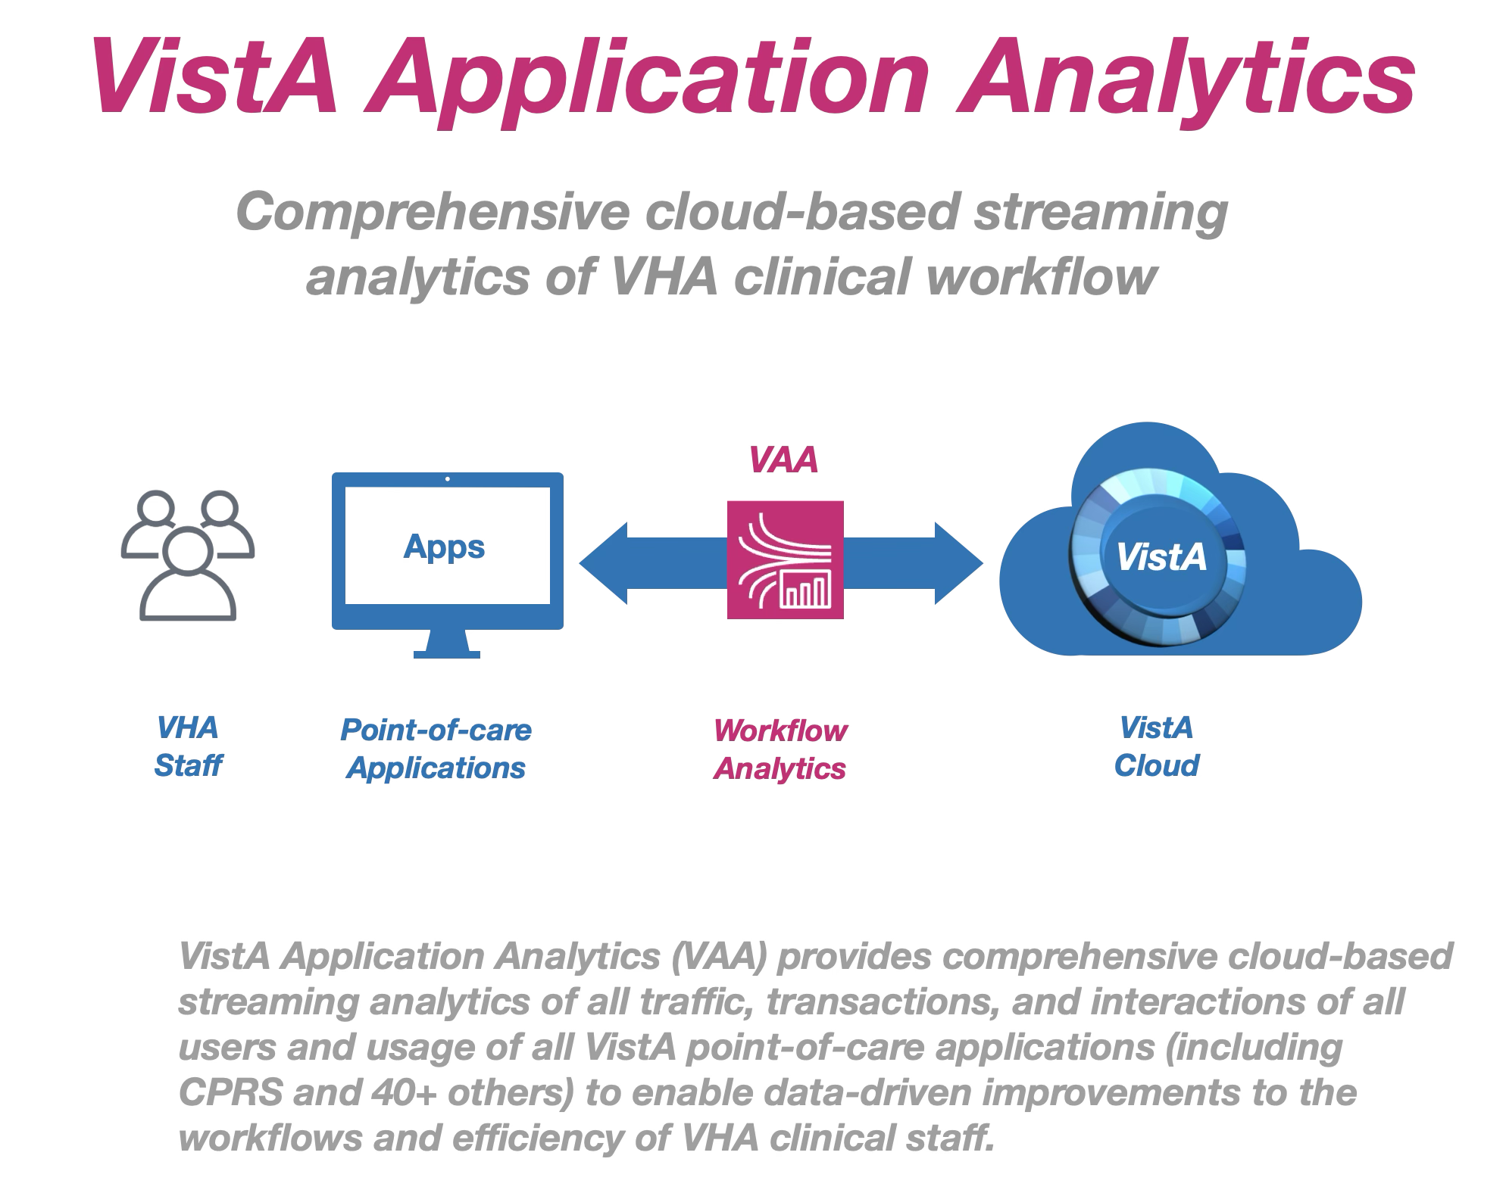

Introduction
To provide a modern, centralized cloud-based platform for veteran healthcare, VA has migrated all VistA systems to the VA Enterprise Cloud, a federally certified commercial cloud managed by Amazon Web Services. VA's new centralized cloud-based VistA ("Cloud VistA") platform provides many new features and capabilities to VistA and veteran care.
By leveraging the new cloud-based traffic streaming capabilities of cloud-based VistA, VHA has the first-ever opportunity to comprehensively analyze the clinical workflows of all staff at VA medical centers. Such analysis would drive improved standards of practice by health care providers. These improvements would be prompted by the actual practice of care and not speculation about how care is being provided.

Background
Each day VHA clinical staff use a suite of VistA point-of-care Applications to create and process over 4 million new documents, orders, and images in VistA. VistA Applications process all their transactions on VistA via remote procedure calls (RPCs). In aggregate, these RPCs between VistA Applications and VistA describe all clinical care transactions and workflow performed at VHA medical centers.
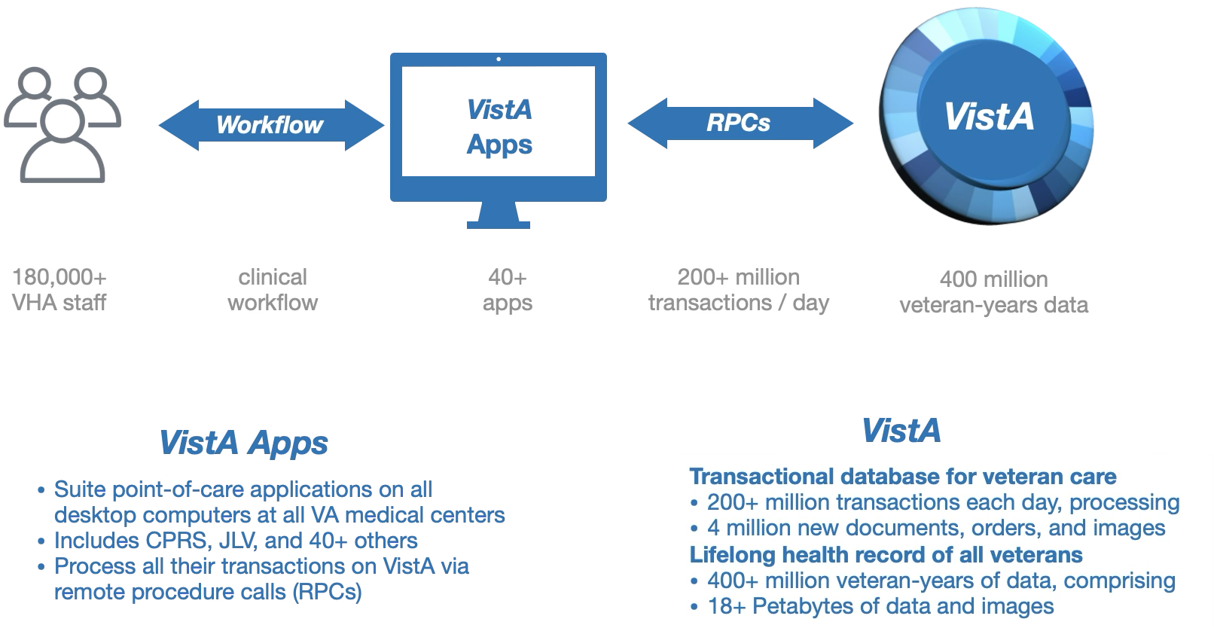

Implementation and Certification
All VistA systems are hosted in the VA Enterprise Cloud, a federally certified commercial cloud managed by Amazon Web Services (AWS). VAA leverages VistA’s AWS technologies and infrastructure, including real-time streaming traffic capture and analytics of all cloud-based VistA Application workflows.
Amazon Web Services (AWS) is a leading commercial cloud services provider
AWS cloud-based VistA inherits hundreds of new features, functionality, and services within the AWS cloud platform, including security, scalability, and streaming traffic capture and analytics
VAA is implemented in the same secure AWS cloud as VistA, which enables streaming analytics of VistA traffic and applications.
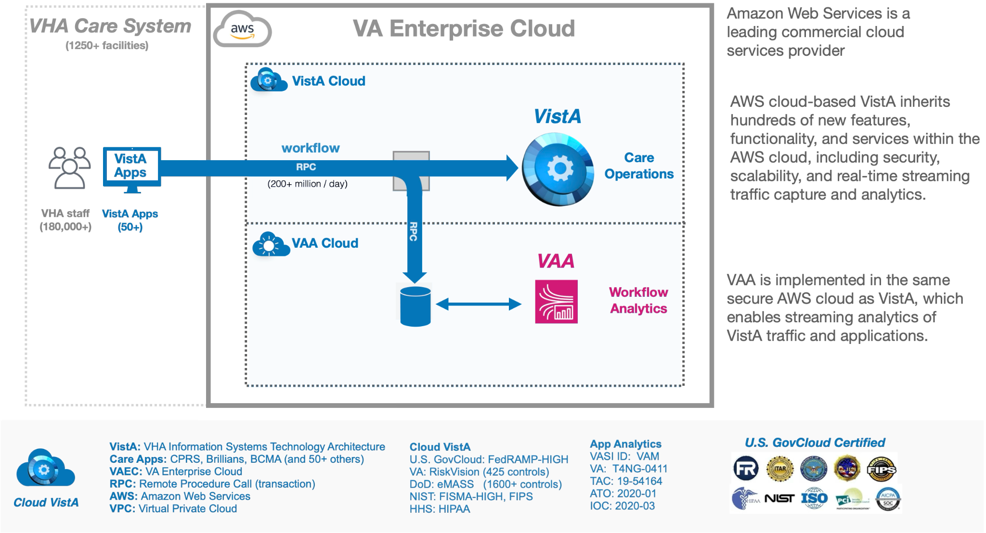

Overview of Analysis
The Vista Application Analytics project will engage VistA data experts to analyze the RPC traffic between VistA clients and three representative VistA servers. The analysis will be provided in a series of precise reports, detailing different aspects of VA care. Analysis will include the types and volumes of structured and unstructured information read and written by clearly identified classes of health care professionals as well as the range of time spent on different tasks. On completion, VHA will possess a set of concrete, actionable recommendations, and demonstrations for improving the care provided to Veterans as well as a guide for how to perform such analysis in the future.

Workflow Capture
All VistA Application workflows (RPC traffic flows) of cloud-based VistA are streamed to cloud storage using the built-in traffic mirroring service in the AWS Cloud.
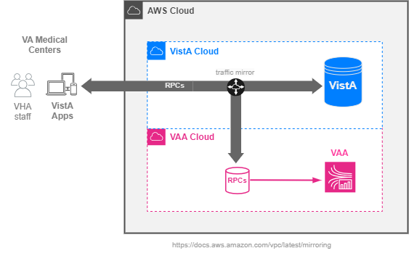

Workflow Analytics
Using the RPC traffic captured, multiple parallel analyses will occur.
- Composite Analysis: Simple and filtered analysis of all traffic from all users for all applications of a specific VistA server. This provides screen metrics to be used in the VistA application-specific analysis.
- Sequence Analysis: Identify and classify the longest common sequences (LCS) of RPCs generated by a given VistA Application. These LCS correspond to the actual workflow of end-users of a given VistA Application.
- Workflow Analysis: The Vista Documentation Library (VDL) contains the User Guides for VistA Applications, which is the documented workflow of VistA Applications. The documentation and screenshots of specific VistA Applications are parsed and classified in a standardized computable form to permit analysis.
- Workflow Correlation Analysis - Correlate the (1) Actual screens generated by live users of a VistA Application (2) Documented screens based on the VDL descriptions for specific VistA Applications (3) Actual workflow - based on the LCS analysis of known RPCs and their function.
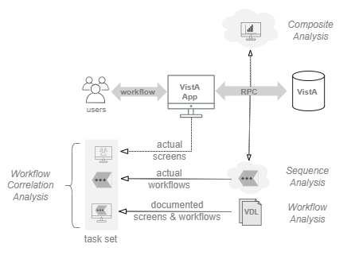

Workflow Correlation
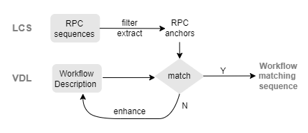

Analytics Methods
analysis | storage | technique | summary
Simple | S3 | direct RPC queries | foundation metrics
Filtered | DynamoDB | RPC extraction scripts | RPC name, type, attributes
Sequence | RedshiftDB | RPC sequence reduction | longest common sequence (LCS) identification
Workflow | Github | VDL reduction | download -> parse, isolate, index -> flowchart (mermaid)
Correlation | Github | sequence comparison to workflow | Task Set identification

VistA Client traffic analysis
Using the client traffic captured, the Analysis Team will analyze all traffic of all VistA clients of all users of three VistA systems. The Analysis Team shall also provide inter-VistA Analysis distinguishing common VistA traffic patterns from VistA-specific traffic patterns.
Traffic Analysis Report for each VistA shall characterize:
a) User volume
b) Client types and volume of use
c) Connection volumes, frequency, and duration
d) Types of user authentication/security and relative use
e) Machine from end Users
f) RPC usage frequency and execution times
g) RPC groupings – representing transactions
h) RPCs specific to a VistA from cross-VistA RPCs
Deliverables:
A. Traffic Analysis Reports for three production VistAs
B. Cross VistA Traffic Analysis Report

Key VistA Client traffic analysis
Based on the traffic and client types isolated during the VistA traffic analysis, the Analysis Team shall produce a detailed Client Traffic Analysis of the operation of three of the most used VistA Applications ("Clients"). CPRS shall be one of the three; the remaining two shall be chosen based on client usage.
All client analyses must be validated and verifiable in a demonstrable way, matching RPC flows to specific client screens and typical tasks. The Analysis Team shall document the verification and validation of the analysis and provide a Client Traffic Analysis Validation and Verification Report.
The per Client Traffic Analysis shall include:
a) User volumes and types. User types shall capture clinical care specialties and roles.
b) Connection volume and duration, tying frequency of client use to user types
c) Types of user authentication/security and relative use
d) Patient volumes
e) Enumeration of all RPCs used by a client and their relative use
f) Distinction of clinical from non-clinical RPCs
g) Distinction of RPCs that change (write) from those that read the clinical record
h) Distinction of slow running, high overhead and variable overhead RPCs
i) Clinical care task sets, represented as groups of RPCs used in tandem
j) Match task sets with the use of one or more specific client screens
k) Task sets employed by different user types
l) Isolate performance issues with patterns of use that slow care
m) Verification and validation that the analysis accurately captures care provision
Deliverables:
A. Three (3) VistA Client Use Analysis Reports
B. Client Analysis Validation and Verification Report
Note: This task requires the Analysis Team to match the RPC traffic flows to client screens and tasks. There is a unique RPC sequence associated with each task (login, logoff, ordering a medication, ordering a lab, writing notes, etc.). There will be thousands of unique RPC sequence - one for each interaction / task. The Analysis Team must demonstrate that the matching of these RPC sequences to specific screens and tasks are complete and correct.

VistA Client Use Improvement
Based solely on the Client Use Analysis Reports, the Analysis Team shall provide recommendations to upgrade the use of the top three RPC-using VistA Clients to deliver better clinical care. These recommendations shall be documented in Client Use Improvement Reports.
Deliverables:
A. Client Use Improvement Reports
Note: This task requires the Analysis Team to provide recommendations to upgrade CPRS (and two other clients) to deliver better clinical care (more safe, more efficient, etc). These recommendations must come from soley the clinical workflow (RPC flows) analysis.

Schedule
Base Period
- Capture of VistA client traffic
- Analysis of all VistA client traffic for three VistAs
- Analysis of Key VistA clients
- VistA client use improvement report
Option Period
- Migrated VistA client traffic analysis (VistA client traffic at EHRM sites)
- VistA Community Care client traffic analysis (JLV and others)

