**U.S. DEPARTMENT OF VETERANS AFFAIRS**



**AI-ENHANCED CLINICAL DOCUMENTATION:**

**PRESERVING STRUCTURE FOR SMARTER CARE**

VistA Application Analytics

Knowledge Based Systems | Digital Health Office

Veterans Health Administration

September 30, 2025

Table of Contents

Executive Summary 4

2. VAA 5

2.1 VistA Application Analytics (VAA) 5

Non-Invasive Communications Capture 5

The VistA Client Interface 5

Captured the Traffic of Two Medical Centers 6

Analyzed Notes and Orders 6

3. Current State 7

3.1 Structured Note Entry 7

Template Types 7

Prompted Text Fields 8

Pulldown Selections 8

Boilerplate Text 9

Objective Data Insertions (“OBJECTs”) 9

3.2 CPRS Note Entry Workflow 11

3.3 Final (Flat) Form 13

4. Empirical Analysis 15

4.1 Methodology and Data Sources 15

4.2 Volume and Class of Notes 15

4.3 Two Worked Examples 19

4.3.1 Medical Reconciliation [VCB] 19

4.3.2 Discharge Summary [Omaha] 25

4.4 OBJECT Usage 30

4.4.1 Number and Variety of OBJECTs 31

4.4.2 Proportion of the Final Note 32

4.5 Key Findings 35

5. Proposed Solution 36

5.1 External Annotation for VistA Notes 36

5.2 Example Annotation Format 37

1. Inline Annotation (e.g., OBJECT: PATIENT NAME) 37

2. Single-Line Annotation (e.g., Prompted Answer, typed by Clinician) 37

3. Multi-Line Block (e.g., OBJECT: ACTIVE MEDICATIONS) 38

4. Multi-Line Block Annotation (Clinician-Authored Free Text) 38

5. Multi-Line Block Annotation (Template-Inserted Boilerplate) 38

5.3 Use Cases for Note Annotations 38

5.3.1. Modern HTML Rendering of Notes 39

5.3.2. Objective Information Trends 39

5.3.3. Procedure Tracking Across Notes 39

5.3.4. Structured Input for AI Models 40

5.4 Implementation Strategies 40

5.4.1. Post-hoc Extraction and Annotation 40

5.4.2. Enhanced CPRS Output 40

5.4.3. Passive Observation of Note Composition 40

# Executive Summary

Clinical documentation in the VA’s electronic health information system (VistA) is created as structured data but ends up stored as unstructured text. Providers document care using templates rich with prompts, structured templates, and auto-generated objective data such as medications, labs, vitals, and appointments. Yet once signed, every note collapses into a monospaced, metadata-free block of text—erasing its structure, provenance, and semantic meaning.

That design made sense when VA’s infrastructure and storage were limited, and simple text storage and display was the norm. Today, this creates major barriers: clinicians must manually read through extensive text to locate key findings, and AI systems cannot effectively interpret the flat, unstructured information.

This report outlines a solution to the **loss of structure and provenance of clinical documentation** that **requires no change to VistA.** By capturing and preserving the structure at the time of note creation, VA can reintroduce semantic clarity and structure for both human and machine understanding. The result:

* Clinicians gain structured, intuitive note views that surface relevant information.
* AI systems gain a consistent, interpretable foundation for clinical insight, summarization, and decision support.

Preserving note structure is not just an improvement in documentation—it’s a foundational step toward transforming VA’s clinical information into an accessible, intelligent, and **AI-ready** resource.

# 2. VAA

## 2.1 VistA Application Analytics (VAA)

VistA Application Analytics (VAA) is a project to analyze clinical workflows at a representative sample of VA medical centers to recommend improvements to clinical clients and workflows. Analysis is enabled by capturing the communications between VistA and clinical end-user client applications. The most important client of VistA is the Computerized Patient Record System (CPRS),

### Non-Invasive Communications Capture

VistA systems are now hosted in the cloud, specifically the federally-certified commercial cloud provided by Amazon Web Services (AWS). The VAA project uses built-in AWS cloud infrastructure to passively capture the traffic sent between VistA instances and their clients, covering a representative sample of sites.

* No changes to VistA or client systems are required.
* The capture is completely non-invasive and does not interfere with clinical operations.
* All communication between clients (like CPRS) and VistA passes through this monitored layer.

This setup allows VAA to observe real-world clinical workflows as they occur, providing a basis for high-fidelity reconstruction and analysis.

### The VistA Client Interface

Communication between VA clinical clients and VistA occurs through a proprietary Remote Procedure Call (RPC) interface. Unlike generic or opaque client-server protocols, this interface is uniquely well-suited for workflow analysis because it is:

* Connection-oriented: Each session is tied to a specific user and clinical context, allowing clear attribution of actions.
* Non-encrypted and human-readable: All traffic is transmitted in plain ASCII text, making it directly inspectable without reverse engineering.
* Fine-grained and task-specific: Thousands of distinct RPCs correspond to discrete clinical operations—such as selecting a patient, retrieving lab results, entering note content, or saving an order—providing high-resolution insight into workflow.

This combination of transparency, specificity, and structure makes the VistA RPC interface an ideal foundation for passively observing and analyzing clinical activity in real time.

### Captured the Traffic of Two Medical Centers

During the VAA project, client traffic was captured from two VA Medical Centers: Valley Coastal Bend (VCB), a typical outpatient-only facility, and Omaha, a major full-service medical center.

* Valley Coastal Bend (VCB): Monitored for six weeks, from Monday 2025-06-23 through Saturday 2025-08-02. Over this period, 23,321 CPRS sessions (defined as a login and access to the record of one or more patients) were recorded for analysis, including a total of 63,295,857 RPCs.
* Omaha: Representative RPC traffic was sampled for 16 days from 2024-11-11 through 2024-11-26, during which 49,701 CPRS sessions were captured for analysis.

### Analyzed Notes and Orders

From the perspective of clinical clients, day-to-day care primarily involves two core activities:

* Creating and viewing clinical notes
* Writing and reviewing orders

Accordingly, VAA’s analysis focused on these two activities, examining how notes are composed (including the use of templates and OBJECTs) and how orders are initiated, modified, and finalized in VistA and its clients.

# 3. Current State

## 3.1 Structured Note Entry

In VA care using CPRS (Computerized Patient Record System), clinical notes are rarely typed into a blank screen. Instead, the clinician selects a Note Type (also called a Title)—such as Discharge Summary, Cardiology Consult, or Telephone Note—which leads to a templated form (“Template”) tailored for that type of note. These templates provide a structured note entry process to guide the clinician.

A template defines a structured layout that typically includes:

* Prompted Text Fields: These request clinician-authored input for specific sections.  
  Example: Diagnosis at Admission, Hospital Course.
* Pulldown Selections: Lists of pre-defined choices selected by the clinician.  
  Example: Diet: Mechanical soft, Disposition: Home.
* Boilerplate Text: Static content inserted for legal, regulatory, or institutional purposes.  
  Example: “If after hours or on weekends, call the main hospital line…”
* Objective Data Insertions: Automatically included objective patient data from VistA.  
  Example: |PATIENT NAME|, |ACTIVE MEDICATIONS|, |FUTURE APPOINTMENTS|.

This layered input produces a highly structured draft, blending guided clinician input, system-generated data, and institutional content. Yet when the note is saved, that structure is discarded—flattened into fixed-width plain text where the origin and type of each entry are no longer identifiable.

The following describes template types and elements in more detail.

### Template Types

There are two types of note template in CPRS: Basic Templates and Clinical Reminder Templates. Both define a structured form for entering a note, tailored to the selected Note Type (e.g., Discharge Summary, Cardiology Consult).

* Basic Templates These are composed of individual components—such as boilerplate text, prompted fields, pulldown selections, and Objective data insertions—which CPRS assembles before rendering the complete template to the clinician.
* Clinical Reminder Templates These templates extend the basic template structure with the ability to generate Patient Care Encounter (PCE) data. As the clinician completes the template, CPRS can automatically capture key structured elements—such as diagnoses, procedures, health factors, education topics, and immunizations—used for clinical coding, workload tracking, and quality measurement.  
  Clinical Reminder Templates are also optimized for single-step loading, allowing CPRS to present the full form immediately without assembling it from separate parts.

Both template types support consistent, guided entry of note content.

### Prompted Text Fields

Prompted text fields request specific, clinician-authored input during note entry. These are not general-purpose free-text areas. Instead, each field is associated with a particular question or heading, which shapes both the content and the clinician’s intent.

For example:

* Diagnosis at Admission
* Hospital Course
* Procedure Performed
* Discharge Instructions

The template ensures these fields are completed in a consistent order and with a consistent focus, improving both readability and downstream data use. It can also make some fields mandatory. However, the formality of this structure is lost in the final note text—reduced to a series of headings and details rendered sequentially in plain text.

### Pulldown Selections

Pulldown selections offer a predefined set of options for the clinician to choose from. These support standardization of phrasing and reduce variation in documentation.

Examples include:

* Diet: → Mechanical soft, Regular, NPO
* Disposition: → Home, Skilled Nursing Facility, Expired

These are rendered in CPRS using dropdown menus similar to those seen in standard web forms.

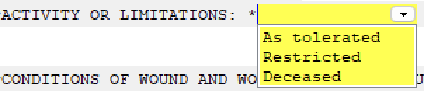

Figure 3.1: Template Dropdown Menu.

Selections may be mapped to internal codes or external standards (e.g., SNOMED CT), but in the stored note they appear only as flat text—without any indication that they were selected from a controlled list.

### Boilerplate Text

Boilerplate text consists of static content automatically included in the note template. This may serve institutional, legal, or informational purposes, and may be required in all notes of a certain type.

Examples:

* “If after hours or on weekends, call the main hospital line…”
* “This patient has been advised of the risks and benefits of the procedure.”

While boilerplate plays a legitimate role in ensuring compliance and consistency, it is indistinguishable from clinician-authored or system-generated content in the final note, which can obscure the most clinically relevant information.

### Objective Data Insertions (“OBJECTs”)

OBJECTs are objective patient data automatically provided by VistA during note composition. They are not typed or chosen by the clinician. Instead, they are evaluated by VistA and inserted by CPRS into designated slots in a note template, reflecting the patient’s current state at the time of note creation.

OBJECTs fall into two broad categories:

#### Inline OBJECTs

These appear as single values embedded within lines of template text. For example, a template might include the line:

|PATIENT NAME| is a |PATIENT AGE| year old |PATIENT SEX|.

This would rendered as:

Joe Smith is a 65 year old Male.

Inline OBJECTs are typically used for short values such as name, age, sex, attending physician, or visit date.

#### Variable-Line OBJECTs

These insert longer sections of structured content, often formatted as one or more full lines of tabulated or formatted text. A common example is |ACTIVE MEDICATIONS|. Here is a typical example:

Active Outpatient Medications (including Supplies):  
  
 Active Outpatient Medications Status  
 =========================================================================  
 1) APIXABAN 5MG TAB TAKE ONE TABLET BY MOUTH TWICE A DAY ACTIVE  
 TO THIN BLOOD  
 2) ATORVASTATIN CALCIUM 40MG TAB TAKE ONE-HALF TABLET BY ACTIVE  
 MOUTH AT BEDTIME FOR HIGH CHOLESTEROL  
 3) FERROUS SULFATE 325MG TAB TAKE ONE TABLET BY MOUTH ACTIVE  
 EVERY 48 HOURS ANEMIA FOR NUTRITION AND ANEMIA.  
 TAKE WITH FOOD IF EXPERIENCING STOMACH UPSET  
 4) HYDROXYZINE HCL 25MG TAB TAKE ONE TABLET BY MOUTH ACTIVE  
 THREE TIMES A DAY AS NEEDED FOR ALLERGIES  
 5) TAMSULOSIN HCL 0.4MG CAP TAKE ONE CAPSULE BY MOUTH ACTIVE  
 EVERY NIGHT FOR PROSTATE  
 Date: MAY 10, 2025

Variable-line OBJECTs are commonly used for clinical information about a patient, such as:

* Medications
* Allergies
* Future Appointments
* Recent Lab Results
* Problem List

VistA supports hundreds of OBJECT types, each designed to expose specific clinical or administrative data for use in templated documentation.

While OBJECTs often account for a large portion of note content, their automated origin is not marked in the final text—leaving them indistinguishable from manually typed entries.

## 3.2 CPRS Note Entry Workflow

The following depicts the CPRS workflow for generating notes, including template processing, clinician input, and finalization.

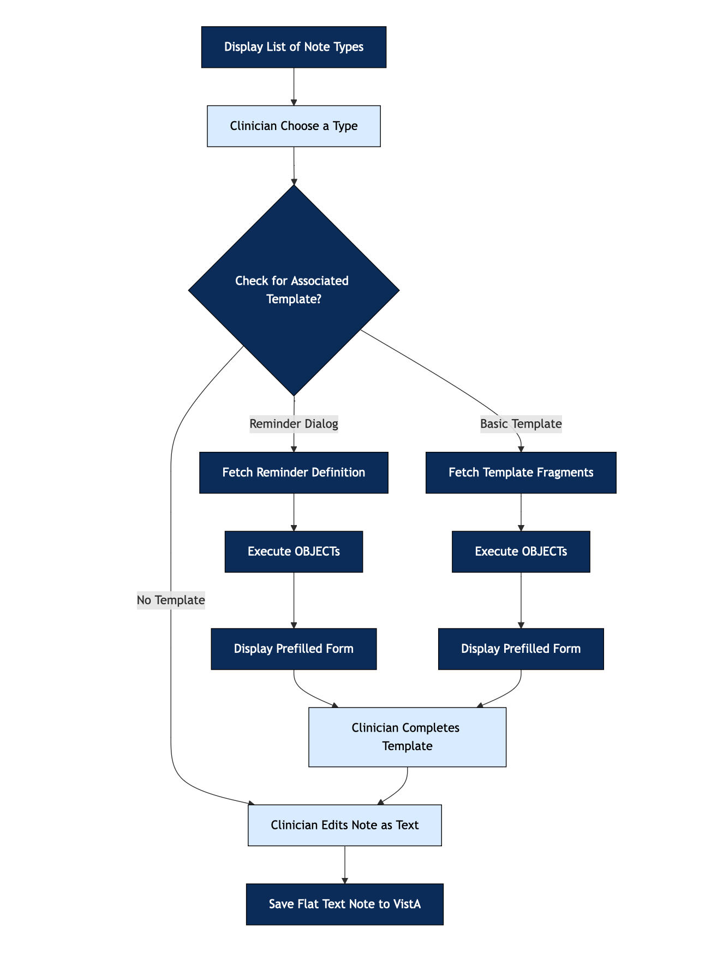

Figure 3.2: CPRS Note Create - Step by Step.

The chart above outlines the high-level logic of TIU note creation in CPRS. The following steps provide a more detailed description of the process, including how templates are fetched, forms are presented, and how the final note is structured and stored.

1. Display List of Note Types CPRS presents the clinician with a menu of available note types to initiate documentation.
2. Check for Associated Template CPRS checks whether the selected note type is linked to a template.
3. Template Fetching and Presentation
   * 3.1 Reminder Dialog Template
     + Fetch the Reminder Dialog definition and associated prompts
     + Execute all OBJECTs embedded in the template, regardless of whether their containing section is ultimately selected or included by the clinician
     + Display a prefilled structured form to the clinician
   * 3.2 Basic TIU Template
     + Fetch up to 100 template fragments via RPCs. Unlike Reminder Dialog Templates, Basic Templates must be retrieved in discrete sections, nested blocks, and fields, then reassembled by CPRS
     + Execute all OBJECTs embedded in the template
     + Display a prefilled structured form to the clinician
   * 3.3 No Associated Template
     + Proceed to the Clinician Editing (Blank) Note as Text
4. Clinician Completes Template (only for 3.1 and 3.2) The clinician interacts with the structured form by filling in free-text fields, selecting from predefined choices (e.g., radio buttons, dropdowns, or checkboxes), and choosing among predefined blocks of templated text. All of this occurs while the form displays the results of previously evaluated OBJECTs—such as current medications, recent labs, vitals, or future appointments—rendered as part of the form context.
5. Clinician Edits Note as Text The clinician may revise, expand, or delete text; drag in additional templates; or paste text from external applications or other TIU notes.
6. Save Flat Text Note to VistA The final output is saved to VistA as a flat, fixed-width (80-character) text document. This note format dates to a time before graphical output or layout controls, and contains no markup, no formatting metadata, and no structural encoding—essentially preserving only the printable text as it would appear on a line printer or basic terminal.

This note creation process gathers a substantial amount of structured information: predefined text blocks, clinician responses to structured prompts, and system-evaluated OBJECTs such as current medications or recent labs. However, once the clinician proceeds to manual text editing, this structure is flattened. The final saved product is a flat, printable text block with no preserved distinction between system-generated content, templated sections, or clinician-authored input. All provenance and structure are lost by the time the note is stored in VistA.

## 3.3 Final (Flat) Form

When a note is saved in CPRS, its rich structure—forms, selections, and system insertions—is flattened into plain, monospaced text. The final output follows a fixed-width layout of 80 characters per line, originally designed for text-based line printers and early dot-matrix devices—not modern displays or digital document standards. It lacks both the visual styling and semantic markup common to contemporary electronic documents. The only apparent “structure” comes from consistent line spacing and all-uppercase section headings—visual conventions, not machine-readable features.

Specifically:

* No syntax support for formatting like bold, italic, font sizes, or indentation rules
* No semantic markup to distinguish headings, sections, or metadata (e.g., diagnosis vs. history vs. medications)
* No structural elements like tables, bullet points, checkboxes, or nested lists
* No provenance indicators to distinguish authored text from system-generated content

This legacy format was sufficient for paper-based workflows and early terminal viewing, but it poses serious limitations for:

* Information reuse (e.g., trend analysis, data extraction, clinical decision support)
* Clinical clarity (e.g., distinguishing clinician-authored, clinician-selected, and boilerplate content)
* AI/NLP analysis, which struggles with untagged, variably structured text

The following excerpt illustrates how three fundamentally different types of information are blended without distinction in the final saved note:

Patient JONES,JACOB J, aged 47, sex MALE.  
  
HISTORY OF PRESENT ILLNESS:  
Patient presents today for routine follow-up. He reports no new  
symptoms. Denies chest pain, SOB, or palpitations.  
  
ACTIVE OUTPATIENT MEDICATIONS (INCLUDING SUPPLIES):  
  
 ACTIVE OUTPATIENT MEDICATIONS STATUS  
=========================================================================  
1) APIXABAN 5MG TAB TAKE ONE TABLET BY MOUTH TWICE A DAY ACTIVE  
 TO THIN BLOOD  
2) ATORVASTATIN CALCIUM 40MG TAB TAKE ONE-HALF TABLET BY ACTIVE  
 MOUTH AT BEDTIME FOR HIGH CHOLESTEROL  
...

This text includes:

* Inline OBJECTs, the patient’s name, age, and sex (JONES,JACOB J, 47, MALE)
* Clinician-authored content, the history of present illness
* Structured objective data, the list of active medications, inserted by CPRS from the medical record

Despite their different origins—automated, manually entered, and system-retrieved—these elements are flattened into the same undifferentiated plain text. No semantic tagging, structural markup, or provenance metadata is retained to distinguish them.

Similarly, responses selected from structured inputs—such as pulldowns—are rendered as if they were free-text entries. For example:

DISCHARGED TO: Return to community (home)   
CONDITION AT DISCHARGE: Good   
DIET: Regular diet

Although each value was chosen from a controlled list in the template, the final note provides no indication of their origin, selection constraints, or alternatives. They appear indistinguishable from text that could have been freely typed by the clinician.

# 4. Empirical Analysis

## 4.1 Methodology and Data Sources

This section provides a quantitative overview of note creation and viewing (“reading”) in CPRS/VistA TIU. The analysis is based on six weeks of captured RPC traffic from CPRS client sessions at the Valley Coastal Bend (VCB) VA.

From Monday, June 23 through Saturday, August 2, 2025, a total of 23,321 CPRS sessions were recorded. Of these, 20,824 involved the selection of at least one patient record. In total, 63,295,857 RPCs were exchanged between CPRS and VistA during these patient-focused sessions.

VCB sees little clinical activity on weekends, but weekdays show a median of 718 patient-selecting sessions.

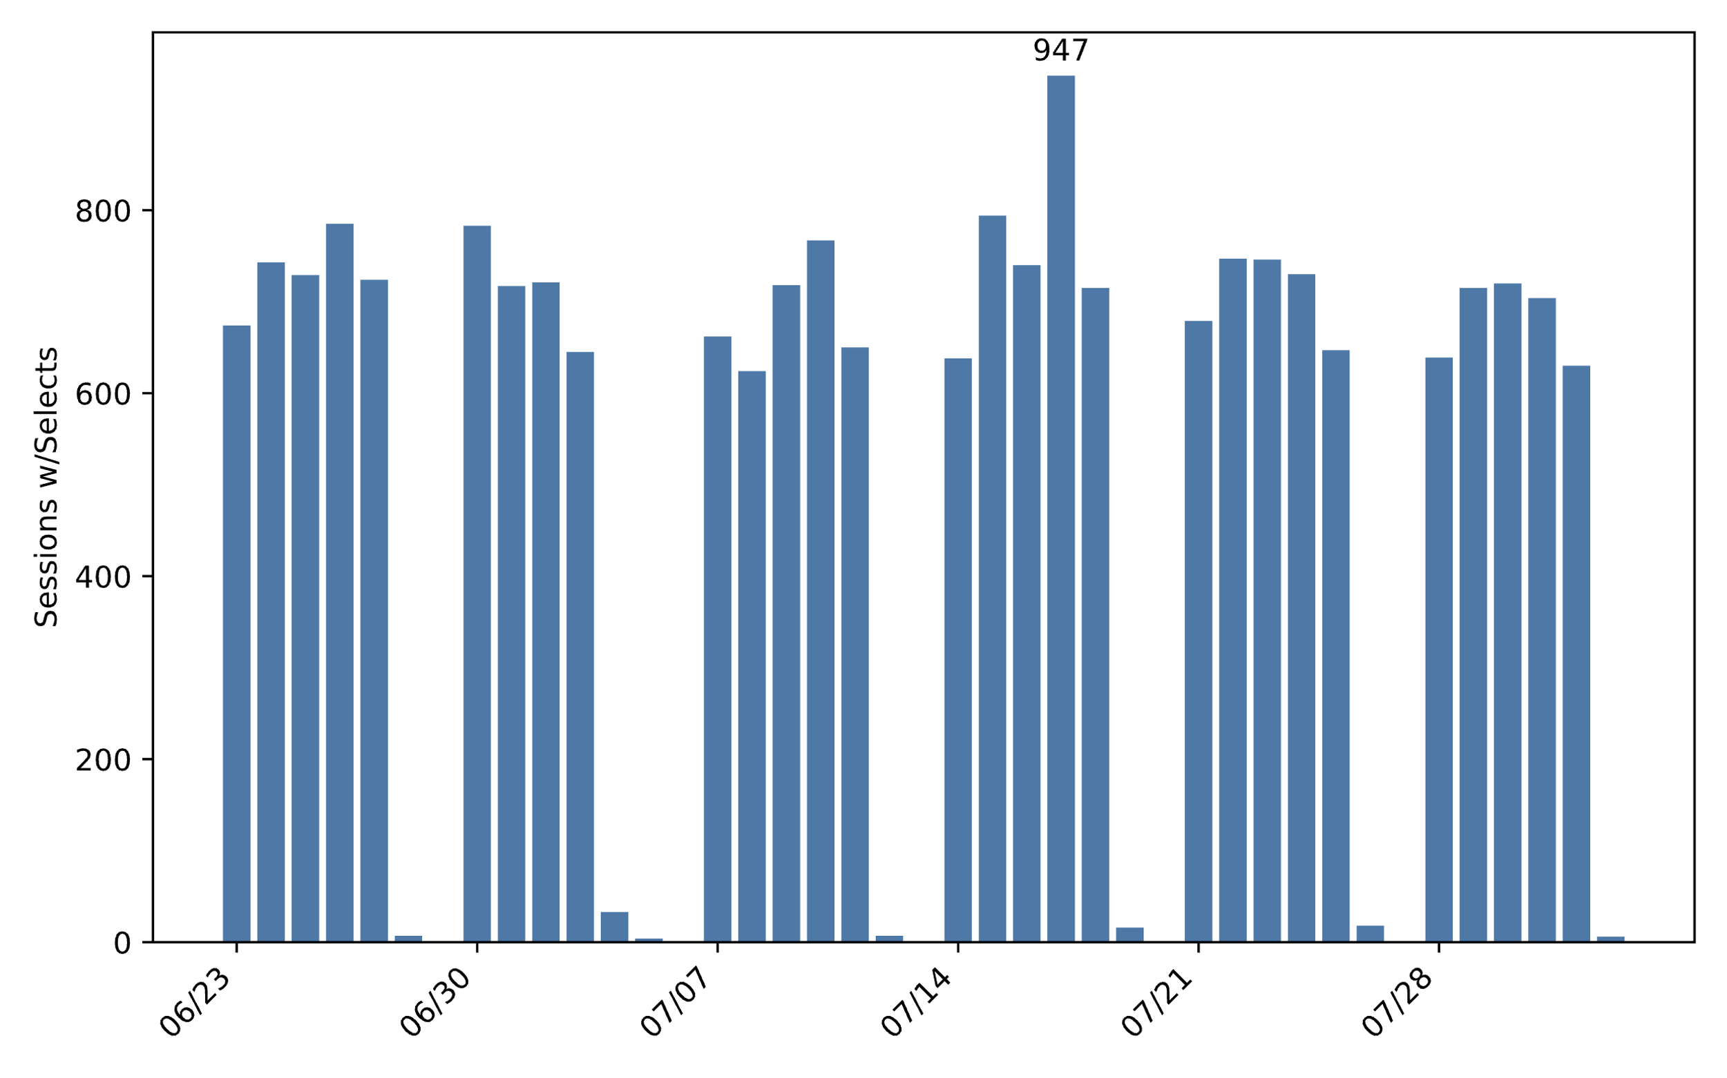

Figure 4.1: Patient sessions per day at VCB.

Notably, 80% of patient-selecting sessions involved reading or creating notes—making this the most common CPRS activity observed.

## 4.2 Volume and Class of Notes

This section categorizes the distinct note types observed in the 6-week VCB traffic sample, based on whether they were created, read, or appeared with metadata. The categories are:

* CPRS Master [Read/Create]: Note types for which both creation and read activity were observed. These form the core of the analysis.
* CPRS [Read/Limited Meta]: Note types read during the period, but only minimal metadata was seen (e.g., titles listed in a menu). No creation activity was captured. These are likely CPRS-supported types with no examples created during the observation window.
* CPRS [Read/No Meta / Outside]: Note types that were read but did not appear elsewhere in the traffic. These were likely created in other VistA clients and only viewed in CPRS.

A total of 1,303 distinct note types were observed in the traffic during the monitoring period. These were grouped based on how CPRS interacted with them—whether each type was both created and read, read with limited metadata, or read without any accompanying metadata or creation activity. Specifically, these categories are:

The table below summarizes counts by note type category, number of types, and observed activity volumes:

| Note Category | Type Count | Create Count | Read Count |
| --- | --- | --- | --- |
| CPRS Master [Read/Create] | 709 | 66,549 | 348,116 |
| CPRS [Read/Limited Meta] | 246 | — | 11,354 |
| CPRS [Read/No Meta / Outside] | 348 | — | 20,118 |

The chart below (Figure 4.2.1) shows the number of distinct note types by CPRS note category. Note types used for creation in CPRS represent a minority of all observed types.

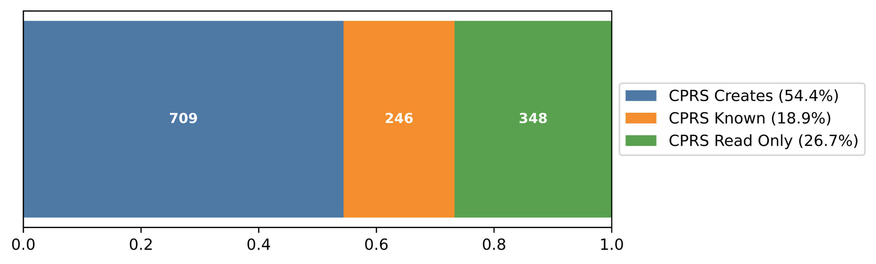

Figure 4.2.1: Count of distinct note types by CPRS category.

In contrast, Figure 4.2.2 shows the total number of distinct notes read, grouped by the same categories. The vast majority were created in CPRS.

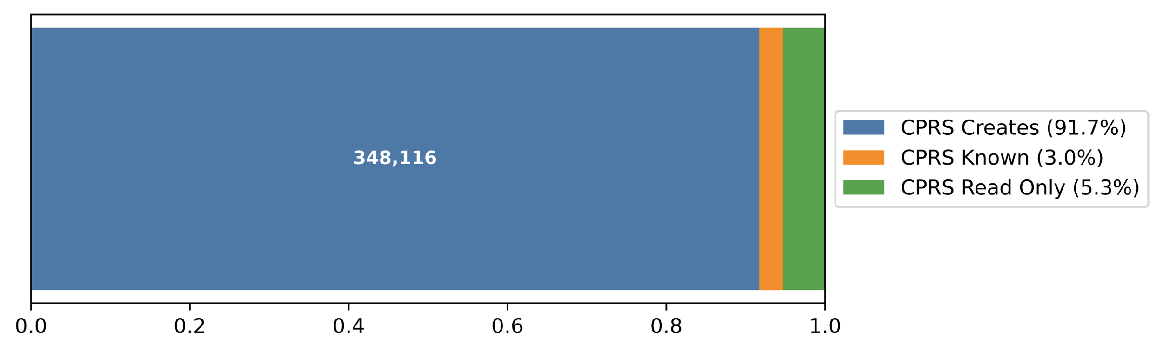

Figure 4.2.2: Distinct notes read by CPRS category.

This suggests that while CPRS can access a wide range of note types, clinicians primarily read notes that were created within CPRS itself.

The remainder of this section focuses on the CPRS Master [Read/Create] set, which comprises 433 distinct note types with full CPRS read and create operations in the traffic. These are further analyzed by their note class, a term used here to distinguish the kind of templating infrastructure associated with each note type:

* Reminder: Notes generated using Reminder Dialog Templates. These templates are highly structured and rule-driven.
* Basic: Notes generated using Basic Templates (TIU Templates without Reminder logic).
* None: Notes created without any associated template, often free-text or copied content. Some have templates “dragged” in.

The breakdown below summarizes this classification by type count, size characteristics (minimum, median, maximum line count), and aggregate content volume. It is notable that Reminder Dialog Template–backed notes constitute the majority of note types used for creation and account for the largest share of resulting note instances. This highlights the central role of Reminder Dialog Templates in driving structured documentation within CPRS.

| Note Class | Type Count | Min Size | Median | Max Size | Line Total | Page Total | Instance Count |
| --- | --- | --- | --- | --- | --- | --- | --- |
| Reminder | 420 | 8 | 83 | 1180 | 26,128,470 | 395,886 | 243,790 |
| Basic | 198 | 8 | 67 | 1512 | 4,355,383 | 65,991 | 39,916 |
| None | 91 | 9 | 27 | 864 | 2,832,074 | 42,911 | 64,410 |

The following chart shows the number of note types in the CPRS Master set, grouped by their associated template class.

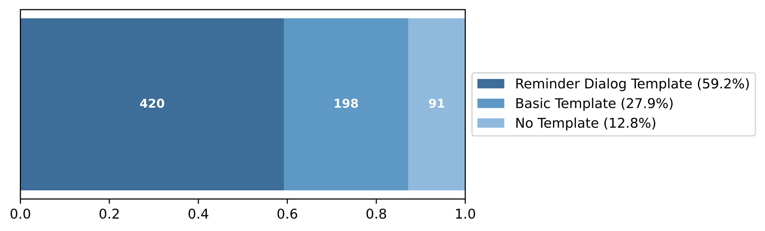

Figure 4.2.3: Distinct note types by template class.

The following displays the total number of note instances created in each class during the observation period.

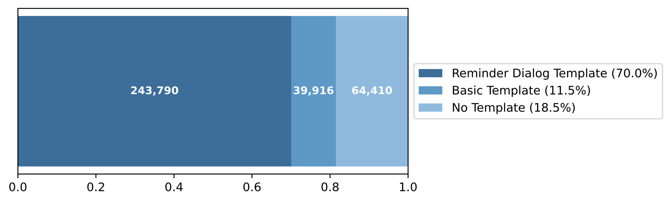

Figure 4.2.4: Note instances by template class.

The following shows the size in lines across all notes in each class.

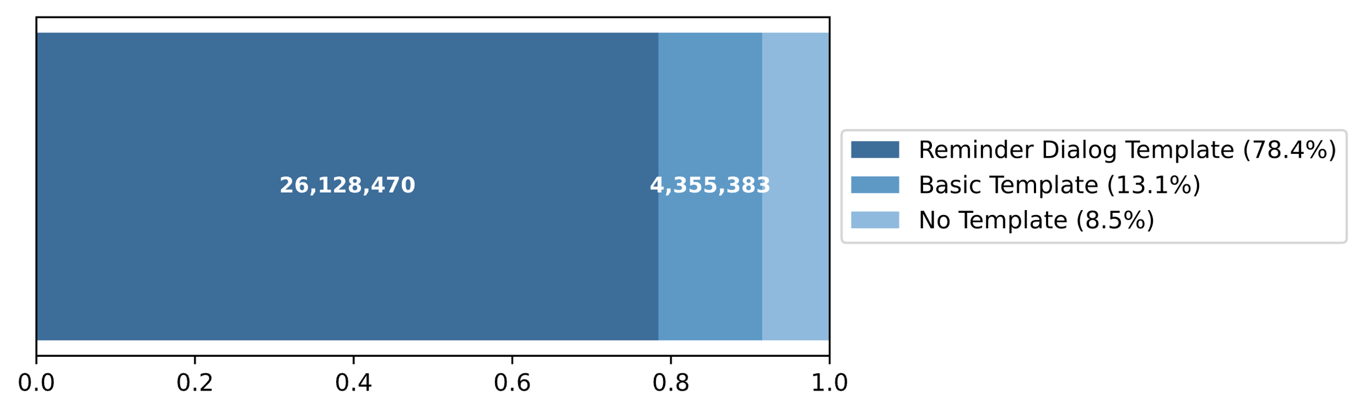

Figure 4.2.5: Total lines across all notes, by template class.

The following compares note length across the same classes, presenting minimum, median, and maximum line counts per note. The chart highlights the greater variability—and generally larger size—of Reminder-based notes.

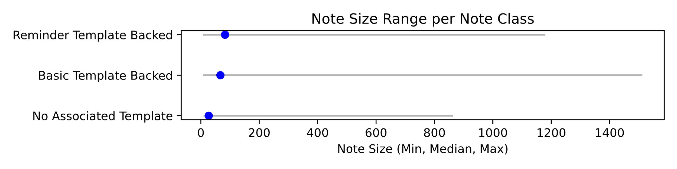

Figure 4.2.6: Note size (min, median, max lines) by template class.

Taken together, these charts reinforce a central claim of this report: CPRS notes are constructed through highly structured mechanisms. The prevalence of Reminder-backed and Basic Template-based notes—by both count and total content—demonstrates the dominance of structured authoring methods, a point explored further in the next sections.

## 4.3 Two Worked Examples

This section presents two structured note examples drawn from VAA RPC traffic samples—one built from a Clinical Reminder Template, the other from a Basic Template. Both illustrate how OBJECTs, templates, and direct clinician input contribute distinct layers of structure to the note’s creation. Yet in the final saved form, that structure is discarded: the result is a flattened, fixed-width plain text document where the origins and types of input—automated, prompted, or authored—are no longer distinguishable.

### 4.3.1 Medical Reconciliation [VCB]

The following breaks down an 89-line, de-identified Medication Reconciliation Note from VCB. This type of note is created using a Clinical Reminder Template and, in this case, contains no manually typed or pasted-in content. It is entirely composed of OBJECTs and templated text.

We begin with the flat note as it appears in VistA and displays in CPRS after creation.

LOCAL TITLE: MED RECONCILIATION   
STANDARD TITLE: MEDICATION MGT NOTE   
DATE OF NOTE: MAY 10, 2025@13:15 ENTRY DATE: MAY 10, 2025@13:15:32  
 AUTHOR: SMITH,TAMMY EXP COSIGNER:   
 URGENCY: STATUS: COMPLETED   
  
MEDICINE RECONCILIATION   
=======================================================================  
HILL,FRED MATTHEW AGE: 69 SEX: MALE  
=======================================================================  
  
  
I have performed med rec with the patient/caregiver utilizing the  
Essential Medication List for Review (MRP-EMLR). This included patient  
MRT5 - Allergies/ADRs(local and remote), MRT1 - Med Reconciliation  
Active,Local and Remote VA prescriptions ,DoD prescriptions,  
local non-VA medications, local inpatient medication orders,  
clinic medication orders and prescriptions that are pending,  
have expired or been discontinued in the last 90 days.  
There were no relevant meds aside from those listed below.  
  
  
 Your provider has NOT prescribed any new medications today.  
  
 _______________________________________________________________________  
  
 Your provider has NOT discontinued any of your medications today.  
  
 A paper copy of this Medication Reconciliation will be mailed to the patient  
 today.  
  
  
  
REMOTE ALLERGY/ADR DATA MAY BE INCOMPLETE; CHECK JLV   
  
FACILITY ALLERGY/ADR  
-------- -----------  
HARLINGEN VA CLINIC No Known Allergies  
SPOKANE VAMC NO KNOWN ALLERGIES  
  
  
  
  
 Allergies: Patient has answered NKA  
 ======================================================================  
  
 Active Outpatient Medications (including Supplies):  
  
 Active Outpatient Medications Status  
 =========================================================================  
 1) APIXABAN 5MG TAB TAKE ONE TABLET BY MOUTH TWICE A DAY ACTIVE  
 TO THIN BLOOD  
 2) ATORVASTATIN CALCIUM 40MG TAB TAKE ONE-HALF TABLET BY ACTIVE  
 MOUTH AT BEDTIME FOR HIGH CHOLESTEROL  
 3) FERROUS SULFATE 325MG TAB TAKE ONE TABLET BY MOUTH ACTIVE  
 EVERY 48 HOURS ANEMIA FOR NUTRITION AND ANEMIA.  
 TAKE WITH FOOD IF EXPERIENCING STOMACH UPSET  
 4) HYDROXYZINE HCL 25MG TAB TAKE ONE TABLET BY MOUTH ACTIVE  
 THREE TIMES A DAY AS NEEDED FOR ALLERGIES  
 5) TAMSULOSIN HCL 0.4MG CAP TAKE ONE CAPSULE BY MOUTH ACTIVE  
 EVERY NIGHT FOR PROSTATE  
 Date: MAY 10, 2025  
 =======================================================================  
  
  
 Consults/procedures/supplies that were ordered today:  
 NO recent pending Consults found.  
 Imaging studies,lab tests and previously scheduled appointments:  
 NO recent pending Radiology found.  
 No pending labs.  
  
 CVF - Future Clinic Visits  
 06/06/2025 08:15 COM CARE-CARDIOLOGY PROCE   
 07/07/2025 12:45 HCC LABORATORY   
 07/09/2025 15:00 HCC BHIP 2 SW   
 07/14/2025 13:30 HRL PACT YELLOW MD   
  
  
 Today your provider was: TAMMY SMITH, MD, FACC CARDIOLOGY & ADVANCED HEART  
 FAILURE  
  
  
  
 If after hours, weekends, holidays or long distance, call 1-888-252-9970,  
 TELECARE.  
 For medication REFILLS call:1-877-752-0650.  
 VCB Call Center: 1-855-864-0516.   
  
 VETERANS CRISIS LINE Phone: 988, push 1 to reach a VA mental health clinician.

Despite its flat appearance, this note is actually composed of 16 structured content segments — a mix of templated text and evaluated OBJECTs selected or triggered during note creation. The following table outlines these segments, distinguishing between fixed template elements, clinician-selected insertions, and OBJECT-derived content:

| Segment | Content |
| --- | --- |
| 1 | VistA-Generated HEADER |
| 2 | Template text with 3 inline OBJECTs (PATIENT NAME, AGE, SEX) |
| 3 | Template paragraph, clinician-chosen (legalistic) |
| 4 | OBJECT AGMC MEDS PENDING DC |
| 5 | Template line, clinician-chosen (how to receive note) |
| 6 | OBJECT LOCAL/REMOTE ALLERGIES |
| 7 | Template line, clinician-chosen (allergies confirmation) |
| 8 | OBJECT ACTIVE MEDICATIONS |
| 9 | Template text prefix for the following OBJECT |
| 10 | OBJECT AGMC CONSULTS PENDING |
| 11 | Template text prefix for the following OBJECTs |
| 12 | OBJECT AGMC XRAY PENDING |
| 13 | OBJECT AGMC LAB PENDING |
| 14 | OBJECT FUTURE APPOINTMENTS NEW |
| 15 | Template text with an inline OBJECT (CURRENT VISTA USER) |
| 16 | Template text (pro-forma) |

Like all notes, this one begins with a VistA-generated Note HEADER, rendered as tabbed text in Segment (1) and followed by the body of the note.

LOCAL TITLE: MED RECONCILIATION   
STANDARD TITLE: MEDICATION MGT NOTE   
DATE OF NOTE: MAY 10, 2025@13:15 ENTRY DATE: MAY 10, 2025@13:15:32  
 AUTHOR: SMITH,TAMMY EXP COSIGNER:   
 URGENCY: STATUS: COMPLETED

Segment (2) comes from the template (MEDICINE RECONCILIATION, AGE:, SEX:, and the === separator) and includes three inline OBJECTs — |PATIENT NAME|, |PATIENT AGE|, and |PATIENT SEX|:

MEDICINE RECONCILIATION   
=======================================================================  
HILL,FRED MATTHEW AGE: 69 SEX: MALE  
=======================================================================

Segment (3) is a fully templated paragraph, selected by the clinician from a set of prewritten legalistic options:

I have performed med rec with the patient/caregiver utilizing the  
Essential Medication List for Review (MRP-EMLR). This included patient  
MRT5 - Allergies/ADRs(local and remote), MRT1 - Med Reconciliation  
Active,Local and Remote VA prescriptions ,DoD prescriptions,  
local non-VA medications, local inpatient medication orders,  
clinic medication orders and prescriptions that are pending,  
have expired or been discontinued in the last 90 days.  
There were no relevant meds aside from those listed below.

Segment (4) contains the key statements that summarize the reconciliation outcome—specifically, that no medication changes were made. These statements were generated by evaluating a single OBJECT, |AGMC MEDS PENDING DC|. CPRS dynamically inserted the relevant lines based on the patient’s medication status:

Your provider has NOT prescribed any new medications today.  
  
 _______________________________________________________________________  
  
 Your provider has NOT discontinued any of your medications today.

Segment (5) reflects an explicit selection by the clinician: how the patient is to receive a copy of the medication reconciliation note. In this case, the clinician chose the “mail” option from among several template-defined alternatives (such as providing a printed copy during the visit or documenting that the patient declined):

A paper copy of this Medication Reconciliation will be mailed to the patient  
 today.

Segment (6) is OBJECT-generated — |LOCAL/REMOTE ALLERGIES| — providing allergy information known to VistA:

REMOTE ALLERGY/ADR DATA MAY BE INCOMPLETE; CHECK JLV   
  
FACILITY ALLERGY/ADR  
-------- -----------  
HARLINGEN VA CLINIC No Known Allergies  
SPOKANE VAMC NO KNOWN ALLERGIES

Segment (7) is another clinician-chosen templated line. It documents that the patient verbally confirmed their allergy information. This segment provides crucial context for the OBJECT-generated allergy summary elsewhere in the note. Specifically, it affirms that, as of the note’s creation date, the allergy information is up to date according to the patient:

Allergies: Patient has answered NKA  
======================================================================

Segment (8) is the evaluated OBJECT |ACTIVE MEDICATIONS|, showing a dated list of outpatient medications:

Active Outpatient Medications (including Supplies):  
  
 Active Outpatient Medications Status  
 =========================================================================  
 1) APIXABAN 5MG TAB TAKE ONE TABLET BY MOUTH TWICE A DAY ACTIVE  
 TO THIN BLOOD  
 2) ATORVASTATIN CALCIUM 40MG TAB TAKE ONE-HALF TABLET BY ACTIVE  
 MOUTH AT BEDTIME FOR HIGH CHOLESTEROL  
 3) FERROUS SULFATE 325MG TAB TAKE ONE TABLET BY MOUTH ACTIVE  
 EVERY 48 HOURS ANEMIA FOR NUTRITION AND ANEMIA.  
 TAKE WITH FOOD IF EXPERIENCING STOMACH UPSET  
 4) HYDROXYZINE HCL 25MG TAB TAKE ONE TABLET BY MOUTH ACTIVE  
 THREE TIMES A DAY AS NEEDED FOR ALLERGIES  
 5) TAMSULOSIN HCL 0.4MG CAP TAKE ONE CAPSULE BY MOUTH ACTIVE  
 EVERY NIGHT FOR PROSTATE  
  
 Date: MAY 10, 2025  
 =======================================================================

Segment (9) introduces a pattern seen in several places: a prefix or header from the template immediately followed by an OBJECT. This one introduces the next section:

Consults/procedures/supplies that were ordered today:

Segment (10) is the OBJECT |AGMC CONSULTS PENDING|:

NO recent pending Consults found.

Segment (11) is a prefix for the next two OBJECTs:

Imaging studies,lab tests and previously scheduled appointments:

Segments (12) and (13) are OBJECTs |AGMC XRAY PENDING| and |AGMC LAB PENDING|:

NO recent pending Radiology found.  
 No pending labs.

Segment (14) doesn’t get a prefix from the template. Its OBJECT, |FUTURE APPOINTMENTS NEW|, starts with a prefix or header line …

CVF - Future Clinic Visits  
 06/06/2025 08:15 COM CARE-CARDIOLOGY PROCE   
 07/07/2025 12:45 HCC LABORATORY   
 07/09/2025 15:00 HCC BHIP 2 SW   
 07/14/2025 13:30 HRL PACT YELLOW MD

Segment (15) is templated text with an inline OBJECT, |CURRENT VISTA USER|, used to populate the clinician’s name and credentials:

Today your provider was: TAMMY SMITH, MD, FACC CARDIOLOGY & ADVANCED HEART  
 FAILURE

The final segment, Segment (16), consists of standard pro-forma contact and help-line information from the template

If after hours, weekends, holidays or long distance, call 1-888-252-9970,  
 TELECARE.  
 For medication REFILLS call:1-877-752-0650.  
 VCB Call Center: 1-855-864-0516.   
  
 VETERANS CRISIS LINE Phone: 988, push 1 to reach a VA mental health clinician.

This example illustrates:

* How a clearly structured note made up of 16 identifiable components is flattened into a fixed-width plain text format
* The embedding of OBJECTs that establish objective clinical information (e.g., medications, allergies) as of the note’s creation date—though often obscured within the plain text
* The use of templated statements for both pro-forma or legalistic content (e.g., “If after hours, weekends…”) and medically relevant inputs (e.g., “Patient has answered NKA”). The flat note treats both the same.
* The blending of summary judgments (e.g., no new or discontinued medications) into the text via OBJECTs, reducing their discoverability in downstream systems

### 4.3.2 Discharge Summary [Omaha]

The Omaha Discharge Summary illustrates a Basic Template Note Type, generated from a CPRS Basic Template.

This template includes:

* one variable-line OBJECT: |FUTURE APPTS|
* multiple inline OBJECTs
* clinician-entered responses via text fields, dropdowns, or multiple-choice selections
* boilerplate sentences inserted without clinician input

This section enumerates the structured input—27 distinct template “segments”—that generated a 97-line Discharge Summary. It is representative of those commonly seen in the VAA-captured Omaha RPC traffic.

| Segment | Template Text / Prompt | Filled By |
| --- | --- | --- |
| 1 |  | Template Line |
| 2 | Attending Physician: | OBJECT ATTENDING PHYSICIAN |
| 3 | ADMISSION DATE: | OBJECT CURRENT ADMISSION |
| 4 | PRIMARY CARE PROVIDER: | OBJECT PATIENT PRIMARY CARE PROVIDER |
| 5 | CHIEF COMPLAINT AT TIME OF ADMISSION: | (left blank) |
| 6 | REASON FOR ADMISSION: | Text entered by doctor |
| 7 | PRESENT ON ADMISSION: | (left blank) |
| 8 | NOT PRESENT ON ADMISSION: | (left blank) |
| 9 | PRINCIPAL DIAGNOSIS: | Text entered by doctor |
| 10 | SECONDARY DIAGNOSIS: | Text entered by doctor |
| 11 | HOSPITAL COURSE: | Text entered by doctor (15 lines) |
| 12 | OPERATIONS, SURGICAL AND BEDSIDE PROCEDURES: | Text entered by doctor |
| 13 | PERTINENT PAST MEDICAL HISTORY: | Text entered by doctor (3 lines) |
| 14 | PERTINENT FINDINGS OF THE PHYSICAL EXAMINATION, PARTICULARLY ABNORMALITIES: | Text entered by doctor |
| 15 | PERTINENT POINTS IN THE REVIEW OF SYSTEMS (INCLUDING ALLERGIES AND DRUG SENSITIVITIES): | Text entered by doctor |
| 16 | PERTINENT FINDINGS OF LABORATORY AND RADIOLOGICAL DATA: | Text entered by doctor (4 lines) |
| 17 | MEDICATIONS AT DISCHARGE: Please refer to Pharmacy Discharge Medication Reconciliation (Consult) Note | (boilerplate) |
| 18 | DISCHARGED TO: | Pulldown — “Return to community (home)” |
| 19 | CONDITION AT DISCHARGE: | Pulldown — “Stable” |
| 20 | DIET: | Pulldown — “Mechanical soft” |
| 21 | ACTIVITY OR LIMITATIONS: | Pulldown — “As tolerated” |
| 22 | CONDITIONS OF WOUND AND WOUND CARE FOLLOW-UP: | Text entered by doctor |
| 23 | FOLLOW-UP CARE: (scheduled appointments with PCP, consultants, therapy, and any diagnostic studies) | Text entered by doctor |
| 24 |  | OBJECT FUTURE APPTS (6 lines) |
| 25 | RETURN TO WORK: | Pulldown — “N/A” |
| 26 |  | Option — one of two choices |
| 27 | Time spent on discharge activities | Pulldown — “30” |

Of the 27 segments, the 11 clinician-entered prompts—highlighted in bold—contain the most critical clinical judgments and would be emphasized in a structured representation of the note.

Segment 1 is a template-defined note title …

DISCHARGE SUMMARY (MED/SURG)

Segments 2–4 are populated by inline OBJECTs: ATTENDING PHYSICIAN, CURRENT ADMISSION, and PATIENT PRIMARY CARE PROVIDER.

Attending Physician - BARNES,RICK T  
  
ADMISSION DATE: Current Admission - MAR 16, 2025@21:05:04  
  
PRIMARY CARE PROVIDER: FERNANDEZ,MANUEL B

Segments 5–10 are prompts for optional clinician-entered text. In this case, only the three mandatory fields (e.g., “REASON FOR ADMISSION”) were filled. The remaining prompts (e.g., “CHIEF COMPLAINT AT TIME OF ADMISSION”) were left blank but still appear in the final note.

CHIEF COMPLAINT AT TIME OF ADMISSION:  
  
REASON FOR ADMISSION: Acute heart failure exacerbation  
  
PRESENT ON ADMISSION:  
  
NOT PRESENT ON ADMISSION:  
  
PRINCIPAL DIAGNOSIS: Acute exacerbation of ... (2 lines filled)  
  
SECONDARY DIAGNOSIS: Encephalopathy, History of ... (3 lines filled)

Segments 11–16 are all mandatory prompts. As shown below, CPRS highlights text boxes in yellow until filled. “HOSPITAL COURSE” generated the longest free-text entry (15 lines).

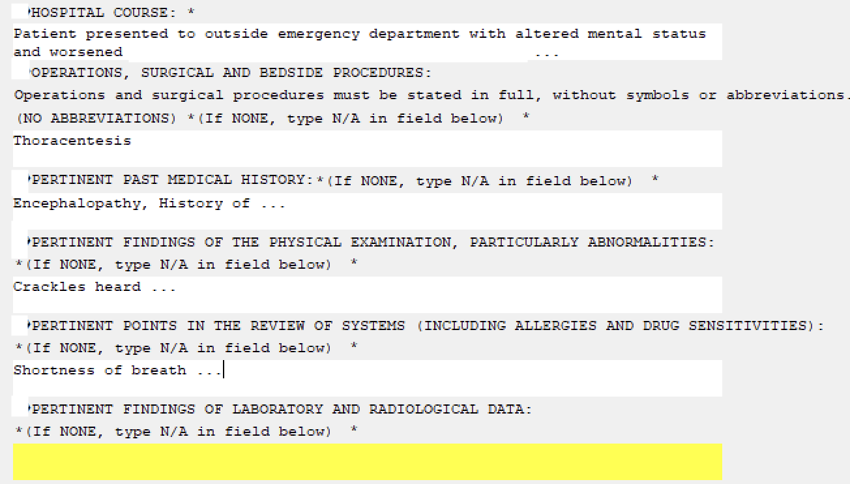

Figure 4.3.2.1: Mandatory Text Prompts

Segment 17 contains boilerplate text directing the reader to consult another note. In a structured representation, this would appear as a clickable link to the referenced consult, rather than a vague instruction to locate it manually.

MEDICATIONS AT DISCHARGE: Please refer to Pharmacy Discharge Medication  
Reconciliation (Consult) Note

Segments 18–21 are pulldown fields, each offering a fixed set of choices. For example:

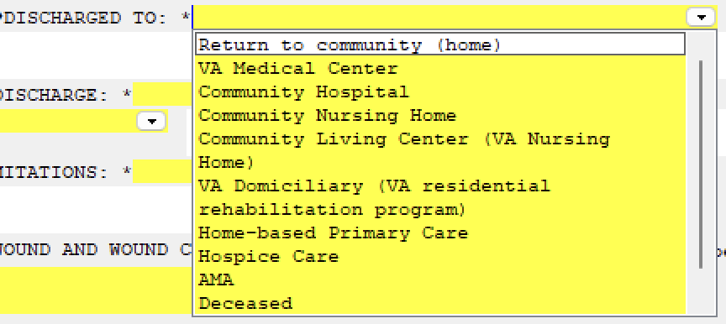

Figure 4.3.2.2: Pulldown Example

Resulting in the following entries:

DISCHARGED TO: Return to community (home)  
  
CONDITION AT DISCHARGE: Stable  
  
DIET: Mechanical soft  
  
ACTIVITY OR LIMITATIONS: As tolerated

Segment 22 is a free-text prompt with guidance on how to indicate N/A. The doctor disregarded the prompt and entered None.

Segment 23 prompts for a description of follow-up care:

FOLLOW UP CARE: (scheduled appointments with PCP, consultants, therapy and any  
diagnostic studies)   
Follow-up in 1 week at post discharge clinic ... (2 lines)

Segment 24 is a variable-line OBJECT, FUTURE APPTS, which inserted a six-line table listing five appointments.

Segment 25 (RETURN TO WORK) is a pulldown; the doctor selected “N/A.”

Segment 26 presented a choice regarding the patient’s cognitive status. The doctor selected the second option:



Figure 4.3.2.3: OBJECT usage frequency by class

Resulting in:

Patient is not cognitively intact to handle VA funds as determined during  
evaluation on (date):

Segment 27 is a template-generated paragraph with an embedded pulldown for time spent on discharge activities:

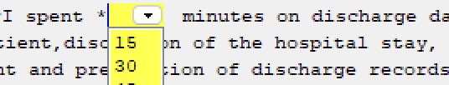

Figure 4.3.2.4: OBJECT usage frequency by class

The doctor selected “30” minutes:

I spent 30 minutes on discharge day activities including   
final examination of patient,discussion of the hospital stay, instruction for  
continuation of care of the patient and preparation of discharge records  
including prescriptions and referral forms.

This example illustrates:

* How a structured discharge summary—composed of 27 distinct segments—is flattened into plain text, obscuring the distinction between doctor-entered content, OBJECT insertions, pulldown selections, and boilerplate.
* That while 11 segments involve free-text entry by the clinician (often including detailed, multi-line narrative), these entries are rendered alongside fixed-choice and even unfilled prompts, without markup or separation in the final note.
* The blending of structured answers (e.g., “Diet: Mechanical soft”) and unstructured narrative (e.g., hospital course) into the same visual style, limiting the ability of downstream systems or readers to prioritize or extract clinically significant input.
* That OBJECTs (e.g., FUTURE APPTS) are included inline as if manually typed, despite being system-generated snapshots, again with no indication of their automated provenance.
* The challenge of distinguishing between critical medical judgment and form-driven compliance text, as both are flattened into one undifferentiated body of note content.

## 4.4 OBJECT Usage

This section focuses on the most widely used class of TIU note in the VCB 6 Week Traffic Set—those backed by Reminder Dialog Templates. These notes are assembled through structured interactions with the CPRS interface, incorporating both clinician-entered inputs and VistA-generated content.

We specifically examine the contribution and presence of OBJECTs, which are one form of structured data in CPRS notes. OBJECTs are VistA-evaluated elements such as current medications, vital signs, recent labs, or scheduled appointments. During note creation, these elements are dynamically resolved and inserted as plain text into the note, blending in with surrounding content.

A substantial portion of these notes originates from structured sources—specifically, OBJECTs evaluated and rendered during note creation.

In the sections that follow, we examine this contribution in two dimensions: * Section 4.4.1 quantifies the number and variety of OBJECTs used in a representative subset of Reminder Dialog–backed notes. * Section 4.4.2 analyzes the proportion of final note text that originates from OBJECTs.

### 4.4.1 Number and Variety of OBJECTs

In the dataset, CPRS fetched 3,794 distinct types of OBJECT. However, only a subset of those were used during actual note creation:

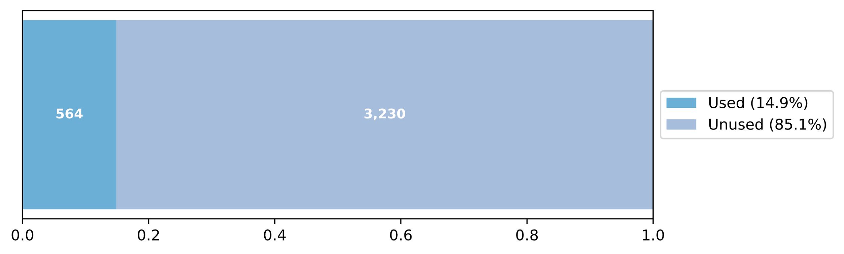

Figure 4.4.1.1: OBJECT types evaluated vs. used

The majority of OBJECTs used are classified as Variable Line. In the VCB 6 Week Traffic Set, such OBJECTs generate between 0 and 1,164 lines of content, depending on patient-specific factors.

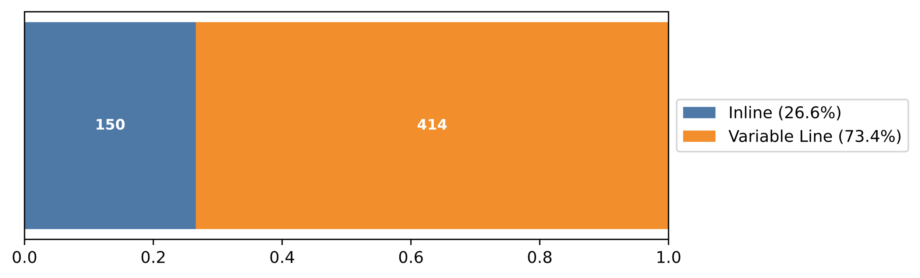

Figure 4.4.1.2: Variable vs Inline OBJECT use

However, Inline OBJECTs (typically single-line insertions like |PATIENT NAME|) are used more frequently. This is unsurprising, as such OBJECTs are inserted in nearly every note, whereas more complex OBJECTs like |LAB PENDING| are used selectively.

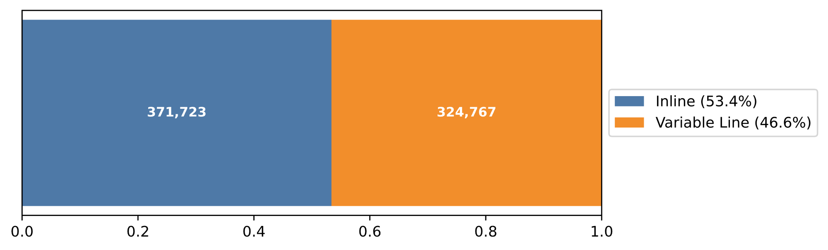

Figure 4.4.1.3: OBJECT usage frequency by class

Despite being used less often, Variable OBJECTs dominate in volume—producing over 64,000 pages (66 lines per page) of note content.

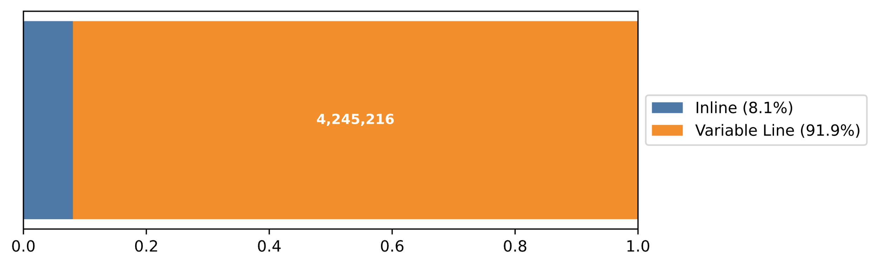

Figure 4.4.1.4: Note content (lines) generated by OBJECT class

### 4.4.2 Proportion of the Final Note

OBJECTs make up a variable portion of the content in Reminder Dialog Template–backed notes. In some cases, OBJECTs are not included at all; in others, they account for nearly the entire note. Across the dataset, the median OBJECT coverage (as a percentage of “content lines,” i.e., lines containing at least one word) is 14%, with a maximum of 100%.

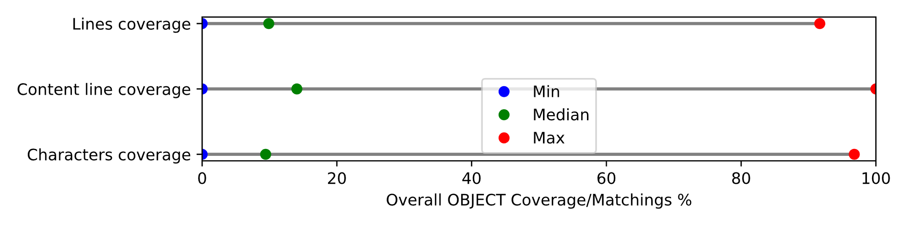

Figure 4.4.2.1: OBJECT coverage across Reminder Dialog–backed notes

By default, CPRS evaluates all OBJECTs embedded in a template. However, not all of these end up in the final note. If the clinician chooses not to include a section of the template that contains an OBJECT, that OBJECT is still evaluated but its output is discarded. Across the sample, the median usage rate is 67%—indicating that roughly one-third of the OBJECTs evaluated are omitted from the final note.

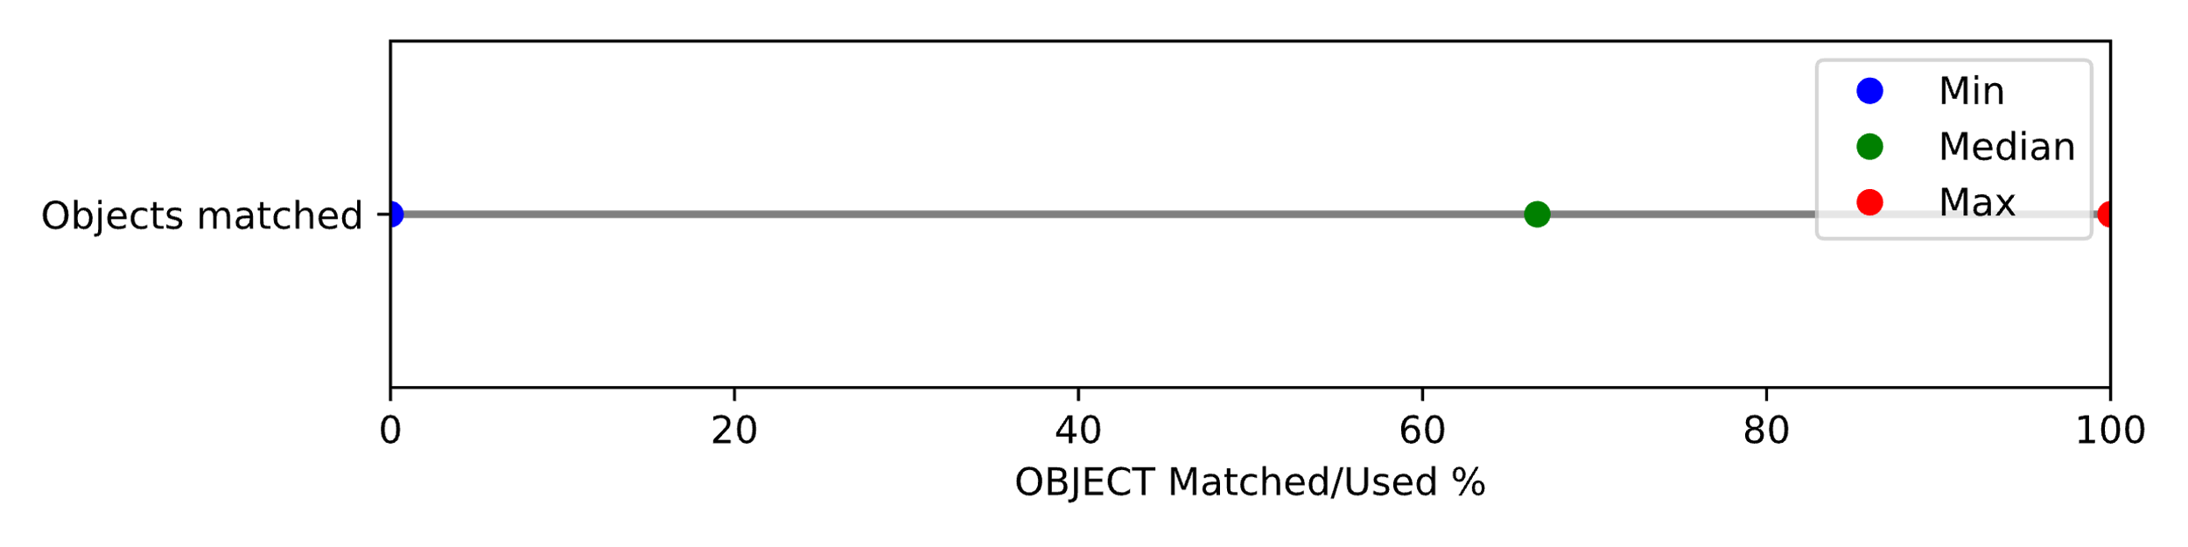

Figure 4.4.2.2: Proportion of evaluated OBJECTs that appear in final note

The chart below shows OBJECT coverage for the ten note types with the highest OBJECT contribution. Several note types are almost entirely composed of OBJECTs.

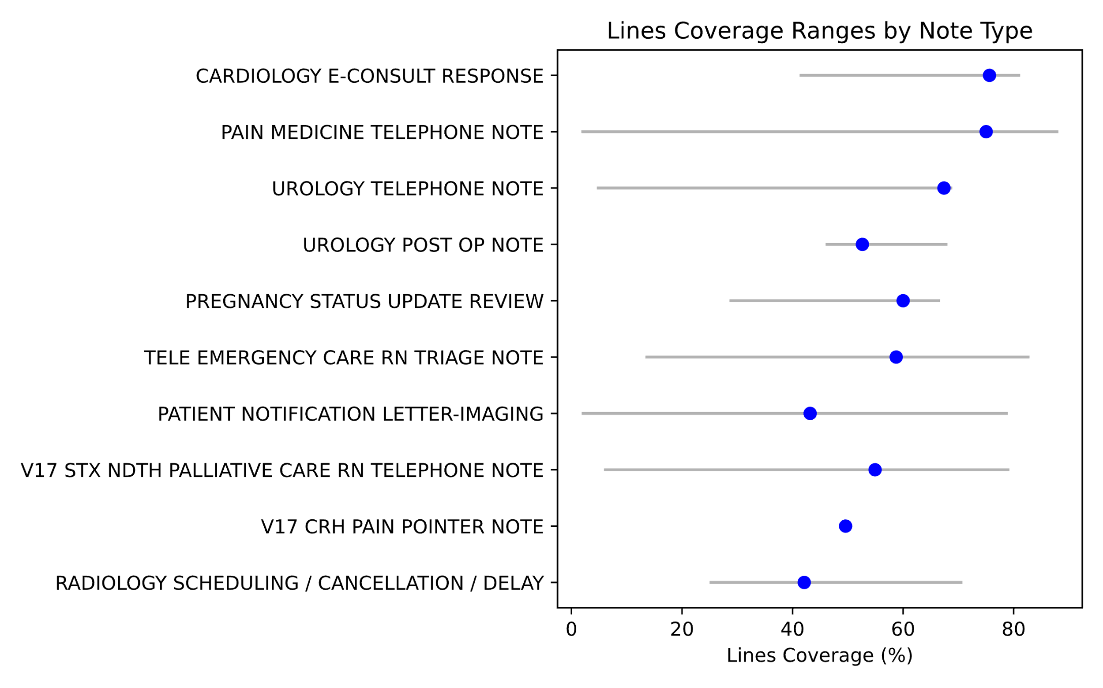

Figure 4.4.2.3: OBJECT coverage for top ten note types

In conclusion, OBJECTs make up a significant and identifiable portion of the content in many CPRS-generated TIU notes.

## 4.5 Key Findings

Clinical notes generated in CPRS are mainly created using a layered, highly structured process—drawing on template-defined prompts, OBJECT insertions, and automated metadata. Clinician-entered text is not free-form; it is prompted and constrained in scope by the template—for example, “Diagnosis at Admission” or “Hospital Course.” Yet the final stored form of these notes discards that structure entirely. What remains is a flattened, fixed-width plain text document, where the provenance, method of entry, and clinical significance of each segment are no longer explicitly represented.

Specifically:

* Structured inputs are flattened into visually uniform text. Notes composed of dozens of distinct components—each traceable to templates, OBJECTs, pulldown fields, or clinician-entered text—are rendered as monolithic blocks of text. This erases machine-readable distinctions between automated inserts, guided inputs, narrative content, and even unfilled prompts.
* OBJECTs make up a substantial and identifiable portion of many notes. These automated insertions supply point-in-time clinical data (e.g., attending physician, medications, appointments) drawn from system sources. Yet they appear inline without metadata or formatting to distinguish them from manually authored narrative.
* The final note blends legal boilerplate and regulatory disclaimers with clinical input. These appear in the same visual form, with no labels to distinguish non-clinical static phrasing from dynamic, patient-specific content.
* Clinician-authored judgments are not visually or structurally prioritized. Even when a clinician provides original, multi-line narrative (e.g., hospital course, diagnosis reasoning), those inputs are flattened into the same format as fixed-choice pulldown answers or unanswered prompt labels. High-value narrative is visually indistinct from routine form-fill.

# 5. Proposed Solution

## 5.1 External Annotation for VistA Notes

Any solution to restore the underlying structure of VistA clinical notes must begin with the flat note output as it exists today. The underlying note cannot be altered—VistA clients depend on notes being flat, printable text, and the saved form is signed by clinicians and constitutes the permanent legal medical record. Therefore, any effort to reintroduce structure, provenance, or semantics must function entirely externally.

We propose an external overlay or annotation layer that can be applied to saved VistA notes. This layer would:

* Support fine-grained annotations: identify a specific substring (e.g., a patient’s name), a single line (e.g., a prompted response), or a block of lines (e.g., a rendered OBJECT like active medications).
* Specify content type: mark content as a known element such as a specific OBJECT (e.g., |ACTIVE MEDICATIONS|), a specific prompted text field, or particular static boilerplate.
* Specify content source: distinguish between clinician-authored text, selections made via template prompts, and automated system insertions.
* Specific content time: specific the date and time content was created or accessed

We propose an external overlay or annotation layer that can be applied to saved VistA notes. This layer would:

* Support fine-grained annotations: Identify a specific substring (e.g., a patient’s name), a single line (e.g., a prompted response), or a block of lines (e.g., a rendered OBJECT like active medications).
* Specify content type: Mark content as a known element such as a specific OBJECT (e.g., |ACTIVE MEDICATIONS|), a prompted text field, or static boilerplate.
* Specify content source: Distinguish between clinician-authored text, template-driven selections, and automated system insertions.
* Specify content time: Record the date and time when content was created, selected, or inserted.

This annotation layer would enable existing flat notes to be rendered in modern, structured formats—such as browser-based displays with collapsible sections, tagged highlights, or source-specific styling. It would also support nuanced interpretation by AI tools, which perform best when they can understand the provenance and purpose of each element in the note.

## 5.2 Example Annotation Format

The following illustrates how an overlay format may annotate content at different granularities within the note:

* Inline (substring) annotations use a "span" to mark character positions within a single line.
* Single-line annotations apply to an entire line.
* Multi-line blocks are denoted by a range of lines.

We use a JSON structure that allows each annotated unit to carry metadata about its type, source, and timestamp. This format is notional—both the data format (e.g., JSON vs. XML or YAML) and the metadata properties (e.g., type, source, time) are illustrative and could be adjusted based on implementation needs.

### 1. Inline Annotation (e.g., OBJECT: PATIENT NAME)

{  
 "5": [  
 {  
 "span": "15-27",  
 "type": "OBJECT",  
 "object": "PATIENT NAME",  
 "source": "VISTA",  
 "time": "2025-08-15T14:23:00Z"  
 }  
 ]  
}

This identifies characters 15 through 27 on line 5 as the patient name, inserted by the system.

### 2. Single-Line Annotation (e.g., Prompted Answer, typed by Clinician)

{  
 "12": {  
 "type": "TEMPLATE:PROMPT",  
 "prompt": "DISCHARGE CONDITION",  
 "source": "CLINICIAN_TYPED",  
 "time": "2025-08-15T14:25:00Z"  
 }  
}

Line 12 is marked as a typed response to a template-driven prompt.

Note: In practice, we could be more precise about the template prompt by specifying the exact template and prompt field identifiers. VistA tracks both using unique internal IDs, enabling precise back-reference to the originating form element.

### 3. Multi-Line Block (e.g., OBJECT: ACTIVE MEDICATIONS)

{  
 "18-25": {  
 "type": "OBJECT",  
 "object": "ACTIVE MEDICATIONS",  
 "source": "VISTA",  
 "time": "2025-08-15T14:22:00Z"  
 }  
}

This range spans lines 18 through 25, representing an inserted OBJECT rendered as a block of lines.

### 4. Multi-Line Block Annotation (Clinician-Authored Free Text)

{  
 "8-11": {  
 "type": "FREE_TEXT",  
 "source": "CLINICIAN_TYPED",  
 "time": "2025-08-15T14:18:00Z"  
 }  
}

Lines 8 through 11 are annotated as free text authored directly by the clinician.

Note: Free text authored by the clinician is often the most clinically significant part of a note. It contains the nuanced interpretation, clinical reasoning, and patient-specific observations that structured templates and automated inserts cannot fully capture.

### 5. Multi-Line Block Annotation (Template-Inserted Boilerplate)

{  
 "18-19": {  
 "type": "TEMPLATE:BOILERPLATE",  
 "source": "TEMPLATE",  
 "time": "2025-08-15T14:20:00Z"  
 }  
}

Note: Boilerplate text is often used for legal disclaimers or documentation requirements—such as “This note was completed in 30 minutes”—rather than clinical observations. It rarely contains clinically relevant information.

## 5.3 Use Cases for Note Annotations

With a structured overlay applied to flat VistA notes, multiple downstream use cases become possible without altering the underlying note content. Below are illustrative applications that highlight the power of external annotation:

### 5.3.1. Modern HTML Rendering of Notes

Annotations can support modern, visually enhanced renderings of CPRS notes in a browser:

* Inline highlights for OBJECTs and prompted responses (e.g., patient name, active problems).
* Collapsible sections for supporting data like OBJECTs (e.g., hide/show ACTIVE MEDICATIONS).
* Styling and layout enhancements:
  + Tables rendered with HTML <table> tags for structured OBJECTs (e.g., medications, labs).
  + Clinician-authored free text highlighted, while boilerplate or templated content is visually faded.
* Semantic cues for section types and provenance, enabling richer navigation and display.

Example:  
The ACTIVE MEDICATIONS block could be rendered as a sortable, interactive HTML table with added timestamps and source annotations.

### 5.3.2. Objective Information Trends

Because OBJECT content is time-stamped and tagged by type, it can be:

* Extracted longitudinally from notes of various types (e.g., progress notes, discharge summaries).
* Grouped and trended over time, e.g.:
  + Lists of active problems, medications, appointments, or future consults.
  + Lab result OBJECTs rendered as graphs to show clinical trends.

Example: Generate a graph of Hemoglobin A1C over time from scattered notes using LAB RESULTS OBJECTs.

### 5.3.3. Procedure Tracking Across Notes

Templated prompts and free-text responses annotated by type and source can support:

* Extraction of performed procedures, diagnoses, or assessments over time.
* Mapping of discrete events (e.g., referrals, interventions) to specific note entries and dates.
* Building structured timelines from unstructured documentation.

Example: Identify every instance where an EKG or wound care procedure was performed, regardless of note type.

### 5.3.4. Structured Input for AI Models

Annotated notes become more intelligible to LLMs and AI tools:

* Clarified authorship and structure reduces hallucination and misattribution.
* Objective vs. subjective distinction aids in reasoning.
* Selective prompts can focus on clinician-authored text or specific objects (e.g., “Summarize clinician’s opinion, excluding system-generated content”).

Example: An AI tool could extract clinician impressions only, ignoring OBJECT blocks and legal boilerplate.

## 5.4 Implementation Strategies

Any annotation system must work entirely externally to VistA, preserving the flat, signed, legal form of the original note. The following strategies offer ways to implement structured overlays without requiring any change to VistA itself:

### 5.4.1. Post-hoc Extraction and Annotation

* Regularly extract newly saved notes from VistA.
* Use domain knowledge of VistA’s note types, templates, and OBJECTs to annotate each note after the fact.
* Allows retrospective enhancement of existing note archives.
* Can be hosted outside the clinical system (e.g., in a parallel informatics or analytics environment).

### 5.4.2. Enhanced CPRS Output

* CPRS, VistA’s main client, uses internal structure (templates, prompts, OBJECTs) to generate notes.
* CPRS could be enhanced to generate a parallel annotation file at the time of note creation.
* This preserves full fidelity of the original composition process—e.g., which template fields were selected, which OBJECTs were used, what text was typed by the clinician.
* The annotation could be stored outside VistA while maintaining the flat note in VistA itself.

### 5.4.3. Passive Observation of Note Composition

* VAA demonstrated that the structured information behind notes can be extracted by monitoring the RPC traffic between VistA and its clients.
* By passively observing these RPCs, one can reconstruct:
  + The OBJECTs inserted into the note,
  + The templates used,
  + The questions prompted and the clinician’s responses.
* This approach enables near-complete structural reconstruction without requiring any changes to CPRS or VistA.