INFS803 CLOUD COMPUTING · 2026 SEMESTER 2
Paperbound
A three-tier cloud web application
Assignment 2 — Option B: Cloud Web Application Development and Deployment
Public web client | https://main.dcgzrxjjzkur.amplifyapp.com/
Git repository | https://github.com/cloudvorkala/INFS803
Public API endpoint | https://8lvgv7w3l0.execute-api.ap-southeast-2.amazonaws.com/dev
Presentation video | [ PASTE THE PUBLIC VIDEO LINK — under 5 minutes, all members presenting ]
Trello board | https://trello.com/b/JeRg9pfp/cloud-computing
GROUP: 26
NAMES: Claude Niu, Liam Naidoo, Tandra Rani Hore & Yu Zhang
Submitted Week 12

Contents
Contents 1
1. Member contribution 2
2. Introduction 4
2.1 Scope of this report 5
2.2 Technology summary 5
3. Project background and requirements analysis 5
3.1 Functional requirements 6
3.2 Non-functional requirements 6
3.3 Requirements the brief sets that are easy to misread 7
3.4 Assumptions, constraints, risks and cloud opportunities 8
4. Project management 9
4.1 Work breakdown structure 10
4.2 Schedule and milestones 10
4.3 Meetings 11
4.4 Worklog 13
5. High-level design 14
5.1 Why each component is there 15
5.2 The tier boundary, stated precisely 16
6. Detailed design 16
6.1 Checkout: the concurrency problem and its solution 17
6.2 Data model 17
6.3 Authentication and authorisation 18
6.4 File upload 18
6.5 Failure handling 19
7. Cloud implementation 19
7.1 DynamoDB 20
PAGEREF _Toc242275546 \h 7.2 S3 21
7.3 Cognito 22
7.4 Lambda, API Gateway and IAM 23
7.5 Client hosting on AWS Amplify 24
7.6 Deployment process 24
7.7 Cost analysis 24
7.8 Security, reliability, scalability and cost optimisation 24
8. User manual 24
8.1 Test accounts 24
8.2 Browsing the catalogue 24
8.3 Signing in 24
8.4 The cart 24
8.5 Placing an order 24
8.6 Order history 24
8.7 Administrator functions 24
8.8 If something goes wrong 24
9. RESTful API list 24
9.1 Status codes 24
9.2 Testing the API without the client 24
10. Testing 24
10.1 Frontend testing 24
Figure 23: Featured Product Display. 24
10.2 API testing 24
11. Summary and reflection 24
11.1 What the project demonstrated 24
11.2 Limitations 24
11.3 What we would do differently 24
11.4 Future work 24
Appendix A — AI Usage Declaration 24
Appendix B — Repository structure 24

TO ADD Right-click the table of contents in Word and choose "Update Field" to populate it before exporting to PDF.

1. Member contribution
The table below records what each member contributed. The Git repository shows the same split as per-author commit history, and the Trello board records it against dated cards.
Member | Contribution | Evidence
Liam Naidoo  Student ID: 22174957 | Client tier: React/Vite single-page application, including catalogue, search and filter, product detail, cart, checkout, order history, admin screens, error boundary and 404 handling. Integration with the deployed API and Cognito authentication. Deployment of the client to AWS Amplify Hosting with Tandra. Wrote the 28 user stories on the Trello board, set up the board, wrote the user manual (Section 8), and coordinated and drafted the report. Seeded the 100-title catalogue and S3 cover images through the deployed API. | LiamN_React_implementation and fix/upload-limit branches; Trello: user stories, user manual and catalogue seeding cards
Claude Niu  Student ID: 22184809 | Backend development and integration: developed the Python/Flask foundation, Product and Cart operations, Cognito permission checks and atomic checkout with AI assistance; maintained the API documentation and Serverless configuration; added checkout test scenarios and SDK-reuse improvements; integrated team changes through pull-request merges; completed the backend sections of this report. | feature/backend_v1, feature/checkout, testing/auto_K6_test and refector/GET_refector branches; PR merges #1-#7
Tandra Rani Hore  Student ID: 26337078 | Performed manual functional testing of the client-side application. Tested key features including product search, category filtering, product sorting (Low-High, High-Low, A-Z), adding products to the cart, removing items, changing cart quantities, and sign-in/ sign-out functionality. Recorded the test results using expected and actual outcomes with pass status and added selected screenshots as testing evidence in Trello. Additionally, performed final verification testing on the deployed live site. Also assisted in preparing the project report. | Feature/tandra-testing branch  Manual functional testing records/results.  Trello: Testing activity/evidence recorded on the relevant Trello card.
Yu Zhang  Student ID: 23182547 | Storage, upload and API verification: set up the S3 cover bucket (paperbound-covers-dev-autinfs803-26) with its covers/uploads/ prefix and public-read bucket policy, and documented the admin-only file upload operation. Verified the RESTful API list against the deployed dev stage, ran the Orders/Upload Postman collection (17 requests, 30/30 assertions and documented API testing. Produced the cost analysis and the budget-risk mitigation. | Postman collection run on orderstest; S3 console evidence in Section 7.2; Trello: S3, upload, API testing and cost cards

2. Introduction
Paperbound is an online bookstore built and deployed as a three-tier cloud application on Amazon Web Services. Customers browse a catalogue of one hundred titles, filter by category, search by title, author or ISBN, add books to a cart, sign in, place an order, and review their order history. Administrators additionally create, update and withdraw titles, and upload cover images.
The application was built to demonstrate a specific architectural claim rather than to be a large piece of software: that separating presentation, application logic and data storage into three independently deployable tiers produces a system whose security and correctness properties can be stated and then tested. Every design decision in this report is presented alongside the alternative that was rejected and the reason, because in cloud architecture the interesting content is almost always the trade-off rather than the component.

2.1 Scope of this report
Section 3 analyses the requirements the brief sets and how they were interpreted. Section 4 records how the project was managed. Sections 5 and 6 give the high-level and detailed design, including the concurrency control at the centre of the checkout path. Section 7 documents the cloud implementation service by service, with the configuration used and the cost consequences of each choice. Section 8 is the user manual, Section 9 the complete list of RESTful services with access URLs, Section 10 the testing, and Section 11 a summary and reflection.

2.2 Technology summary
Tier | Technology | AWS service
Client (presentation) | React 18, React Router 6, Vite 5, CSS Modules | AWS Amplify Hosting
Application (logic) | Python 3.12, Flask, serverless-wsgi, Pydantic | AWS API Gateway and AWS Lambda
Data (persistence) | Key-value/document tables accessed with boto3 | Amazon DynamoDB
Object storage | Cover images stored as S3 objects; boto3 uploads | Amazon S3
Identity | Cognito ID tokens; Amplify Auth and Flask JWT verification | Amazon Cognito

3. Project background and requirements analysis
The brief asks for a shopping-style web application built as three tiers and deployed to a public cloud, with a documented set of RESTful services, cloud object storage for assets, and a managed cloud database. An online bookstore was chosen as the domain because a book catalogue has the properties that make the architecture interesting: items have finite stock, so concurrent purchases genuinely conflict; items have images, so object storage is a real requirement rather than a box to tick; and the catalogue is naturally filtered and searched, so the database access patterns are varied enough to need deliberate key design. Administrators can manage the catalogue, update stock and upload book cover images.

3.1 Functional requirements
Ref | Requirement | Where it is met
F1 | Browse a catalogue of products with images and prices | GET /products; covers served from S3
F2 | Filter the catalogue by category | GET /products?category= — the backend scans Products and applies case-insensitive category filtering in Python
F3 | Search by title, author or ISBN | GET /products?search= — Scan, then case-insensitive matching on title, author and ISBN
F4 | View a single product in detail | GET /products/:id
F5 | Register an account and sign in | Cognito user pool, called directly from the browser through Amplify; the API verifies the resulting ID token
F6 | Maintain a cart that persists across devices | GET/POST /cart, PUT and DELETE /cart/:productId
F7 | Place an order, decrementing stock correctly | POST /checkout — one DynamoDB transaction
F8 | Review order history | GET /orders
F9 | Administrators manage the catalogue | POST, PUT, DELETE /products — admin group only
F10 | Administrators upload cover images to cloud storage | POST /upload_file — writes to S3, returns the object URL

3.2 Non-functional requirements
Ref | Requirement | How it was addressed
N1 | Three genuinely separate tiers | The client holds no business logic. Stock rules, pricing, authorisation and the checkout transaction are in the application tier only. The cart is server-side state, not browser state — which is the difference between three tiers and a client with a database behind it.
N2 | No credentials in the client or on the instance | Lambda uses an IAM execution role for DynamoDB and S3 access; access keys are not embedded in the Python application. Public Cognito pool/client identifiers are configuration. Local .env files are excluded from the deployment package, and the browser app client is configured without a client secret.
N3 | Correct behaviour under concurrent purchase | Checkout rechecks product data and submits order creation, stock decrements and purchased cart-line deletions as one conditional DynamoDB transaction. A failed stock or quantity condition prevents partial writes and returns a conflict response.
N4 | Markers can exercise the API without the client | Sign-up and sign-in are handled by Cognito, so the API has no login route of its own. Every protected route verifies the Cognito ID token sent with the request. Section 9.2 explains how to obtain a token and exercise every route with Postman or curl, without the client.
N5 | Deployed cost must stay within free allowances | The backend avoids an always-running application VM and uses one Lambda function, on-demand DynamoDB tables and limited log retention, so cost follows actual requests and an idle month costs close to nothing (Section 7.7).
N6 | The application must survive a reboot | Products, carts and orders persist in DynamoDB, and uploaded images persist in S3. Replacing or restarting a Lambda execution environment does not remove these records; the function reconstructs the Flask application from its deployment package and configuration.

3.3 Requirements the brief sets that are easy to misread
Three points in the brief were interpreted deliberately, and are recorded here because a different reading would have produced a different system.
"At least ten RESTful services, of which at least three are POST." The API exposes twelve routes, four of them POST: five for products, four for the cart, and one each for checkout, orders and file upload. Sign-up and sign-in are handled entirely by Cognito, so the browser authenticates directly with the user pool and the API never sees a password. The API's job is to verify the Cognito ID token on every protected route. None of the twelve routes exists only to proxy authentication, so the count reflects real application functionality.
"You are not allowed to set up a local database in a VM." Paperbound uses the managed DynamoDB service for Products, Carts and Orders. No MySQL, SQL Server or other database is installed inside the application runtime or on an EC2 instance. Images are stored separately in S3; Cognito manages account identities.

"Assets such as pictures should be stored in cloud storage." Paperbound stores uploaded book cover images in Amazon S3. Administrators upload images through the backend, which returns the S3 object URL. The frontend uses this URL to directly from S3 displays the cover image, and the browser retrieves the image.

3.4 Assumptions, constraints, risks and cloud opportunities
Assumptions:
- Traffic is low and bursty: markers and a small group of test users, not a public storefront. This is why the design favours pay-per-use services over always-on capacity.
- The catalogue is small (about one hundred titles), so simple access patterns are acceptable and are documented where they would need to change at scale.
- No real payments are taken. Checkout records an order and a delivery address only.
- Markers access the system from a standard browser over HTTPS, and through Postman or curl for the API.
Constraints:
- Cost must stay within AWS free allowances, which rules out always-on paid components such as load balancers and NAT gateways.
- The brief forbids a database installed on a virtual machine, so persistence must use a managed cloud database.
- Client and backend must both stay publicly reachable from submission until marking is complete.
- Four developers worked in parallel on separate tiers, so the API contract had to be agreed before either side was finished.
Risk | Likelihood | Impact | Mitigation
Free-tier allowance exceeded, producing a bill | Low | Medium | Pay-per-use and on-demand services with nothing always-on; cost review in Section 7.7. No AWS Budgets alert was set; adding one would be the next step before any wider use
Frontend and backend disagree on the API contract | High | High | Contract agreed early on Trello; this risk did occur (auth flow and token header format) and was resolved through a tracked change
Overselling when two customers buy the last copy | Medium | High | Stock checked and decremented atomically in the backend (Section 6.1)
Credentials leaked through the client or repository | Low | High | Client holds only public Cognito identifiers; backend uses IAM roles, no access keys in code
Deployment unavailable during marking | Low | High | Managed services with no servers to maintain; teardown only after marks are released

Cloud opportunities:
Managed services enable students in a four-person team to provide capabilities that otherwise would require dedicated infrastructure work. Cognito provides secure identity without storing passwords. Durable, replicated storage without database administration is provided by DynamoDB and S3. Lambda and Amplify are scalable and free when not in use. This makes the business needs of the brief, which are frequently present in a business (a never-closed shop, secure accounts, image storage and safe simultaneous purchasing) technical goals that are covered by the cloud platform to a significant degree.

4. Project management
Work was tracked on a Trello board with dated cards, so the worklog carries timestamp evidence rather than a retrospective narrative.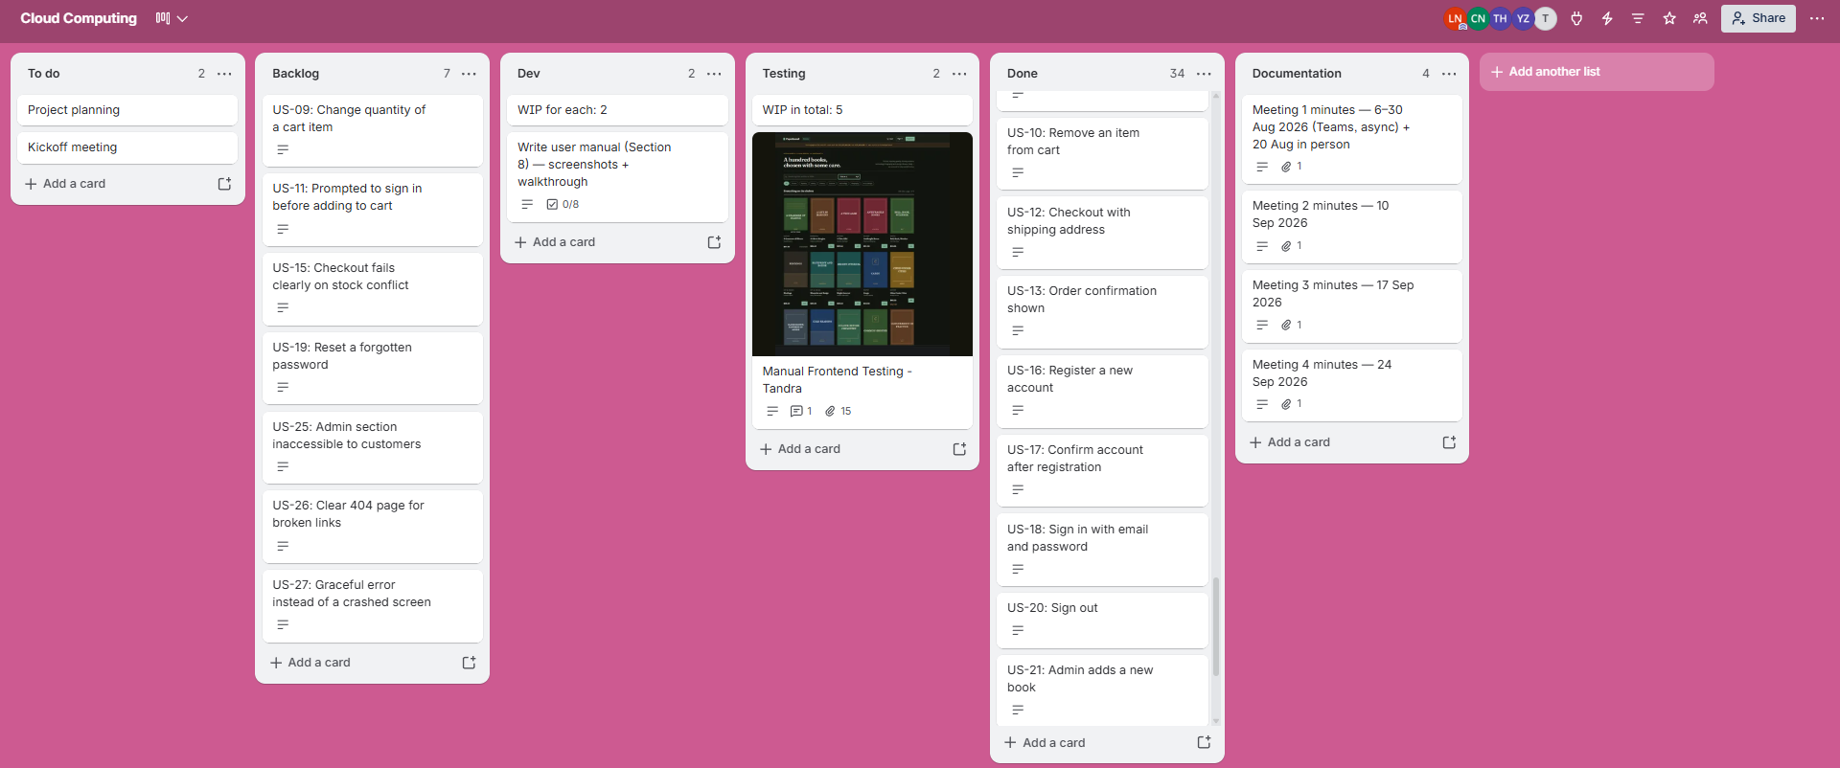Figure 1 — The Trello board used to plan and track the project.

4.1 Work breakdown structure
ID | Work package | Tasks | Deliverable
1 | Requirements and design | Analyse the brief; choose the domain; design the API contract; design the data model | API contract, table definitions
2 | Client tier | Catalogue, search and filter, product detail, cart, checkout, order history, admin screens, error handling | React SPA
3 | Data tier | DynamoDB tables and indexes; seed 100 titles; S3 covers bucket and policy; Cognito user pool | Live database and storage
4 | Application tier | Implement 12 REST operations; verify Cognito ID tokens and admin permissions; validate requests; maintain per-user carts; commit checkout as one DynamoDB transaction; upload covers to S3. | Python/Flask API hosted in AWS Lambda behind API Gateway.
5 | Testing | Manual frontend tests (16 cases); Postman API tests (30 assertions); backend pytest suite; k6 checkout race and rollback scenarios | Test records and scripts
6 | Deployment | Package Python dependencies with Docker; deploy Lambda/API Gateway and the execution role using Serverless Framework; configure environment variables and CORS; integrate the Amplify client. | Public URLs
7 | Documentation | This report; user manual; API list; presentation video | Report and video

4.2 Schedule and milestones
Milestone | Definition of done | Date
M1 — Client complete | Every screen works against the mock API | 5 Sep 2026
M2 — Design agreed | Three DynamoDB tables and Cognito auth agreed (Meeting 2); user stories written | 10 Sep 2026
M3 — Data tier live | Tables created and test products loaded; user pool created | 14 Sep 2026
M4 — API complete | All 12 routes implemented and tested against DynamoDB (Postman 30/30) | 30 Sep 2026
M5 — Deployed | Client and API both reachable at public HTTPS URLs | 1 Oct 2026
M6 — Catalogue seeded | 100 titles and S3 covers loaded through the deployed API | 4 Oct 2026
M7 — Submitted | Report, video and repository finalised | 16 Oct 2026
The client was built against a mock API first, so it was complete before the data model was fixed; the mock was replaced by the live API once the backend was deployed. Dates are taken from the Git history, the Trello cards and the meeting minutes.

4.3 Meetings
Meetings were held in person at WZ Building and on Microsoft Teams, with recordings where available. Minutes are recorded on the Trello board's Documentation list, one card per meeting, with the full minutes attached: https://trello.com/b/JeRg9pfp/cloud-computing
# | Date | Format | Attendance | Key outcomes
1 | 6–30 Aug 2026 | Teams (async); in-person 20 Aug | All contributed; Tandra unable to attend 20 Aug | Bookstore chosen; React, Cognito and Amplify proposed; frontend preview shared; AWS access set up
2 | 10 Sep 2026 | WZ Level 3 + Teams | All four | Three DynamoDB tables and Cognito auth agreed; Trello adopted; testing and Amplify assigned
3 | 17 Sep 2026 | Teams | All four | Branch and pull-request workflow agreed; testing evidence and report ownership assigned
4 | 24 Sep 2026 | Teams | Liam, Claude, Yu (Tandra absent) | Flask on Lambda confirmed; Amplify setup and environment variables; report target 10 Oct, then video
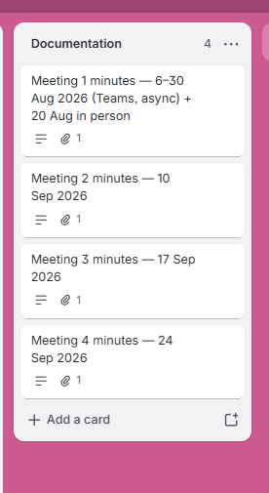
Figure 2 — Meeting minutes recorded on the Trello board, one card per meeting, each with the full minutes attached.

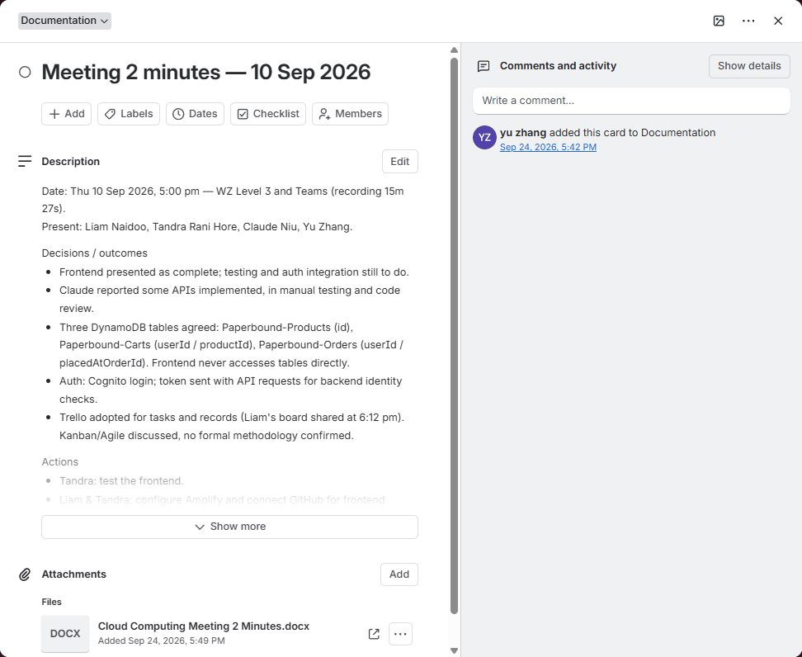
Figure 3 — The Meeting 2 card, showing the summary of decisions and actions and the attached minutes document.

4.4 Worklog
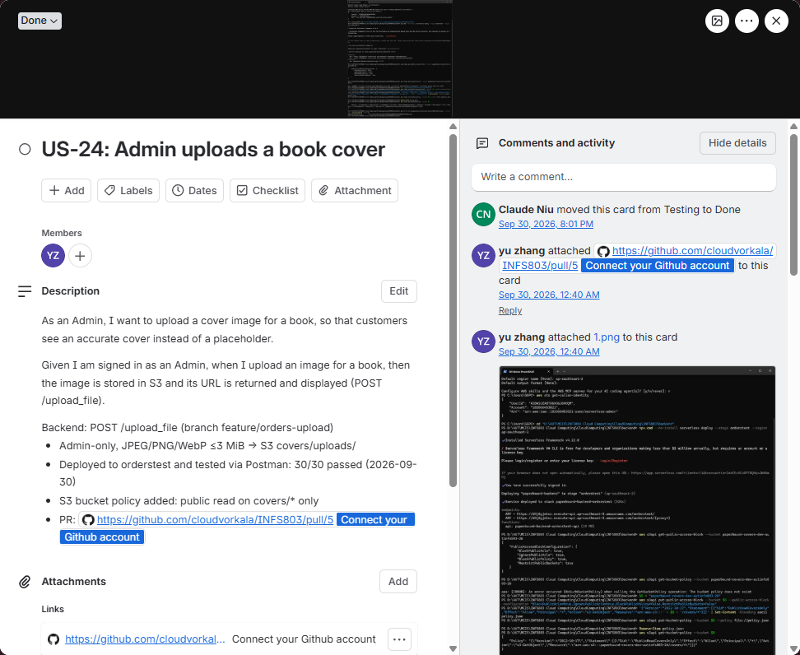
Figure 4 — The history of user story US-24, from creation to Done, with the pull request and deployment output attached.

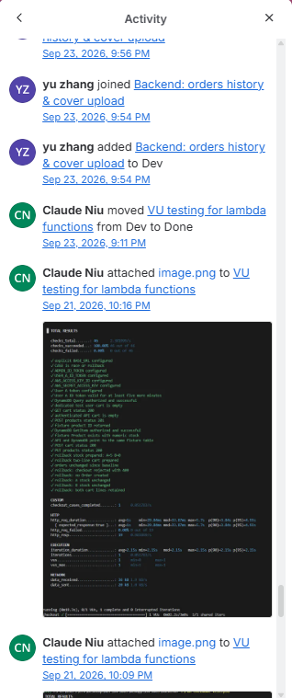
Figure 5 — Board activity log, showing team members moving cards and attaching evidence with timestamps.

5. High-level design
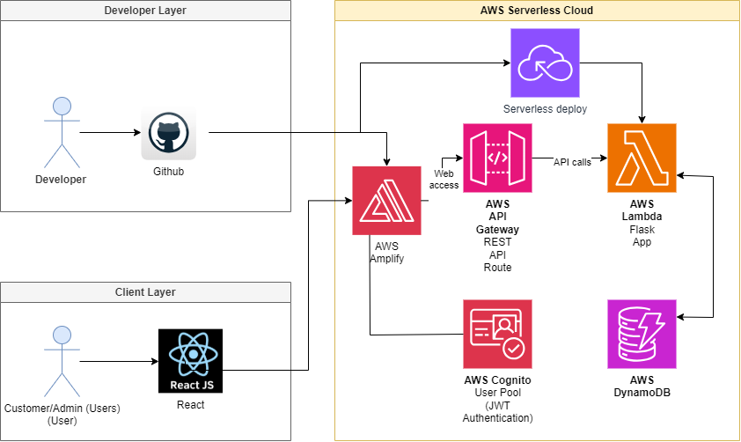Figure X — Paperbound architecture: the React client on Amplify, the Flask API on Lambda behind API Gateway, and DynamoDB, S3 and Cognito as managed services

The system is three tiers plus two supporting managed services. A request for a page and a request for data take different routes through it, and keeping those routes separate is what allows the static site to be cached aggressively while the API is never cached at all.

5.1 Why each component is there
Component | Why it is in the design, and what was rejected
AWS Amplify  (client hosting) | The client is a single page application and does not need any dynamic content, so it requires HTTPS, global caching and a rule that redirects /books/bk-001 to index.html. All three are offered by Amplify Hosting, and are rebuilt and redeployed automatically on any push to the connected GitHub branch, meaning that the client tier gets continuous deployment without additional tooling. The client was first previewed on Netlify against its mock API, while the production client was hosted on Amplify alongside the rest of the system on AWS, so every tier shares one account, one console and one set of access controls. S3 with CloudFront was the other option. It's working, but it requires manual configuration of origin access control, mapping of error pages and cache invalidation on each deploy—these are handled by Amplify.
API Gateway | Provides the public HTTPS REST endpoint and forwards requests to Lambda. A REST proxy lets Flask own routing and keeps the API independently callable. An EC2-hosted web server would add server administration for the same small workload.
AWS Lambda | Runs one Python 3.12 Flask application through serverless-wsgi. It avoids an always-running backend VM and preserves the agreed framework. The trade-off is cold-start latency and shared deployment settings for every operation.
DynamoDB | Stores Products, Carts and Orders using keys matched to catalogue and per-user access. Conditional transactions protect checkout. A managed SQL database would also satisfy the brief, but relational joins are not needed for the chosen model.
Amazon S3 | Stores cover uploads independently of the application package and returns image URLs. Uploads are restricted to administrators; the recorded bucket policy makes only covers/* publicly readable. Storing uploads in Lambda temporary storage would not provide durable asset storage.
Amazon Cognito | Provides registration, email confirmation and sign-in through the browser SDK. Flask verifies the resulting ID token and group membership. Custom password storage and duplicate authentication routes would add unnecessary security work.

5.2 The tier boundary, stated precisely
It is easy to build something that looks like three tiers and is not. The specific test applied here was: could the client be replaced by a mobile application without moving any logic? Three consequences follow from taking that seriously.
- The cart is stored in DynamoDB keyed by the Cognito subject, not in browser storage. Signing in on a second device shows the same cart, because the cart was never a property of the browser session.

- Stock rules, price calculation and the admin check all live in the application tier. The client hides administrative screens from ordinary customers, but that is presentation: the API refuses the request regardless. The Postman suite proves this by signing in as an ordinary customer and asserting a 403 on POST /upload_file (Section 10.2).

- The client holds no credential capable of touching AWS. It holds public Cognito identifiers, which are designed to ship inside a browser bundle, and a signed token that expires within the hour.

6. Detailed design

6.1 Checkout: the concurrency problem and its solution
POST /checkout requires a signed-in customer and a delivery address. The backend derives the customer from the verified Cognito sub, reads that customer's cart, and checks the current product prices and stock. An empty cart is rejected with 400, a missing product with 404, and insufficient stock with 409. Prices and totals are calculated on the backend rather than accepted from the browser.
The service creates a purchase-time snapshot of each item and submits one DynamoDB TransactWriteItems request: create the order, decrement each product's stock, and delete the purchased cart lines. The stock condition must still be satisfied at commit time, and the cart quantities must match the quantities read. All transaction writes succeed together or none succeeds.
If two customers request the last copy, both may initially read stock of one, but the conditional decrement prevents both purchases from committing. A successful request returns 201 with a CONFIRMED order. A conflicting transaction returns 409 with {"message":"Checkout conflict. Refresh your cart and try again."}; prevalidation of insufficient stock returns {"message":"Requested quantity exceeds available stock."}. These messages do not identify a particular title. The rejected transaction creates no order and performs no stock or cart deletion of its own.
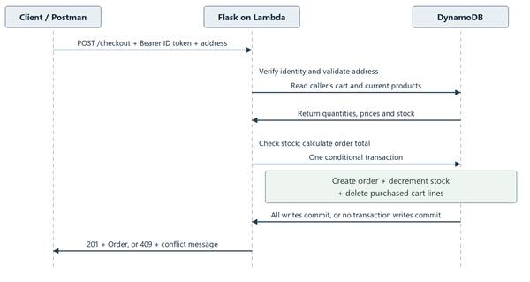
Figure 6 — Checkout sequence showing the implemented transaction boundary.
Checkout supports at most 40 different cart lines and does not collect payments. The implementation has no checkout idempotency key, so a lost success response needs to be checked against order history before another purchase is attempted.

6.2 Data model
Table | Partition / sort key | Stored data and access
Paperbound-Products | id / none | Book details, current price and stock. GetItem for details; Scan and Python filtering for the catalogue.
Paperbound-Carts | userId / productId | One user's product quantity per row. Query by verified Cognito sub; product details and totals are resolved by the backend.
Paperbound-Orders | userId / placedAtOrderId | Address, order status, total and purchase-time item details. Query by owner; timestamp plus order ID supports newest-first history.
The Products setup definition includes category-title-index (category/title) and author-title-index (author/title). Current Python repositories and Lambda IAM permissions use the tables directly and do not use either index. Catalogue requests scan all DynamoDB pages, then apply case-insensitive category equality and title/author/ISBN substring matching. Combined filters use AND. A searchText attribute is maintained on product writes, but the current filter reads the three mapped fields rather than that attribute.
The API returns the complete matching catalogue; React performs sorting and pagination. Orders preserve the purchased titles and prices, so later product edits do not alter order history. Deleting a product does not scan every cart: a subsequent read of the owning user's cart omits the missing product and conditionally cleans its stale reference.

6.3 Authentication and authorisation
The deployed client uses Cognito mode. frontend/src/services/cognitoAuth.js calls Amplify signUp, confirmSignUp, signIn and signOut against the configured user pool. The /register and /login browser pages are client routes, not REST endpoints in the Python backend. No custom POST /register, /login or /logout service is registered in Flask.
For protected API calls, apiClient.js fetches the Cognito ID token and sends Authorization: Bearer <Cognito ID token>. Flask decorators verify the token's signature, expiry, issuing pool, app-client audience and ID-token type. API Gateway forwards the request; the current configuration has no Cognito Gateway authorizer.
Cart, checkout and order history use only the verified sub as userId. Supplying another userId in a request cannot change the owner. Product creation, update, deletion and file upload also require the exact admins group in the verified token. Missing or invalid authentication returns 401; a valid customer token on an admin operation returns 403. Hiding the Admin page in React is an additional interface check, while the backend enforces the permission.

6.4 File upload
Administrators add book covers through POST /upload_file. The client sends the image as base64 data in a JSON body, and the backend validates the request with Pydantic before anything is written. Only JPEG, PNG and WebP images are accepted, and the decoded image must not exceed 3 MiB; a wrong type or an oversized image returns 400 with a message naming the problem. This is separate from the 5 MiB limit on the whole request body, which Flask enforces with 413 before validation runs (Section 6.5).
A valid file is written to S3 under the covers/uploads/ prefix with a generated name of the form img-<32 hex characters>.<extension>, so uploads never overwrite each other and the client's original file name is never trusted. The response is 201 with { s3Key, url }; the client stores the url on the product, and the browser then loads the cover directly from S3 rather than through the API.
Covers are public, so the bucket policy grants anonymous s3:GetObject on covers/* only. Nothing outside that prefix is readable, and the policy grants no public write, list or delete. Writing is restricted at two levels. In the application, the route requires a valid Cognito ID token whose cognito:groups claim contains admins; no token returns 401 and a customer token returns 403, whatever the client shows. In IAM, the Lambda execution role may only call s3:PutObject on the bucket's covers/uploads/* prefix (Section 7.4), so even a fault in the application could not write elsewhere in the bucket.

6.5 Failure handling
Failure | Behaviour
A render error in the client | An error boundary replaces the broken page with an explanation, leaves the header and footer intact, offers reload and a way back, and clears itself on navigation. Without it, one thrown exception blanks the entire application.
The API is unreachable | The client reports that it could not reach the API and suggests the two usual causes, rather than showing an empty catalogue that looks like a shop with no books.
A build with no API URL | The client build fails rather than silently falling back to its in-memory mock. That fallback looks completely healthy from the outside, which is precisely why it is refused.
Invalid JSON, fields or body type | Malformed JSON and invalid request fields return 400 with a JSON message. Non-JSON bodies return 415. Request data is validated with Pydantic before business logic runs.
Missing, malformed or expired authentication | Protected operations return 401. A valid non-admin token on an admin operation returns 403. The client receives the API message; the backend does not rely on a hidden UI control.
Missing record or concurrent business change | Missing products/cart lines return 404. Stock, cart or checkout conflicts return 409. A cancelled checkout transaction does not partially create an order or deduct inventory.
Unexpected DynamoDB/S3 or application error | The exception is logged server-side and the API returns 500 with {"message":"An unexpected backend error occurred."}. Capacity or IAM failures are not falsely reported as stock conflicts.
Oversized request or image | Flask rejects bodies larger than 5 MiB with 413. Pydantic validation rejects a decoded image larger than 3 MiB with 400; these are separate limits.

7. Cloud implementation
Paperbound's application configuration uses the Sydney region, ap-southeast-2. API Gateway exposes the HTTPS REST endpoint and invokes one Python 3.12 Lambda running Flask through serverless-wsgi. DynamoDB stores the three business tables, S3 stores uploaded covers, and Cognito supplies identities. Lambda uses its execution role for AWS access. The separately hosted React client uses Amplify. The shared backend stage is dev, at https://8lvgv7w3l0.execute-api.ap-southeast-2.amazonaws.com/dev; docs/current-status.md records deployment of all twelve operations.

7.1 DynamoDB
The backend references the existing Paperbound-Products, Paperbound-Carts and Paperbound-Orders tables through environment variables; serverless.yml does not recreate them. The repository's JSON table definitions specify provisioned capacity, but the live tables were created with on-demand capacity, as the console shows below. On-demand billing charges per request and scales throughput automatically, which suits the low and bursty traffic of this application (Sections 7.7 and 7.8). The Products table also has two secondary indexes, category-title-index and author-title-index, which are defined but not yet used by the API (Section 6.2).
The 100-title seed catalogue was loaded into the live Products table through the deployed API on 4 October 2026; the live catalogue can change as administrators add or remove titles. Cart and Order counts vary as customers use the application. The table key and access design is shown in Section 6.2.
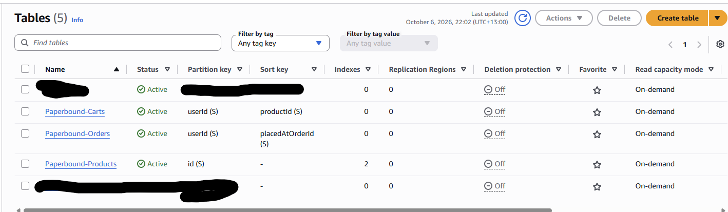
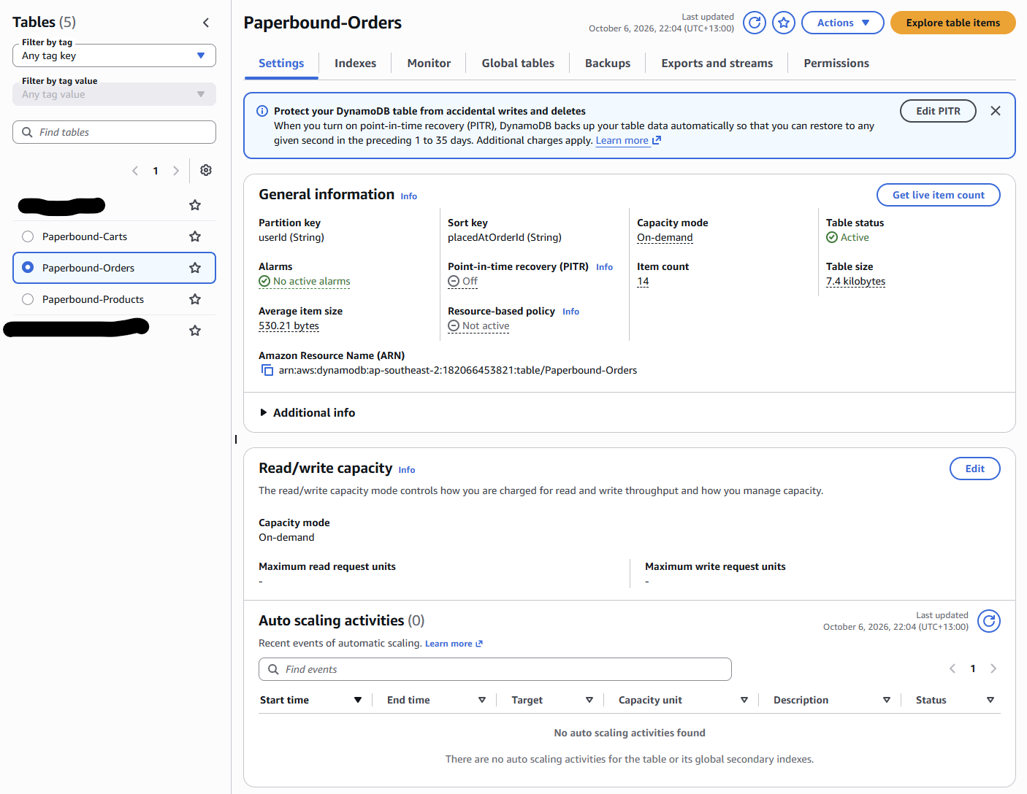

7.2 S3
Uploaded covers are stored in one S3 bucket, paperbound-covers-dev-autinfs803-26, in ap-southeast-2 alongside the other resources. The bucket name is passed to Lambda as an environment variable rather than written into the code. All objects sit under one folder path, covers/uploads/, which is the only prefix the application writes to. The screenshot below shows that prefix holding 104 PNG covers of 19.5 to 33.8 KB each in the Standard storage class, uploaded on 4 October 2026 when the catalogue was seeded through the deployed API.
The bucket policy has a single statement allowing public s3:GetObject on arn:aws:s3:::paperbound-covers-dev-autinfs803-26/covers/*, which lets any browser display a cover without credentials. Because public read is granted by policy, the two Block Public Access settings that govern bucket policies are switched off, while the ACL settings stay on and object ACLs are not used. Public access therefore covers reading cover images only: listing the bucket, writing and deleting all require IAM permissions, and the only principal with write access is the Lambda execution role, restricted to covers/uploads/*.
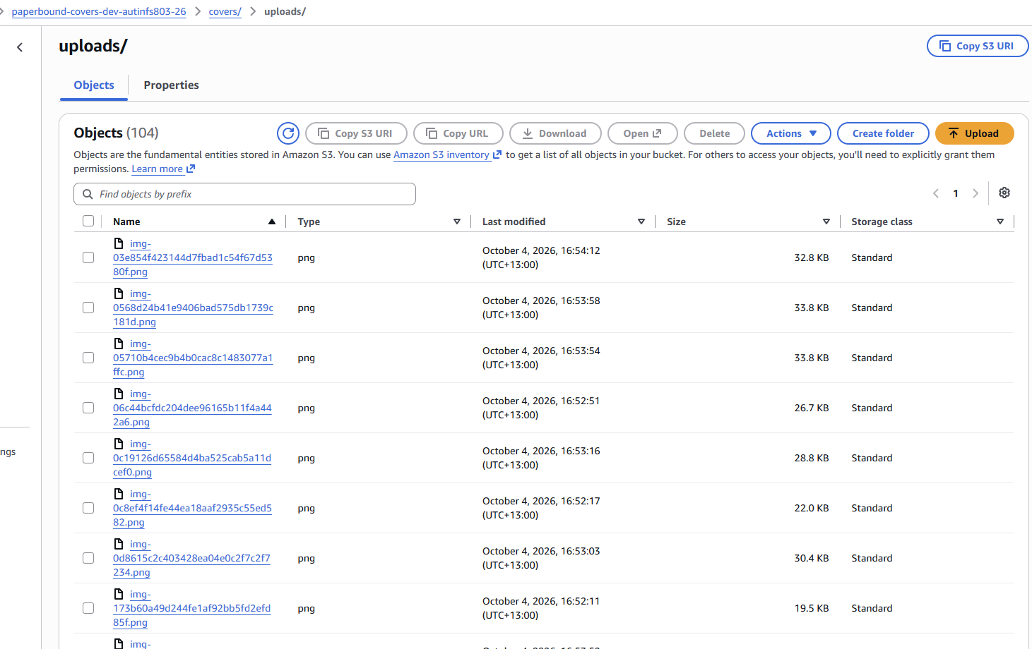
Figure 7 — S3 console: the covers/uploads/ prefix in paperbound-covers-dev-autinfs803-26, holding the seeded cover images.

7.3 Cognito
Configuration | Project value or source
Region / User Pool ID | ap-southeast-2 / ap-southeast-2_kGqZevk6X; matches the local frontend and backend configuration.
App Client ID | 1m3kra2v7a95sph3us13e59bfq; the same audience is configured for browser sign-in and backend verification.
Browser client / groups | The provisioning script creates a client without a secret and an admins group; backend authorization requires that exact group.
Password / account policy in setup script | Minimum 8 characters with uppercase, lowercase, number and symbol; email as username and automatic email verification.
Authentication flows in setup script | ALLOW_USER_SRP_AUTH, ALLOW_USER_PASSWORD_AUTH and ALLOW_REFRESH_TOKEN_AUTH. An existing client is reused without resetting its settings.
These identifiers agree across the local configuration. The setup script specifies the password policy and authentication flows, but it does not prove the live settings of an already-existing pool/client. ALLOW_USER_PASSWORD_AUTH is confirmed enabled on the live app client: the Postman sign-in requests use this flow and return 200 (Section 9.2). Section 9.2 gives a repeatable token request rather than embedding an expiring token.
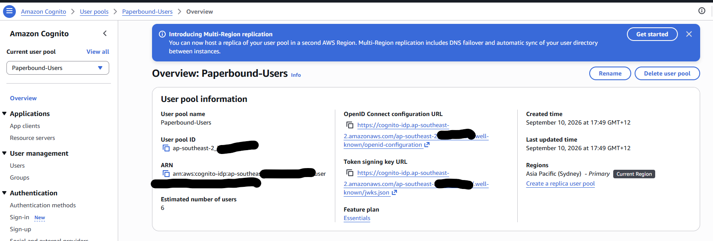

7.4 Lambda, API Gateway and IAM
Setting | Backend configuration
Framework / function | Serverless Framework 4.22.0; one function api, handler lambda_handler.handler.
Runtime / region | Python 3.12, x86_64, ap-southeast-2.
Memory / timeout / logs | 512 MB memory, 15-second timeout, 14-day log retention.
Gateway integration | REST API proxy events ANY / and ANY /{proxy+}; Flask registers the twelve business operations.
Authentication / CORS | Flask Cognito decorators; no Gateway authorizer. Exact configured origins include the Amplify site and localhost:5173; OPTIONS returns 204 with a 300-second preflight cache lifetime.
lambda_handler.py retains the Flask application for warm invocations, and serverless-wsgi translates API Gateway events into WSGI requests. Required environment variables select the existing table names, S3 bucket, user pool, app client and allowed origins. These are source configuration values; a Lambda console capture should confirm the deployed runtime, memory and timeout.
The execution role grants Product table reads/writes, Cart table queries and mutations, and Order table queries plus order creation through checkout transactions. S3 access is limited to PutObject under the configured bucket's covers/uploads/* prefix. No wildcard DynamoDB grant or Cognito administration permission is needed by the application. IAM constrains the function's resource access; Flask constrains customer/admin access.
Earlier Orders and Upload testing used orderstest and passed 30/30 Postman assertions on 30 September. The later deployment of all operations to dev is recorded separately. Both stages used the same database/storage resources, so the stage names do not establish data isolation or prove a repeated authenticated test on dev.
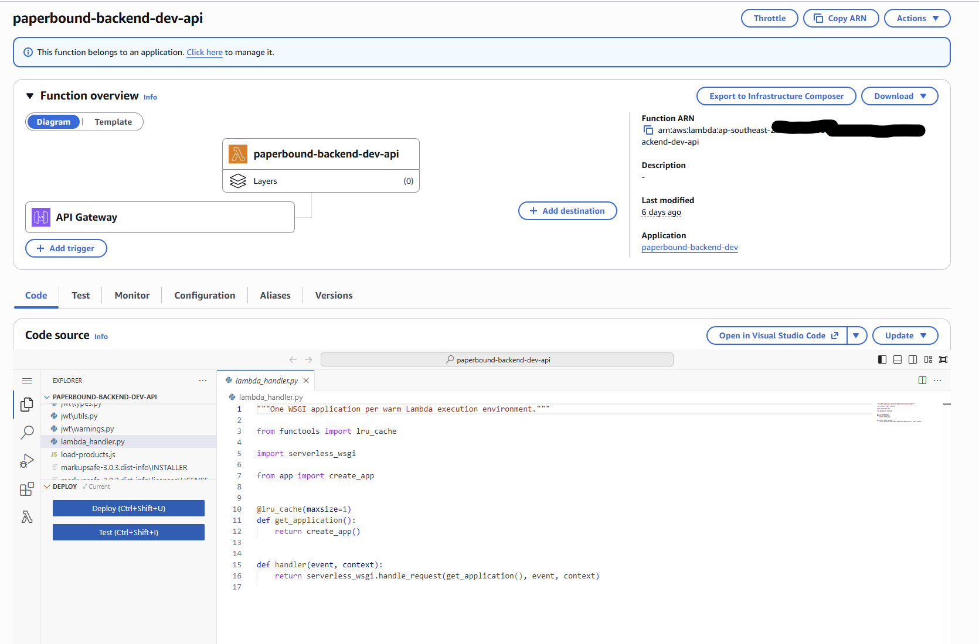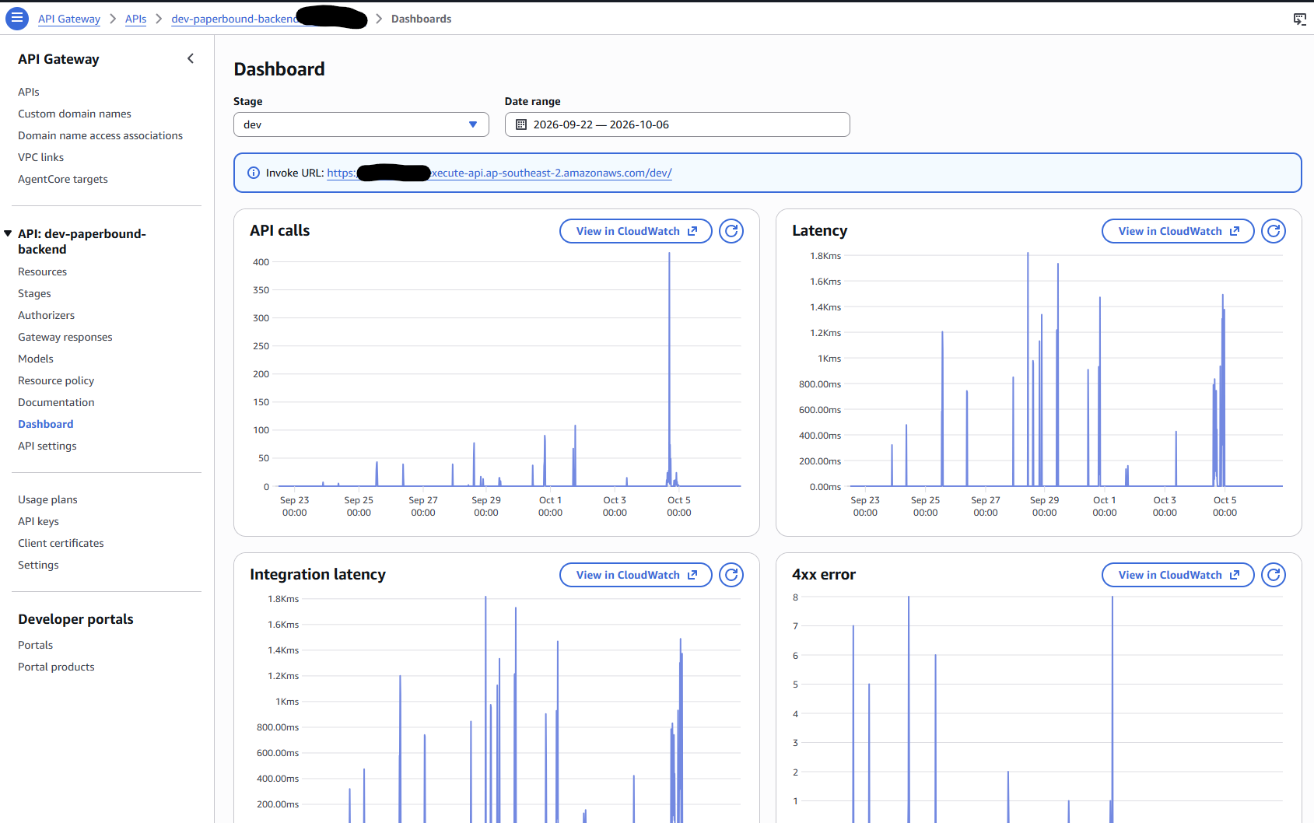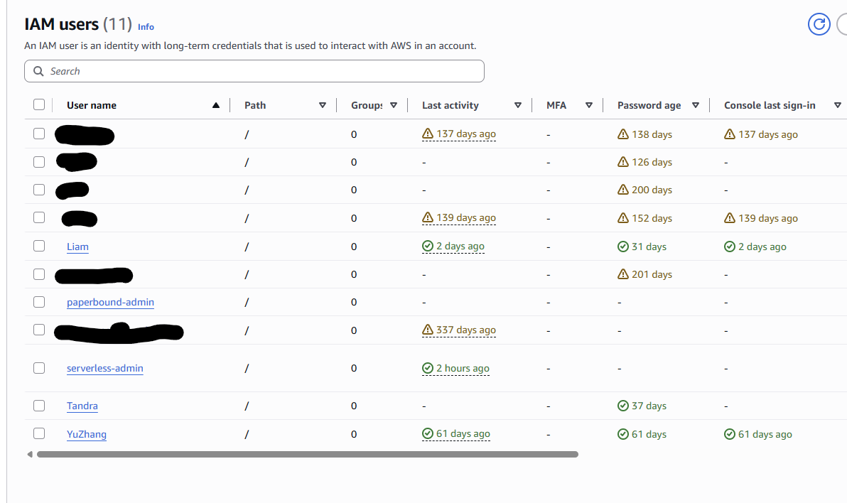

7.5 Client hosting on AWS Amplify
Setting | Value and reason
Source | GitHub repository INFS803, branch main. The repository holds both tiers, so amplify.yml sets appRoot: frontend and Amplify builds only the client.
Build | Build settings are versioned in amplify.yml at the repo root, not set by hand in the console. Pre-build: Node 22 via nvm, then npm ci for a reproducible install from the lockfile. Build: npm run build. Output directory: dist. node_modules is cached between builds.
Environment variables | VITE_API_BASE_URL, VITE_AUTH_MODE, VITE_COGNITO_USER_POOL_ID, VITE_COGNITO_CLIENT_ID, VITE_COGNITO_REGION. Set in the Amplify console and injected at build time. .env is gitignored, so no configuration is committed. Vite only exposes VITE_-prefixed variables, and all of these are public identifiers, not secrets. Amplify also sets AMPLIFY_MONOREPO_APP_ROOT to frontend, matching the appRoot in amplify.yml.
Rewrites | A single-page-app rewrite set up in the Amplify console. Any path without a static-file extension (such as /books/bk-001 or /orders) is served /index.html with status 200, so React Router handles it in the browser. Real assets like .js, .css and image files are still served directly. Verified by opening a book's deep link in a new private window.
Deployment | Automatic on every push to the connected branch. This is the project's CI/CD for the client tier.
HTTPS | Amplify's managed certificate on the amplifyapp.com domain.
A pre-build guard (scripts/check-env.mjs) runs before every production build. Otherwise the client would end up using its in-memory fake API and the site would appear to be fully functioning but would not actually make any calls to the backend. If the API URL is not present, is not in the correct format, if auth is not set to use real credentials, if there are no Cognito IDs or if a VITE_ variable is named something that resembles a secret, e.g., a name containing SECRET or ACCESS_KEY, the guard will refuse to build. A misconfigured deployment will then fail loudly in the Amplify build log, rather than silently.

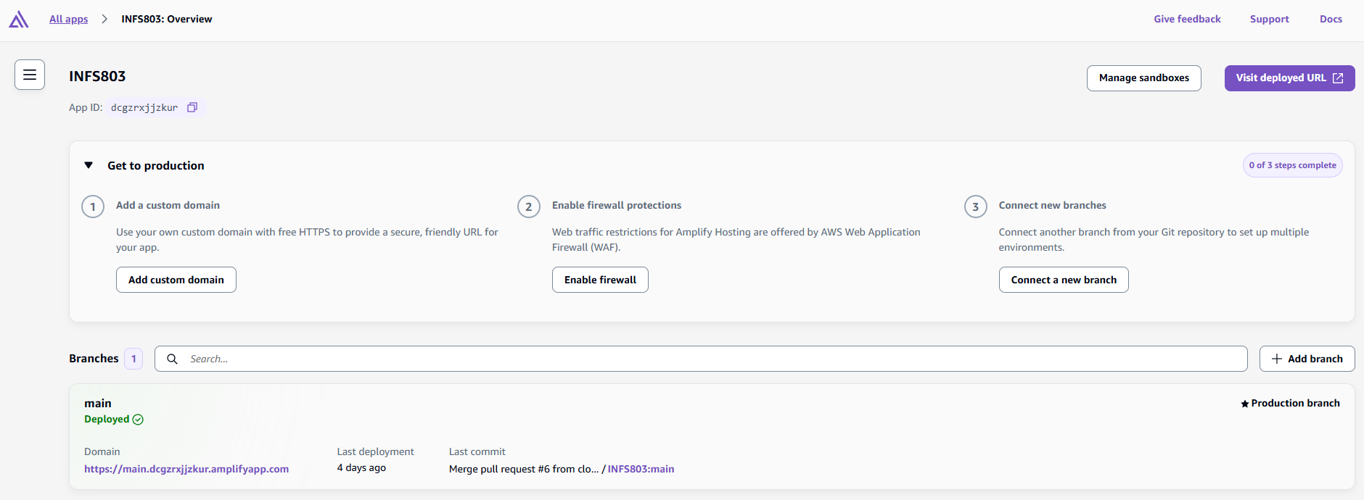Figure 8 — Amplify app overview: the main branch is deployed and set as the production branch.

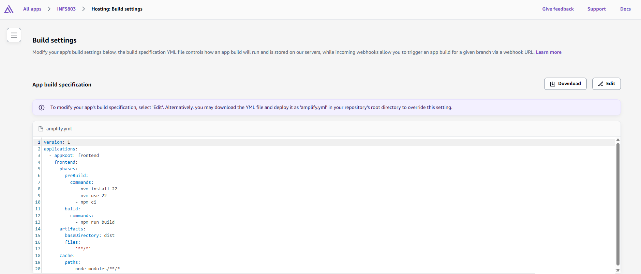Figure 9 — Build settings: the build specification read from amplify.yml in the repository.

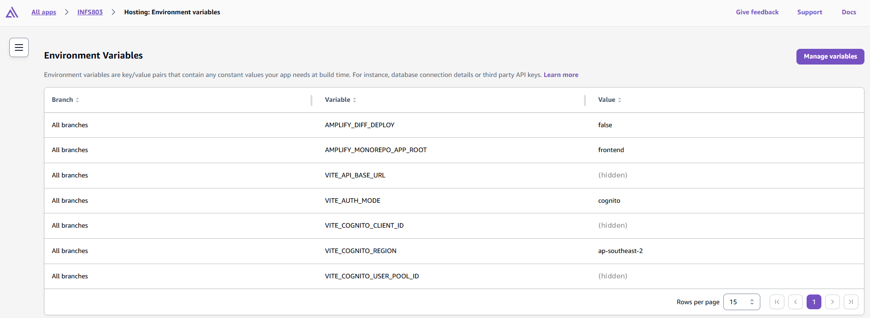
Figure 10 — Build-time environment variables (identifier values hidden).

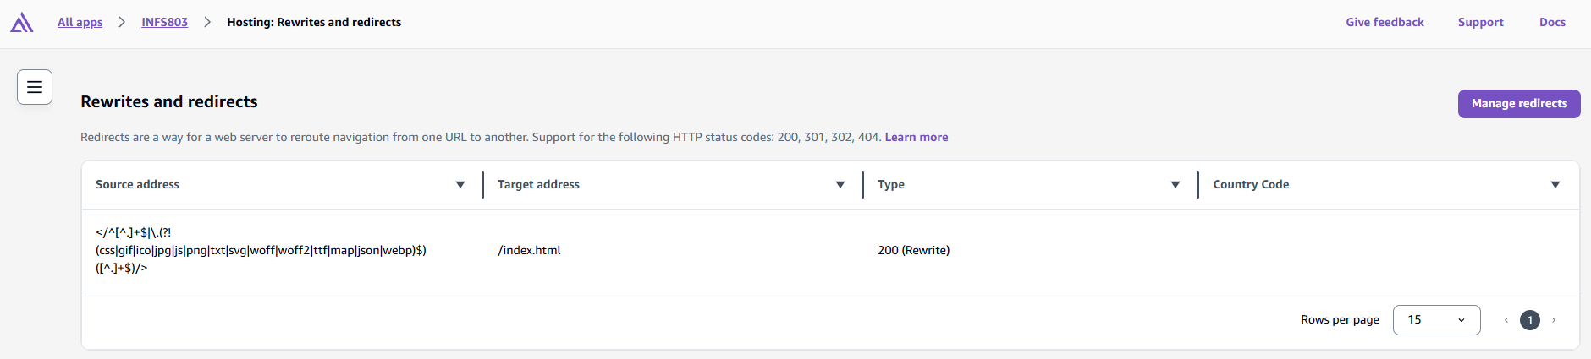Figure 11 — Rewrite rule sending client-side routes to index.html with status 200.

7.6 Deployment process
The backend is packaged and deployed with Serverless Framework. In the backend directory, npm.cmd ci installs the CLI version from package-lock.json. Docker Desktop's Linux engine builds Python dependencies using the configured Python 3.12 x86_64 build image. With an authorised AWS deployment profile and Serverless CLI authentication, the deployment command is:
npx.cmd --no-install serverless deploy --stage dev --region ap-southeast-2
After pulling changes, repeat this deployment command to update the backend; reinstall Node dependencies when the lockfile changes. The stack manages Lambda, API Gateway and its execution role while referring to the existing application resources. Local .env files, tests and development dependencies are excluded from the function package. Backend deployment is manual; amplify.yml automates only the frontend build. Verify the public catalogue and the relevant protected operations after deployment, and preserve the endpoint until marking is complete.

7.7 Cost analysis
Every component is billed per use, so the monthly cost follows traffic rather than provisioned capacity. The API Gateway dashboard for the dev stage (Section 7.4) shows a few thousand requests in total between 22 September and 6 October, with a single-day peak of about 400 during catalogue seeding. The table below estimates a marking month at roughly 10,000 API requests, about five times that level, using pay-as-you-go prices for ap-southeast-2.
 | What drives the cost | Free allowance | Estimated monthly cost
Lambda | Requests and GB-seconds at 512 MB; about 5,000 GB-s for 10,000 requests | 1 million requests and 400,000 GB-s per month (always free) | USD 0.00
API Gateway (REST) | Number of API calls | 1 million calls per month for 12 months on legacy free-tier accounts | Under USD 0.05
DynamoDB (on-demand) | Read and write request units; storage under 1 MB | 25 GB storage (always free) | Under USD 0.05
S3 | About 3.2 MB of covers, GET requests and transfer out | 5 GB Standard storage for 12 months; 100 GB transfer out per month | Under USD 0.01
Cognito | Monthly active users (under 20) | 10,000 MAU per month | USD 0.00
Amplify Hosting | Build minutes, stored build output and data served | 1,000 build minutes, 5 GB stored, 15 GB served for 12 months | Under USD 0.20
CloudWatch Logs | Lambda log ingestion and 14-day retention | 5 GB ingestion per month | USD 0.00
Total |  |  | Under USD 1 per month

At this volume the application costs well under USD 1 a month, and an idle month costs close to nothing: Lambda, API Gateway and DynamoDB on-demand charge only when called, and the remaining standing cost is a few megabytes of S3 and Amplify storage. Accounts on AWS's newer credit-based free plan receive credits instead of some of the 12-month allowances above, which covers these amounts in either case. These figures are estimates, not billed amounts: Paperbound has been designed and deployed for assessment but not released to real customers, so the only traffic so far is the team's own development and testing, and there is no production bill to report.
Several common components were deliberately left out to keep cost near zero. There is no NAT gateway or load balancer, each of which bills by the hour whether or not traffic arrives, and no EC2 instance or RDS database, because Lambda and DynamoDB replace both without an always-on charge. Lambda has no provisioned concurrency, so cold starts are accepted in exchange for paying nothing while idle. DynamoDB point-in-time recovery is off, as the Orders table console shows, because it adds a storage charge and the seed catalogue can be reloaded. No separate CloudFront distribution sits in front of the API; Amplify already serves the client through its own CDN. Log retention is capped at 14 days so log storage does not accumulate.

7.8 Security, reliability, scalability and cost optimisation
Security. Cognito token verification and admins checks protect mutations, and owner-partition queries protect customer carts and orders. The Lambda role is limited to the required tables and upload prefix. HTTPS protects transport; CORS controls which browser origins can read responses and is not an authorization substitute. Public cover images are separated from authenticated order/address data.
Reliability and availability. Managed database and object storage avoid reliance on one application machine's disk. Checkout transactions keep orders, stock and purchased cart lines consistent when a condition fails. This does not establish a tested regional recovery plan: backup restoration, monitoring alarms and recovery objectives are not recorded as implemented features.
Cost optimisation. One Lambda avoids an always-running backend VM; configured memory, duration, request counts, database operations, image storage/transfer and logs still affect charges. SDK connection reuse reduces repeated setup work without caching stock. Log retention is limited to 14 days.

Scalability and elasticity: Each tier grows without human input and without any of the design elements being fixed for a particular load. Amplify leverages a global CDN and cover images load directly from S3, meaning there is no need for page loads or images to pass through the API. The application tier scales horizontally: Lambda scales up to add more execution environments as requests arrive concurrently, and scales down to zero when no requests are arriving, so scales in either direction and is free when idle. The Flask application is stateless between requests (carts, orders and stock will all be stored in DynamoDB), meaning that each execution environment can host each user; there is no need for coordination in adding environments. The DynamoDB tables are on-demand, meaning that read and write throughput scales automatically based on traffic, without the need for capacity planning or auto-scaling rules.
Component | How it scales | Limit that would apply first
Amplify Hosting | Global CDN; static files cached at edge locations | Effectively none at this scale
API Gateway | Managed; no capacity to configure | Account-level throttling (10,000 requests per second by default)
Lambda | New execution environments per concurrent request; scales to zero | Regional concurrency quota; cold starts after idle periods; 15-second timeout
DynamoDB (on-demand) | Throughput follows traffic automatically | Sudden spikes far above previous peaks can be briefly throttled
S3 | Managed object storage; browsers fetch covers directly | Thousands of requests per second per prefix
Cognito | Managed user pool | Not a constraint at this scale

This elasticity was tested with a seeding run done on 4 October, where all 97 remaining books were created and verified with approximately 300 API calls over a few minutes, without any failure and without any configuration change. The k6 scenarios load the catalogue endpoint with 10 requests per second and fail if more than 1% of the requests fail.
The first limits to growth are in the application design rather than the infrastructure. Every catalogue request scans the whole Products table and returns every matching title, with pagination done in the browser, so read cost and response size grow linearly with the catalogue. Lambda responses are capped at 6 MB, which a full-catalogue response would reach at tens of thousands of titles. Checkout stays correct under any level of concurrency, but many customers buying the same title at once would contend on one item, so most would receive a 409 and need to retry. A larger deployment would therefore need server-side pagination using the category and author indexes already defined, a search service such as OpenSearch (Section 11.4), and retry handling in the client for checkout conflicts. Cold starts could be removed with provisioned concurrency, at the cost of the always-on charge this design deliberately avoids (Section 7.7)

8. User manual
Open https://main.dcgzrxjjzkur.amplifyapp.com in any modern browser. Nothing needs to be installed.

8.1 Test accounts
Email | Password | What it can do
admin-test@test.com | YourStrongTestPassword123! | Everything a customer can do, plus the Admin page: add, edit and remove titles, and upload covers
normal-test-a@test.com | StrongTestPasswordA123! | Customer: browse, cart, checkout, order history
normal-test-b@test.com | StrongTestPasswordB123! | Customer: a second account, for checking that carts and orders are kept separate per user
You may also register your own account from the Register link; new accounts are ordinary customers.

8.2 Browsing the catalogue
- The home page lists all one hundred titles, 24 to a page. Use the numbered buttons at the foot of the grid to page through them.
- The category buttons above the grid filter the list. "All" clears the filter.
- The search box matches on title, author and ISBN, and is not case sensitive. Clear it to return to the full list.
- The Sort control reorders the visible titles by price or name.
- Click any book to open its detail page, which shows the full description, the ISBN, the year and how many copies remain.
Figure 12 — The catalogue. Titles with no copies left are marked OUT OF STOCK and cannot be added.
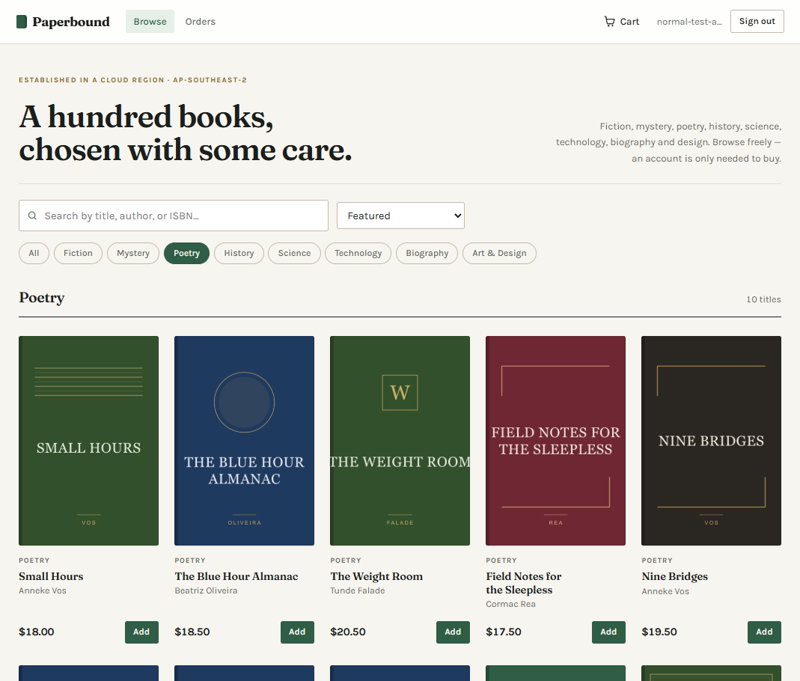Figure 13 — Filtering by category. The count and the heading both update.

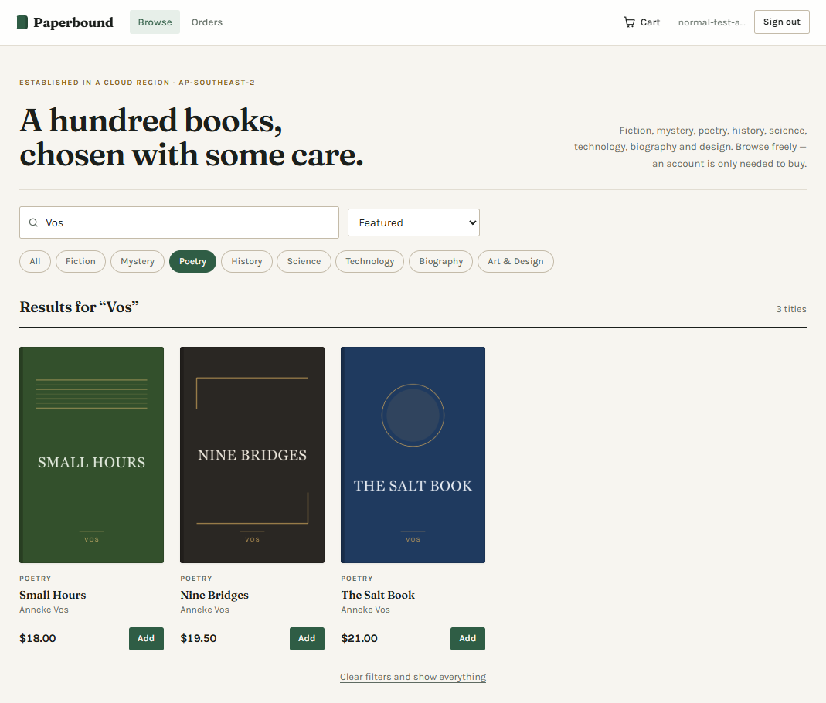Figure 14 — Searching within the selected category. The term is matched against title, author and ISBN.

Figure 15 — A product page, showing the description, ISBN, year and remaining stock.

8.3 Signing in
- Click Sign in and enter an email and password. To create an account, click Register instead.
- After registering, check your email for a six-digit verification code and enter it on the Verify your email page. If it doesn't arrive, click Send a new code. If you sign in before verifying, you are taken back to this page. Once verified, sign in with your new email and password.
- If your sign-in expires, you are asked to sign in again; your cart is preserved.
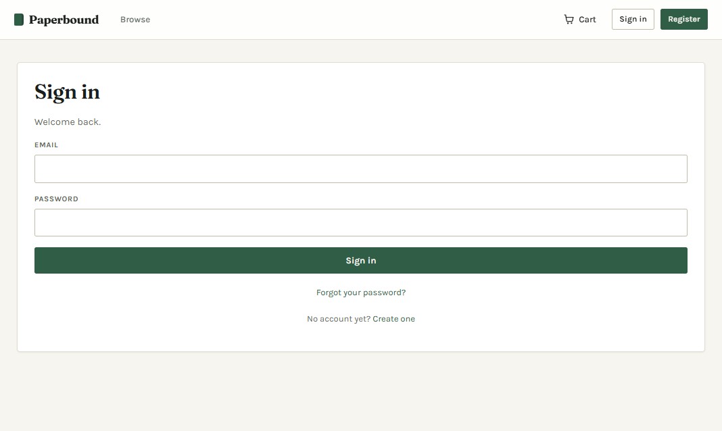Figure 16 — Signing in. Credentials are checked by Cognito, not by this application.

8.4 The cart
- Add adds one copy. The number beside the cart icon in the header shows how many items you are holding.
- On the Cart page, use the − and + buttons to change a quantity, or type a number directly into the box and press Enter.
- Remove takes a line out entirely. A quantity must be at least 1; entering 0 restores the previous quantity, so use Remove instead.
- Your cart is stored against your account, not in this browser. Sign in on another device and it will be there.
- You cannot add more copies than remain in stock; the shop will tell you how many are available.
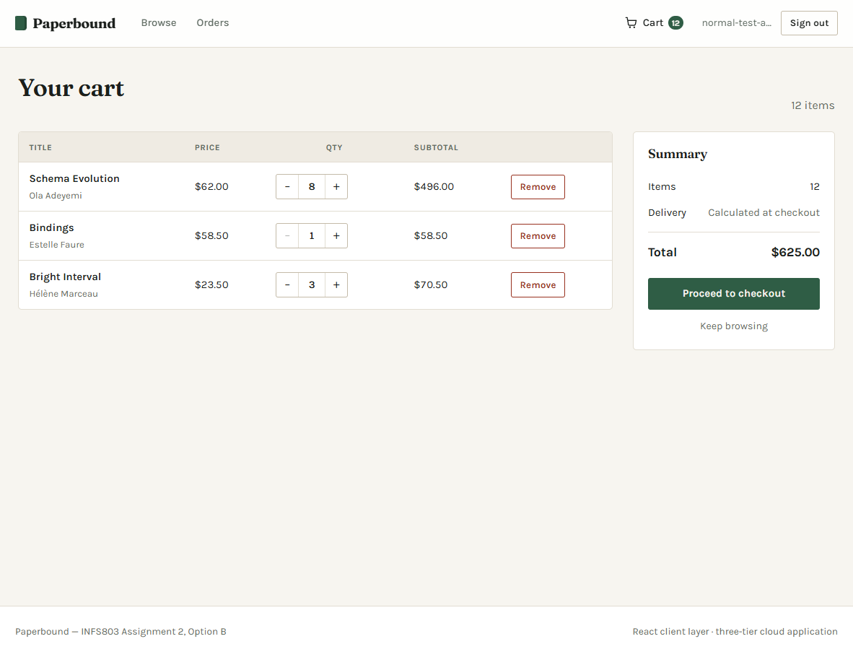Figure 17 — The cart. Quantity controls save immediately; the summary recalculates from the server's response.

8.5 Placing an order
- From the cart, click Proceed to checkout.
- Fill in the delivery address. All fields are required.
- Click Place order. You will see a confirmation with an order number beginning "ord-".
- If a title sells out while you are checking out, the order is refused and you are asked to refresh your cart and try again. No order is created and no stock is taken.
No payment details are collected anywhere in this application. A production build would redirect to a hosted payment page so that card data never touches our servers, which keeps the compliance obligations with the payment provider.
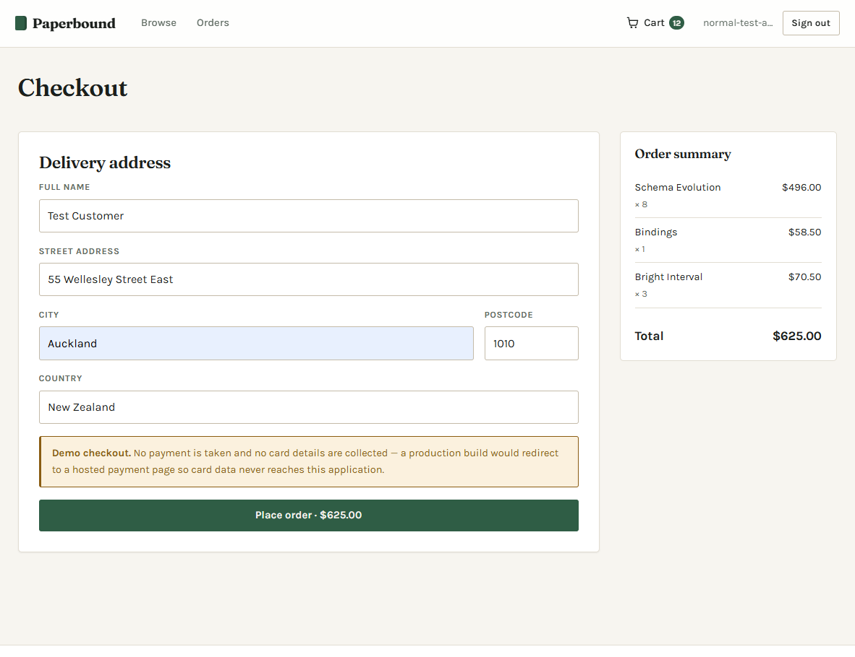Figure 18 — Checkout. A delivery address only; no card details are requested at any point.
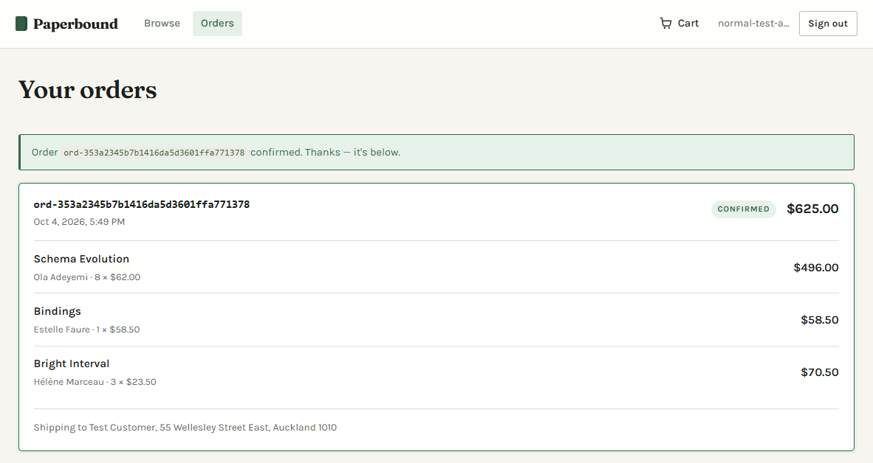Figure 19 — Order confirmed. The banner names the new order, which records the price paid for each title and the delivery address.

8.6 Order history
Orders opens your past orders, newest first, each showing its date, status, the titles bought, the price paid for each and the order total. Orders record the price at the time of purchase, so a later price change does not alter your history. Figure 19 shows the same view immediately after an order is placed.

8.7 Administrator functions
Sign in with the administrator account to see the Admin link in the header.
- Add a title: complete the form and click Add to catalogue. Title, author, category and price are required.
- Upload a cover: choose an image file. It is uploaded to cloud storage and attached to the title. PNG, JPEG and WebP are accepted, up to 3 MiB. SVG files are refused for security reasons.
- Edit a title: change the fields you want and save. Fields you leave alone are unchanged.
- Remove a title: it disappears from the shop immediately, and is removed from any customer's cart the next time they open it.
Attempting to reach the admin page as an ordinary customer shows a message rather than the form, and the API refuses the underlying request regardless of what the browser sends.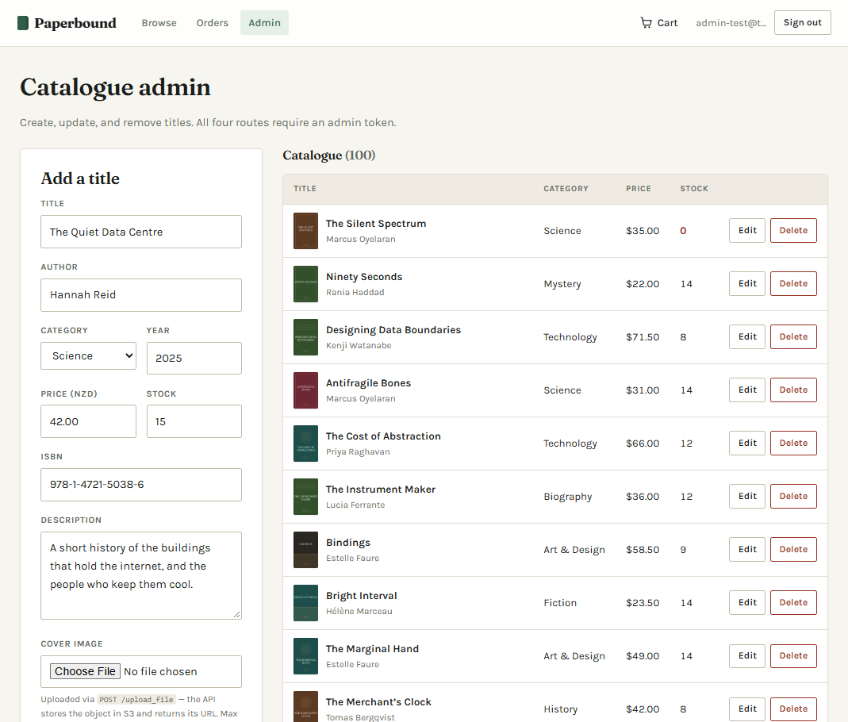
Figure 20 — The administrator screen. Visible only to accounts in the admins group, and the API enforces that independently of what the browser displays.

8.8 If something goes wrong
What you see | What it means
"Could not reach the API" | The application tier is not responding. Try again in a minute; if it persists, the backend may be unavailable.
"This page didn't load properly" | A page failed to render. Your cart and account are unaffected. Use Reload, or Back to browsing.
"Your session has expired" | Your sign-in has expired. Sign in again; your cart is preserved.
"Only n copies in stock" | Someone else bought some. Reduce the quantity.
An orange banner about mock data | The site is running on built-in sample data rather than the real API. This must not appear on the deployed site.

9. RESTful API list
Base URL: https://8lvgv7w3l0.execute-api.ap-southeast-2.amazonaws.com/dev (stage dev)
Twelve services, four of them POST, against a requirement of ten and three. The list matches the twelve operations Flask registers and docs/current-status.md records as deployed to dev; there are no other routes. Authenticated routes take the Cognito ID token in the Authorization header.
# | Method | Path | Auth | Purpose and response
1 | GET | /products | None | List the catalogue. Accepts ?category= and ?search=. 200 with { count, products }.
2 | GET | /products/:id | None | One title. 200 with the product; 404 if unknown.
3 | POST | /products | Admin | Create a title. 201 with the created product; 400 names missing fields.
4 | PUT | /products/:id | Admin | Update a title. 200 with the updated product.
5 | DELETE | /products/:id | Admin | Withdraw a title and clear it from carts. 200.
6 | GET | /cart | User | The caller's cart, priced. 200 with { items, itemCount, total }.
7 | POST | /cart | User | Add { productId, quantity }. 200 with the cart; 409 beyond stock.
8 | PUT | /cart/:productId | User | Set { quantity } outright; 0 removes. 200 with the cart.
9 | DELETE | /cart/:productId | User | Remove a line. 200 with the cart.
10 | POST | /checkout | User | Cart to order, atomically. 201 with the order; 409 with a conflict message.
11 | GET | /orders | User | Order history, newest first. 200 with { count, orders }.
12 | POST | /upload_file | Admin | Cover image to S3. 201 with { s3Key, url }.

9.1 Status codes
Code | Meaning in this API
200 / 201 | Success; 201 where something was created
400 | The request is malformed or incomplete. The message names what is wrong.
401 | No token, or a token that is invalid or expired
403 | Signed in, but not permitted — an ordinary customer attempting an administrative action, or a disallowed browser origin
404 | No such product, cart line or route
409 | A conflict with the world as it is — insufficient stock, or a cart or checkout that changed concurrently
413 | The request body exceeds 5 MiB (an image over 3 MiB inside a smaller body returns 400)
500 | An unexpected server fault. Logged in full, reported in outline.

9.2 Testing the API without the client
Markers can exercise every operation directly with Postman, without the React client. The team's Postman collection, INFS803 – Orders & Upload tests, and its environment, INFS803 orderstest, are kept in the team's Postman workspace and are not exported to the repository. Requests reach the API through the {{BASE_URL}} environment variable, which points at the orderstest stage used for the recorded run; change it to the dev endpoint to test dev. The first folder signs in the administrator, User A and User B through Cognito. The returned ID tokens are copied by hand into the environment before the remaining folders are run, and the sign-in requests are re-run when the tokens expire after one hour.
The collection has four folders, run in order: 0. Login (get fresh ID tokens); 1. Setup: User A places an order, which picks an in-stock product, adds it to the cart and checks out; 2. GET /orders (US-14); and 3. POST /upload_file (US-24). Each request carries Postman test scripts that assert the status code and the content of the response. The whole collection can be run in one pass from the Collection Runner; the recorded result is described in Section 10.2. Because the collection is not in the repository, markers can reproduce the same requests in their own Postman with the steps below, which obtain an ID token manually.
A marker can obtain a fresh Cognito ID token without opening Paperbound. In Postman, create POST https://cognito-idp.ap-southeast-2.amazonaws.com/ with Authorization set to No Auth. Add Content-Type: application/x-amz-json-1.1 and X-Amz-Target: AWSCognitoIdentityProviderService.InitiateAuth. Select raw JSON and use a confirmed test account:
{
"AuthFlow": "USER_PASSWORD_AUTH",
"ClientId": "1m3kra2v7a95sph3us13e59bfq",
"AuthParameters": {
"USERNAME": "<confirmed-test-account-email>",
"PASSWORD": "<current-test-account-password>"
}
}
This request uses the public Cognito app client, not an AWS access key. The app client has ALLOW_USER_PASSWORD_AUTH enabled; the Login requests in the Postman run (Figure 22) use this flow and return 200. A complete successful sign-in returns AuthenticationResult.IdToken. If Cognito returns a challenge, complete the required verification/password step before using the account; a challenge response is not an ID token. AWS documents this operation at https://docs.aws.amazon.com/cognito-user-identity-pools/latest/APIReference/API_InitiateAuth.html.
Copy IdToken to a Postman environment variable idToken and set baseUrl to https://8lvgv7w3l0.execute-api.ap-southeast-2.amazonaws.com/dev. Choose Bearer Token with {{idToken}} for protected business requests. Use the returned token expiry rather than submitting a fixed token; repeat the sign-in request when it expires. Do not substitute AccessToken, and do not omit the Bearer prefix.
Example request | Expected result
GET {{baseUrl}}/products; no Authorization needed | 200 with count and products. Save an actual returned product id.
GET {{baseUrl}}/cart; Bearer {{idToken}} | 200 with only the signed-in account's items, itemCount and total.
GET {{baseUrl}}/orders; Bearer {{idToken}} | 200 with only that account's order history, newest first.
The same token can be used for POST /cart with {"productId":"<returned-id>","quantity":1}; a successful request returns the complete cart with 200. Admin operations require a token issued to a member of admins.
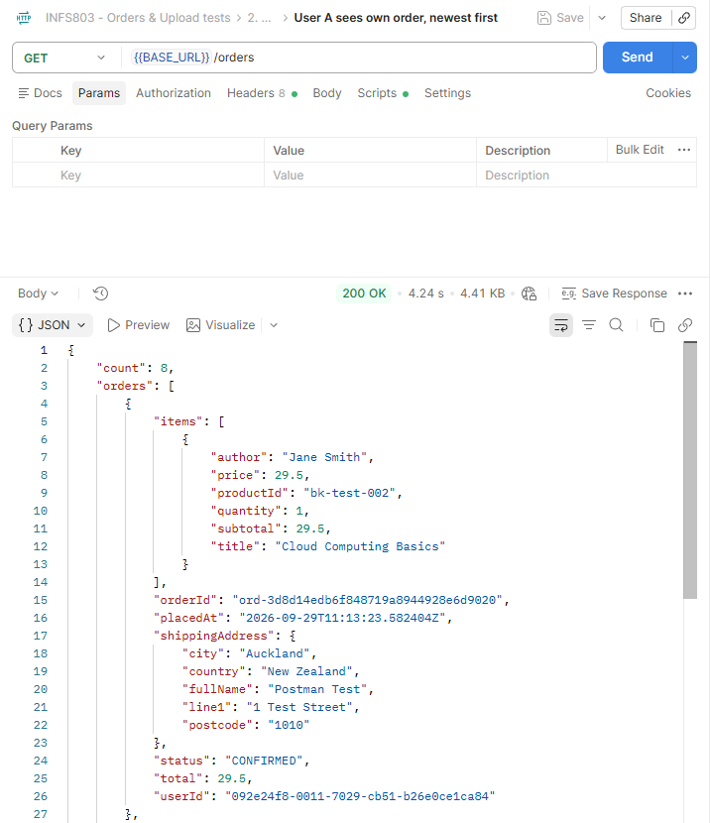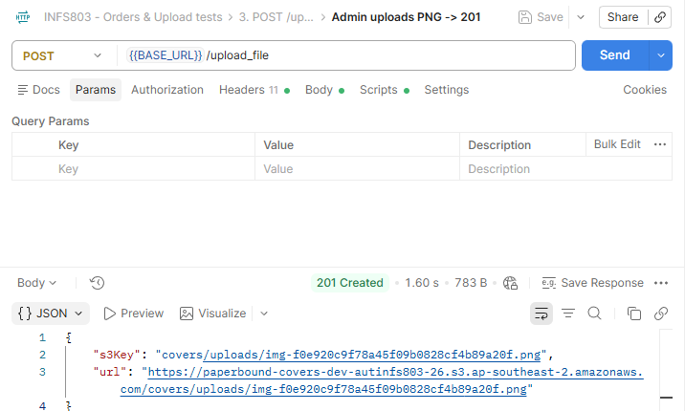
Figure 21 — Example responses from the deployed orderstest stage in Postman. Left: GET /orders returns 200 with count and only the signed-in account's orders, newest first. Right: an administrator's POST /upload_file returns 201 with the s3Key under covers/uploads/ and the public S3 url.

10. Testing

10.1 Frontend testing
Testing covered catalogue browsing, filtering, searching, sorting, authentication, cart management, and pagination in the local mock API and mock authentication environment. All 16 cases were recorded as PASS. Sign-in, Add to cart, and Checkout were re-tested on the deployed live site. All three tests passed successfully. The user was able to sign in, add a book to the cart, complete the demo checkout, and view the successfully created order.
Test ID | Feature | Expected Result | Actual Result | Status
TC-01 | Browse Category | Display books from the selected category. | The selected category displayed correctly. | PASS
TC-02 | Filter | Display only results matching the selected filter. | The filter displayed matching results correctly. | PASS
TC-03 | Search Function | Searching for “The Salt Path Home” returns the matching book. | The matching book was displayed correctly. | PASS
TC-04 | Price Low to High | Display books in ascending price order. | Books were sorted correctly from lowest to highest price. | PASS
TC-05 | Add to Cart | Add the selected book to the cart. | “Field Notes for the Sleepless” was added successfully. | PASS
TC-06 | Remove from Cart | Remove the selected book from the cart. | The selected book was removed successfully. | PASS
TC-07 | Sign Out | Sign out the user and display the Sign in option. | The user was signed out and the Sign in option appeared. | PASS
TC-08 | Valid Sign In | Sign in successfully using valid credentials. | The user signed in successfully. | PASS
TC-09 | Add Multiple Quantity | Add the selected book with a quantity of 5. | The book was recorded as added with quantity 5. | PASS
TC-10 | Update Cart Quantity | Update “Weatherhouse” to quantity 2 and recalculate the price. | Quantity updated to 2; subtotal and total were $55.00. | PASS
TC-11 | Price High to Low | Display books in descending price order. | Books were sorted correctly from highest to lowest price. | PASS
TC-12 | Newest First | Display books from newest to oldest publication. | The test record reports the newest books displayed first. | PASS
TC-13 | Title A-Z | Display book titles in alphabetical order. | Book titles were displayed correctly from A to Z. | PASS
TC-14 | Pagination | Open page 2 and display the next set of books. | Page 2 opened successfully with a new set of books. | PASS
TC-15 | History Category Filter | Display only History books. | Only History category books were displayed. | PASS
TC-16 | Art & Design Category Filter | Display only Art & Design books. | Only Art & Design category books were displayed. | PASS
Result: 16 tests completed, 16 passed, and 0 failed.
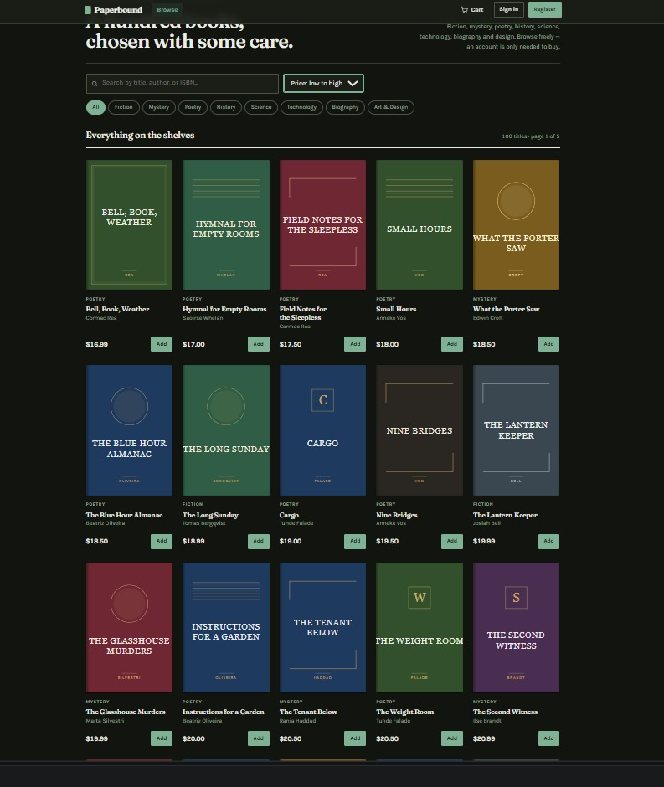
Figure 22: Manual testing product sorting test (Low to High)

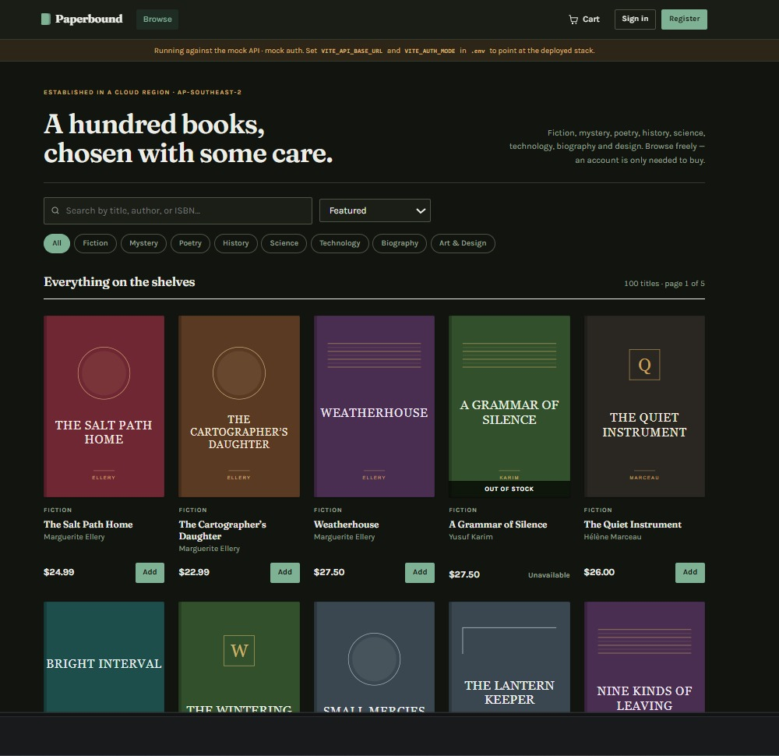
Figure 23: Featured Product Display.
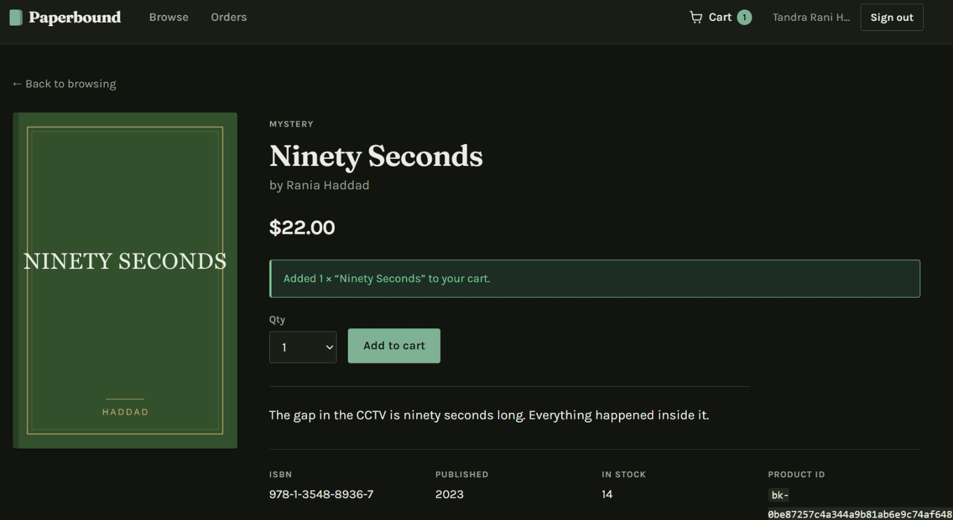Figure 24: Live site Testing.

10.2 API testing
The backend was tested at two levels: end-to-end requests against the deployed API in Postman, and offline unit and contract tests with pytest.
Postman. The Orders and Upload collection (Section 9.2) was run against the deployed orderstest stage on 30 September 2026. The Collection Runner completed all 17 requests in about 20 seconds with 30 of 30 assertions passing and no errors (average response time 1,064 ms). The collection first signs in an administrator and two customers, User A and User B, through Cognito. User A then picks an in-stock product, adds it to the cart and checks out, receiving 201 with status CONFIRMED. GET /orders for User A returns only User A's orders, newest first, with money as JSON numbers and no internal sort key exposed. The administrator's PNG upload returns 201 with a key under covers/uploads/, and the returned S3 URL serves the file publicly as image/png. The rejection cases asserted are: 401 for GET /orders and for POST /upload_file without a token; 403 when a customer calls POST /upload_file; and 400 for an upload whose content is not a real image, for a GIF, and for a request with no dataUrl. Order isolation is also asserted: User B's GET /orders contains none of User A's orders, including when ?userId=<User A's id> is passed with User A's id as its value, because the API ignores that parameter and reads the user from the token. The later deployment of all twelve operations to dev is recorded separately in docs/current-status.md; as Section 7.4 notes, the two stages share the same tables and bucket, so this run is evidence for the code and resources rather than a repeated test on dev.
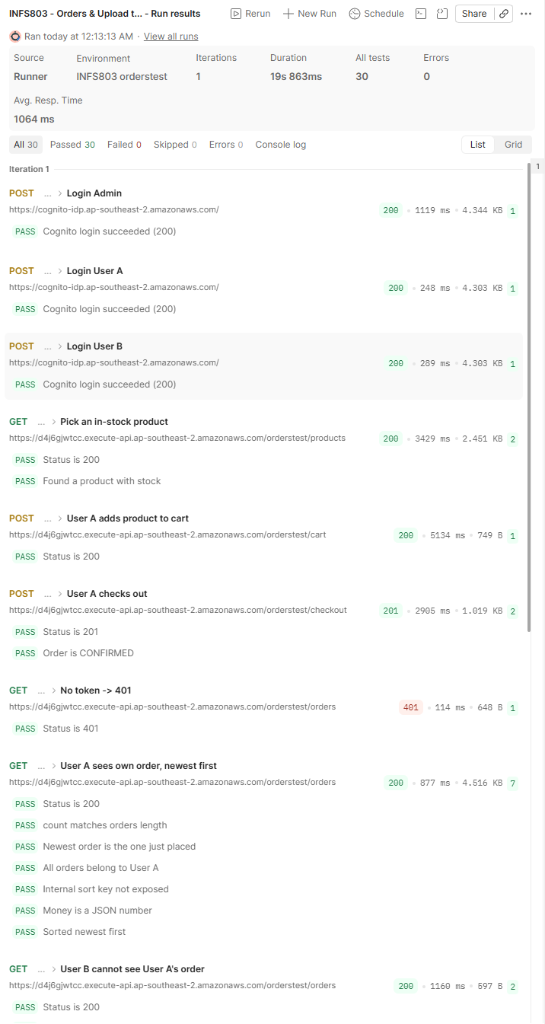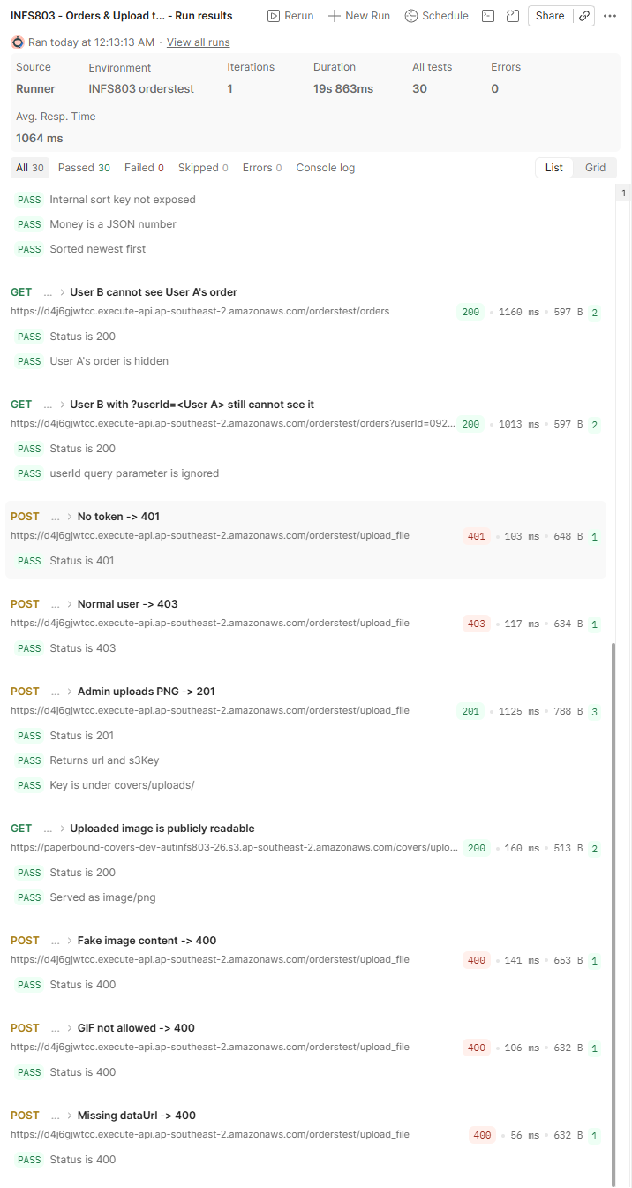
Figure 22 — Collection Runner result for INFS803 – Orders & Upload tests against orderstest: 30 tests, 30 passed, 0 failed, 0 errors. Left: sign-in, setup order and GET /orders checks. Right: order isolation and POST /upload_file checks, including the 401, 403 and 400 rejection cases.
pytest. The backend/tests/ suite runs offline with no AWS calls and covers application and configuration loading, Cognito authentication and permissions, Pydantic request/response contracts, the Serverless configuration, and the Orders and Upload routes. docs/current-status.md records the latest run as 143 passed and 3 failed; the three failures are attributed to earlier foundation expectations that predate later changes to the code. Run it from the backend directory with python -m pytest.
Checkout under concurrency is tested separately by the k6 race and rollback scenarios in backend/test-checkout.js, which target the last-copy problem described in Section 6.1.

11. Summary and reflection
Paperbound is an online bookstore deployed on AWS as a three-tier application. A React web app, deployed to Amplify continuously from GitHub, communicates over HTTPS with a Flask API running on Lambda behind API Gateway. The API exposes twelve RESTful operations, verifies Cognito ID tokens on every protected route, stores products, carts and orders in DynamoDB, and keeps one hundred cover images in S3. Checkout runs as a single conditional DynamoDB transaction, so two customers cannot both buy the last copy of a book. The system was tested with 16 manual frontend tests (with key steps re-tested on the live site), a 30-assertion Postman suite against the deployed API, an offline pytest suite and k6 concurrency scenarios, and it costs less than USD 1 per month.

11.1 What the project demonstrated
- The tier boundary is only real if it is enforced. Moving the cart out of the browser and into DynamoDB, and enforcing the administrator check in the API rather than by hiding a button, were the two changes that turned a plausible-looking layout into an actual separation.
- Concurrency has to be designed for, not tested for. No amount of manual testing would have found the overselling defect; it required noticing that a read followed by a write is two operations, and then choosing a database primitive that makes them one.
- The dangerous failures are the invisible ones. A client silently serving mock data and a server running with development authentication both look perfectly healthy. Both are now refused at build or boot rather than warned about.

11.2 Limitations
FOR CLAUDE / YU Check the two remaining backend limitations above (search method, sign-out) are true of the deployed backend. Add any real limitations of the Lambda/API Gateway setup.
Catalogue listing and search scan the Products table and filter in Python. This is proportionate to the teaching catalogue, but read work and response size grow with the number of books. The existing index definitions are not used by this API; a larger catalogue would need revised access patterns and coordinated server-side pagination.
The frontend signs out through Amplify/Cognito and clears its session. Flask verifies JWTs locally and does not call Cognito on every request to check revocation, so an already-issued ID token may remain acceptable until its expiry. Token lifetime is a pool/client setting; it does not imply that an active browser session always ends after one hour, because Amplify can refresh tokens.
- No payment processing. Deliberate — collecting card details would have brought compliance obligations that a student project cannot meet, and the honest design is to redirect to a payment provider.
Additional backend limits are Lambda cold starts, the configured 15-second timeout, the absence of a checkout idempotency key, and the 40-line checkout limit. The current dev and orderstest stages share data resources. Separate test resources and preserved cloud regression evidence would be needed before broader load or destructive testing.

11.3 What we would do differently
Claude Niu: I would keep the API contract and exported test collection together in the repository, and repeat protected-request checks after each backend deployment. I would also use separate test tables and preserve concurrent-checkout results so that regression testing can be repeated without changing the shared catalogue.
Tandra Rani Hore: I would start manual testing earlier in the development process so that any issues could be identified and fixed sooner. I would also organise the test results more clearly and include selected screenshots as evidence of the key tests performed on the live site. Overall, this project was a valuable learning experience, and I gained a better understanding of manual testing and working as part of team.
Liam Naidoo: I would connect the client to the deployed backend much earlier, instead of building the whole frontend against a mock API first. Differences such as the authentication method and the token header format only became clear during integration, and the first version of the report had to be rewritten once the real backend was known. I would also deploy to Amplify in the first week, so configuration problems showed up while there was still plenty of time to fix them.
Yu Zhang: Our serverless.yml only references the existing bucket, tables and user pool rather than creating them, so I had to relax the S3 Block Public Access settings and add the covers/* bucket policy by hand with the AWS CLI. I would instead define these resources in the deployment configuration from the start, so that every stage is set up the same way and no manual step can be forgotten. I would also export the Postman collection and a token-free environment to the repository early, and add a pre-request sign-in script so tokens no longer have to be copied by hand. Finally, I would re-run the collection against dev after the final deployment and set an AWS Budgets alert, so the test evidence and the cost review both match the stage markers actually use.

11.4 Future work
- OpenSearch, or DynamoDB streams into an index, once the catalogue outgrows a Scan.
- Payment through a hosted provider page.
- CloudWatch alarms and structured logging, so a failing instance is noticed before a customer notices it.

Appendix A — AI Usage Declaration
Generative AI was used during this project. The following table records where and how.
Area | Extent of AI assistance | Human contribution
Client tier (React) | Moderate: AI suggested components and helped debug; | Liam designed the screens and wrote the 28 user stories, reviewed and corrected the AI suggestions , integrated it with Cognito and the deployed API, deployed it on Amplify, seeded the live catalogue, and tested every user-manual step on the live site. Liam wrote most of the code.
Application tier (backend) | [CLAUDE/YU] | [CLAUDE/YU]
Data model | [CLAUDE/YU] | [CLAUDE/YU]
Infrastructure / deployment | S3 storage and upload (Yu Zhang): substantial — AI generated the first draft of the bucket policy and upload configuration. Serverless / Lambda deployment: [CLAUDE] | Yu Zhang created the S3 bucket, applied and adjusted the public-read policy for the covers/uploads/ prefix, and tested admin-only uploads against the deployed API. Serverless / Lambda deployment: [CLAUDE]
API testing (Postman) | Substantial — AI generated the first draft of the Orders/Upload Postman collection and its test assertions | Yu Zhang revised the requests and assertions, ran the collection against the deployed orders test stage (17 requests, 30/30 assertions passed), checked the results against the RESTful API list and wrote up the API testing section
Cost analysis | Substantial — AI produced the first draft of the cost table and calculations | Yu Zhang checked the figures against AWS pricing, adjusted the usage assumptions and wrote the budget-risk mitigation
This report | Assisted — drafted with AI, then edited | [ describe your own editing and the sections you wrote ]
Seed catalogue data | Generated — the 100 book titles, authors and descriptions are fictional and AI-generated | Reviewed for suitability

Appendix B — Repository structure
INFS803/
├─ frontend/
│ ├─ src/ React pages, components, context and API/auth clients
│ ├─ scripts/ production environment and build checks
│ └─ tools/aws/ table definitions and setup scripts
├─ backend/
│ ├─ app.py Flask application assembly
│ ├─ lambda_handler.py Lambda/serverless-wsgi entry point
│ ├─ serverless.yml function, API, IAM and package configuration
│ ├─ auth/ Cognito verification and permissions
│ ├─ routes/ Product, Cart, Checkout, Order and Upload routes
│ ├─ models/ Pydantic request/response contracts
│ ├─ services/ cart, checkout and upload logic
│ ├─ repositories/ DynamoDB and S3 access
│ ├─ tests/ offline pytest tests
│ ├─ test-checkout.js k6 race/rollback scenarios
│ └─ run-checkout-test.ps1 token refresh and k6 launcher
├─ docs/ architecture, API contract/reference and status
├─ testing/TESTING_REPORT.txt frontend manual results
├─ amplify.yml frontend build specification
└─ Cloud_Computing_DRAFT_for_team.docx
The backend pytest files cover application/configuration, authentication, contracts, Serverless configuration, and Orders/Uploads. docs/current-status.md records the existing-suite result as 143 passed and 3 failed, with the failures attributed to earlier foundation expectations. The k6 script defines concurrent checkout and rollback scenarios; a cloud run of these scenarios remains to be recorded.
docs/current-status.md records a user-run Orders/Upload Postman collection on orderstest (17 requests, 30/30 assertions). Independent API requests are documented in docs/api-reference.md and Section 9.2.

