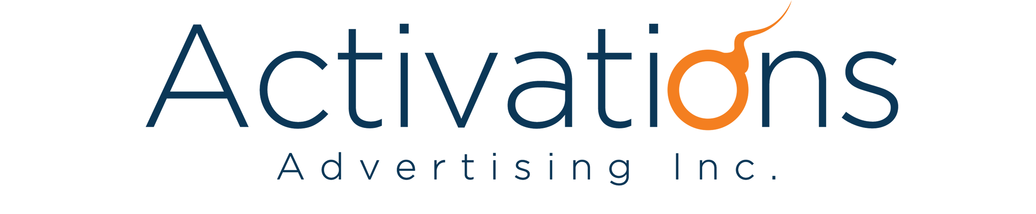

OVERVIEW:
ATTENDEES:
- Unilever (Maui Velasco)
- AAI (Molie Gonzales, Phoebe Milan, Kimberly Chua)
DATE: February 20, 2017
TIME: 10AM
LOCATION: Unilever Office

AGENDA:
Briefing: Dove Masterbrand Gifting Activation 2017

NOTES:
Project Overview
- During the previous years, Dove Masterbrand has been present in-store via Pre-Banded Packs (PBPs) in-store.
- For 2017, Dove Masterbrand wants to have a gifting activation in time for the Christmas Season (Target Breakdate: September 2017)
  - In-store: via Gift with Purchase (GWP)
  - Out of Store: via Personalized Gifts (Experiential Customization and Personalization)

Agency’s Scope of Work
- Out of store Gifting
  - A booth/space we can mount in a public area (i.e. mall), wherein we allow consumers to make their own Dove gifts (ala Make Your Own Havaianas)
  - Consumers can buy ready-made PBPs, but also have the option to customize their own gifts, with the help of a BA
  - This would be for Christmas – rollout will start in September
  - Objective is to drive premium image of Dove
    - Keywords: Personalized, Experience, Premium

Expected Agency’s Output
- Entire look and concept of the booth
  - Need a max, medium and mini version for this, in the event that our customers would also like to activate this in-store.
  - Sizes of each
    - Max – Please propose. This would depend on the space we get.
    - Med – 3x3M
    - Mini – 1.5x1.5M
  - Include the entire consumer journey, activation handle, personalization scheme, gift wrapping area, PBPs area, manpower uniform, etc.
    - For example: How can consumers customize their Dove purchase? – Personalized Dove Bar/Bottles, Pouch, etc?
- Possible venues we can hold the out of store gifting
- Costings per booth
a. Production/mounting of the booth
b. Manpower
c. Premiums
d. Peg costs for venues

NEXT STEPS AND DELIVERABLES:
Presentation Schedule: March 01, 2017

=== NOTHING FOLLOWS ===

