Testing Guidelines

* Overview
* Test Preparation
* Testing Parameter Explanation
* General Testing process
* Example: iLP_galvanic with FSK under no noise
* Testing result
* Debug Tips:
* Future Testing suggestions
* Overview:

The purpose for this experiment is doing assessment on the apple-to-apple communication between iLP_acoustic and iLP_galvanic device by adjusting several parameters in the physical layer testing environment and by trying limited, major parameters in the Software bench modems. The final assessment is mainly focus on the accuracy of transmission (BER) and the power consumption of transmission.

* Test Preparation:
  1. Instrument Requirements:
     1. iLP_Galvanic and iLP_Acoustic
     2. Two Hackrf Ones (Used as SDR at TX/RX)
     3. Function Generator (Used as noise generator and debugging tool)
     4. Oscilloscope (Used as debugging tool)
     5. A container surrounded with acoustic-absorbing materials (foam)
     6. Salt and conductivity meter (Used to simulate the blood conductivity)
     7. iLP_Acoustic special:
        + hydrophone (Use as debugging tool)
        + External amplifier XXX (Use to amply the input to TX)
        + DC Power supply (Use as power for external amplifier and build-in RX side amplifier)
  2. Schematic:

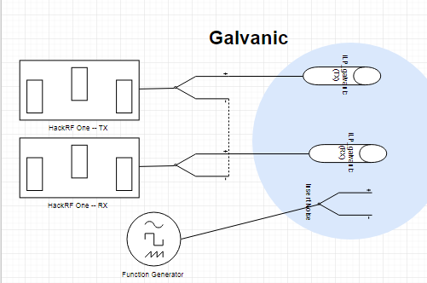

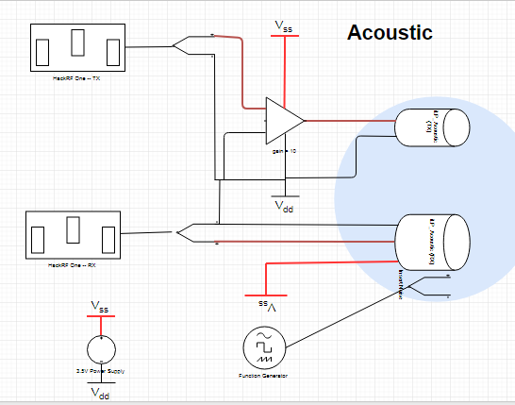

* 1. Check the settings:
     1. Make sure the Hackrf One to Hackrf One (connected by cable only) communication works, which means it can successfully do the whole modulation and de-modulation process.
     2. Acoustic:
        + **Check the input signal:** Connect the Hackrf One TX to the amplifier first, make sure the amplified signal is around 2V peak-to-peak amplitude. And the output is a clear cosine wave (or maybe a little triangle wave which is also ok because the capacitor connected to the iLP TX will filter out the high frequency and turn it back to cosine wave again) with desired frequency. 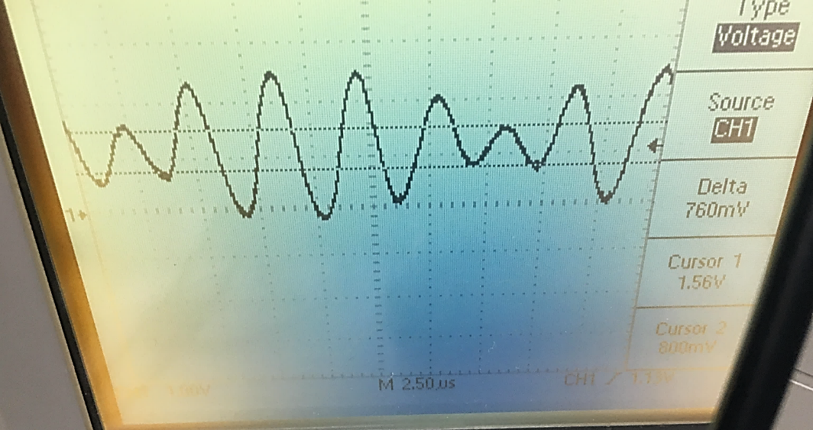
        + **Check if the transmitter transmit the acoustic signal:**
          - Use the function generator as input to TX (no external amplifier connected). Set it to the burst mode with N=10, interval time = 2ms, f = 270KHz, voltage = 2V.
          - Use the hydrophone connected to oscilloscope as RX. You should see the burst signal around 5-15mV. If it is hard to see you can use trigger to capture that. The reason we use hydrophone is that it can only capture the acoustic signal. So we get rid of the electrical signal intervene.
        + **Check if the receiver with build-in amplifier works:**
          - Now replace the hydrophone with iLP receiver (don’t forget to power it). You should see the similar pattern with much larger amplitude. Make sure do not coupling the RX wires with TX wires!
          - In order to let Hackrf One RX recognize the signal. The output from iLP receiver should be …..
     3. Galvanic: The set for galvanic is quite easy so you can directly step into experiment first. I didn’t meet any issues by now.
  2. Requirements and limitation during testing:
     1. Software Modems (for FSK):
        + Recommended gain for Hackrf One build in amplifier is TX_RF = 14, TX_IF = 47, TX_BB (doesn’t matter); RX_RF = 14, RX_IF = 16, RX_BB = 16. This is the maximum gain you could get without much distortion for FSK. Further increase for RX_IF and RX_BB will fail to get target frequency. ASK and PSK not been tested yet. For more details on amp gain adjustment please refer to **Software modem instruction <Interface to receiver>/<Interface to transmitter>** 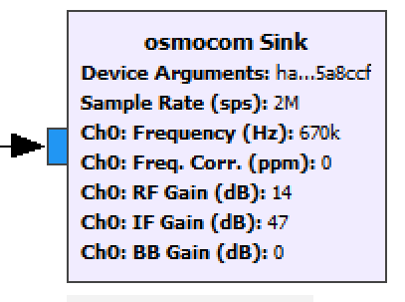 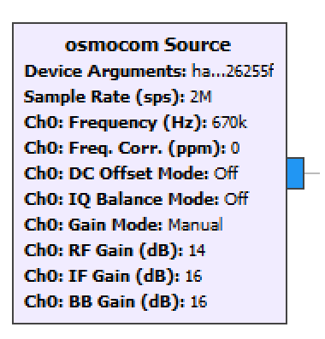
        + Recommended for synchronize threshold, which used to synchronize the generated signal and demodulated signal to do BER assessment is 10. Higher threshold will fail in synchronizing, causing high BER in received signal. Lower threshold may be two strict that not easy for us to see the BER changes. For more details on amp gain adjustment please refer to **Software modem instruction <Packet Decoder>.**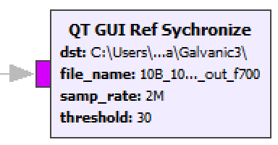
        + Recommended sample rate and symbol rate for narrow down the testing scope purpose is 2M. Change in sample rate may lead to more deep adjustment to the SDR system. Please refer to **Software modem instruction** for more deeper change.
        + Recommended repeat time for message is >= 100 times. This is used to better assess the BER, avoiding some random interrupt. For more details on amp gain adjustment please refer to **Software modem instruction <Packet Encoder>.**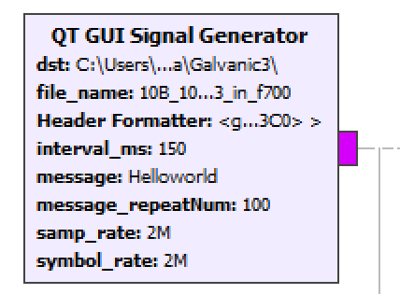
     2. Galvanic:
        + Recommended testing range for carrier wave frequency generated by Hackrf One is 700KHz (pkp_amp=94-751mV) – 1990KHz. Any f < 500KHz will not work. f between 500KHz and 600KHz only works without noise. The reason might due to the insufficient pkp-amplitude. Frequency between 1990KHz and 2000KHz also not work, probably due to hackrf’s own limitation. f > 2000KHz is not tested yet.
     3. Acoustic:
        + The driven voltage (pkp-amp) for TX need to be >= 2V
        + The DC power required by RX is around 3V. DO NOT go to high, this may cause amplifier saturation which may destroy the build-in amplifier.
        + Recommended testing range for carrier wave frequency generated by Hackrf One is 270KHz – 310KHz.
     4. Other requirements:
        + Do not couple the wires.
        + Try to avoid other EM source besides the signal from wires.
        + Container must be surrounded by anechoic material
        + Water Saline Concentration ~=1.8g/L, with electrical conductivity = 2.85mS/cm . This may varies case to case.
        + When you hang the clip from generator to introduce noise, try to keep the clip in the same position during whole test. Different position may result different result.
  3. Setting examples:

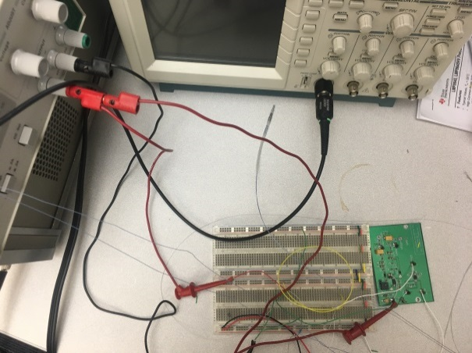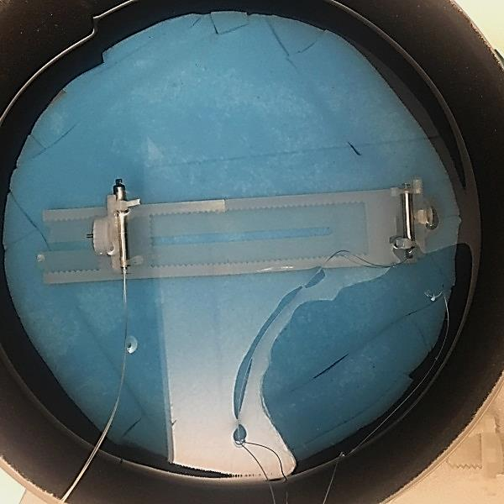

* Parameter Explanation:
  1. Some helper parameters:
     1. Dst: the destination folder I want put all my signal file in.
        + Parameter defined here: 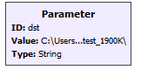
        + Parameter used here:

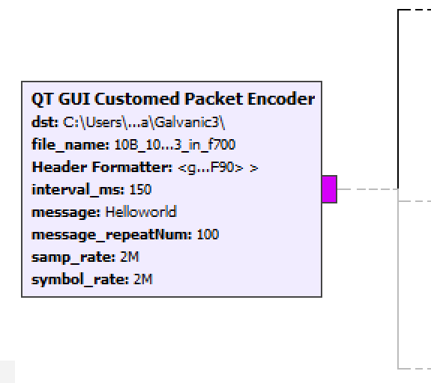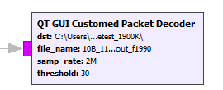

* + - * In this experiment, one I used is “User/cheny/Document/Bodyarea_Network_Communications/data/Galvanic_noisetest_700K/”
    1. In_file_name: the name of the generated signal , used for future reference. *The naming rule I use to name is “byteNumber_distance(m)_noiseDeviation_noiseAmp_iLPType_orientaion_in_frequency”*
       - Parameter used here: 
       - For example the one I use “1B_100m_noise9_001_galv_po3_in_f700”. Means 1Byte, 100mm distance, carrier_frequency+9KHz, 10mV, iLP_galvanic, orientation 3, carrier frequency = 700KHz.
    2. Out_file_name: file to save the demodulated signal for BER assessment later. The naming rule is same as before, just change ‘in’ to ‘out’
       - Parameter used here: 
       - For example the one I use “1B_100m_noise9_001_galv_po3_out_f700”.
  1. Message Related:
     1. Message Length: 1 byte (1 character) ; 10 byte : 1 byte (1 character)
        + Parameter defined here: 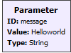
        + Parameter used here: 
        + Here I use ‘H’ as 1B message and ‘Helloworld’ as 10B message.
     2. Message Interval: The interval time between two messages, range from 150 ms to 500 ms. This parameter might be related to human heart rate.
        + Parameter defined here: 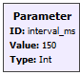
        + Parameter used here: 
        + Here I test 150ms
  2. Physical Setting related: A close up of a device

     Description generated with very high confidence
     1. iLP device: Acoustic and galvanic. Please refer to **<Test preparation: Requirements and limitation during testing>** for detail requirement.
     2. Orientation: Each iLP can be freely rotated along y-axis or x-axis for any degree.
        + Below is the three most typical one I choose in this experiment

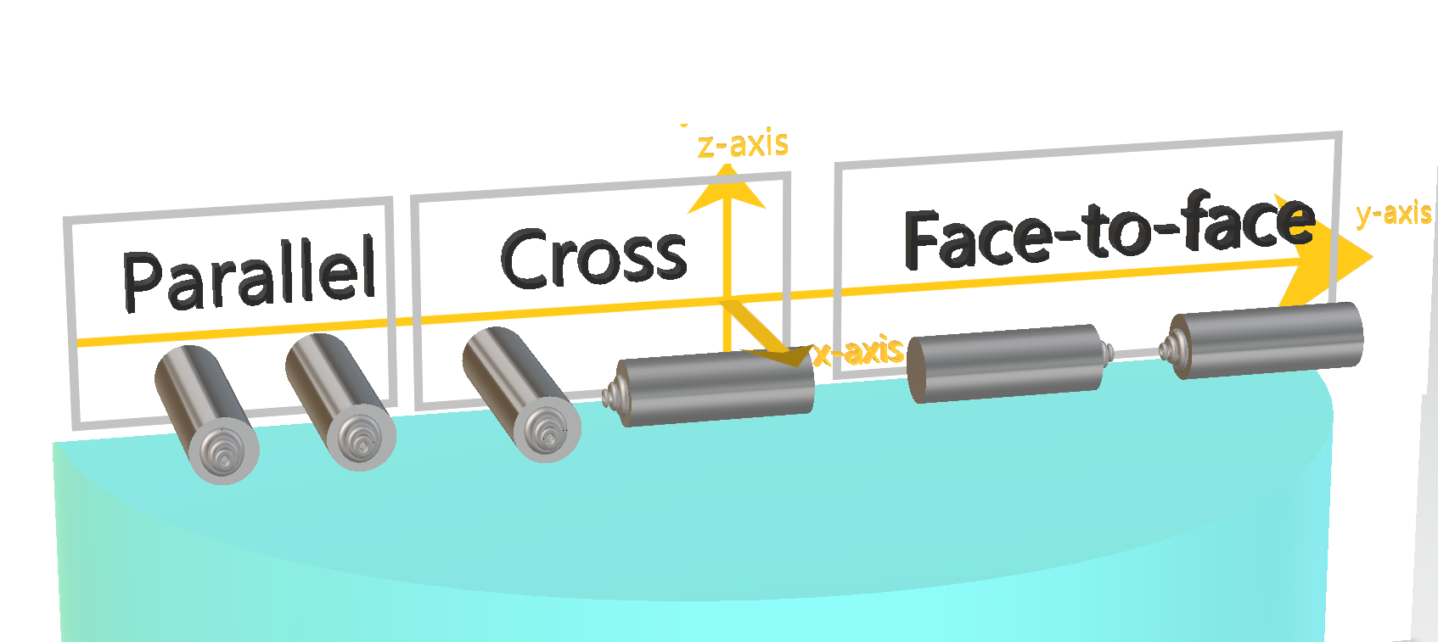

* + 1. Distance: the distance between two middle of iLP, can varies between 40mm – 250mm.
       - In this experiment I choose 100 mm as the most usual distance.
    2. Transmission Media
       - Water with certain conductivity to simulate the blood/body fluid)
       - Water + Air (in the balloon) to simulate the lungs and body fluid. This is only needed in the S-ICD case
       - In this experiment I only use water with saline ~= 1.8g/L,. Conductivity ~=2/85mS/cm as media.
  1. Software algorithm related: (refer to the **Software modem instruction** for more details)
     1. Modulation Algorithm:
        + FSK: Theoretically this is the most preferable algorithm. This one has good noise immunity and is
        + PSK: This one take longer time to process and maybe more power consumption. But can still try.
        + OOK: This one is very subjective to noise and is less bandwidth efficient. So I not recommended trying this on.
        + In this experiment, I test FSK. Also FSK might not work or need a larger frequency deviation for the acoustic iLP, need further testing.
     2. Total Bandwidth (= Minimum required sample rate): Suppose we are able to do all frequency down-converting in the analog device, which means after A to D converting, signal in the frequency domain will be zero – centered. This is the total Bandwidth that contains the targeted message information.
        + Total Bandwidth < RX_sample_rate <= TX_sample_rate
        + Total Bandwidth = ideal_BW + EBW.
          - For FSk, EBW is close to 0.
          - For ASK,EBW is hard to assess
        + Parameter defined here:
        + In this experiment I choose 10KHz total Bandwidth for FSK, 13.5KHz for PSK and 20KHz for ASK.
  2. Environment related:
     1. Noise: The algorithm is theoretically designed as a Low pass filter to reject noise with frequency out of range carrier_wave+- Total_Bandwidth/2. In this experiemnt I choose Total_Bandwidth = 20KHz. So theoretically it should reject all frequency out of carrier frequency +- 10KHz. My test comform with this theory. So in order to push to its limited noise immunity. I choose the noise with frequency = carrier frequency + 9KHz.
        + Use function generator to generate the noise
        + For galvanic one with f = 700KHz, I choose noise with f=709KHz and amplitude = 0mV, 10mV, 20mV, 30mV,40mV
        + For galvanic one with f = 1990KHz, I choose noise with f=1999KHz and amplitude = 0mV, 200mV, 220mV, 240mV, 260mV,280mV,300mV
        + For acoustic,…
  3. Targeted Result:
     1. Bit Error Rate: It is actually impossible to get exact BER so I consider the result below.
        + **Received Packet Percentage**. The packet decoder will check the access code first to synchronize the demodulated data and the sent data. The total length of access code is 96 while maximum wrong data I allowed is 10. So received packet number means the percent of packets in total 100 packets that has BER of access code < 10/96 = 10.41%.
          - I have encountered a very rare case that received packets number = 100, but the BER of received signal is 21.3%. That might just be an exceptional that the random generated access code is accidentally close to the message itself. It rarely occur so we can just throw out this data.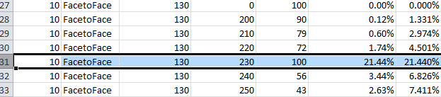
        + **Received BER**. The bit error rate of received signal. Because we already reject those packet with BER > 31.35%. So the Receiver BER will usually be lower than actual value.
        + **Estimated Total BER.** The way I calculate the estimated Total BER is: (*Received_BER * Received_Packet_number *8*Packet_length+ 10.41%*(100- Received_Packet_number)*96)/ ( Received_Packet_number *8*Packet_length+%*(100- Received_Packet_number)*96) .* Because it will automatically reject BER > 10.41%, so the actual total BER are likely to be higher.
     2. Relative power-consumption (could be roughly estimated from following parameters):
        + Amplify gain (the lower the better)
        + Total Bandwidth (= Minimum required sample rate): the lower the better)
          - For example in this experiment is I choose 10KHz total Bandwidth for FSK, 13.5KHz for PSK and 20KHz for ASK. Then if each of them is able to get similar accuracy then we say the general trend for increasing power consumption order is FSK, PSK, ASK
          - I haven’t do the actual testing on PSK and ASK.
        + Activation Time (This one seems need the code on more basic level and is unachievable by GNUradio)
* General Testing Process:
  1. Use the desired parameter, select the modulation method and run **BAN modem** until no more received message printed to the screen. You will see a continuous sequence of “UUU” is printed out in a obviously higher speed than before.
  2. Select the saved original signal file and the saved demodulated file. Run the **Check Bit Error** to calculate the final BER. If the BER = 0 and nothing shows in the signal time domain, 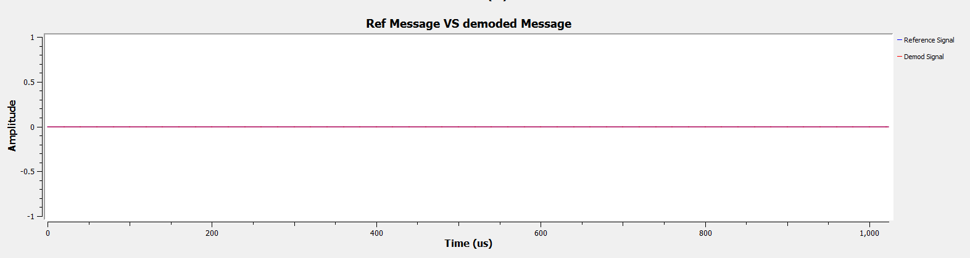then you may not receive all the packets. Adjust *message_repeatNum* 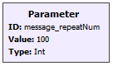to find the actual received packets Number until something shows on the screen.
* Testing examples:
  1. Settings
     1. Message Length: 10 bytes (‘Helloworld’), sent 100 times
     2. Device: galvanic to galvanic
     3. Orientation: face-to-face
     4. Distance: 100mm
     5. Noise Amplitude: 0V (no noise)
     6. Modulation Algorithm: FSK
     7. Total Required bandwidth (=Minimum required sample rate): 10KHz
     8. Conductivity: 3.01 mS/cm
  2. Software Modem: 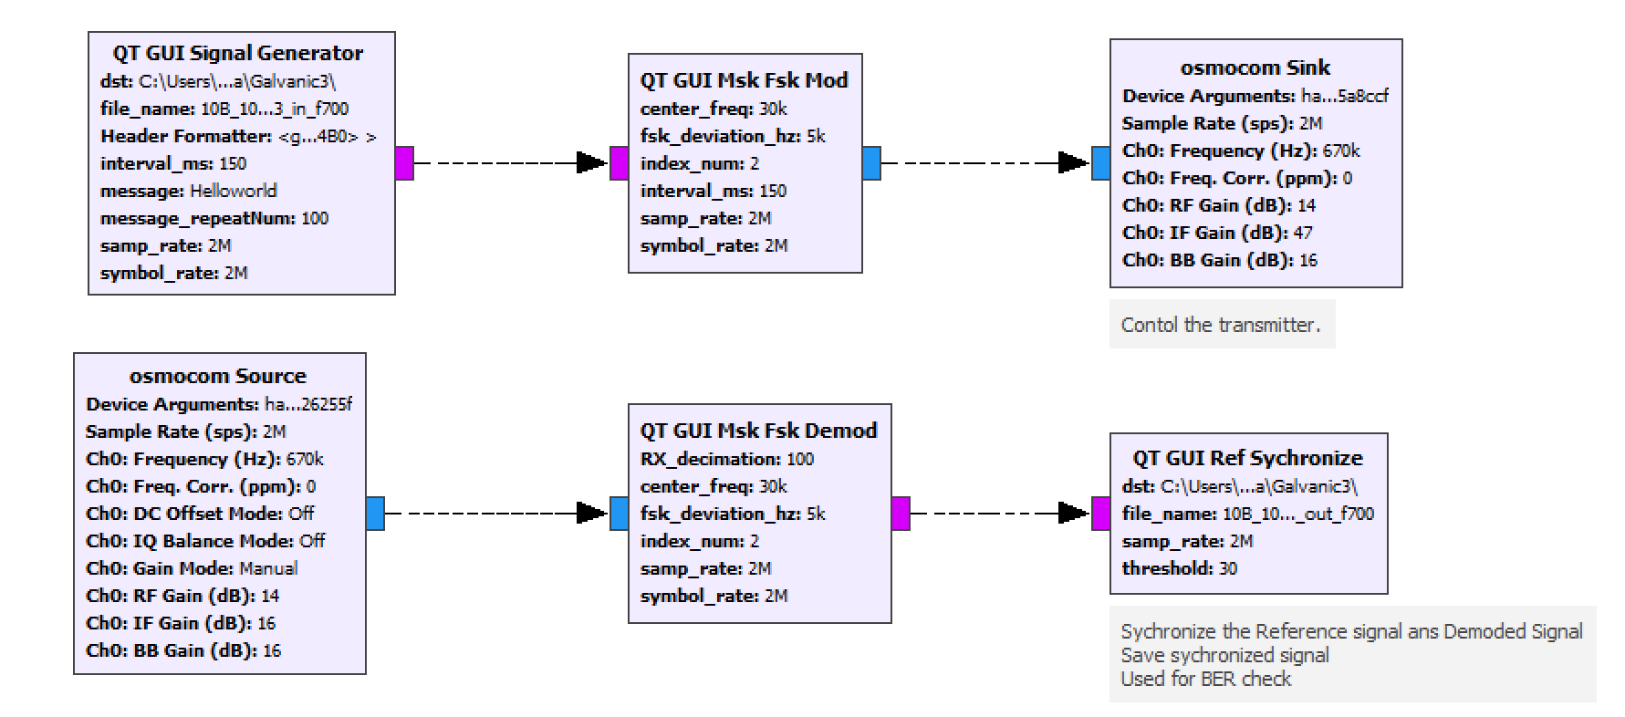
  3. Top: Received signal; Bottom: signal after eliminating DC offset and Down-sampling (Low Pass Filter)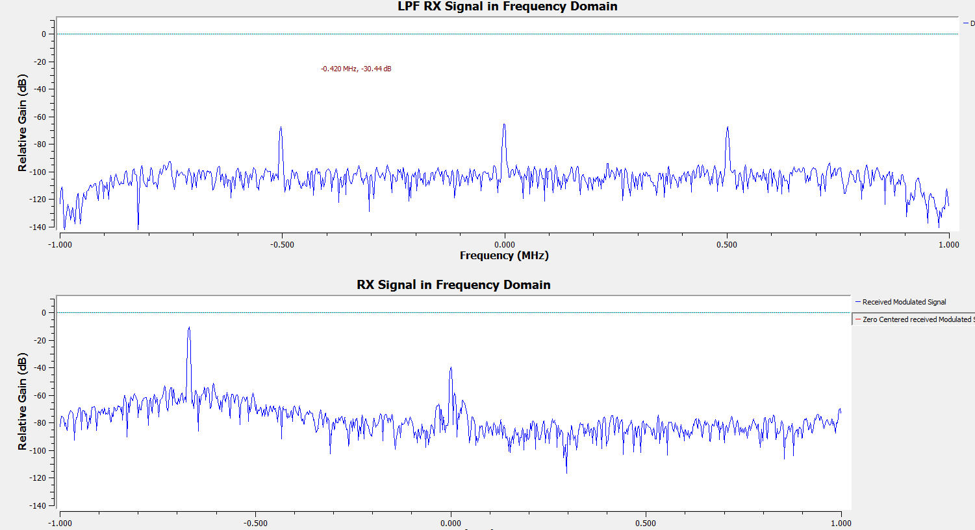
  4. Received Message printout in the console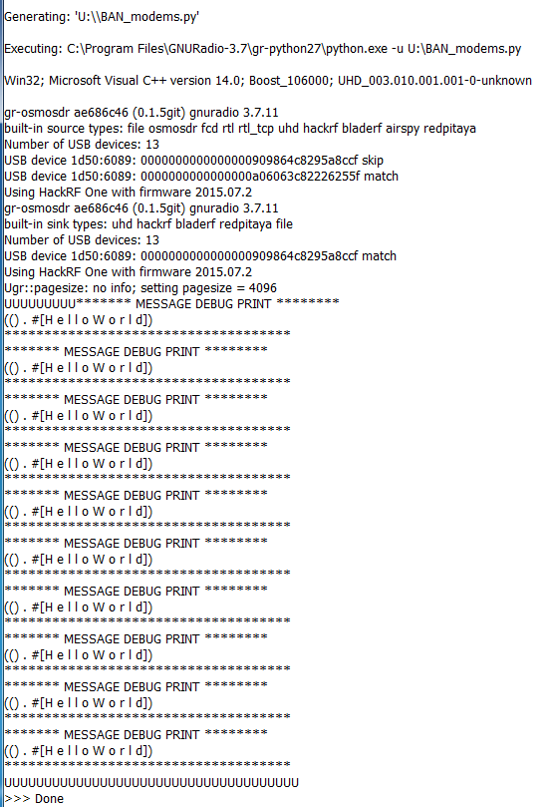
  5. Check bit error rate and the result: Plase refer to **Software modem instruction <Check Error Rate)** for more details about how to use that program.
     1. I assess the BER using moving average, so when pool is small, BER will begin with a larger value but wil finally converge towards 0.2%. The final point is the BER we need.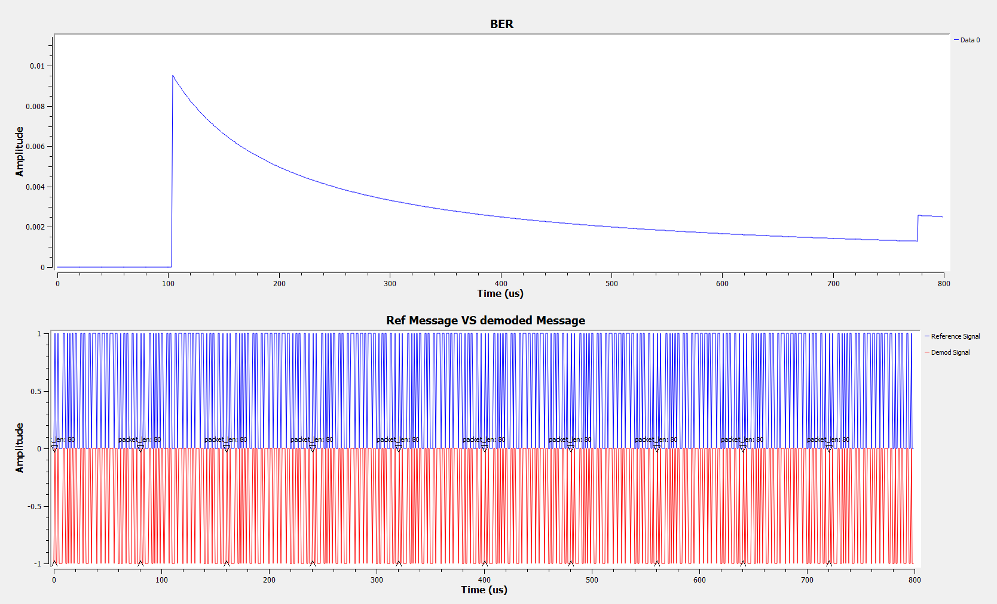
     2. Also here I manually look for the received packet number, which I received all the 100 packets . Updates on automatic?
* Report Summary: Please see the spreadsheet.
* Debug Tips:
  1. First make sure you done **Check Settings** in the **Test Preparation Section**.
  2. If the accuracy VS. noise trends doesn’t seem monotonous?
     + A little fluctuation is normal.
     + Check if your noise input is still immersed in the water , and roughly keep in the same position.
     + Check if the positioning fixture still stands in the right position.
  3. Why the Rx side probe connected to Hackrf / oscilloscope is disconnected from iLP but I still received signal?
     + If you are using function generator as signal source to do the debugging, make sure voltage of function generator need to be < 4V. Otherwise the received signal may come from the EM field.
     + Check if the probe is getting too close to the components on the Tx .
* Future testing suggestion:
  1. ..
  2. …