* **Environment Setting ( Windows 7):** 
  + Hackrf One USB Driver: zadig_v2.0.1.160.7z (<https://sourceforge.net/projects/libwdi/files/zadig/>)
  + GNUradio Windows 64 Binary Version: (<http://www.gcndevelopment.com/gnuradio/>)
    - Because windows version is not officially supported, so my experience is using Out-of-Tree Tools (OOT) <https://wiki.gnuradio.org/index.php/OutOfTreeModules> will cause some issues. Other features work fine.
  + Verify the installation:
    - Plug in Hackrf One
    - You should see it appeared in Device Manager: 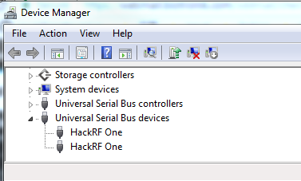
    - Open the GNUradio Command Prompt, type *in ‘hackrf_info’,*you should see information like this: 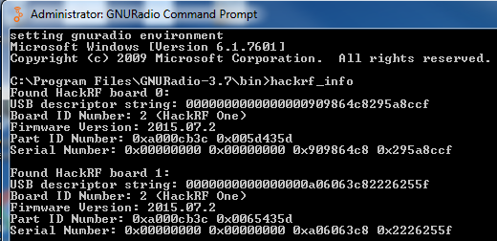
    - Remember the last 8 digits like 2226255f, this is the address you want to call the specific hackrf in the future. Now we are ready to go!
* **System Overview:**
* **Signal Generator:**
  + 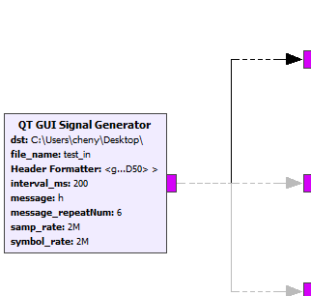
  + Parameters:
    - **Dst**: Designation folder of all saved signal files
    - **Filename:** the name of the original digital signal transformed from test message
    - **Header Format:** Used to generate the access code attached to the beginning of each signal packet. During actual transmission mode, computer at the receiver side will check the access code first. If the error of access code is below the threshold. Then computer will regarded the following signal as target message. During the testing mode, access code will help to synchronize the reference signal and the received signal for bit error comparison.
      * GNUradio has build-in function to generate the access code *‘digital.header_format_default(digital.packet_utils.default_access_code, 0)’*
    - **Interval_ms:**  The interval time between two messages. The unit is ms so ‘200’ means 200ms.
      * In the heart rate simulation it is usually the interval time between two beats. So ….
    - **Message:**  The actual text message you want to send. One character is 1 byte long signal. For example, send “Helloworld” is actually sending 80 bits signals.
    - **Message_RepeatTime:** How many times to you want to send the same message. To get an accurate Bit Error rate, we usually repeat the message several times and calculate the average Bit Error Rate. Here I repeat 5 times.
    - **Sample Rate**: The sample rate of generated signal., means number of discrete samples the computer will process per seconds.
      * Require to be >=2*maximum frequency of processing signals.
      * In the function generator …
      * Sample rate should not within the chip capacity, usually smaller than clock rate
    - **Symbol Rate:** Number of symbols per second. For example, ‘a’ can be decode as ‘01100001’, if the symbol rate is 100 then each ‘1’/’0’ should last for 0.01 seconds.
      * The symbol rate should > actual need.
      * The symbol rate should < = sample rate, otherwise the computer is unable to process.
  + Workflow Details:
    - 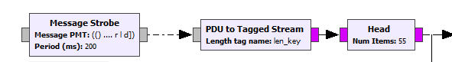
      * Generate text message for each Interval _ms *(Interval _ms = 200)* and convert that to digital stream. Use head to only transmit ‘len(message)*(message_repeatNum) ‘ digits. *(message_repeatNum = 5, and len(message) = 11)*
    - 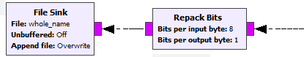
      * Repack the 1 byte symbol into 8 bots and save the original signal file as reference when do bit error comparison *(whole_name = dst + filename)*
    - 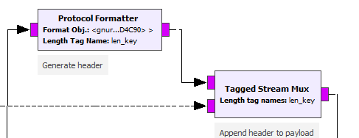
      * Attach the access code to the message.
    - 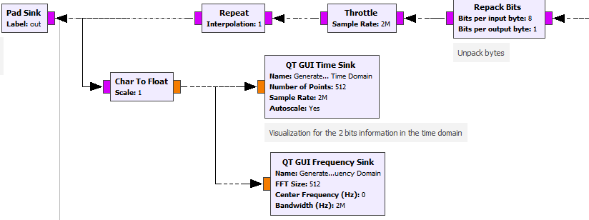
      * Repack the access-code-attached message symbol into 8 bits. Send that to the next stage in Pad Sink and also visualize them in Time Domain and Frequency Domain.
  + Example Result Screenshot: 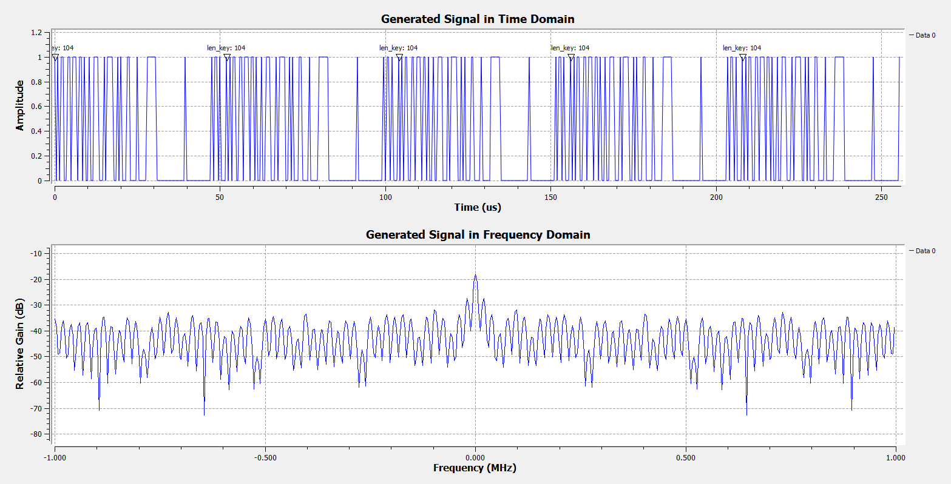
    - In the example screenshot I send one byte signal ‘H’. The length of access code is always 96. So the total length is 104 and the same pattern repeated for 5 times as you can see from the time domain.
* **Modulation/FSK:** 
  + 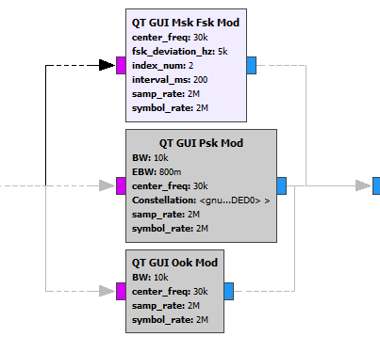
  + Parameter: 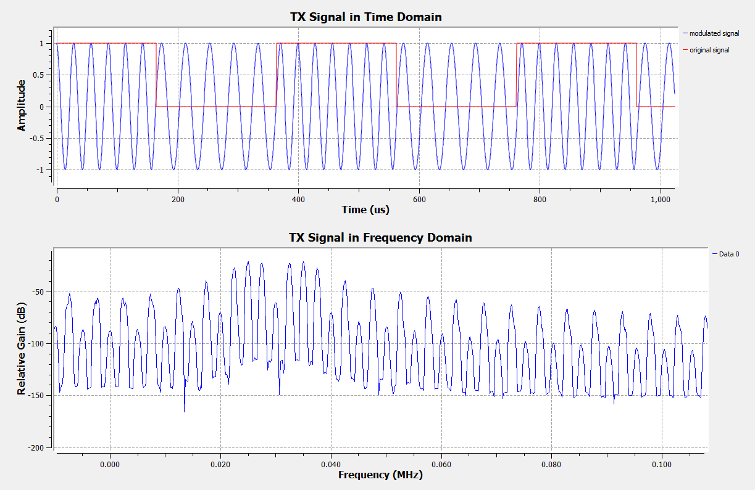
    - **Center_freq:** The center of f0 ( ‘0’ frequency) and f1 ( ‘1’ frequency). For example, in the picture, I use 25KHz to represent 0 and 35KHz to represent 1, so the center_freq=30KHz
    - **Fsk_deviation:** |f1-f0|/2, in the above example, fsk_deviation = 5KHz
      * In the FSK algorithm, required *|f1-f0|=symbol_rate*index_num/2* to keep orthogonality.
      * Ideally, |f1-f0| is the minimum requirement for sample rate. In the practice, we want center_freq to be some positive number in order to get a better gain. So the minimum requirement for sample_rate is *fsk_deviation + center_freq*
    - **Index_num**: …. Must be an positive integer
      * When index_num = 1, the algorithm is MSK (minimum shift key). Here index_num =2 achieved best result.
    - **Interval_ms**: refer to the signal generator section. Must be the same
    - **Sample_rate:** refer to the signal generator section. Must be the same
    - **Symbol_rate:** refer to the signal generator section. Must be the same.
  + Dependent Variables:
    - **SPS: *=( symbol_rate/fsk_deviation_hz/4)*(index_num).* Must be integer*.***
      * Sample per symbol. As I mentioned above, 2*fsk_deviation = *|f1-f0|=symbol_rate*index_num/2.* However the symbol rate it required to fulfill the fsk_deviation needs might be too low for us to capture. So we repeat the each sample for **SPS** times to generate some “pseudo symbol rate”. For example the original symbol rate is 2MHz which means each symbol last *1/2M = 0.5e-6 s*, by repeating SPS=200 times, each symbol last *1/2M*200 = 1e-4 s,* which means the “pseudo symbol rate” *2M/200 = 10KHz.*In the above picture you can realize without SPS, the modulated wave is unable to catch such fast sample rate.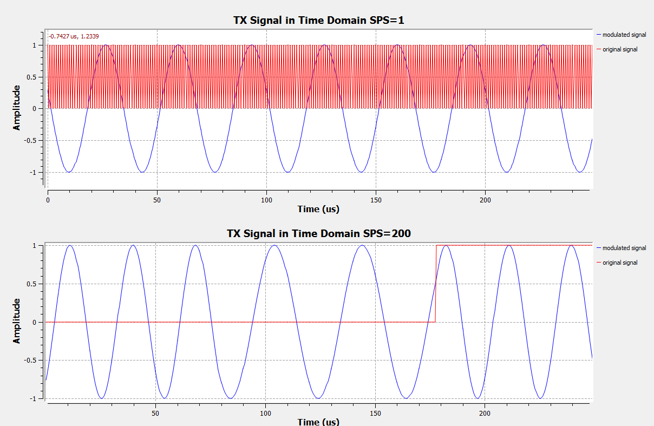
    - **Pream_vec_len: *= samp_rate*interval_ms*1e-3/SPS***
      * Length of preamble vector. During the interval time, there is only noise existing instead of message. So large error will occur when jump from the noise to received message. In order to avoid such error, I send 1,0,1,0 … during the interval time.
  + Workflow Details:
    - 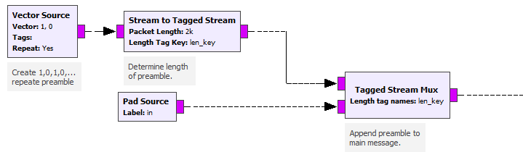
      * Attach the preamble 1,0,1,0… signal to the encoded signal packet created from **Signal Generator (from pad source).**
    - 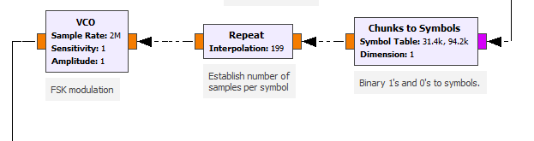
      * Match the binary digits to its representative frequency, repeat that for **SPS** times to generate “pseudo symbol” and use vco to actually generate the cosine wave with corresponding frequency
    - 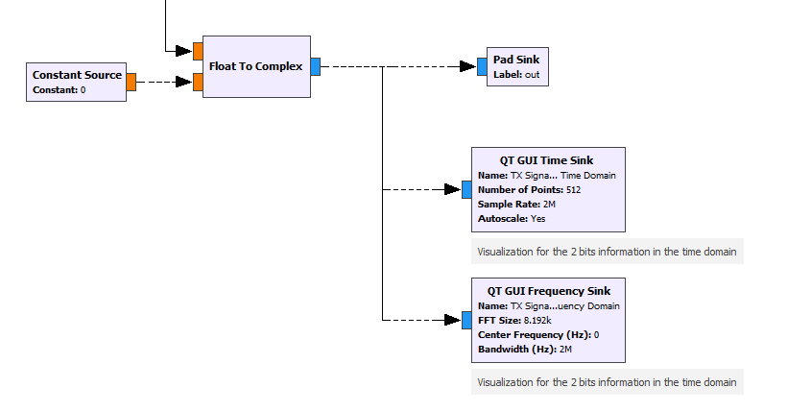
      * Because signal in reality is always in complex form. So change float to complex by inserting 0 imaginary part. Then send it to the next stage as well as visualize it in the frequency/time domain.
* **Modulation/PSK:** 
  + 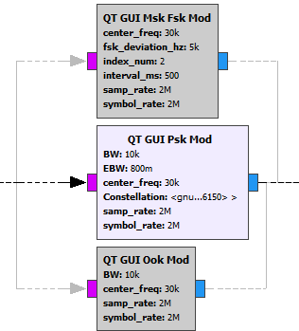
  + Parameter:
    - **BW:**  Ideal bandwidth of modulated signal. …
    - **EBW:** Excess Bandwidth.
      * A normalized factor based on BW (0.0-1.0). For example, 0.8 means 0.8*BW extra bandwidth required. Total required bandwidth = BW *(1+EBW)
      * Usually lower EBW means more bandwidth efficient and more accurate the resampler is. But also means more power consumption.
      * Here we try to generated continuous cosine wave corresponding to different phases. A perfect cosine wave has a rectangle shape in frequency domain (EBW = 0). However in the reality it is impossible to generate a perfect wave. So the relation between EBW and the wave in time domain can be referred from below plots. (<https://en.wikipedia.org/wiki/Root-raised-cosine_filter>)

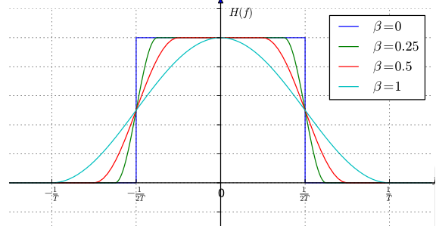 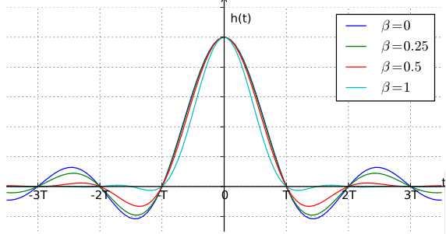

* + - **Center_freq: …**
    - **Constellation:** Default parameter when using Binary PSK (BPSK), (-1,1).
      * No need to change.
    - **Samp_rate:** Please refer to function generator. Must be the same.
    - **Symbol_rate: :** Please refer to function generator. Must be the same.
  + Dependent Parameter:
    - **SPS:** Symbol per sample. Similar to FSK, used to up-sample the signal to let the symbol rate match the algorithm requirement.
      * **=** symbol_rate/BW
    - **RRC Filter Taps: …**
  + Workflow Details:
    - 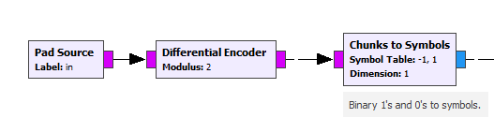
      * Differential Coding is used in noon-coherent reception. PSK is very likely to invert the received signal without way to recognized. By using differential encoding, the decoded value is not only depends on current signal but also previous signal. Thus to avoid inverting problem
    - 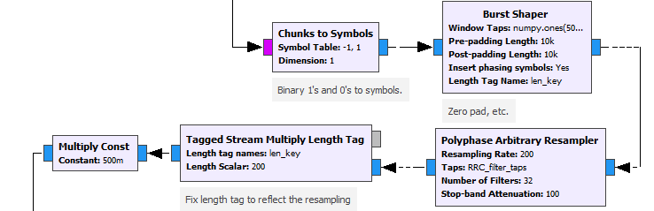
      * Match ‘0’,’1’ to the phase ‘-1’ and ‘1’, do the BPSK modulation and up=sampling at the same time via Polyphase Arbitrary Resampler
    - 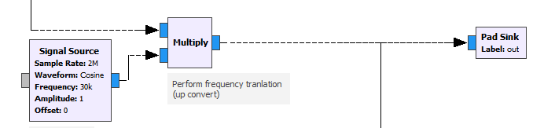
      * Up-convert to its center_freq. Refer to **FSK Modulation section** for more details
  + Result Screenshot:
    - 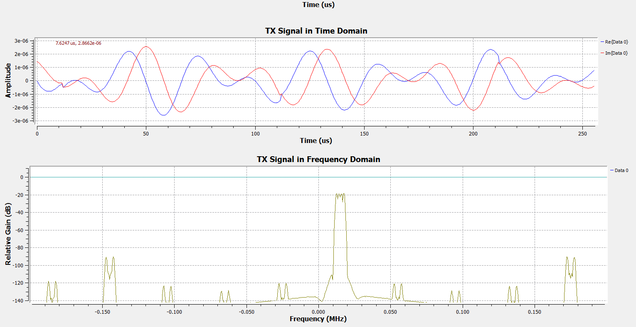

Targeted frequency range. Total Bandwidth = BW*(1+EBW) range

* **Interface to transmitter:**
  + 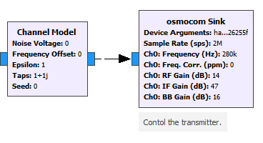
  + Parameter:
    - **Device Argument:** The address number of hackrf. Type command “hackrf_info” to check the hackrf you connected with.
    - **Sample Rate:** refer to the signal generator section. Must be the same
    - **RF Gain (dB):** 0 or 14 dB; amplifier for the final transmitting frequncty
      * Here I choose the maximum 14
      * …
    - **IF Gain (dB):** 0 to 47 dB in 1dB steps.
      * Here I choose the maximum 47dB; amplifier for intermediate frequency
      * …
    - **BB Gain:**  Not used in TX side.
    - **In the TX side, there are not much difference in RF and IF gain.**
    - **Noise Voltage:** Used to simulate the noise voltage in channel
      * If you are using the physical plug in noise, just set it to 0.
    - **Frequency offset:** The normalized frequency offset. 0 is no offset; 0.25 would be, for a digital modem, one quarter of the symbol rate.
      * Usually set to 0
    - **epsilon** : The sample timing offset to emulate the different rates between the sample clocks of the transmitter and receiver. 1.0 is no difference.
      * Usually set to 0
    - **taps :** Taps of a FIR filter to emulate a multipath delay profile.
      * Usually set to 0
    - **noise_seed** : A random number generator seed for the noise source.
      * Usually set to 0
  + Dependent Variable:
    - **Ch0 Frequency: *= carrier_freq – center_freq (see the Modulation section)***
      * …
  + Workflow Details:
    - Channel Model is used to simulate the channel environment and Osmocom Sink is the interface to control Hackrf as transmitter.
  + Example Result Screenshot:
    - This is what the transmitted signal looks like when the frequency is in the recommended range, for example Fs=2M,Fc=2.01M,Amp: 252mV-632mV/2, , (0dB RF Gain, 16dB IF Gain) 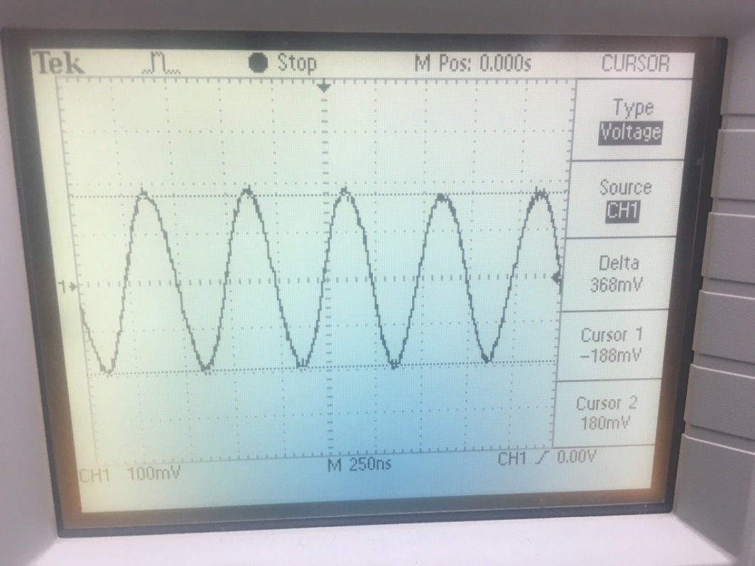
    - This is what the transmitted signal looks like when the frequency is OUT OF the recommended range, for example Fs=2M, Fs=270K,Fc=280K, Amp: 60mV/2, (0dB RF Gain, 16dB IF Gain) 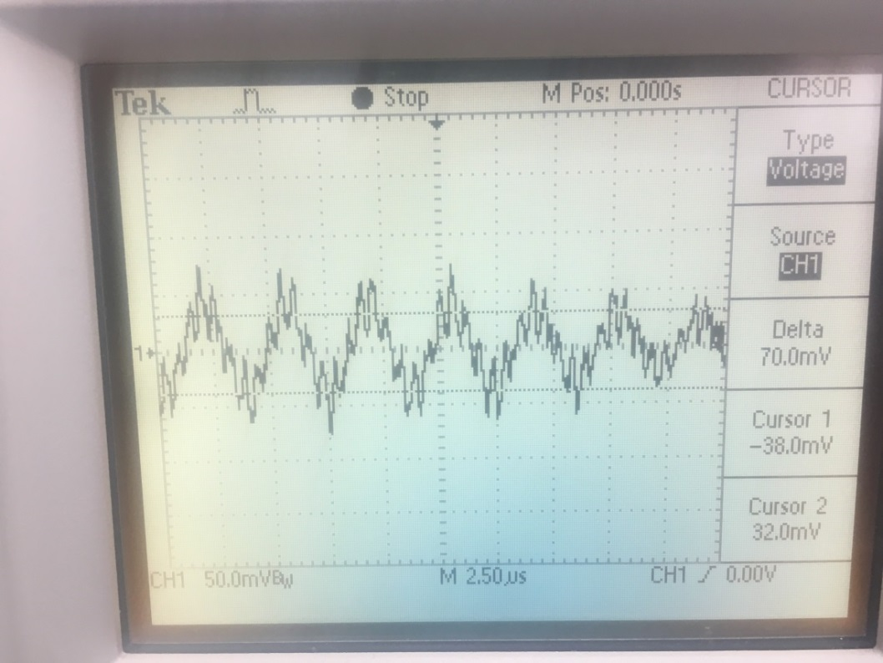
    - Other in/out of range signals have similar behavior as these two examples.
* **Interface to Receiver**
  + 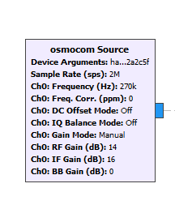
  + Parameter:
    - **Device Argument:** refer to the Interface to Transmitter
    - **Sample Rate:** refer to the signal generator section.
      * Must <= samp_ rate of transmitter.
      * If smaller than the Hackrf act as a low pass filter. For example when the sample rate of the transmitter is 2M, which include 0-1MHz signals. 1M sample rate for the receiver will exclude all high frequency signals that are > 0.5MHz.
      * Here I choose the same sample rate as the transmitter. Please refer to … for more details.
    - **RF Gain (dB):** amplifier for the final transmitting frequency
      * Allowed range: 0 or 14 dB;
      * Here I choose the maximum 14
      * …
    - **IF Gain (dB):** 0 to 40 dB in 8dB steps. amplifier for intermediate frequency
      * Here I choose the 16dB because the bigger gain will introduce additional more strong low frequency noise;
      * …
    - **BB Gain:**  0 to 62 in 2dB steps; amplifier at base band stages
      * **…**
      * Here I choose 0dB because…
    - **In the RX side, RF gain should be the first choice.**
  + Dependent Variable:
    - **Ch0 Frequency: *= carrier_freq – center_freq (see the Modulation section)***
    - In order to recover the modulated Signals, this hould be exactly the same as transmitter (unless there is frequency offset in the channel which is unusual).
* **Demodulation_FSK**
  + 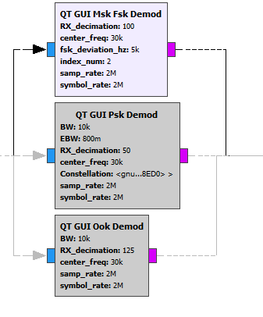
  + Parameters:
    - **RX_decimation:**  This parameter serves the equivalent function as Low Pass Filter. The maximum frequency it can reserve is samp_rate/RX_decimation/2
      * Integer, SPS(of FSK Modulation) % RX_decimation = 0
      * Fsk_deviation*2*RX_decimation < samp_rate
      * After down-sampling (decimation), the frequency domain is extended. Suppose we originally has targeted signal from -5KHz to 5KHz and noise at 20 KHz, by decimation of 100, now +-5KHz becomes +-500KHz and 20KHz becomes 2MHz. Because computer con only capture the frequency <= samp_rate/2, so we exclude the noise while still preserving the targeted signal. (See more screenshots on workflow section)
      * Please refer to <https://en.wikipedia.org/wiki/Decimation_(signal_processing)> for moew details
    - **Center_freq:** Please refer to FSK Modulation section.
      * Must be the same as modulation block
    - **Fsk_deviation:** Please refer to FSK Modulation section
      * Must be the same as modulation block
    - **Index_num**: **:** Please refer to FSK Modulation section
      * Must be the same as modulation block
    - **Sample_rate:** Please refer to FSK Modulation section.
      * Must be the same as modulation block
    - **Symbol_rate:** Please refer to FSK Modulation section
      * Must be the same as modulation block
  + Dependent Variables:
    - **SPS**: Please refer to FSK Modulation section
      * Must be the same as modulation block
    - **Polyphase**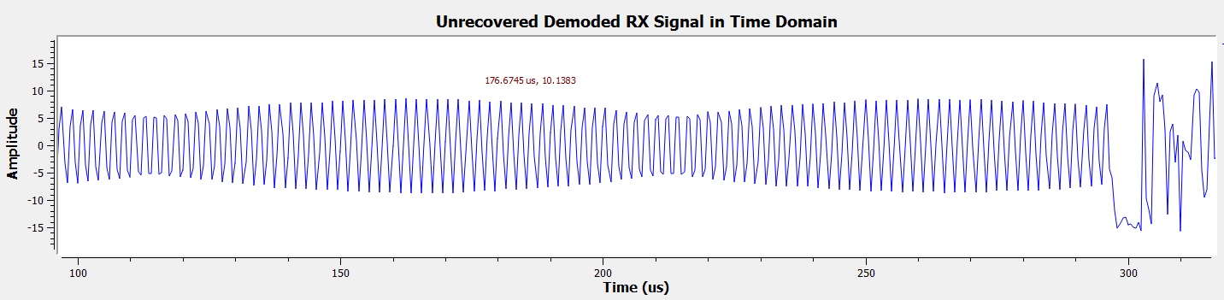
  + Workflow Details
    - 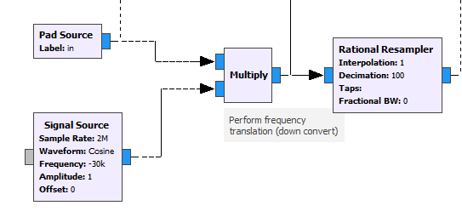
      * Down-sample (Decimation) the received signal to exclude high frequency noise; Make it zero centered. From the example below, the signal contains 25KHz and 35kHz becomes -500KHz, 500KHz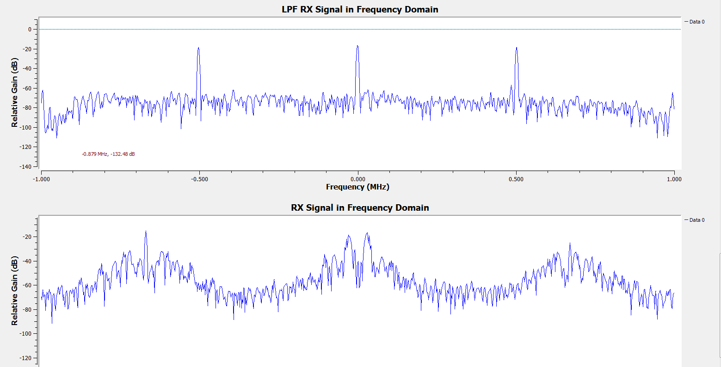
    - 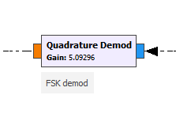
      * Quadrature Demodulation is the specific demodulation algorithm for FSK. Buffer is needed to physically implement this demodulation. Please refer to …..
    - 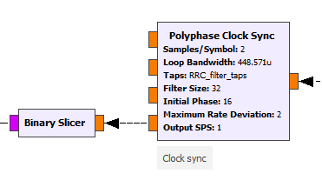
      * These blocks are used to recover the previous up-sampled signal to its original symbol rate and convert floating point to binary. **Sample/Symbol** **= SPS/RX_decimation.** Remember in the previous step, in order to exclude the noise we already do down-sample once. So here we only recovered the remained up-sampled factors. (e.g.: Here my SPS = 200, RX_decimation = 100, so the **Sample/Symbol** we need to recover is 2). PS. My recommendation is Samples/Symbol >=2.
  + Result Screenshot:
    - 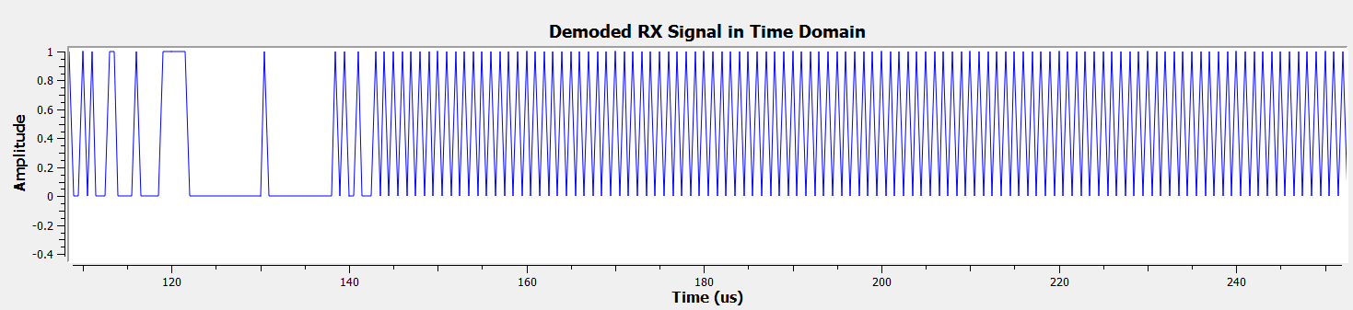

Preamble: 1,0,1,0,…

Target message

* **Demodulation_PSK**
  + 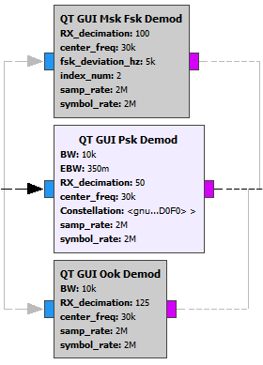
  + Parameters:
    - **RX_decimation:** Please refer to FSK Demodulation Section.
      * Integer, SPS (of PSK Modulation) %RX_decimation = 0
      * BW*(1+EBW)*RX_decimation < samp_rate
      * Because this is not frequency demodulation, so it is less subjective to high frequency. Thus in order to save power consumptions, the decimation number can be a little smaller.
    - **BW:** Please refer to **PSK Modulation**. Must be the same.
    - **EBW:** Please refer **to PSK Modulation**. Must be the same.
    - **Center_freq:** Please refer to **PSK Modulation**. Must be the same.
    - **Constellation:** Please refer to **PSK Modulation**. Must be the same.
    - **Samp_rate:** Please refer to **Interface to Receiver**. Must be the same.
  + Dependent Variables:
    - **SPS**: Please refer to **PSK Modulation**. Must be the same.
  + Workflow Details:
    - 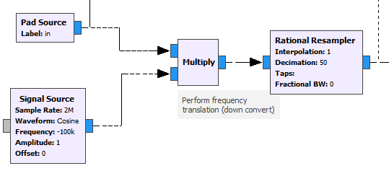
      * Down-sample and zero-centered. Please refer to **FSK Modulation.**
    - 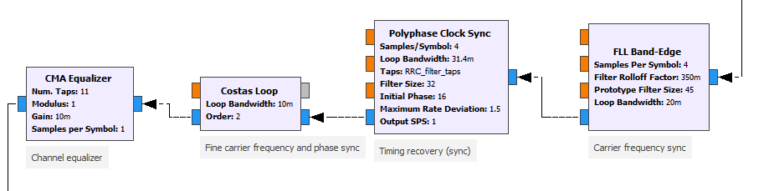
      * … (https://wiki.gnuradio.org/index.php/Guided_Tutorial_PSK_Demodulation)
      * 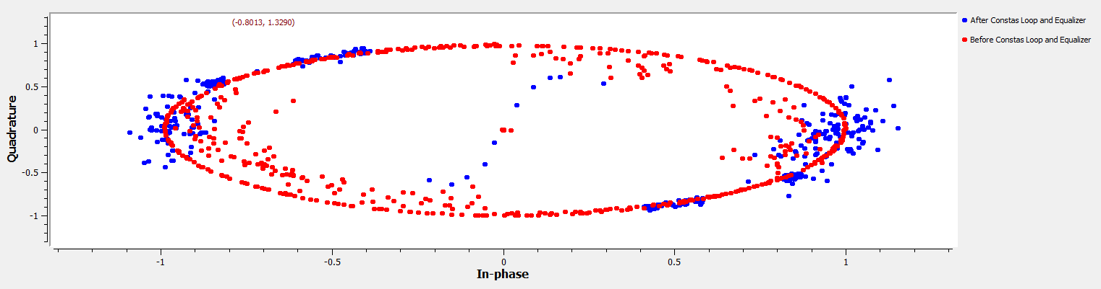
    - 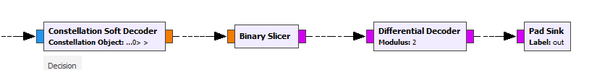
      * After Clean up all the noise and offset, call the demodulator and finally decode the differential coded signal into original one
* **Packet Decoder:**
  + 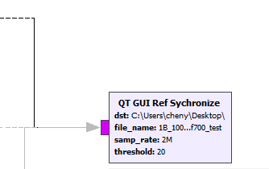
  + Parameters:
    - **Dst:** Please refer to function generator. Must be the same
    - **File_name:** Please refer to function generator.
    - **Samp_rate:** Please refer to function generator. Must be the same.
    - **Threshold:** The maximum errors allowed when check the access code.
      * My recommendation is 20.
      * The access code indicate the beginning of our targeted message, thus to synchronize the received and demodulated message with the sent message. Too small threshold will only allow the extremely accurate transmission to go through, which let us unable to catch the bit error rate variance. Too big threshold will failed in synchronization.
  + Detailed Workflow:
    - 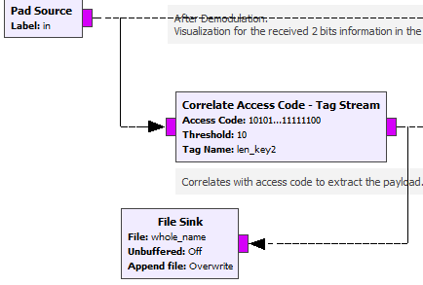
      * Check the access code and save the synchronized message to the file for BER test later
    - 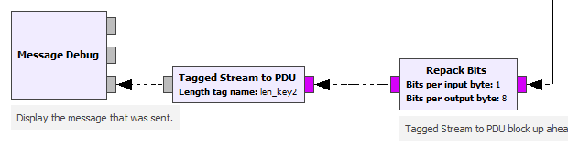
      * Repack the 8 bits into 1 byte, convert the asci code into text and print out. Help us get a general idea of transmission before do quantized testing (BER)