AAE

**discriminator 1**

Draw samples from *p*(**y**)

style

style

style

style

style

+

Input

-

style

**decoder**

$$X$$

$$\hat{x}$$

**encoder**

**y**

softmax

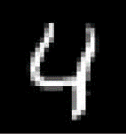

+

style

Style

**z**

linear

DGR

**discriminator 2**

-

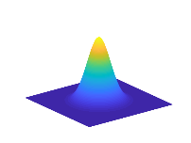

Draw samples from *p*(**z**)

**static decoder**

Input

Draw samples from *p*(**y**)

style

style

style

style

style

+

$$X_{g}$$

Train



Draw samples from *p*(**z**)

Transfer