$$X$$

$$\hat{x}$$

**z** ～ *q* (**z**)

Input

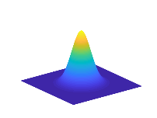

Draw samples from *p*(**z**)

+

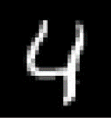

**enc oder**

*q*(**z**|**x**)

**decoder**

-

**discriminator**

**discriminator 1**

+

Draw samples from *p*(**y**)

style

style

style

style

style



**z**

**y**

**decoder**

**encoder**

Input

-

-

style

style

Style

Input



Draw samples from *p*(**z**)

+

$$\hat{x}$$

$$X$$

softmax



linear

**discriminator 2**