HARIHARAN J  Cloud Engineer | AWS Certified Cloud Practitioner | Google Associate Cloud Engineer  Madurai, Tamil Nadu, India | +91-9500963476 | jhariharancse@gmail.com  linkedin.com/in/hariharan-j-2a909a290 | github.com/cloudy-fix |  AWS CCP  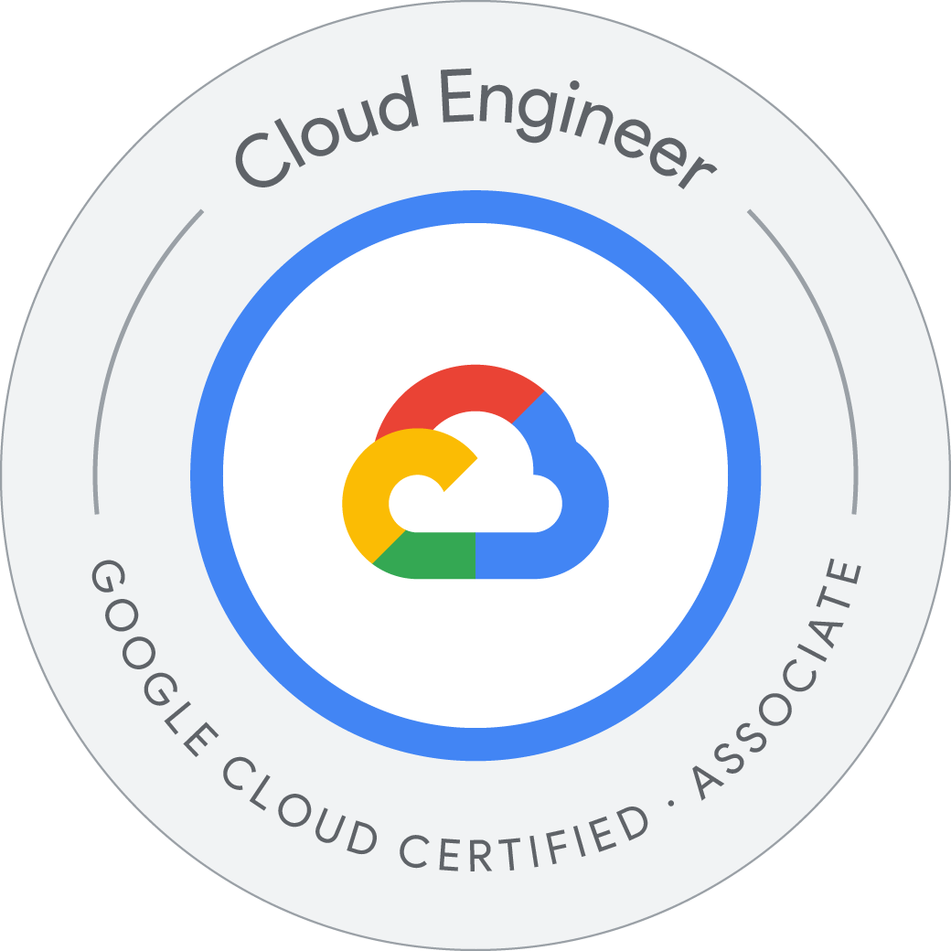 Google ACE   OCI Learning   DevOps
PROFESSIONAL SUMMARY
Cloud engineering fresher with hands-on experience administering AWS and Google Cloud infrastructure - IAM, VPC, DNS, VPN, database migration, load balancing, and Linux operations. AWS Certified Cloud Practitioner and Google Associate Cloud Engineer with a Cybersecurity Engineering foundation and backend automation experience in Python and FastAPI. Currently building working knowledge of Oracle Cloud Infrastructure (OCI) and IBM Cloud to extend existing multi-cloud administration skills.
TECHNICAL SKILLS
Cloud Platforms | Amazon Web Services (AWS), Google Cloud Platform (GCP), Oracle Cloud Infrastructure (OCI - in progress), IBM Cloud (in progress).
Cloud Administration | IAM, VPC/VCN, EC2, Compute Engine, Object and Cloud Storage, Cloud DNS, Route 53, Cloud SQL, Load Balancing, Security Groups, Monitoring.
Automation and IaC | Terraform, Docker, Kubernetes, GitHub Actions, AWS CodePipeline, CI/CD, Bash scripting.
Networking and Security | VPN, HA VPN, Site-to-Site VPN, BGP, SSL/TLS, DNS migration, subnetting, routing, least-privilege access control.
Programming | Python, Bash, FastAPI, REST APIs, Java, PostgreSQL, Linux Administration, Git.
PROFESSIONAL EXPERIENCE
 Cloud Engineer Intern
Cloud Ambassadors, Google Cloud Partner | Jan 2026 - Present
- Provision and administer Compute Engine, Cloud Storage, IAM roles, VPC networks, firewall rules, and secure access policies.
- Support AWS and GCP infrastructure operations across networking, IAM, DNS, load balancing, VPN, and migration workflows, including troubleshooting.
- Configure Cloud DNS and Route 53 records, HTTPS load balancer validation, and SSL/TLS certificate workflows.
- Apply Docker, Kubernetes/GKE, Linux, Git, Bash, and Terraform fundamentals for infrastructure automation.
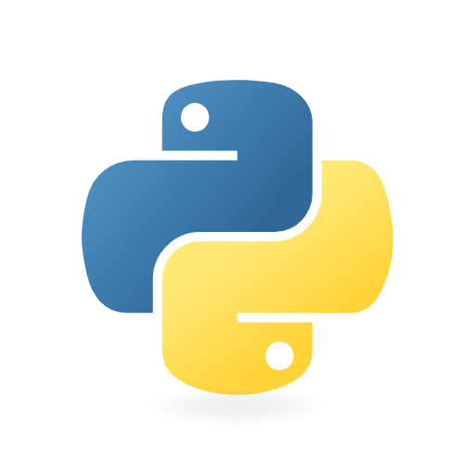 Backend Developer
Chella Corporations | Jul 2025 - Dec 2025
- Developed REST APIs using Python and FastAPI for an AI-driven medical platform.
- Implemented secure authentication, service integration, database integration, and debugging for production systems.
- Deployed and maintained backend services on Linux servers, strengthening cloud operations readiness.
 AI Application Developer Intern
Infosys Springboard | Sep 2025 - Nov 2025
- Built a RAG-based compliance checker for automated document retrieval, analysis, and scoring.
- Integrated GPT-based workflows that improved compliance review efficiency by 70%.

PROJECT HIGHLIGHTS
AWS Route 53 to Google Cloud DNS Migration
Documented a zero-downtime domain migration covering DNS inventory, Cloud DNS zone setup, record replication, NS cutover, validation, and rollback planning.
Private AWS RDS to GCP Cloud SQL Migration
Designed a private PostgreSQL migration using VPC/VGW, HA VPN, IPsec, BGP, Private Services Access, and Database Migration Service.
Private Cloud Storage Behind Load Balancer
Built a private storage access pattern using a global external load balancer with backend bucket validation.
AWS to GCP Site-to-Site VPN
Configured hybrid-cloud VPN connectivity with secure tunnel setup, routing, and validation.
 Swiggy Demo Application Deployment on AWS and Migration to GCP
Created production-style infrastructure with SonarQube, Trivy, and OWASP checks for code quality and image scanning, configured blue-green deployment, and migrated the same pattern to GCP.
CERTIFICATIONS
AWS Certified Cloud Practitioner  Cloud concepts, AWS core services, security, pricing, and support fundamentals. | Google Associate Cloud Engineer  Google Cloud deployment, IAM, networking, and operations foundation.
AWS re/Start Cloud Practitioner - TN Skill Corporation  Grade A+, 98% scorecard; certificate no. TNSC-VN-ITS-AWS-0526-0005. | Google Cloud Digital Leader Learning Path  Cloud transformation, Google Cloud products, data, AI, security, and value.
Google Professional Cloud Architect Learning Path  Cloud architecture, infrastructure design, reliability, operations, and migration planning. | Google Professional Cloud Security Engineering Learning Path  In progress.
EDUCATION
B.E. Cybersecurity Engineering
J.J. College of Engineering and Technology, Anna University | 2022 - 2026 | CGPA: 9.0 / 10

