2012.11.7

吴老师说Romit Roy Choudhury和J.P. hubuax的文章很值得读，很浅，可以挖的东西很多。

另外吴老师推荐了一篇Performance analysis of the IEEE 802.11 distributed coordination function，作为对802.11的解释

下周三我需要讲INFOCOMM2011的PeerCast，这里做点笔记：

作者熊杰：http://www0.cs.ucl.ac.uk/staff/jxiong/pub.html

作者Romit：http://people.ee.duke.edu/~romit/index.html

2012.11.29

今天我审了我的第一篇审稿

#229

ECPC: Preserve Downtime Data Persistence in Disruptive Sensor Networks

Reviewer expertise

Some familiarity

Paper summary

This paper proposes a novel method based on erasure code for preserving data for sensor network in challenging network conditions. They reduce the significant message cost in existing random walk based schemes to O(1) per node via randomly broadcasting casting at serveral power levels. Their main cotribution are : a power distribution obtained from Bayes' Theorem instead of random walk and a distributed erasure code scheme. Their ideas are interesting and simple, and show strong evaluation results.

Paper strengths

(1) power control through Bayes' Theorem

(2) distributed Raptor Code scheme

(3) complete math proof

(4) strong evaluation results

Paper weaknesses

(1) poor article arrangement(a little)

(2) unclear problem statement for both network model and the encoding and decoding of Raptor Codes

(3) too many math symbols

(4) evaluation is not complete(a little)

Comments for author

(1)Arrangement problem : Figure 1 is behind Figure 2, and maybe it's better for you to put the walk-through example after algorithm 3 for reader's understanding, and also I think it's better to detail the example by splitting it into two phases of the Raptor Code.

(2)You should add referernces for terminology in Raptor codes(i.e belief propagation, epsilon, code degree). Also, you should explain what's the difference in 'distributed erasure coding' and normal 'erasure coding' in Related Work or somewhere else.

(3)Unclear problem statement: the problem statement is not very clear: how and when do nodes generate sensor data? And how and when are these data packets collected?

(4)Since you don't care about the battery cosumption, what about a naive(greedy) power scheme? Can it achieve the same result? You could address this in some more evaluation tests.

(5)For completeness, please add time-out events to Algorithm 3 in case for failure. Also Algorithm 3 is a little unclear: will a packet be transmitted mutiple times? (multi-hop), or it's only distributed through its neighbour(from the algorithm it's what I guess)? That's why I want a more complete walk-through example.

(6)ECPC mainly focuses on the message overhead, but in the evaluation, it also shows better performance in data recovery ratio, can you analyze the reason?

2012.12.14

roxanneluoxuan@gmail.com

下学期要问问她傅里叶和实分析的课什么时候上

2012.12.15

开始考虑我的方向

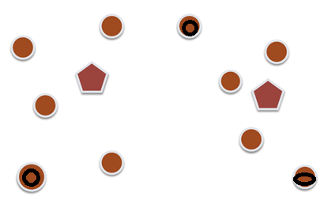

使用场所：会议，办公楼的multicast

Setting:

1.Real-time \ on-demand

2.只有一些节点（一个）会发送视频流

挑战：

1. 丢包率

2．路由（参考SCOOP）

3. 公平性

4. 设备的计算性能和电池

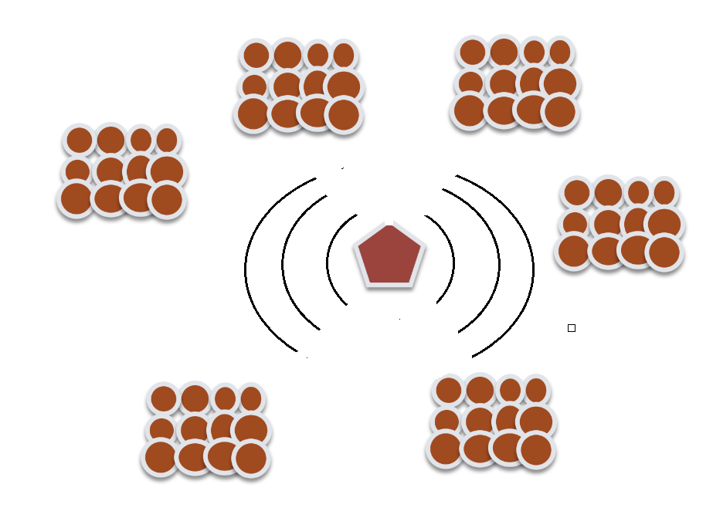

Setting:

球赛，演唱会，学校环境（传单）中的broadcast中的cooperative-delivery（Romit）

就是一个快速大规模的文件发放

是否没用？

1.Real-time \ on-demand

2.只有一个节点会发送信息流

3.接收节点非常非常多

挑战：

1丢包率

2．节点非常非常多如何做合作

3 设备的计算性能和电池