**HAPPY VALENTINES DAY!**

 **ANTIPASTO-APPETIZERS**

PERA 12

Grilled pear with prosciutto and aged cabernet sauvignon Sonoma vinegar glaze

ASPARAGO 16

Pan seared Scallop, prawn with asparagus in a lemon butter sauce

BELLA VITA 12 Heirloom tomato, fresh mozzarella, basil in a balsamic dressing

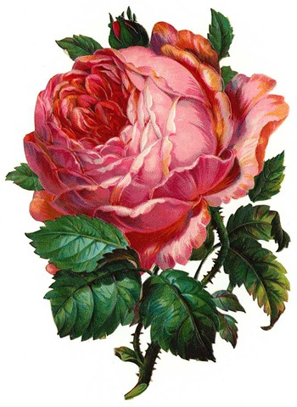

**INSALATE**-**SALADS**

BUTTER LETTUCE 9 Butter lettuce, strawberry

Topped with blue cheese in a mango dressing

TUSCAN KALE 9 Baby kale, baby carrots, shaved grana padana

Cheese fresh Raspberry and raspberry dressing

**SECONDI- EN**T**REE**

PAPPARDELLE 26

Pasta with scallops, prawns, asparagus in a vodka cream sauce

RAVIOLI DI GAMBERI 24

Ravioli stuffed with prawn in creamy vodka, dill and lemon sauce

RAVIOLI CON FUNGHI 18

Pasta stuffed with Portobello mushroom in a creamy gorgonzola sauce topped with walnuts

CANNELONI NAPOLITANO 24

Homemade crapes stuffed with veal, veggie, ricotta and grana cheese topped with mozzarella cheese in a pink sauce

Thank you for dining Bella Vita

[www.dinebellavita.com](http://www.dinebellavita.com)

dine@dinebellavita.com

COTOLETTA DI ANGELO 37

Grilled lamb chops in a black berry sauce served with veggie and polenta cake

CIOPPINO 28

Italian seafood stew in light tomato sauce served with garlic bread

RISOTTO 24

Italian Arborio rice with chicken, oyster mushroom, sun-dried tomato and asparagus in a pink sauce

POLLO ALLA SCAMPI 24

Breast of chicken and prawn sautéed with artichoke, sun-dried tomato, capers and lemon and white wine sauce Served with veggie and mashed potatoes

CERNIA 34

Pan seared fresh wild Grouper with fresh dill, tomato, capers and white wine sauce

Served with veggie and orzo