# Complete_Profile5

1. In following screen images shown with red arrows , require without background.

Currently when we implement it in our screen, screen will be look like given below.

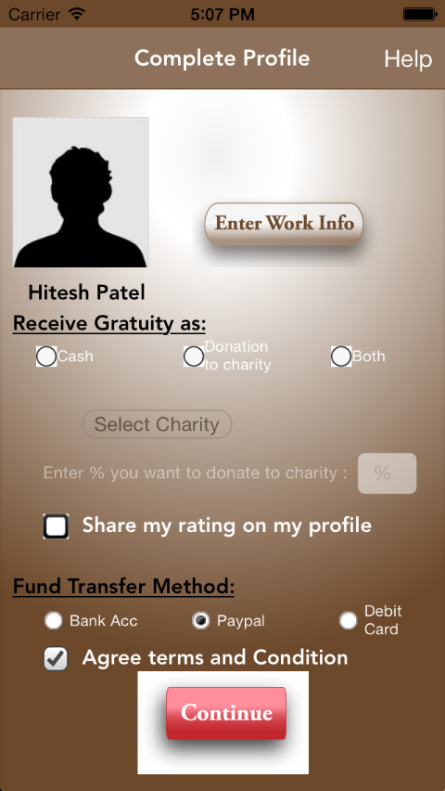

Require label with border,does’ t button image

It display white background

It display white background

It display white background

1. In above screen You send ‘Select Charity’ as button but here it is for label and its value also be changed as per selection(means simple box with border).
2. We require image for selected value for check box and radio button like ‘Paypal’ and ‘Agree terms and conditions in above screen.

# Landmark

1. In given screen we need magnifier icon for search bar.

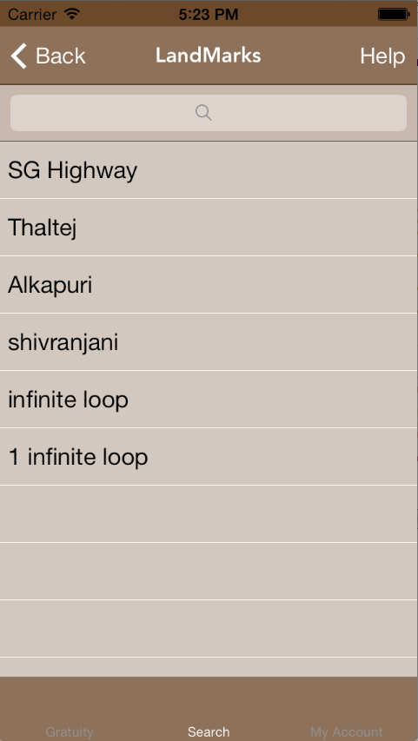

# General

1. We need font style and size for whole application