Project Plan

C# programming language and Visual Studio 2012 software environment.

Windows form for GUI

Visual studio for unit test

Version control system “Git”

Requirement

Choose the file

Appear the name of files

Choose the way you want to rename the filename

Edit the name part and number part.

Save the name.

Choose the files by dragging them into the window.

Choose the files by choosing a folder.

Initial Design



Prefactor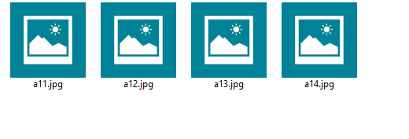



Actualization



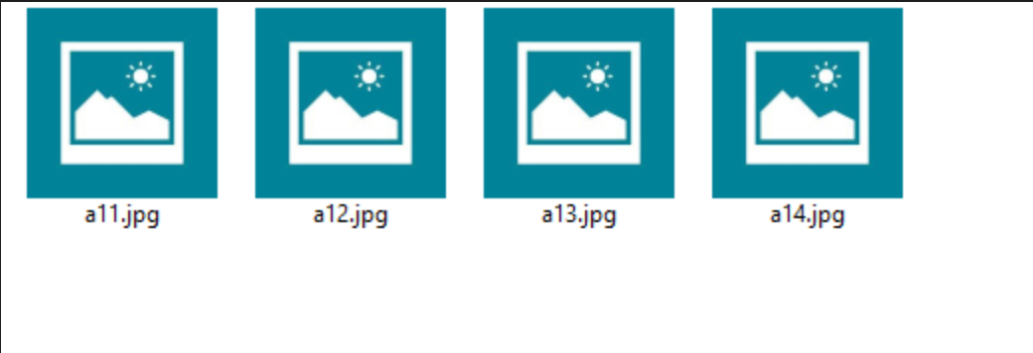

We need to open the changed folder to see whether the name is correct.