W08_Capstone_Report

InGen Dynamics Inc.

Physical AI Data Analytics:
From Robot Telemetry to Operational Insights

8-Week Data Analyst Internship Capstone Report

Prepared by:
Ziqing Yang (Clover)

Position:
Data Analyst Intern

Program Period:
June 22, 2026 – August 14, 2026

Date:
August 2026

Confidentiality Note:
This project uses synthetic and public data only and contains no proprietary
InGen customer or internal operational data.

1. Executive Summary
This report summarizes an eight-week data analysis project completed for InGen Dynamics. The project focused on transforming synthetic physical AI and robotic sensor data into interpretable analytical findings, operational KPIs, automated reports, and dashboard-ready outputs.
The project covered the full data analysis lifecycle, including data quality validation, exploratory data analysis, statistical testing, clustering, time-series feature extraction, machine learning feature importance, automated reporting, KPI design, and dashboard development.
Three major findings emerged from the analysis.
First, Aido Rover operating status was not driven by one dominant sensor feature. Battery rolling mean ranked first in the Random Forest model with an importance score of 0.0706, followed by battery rolling standard deviation at 0.0703. However, the top-ranked values were close together, indicating that Rover health depends on several complementary temporal, rate-of-change, and wheel-torque frequency features.
Second, Fari interaction quality was more concentrated in a small number of features. Response length accounted for 38.47% of feature importance, while sentiment score accounted for 29.55%. Together, these two variables represented approximately 68% of the model's total importance. The Fari classification model achieved approximately 88% test accuracy.
Third, the automated reporting pipeline identified 600 high-risk Rover timesteps based on a composite anomaly score. The pipeline converted raw sensor records into KPI summaries, anomaly tables, charts, and a structured Markdown report.
The primary recommendation is to maintain a clear separation between data processing and presentation. Analytical notebooks should generate validated, pre-computed outputs that can be consumed by dashboards and operational reporting tools. Future work should connect this architecture to real telemetry streams, persistent databases, and automated alerting.
Key Finding: The project demonstrated that physical AI data becomes operationally valuable only when data quality, analytical evidence, and decision-oriented reporting are connected in one reproducible workflow.

2. Project Context and Objectives

2.1 InGen Dynamics Platform Context
Aido Rover: outdoor patrol and mobile robotics telemetry
Fari: human–robot interaction and companion AI sessions
Sentinel Prime AI: security event and monitoring data
Senpai: education and learner interaction data
Aido Humanoid: joint movement and motion mode data
Origami AI / PIC 2.0: physical intelligence platform context

2.2 Project Objectives
The project had four objectives:
1. Establish a production-oriented data quality and EDA workflow.
2. Identify statistical and behavioral patterns in robotic telemetry.
3. Extract informative time-series and frequency-domain features.
4. Build automated reporting and dashboard-ready outputs for stakeholders.
Finding: Different InGen platforms require different data and KPI strategies, but all rely on the same foundation of validated, reproducible data.

3. Data and Data Quality

3.1 Aido Rover Dataset
The primary dataset contained 12,000 timestamped synthetic Aido Rover telemetry records.

The fields included:
- Timestamp
- Latitude
- Longitude
- LiDAR distance
- Battery state of charge
- Four wheel-torque channels
- Temperature
- Operating status: normal, warning, or fault

3.2 Data Quality Checks
• Row and column count
• Missing values
• Data types
• Duplicate records
• Battery range
• Negative LiDAR values
• Status distribution
• Sensor outliers

3.3 Known Quality Issues
The synthetic telemetry intentionally included realistic quality problems:
- Approximately 3% GPS dropout
- LiDAR saturation events
- Random torque noise spikes
- Rolling-window missing values at the beginning of derived features

Numeric missing values were interpolated using time-series-aware interpolation. Physical range checks were completed before visual or statistical analysis. Rows without complete rolling-window features were removed only at the model-training stage.

Finding: GPS dropout, LiDAR saturation, and wheel-torque spikes could invalidate downstream analysis if they were not identified and handled before modeling.

4. Exploratory Data Analysis
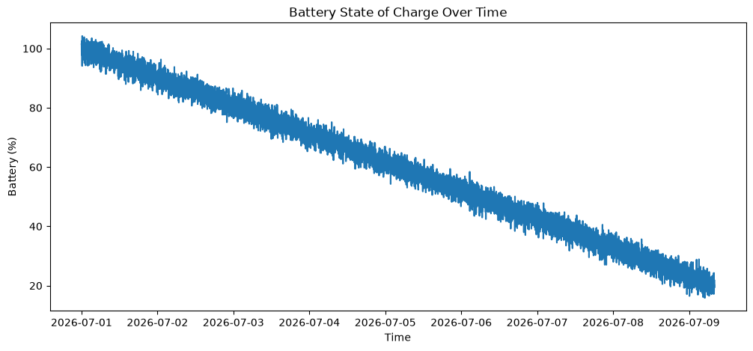
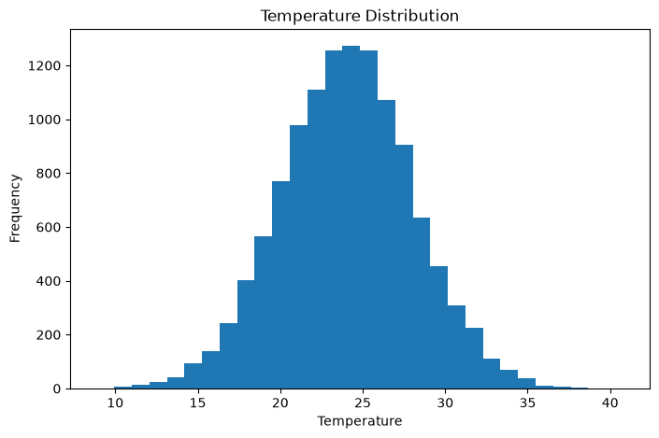
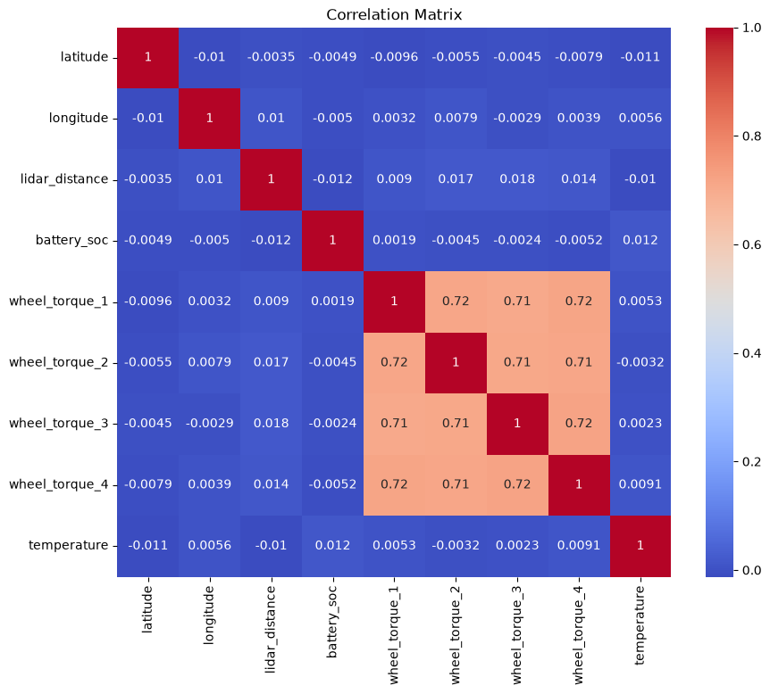
EDA was used to understand the distribution, stability, and relationship of Rover sensor variables.
Battery state of charge showed local variation over time, while LiDAR data included saturation-like values. Wheel-torque distributions differed across operating status categories, supporting further investigation through statistical tests and feature engineering.
The correlation analysis helped identify redundant variables and informed the feature set used in later clustering and regression analysis.

Finding: The EDA showed that Rover status is associated with a combination of battery behavior, LiDAR variation, and torque patterns rather than a single isolated measurement.

5. Statistical Analysis
The regression was used as an interpretability exercise rather than a production forecasting model.
Finding: Statistical testing provided evidence that selected Rover sensor behaviors differed across operating conditions, although the practical usefulness of each relationship depended on effect size and model fit.

6. Segmentation and Clustering

6.1 Feature Preparation
Highly redundant features were removed, and the remaining numeric variables were standardized using StandardScaler.

6.2 K-Means Selection
Best k = 4
The number of clusters was selected using both the elbow method and silhouette score. A value of k = 4 provided the best balance between compactness and interpretability.
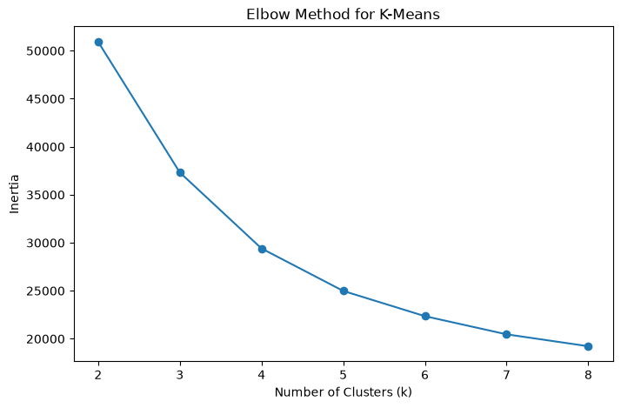
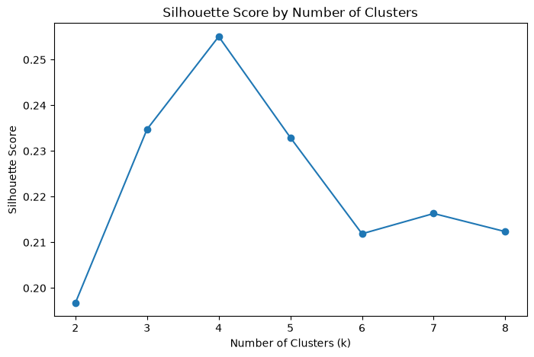
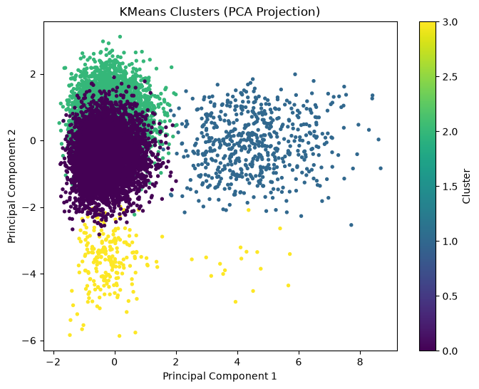

6.3 DBSCAN Comparison
DBSCAN was evaluated using the same standardized feature set. The comparison considered the number of clusters, the share of noise samples, and the silhouette score of non-noise observations.

K-Means was more useful for this synthetic operational-mode task because it produced clearer and more complete cluster assignments. DBSCAN remained useful for identifying isolated or unusual observations.

Finding: K-Means identified four interpretable Rover operating modes and provided clearer segmentation than DBSCAN for the synthetic telemetry dataset.

7. CV-Informed Feature Engineering

7.1 Feature Types
Feature Type | Sensor Application | Computer Vision Parallel
Rolling mean | Local battery/LiDAR level | Smoothing filter
Rolling standard deviation | Local instability | Texture descriptor
Rate of change | Rapid sensor transition | Edge detection
FFT dominant frequency | Repeated torque cycles | Frequency-domain texture
Spectral power | Strength of periodic variation | Frequency energy
Composite anomaly score | Combined instability | Multi-feature anomaly map

7.2 Aido Rover Results
Rank | Feature | Importance
1 | battery_rolling_mean | 0.070588
2 | battery_rolling_std | 0.070319
3 | lidar_rolling_mean | 0.067617
4 | lidar_abs_rate_change | 0.067353
5 | lidar_rolling_std | 0.067307
6 | wheel_torque_3_spectral_power | 0.066807
7 | battery_abs_rate_change | 0.066522
8 | lidar_rate_of_change | 0.066149
9 | battery_rate_of_change | 0.065223
10 | wheel_torque_2_spectral_power | 0.064112

The feature importance distribution was relatively flat. Battery rolling mean ranked first, but it did not dominate the model. The result suggests that physical robot status is represented by several complementary sensor behaviors.

7.3 Fari Results
Rank | Feature | Importance
1 | response_length | 0.384714
2 | sentiment_score | 0.295451
3 | topic_coherence | 0.156744
4 | latency_ms | 0.096397
5 | session_duration | 0.066693

The Fari model achieved approximately 88% test accuracy. Unlike the Rover model, importance was concentrated in the top two predictors. Response length and sentiment together accounted for approximately 68% of total importance.

Because the Fari data and quality label were synthetic, the result should be interpreted as a pipeline demonstration rather than evidence about real users.

Finding: Rover health required multiple complementary temporal and frequency features, while Fari interaction quality was concentrated primarily in response length and sentiment.

8. Automated Reporting Pipeline
Raw CSV
↓
ingest()
↓
create_features()
↓
compute_health_kpis()
↓
compute_anomaly_summary()
↓
generate_summary_table()
↓
generate_charts()
↓
generate_report()

The reported fault rate was 0.0 in the final pipeline output. This reflects the specific cleaned synthetic dataset and status values used in the reporting run. It should not be interpreted as evidence of zero production risk.

Finding: The reporting pipeline successfully converted raw telemetry into reproducible KPIs, anomaly summaries, charts, and a structured report without manual calculation.

9. KPI Framework
Platform | KPI 1 | KPI 2 | Primary Decision
Aido Rover | Fleet fault rate | Battery health score | Maintenance and charging
Sentinel Prime AI | Alert frequency | Critical-event rate | Patrol scheduling
Fari | Interaction quality score | Response latency | Conversation improvement
Senpai | Session completion rate | Engagement score | Learning design
Aido Humanoid | Motion stability score | Mode distribution | Motion-control review

Each KPI included five elements:
1. Name
2. Operational definition
3. Measurement method
4. Update frequency
5. Decision link

Finding: A KPI is only actionable when its calculation is connected to a specific operational decision.

10. Dashboard Overview

10.1 Fleet Health Overview
- Average battery SoC
- Fault rate
- Mean LiDAR distance
- High-risk anomaly count
- Battery and anomaly charts

10.2 Feature Intelligence View
- Rover Top 10 features
- Fari feature importance
- Platform comparison

10.3 KPI Monitoring View
- Five-platform KPI list
- Update frequency
- Threshold and decision link

Finding: The dashboard design translated the same analytical outputs into different levels of detail for analysts, product managers, and executives.

11. Limitations

11.1 Synthetic Data
The datasets were synthetic and do not fully represent production robot behavior, customer diversity, or real operating environments.

11.2 Synthetic Labels
The Fari quality label was generated from a predefined formula. The model therefore learned patterns partly determined by the data-generation assumptions.

11.3 Feature Importance
Random Forest importance measures predictive contribution, not causation.

11.4 Window Size
Only one rolling window of 20 timesteps was evaluated.

11.5 Reporting Threshold
The anomaly threshold used the 95th percentile and was not validated against real maintenance outcomes.

11.6 Dashboard Environment
The local dashboard encountered dependency compatibility issues and was not deployed to a production server.

Finding: The analytical workflow is reproducible, but all numerical conclusions require validation on real telemetry and operational outcomes.

12. Recommendations and Next Steps

Short-Term
- Standardize data schemas
- Add automated data quality alerts
- Test rolling windows of 10, 20, 50
- Add confusion matrices and class-specific metrics
- Improve dependency management in requirements.txt

Medium-Term
- Use SHAP for local model explanation
- Connect the pipeline to a database
- Schedule daily report generation
- Define KPI thresholds with engineering teams
- Deploy dashboard in a stable cloud environment

Long-Term
- Use real-time streaming telemetry
- Build predictive-maintenance labels
- Add alert notification workflow
- Compare multiple model families
- Validate KPIs against business and maintenance outcomes

Finding: The highest-priority next step is replacing static synthetic inputs with validated real-time telemetry and operational labels.

13. Conclusion
The eight-week internship project delivered an end-to-end data analysis workflow for physical AI and robotic data.
The work began with platform and data landscape research, followed by synthetic telemetry generation, data quality validation, exploratory analysis, statistical testing, clustering, and sensor feature engineering. Random Forest models were then used to evaluate feature importance for both Aido Rover operating status and Fari interaction quality.
The project also moved beyond isolated notebook analysis. A reusable reporting pipeline was created to calculate fleet-health KPIs, identify high-risk periods, generate charts, and produce a structured report. These outputs were then organized into a dashboard design for multiple stakeholder personas.
The most important technical finding was that Rover health depends on several complementary sensor behaviors rather than one dominant feature. The most important business lesson was that analytical outputs must be connected to a clear decision. A model score, chart, or KPI has limited value unless stakeholders understand what action it should support.
The final repository provides a reproducible foundation for future work involving real telemetry, real-time monitoring, production deployment, and decision-oriented physical AI analytics.
Final Finding: The project successfully transformed raw synthetic telemetry into validated findings, predictive features, operational KPIs, automated reports, and dashboard-ready outputs.

