**Yi Ma**

**Homework 7**

1. Estimate the two-equation SUR system for hourly wage and hourly benefits using FGLS to achieve results identical to those in Table 7.1 in the text.

The results from Table 7.1 in the text is shown below:

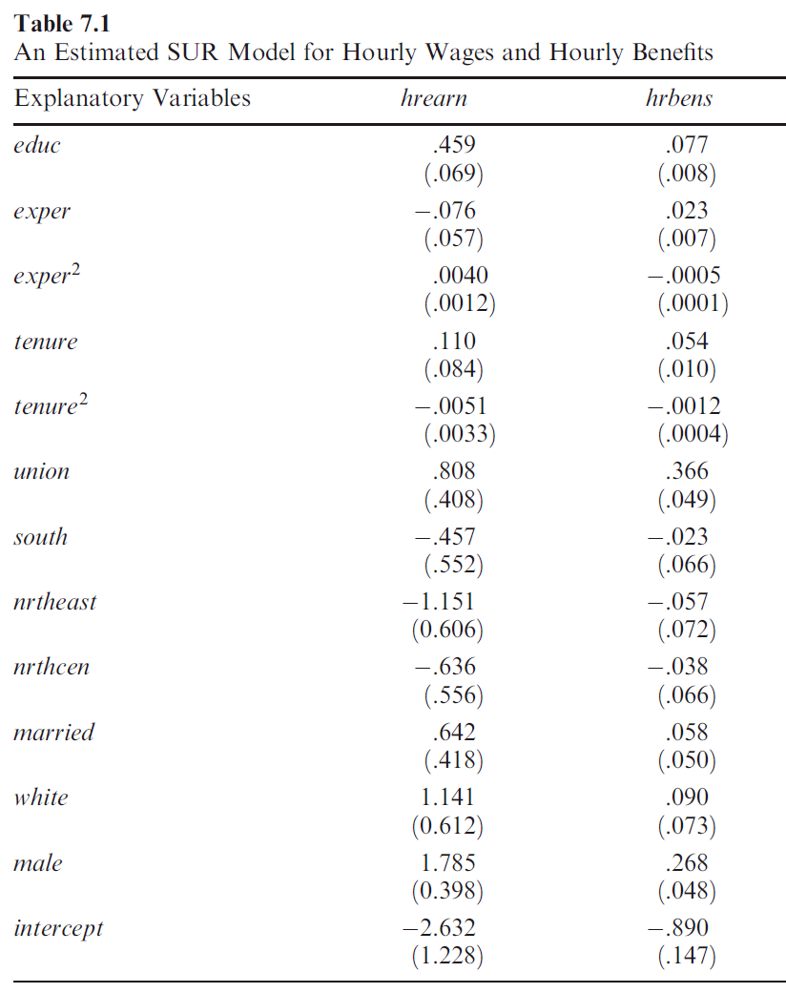

The results from FGLS in R is shown below:

systemfit results

method: SUR

SUR estimates for 'earnings' (equation 1)

Model Formula: hrearn ~ educ + exper + expersq + tenure + tenuresq + union +

south + nrtheast + nrthcen + married + white + male

Estimate Std. Error t value Pr(>|t|)

(Intercept) -2.63212671 1.22832151 -2.14286 0.0325236 *

educ 0.45881395 0.06912628 6.63733 7.1256e-11 ***

exper -0.07584282 0.05734542 -1.32256 0.1864828

expersq 0.00399449 0.00117795 3.39104 0.0007418 ***

tenure 0.11008462 0.08380979 1.31351 0.1895122

tenuresq -0.00507064 0.00327692 -1.54738 0.1222965

union 0.80799328 0.40780495 1.98132 0.0480089 *

south -0.45662223 0.55170344 -0.82766 0.4081912

nrtheast -1.15075861 0.60575425 -1.89971 0.0579478 .

nrthcen -0.63626628 0.55604484 -1.14427 0.2529651

married 0.64238821 0.41779850 1.53756 0.1246820

white 1.14089121 0.61193899 1.86439 0.0627530 .

male 1.78470236 0.39800745 4.48409 8.7674e-06 ***

---

SUR estimates for 'benefits' (equation 2)

Model Formula: hrbens ~ educ + exper + expersq + tenure + tenuresq + union +

south + nrtheast + nrthcen + married + white + male

Estimate Std. Error t value Pr(>|t|)

(Intercept) -0.889747099 0.146883282 -6.05751 2.4342e-09 ***

educ 0.076792360 0.008266154 9.28997 < 2.22e-16 ***

exper 0.022564931 0.006857393 3.29060 0.0010581 **

expersq -0.000473359 0.000140860 -3.36049 0.0008272 ***

tenure 0.053555571 0.010022015 5.34379 1.2924e-07 ***

tenuresq -0.001163631 0.000391856 -2.96954 0.0031010 **

union 0.365908540 0.048765513 7.50343 2.2404e-13 ***

south -0.022686547 0.065972964 -0.34388 0.7310591

nrtheast -0.056746823 0.072436387 -0.78340 0.4336986

nrthcen -0.037998394 0.066492111 -0.57147 0.5678925

married 0.057862604 0.049960547 1.15817 0.2472548

white 0.090158182 0.073175962 1.23207 0.2184017

male 0.268338264 0.047593923 5.63808 2.6438e-08 ***

---

The above results show that they produce identical outcomes.

1. Estimate the same two-equation SUR system using SOLS.

systemfit results

method: OLS

OLS estimates for 'earnings' (equation 1)

Model Formula: hrearn ~ educ + exper + expersq + tenure + tenuresq + union +

south + nrtheast + nrthcen + married + white + male

Estimate Std. Error t value Pr(>|t|)

(Intercept) -2.63212671 1.22832151 -2.14286 0.0325236 *

educ 0.45881395 0.06912628 6.63733 7.1256e-11 ***

exper -0.07584282 0.05734542 -1.32256 0.1864828

expersq 0.00399449 0.00117795 3.39104 0.0007418 ***

tenure 0.11008462 0.08380979 1.31351 0.1895122

tenuresq -0.00507064 0.00327692 -1.54738 0.1222965

union 0.80799328 0.40780495 1.98132 0.0480089 *

south -0.45662223 0.55170344 -0.82766 0.4081912

nrtheast -1.15075861 0.60575425 -1.89971 0.0579478 .

nrthcen -0.63626628 0.55604484 -1.14427 0.2529651

married 0.64238821 0.41779850 1.53756 0.1246820

white 1.14089121 0.61193899 1.86439 0.0627530 .

male 1.78470236 0.39800745 4.48409 8.7674e-06 ***

---

OLS estimates for 'benefits' (equation 2)

Model Formula: hrbens ~ educ + exper + expersq + tenure + tenuresq + union +

south + nrtheast + nrthcen + married + white + male

Estimate Std. Error t value Pr(>|t|)

(Intercept) -0.889747099 0.146883282 -6.05751 2.4342e-09 ***

educ 0.076792360 0.008266154 9.28997 < 2.22e-16 ***

exper 0.022564931 0.006857393 3.29060 0.0010581 **

expersq -0.000473359 0.000140860 -3.36049 0.0008272 ***

tenure 0.053555571 0.010022015 5.34379 1.2924e-07 ***

tenuresq -0.001163631 0.000391856 -2.96954 0.0031010 **

union 0.365908540 0.048765513 7.50343 2.2404e-13 ***

south -0.022686547 0.065972964 -0.34388 0.7310591

nrtheast -0.056746823 0.072436387 -0.78340 0.4336986

nrthcen -0.037998394 0.066492111 -0.57147 0.5678925

married 0.057862604 0.049960547 1.15817 0.2472548

white 0.090158182 0.073175962 1.23207 0.2184017

male 0.268338264 0.047593923 5.63808 2.6438e-08 ***

---

1. Comment on the relationship between the above two sets of results.

The above two sets of results is an example where SOLS and FGLS are identical. There are two situations where SOLS and FGLS are identical. 1) if omega-hat is a diagonal matrix; 2) if, for every observation, the same regressors show up in every equation. The two sets of results above satisfy these two conditions.

1. Disaggregate the hourly benefits variable into its four components:

* Value of vacation days
* Value of sick leave
* Value of employer-provided insurance
* Value of pension

Estimate a SUR model of this five-equation system.

systemfit results

method: SUR

SUR estimates for 'vacation' (equation 1)

Model Formula: hrvacdays ~ educ + exper + expersq + tenure + tenuresq + union +

south + nrtheast + nrthcen + married + white + male

Estimate Std. Error t value Pr(>|t|)

(Intercept) -1.84235e-01 3.96213e-02 -4.64989 4.0834e-06 ***

educ 2.01829e-02 2.22977e-03 9.05156 < 2.22e-16 ***

exper 6.64930e-03 1.84976e-03 3.59468 0.00035135 ***

expersq -1.49186e-04 3.79966e-05 -3.92631 9.6216e-05 ***

tenure 1.23860e-02 2.70341e-03 4.58162 5.6093e-06 ***

tenuresq -2.15548e-04 1.05702e-04 -2.03921 0.04186485 *

union 6.37464e-02 1.31544e-02 4.84603 1.6039e-06 ***

south -1.79005e-02 1.77960e-02 -1.00587 0.31488065

nrtheast -1.69824e-02 1.95395e-02 -0.86913 0.38512192

nrthcen 2.51051e-04 1.79361e-02 0.01400 0.98883702

married 2.27586e-02 1.34767e-02 1.68874 0.09178702 .

white 8.48687e-03 1.97390e-02 0.42995 0.66738237

male 5.69525e-02 1.28383e-02 4.43614 1.0888e-05 ***

---

SUR estimates for 'sickleave' (equation 2)

Model Formula: hrsicklve ~ educ + exper + expersq + tenure + tenuresq + union +

south + nrtheast + nrthcen + married + white + male

Estimate Std. Error t value Pr(>|t|)

(Intercept) -9.37606e-02 1.62271e-02 -5.77803 1.2121e-08 ***

educ 9.60544e-03 9.13213e-04 10.51829 < 2.22e-16 ***

exper 2.14499e-03 7.57578e-04 2.83138 0.0047894 **

expersq -3.82570e-05 1.55617e-05 -2.45841 0.0142354 *

tenure 5.00207e-03 1.10719e-03 4.51780 7.5205e-06 ***

tenuresq -1.39104e-04 4.32907e-05 -3.21325 0.0013824 **

union -4.66553e-03 5.38742e-03 -0.86600 0.3868323

south -1.19420e-02 7.28844e-03 -1.63848 0.1018432

nrtheast -2.66511e-03 8.00249e-03 -0.33303 0.7392236

nrthcen -2.22014e-02 7.34579e-03 -3.02233 0.0026148 **

married 3.83380e-03 5.51945e-03 0.69460 0.4875745

white 3.86350e-03 8.08420e-03 0.47791 0.6328891

male 4.25383e-03 5.25799e-03 0.80902 0.4188218

---

SUR estimates for 'insurance' (equation 3)

Model Formula: hrinsur ~ educ + exper + expersq + tenure + tenuresq + union +

south + nrtheast + nrthcen + married + white + male

Estimate Std. Error t value Pr(>|t|)

(Intercept) -1.18082e-01 4.48636e-02 -2.63203 0.00870496 **

educ 8.00420e-03 2.52479e-03 3.17024 0.00160035 **

exper 5.40522e-03 2.09450e-03 2.58067 0.01009616 *

expersq -1.26561e-04 4.30239e-05 -2.94164 0.00339007 **

tenure 1.16978e-02 3.06110e-03 3.82145 0.00014643 ***

tenuresq -2.46647e-04 1.19688e-04 -2.06076 0.03975416 *

union 1.44154e-01 1.48948e-02 9.67811 < 2.22e-16 ***

south 1.96786e-02 2.01506e-02 0.97657 0.32917143

nrtheast -5.25635e-03 2.21248e-02 -0.23758 0.81228950

nrthcen 2.42515e-02 2.03092e-02 1.19411 0.23290279

married 3.65441e-02 1.52598e-02 2.39479 0.01693391 *

white 3.78883e-02 2.23507e-02 1.69518 0.09055839 .

male 1.12006e-01 1.45370e-02 7.70490 5.4179e-14 ***

---

SUR estimates for 'pension' (equation 4)

Model Formula: hrpension ~ educ + exper + expersq + tenure + tenuresq + union +

south + nrtheast + nrthcen + married + white + male

Estimate Std. Error t value Pr(>|t|)

(Intercept) -4.92834e-01 7.12776e-02 -6.91429 1.2014e-11 ***

educ 3.90226e-02 4.01129e-03 9.72819 < 2.22e-16 ***

exper 8.37915e-03 3.32767e-03 2.51803 0.0120593 *

expersq -1.59506e-04 6.83548e-05 -2.33350 0.0199494 *

tenure 2.43758e-02 4.86335e-03 5.01214 7.0843e-07 ***

tenuresq -5.59692e-04 1.90155e-04 -2.94335 0.0033717 **

union 1.62140e-01 2.36643e-02 6.85169 1.8059e-11 ***

south -1.30816e-02 3.20145e-02 -0.40862 0.6829670

nrtheast -3.23117e-02 3.51510e-02 -0.91923 0.3583446

nrthcen -4.08177e-02 3.22664e-02 -1.26502 0.2063528

married -5.17554e-03 2.42442e-02 -0.21348 0.8310283

white 3.95839e-02 3.55099e-02 1.11473 0.2654100

male 9.52459e-02 2.30958e-02 4.12395 4.2469e-05 ***

---

SUR estimates for 'earnings' (equation 5)

Model Formula: hrearn ~ educ + exper + expersq + tenure + tenuresq + union +

south + nrtheast + nrthcen + married + white + male

Estimate Std. Error t value Pr(>|t|)

(Intercept) -2.63212671 1.22832151 -2.14286 0.0325236 *

educ 0.45881395 0.06912628 6.63733 7.1256e-11 ***

exper -0.07584282 0.05734542 -1.32256 0.1864828

expersq 0.00399449 0.00117795 3.39104 0.0007418 ***

tenure 0.11008462 0.08380979 1.31351 0.1895122

tenuresq -0.00507064 0.00327692 -1.54738 0.1222965

union 0.80799328 0.40780495 1.98132 0.0480089 *

south -0.45662223 0.55170344 -0.82766 0.4081912

nrtheast -1.15075861 0.60575425 -1.89971 0.0579478 .

nrthcen -0.63626628 0.55604484 -1.14427 0.2529651

married 0.64238821 0.41779850 1.53756 0.1246820

white 1.14089121 0.61193899 1.86439 0.0627530 .

male 1.78470236 0.39800745 4.48409 8.7674e-06 ***

---

1. Test whether marital status has an effect on any of the five forms of compensation.

Linear hypothesis test (F statistic of a Wald test)

Hypothesis:

vacation_married = 0

sickleave_married = 0

insurance_married = 0

pension_married = 0

earnings_married = 0

Model 1: restricted model

Model 2: res.FGLS

Res.Df Df F Pr(>F)

1 3020

2 3015 5 2.8354 0.01468 *

---

Signif. codes: 0 ‘***’ 0.001 ‘**’ 0.01 ‘*’ 0.05 ‘.’ 0.1 ‘ ’ 1

The F test shows that marital status has effect on at least on of the five forms of compensation. According to the result from part e, marital status only has effect on hrinsur (.037 with t=2. 42). It is also almost significant for the effect on hrvacdays.

1. Test whether another year of education increases expected pension value and expected insurance by the same amount.

Linear hypothesis test (F statistic of a Wald test)

Hypothesis:

pension_educ - earnings_educ = 0

Model 1: restricted model

Model 2: res.FGLS

Res.Df Df F Pr(>F)

1 3016

2 3015 1 37.979 8.101e-10 ***

---

Signif. codes: 0 ‘***’ 0.001 ‘**’ 0.01 ‘*’ 0.05 ‘.’ 0.1 ‘ ’ 1

The linear hypothesis command tests whether another year of education has the same effect on hrpension and hrinsur. The f statistic is 37.979 > 10 and the p-value is close to zero. The estimate in the hrpension equation (with standard error) is .039 (. 004) while the estimate in the hrinsur equation is .008 (. 003). Thus, each is positive and statistically significant, and they are significantly different from one another.