SIEM Home Lab

Splunk Enterprise – Threat Detection & Alert Engineering

Prepared by | Cameron Lowe
SIEM Platform | Splunk Enterprise 10.2.1
Log Source | Windows Server 2022 – Active Directory Domain Controller (LAB-DC01.lab.local)
Detection Rules | 3 custom alerts – Brute Force, New User Account, Privileged Group Change
Framework Alignment | NIST CSF · NIST SP 800-53 · MITRE ATT&CK
Validation | Live triggered alerts confirmed in Splunk Activity log
Document Version | 1.0 – Full evidence release

This lab book documents the end-to-end build of a functional home SIEM environment. All detections were developed using real Windows Security event logs from an Active Directory domain controller, tested against live attack simulations, and validated through Splunk's triggered alerts pipeline.

Overview & Lab Architecture
This lab demonstrates the practical implementation of a Security Information and Event Management (SIEM) system in a home lab environment. Using Splunk Enterprise installed directly on an Active Directory domain controller, Windows Security event logs were ingested, parsed, and used to build three detection rules aligned to real-world SOC use cases.

Component | Technology | Detail
SIEM Platform | Splunk Enterprise 10.2.1 | Installed on LAB-DC01, accessible via localhost:8000
Log Source | Windows Security Event Log | WinEventLog:Security – ingested via local event log collection
Domain | Active Directory – lab.local | Domain controller LAB-DC01 generating authentication and IAM events
Detection Rules | 3 SPL-based alerts | Brute Force, New User Account, Privileged Group Membership Change
Validation | Live triggered alerts | Real-time alerts confirmed firing in Splunk Activity log

Why These Detections
The three detections selected represent the highest-frequency alert categories in enterprise SOC environments. Failed logon monitoring addresses credential-based attacks (MITRE T1110). User account creation monitoring detects persistence techniques (MITRE T1136). Group membership monitoring detects privilege escalation (MITRE T1098). All three are foundational to any security monitoring program.

Phase 1 – Environment Setup
Splunk Enterprise 10.2.1 was downloaded and installed on the Windows Server 2022 Active Directory domain controller (LAB-DC01). Using the existing AD infrastructure — already configured with Organizational Units, user accounts, and security groups — as the log source maximizes detection relevance by generating authentication, account management, and group membership events from the first moment of operation.

Splunk Installation
Step | Action | Outcome
1 | Downloaded Splunk Enterprise 10.2.1 Windows 64-bit .msi | Installer file confirmed via Splunk download portal
2 | Ran installer – accepted license, default path C:\Program Files\Splunk | Splunk Enterprise installed successfully
3 | Splunk service started automatically post-install | Web UI accessible at http://localhost:8000
4 | Logged in as Administrator | Splunk Enterprise home dashboard confirmed operational
5 | Added Windows Security log via Settings → Add Data → Monitor → Local Event Logs | WinEventLog:Security input created successfully

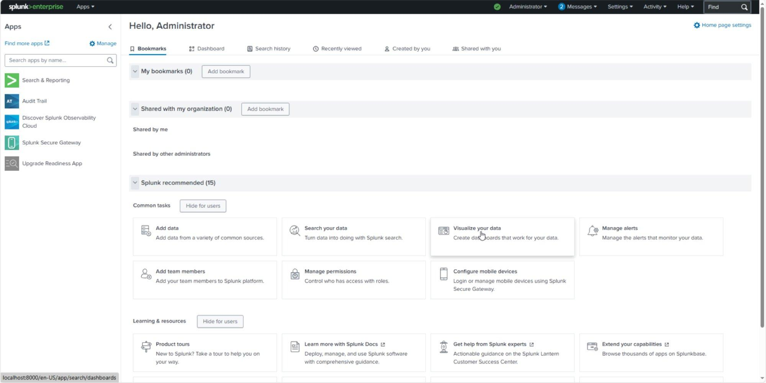
Figure 1.1 – Splunk Enterprise 10.2.1 home dashboard: Administrator logged in, Search & Reporting and Audit Trail apps active, running at localhost:8000 on LAB-DC01

Log Source Verification
Following data input configuration, a verification search confirmed Windows Security events were actively flowing into Splunk from the LAB-DC01 domain controller. Event codes observed immediately included 4624 (successful logon), 4634 (logoff), and 4672 (special privileges assigned to new logon) — all high-value authentication events.
SPL Verification Search:
index=main source="WinEventLog:Security" | head 20

Result: 20 events returned from LAB-DC01.lab.local
Event codes observed: 4624 (Logon), 4634 (Logoff), 4672 (Privilege use)

Phase 1 – NIST Alignment
Framework | Control | Description
NIST CSF | Identify (ID.AM) | Asset management – log source identified and ingestion confirmed
NIST SP 800-53 | AU-2 | Audit Events – Windows Security log selected as primary audit source
NIST SP 800-53 | SI-4 | System Monitoring – SIEM operational, continuous log ingestion active

Detection 1 – Brute Force / Multiple Failed Logons
MITRE ATT&CK: T1110 – Brute Force | Severity: Critical | Alert Type: Real-time, Per Result

Failed authentication events are one of the most reliable indicators of credential-based attacks. Windows Security EventCode 4625 is generated for every failed logon attempt, regardless of whether the account exists. This detection monitors all 4625 events in real-time, alerting on each occurrence to enable rapid investigation of potential password spraying, brute force, or credential stuffing activity against domain accounts.

SPL Detection Query
index=main source="WinEventLog:Security" EventCode=4625
| stats count by Account_Name, IpAddress, ComputerName
| where count >= 5
| sort -count

Analysis query groups failed logons by account and source IP,
surfacing accounts with 5+ failures as priority investigation targets.

Test & Validation
A controlled brute force simulation was performed by deliberately entering incorrect credentials for the domain account jsmith multiple times from the LAB-DC01 console. This generated 7 EventCode 4625 events within seconds, confirming the detection pipeline was capturing failed authentication activity from the domain controller security log.
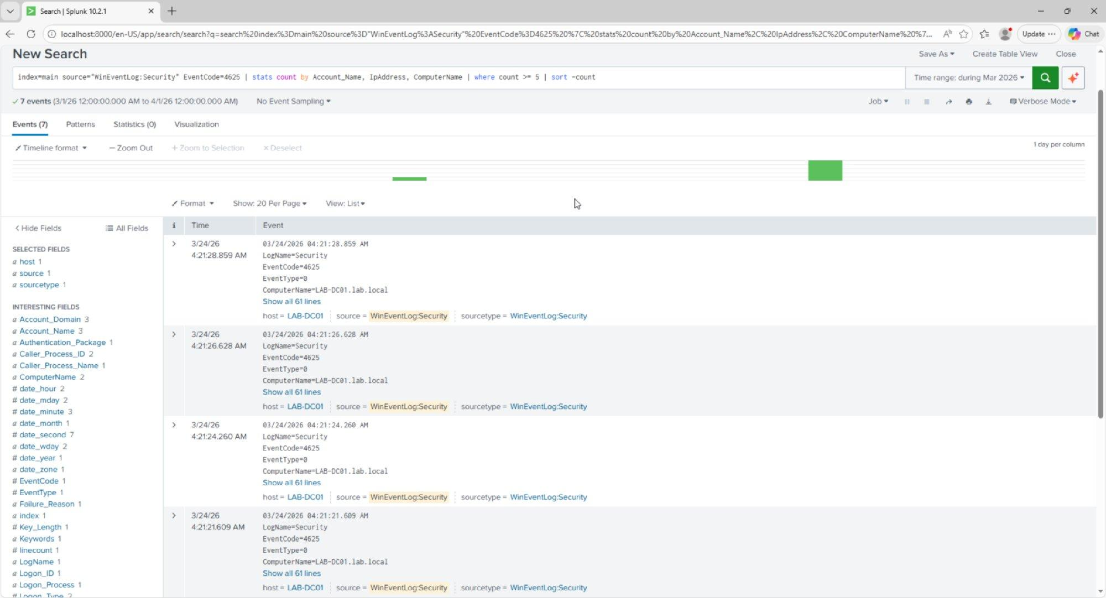
Figure 2.1 – Brute force detection results: 7 EventCode 4625 failed logon events captured from LAB-DC01.lab.local during controlled simulation. Event fields include Account_Name, ComputerName, and Failure_Reason.

Alert Configuration
Alert Name: Brute Force - Multiple Failed Logons
Alert Type: Real-time
Trigger: Per Result (fires on every 4625 event)
Severity: Critical
Action: Add to Triggered Alerts
Description: Detects accounts with 5 or more failed logon attempts (EventCode 4625)
within the last hour. Indicates potential brute force or password spray
attack. Maps to MITRE ATT&CK T1110 - Brute Force.

Event Field | Value Observed | Significance
EventCode | 4625 | Windows failed logon – universal brute force indicator
Account_Name | jsmith | Target account under attack
ComputerName | LAB-DC01.lab.local | Domain controller receiving authentication requests
Failure_Reason | Unknown user name or bad password | Credential failure confirmed
LogName | Security | Windows Security audit log – highest fidelity source

Detection 1 – NIST & MITRE Alignment
Framework | Control | Description
MITRE ATT&CK | T1110 – Brute Force | Password guessing and spraying against domain accounts
NIST CSF | Detect (DE.CM) | Continuous monitoring – real-time alert on every failed logon
NIST SP 800-53 | AC-7 | Unsuccessful Logon Attempts – detect and respond to repeated failures
NIST SP 800-53 | SI-4 | System Monitoring – automated alerting on anomalous authentication events

Detection 2 – New User Account Created
MITRE ATT&CK: T1136 – Create Account | Severity: High | Alert Type: Real-time, Per Result

Unauthorized account creation is a common persistence technique used by attackers to maintain access after initial compromise. Windows Security EventCode 4720 is generated whenever a new user account is created in Active Directory. This detection fires in real-time on every account creation event, enabling immediate investigation of whether the creation was authorized and expected.

SPL Detection Query
index=main source="WinEventLog:Security" EventCode=4720
| table _time, Account_Name, ComputerName, Message

Returns all new account creation events with full AD attributes
including SAM Account Name, Display Name, UPN, and creating administrator.

Evidence – Account Creation Events
The detection returned 5 account creation events from the Active Directory lab environment. The most significant entry documents the creation of jdoe (Jane Doe) in the lab.local/Help_Desk OU by the Administrator account. Full AD attributes are captured including Security ID, User Principal Name (jdoe@lab.local), Display Name, and UAC flags confirming account configuration.
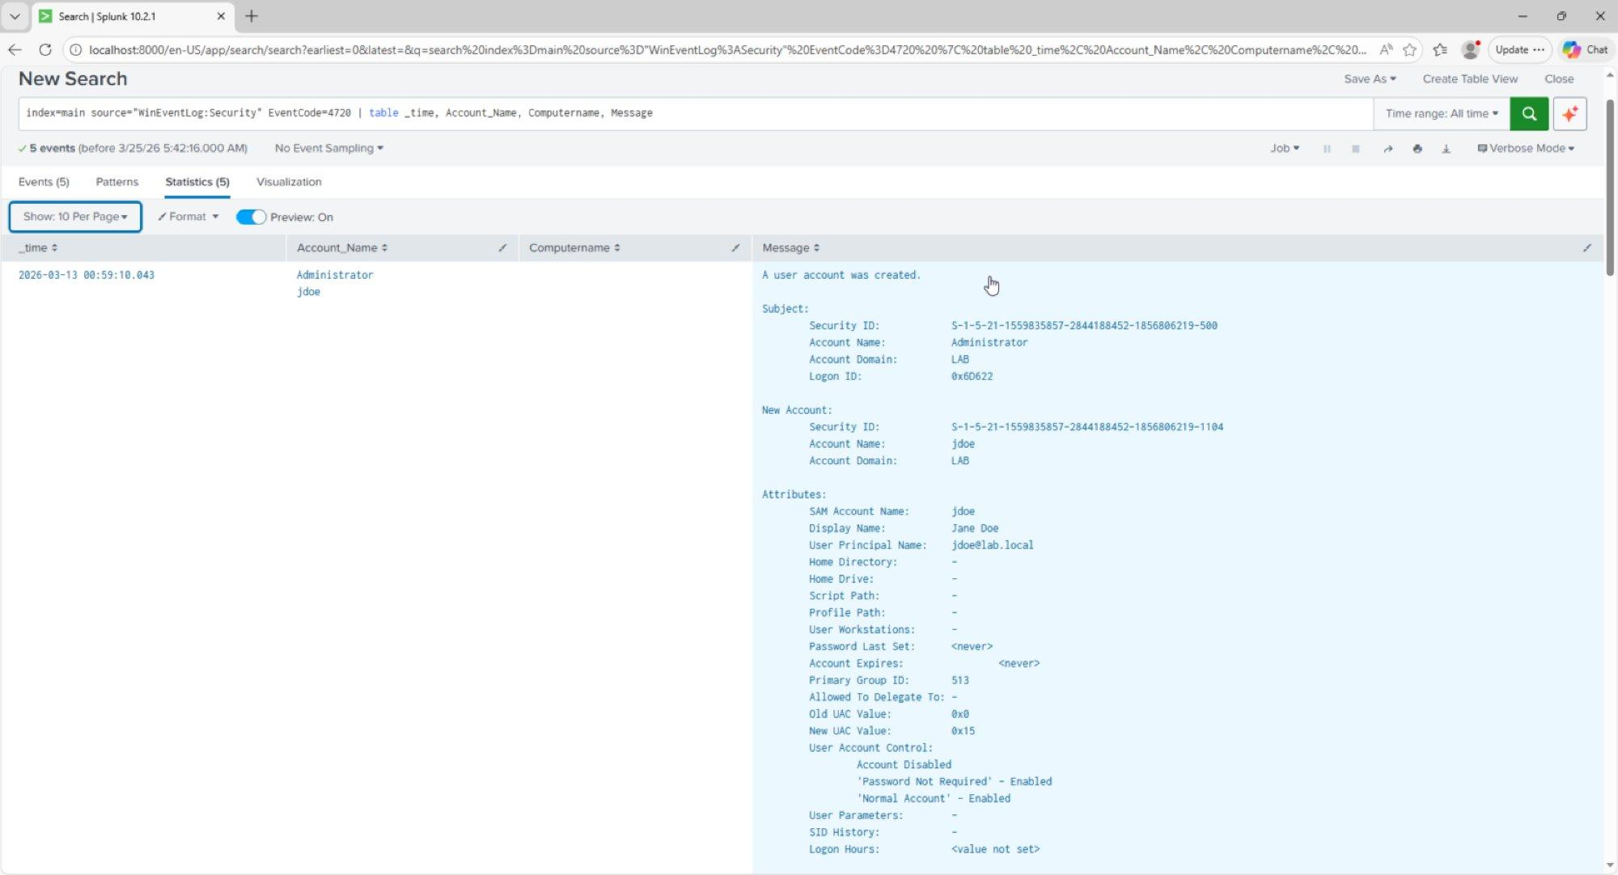
Figure 3.1 – New user account detection results: EventCode 4720 showing jdoe (Jane Doe) created in lab.local/Help_Desk by Administrator. Full AD attributes captured including UPN jdoe@lab.local, Security ID, and account control flags.

Alert Configuration
Alert Name: New User Account Created
Alert Type: Real-time
Trigger: Per Result (fires on every account creation)
Severity: High
Action: Add to Triggered Alerts
Description: Triggers whenever a new user account is created in Active Directory.
Enables immediate review of whether account creation was authorized.

Event Field | Value Observed | Significance
EventCode | 4720 | New user account created – persistence indicator
Account_Name | jdoe | Newly created account SAM name
Display Name | Jane Doe | Full name of created account
User Principal Name | jdoe@lab.local | Domain UPN – confirms domain account, not local
Subject Account | Administrator | Who created the account – audit trail
New UAC Value | 0x15 – Normal Account | Account type and status flags

Detection 2 – NIST & MITRE Alignment
Framework | Control | Description
MITRE ATT&CK | T1136 – Create Account | Adversary creates accounts to maintain persistence post-compromise
NIST CSF | Detect (DE.CM) | Continuous monitoring – real-time alert on every account creation
NIST SP 800-53 | AC-2 | Account Management – all account creation events reviewed and audited
NIST SP 800-53 | AU-9 | Protection of Audit Information – creation events captured with full attribution

Detection 3 – Privileged Group Membership Change
MITRE ATT&CK: T1098 – Account Manipulation | Severity: High | Alert Type: Real-time, Per Result

Unauthorized modification of privileged group membership is a primary privilege escalation technique. When an attacker adds a compromised account to a high-privilege group, they gain elevated access without creating new accounts. Windows Security EventCodes 4728, 4732, and 4756 capture additions to security-enabled global, local, and universal groups respectively. This detection covers all three, alerting on any group membership change in real-time.

SPL Detection Query
index=main source="WinEventLog:Security"
EventCode=4728 OR EventCode=4732 OR EventCode=4756
| table _time, Account_Name, ComputerName, Message

4728 = Member added to security-enabled global group
4732 = Member added to security-enabled local group
4756 = Member added to security-enabled universal group

Evidence – Group Membership Changes
The detection returned 22 events capturing all group membership changes made during the Active Directory lab. Two primary entries document the RBAC assignments: Jane Doe (CN=Jane Doe,OU=Help_Desk,DC=lab,DC=local) added to HD_ReadOnly, and John Smith (CN=John Smith,OU=IT_Staff,DC=lab,DC=local) added to IT_Staff. Both actions were performed by the Administrator account, providing a complete audit trail linking the RBAC design to specific security events.
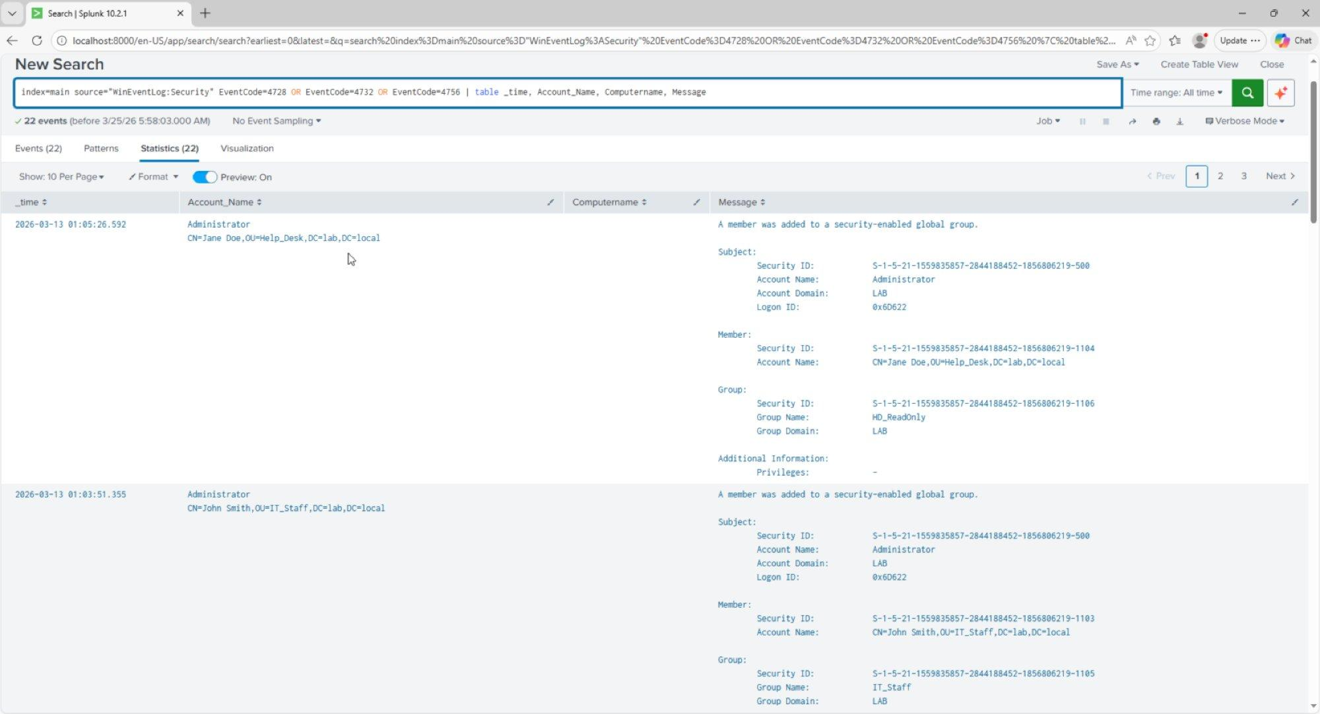
Figure 4.1 – Privileged group membership detection results: 22 events showing Jane Doe added to HD_ReadOnly group and John Smith added to IT_Staff group by Administrator. Full group DN and member DN captured.

Alert Configuration
Alert Name: Privileged Group Membership Change
Alert Type: Real-time
Trigger: Per Result (fires on every group membership change)
Severity: High
Action: Add to Triggered Alerts
Description: Triggers when there is a privileged group membership change.
Detects potential privilege escalation via group manipulation.

Event Field | Value Observed | Significance
EventCode | 4728 | Member added to security-enabled global group
Member | CN=Jane Doe,OU=Help_Desk,DC=lab | Full DN of account added to group
Group Name | HD_ReadOnly / IT_Staff | Target security group – RBAC enforcement
Group Domain | LAB | Domain context – confirms domain group modification
Subject | Administrator | Actor performing the group change – full attribution

Detection 3 – NIST & MITRE Alignment
Framework | Control | Description
MITRE ATT&CK | T1098 – Account Manipulation | Modifying group membership to escalate privileges post-compromise
NIST CSF | Detect (DE.CM) | Continuous monitoring – real-time alert on group membership changes
NIST SP 800-53 | AC-6 | Least Privilege – any deviation from expected group membership flagged immediately
NIST SP 800-53 | AC-2 | Account Management – group changes audited with full subject attribution

Alert Summary & Live Validation

All Three Alerts – Active and Enabled
The Splunk Alerts dashboard confirms all three detection rules are saved, enabled, and operational. Two alerts (New User Account Created and Privileged Group Membership Change) run in real-time mode with per-result triggering. The Brute Force alert runs in real-time mode firing on each detected EventCode 4625.
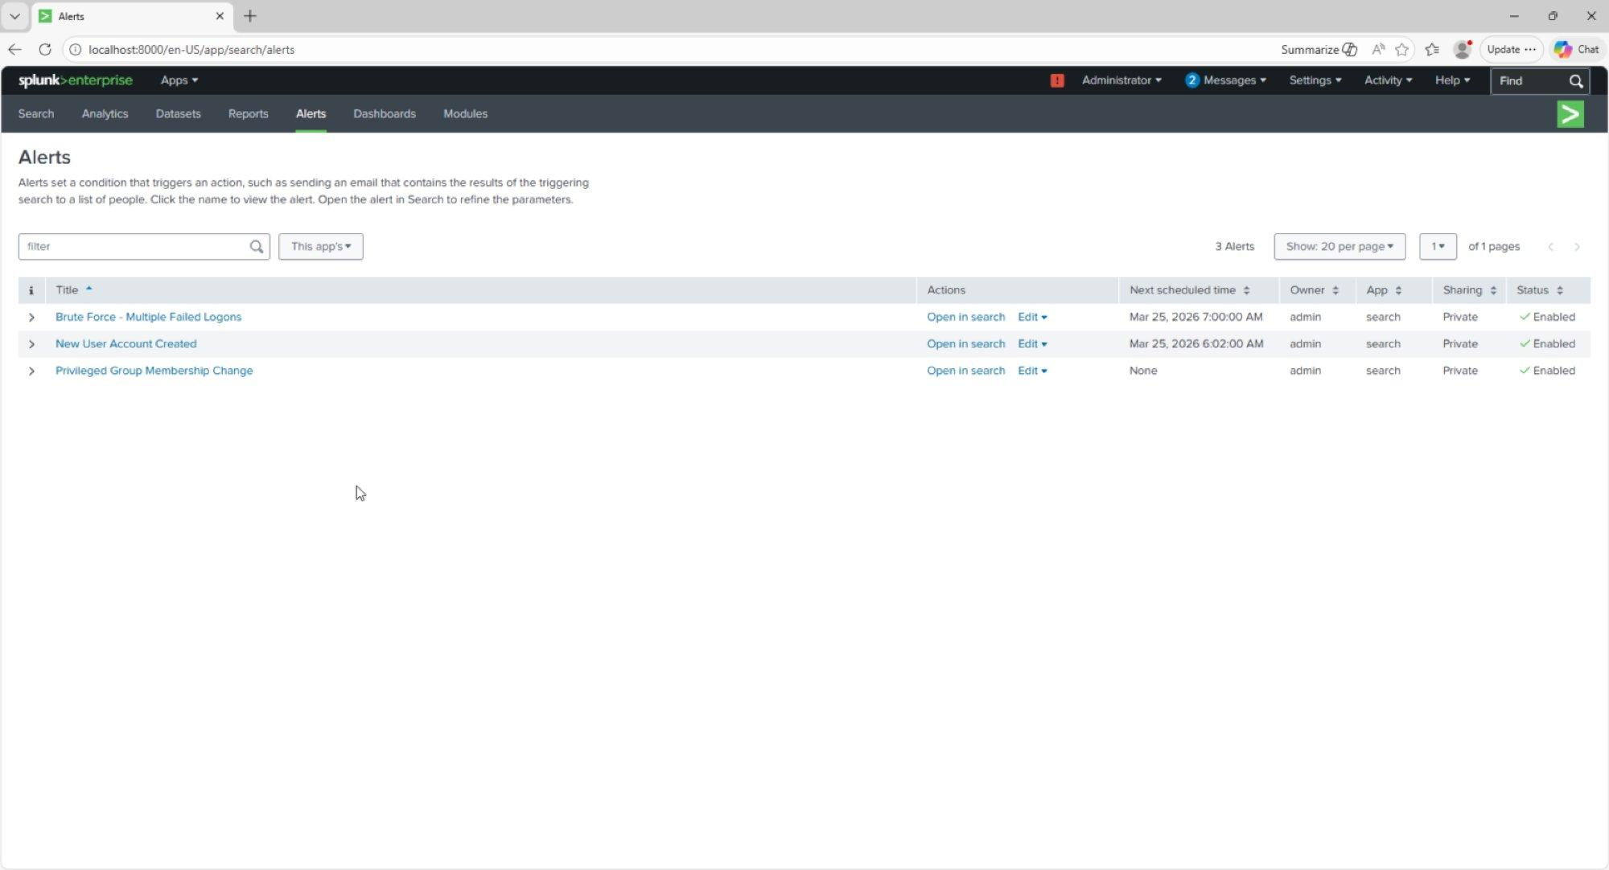
Figure 5.1 – Splunk Alerts dashboard: All 3 detection rules confirmed active – Brute Force - Multiple Failed Logons, New User Account Created, and Privileged Group Membership Change. Status: Enabled for all.

Live Triggered Alerts – End-to-End Validation
To confirm the complete detection pipeline was operational, a controlled brute force simulation was executed against domain account jsmith. The Brute Force alert fired 4 times in real-time within seconds, with each failed logon attempt generating an individual triggered alert entry. All alerts correctly reported Critical severity and Per Result mode, confirming the detection pipeline from Windows event generation through Splunk indexing to alert firing is fully functional.
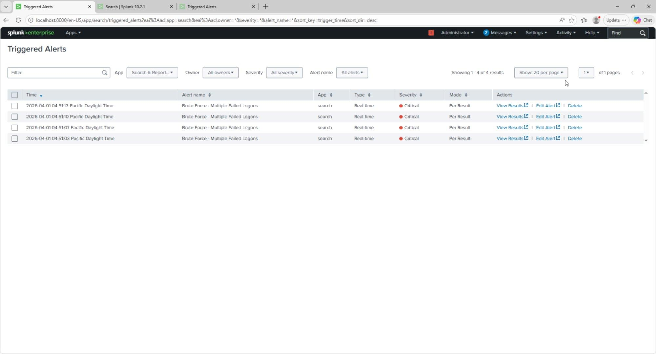
Figure 5.2 – Triggered Alerts dashboard: 4 live Brute Force alerts fired April 1, 2026 between 04:51:03 and 04:51:12 Pacific Time. Severity: Critical. Type: Real-time. Mode: Per Result. End-to-end detection pipeline confirmed operational.

Alert | Trigger Event | Mode | Severity | Validated
Brute Force - Multiple Failed Logons | EventCode 4625 – failed domain logon | Real-time / Per Result | Critical | ✓ 4 live triggers confirmed
New User Account Created | EventCode 4720 – AD account creation | Real-time / Per Result | High | ✓ 5 historical events captured
Privileged Group Membership Change | EventCode 4728/4732/4756 – group modification | Real-time / Per Result | High | ✓ 22 historical events captured

Framework Alignment Summary

MITRE ATT&CK Coverage
Technique | ID | Detection | Coverage
Brute Force | T1110 | Detection 1 – EventCode 4625 | Real-time alert on every failed logon
Create Account | T1136 | Detection 2 – EventCode 4720 | Real-time alert on every AD account creation
Account Manipulation | T1098 | Detection 3 – EventCodes 4728/4732/4756 | Real-time alert on group membership changes

NIST SP 800-53 Control Coverage
Control | Title | How This Lab Satisfies It
AC-2 | Account Management | All account creations and group changes logged and alerted
AC-6 | Least Privilege | Group membership changes monitored to detect privilege escalation
AC-7 | Unsuccessful Logon Attempts | Failed logons alerted in real-time with full account attribution
AU-2 | Audit Events | Windows Security log ingested as primary audit source
AU-6 | Audit Review | Automated alerting replaces manual log review for high-risk events
SI-4 | System Monitoring | Continuous real-time SIEM monitoring across all three detection categories
CA-7 | Continuous Monitoring | Live triggered alerts confirm ongoing detection capability

Lessons Learned & Analyst Notes
Observation | Impact | Recommendation
Splunk scheduled alerts do not fire instantly | Initial testing showed no triggered alerts because the hourly schedule hadn't run | Use real-time alerts for high-severity detections; reserve scheduled alerts for aggregation-based rules that require a time window
Stats-based SPL is incompatible with real-time per-result mode | The count >= 5 threshold never fired because real-time mode evaluates individual events | Use simple event-match queries for real-time alerts; apply aggregation logic in dashboards or scheduled reports
Domain controller logs are high-value from day one | Authentication, IAM, and group events were already present before any simulation | In enterprise environments, prioritize DC log ingestion as the first SIEM data source — it provides the broadest visibility with minimum configuration
Alert severity calibration matters | All three alerts set to High or Critical ensures they surface prominently | Map severity to business impact: failed logons are Critical, account creation is High, group changes are High — matches real SOC triage priorities

Lab Completion Statement
This SIEM home lab demonstrates end-to-end security monitoring capability: environment setup, log ingestion, detection engineering, alert configuration, and live validation. All three detection rules are operational, all alerts are confirmed firing against real Windows Security events from a live Active Directory environment, and all findings are documented to professional portfolio standards.

