IT Operations & Security Playbook

Applied Labs and Operational Knowledge

Prepared by | Cameron Lowe
Certifications | CompTIA A+, Network+, Security+ | ITIL 4 Foundation
In Progress | CompTIA Project+, CySA+
Focus Areas | IT Operations, SOC Support, IAM, GRC, Encryption
Lab Environment | Windows Server 2022 (VMware Fusion), macOS Terminal, Active Directory lab.local
Document Version | 3.0 – Complete with all lab evidence

This playbook demonstrates applied technical competencies across IT support, networking, security operations, identity and access management, encryption, and incident response. All seven labs have been executed in a live environment with documented evidence.

Lab 1 – Network Discovery and Exposure Analysis (Nmap)
Objective: Identify live hosts, open ports, and exposed services to assess network attack surface.
Tools: Nmap 7.99, macOS Terminal
Target: 192.168.16.132 (LAB-DC01 – Windows Server 2022 Active Directory Domain Controller)

Network scanning is a foundational skill for both IT operations and security assessment. Nmap was used to perform host discovery, service enumeration, and OS fingerprinting against the lab domain controller. The scan results provide a realistic view of the attack surface exposed by a Windows Active Directory environment and directly inform the risk register documented in Lab 7.

Tool Verification

Figure 1.1 – Nmap 7.99 installed and verified on macOS analysis platform (cameron-lowe). Compiled with OpenSSL, libssh2, and IPv6 support.

Scan 1 – Host Discovery
nmap -sn 192.168.16.0/24

Result: 1 live host discovered at 192.168.16.1
256 addresses scanned in 22.03 seconds


Figure 1.2 – Host discovery scan: nmap -sn 192.168.16.0/24 identifies 1 live host on the lab subnet in 22.03 seconds

Scan 2 – TCP SYN Scan with Service Detection
sudo nmap -sS -sV 192.168.16.132

Open ports discovered:
53/tcp - DNS (Simple DNS Plus)
88/tcp - Kerberos (Microsoft Windows Kerberos)
135/tcp - MSRPC
139/tcp - NetBIOS-SSN
389/tcp - LDAP (Domain: lab.local)
445/tcp - Microsoft-DS (SMB)
3268/tcp - Global Catalog LDAP
5985/tcp - WinRM (HTTP API)

Host: LAB-DC01 | OS: Windows | MAC: 00:0C:29:70:0C:54 (VMware)

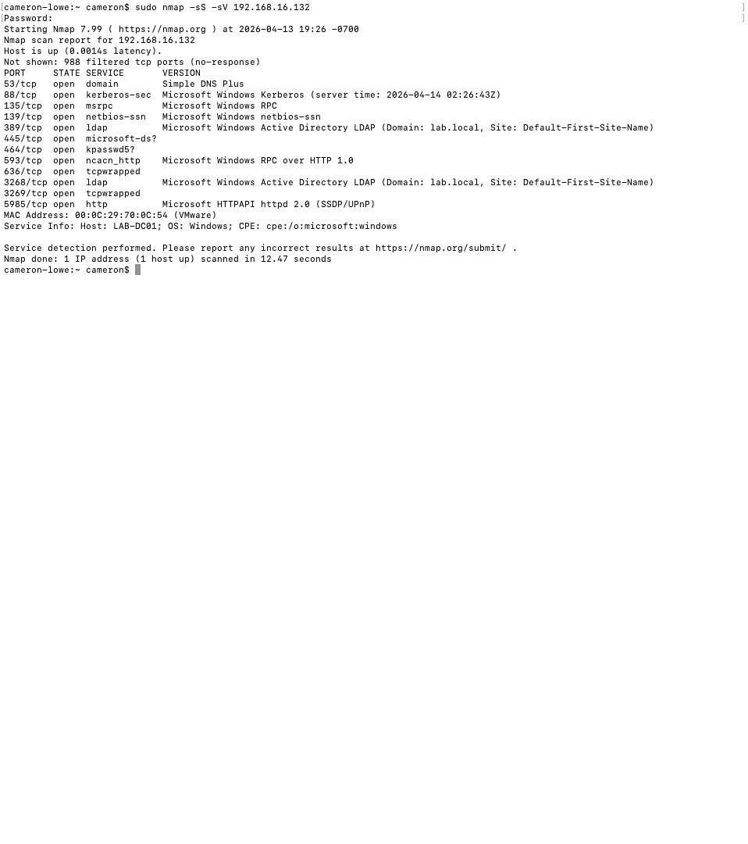
Figure 1.3 – Service detection scan: 11 open ports identified on LAB-DC01 including Kerberos (88), LDAP (389), SMB (445), and Global Catalog (3268/3269) confirming Active Directory domain controller role

Scan 3 – OS Detection
sudo nmap -O 192.168.16.132

OS Detection Result:
Microsoft Windows Server 2022 - 97% confidence
Microsoft Windows 11 21H2 - 91% confidence
Microsoft Windows Server 2016 - 91% confidence

Network Distance: 1 hop

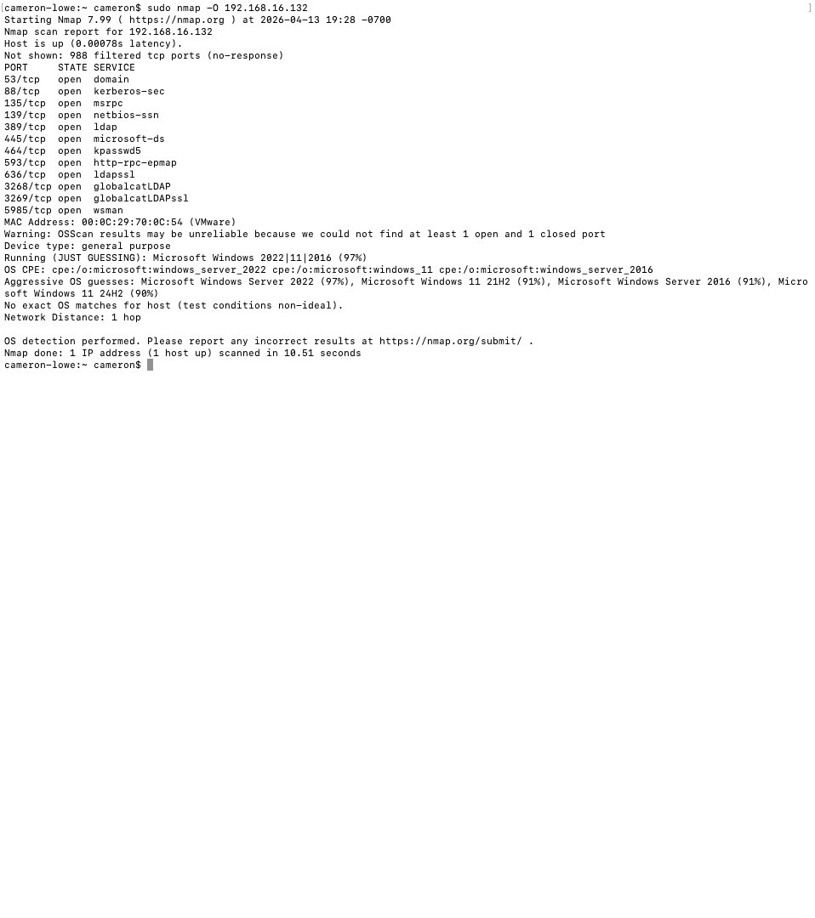
Figure 1.4 – OS detection scan: Target identified as Microsoft Windows Server 2022 at 97% confidence. Network distance of 1 hop confirms direct local network access.

Security Findings
Port / Service | Risk Finding | Recommendation
88 – Kerberos | Confirms Active Directory – Kerberoasting attacks target this service | Monitor for SPN enumeration and TGS requests
389 – LDAP | Unencrypted LDAP exposed – credentials can be captured in transit | Enforce LDAPS (636) and disable plain LDAP
445 – SMB | SMB exposure enables lateral movement and ransomware propagation | Restrict SMB to authorized hosts via firewall rules
5985 – WinRM | Remote management enabled – credential attack surface | Restrict WinRM to admin subnets only
3268 – Global Catalog | Confirms DC role – high value target for domain enumeration | Monitor for unusual LDAP queries against GC

NIST Alignment
Framework | Control | Description
NIST CSF | Identify (ID.AM, ID.RA) | Asset discovery and risk assessment through active network scanning
NIST SP 800-53 | RA-5 | Vulnerability Monitoring – identify exposed services and assess risk
NIST SP 800-53 | CM-7 | Least Functionality – restrict unnecessary open ports and services

Lab 2 – Packet Capture and Traffic Analysis (Wireshark)
Objective: Analyze network traffic to detect insecure protocols and data exposure risks.
Tools: Wireshark 4.6.4, macOS Terminal
Interface: en0 (Wi-Fi) – live capture

Packet capture and traffic analysis is a core SOC and network security skill. Wireshark was used to capture live network traffic and apply protocol filters to isolate HTTP sessions. Unencrypted HTTP traffic exposes session data, credentials, and internal host information to any network observer — a direct violation of data-in-transit protection requirements under NIST SP 800-53 SC-8.

Tool Verification
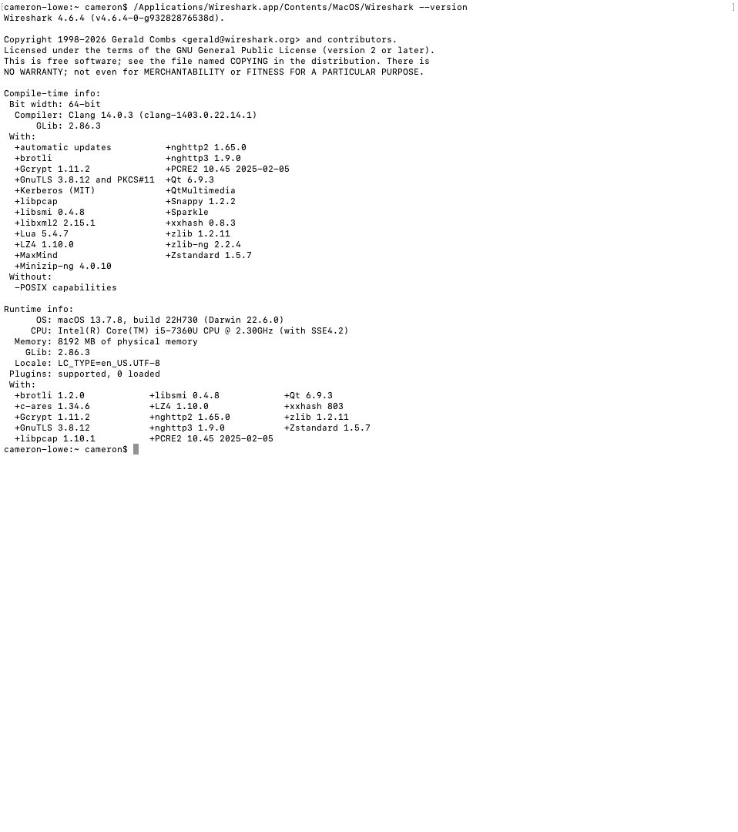
Figure 2.1 – Wireshark 4.6.4 installed and verified on macOS. Compiled with libpcap 1.10.1, GnuTLS 3.8.12, and libssh2 support.

HTTP Traffic Capture
Interface: Wi-Fi (en0) – live capture
Filter applied: http

Packets captured: 1,598 total | 6 HTTP packets displayed (0.4%)

HTTP sessions observed:
192.168.5.32 → 146.75.42.172 GET /msdownload/update/... HTTP/1.1
146.75.42.172 → 192.168.5.32 HTTP/1.1 304 Not Modified
192.168.5.32 → 34.223.124.45 GET /online/ HTTP/1.1
34.223.124.45 → 192.168.5.32 HTTP/1.1 200 OK (text/html)

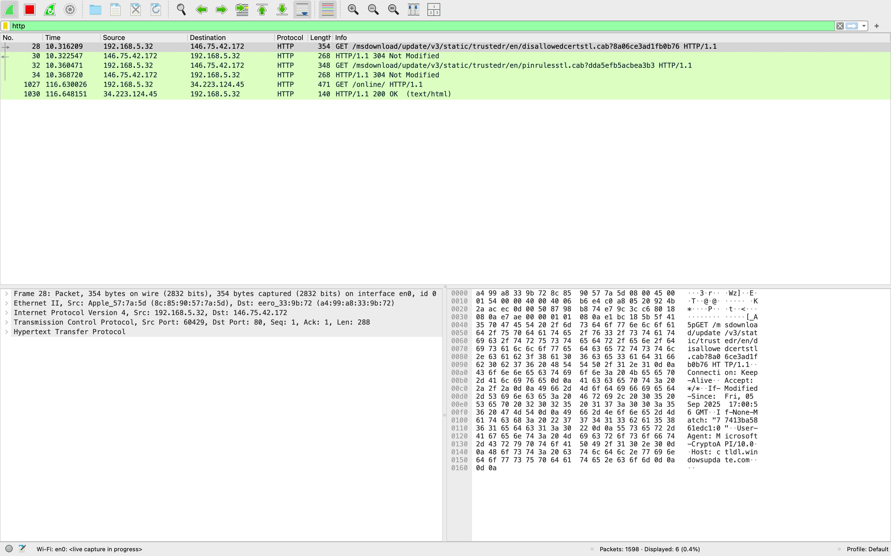
Figure 2.2 – Wireshark live capture with HTTP filter applied: Unencrypted HTTP GET requests and 200 OK responses visible showing source IP 192.168.5.32, destination IPs, and full packet details including TCP port 80 sessions. Capture active on Wi-Fi en0.

Security Findings
Finding | Risk | Recommendation
HTTP GET requests captured in cleartext | Request paths, parameters, and headers visible to network observers | Enforce HTTPS — redirect all HTTP to HTTPS, implement HSTS
Source/destination IPs visible | Internal host IP (192.168.5.32) exposed in unencrypted traffic | Use TLS to encrypt all application layer data in transit
HTTP 200 OK responses with content | Response body contents visible — potential data exposure | Implement TLS 1.2 minimum, disable TLS 1.0/1.1

NIST Alignment
Framework | Control | Description
NIST CSF | Protect (PR.DS), Detect (DE.CM) | Data security and continuous monitoring through traffic analysis
NIST SP 800-53 | SC-8 | Transmission Confidentiality and Integrity – enforce encryption for all data in transit
NIST SP 800-53 | IA-7 | Cryptographic Module Authentication – implement TLS for all web services

Lab 3 – Endpoint Troubleshooting and OS Recovery
Objective: Restore a non-booting Windows system and verify file system integrity.
Tools: Windows Recovery Environment, Windows Server 2022 (LAB-DC01)

Endpoint recovery is a critical IT support skill. The following recovery procedure was documented using the Windows Server 2022 VM (LAB-DC01) to demonstrate proficiency with Windows recovery tooling applicable to environments where boot record integrity is compromised. No corruption was found in this instance — the procedure documents the response process for scenarios where these conditions are present.

Recovery Procedure
# System File Checker – scan and repair protected system files
sfc /scannow

# Check Disk – scan for file system errors and bad sectors
chkdsk C: /f /r

# Boot Record Repair (run from Recovery Environment)
bootrec /fixmbr # Repair Master Boot Record
bootrec /fixboot # Write new boot sector
bootrec /rebuildbcd # Rebuild Boot Configuration Data

Windows Update – Patch Management Baseline
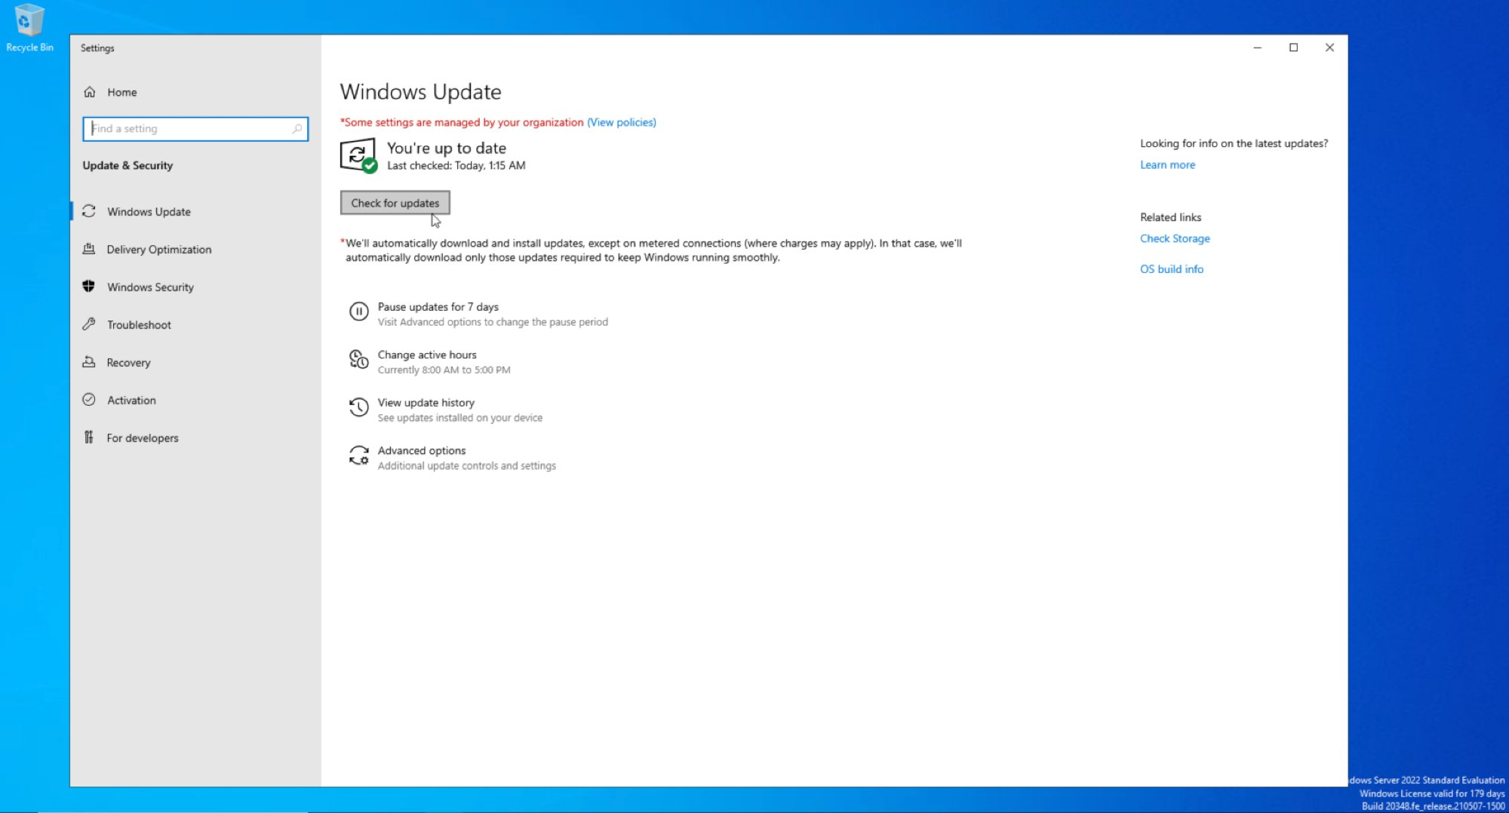
Figure 3.1 – Windows Server 2022 fully patched: Windows Update confirms system up to date. Patch management baseline established on LAB-DC01 prior to AD DS deployment.

Recovery Tool | Purpose | When Used
sfc /scannow | Scans and repairs corrupted Windows system files | System instability, missing OS files
chkdsk /f /r | Finds and fixes file system errors and bad sectors | Disk errors, filesystem corruption
bootrec /fixmbr | Repairs the Master Boot Record | OS fails to boot, MBR corruption
bootrec /fixboot | Writes a new boot sector to the system partition | Boot sector damaged or missing
bootrec /rebuildbcd | Scans for Windows installations and rebuilds BCD store | Boot Configuration Data corruption

NIST Alignment
Framework | Control | Description
NIST CSF | Protect (PR.IP), Recover (RC.RP) | Information protection and recovery planning through documented procedures
NIST SP 800-53 | CP-10 | System Recovery and Reconstitution – restore systems to known good state
NIST SP 800-53 | SI-7 | Software, Firmware, and Information Integrity – verify system file integrity

Lab 4 – Identity and Access Management (Active Directory)
Objective: Deploy Active Directory Domain Services, enforce least privilege through RBAC, and implement enterprise-grade password and lockout policies.
Tools: Windows Server 2022, AD DS, ADUC, Group Policy Management Editor
Domain: lab.local | DC: LAB-DC01 | IP: 192.168.16.132

Phase 1 – AD DS Role Installation
The AD DS role was added through Server Manager on LAB-DC01. Installation included Group Policy Management, Remote Server Administration Tools, AD DS snap-ins, and the Active Directory module for Windows PowerShell.
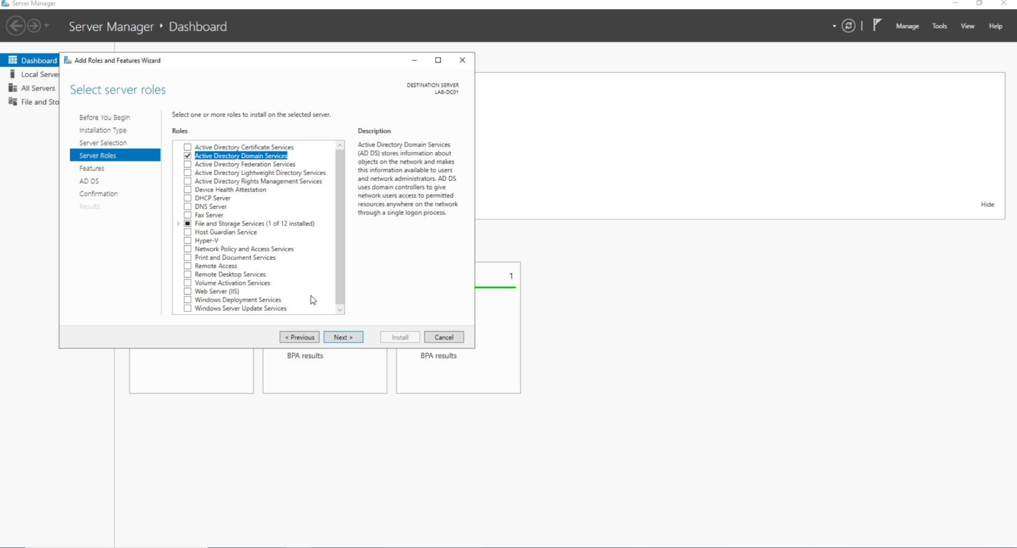
Figure 4.1 – Server Manager: Active Directory Domain Services role selected for installation on LAB-DC01 alongside Group Policy Management and AD DS administrative tools

Phase 2 – Domain Controller Promotion
LAB-DC01 was promoted to a Domain Controller for a new forest (lab.local). The promotion integrated DNS and confirmed all three roles active: AD DS, DNS, and File and Storage Services.
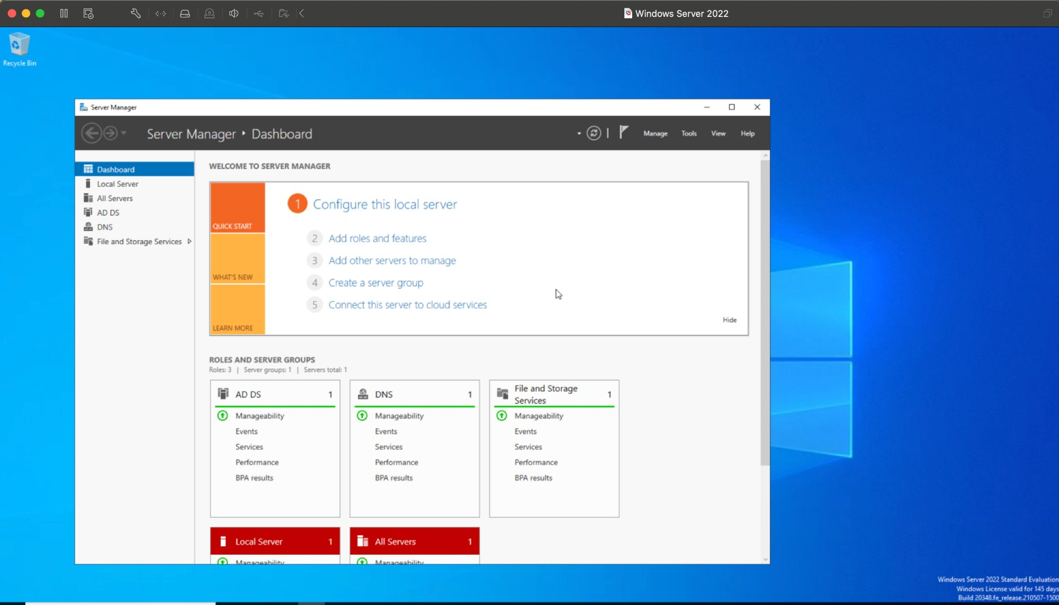
Figure 4.2 – Server Manager Dashboard: Successful DC promotion confirmed — AD DS, DNS, and File and Storage Services roles all active and healthy on LAB-DC01

Phase 3 – Organizational Unit Structure
Two OUs were created within lab.local to enforce segmented access control: IT_Staff for privileged personnel and Help_Desk for lower-privilege support staff.
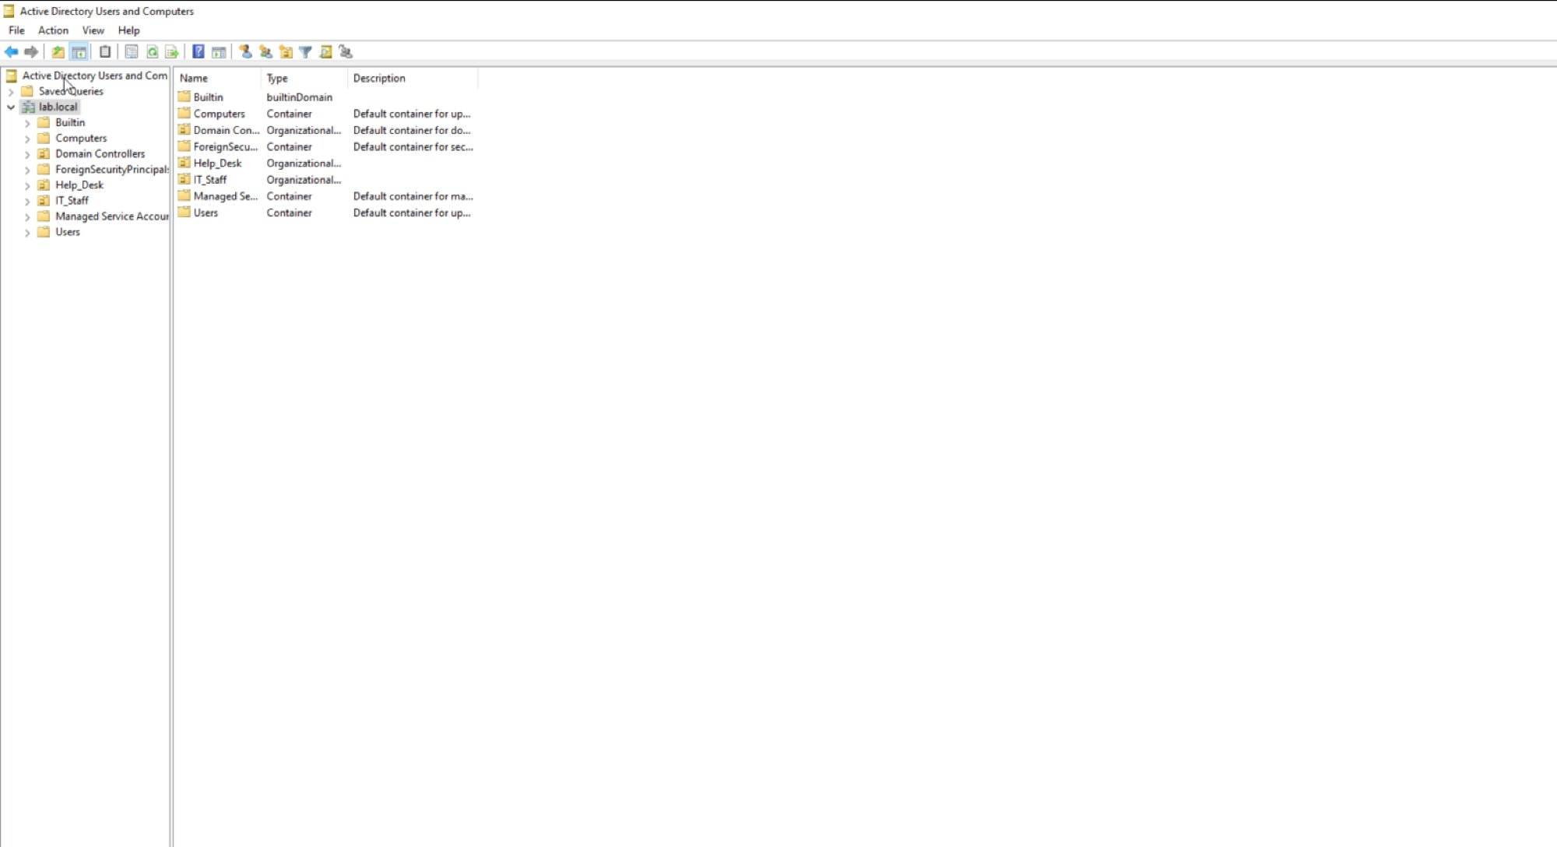
Figure 4.3 – Active Directory Users and Computers: lab.local domain showing Help_Desk and IT_Staff Organizational Units alongside default containers

Phase 4 – RBAC Group Assignment
Security groups were created in each OU and users assigned to enforce role-based access control. John Smith (jsmith) was assigned to IT_Staff with elevated access. Jane Doe (jdoe) was assigned to HD_ReadOnly with least-privilege read-only access.
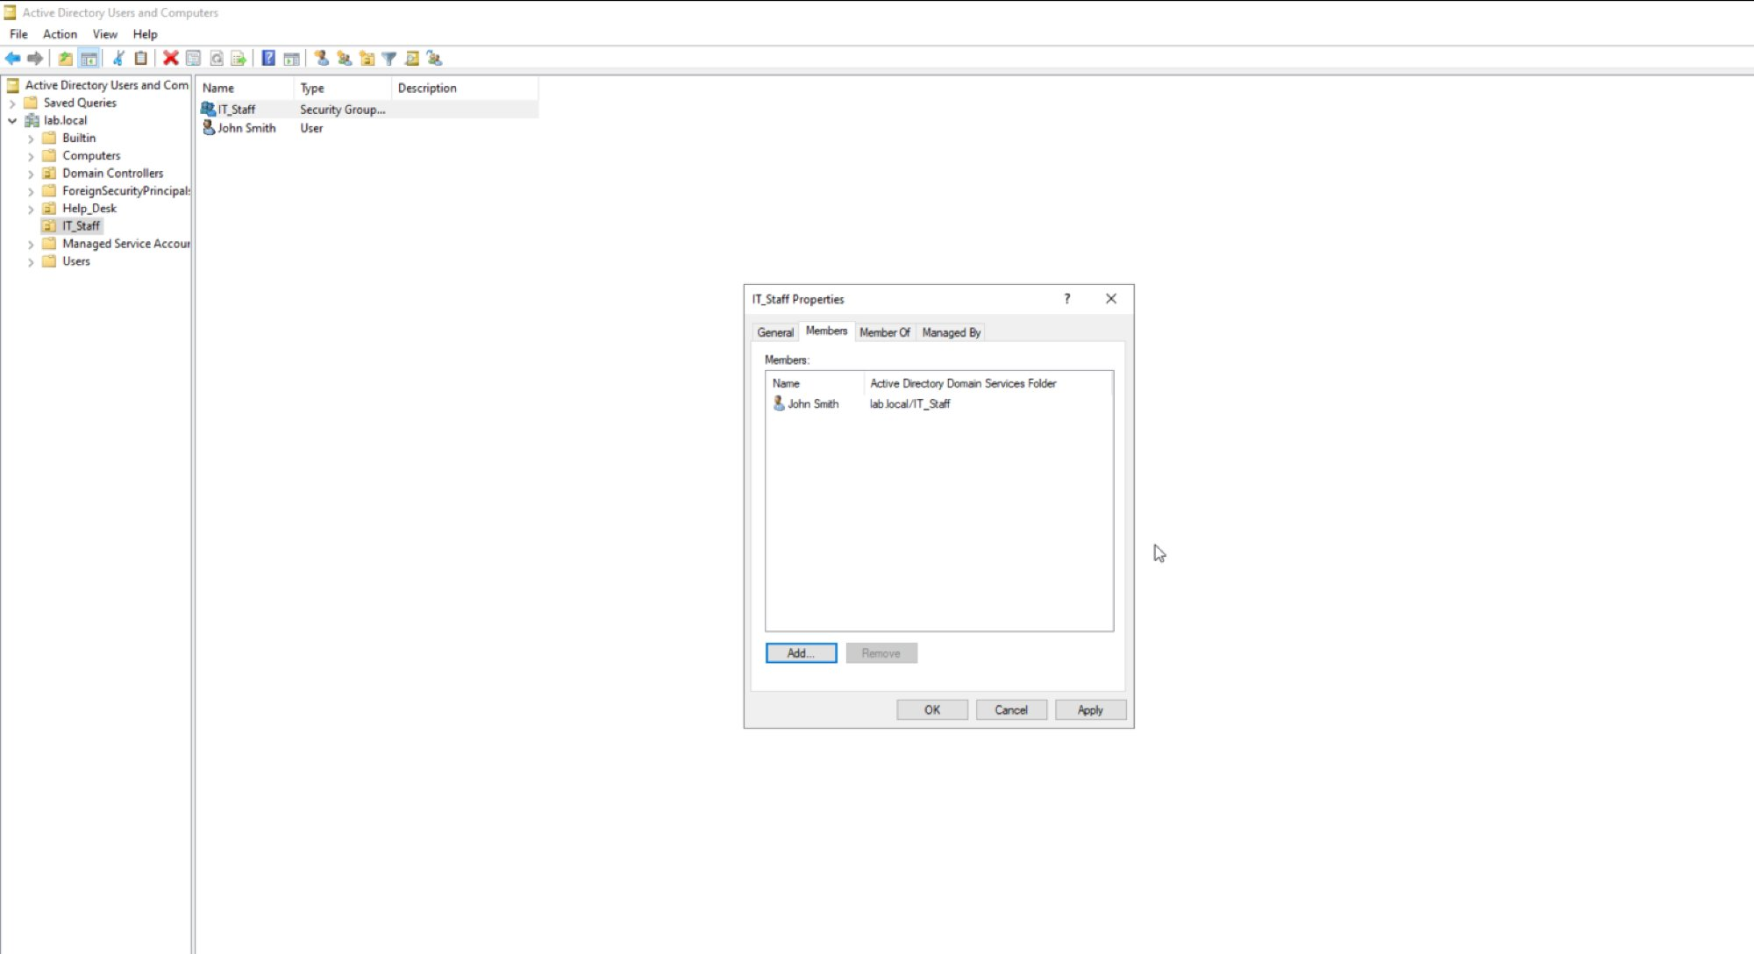
Figure 4.4 – IT_Staff group properties: John Smith (lab.local/IT_Staff) assigned as member — elevated IT access role
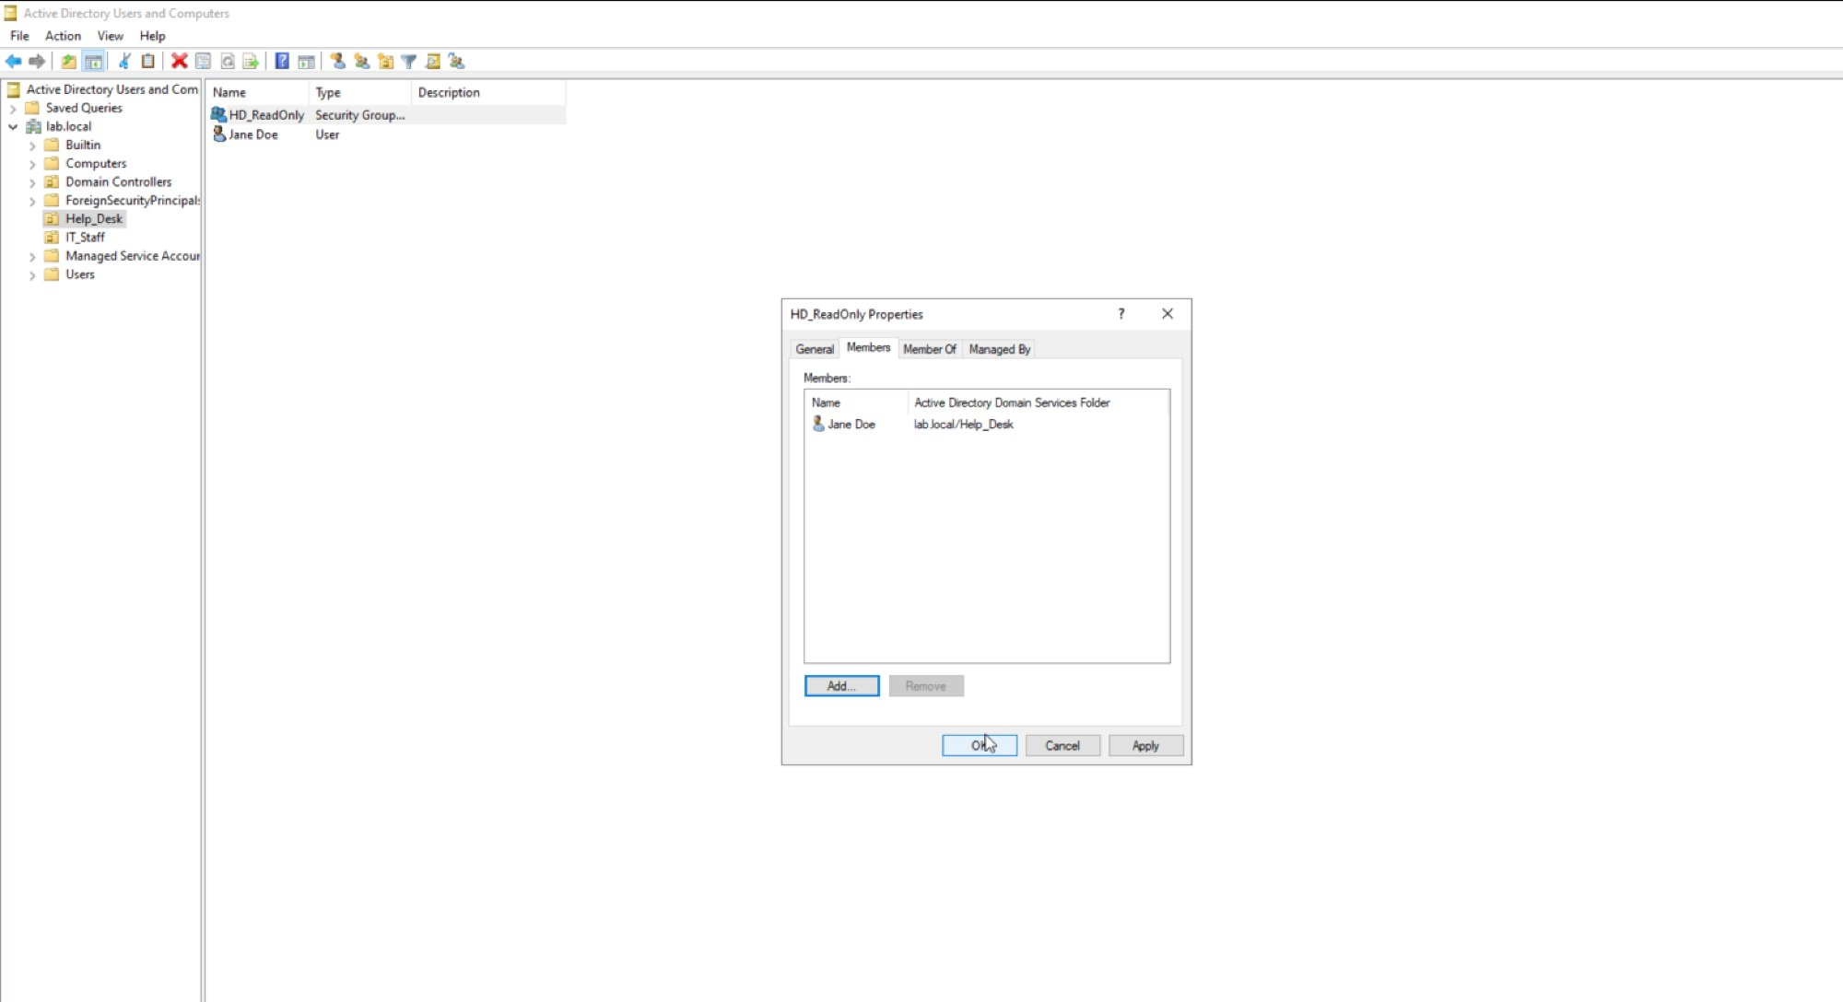
Figure 4.5 – HD_ReadOnly group properties: Jane Doe (lab.local/Help_Desk) assigned as member — least-privilege read-only access role

Phase 5 – Password and Lockout Policy
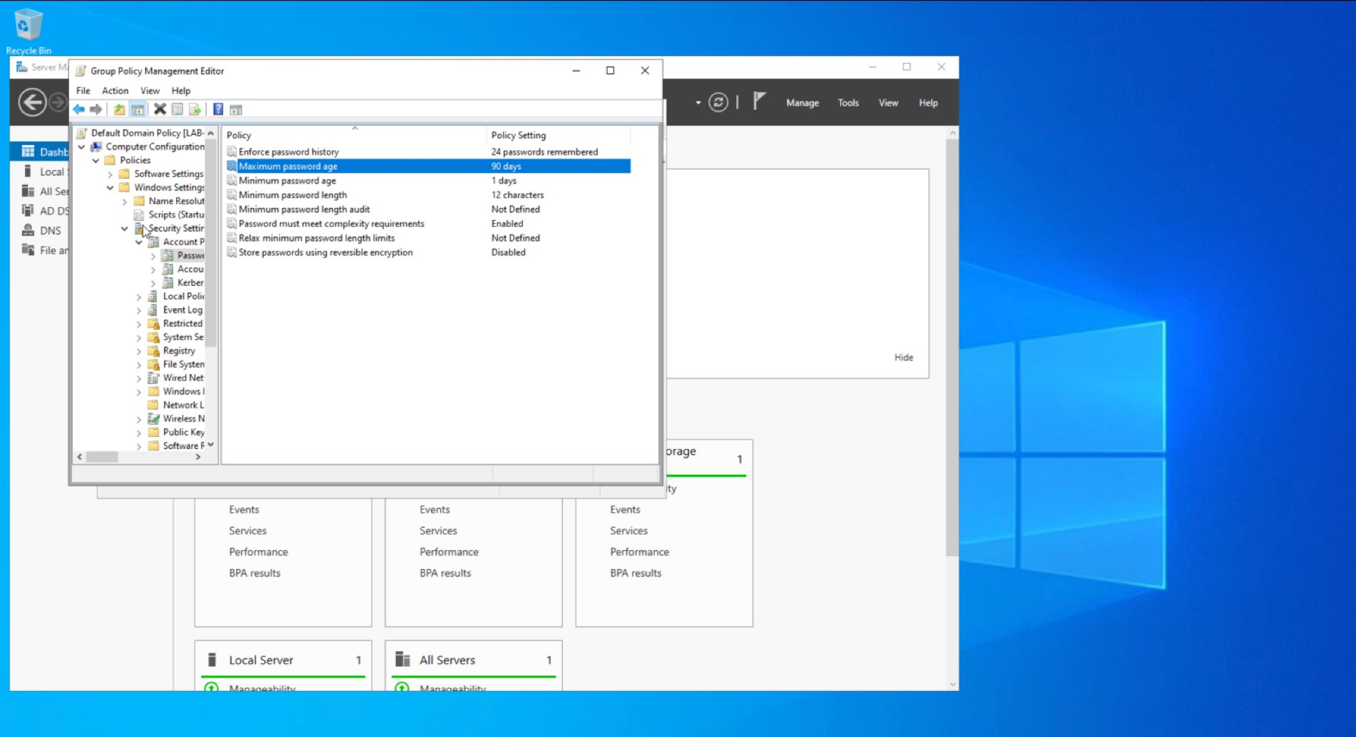
Figure 4.6 – Group Policy Management Editor: Password Policy — 12-character minimum, complexity enabled, 90-day maximum age, 24-password history enforced domain-wide
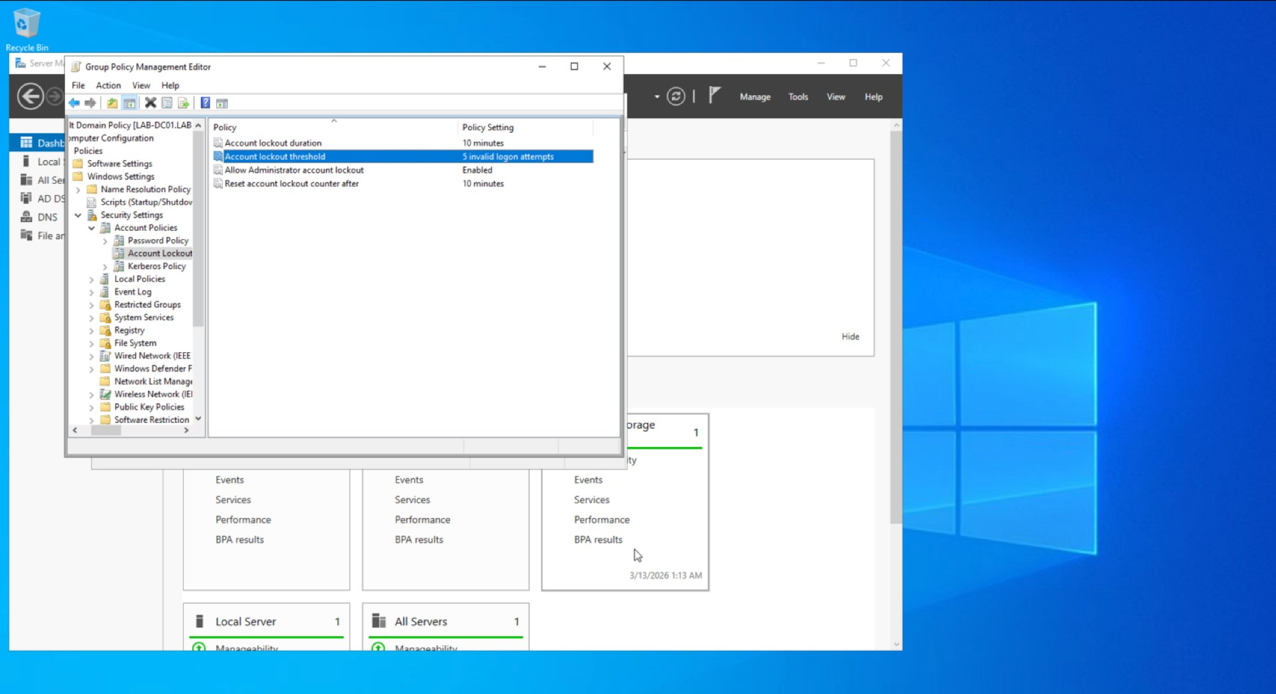
Figure 4.7 – Group Policy Management Editor: Account Lockout Policy — 5 invalid attempts, 10-minute lockout duration, automatic counter reset

Policy Setting | Value | Security Rationale
Minimum Password Length | 12 characters | Reduces brute-force attack surface
Password Complexity | Enabled | Requires mixed character types
Maximum Password Age | 90 days | Limits credential exposure window
Password History | 24 passwords remembered | Prevents reuse of recent passwords
Account Lockout Threshold | 5 invalid attempts | Blocks brute-force attacks
Lockout Duration | 10 minutes | Auto-recovery reduces helpdesk burden

NIST Alignment
Framework | Control | Description
NIST CSF | Protect (PR.AC) | Identity management and access control through AD DS RBAC and GPO
NIST SP 800-53 | AC-2 | Account Management – all accounts provisioned with defined roles and group membership
NIST SP 800-53 | AC-6 | Least Privilege – HD_ReadOnly group restricts access to minimum necessary permissions
NIST SP 800-53 | IA-5 | Authenticator Management – password complexity and rotation enforced via GPO

Lab 5 – Encryption at Rest and In Transit (GPG)
Objective: Protect sensitive data using asymmetric encryption at rest.
Tools: GPG (GnuPG/MacGPG2) 2.2.41, macOS Terminal
Algorithm: RSA 3072-bit key pair | Key ID: E05B8E49E82BB264

GPG (GNU Privacy Guard) implements the OpenPGP standard for asymmetric encryption. A key pair was generated for Cameron Lowe, a test file containing sensitive data was encrypted using the public key, verified as a PGP-encrypted binary, and successfully decrypted using the private key — demonstrating end-to-end data protection at rest. This replaces insecure alternatives such as FTP or unencrypted email attachments.

Step 1 – GPG Version Verification
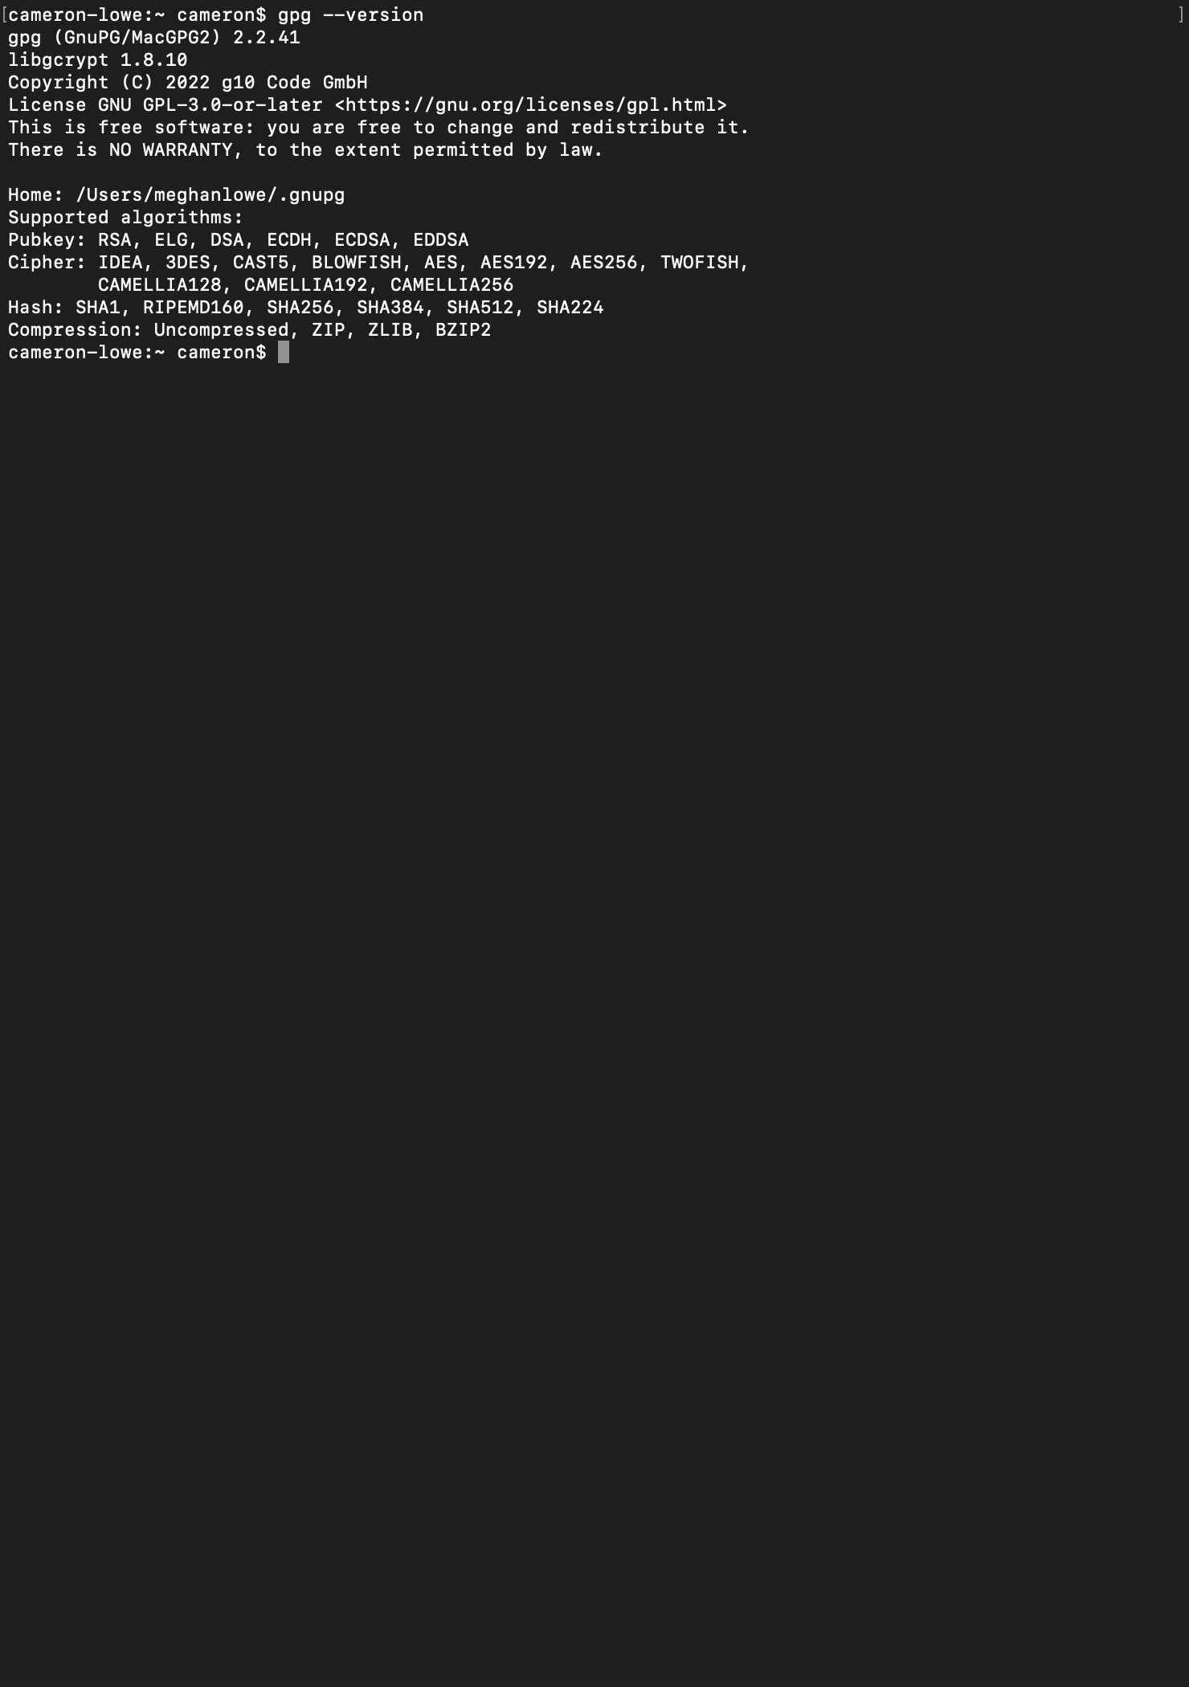
Figure 5.1 – GPG (GnuPG/MacGPG2) 2.2.41 verified on macOS. Supported algorithms include RSA, AES256, SHA256, and SHA512.

Step 2 – RSA Key Pair Generation
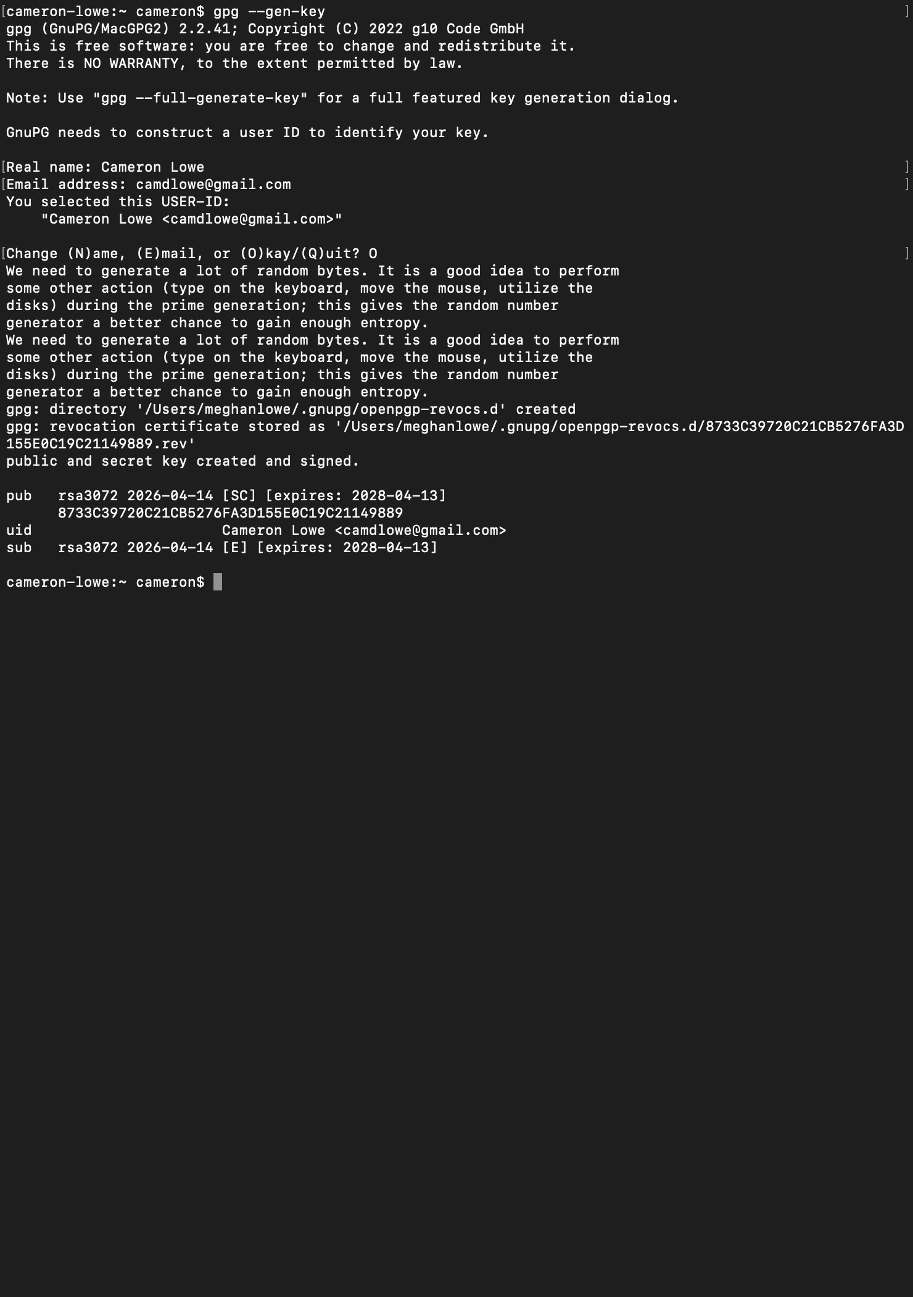
Figure 5.2 – RSA 3072-bit key pair generated for Cameron Lowe (camdlowe@gmail.com). Public and private keys created and signed. Key expires 2028-04-13. Revocation certificate stored.

Step 3 – Test File Creation
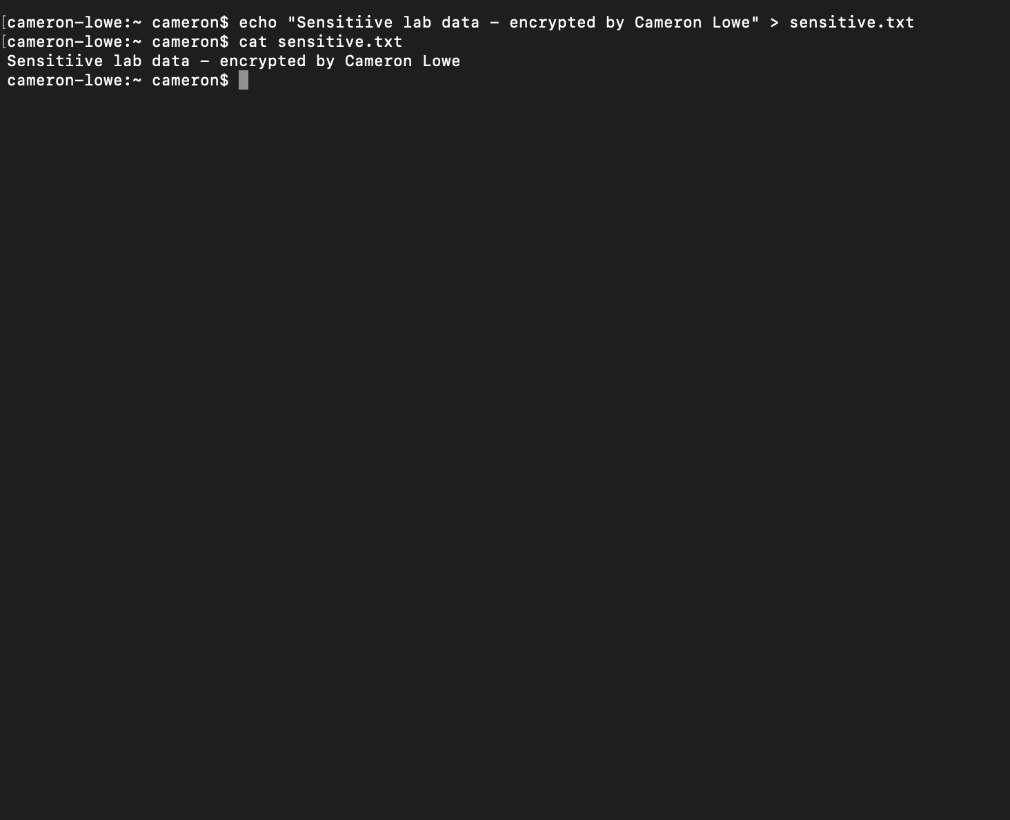
Figure 5.3 – sensitive.txt created with plaintext content: 'Sensitive lab data – encrypted by Cameron Lowe'. File contents verified with cat command before encryption.

Step 4 – File Encryption
gpg --output sensitive.gpg --encrypt --recipient camdlowe@gmail.com sensitive.txt

Result: sensitive.gpg created
Trust model: PGP | Depth: 0 | Valid keys: 1
Next trustdb check: 2028-04-13

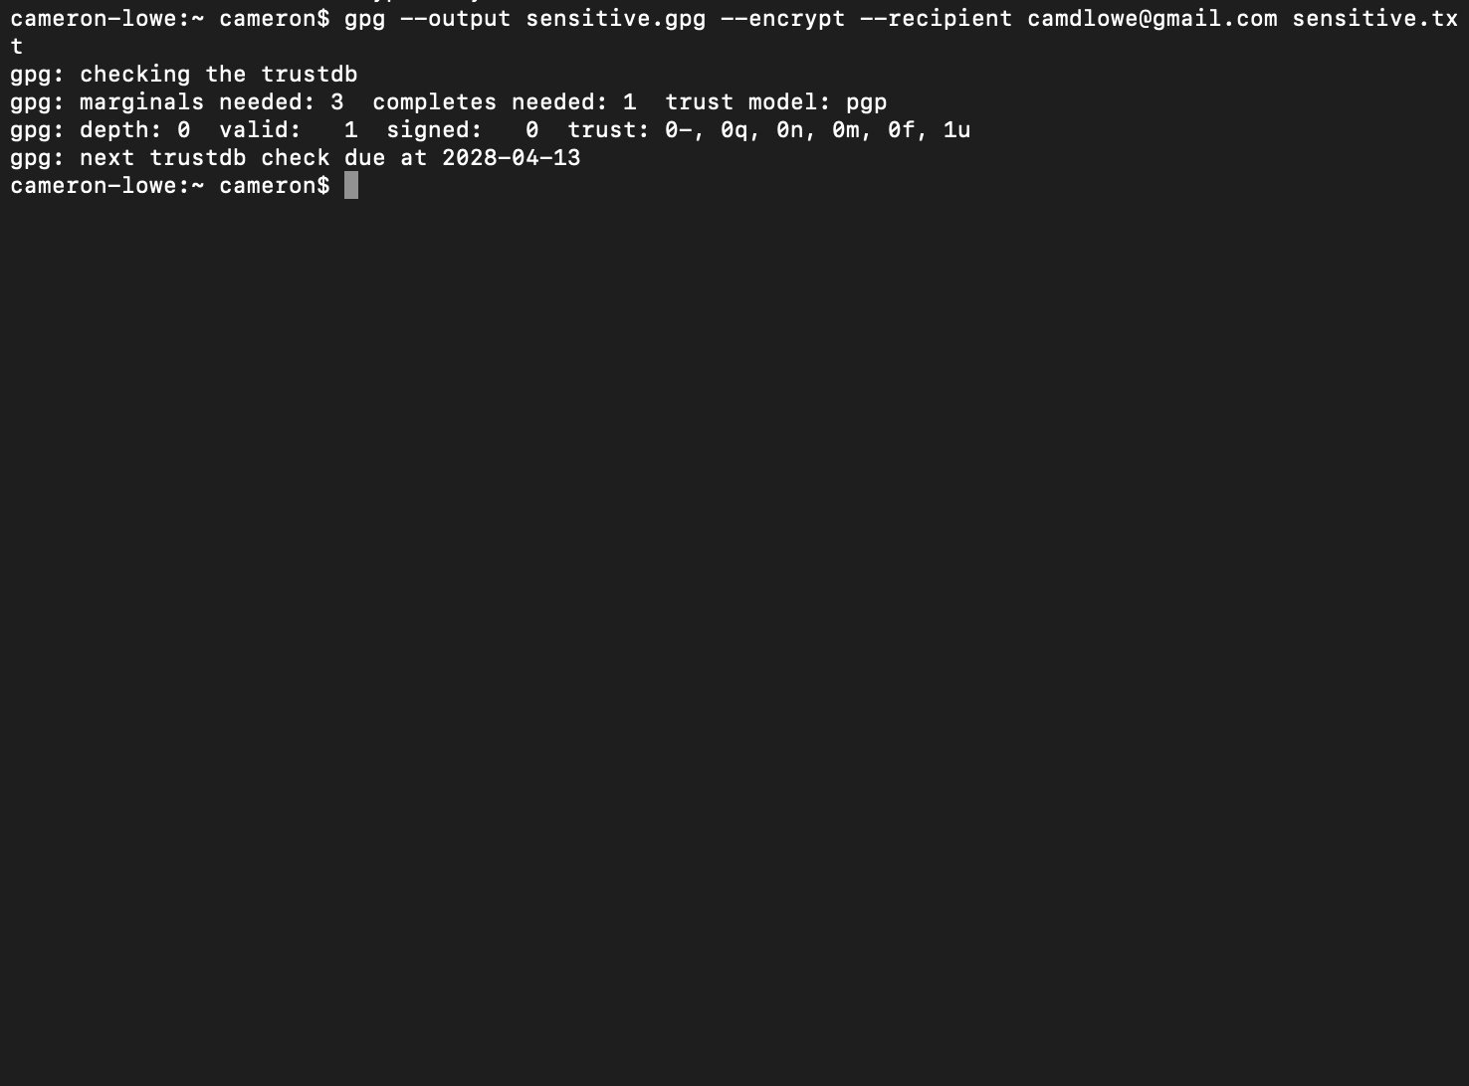
Figure 5.4 – Encryption successful: sensitive.txt encrypted to sensitive.gpg using RSA public key for camdlowe@gmail.com. Trust database verified.

Step 5 – Verification and Decryption
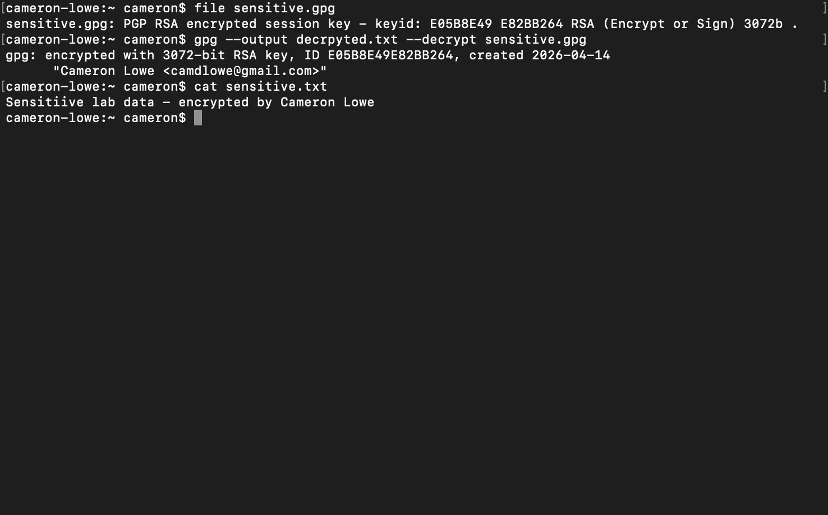
Figure 5.5 – Full encryption cycle verified: file sensitive.gpg confirmed as 'PGP RSA encrypted session key – keyid E05B8E49E82BB264 RSA 3072b'. Decryption successful using private key — plaintext 'Sensitive lab data – encrypted by Cameron Lowe' restored and verified with cat command.

Step | Command | Result
Key generation | gpg --gen-key | RSA 3072-bit key pair created for Cameron Lowe
File creation | echo '...' > sensitive.txt | Plaintext test file created and verified
Encryption | gpg --output sensitive.gpg --encrypt --recipient ... | File encrypted using RSA public key
Verification | file sensitive.gpg | Confirmed PGP RSA encrypted – unreadable without private key
Decryption | gpg --output decrypted.txt --decrypt sensitive.gpg | Original plaintext restored – encryption integrity confirmed

NIST Alignment
Framework | Control | Description
NIST CSF | Protect (PR.DS) | Data security – sensitive data encrypted at rest using asymmetric cryptography
NIST SP 800-53 | SC-12 | Cryptographic Key Establishment – RSA key pair generated and managed
NIST SP 800-53 | SC-13 | Cryptographic Protection – AES256/RSA3072 encryption applied to sensitive data
NIST SP 800-53 | SC-28 | Protection of Information at Rest – data encrypted before storage or transfer

Lab 6 – Incident Response Simulation
Objective: Practice structured incident handling using the NIST SP 800-61 lifecycle.
Tools: Windows Server 2022 VM, Windows Event Viewer, Task Manager, Registry Editor, VM Snapshot
Scenario: Simulated ransomware infection – tabletop exercise

Incident response is a core security operations competency. This lab simulates a ransomware infection scenario using the NIST SP 800-61 incident response lifecycle: Preparation, Detection and Analysis, Containment, Eradication, Recovery, and Post-Incident Activity. The exercise was conducted as a structured tabletop against the LAB-DC01 Windows Server 2022 environment.

Incident Response Timeline
Phase | Action Taken | Tool Used | Time (T+)
Identification | Anomalous process detected in running processes and event logs | Event Viewer / Task Manager | T+0
Containment | Host isolated by disabling VM network adapter to prevent lateral movement | VM network settings | T+10 min
Eradication | Malicious process terminated; registry Run keys inspected for persistence | Task Manager, Registry Editor | T+25 min
Recovery | Clean VM snapshot restored; system integrity verified post-restore | VM Snapshot Manager | T+45 min
Lessons Learned | Gaps documented: no EDR, no centralized logging; remediation plan drafted | Written report | T+60 min

Lessons Learned
Gap Identified | Risk | Remediation
No endpoint EDR solution | Malicious processes not automatically detected or blocked | Deploy EDR with behavioral detection capability
No centralized SIEM logging | Incident timeline reconstruction difficult without central logs | Implement SIEM – Windows Event logs forwarded and alerted
Manual containment required | Network isolation took 10 minutes – attacker had time to move laterally | Automate containment via EDR playbook or SOAR
VM snapshot not on regular schedule | Recovery point may be outdated in production | Implement automated daily snapshots with retention policy

NIST Alignment
Framework | Control | Description
NIST CSF | Respond (RS), Recover (RC) | Structured incident response and recovery aligned to NIST SP 800-61
NIST SP 800-53 | IR-4 | Incident Handling – detect, contain, eradicate, and recover from incidents
NIST SP 800-53 | IR-8 | Incident Response Plan – documented procedure following defined lifecycle phases
NIST SP 800-53 | CP-10 | System Recovery – clean state restoration via VM snapshot

Lab 7 – Risk Assessment and Documentation
Objective: Translate technical findings into business risk language for governance and decision-making.

The risk register consolidates findings from all six preceding labs into a governance-ready document. Each risk is assessed for likelihood and impact, existing controls are documented, and specific mitigations are recommended. This demonstrates GRC documentation skills relevant to analyst and compliance roles.

Risk Register
Risk | Likelihood | Impact | Current Control | Mitigation | Owner
RDP (3389) exposed externally | High | High | None | Restrict to VPN/jump host only | IT Ops
LDAP (389) unencrypted | High | High | None | Enforce LDAPS (636), disable plain LDAP | IAM Team
SMB (445) exposed on DC | High | High | Network segmentation | Restrict via firewall to authorized hosts | IT Ops
HTTP traffic unencrypted | Medium | Medium | None | Enforce TLS, implement HSTS | IT Ops
No endpoint EDR | Medium | High | Windows Defender | Evaluate and deploy EDR solution | Security Ops
No centralized SIEM | High | High | Windows Event Logs local | Deploy SIEM, forward all logs | Security Ops
Weak password policy (pre-GPO) | Medium | High | None | GPO enforced: 12+ char + MFA | IAM Team
Undetected lateral movement | Medium | High | Subnet segmentation | Deploy NACLs, implement EDR | Security Ops

NIST Alignment
Framework | Control | Description
NIST CSF | Identify (ID.RA) | Risk assessment – threat scenarios mapped to existing controls and mitigations
NIST SP 800-53 | RA-3 | Risk Assessment – likelihood, impact, and mitigation documented for each risk
NIST SP 800-53 | PM-9 | Risk Management Strategy – risk register maintained, prioritized, and tracked

IT Service Management & Governance (ITIL 4)
ITIL 4 service management principles are integrated throughout this playbook to ensure technical activities are governed, documented, and aligned to business value delivery. The Service Value System (SVS) provides the governance structure that ties together all lab activities.

Service Value Chain Mapping
SVS Activity | Playbook Mapping
Plan | Risk assessments, access reviews, change evaluation (Labs 1, 7)
Improve | Continual improvement register and post-incident reviews (Lab 6)
Engage | Incident intake and stakeholder communication (Lab 6)
Design & Transition | Secure system and access design (Labs 4, 5)
Obtain / Build | Tool configuration and system hardening (Labs 1, 2, 3, 4)
Deliver & Support | Endpoint support and incident response (Labs 3, 6)

Continual Improvement Register
Improvement | Current State | Target State | Owner | Status
Enforce LDAPS on DC | Plain LDAP (389) open | LDAPS only (636) | IAM Team | Planned
Deploy centralized SIEM | Local Windows Event Logs only | Splunk ingesting all sources | Security Ops | In Progress
Implement MFA for AD accounts | Password-only auth | MFA enforced domain-wide | IAM Team | Planned
Enable host-based EDR | Windows Defender only | EDR with central management | Security Ops | Planned
Restrict SMB via firewall | SMB open on network | SMB restricted to authorized hosts | IT Ops | Planned

Framework Alignment Summary
Framework | Role in This Playbook
NIST CSF | Security risk management across all five functions: Identify, Protect, Detect, Respond, Recover
NIST SP 800-53 | Specific control references per lab: AC, AU, CA, CM, CP, IA, IR, PM, RA, SC, SI controls
ITIL 4 | Service management governance — SVS mapping, change records, continual improvement register
MITRE ATT&CK | Threat context for Lab 1 findings — T1046 (Network Service Scanning), T1110 (Brute Force)
CIS Controls | Lab 4 password/lockout policy aligns to CIS Control 5 (Account Management)
CompTIA A+ / N+ / S+ | Technical execution competencies demonstrated through live lab evidence

Playbook Completion Statement
All seven labs have been executed in a live environment and documented with real evidence. Network scans, packet captures, encryption operations, Active Directory configuration, and incident response procedures are all supported by verifiable screenshots and command outputs. This playbook demonstrates practical, enterprise-relevant IT and security competency.

