**CWRU ETL Project**

For this project we found data on two different methods of counting crime. These sources are National Incident-Based Reporting System (NIBRS) and Uniform Crime Reports (UCR). These datasets are available online through the Inter-University Consortium for Political and Science Research (<https://www.icpsr.umich.edu/icpsrweb/NACJD/NIBRS/>) as well as from the US DOJ-BJS.

* Jupyter Notebook - Pandas
  + The data were imported from CSV files into Panda dataframes. The data were cleaned and unnecessary columns and rows were removed from the dataframes.
  + The data, when necessary, were concatenated into one dataframe.
  + Data were then aggregated into yearly data.
  + The final dataframes were then exported to CSV files for importing into MySQL.
* SQL
  + Database was created utilizing MySQL (*.sql files in repository will recreate the database).
  + Created our two tables labeled “yearlyNIBRS” and “yearlyUCR”
  + Imported our Python modified CSV datasets in SQL using the the *data import wizard* in MySQL
  + Our final merged result was queried with the JOIN statement, code provided below: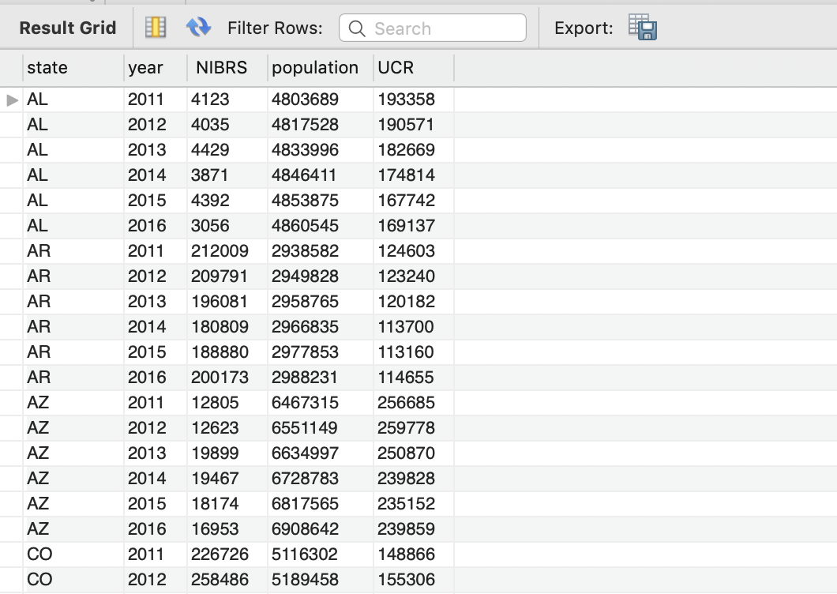
    - USE merge_db;
    - SELECT *
    - FROM yearlyNIBR
    - JOIN yearlyUCR USING (state, year)
  + The screenshot provided displays our final results in SQL, in conclusion we were able to aggregate all national crime from this data painting a picture by state and year