Katrina Anne A. Tredes

My module is all about adding appointment, edit and delete and put it in the calendar. So far, I started my module and it’s only displaying the calendar and the infos can be saved in the database.

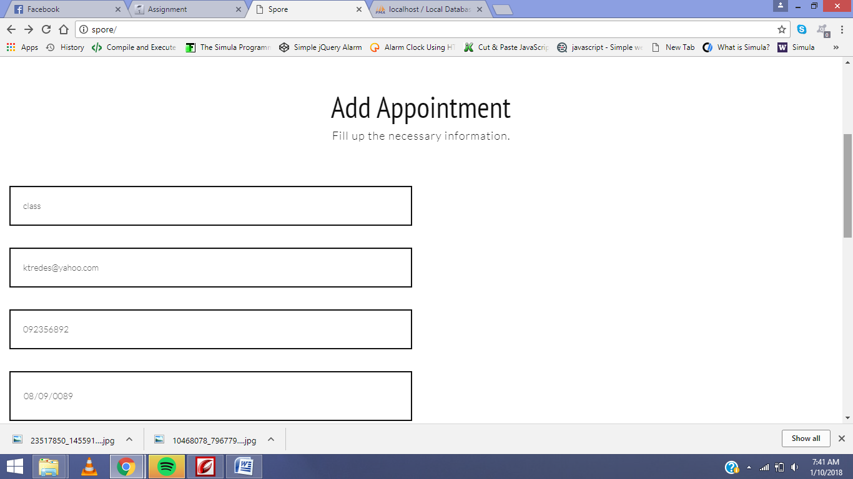

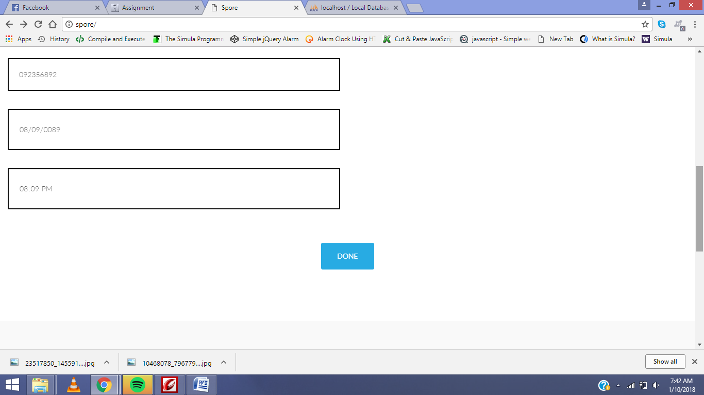

So if you click the Done button, the calendar should have a marking in the certain date that was chosen by the user the symbolizes that he/she has already have an appointment in that certain date. But sadly, I still can’t connect them.

