1. Objectives and Lab Description
   1. The main objectives of this lab is learning debugger, in our case is the GDB. We learn it using command line and then use the eclipse to debug our program.
   2. There are total of 8 examples and a seg_fault example, we need to debug the first example and the seg_fault example with command, and the rest of the example using eclipse debugger.
   3. We need to learn the debug process, different type of error, types of segmentation fault, memory leak and the way to find them, fix them.
2. Implementations:
   1. Implementation of the SegFault example is straight forward following the Lab procedure, it basically is an introduction on how to use the key word in GBD, and at the end we found the the address C is try to access is not valid, then I change all the index to the range between 1-9999
   2. First example we used GBD to debug, it was writing some characters to a file, which the name of the file is decide by the user.
      1. First I compile it using gcc –g Lab4-ex1.c –o ex1.out (which create a executable named ex1.out and have the debug simple because of -g)
      2. then gdb ex1.out (run the debugger with the file)
      3. typed start in the command line, it start the program, after I typed name of the file, the error massage come out and saying program received signal SIGSEGV, segmentation fault.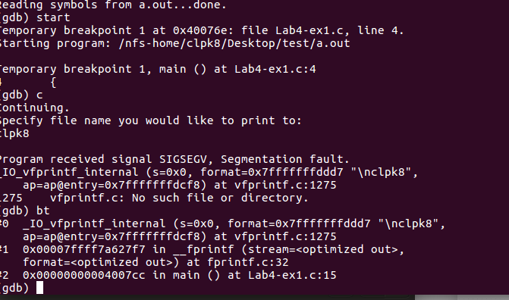
      4. I used back trace to see which frame is wrong, and I found there are a lot of massage is associated with fprintf.

I looked up the format of fprintf, fprintf(fp, "%s %s %s %d", "We", "are", "in", 2012);

* + 1. Referenced from tutorialspoint, and I found the format of fprintf is wrong, and then I corrected it. but there are still error massage.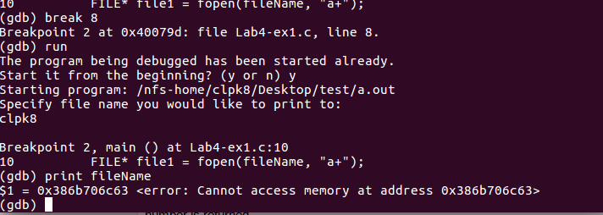
    2. I realized that the name of the file I entered is lost in address. I check the scanf function and it has a &, and I fixed the issue, then the program run and operate its task without issue.

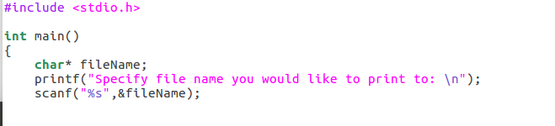

* 1. On the ex2.c, we told to use the eclipse to do the debugging.
     1. First we create a project and using debug instead of release.
     2. We cope and paste the program to the eclipse, compile it and run it. The result is not showing up, that indicated that there is an error
     3. I went to the debug section, and step through the program. 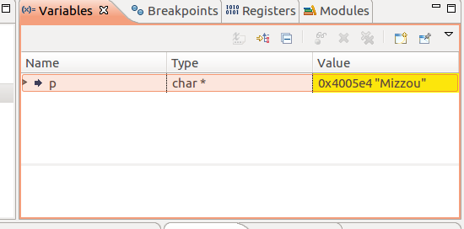
     4. Pointer p is point to an address containing MIZZOU as a string, but when the program want to change the forth value of a pointer to P, that’s there the error is.

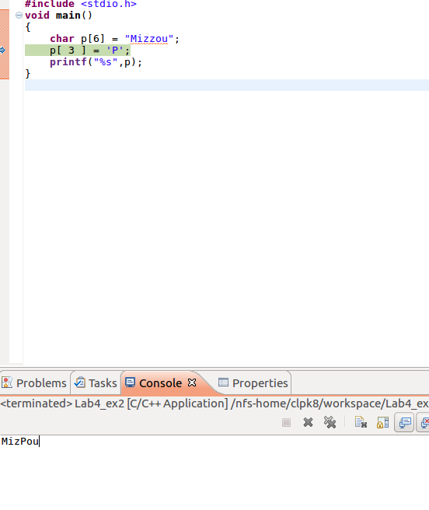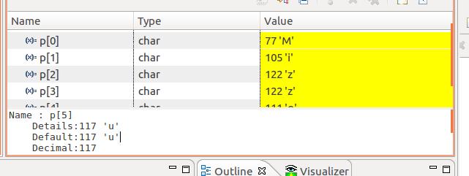

* + 1. I made a little change to the declaration, and step trough it to make sure it is alright. It successfully changed the forth value to P.