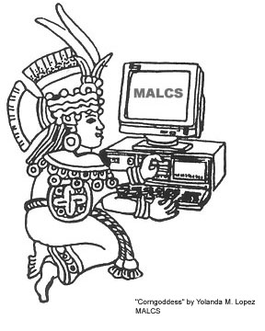

The UC Davis Campus Chapter of

MALCS

Mujeres Activas en Letras y Cambio Social

(Women Active in Letters and Social Change)

Invites all Chicana, Latina, and Indigenous identified women students, staff, and faculty to the MALCS Monthly Plática.

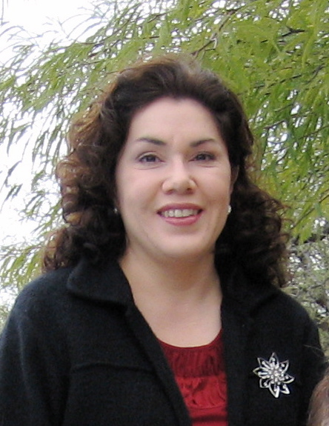

May plática features:
Prof. Lorena Oropeza
Dept. of History, UCD
Author of ¡Raza Sí! ¡Guerra No!: Chicano Protest and Patriotism During the Viet Nam Era
Current research focus: Alianza land-grant movement in New Mexico employing theme of memory and history.

Our pláticas (informal dialogue circles) aim to connect students with faculty and staff, to raise awareness of the experiences of Chicana, Latina, and Indigenous identified women in academia, and to explore different areas of study.

Friday, May 15th, 2009

HIA Conference Room, 5214 SS&H
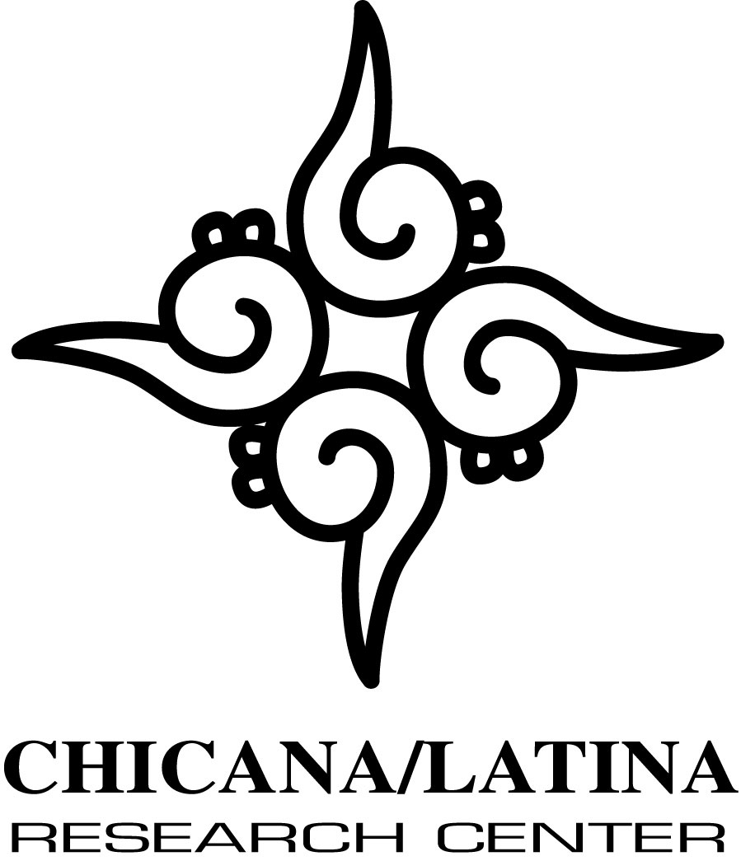
12:00-2:00 p.m.

Sponsored by:

