1. Connected to database



1. Main Menu

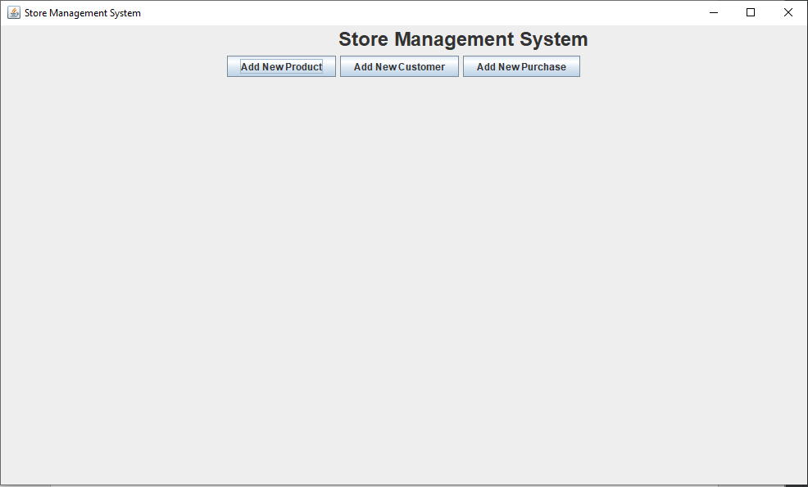

1. Add Customer Menu

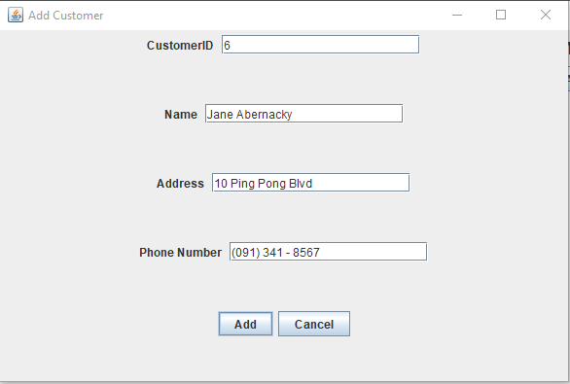

1. Add Customer…

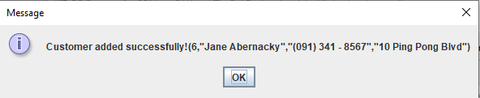



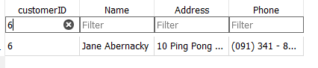

1. Add Product Menu

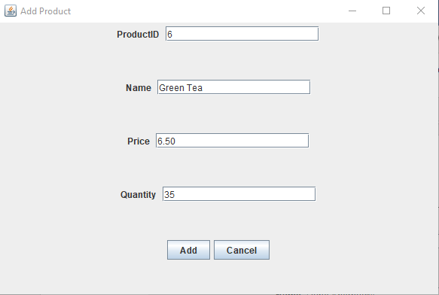

1. Add Product…

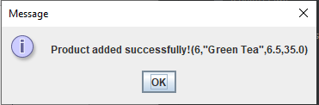



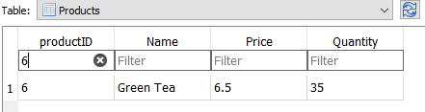

1. Add Purchase Menu

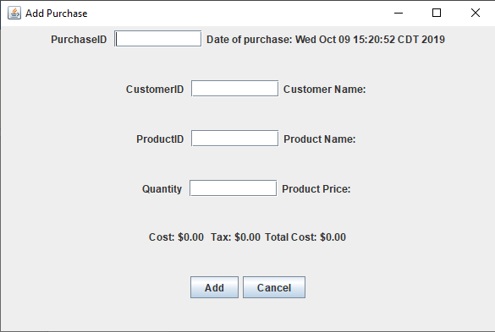

1. Add Purchase Info Look Up…

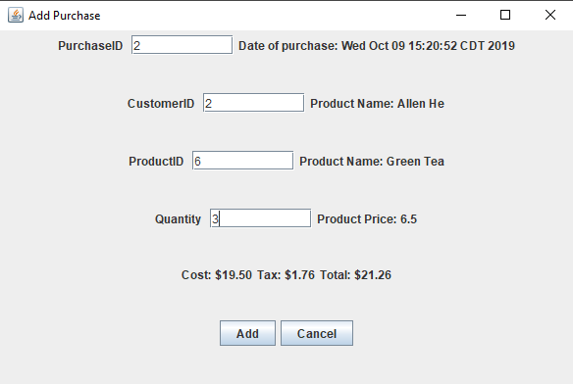

1. Add Purchase…

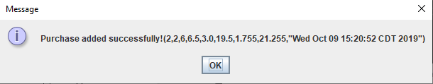



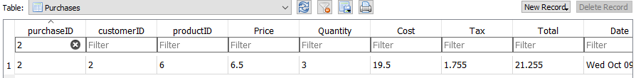

1. Add Product Duplicate Error

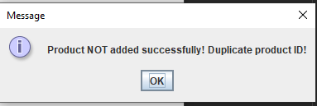

1. Add Customer Duplicate Error

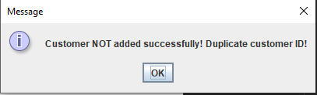

1. Add Purchase Duplicate Error

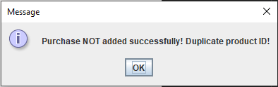

1. Customer ID not found Error in Add Purchase

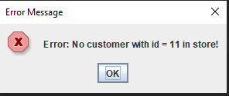

1. Product ID not found Error in Add Purchase

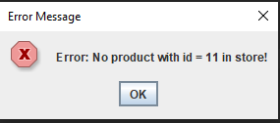

1. Not enough quantity Error in Add Purchase

