mknod /dev/cl_rd b 220 0

mke2fs /dev/cl_rd

mount /dev/cl_rd /home/cl/Project/linux_modules/blkdisk/disk

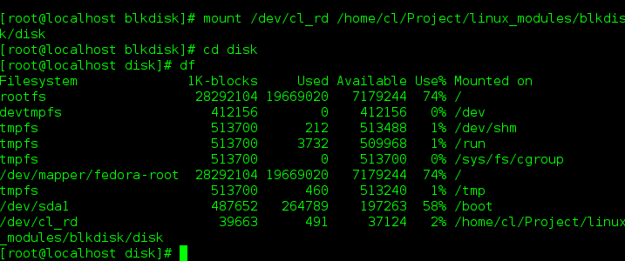

Create a memory dksk with 40M space