[root@localhost netlink_broadcast]# insmod netlink_broad.ko

[root@localhost netlink_broadcast]# cd src

[root@localhost src]# ./netlink_broadcast

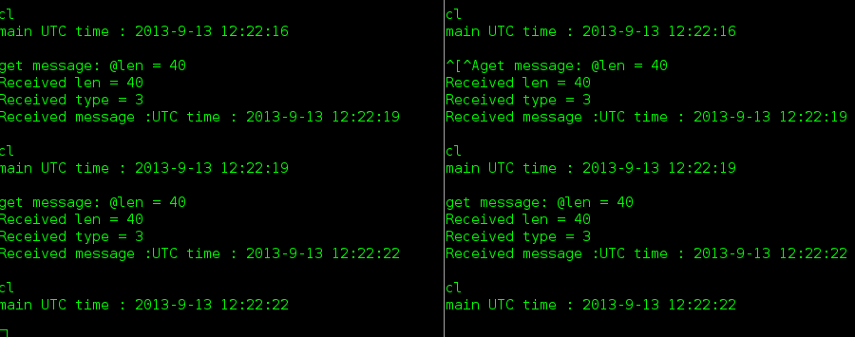 the kernel send msg to the process which has the same dst.group