






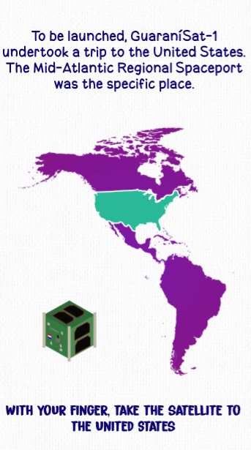


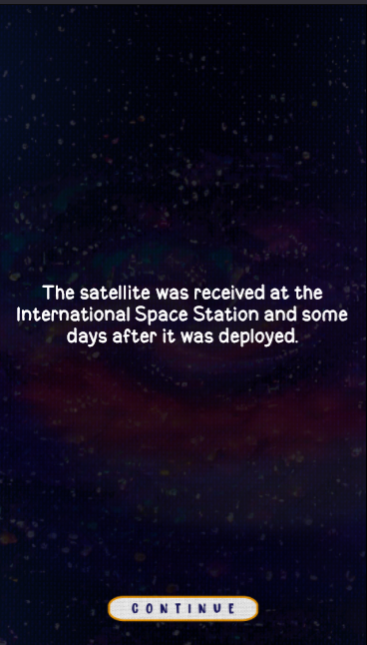

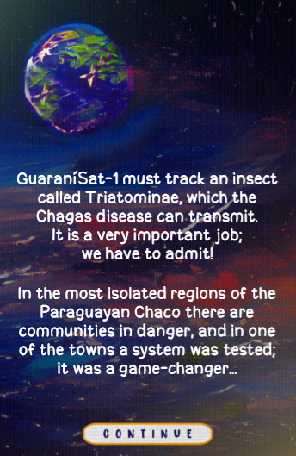
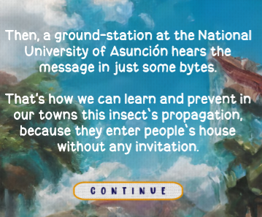


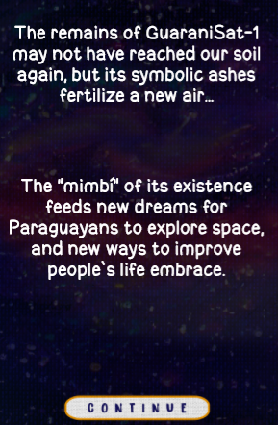

- What does MIMBI mean?

IMBI is a story that introduces people to the wonders of GuaraniSat-1, but it is not a normal and boring story, this is a different way of telling a story, because the creator keeps the reader's focus, with little games in parts of the story and gifs in the background.

- What space agencies were involved in the project?

The two space agencies involved were the Paraguayan Space Agency and NASA.

- What kind of satellite was the Guaranisat-1?

Guaranisat-1 was a nanosatellite designed for a bird project.

- What country was the satellite launched from?

The satellite was launched from United States.

- What was the mission of Guarani-Sat-1?

Guaranisat-1 was used to detect an insect.

