Instalación de TomCat en windows server

Comandos:

sudo apt update

sudo add-apt-repository ppa_linuxprising/java

sudo apt update

sudo apt install oracle-java17-installer

sudo apt update

java -version

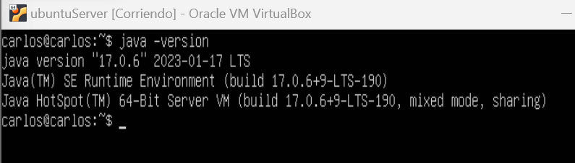
sudo apt install oracle-java17-set-default

sudo apt install tomcat9 tomcat9-admin

sudo apt install default-jdk

sudo systemctl status tomact9

sudo systemctl restart tomcat9

sudo systemctl status tomcat9

ss -ltn

sudo nano /etc/tomcat9/tomcat-users.xml » <user username=”admin” password=”admin” roles=”admin-gui,manager-gui”/>

sudo systemctl restart tomcat9

172.22.0.5/manager/html, comprobamos que se ha instalado correctamente

