THE CLARVOY
Bias-Control Reference Catalog

A field guide to the biases that distort judgment and the measures that hold it to account

How to read this catalog
The catalog is built around a single idea. Good judgment is not a matter of character but of record. A claim that cannot be checked by a second person is not yet knowledge, only confidence. Every entry that follows turns a familiar way of going wrong into something a reviewer can look for, and every measure turns a forecast into a number that the future can confirm or deny.
Each entry holds four parts. The first says plainly what the bias or measure is. The second gives the equation or control signal, with each symbol named directly beneath it. The last two describe how the entry serves a nonprofit board and a company board, since the same failure of judgment visits the boardroom of a charity and a corporation alike.
A flag in this catalog is never an accusation. It is a request for better evidence, or for an honest record of what was predicted before the outcome was known. Greek symbols such as kappa and alpha denote control coefficients and pressures. Latin symbols such as N and p denote counts and probabilities. Each calculation defines its own terms beneath the formula.
Contents

Bias Entries (33)
This first part of the catalog names 33 ways a careful mind still goes wrong. Each entry describes a single bias, the moment it tends to strike, and a control signal that a reviewer can compute to see whether a record has guarded against it. The biases are grouped by the kind of reasoning they distort, from probability and social pressure to value and evidence.

A1 - Anchoring Bias

What it measures
Anchoring bias is the mind's habit of latching onto the first number it hears and then adjusting too little from it. The mind treats that opening figure as a gravitational center, even when it is arbitrary. A board hears that a partner organization once valued a building at 4 million dollars, and every later estimate drifts toward that figure, though the honest appraisal sits closer to 2.8 million. The danger arrives early, in the first quote or the first deadline, before anyone has gathered the evidence that should set the real range.
How it is calculated
κ_A = w_ππ + w_ρρ + w_ιι + w_δδ − w_αα
The control here is independent blind aggregation paired with a prior distribution fixed before the first quote or valuation lands. The score rises with genuine priors and falls as anchor pressure grows.
κ_A is the strength of the statistical or probability control.
π is the explicit prior or base-rate distribution.
ρ is the reference-class coverage.
ι is the independent blind estimate indicator.
δ is the documented dissent or counterfactual challenge.
α is the anchor or streak pressure strength.
w_* is the set of pre-set governance weights.
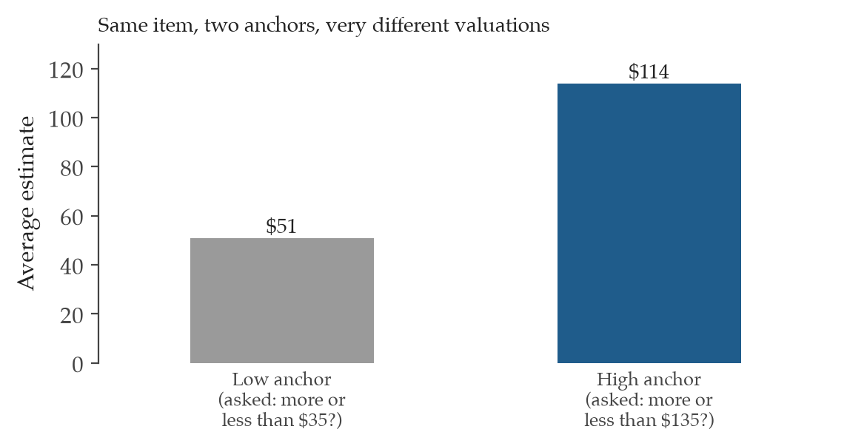
Figure 1. How a starting number drags a final estimate. Two groups valued the same item after seeing a different opening figure. The group shown the higher anchor landed more than twice as high. The first number on the table pulls every later judgment toward itself, even when everyone knows it was arbitrary.
Where it is used
Nonprofit director and board | For a nonprofit director and board, anchoring bias is worth naming whenever the first figure on the table sets the tone for a lease, a salary band, or a fundraising target. The control asks each reviewer to record an independent estimate, and a prior range, before the opening number is spoken aloud. That small discipline keeps the mission and the budget answering to the evidence rather than to whoever quoted first.
Company leadership and board | For company leadership and a board, anchoring bias most often bites during pricing, capital allocation, and acquisition talks, where a seller's opening valuation can quietly become the reference for the whole negotiation. Gathering blind estimates and a stated prior before that first number arrives separates the evidence from the momentum of the conversation. The result is a deal judged on its own worth rather than on the anchor someone planted.

A2 - Availability Heuristic

What it measures
The availability heuristic is the mind's shortcut of judging how common something is by how easily an example comes to mind. Vivid or recent events feel frequent, while quiet base rates stay invisible. After one widely shared story of a grant being clawed back, a director starts treating clawbacks as a looming threat, though the records show it has happened twice in 300 grants. The bias bites hardest right after a dramatic event, when the freshest memory crowds out the longer record.
How it is calculated
κ_A = w_ππ + w_ρρ + w_ιι + w_δδ − w_αα
The control is base-rate retrieval combined with a noise audit run across the evaluators. The score rises as real frequencies enter the room and falls as recall pressure takes over.
κ_A is the strength of the statistical or probability control.
π is the explicit prior or base-rate distribution.
ρ is the reference-class coverage.
ι is the independent blind estimate indicator.
δ is the documented dissent or counterfactual challenge.
α is the anchor or streak pressure strength.
w_* is the set of pre-set governance weights.
Where it is used
Nonprofit director and board | For a nonprofit director and board, the availability heuristic shows up when a single memorable incident reshapes a staffing or partnership decision out of proportion to how often such things actually occur. Pulling the real base rate, and checking how widely evaluators disagree, restores the longer record to the conversation. The board then weighs the threat by its true frequency rather than by how loudly the last example still echoes.
Company leadership and board | For company leadership and a board, the availability heuristic distorts risk and product judgments when a recent failure or a rival's stumble dominates the discussion. Retrieving the underlying frequency, and auditing the spread of opinion before consensus is claimed, keeps a single vivid case from steering capital. Decisions then track what the data says is common rather than what memory says is recent.

A3 - Base Rate Neglect

What it measures
Base rate neglect is the mind's tendency to fix on specific, vivid evidence and forget the underlying prior probability. A detailed case description feels so telling that the background frequency simply drops out of the calculation. A program officer reads a glowing profile of an applicant and judges success near certain, ignoring that programs of this kind succeed roughly 30% of the time. The bias bites whenever a compelling particular case arrives without its statistical backdrop.
How it is calculated
κ_A = w_ππ + w_ρρ + w_ιι + w_δδ − w_αα
The control is a Bayesian decomposition that blends the specific evidence back into the reference class. The score climbs as priors and reference coverage return to the reasoning.
κ_A is the strength of the statistical or probability control.
π is the explicit prior or base-rate distribution.
ρ is the reference-class coverage.
ι is the independent blind estimate indicator.
δ is the documented dissent or counterfactual challenge.
α is the anchor or streak pressure strength.
w_* is the set of pre-set governance weights.
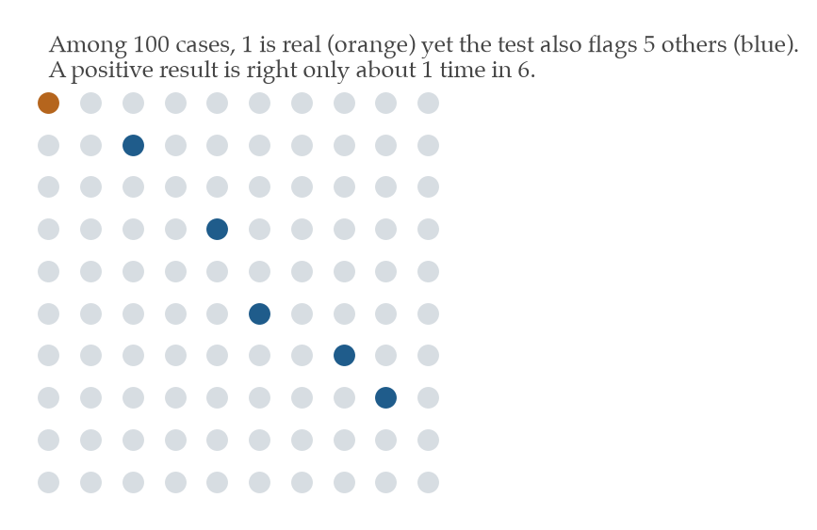
Figure 2. Why a positive test can still be mostly wrong. Each dot is one of 100 cases. One case is genuinely positive. A test that is 95% accurate still raises several false alarms among the 99 negatives, so most positive results are false. The mind tends to forget the base rate and trust the test.
Where it is used
Nonprofit director and board | For a nonprofit director and board, base rate neglect appears when one persuasive application or proposal eclipses what similar efforts have historically achieved. Restating the prior, and the reference class it belongs to, sets the vivid case back inside its real odds. The board can then fund with eyes open to how often this kind of bet pays off.
Company leadership and board | For company leadership and a board, base rate neglect undermines forecasts when a striking pitch or a single data point overrides the historical success rate of comparable ventures. A Bayesian read that weighs the new evidence against the reference class keeps the prior in view. Capital then flows on the full picture rather than on the most arresting story in the deck.

A4 - Conjunction Fallacy

What it measures
The conjunction fallacy is the mind's error of judging a detailed, specific scenario as more likely than a broader one that contains it. A rich story feels more probable than a plain statement, even though added detail can only narrow the odds. A board guesses that a major donor will both increase giving and join the gala committee is likelier than simply increasing giving, though the joint event can never outrank its part. The bias bites whenever a plausible narrative dresses up a claim with extra conditions.
How it is calculated
κ_A = w_ππ + w_ρρ + w_ιι + w_δδ − w_αα
The control forecasts each conjunct on its own and checks that P(A and B) never exceeds P(A). The score rises as separate estimates replace the seductive combined story.
κ_A is the strength of the statistical or probability control.
π is the explicit prior or base-rate distribution.
ρ is the reference-class coverage.
ι is the independent blind estimate indicator.
δ is the documented dissent or counterfactual challenge.
α is the anchor or streak pressure strength.
w_* is the set of pre-set governance weights.
Where it is used
Nonprofit director and board | For a nonprofit director and board, the conjunction fallacy surfaces when a detailed plan, with several happy conditions all holding at once, feels safer than a simpler version. Estimating each piece separately reveals that more moving parts mean lower combined odds. The board then plans around the real probability rather than the comfort of a complete-sounding story.
Company leadership and board | For company leadership and a board, the conjunction fallacy inflates confidence in elaborate market scenarios that require many conditions to align. Forecasting each condition on its own, and confirming the joint case stays below any single part, restores honest odds. Strategy then rests on probabilities that the arithmetic actually supports.

A5 - Gambler's Fallacy

What it measures
The gambler's fallacy is the mind's belief that independent random events owe a correction after a run. A streak of one outcome feels like it must be balanced by the other, though chance has no memory. After three failed grant applications, a development lead feels the fourth is overdue to land, as if past rejections improved the next roll. The bias bites wherever genuinely independent trials are read as though they are tied together.
How it is calculated
κ_A = w_ππ + w_ρρ + w_ιι + w_δδ − w_αα
The control requires stating the assumed dependence structure before any reasoning about streaks begins. The score rises once independence is made explicit and falls under unexamined pattern pressure.
κ_A is the strength of the statistical or probability control.
π is the explicit prior or base-rate distribution.
ρ is the reference-class coverage.
ι is the independent blind estimate indicator.
δ is the documented dissent or counterfactual challenge.
α is the anchor or streak pressure strength.
w_* is the set of pre-set governance weights.
Where it is used
Nonprofit director and board | For a nonprofit director and board, the gambler's fallacy can creep into fundraising and hiring when a string of setbacks breeds a sense that good fortune is now due. Naming whether the events are truly independent settles whether the streak carries any signal at all. The board then acts on the underlying odds rather than on a felt sense of cosmic balance.
Company leadership and board | For company leadership and a board, the gambler's fallacy distorts risk judgments when a run of wins or losses is read as a trend that must reverse. Declaring the assumed dependence structure up front shows whether the sequence means anything. Capital and risk decisions then rest on the actual structure of the events rather than on a craving for the table to even out.

A6 - Hot-Hand Fallacy

What it measures
The hot-hand fallacy is the mind's habit of reading a recent run of success as proof that more success will follow, when the underlying events may be independent. A streak feels like momentum, a force that carries forward. After a manager closes four strong quarters, the board treats a fifth as nearly assured, mistaking a likely coincidence for a sustained edge. The bias bites when a short run of good outcomes is taken as evidence of a lasting pattern.
How it is calculated
κ_A = w_ππ + w_ρρ + w_ιι + w_δδ − w_αα
The control is an independence audit, joined by a runs test when the sample is large enough to support one. The score rises as the streak is tested rather than assumed.
κ_A is the strength of the statistical or probability control.
π is the explicit prior or base-rate distribution.
ρ is the reference-class coverage.
ι is the independent blind estimate indicator.
δ is the documented dissent or counterfactual challenge.
α is the anchor or streak pressure strength.
w_* is the set of pre-set governance weights.
Where it is used
Nonprofit director and board | For a nonprofit director and board, the hot-hand fallacy appears when a recent run of successful campaigns or placements is read as durable skill rather than possible luck. An independence check, with a runs test where the numbers allow, tells whether the streak holds real signal. The board then bets on demonstrated reliability rather than on the warmth of a recent winning spell.
Company leadership and board | For company leadership and a board, the hot-hand fallacy inflates faith in a team or a product line riding a recent streak, which can pull capital toward momentum that may not persist. Auditing for independence, and testing the run when the sample permits, distinguishes genuine edge from chance. Investment then follows proven performance rather than the glow of a hot quarter.

A7 - Zero-Risk Bias

What it measures
Zero-risk bias is the mind's pull toward wiping out one small risk entirely rather than making a larger cut in overall danger. The clean certainty of zero feels worth more than a bigger reduction that leaves some risk standing. A board spends heavily to erase a 1% hazard completely while passing on a measure that would have lowered a 12% hazard to 4%. The bias bites whenever the comfort of eliminating a category outweighs the larger good of reducing total exposure.
How it is calculated
κ_A = w_ππ + w_ρρ + w_ιι + w_δδ − w_αα
The control is a cost-loss analysis that compares the size of the risk reduction rather than the size of the risk left behind. The score rises as reasoning shifts from remaining risk to risk removed.
κ_A is the strength of the statistical or probability control.
π is the explicit prior or base-rate distribution.
ρ is the reference-class coverage.
ι is the independent blind estimate indicator.
δ is the documented dissent or counterfactual challenge.
α is the anchor or streak pressure strength.
w_* is the set of pre-set governance weights.
Where it is used
Nonprofit director and board | For a nonprofit director and board, zero-risk bias shows up when scarce funds are spent to fully close one small hazard while a larger one goes underaddressed. A cost-loss view that ranks options by how much total risk each removes redirects effort to where it does the most good. The board then protects the people it serves by the weight of the reduction rather than by the appeal of a tidy zero.
Company leadership and board | For company leadership and a board, zero-risk bias misallocates safety and compliance spending toward eliminating minor exposures while greater ones persist. Comparing options by the magnitude of risk reduced, not the residue that remains, keeps capital aimed at the largest gain. Resources then buy the most overall protection rather than the satisfaction of a single risk reaching zero.

B1 - Authority Bias

What it measures
Authority bias is the mind's tendency to weigh a powerful person's opinion far more heavily than the evidence behind it. A title or a reputation can quietly stand in for proof. When a respected board chair voices a view first, the rest of the room nods, and a quiet analyst who saw a flaw in the projection lets it pass. The bias bites whenever standing in the hierarchy substitutes for the strength of the argument.
How it is calculated
κ_B = w_ιι + w_δδ + w_σσ_s − w_γγ_social − w_GG
The control gathers blind estimates before any authority speaks and tracks an influence Gini to see how concentrated the sway has become. The score rises with independence and dissent, and falls as social pressure and influence concentration grow.
κ_B is the strength of the reviewer-independence control.
ι is the independent or blind judgment indicator.
δ is the dissent or challenge record.
σ_s is the observed score spread before consensus.
γ_social is the authority or crowd pressure.
G is the influence Gini concentration.
w_* is the set of pre-set governance weights.
Where it is used
Nonprofit director and board | For a nonprofit director and board, authority bias is worth watching when a founder or a senior funder speaks early and shapes the room before quieter voices weigh in. Collecting independent judgments first, and measuring how concentrated the influence is, lets the evidence stand apart from the title. The board then hears the dissent it needs rather than the deference it is used to.
Company leadership and board | For company leadership and a board, authority bias can let a charismatic executive's view override sound analysis in strategy and capital decisions. Blind estimates taken before that voice enters, paired with a read on how concentrated the influence has grown, keep evidence separate from rank. Decisions then answer to the argument rather than to the corner office.

B2 - Bandwagon Effect

What it measures
The bandwagon effect is the mind's drift toward whatever the crowd already believes, rather than toward the evidence. Agreement feels like safety, so opinions cluster around the majority. As most of a committee leans toward approving a partnership, a skeptical member quietly drops the objection and joins the consensus. The bias bites whenever the comfort of the group's direction starts to outweigh what the facts would say on their own.
How it is calculated
κ_B = w_ιι + w_δδ + w_σσ_s − w_γγ_social − w_GG
The control uses blind aggregation and a counterfactual prompt that asks whether a flip in the crowd would actually move the estimate. The score rises with independent judgment and falls under crowd pressure.
κ_B is the strength of the reviewer-independence control.
ι is the independent or blind judgment indicator.
δ is the dissent or challenge record.
σ_s is the observed score spread before consensus.
γ_social is the authority or crowd pressure.
G is the influence Gini concentration.
w_* is the set of pre-set governance weights.
Where it is used
Nonprofit director and board | For a nonprofit director and board, the bandwagon effect appears when a forming majority pulls undecided members along before the evidence has been fully aired. Gathering views blindly, and asking whether a reversal in the crowd would change anyone's number, keeps judgment anchored to the facts. The board then decides on the merits rather than on the momentum of the room.
Company leadership and board | For company leadership and a board, the bandwagon effect can sweep a team toward a popular strategy or a hot market simply because everyone seems to agree. Blind aggregation, with a check on whether a crowd flip would truly shift the estimate, separates conviction from conformity. Capital then follows the evidence rather than the consensus of the moment.

B3 - Dunning-Kruger Effect

What it measures
The Dunning-Kruger effect is the pattern in which the least skilled judges are often the most confident, because the same gaps that cause errors also hide them. Competence and calibration can run in opposite directions. A new evaluator, sure of every call, rates forecasts with bold certainty, while a seasoned one hedges and turns out far better calibrated. The bias bites when loud confidence is mistaken for real accuracy.
How it is calculated
κ_B = w_ιι + w_δδ + w_σσ_s − w_γγ_social − w_GG
The control publishes Brier and calibration curves built over repeated forecasts, so confidence can be checked against the record. The score rises as independent, well-calibrated judgment is documented.
κ_B is the strength of the reviewer-independence control.
ι is the independent or blind judgment indicator.
δ is the dissent or challenge record.
σ_s is the observed score spread before consensus.
γ_social is the authority or crowd pressure.
G is the influence Gini concentration.
w_* is the set of pre-set governance weights.
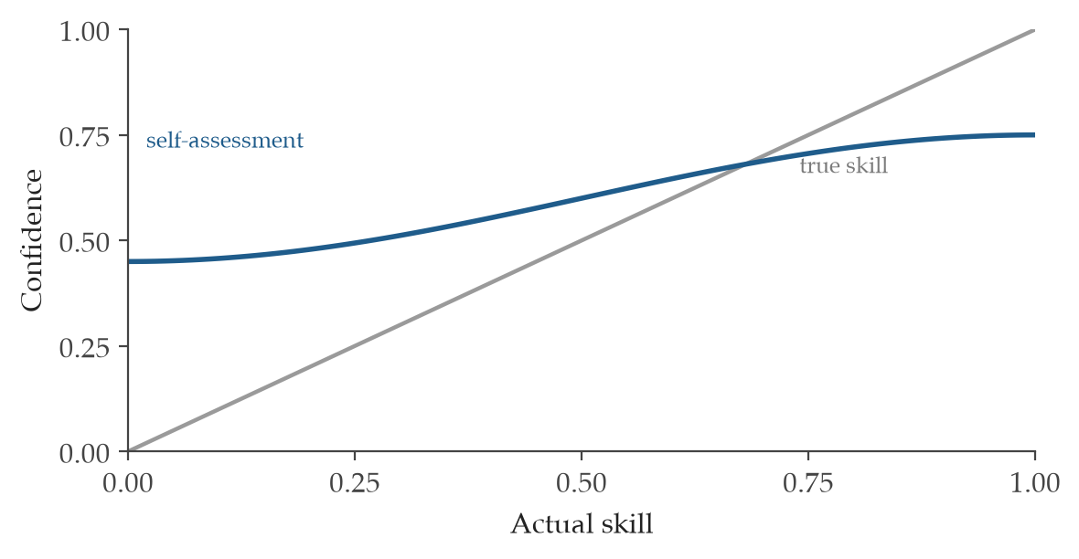
Figure 3. Confidence against real skill. The least skilled tend to rate themselves well above their true ability, while the most skilled often rate themselves slightly below. The gap between the two curves is the blind spot. It is widest exactly where competence is lowest.
Where it is used
Nonprofit director and board | For a nonprofit director and board, the Dunning-Kruger effect matters when a confident but untested voice carries weight it has not earned. Tracking each evaluator's calibration over many forecasts shows whose certainty is backed by accuracy. The board then leans on judgment that the record has proven rather than on the volume of someone's conviction.
Company leadership and board | For company leadership and a board, the Dunning-Kruger effect can place the boldest, least-tested forecaster at the center of strategy. Publishing Brier and calibration curves over repeated calls reveals who is actually reliable. Decisions then rest on a measured track record rather than on displayed confidence.

B4 - Egocentric Bias

What it measures
Egocentric bias is the mind's habit of placing its own perspective at the center, so memory and judgment tilt toward one's own role and experience. We recall our contributions more vividly than others' and assume the world sees what we see. A director remembers steering a successful program almost single-handedly, though colleagues recall a far more shared effort. The bias bites whenever the operator's own vantage point is mistaken for the whole picture.
How it is calculated
κ_B = w_ιι + w_δδ + w_σσ_s − w_γγ_social − w_GG
The control applies an outside-view prompt and reference-class forecasting, pulling judgment away from the personal vantage point. The score rises as the wider class of cases re-enters the reasoning.
κ_B is the strength of the reviewer-independence control.
ι is the independent or blind judgment indicator.
δ is the dissent or challenge record.
σ_s is the observed score spread before consensus.
γ_social is the authority or crowd pressure.
G is the influence Gini concentration.
w_* is the set of pre-set governance weights.
Where it is used
Nonprofit director and board | For a nonprofit director and board, egocentric bias can color how leaders read their own organization's role in a shared success or a setback. An outside view, drawn from how comparable organizations have fared, widens the lens beyond one perspective. The board then judges the work as an observer would rather than as its most invested participant.
Company leadership and board | For company leadership and a board, egocentric bias can inflate a team's sense of its own decisive role in a market outcome. Reference-class forecasting, set against how similar firms performed, corrects for the inside view. Strategy then rests on the broader pattern rather than on a self-centered account of past wins.

B5 - False Consensus Effect

What it measures
The false consensus effect is the mind's tendency to assume that others share our views far more widely than they actually do. We read our own opinion as the obvious one, so agreement feels like the default. A program lead, certain a new policy is welcome, is startled when a quiet survey shows the staff sharply divided. The bias bites whenever private agreement is presumed without ever being measured.
How it is calculated
κ_B = w_ιι + w_δδ + w_σσ_s − w_γγ_social − w_GG
The control is a noise audit that measures how far judgments spread before anyone claims consensus. The score rises as that real spread is surfaced and weighed.
κ_B is the strength of the reviewer-independence control.
ι is the independent or blind judgment indicator.
δ is the dissent or challenge record.
σ_s is the observed score spread before consensus.
γ_social is the authority or crowd pressure.
G is the influence Gini concentration.
w_* is the set of pre-set governance weights.
Where it is used
Nonprofit director and board | For a nonprofit director and board, the false consensus effect can lead leaders to assume staff or community support that has never been tested. Measuring the spread of views before declaring agreement reveals whether the consensus is real. The board then acts on evidence of where people actually stand rather than on a hopeful assumption.
Company leadership and board | For company leadership and a board, the false consensus effect can make a team believe customers or colleagues share its enthusiasm for a product direction. A noise audit that captures the true spread of opinion before consensus is claimed exposes hidden disagreement. Bets then rest on measured sentiment rather than on assumed agreement.

B6 - Fundamental Attribution Error

What it measures
The fundamental attribution error is the mind's habit of blaming others' failures on their character while excusing its own on circumstance. When someone else stumbles we see a flaw in them, but when we stumble we see a hard situation. A board judges a struggling grantee as poorly run, yet explains its own missed targets by pointing to a difficult funding climate. The bias bites whenever the same conduct is read by one standard for others and another for ourselves.
How it is calculated
κ_B = w_ιι + w_δδ + w_σσ_s − w_γγ_social − w_GG
The control applies one symmetric attribution rule to self and others alike, so the same evidence is read the same way. The score rises as that even-handed standard is documented.
κ_B is the strength of the reviewer-independence control.
ι is the independent or blind judgment indicator.
δ is the dissent or challenge record.
σ_s is the observed score spread before consensus.
γ_social is the authority or crowd pressure.
G is the influence Gini concentration.
w_* is the set of pre-set governance weights.
Where it is used
Nonprofit director and board | For a nonprofit director and board, the fundamental attribution error can make a partner's setback look like incompetence while a similar internal setback looks like bad luck. Holding self and others to one attribution rule keeps the judgment fair. The board then evaluates performance evenly rather than through a lens that flatters its own side.
Company leadership and board | For company leadership and a board, the fundamental attribution error can lead to harsh reads of a competitor's misstep and gentle reads of an identical internal one. Applying a single attribution standard across both keeps the analysis honest. Decisions about talent and strategy then rest on consistent reasoning rather than on a double standard.

B7 - Groupthink

What it measures
Groupthink is the pattern in which a group prizes harmony so highly that it quietly silences doubt and lets decision quality slip. The wish to stay united makes disagreement feel like betrayal. In a tight-knit board, a member who senses a flaw in the plan stays quiet rather than break the warm mood, and the flaw sails through unexamined. The bias bites whenever the cost of dissent feels higher than the cost of a bad decision.
How it is calculated
κ_B = w_ιι + w_δδ + w_σσ_s − w_γγ_social − w_GG
The control combines independent blind aggregation with a measurement of the coordination tax the group pays for its cohesion. The score rises with documented dissent and falls as social pressure mounts.
κ_B is the strength of the reviewer-independence control.
ι is the independent or blind judgment indicator.
δ is the dissent or challenge record.
σ_s is the observed score spread before consensus.
γ_social is the authority or crowd pressure.
G is the influence Gini concentration.
w_* is the set of pre-set governance weights.
Where it is used
Nonprofit director and board | For a nonprofit director and board, groupthink is a real danger in close, mission-driven boards where unity can quietly outrank scrutiny. Collecting judgments independently before discussion, and noticing what cohesion costs in candor, protects the space for dissent. The board then reaches decisions that have been tested rather than merely agreed to.
Company leadership and board | For company leadership and a board, groupthink can let a confident leadership team march toward a flawed strategy because no one wants to break ranks. Independent blind aggregation, with attention to the coordination tax of consensus, keeps disagreement alive long enough to matter. Major bets then survive real challenge before capital is committed.

B8 - Halo Effect

What it measures
The halo effect is the mind's tendency to let one strong impression spill over into unrelated judgments. A single admired trait colors everything else about a person or a proposal. A candidate who interviews with great warmth is assumed to be equally strong on budgets and strategy, though nothing in the record speaks to either. The bias bites whenever one shining quality quietly raises the score on dimensions it has nothing to do with.
How it is calculated
κ_B = w_ιι + w_δδ + w_σσ_s − w_γγ_social − w_GG
The control decomposes the judgment into separate dimensions and rates each before any of them are combined. The score rises as the parts are assessed on their own merits.
κ_B is the strength of the reviewer-independence control.
ι is the independent or blind judgment indicator.
δ is the dissent or challenge record.
σ_s is the observed score spread before consensus.
γ_social is the authority or crowd pressure.
G is the influence Gini concentration.
w_* is the set of pre-set governance weights.
Where it is used
Nonprofit director and board | For a nonprofit director and board, the halo effect can let one impressive quality in a hire or a partner inflate confidence across areas no one has actually examined. Rating each dimension separately before combining keeps a single strength from carrying the rest. The board then judges each quality on its own evidence rather than on the glow of a first impression.
Company leadership and board | For company leadership and a board, the halo effect can let a charismatic founder or a sleek product win marks on competence it has not demonstrated. Breaking the assessment into distinct dimensions, scored independently, contains the spillover. Decisions on talent and acquisitions then rest on each merit in turn rather than on one dazzling trait.

C1 - Commission Bias

What it measures
Commission bias is the mind's pull toward doing something rather than nothing, even when acting is the worse choice. Action feels responsible and visible, while restraint can feel like neglect. Under pressure to respond to a funding dip, a director launches a costly new campaign, though holding steady and waiting one quarter would have served the mission better. The bias bites whenever the urge to act crowds out the honest option of doing nothing.
How it is calculated
ΔU = E[U(option)] − E[U(status quo)]
κ_C = w_EΔU + w_RR_rev + w_XX_alt − w_λλ_loss − w_sS_sunk
The control runs a pre-mortem with a quantified register that explicitly includes the choice to do nothing. The score rises as reversibility and a real alternative comparison enter the decision.
ΔU is the expected-utility difference.
E[U(·)] is the expected utility under the stated option.
R_rev is the reversibility score.
X_alt is the explicit alternative or inaction comparison.
λ_loss is the loss-aversion weight.
S_sunk is the sunk-cost salience.
w_* is the set of pre-set governance weights.
Where it is used
Nonprofit director and board | For a nonprofit director and board, commission bias can drive expensive new initiatives when patience would have been wiser. A pre-mortem that puts the do-nothing option on the same quantified footing as action keeps restraint a genuine candidate. The board then chooses to act only when the numbers favor acting over waiting.
Company leadership and board | For company leadership and a board, commission bias can push teams into deals or product moves simply to be seen doing something. Weighing each option against the status quo, with reversibility and inaction priced in, keeps the bar where it belongs. Capital then moves only when action clearly beats standing still.

C2 - Endowment Effect

What it measures
The endowment effect is the mind's habit of valuing something more once we own it than we would if we did not. Possession adds a premium that the market never agreed to. A board clings to an aging building, pricing it far above what any buyer would pay, because letting go of what is theirs feels like a loss. The bias bites whenever ownership inflates worth beyond what the same item would command if it were merely on offer.
How it is calculated
ΔU = E[U(option)] − E[U(status quo)]
κ_C = w_EΔU + w_RR_rev + w_XX_alt − w_λλ_loss − w_sS_sunk
The control is a substitution test that asks whether the item would be acquired today, at that price, if it were not already owned. The score rises as that fresh-eyes comparison enters the decision.
ΔU is the expected-utility difference.
E[U(·)] is the expected utility under the stated option.
R_rev is the reversibility score.
X_alt is the explicit alternative or inaction comparison.
λ_loss is the loss-aversion weight.
S_sunk is the sunk-cost salience.
w_* is the set of pre-set governance weights.
Where it is used
Nonprofit director and board | For a nonprofit director and board, the endowment effect can keep an organization holding onto property or programs long past their usefulness, simply because they are already theirs. Asking whether they would acquire the same asset today at its real price cuts through that attachment. The board then weighs what to keep by present value rather than by the comfort of ownership.
Company leadership and board | For company leadership and a board, the endowment effect can inflate the perceived worth of an existing product line or business unit and delay a needed sale. A substitution test, asking whether the firm would buy the asset today at that price, restores an outsider's view. Divestment decisions then rest on current value rather than on the premium that ownership quietly adds.

C3 - Loss Aversion

What it measures
Loss aversion is the mind's habit of feeling a loss far more sharply than a gain of the same size, so a threatened 100 dollars hurts roughly twice as much as a possible 100 dollars pleases. It belongs to the economic and outcome family of biases, where the pain of giving something up quietly distorts what a choice is really worth. Picture a director who refuses to close a beloved but failing program because shutting it down feels like a wound, even though the same money would do more good elsewhere. The bias bites hardest when a decision is framed as surrendering something already held rather than as choosing the better of two futures.
How it is calculated
ΔU = E[U(option)] − E[U(status quo)]; κ_C = w_EΔU + w_RR_rev + w_XX_alt − w_λλ_loss − w_sS_sunk
The control surface here is gain framing paired with a reference-point sensitivity check, which restates the choice from a fresh starting point so the fear of loss stops doing the deciding. The reading is that a record earns a higher control score when the genuine expected-utility gap leads and the loss-aversion weight is held in check.
ΔU is the expected-utility difference between the option and the status quo.
E[U(·)] is the expected utility under the stated option.
R_rev is the reversibility score.
X_alt is the explicit comparison against an alternative or inaction.
λ_loss is the loss-aversion weight.
S_sunk is the salience of sunk cost.
w_* are the pre-set governance weights.
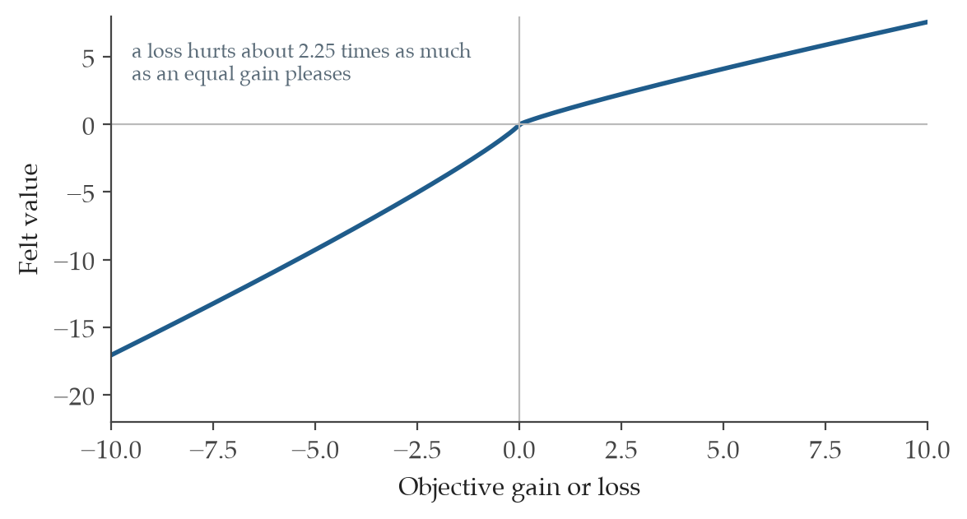
Figure 4. The value function behind loss aversion. The curve bends more steeply below zero than above it. A loss and a gain of the same size do not weigh the same in the mind. The factor here is 2.25, the value Kahneman and Tversky estimated, which is why people cling to losing projects far longer than the numbers justify.
Where it is used
Nonprofit director and board | For a nonprofit director and board, loss aversion is worth naming whenever the choice is to wind down a service, change a staffing model, or let a long-held partnership lapse. The reference-point check asks the board to weigh the option as if starting fresh today, so a program is kept because it serves people well rather than because ending it feels like defeat.
Company leadership and board | For company leadership and a board, loss aversion shows up when exiting a product line, retiring an aging asset, or releasing capital tied to a past bet. Restating the decision from a clean starting point keeps the team from pouring money into a position only because walking away feels like admitting a loss.

C4 - Status Quo Bias

What it measures
Status quo bias is the mind's pull toward leaving things as they are, treating the current arrangement as the safe default even when a different path would plainly serve better. It sits in the economic and outcome family, where inertia masquerades as prudence. Imagine a board that renews the same insurance broker for the eighth year running, never quite asking whether a fresh search would save 30% on premiums, because changing feels like effort and risk. The bias bites whenever doing nothing is allowed to pass as a decision rather than being judged as one option among others.
How it is calculated
ΔU = E[U(option)] − E[U(status quo)]; κ_C = w_EΔU + w_RR_rev + w_XX_alt − w_λλ_loss − w_sS_sunk
The control surface is a change-of-reference-point pre-mortem that treats staying put as an active choice with its own costs and risks. The reading is that the record scores well when the status quo must defend itself on the same evidence as every rival option.
ΔU is the expected-utility difference between the option and the status quo.
E[U(·)] is the expected utility under the stated option.
R_rev is the reversibility score.
X_alt is the explicit comparison against an alternative or inaction.
λ_loss is the loss-aversion weight.
S_sunk is the salience of sunk cost.
w_* are the pre-set governance weights.
Where it is used
Nonprofit director and board | For a nonprofit director and board, status quo bias matters when renewing vendors, keeping a familiar program design, or holding to a long-standing staffing pattern. Treating the current arrangement as an active choice forces the same scrutiny on staying put that any new proposal would face, so continuity is earned rather than assumed.
Company leadership and board | For company leadership and a board, status quo bias surfaces in budget cycles that simply repeat last year and in markets defended out of habit. A pre-mortem that puts the existing strategy on trial alongside the alternatives keeps capital from sitting where it sits only because no one asked it to move.

C5 - Sunk Cost Fallacy

What it measures
The sunk cost fallacy is the mind's urge to keep spending on a course of action in order to honor money or effort already gone, as if past investment created a debt the future must repay. It belongs to the economic and outcome family, where yesterday's spending wrongly steers tomorrow's choice. Think of a board that pours another 200,000 dollars into a software build that has already swallowed 800,000 dollars and two years, chiefly because abandoning it would mean admitting the first 800,000 was lost. The bias bites most when the cost already incurred is large and visible and the decision is framed as finishing what was started.
How it is calculated
ΔU = E[U(option)] − E[U(status quo)]; κ_C = w_EΔU + w_RR_rev + w_XX_alt − w_λλ_loss − w_sS_sunk
The control surface is a forward-only cost-benefit analysis that deliberately excludes whatever has already been spent. The reading is that the record scores well when the choice rests on future value alone and the sunk-cost term is driven toward zero.
ΔU is the expected-utility difference between the option and the status quo.
E[U(·)] is the expected utility under the stated option.
R_rev is the reversibility score.
X_alt is the explicit comparison against an alternative or inaction.
λ_loss is the loss-aversion weight.
S_sunk is the salience of sunk cost.
w_* are the pre-set governance weights.
Where it is used
Nonprofit director and board | For a nonprofit director and board, the sunk cost fallacy appears when a capital project, a grant-funded initiative, or a building renovation runs over budget and the instinct is to finish it because so much has already gone in. A forward-only review asks only what the remaining dollars will buy from here, which protects the mission from being held hostage by past spending.
Company leadership and board | For company leadership and a board, sunk cost shows up in failing acquisitions and overrun development programs that keep drawing capital to justify earlier rounds. Judging the next dollar purely on the return it can still earn keeps good money from chasing bad.

D1 - Confirmation Bias

What it measures
Confirmation bias is the mind's tendency to seek and trust evidence that fits what it already believes while quietly discounting whatever does not. It belongs to the structural and narrative family, where the shape of the search, not the strength of the truth, decides the answer. Picture a director convinced a new hire is excellent who notices every success and explains away every missed deadline, so the early verdict hardens into certainty. The bias bites whenever a conclusion is reached early and the later evidence is gathered to defend it rather than to test it.
How it is calculated
κ_D = w_δδ_disconfirm + w_φ|Δφ| + w_hH_0 − w_νν_story
The control surface is a steelman of the opposing case paired with a required quota of disconfirming evidence, so the search is forced to look where it would rather not. The reading is that the record scores well when genuine counter-evidence is present and the pull toward a tidy story is held down.
κ_D is the structural and narrative control strength.
δ_disconfirm is the coverage of disconfirming evidence.
Δφ is the difference between equivalent frames.
H_0 is the null-model or baseline hypothesis.
ν_story is the pressure toward narrative closure.
w_* are the pre-set governance weights.
Where it is used
Nonprofit director and board | For a nonprofit director and board, confirmation bias matters when evaluating a favored program, a trusted partner, or a strategy the leadership already loves. Requiring the team to bring the strongest evidence against its own preference turns a comfortable review into an honest one.
Company leadership and board | For company leadership and a board, confirmation bias distorts diligence on a deal the CEO wants and forecasts for a product the team is proud of. A standing demand for disconfirming evidence keeps the analysis from becoming a brief for a conclusion already chosen.

D2 - Framing Effect

What it measures
The framing effect is the mind's habit of judging the very same facts differently depending on how they are worded, so a result called a 90% success rate feels better than the identical 10% failure rate. It belongs to the structural and narrative family, where presentation quietly overrides substance. Imagine a board that approves a reserve policy described as protecting 9 of every 10 programs yet hesitates at the same policy described as risking 1 in 10. The bias bites whenever a single framing is allowed to stand unchallenged and no one restates the choice in its opposite terms.
How it is calculated
κ_D = w_δδ_disconfirm + w_φ|Δφ| + w_hH_0 − w_νν_story
The control surface is a restatement of the decision in opposing frames before any choice is made, which exposes how much of the preference came from wording alone. The reading is that the record scores well when the gap between equivalent frames is measured rather than ignored.
κ_D is the structural and narrative control strength.
δ_disconfirm is the coverage of disconfirming evidence.
Δφ is the difference between equivalent frames.
H_0 is the null-model or baseline hypothesis.
ν_story is the pressure toward narrative closure.
w_* are the pre-set governance weights.
Where it is used
Nonprofit director and board | For a nonprofit director and board, the framing effect matters when a budget cut is described as a saving or a fee increase as a sustainability measure. Asking for the same proposal stated in its plainest opposite terms lets the board react to the facts rather than to the wording.
Company leadership and board | For company leadership and a board, framing shapes how pricing changes and layoffs are presented for approval. Requiring each material decision to be read once in gain terms and once in loss terms keeps the vote anchored to substance.

D3 - Hindsight Bias

What it measures
Hindsight bias is the mind's trick of believing, once an outcome is known, that it was obvious all along, quietly rewriting how uncertain things actually felt beforehand. It belongs to the structural and narrative family, where memory bends to fit the ending. Picture a board reviewing a grant that fell through and insisting the warning signs were clear, when six months earlier every member had voted for it with confidence. The bias bites in every post-mortem, where it punishes reasonable past judgment and teaches false lessons about what could have been foreseen.
How it is calculated
κ_D = w_δδ_disconfirm + w_φ|Δφ| + w_hH_0 − w_νν_story
The control surface is the capture of pre-registered forecasts written down before outcomes land, so the record holds what was really believed at the time. The reading is that the record scores well when a stated baseline exists to check memory against and the urge to tidy the story is restrained.
κ_D is the structural and narrative control strength.
δ_disconfirm is the coverage of disconfirming evidence.
Δφ is the difference between equivalent frames.
H_0 is the null-model or baseline hypothesis.
ν_story is the pressure toward narrative closure.
w_* are the pre-set governance weights.
Where it is used
Nonprofit director and board | For a nonprofit director and board, hindsight bias matters most when reviewing a program that failed or a partnership that soured. Comparing the outcome against forecasts written before the result was known lets the board learn what was truly knowable, not what only looks obvious now.
Company leadership and board | For company leadership and a board, hindsight bias warps post-mortems on missed targets and failed launches, breeding unfair blame and false confidence. Recording forecasts in advance gives the review an honest yardstick for what the team could reasonably have seen.

D4 - Law of Triviality

What it measures
The law of triviality is the mind's drift toward spending the most attention on the matters easiest to grasp, so a small, familiar question crowds out a large, hard one. It belongs to the structural and narrative family, where comfort of understanding, not size of stake, sets the agenda. The classic scene is a board that debates the color of the new bike shed for 45 minutes and waves through a 4 million dollar reactor budget in 5. The bias bites whenever the items everyone feels equipped to discuss soak up the time that the consequential decisions deserve.
How it is calculated
κ_D = w_δδ_disconfirm + w_φ|Δφ| + w_hH_0 − w_νν_story
The control surface is a time budget set per option in proportion to its value or strategic weight, so attention follows stakes rather than ease. The reading is that the record scores well when discussion time is allocated deliberately instead of by whatever feels approachable.
κ_D is the structural and narrative control strength.
δ_disconfirm is the coverage of disconfirming evidence.
Δφ is the difference between equivalent frames.
H_0 is the null-model or baseline hypothesis.
ν_story is the pressure toward narrative closure.
w_* are the pre-set governance weights.
Where it is used
Nonprofit director and board | For a nonprofit director and board, the law of triviality matters when an agenda lets office logistics or event details consume the hour reserved for the annual budget or a major program decision. Assigning meeting time in proportion to what is at stake keeps the big choices from being rushed.
Company leadership and board | For company leadership and a board, this bias appears when a committee polishes wording in a policy while skimming the capital plan behind it. A time budget tied to the value of each item keeps the room's attention on the decisions that move the business.

D5 - Narrative Fallacy

What it measures
The narrative fallacy is the mind's compulsion to wrap a clean cause-and-effect story around events that may be little more than chance. It belongs to the structural and narrative family, where a satisfying tale feels truer than scattered data. Picture a board crediting a charismatic new director for a 20% jump in donations, when the rise tracked a one-time bequest and a strong market that had nothing to do with leadership. The bias bites whenever a vivid explanation arrives before anyone has checked whether plain randomness could account for the same pattern.
How it is calculated
κ_D = w_δδ_disconfirm + w_φ|Δφ| + w_hH_0 − w_νν_story
The control surface is a null-model audit run before any story is told, asking whether noise alone could have produced the pattern. The reading is that the record scores well when a baseline hypothesis is tested and the pressure toward a neat narrative is held down.
κ_D is the structural and narrative control strength.
δ_disconfirm is the coverage of disconfirming evidence.
Δφ is the difference between equivalent frames.
H_0 is the null-model or baseline hypothesis.
ν_story is the pressure toward narrative closure.
w_* are the pre-set governance weights.
Where it is used
Nonprofit director and board | For a nonprofit director and board, the narrative fallacy matters when a single good or bad quarter is explained by a tidy story about a person or a program. Asking first whether ordinary variation could account for the swing keeps strategy from being rebuilt around a coincidence.
Company leadership and board | For company leadership and a board, this bias turns one strong quarter into a sweeping theory of why the strategy works. Testing the result against a null model first keeps capital from following a story that the data does not actually support.

D6 - Pro-Innovation Bias

What it measures
Pro-innovation bias is the mind's habit of overvaluing whatever is new and underweighting the evidence about how often new things disappoint. It belongs to the structural and narrative family, where the glow of novelty stands in for proof. Imagine a board that commits 500,000 dollars to an untested platform because it promises to transform service delivery, while three similar promises in the sector quietly failed in the past two years. The bias bites whenever the excitement of being early outruns a sober look at the base rate of such projects.
How it is calculated
κ_D = w_δδ_disconfirm + w_φ|Δφ| + w_hH_0 − w_νν_story
The control surface is reference-class forecasting against the actual record of past innovative projects, which replaces hope with history. The reading is that the record scores well when an outside baseline grounds the estimate and the seductive story of novelty is held in check.
κ_D is the structural and narrative control strength.
δ_disconfirm is the coverage of disconfirming evidence.
Δφ is the difference between equivalent frames.
H_0 is the null-model or baseline hypothesis.
ν_story is the pressure toward narrative closure.
w_* are the pre-set governance weights.
Where it is used
Nonprofit director and board | For a nonprofit director and board, pro-innovation bias matters when a new technology or program model promises to leap past old constraints. Checking the plan against how comparable innovations actually fared keeps scarce funds from chasing novelty for its own sake.
Company leadership and board | For company leadership and a board, this bias drives over-investment in unproven products and platforms sold on transformation. Forecasting against the real track record of similar ventures keeps the capital decision honest about the odds.

E1 - Affect Heuristic

What it measures
The affect heuristic is the mind's shortcut of letting a quick feeling about something stand in for a careful judgment of it, so a warm glow or a flash of dread decides the answer before analysis begins. It belongs to the cognitive-noise and processing family, where emotion arrives first and reasons are recruited after. Picture a director who approves a partnership within minutes because the founder is likable, then assembles the business case to match that first impression. The bias bites most when a choice stirs strong feeling and the decision is made in the heat of that moment.
How it is calculated
κ_E = w_RR_rubric + w_ττ_delay + w_ρρ_ref − w_αα_affect − w_μμ_memory
The control surface is a cool-down delay paired with a structured rubric, so the strong first feeling has time to settle and the judgment runs against fixed criteria. The reading is that the record scores well when a rubric and a pause carry the decision and raw affect carries less of it.
κ_E is the cognitive-processing control strength.
R_rubric is the completeness of the structured rubric.
τ_delay is the cooling-off interval.
ρ_ref is reference-class retrieval.
α_affect is the affective intensity.
μ_memory is recency or recall salience.
w_* are the pre-set governance weights.
Where it is used
Nonprofit director and board | For a nonprofit director and board, the affect heuristic matters when a compelling story or a charismatic applicant produces an instant yes or no. A short delay and a written rubric let the board test that gut reaction against the actual merits before committing.
Company leadership and board | For company leadership and a board, this bias shapes snap reactions to a polished pitch or a frightening headline. A mandatory pause and a scoring rubric keep capital and hiring choices anchored to evidence rather than to the feeling of the moment.

E2 - Curse of Knowledge

What it measures
The curse of knowledge is the mind's difficulty in imagining what it is like not to know something it already knows, so an expert assumes context that others simply lack. It belongs to the cognitive-noise and processing family, where fluency in a subject hides the gaps in everyone else's picture. Picture a finance director presenting a budget so steeped in internal shorthand that the board approves it without grasping where the real risk sits. The bias bites whenever a knowledgeable person judges or explains a matter without checking what the audience actually understands.
How it is calculated
κ_E = w_RR_rubric + w_ττ_delay + w_ρρ_ref − w_αα_affect − w_μμ_memory
The control surface is an explain-to-novice test that draws out the context an expert was silently assuming. The reading is that the record scores well when the explanation has been checked against a non-expert and the unstated assumptions are made plain.
κ_E is the cognitive-processing control strength.
R_rubric is the completeness of the structured rubric.
τ_delay is the cooling-off interval.
ρ_ref is reference-class retrieval.
α_affect is the affective intensity.
μ_memory is recency or recall salience.
w_* are the pre-set governance weights.
Where it is used
Nonprofit director and board | For a nonprofit director and board, the curse of knowledge matters when staff present technical or financial material to a volunteer board that does not share their fluency. Asking the presenter to explain the decision as if to a newcomer reveals the assumptions the board needs to see before it votes.
Company leadership and board | For company leadership and a board, this bias hides risk inside expert briefings that skip the context outsiders need. An explain-to-novice check forces the unspoken assumptions into the open before a major decision is made.

E3 - Empathy Gap

What it measures
The empathy gap is the mind's poor reach across its own emotional states, so a calm person cannot truly picture how they will feel under stress, and a hungry one cannot picture being full. It belongs to the cognitive-noise and processing family, where the present mood blinds us to a future one. Picture a board that approves an austere cost-cutting plan in a comfortable quarter, then watches staff morale collapse in the lean months it failed to feel in advance. The bias bites whenever a decision made in one emotional state will be lived out in a very different one.
How it is calculated
κ_E = w_RR_rubric + w_ττ_delay + w_ρρ_ref − w_αα_affect − w_μμ_memory
The control surface is an affective-forecast pre-mortem joined to reference-class memory, which asks how people will actually feel when the plan meets reality. The reading is that the record scores well when a remembered comparison grounds the forecast and present mood is kept from doing the predicting.
κ_E is the cognitive-processing control strength.
R_rubric is the completeness of the structured rubric.
τ_delay is the cooling-off interval.
ρ_ref is reference-class retrieval.
α_affect is the affective intensity.
μ_memory is recency or recall salience.
w_* are the pre-set governance weights.
Where it is used
Nonprofit director and board | For a nonprofit director and board, the empathy gap matters when a plan made in good times will be carried out by staff and clients in hard ones. Forecasting how people will really feel under the new conditions, drawing on past cycles, keeps the decision humane as well as sound.
Company leadership and board | For company leadership and a board, this bias distorts decisions about layoffs, on-call burdens, and customer changes that feel manageable on paper. A pre-mortem on the lived experience, anchored to how similar moves landed before, keeps the plan from breaking under its own strain.

E4 - Information Bias

What it measures
Information bias is the mind's appetite for more data even when the extra data cannot change what will be done, mistaking the comfort of knowing for the value of knowing. It belongs to the cognitive-noise and processing family, where gathering feels like progress while the decision waits. Picture a board that delays a clear hire for three weeks to commission a reference check that, whatever it returns, will not alter the offer. The bias bites whenever a search for information is launched without first asking whether any answer would shift the action.
How it is calculated
κ_E = w_RR_rubric + w_ττ_delay + w_ρρ_ref − w_αα_affect − w_μμ_memory
The control surface is a pre-action test that asks, before collecting a datum, whether its answer could change the decision. The reading is that the record scores well when each information request must justify itself against the choice it is meant to inform.
κ_E is the cognitive-processing control strength.
R_rubric is the completeness of the structured rubric.
τ_delay is the cooling-off interval.
ρ_ref is reference-class retrieval.
α_affect is the affective intensity.
μ_memory is recency or recall salience.
w_* are the pre-set governance weights.
Where it is used
Nonprofit director and board | For a nonprofit director and board, information bias matters when a decision stalls for studies or reports that will not change the choice. Asking in advance whether any finding could move the action keeps the organization from spending time and money to feel more certain about a settled call.
Company leadership and board | For company leadership and a board, this bias breeds analysis paralysis, where another study delays a decision the data already supports. A simple test of whether the result could change the action keeps diligence from sliding into delay.

E5 - Planning Fallacy

What it measures
The planning fallacy is the mind's habit of forecasting a project's time and cost from its best imagined path, ignoring how long similar efforts actually took. It belongs to the cognitive-noise and processing family, where the inside view of a plan crowds out the outside record. Picture a team that promises a new database in 6 months when every comparable build in the sector ran closer to 14, because this time feels different. The bias bites whenever an estimate is drawn from the specifics of the plan rather than from the base rate of projects like it.
How it is calculated
κ_E = w_RR_rubric + w_ττ_delay + w_ρρ_ref − w_αα_affect − w_μμ_memory
The control surface is reference-class forecasting with uplift bands, which sets the estimate against how comparable projects truly ran and adds room for the usual overrun. The reading is that the record scores well when an outside baseline shapes the forecast rather than the optimism of the plan.
κ_E is the cognitive-processing control strength.
R_rubric is the completeness of the structured rubric.
τ_delay is the cooling-off interval.
ρ_ref is reference-class retrieval.
α_affect is the affective intensity.
μ_memory is recency or recall salience.
w_* are the pre-set governance weights.
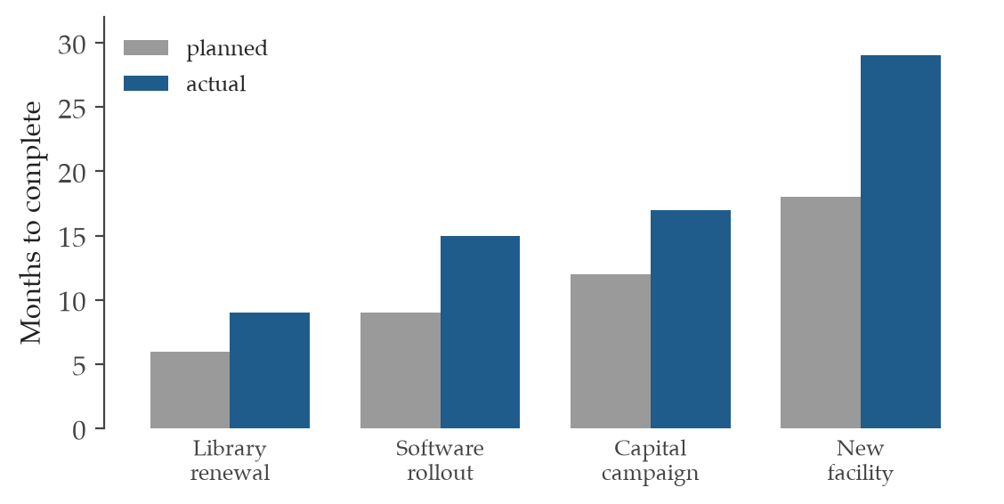
Figure 5. Planned against actual duration. People estimate how long a task will take by imagining it going smoothly, so plans cluster below reality almost every time. The pattern holds even for those who have overrun on the very same kind of task before.
Where it is used
Nonprofit director and board | For a nonprofit director and board, the planning fallacy matters when a grant timeline or a building project is promised faster and cheaper than experience warrants. Estimating from how similar projects actually unfolded, with a margin added, protects the organization from commitments it cannot keep.
Company leadership and board | For company leadership and a board, this bias drives missed launch dates and blown budgets that erode credibility with investors. Building forecasts from the real record of comparable work, with realistic uplift, keeps commitments grounded.

E6 - Recency Bias

What it measures
Recency bias is the mind's habit of giving the latest events far more weight than older ones, as though what happened last week reveals more than the years before it. It belongs to the cognitive-noise and processing family, where the freshest memory shouts loudest. Picture a board that overhauls its investment policy after one bad quarter, forgetting the decade of steady returns that preceded it. The bias bites whenever a recent stretch of good or bad results is treated as the whole pattern rather than as one slice of a longer record.
How it is calculated
κ_E = w_RR_rubric + w_ττ_delay + w_ρρ_ref − w_αα_affect − w_μμ_memory
The control surface is time-balanced sampling that deliberately pulls in older comparables alongside the recent ones. The reading is that the record scores well when the evidence spans the full history and the loudness of recent memory is held down.
κ_E is the cognitive-processing control strength.
R_rubric is the completeness of the structured rubric.
τ_delay is the cooling-off interval.
ρ_ref is reference-class retrieval.
α_affect is the affective intensity.
μ_memory is recency or recall salience.
w_* are the pre-set governance weights.
Where it is used
Nonprofit director and board | For a nonprofit director and board, recency bias matters when one strong or weak season reshapes fundraising or program decisions. Deliberately setting recent results beside several earlier years keeps the board reacting to the trend rather than the last data point.
Company leadership and board | For company leadership and a board, this bias overweights the latest quarter in forecasts and strategy resets. Sampling across a longer span of comparable periods keeps a single run of results from rewriting the plan.

F1 - Bias Blind Spot

What it measures
The bias blind spot is the mind's curious blindness to its own distortions while seeing them clearly in everyone else, so a person who can name a colleague's bias believes their own judgment is clean. It belongs to the meta-cognitive family, where the very faculty meant to catch error exempts itself. Picture a director who confidently spots favoritism in another department's hiring yet cannot see it in their own, certain that their reasoning is purely objective. The bias bites hardest in self-review, where confidence in one's own neutrality blocks the correction that is most needed.
How it is calculated
κ_F = w_ss_self + w_dd_challenge + w_qq_evidence − w_bb_blindspot
The control surface is a third-party calibration audit that judges decisions against externally visible scores rather than self-assessment. The reading is that the record scores well when an outside check carries weight and the untested belief that bias lives only in others is held down.
κ_F is the self-audit control strength.
s_self is the explicit record of self-scrutiny.
d_challenge is the completeness of challenge and dissent.
q_evidence is the support from evidence quality.
b_blindspot is the untested assumption that bias is only external.
w_* are the pre-set governance weights.
Where it is used
Nonprofit director and board | For a nonprofit director and board, the bias blind spot matters whenever the leadership reviews its own decisions and judges them sound. Inviting an outside party to score those choices against visible measures gives the board a mirror its own confidence cannot provide.
Company leadership and board | For company leadership and a board, this bias lets a team certify its own diligence as objective while missing the slant inside it. An external calibration audit against measurable outcomes supplies the check that self-review alone never will.

Quant Entries (28)
The 28 entries here are the measuring instruments of forecasting. Where the bias entries describe how judgment fails, these convert a judgment into a number that another person can check. They run from the scoring rules that grade a single forecast, through the calibration tools that test a whole record, to the decision rules that turn a probability into a choice.

Q1 - Brier Score

What it measures
The Brier score measures how far a stated probability sat from the event that actually happened, averaged across every forecast on the record. It belongs to the family of proper scoring rules, which reward a forecaster only for saying what the evidence truly supports. A director who tells the board that a grant renewal is 70% likely collects a penalty of 0.09 when the grant arrives and 0.49 when it does not. Across a thousand such judgments the average settles into one number between 0 and 1, where 0 marks a forecaster who was certain and right every time.
How it is calculated
BS = (1/N)∑_{i=1}^{N}(p_i − o_i)^2
Reading: the Brier score is the mean of the squared gap between each forecast probability and what actually happened, BS = mean((p - o)^2).
BS is the Brier score.
N is the number of forecasts.
p_i is the forecast probability for case i.
o_i ∈ {0,1} is the realized binary outcome.
∑ is the summation over all scored cases.
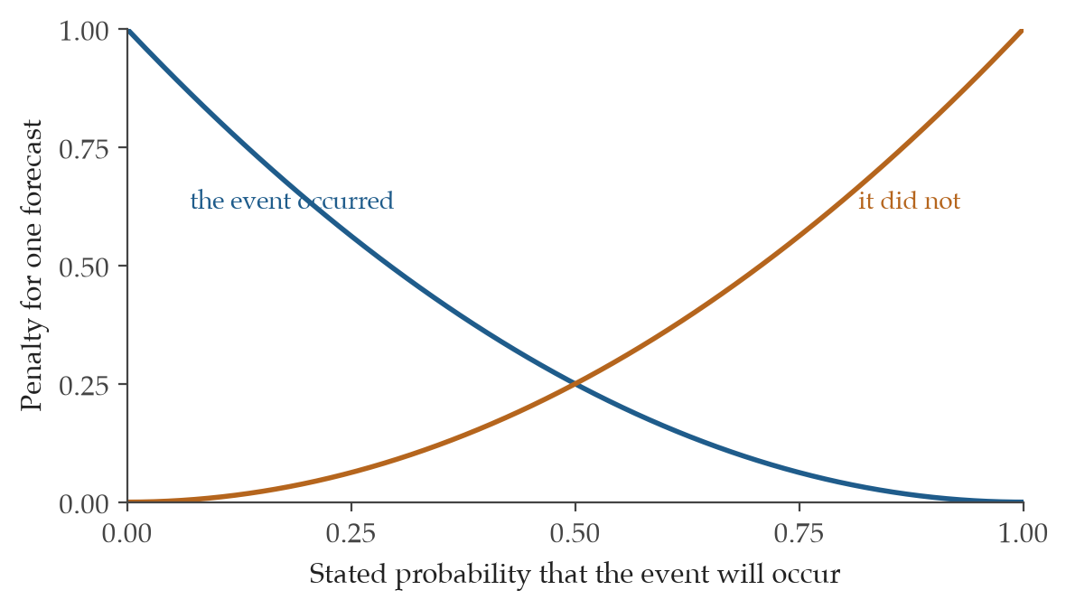
Figure 6. The penalty attached to one forecast. The blue curve applies when the event occurs and the orange curve when it does not. A forecaster who says 95% and is right pays almost nothing, while one who says 95% and is wrong pays nearly a full unit. The curves meet at one half, the point of pure indecision.
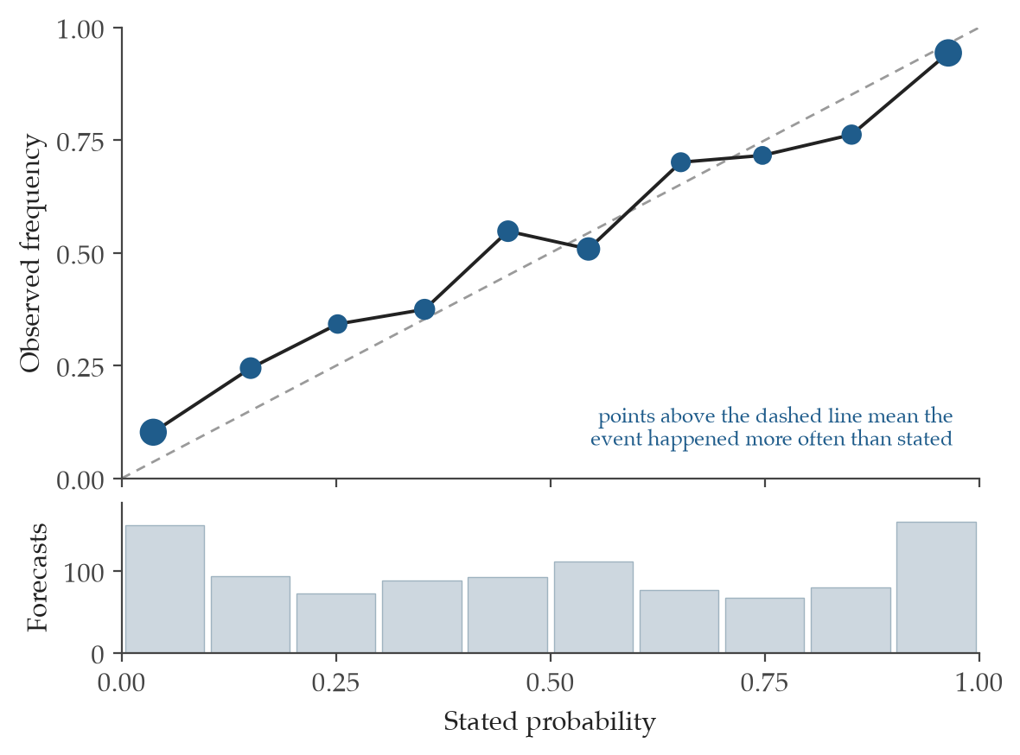
Figure 7. A reliability diagram for 1,000 forecasts. Each point gathers the forecasts in one band of stated probability and shows how often the event then occurred. The dashed line is perfect calibration. The bars beneath count how many forecasts fell in each band.
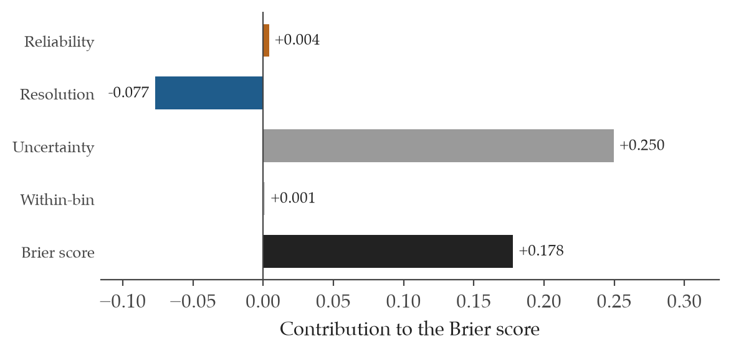
Figure 8. The Brier score divided into its sources. Reliability rewards calibration. Resolution credits a forecaster for telling likely from unlikely cases and so subtracts from the score. Uncertainty belongs to the question rather than the forecaster. The parts sum to 0.178.
Where it is used
Nonprofit director and board | For a nonprofit director and board, the Brier score gives a fair record of how well the organization reads its own future across its revenue and fundraising calls. A development office that scores each major gift forecast against what donors actually did learns within one cycle whether its confidence has been earned.
Company leadership and board | For company leadership and a board, the Brier score turns a year of capital and pricing forecasts into a single honest tally of how often stated odds matched reality. When every binary call is scored at the unit level, the leaders who quietly guessed well become visible next to those whose confidence ran ahead of their results.

Q2 - Brier Skill Score

What it measures
The Brier skill score asks a sharper question than raw accuracy. It measures how much better a forecaster did than a dull baseline that simply predicts the long-run base rate every time. A score of 0 means the forecaster matched that baseline and added nothing. A score approaching 1 means the forecaster crushed it, while a negative score is the quiet embarrassment of having done worse than a clock that is right twice a day.
How it is calculated
BSS = 1 − BS_f/BS_ref
Reading: the skill score is 1 minus the ratio of the forecaster's Brier score to the baseline's Brier score, BSS = 1 - BS_forecast / BS_reference.
BSS is the Brier skill score.
BS_f is the Brier score for the focal forecast.
BS_ref is the Brier score for the reference or climatology baseline.
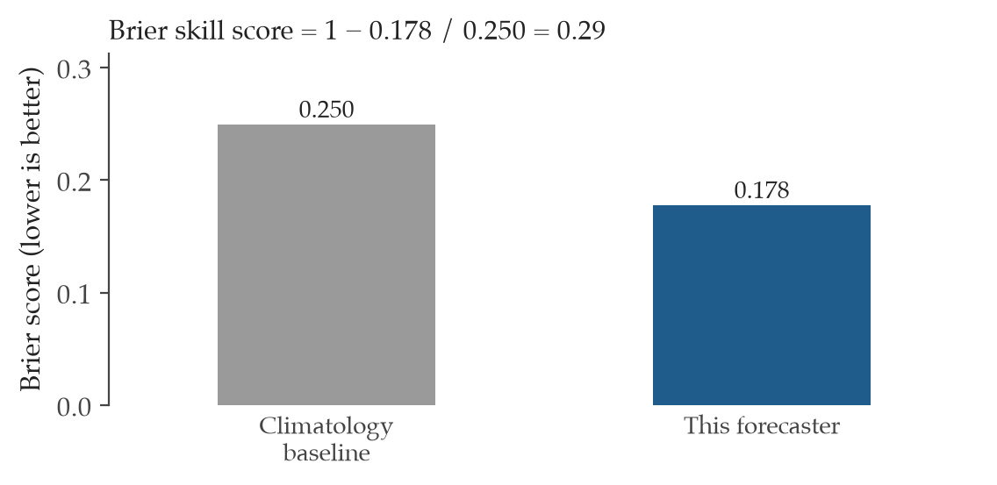
Figure 9. A skill score against the naive baseline. The skill score rescales the Brier score so that 0 means no better than always predicting the long-run base rate and 1 means perfection. This forecaster reaches 0.29, a real but modest edge.
Where it is used
Nonprofit director and board | For a nonprofit director and board, the Brier skill score lets you compare two program officers who forecast on very different terrain, because each is measured against the natural base rate of their own work. A grants team that beats the baseline by a wide margin is reading donors better than chance, not merely riding an easy year.
Company leadership and board | For company leadership and a board, this score separates real forecasting skill from a market that was simply easy to call. When you compare analysts across product lines with different base rates, the skill score puts them on common ground and exposes anyone whose record was no better than guessing the average.

Q3 - Logarithmic Scoring Rule

What it measures
The logarithmic scoring rule grades a forecast by the probability it placed on the outcome that actually occurred, then punishes confident wrongness without mercy. It is strictly proper, so a forecaster minimizes the expected penalty only by reporting honest beliefs. The cruelty is in the tail. A manager who declared an outcome 1% likely, only to watch it happen, earns a penalty of roughly 4.6, while a humble 50% guess on the same event costs only 0.69.
How it is calculated
NLL = −(1/N)∑_{i=1}^{N}ln p_i(y_i)
Reading: the score is the average negative natural log of the probability each forecast assigned to the outcome that truly occurred, NLL = -log(p_observed).
NLL is the negative log likelihood, also called the logarithmic score.
p_i(y_i) is the probability assigned to the realized outcome y_i.
ln is the natural logarithm.
N is the number of observations.
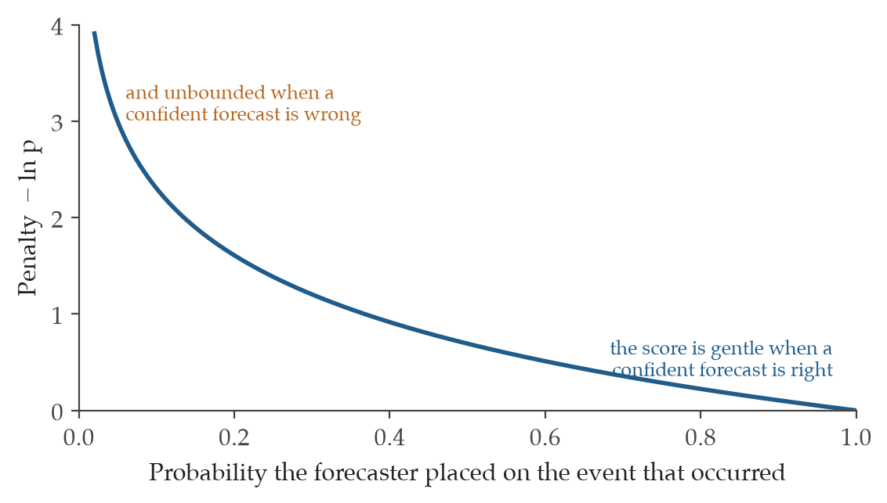
Figure 10. The logarithmic penalty. The penalty is the negative logarithm of the probability the forecaster placed on what actually happened. A forecaster who assigns near zero to an event that occurs is punished without limit, which is why this rule is the harshest judge of false certainty.
Where it is used
Nonprofit director and board | For a nonprofit director and board, the logarithmic score catches the dangerous habit of ruling something out entirely. A program leader who keeps insisting a funding source is dead certain, then is blindsided when it shifts, will see that overconfidence show up here as a heavy penalty that the Brier score would have softened.
Company leadership and board | For company leadership and a board, this score is the right tool when a single overconfident call can sink real capital. It singles out the executive who assigns near-zero probability to a competitor move or a demand collapse that then arrives, the exact failure that a gentler average would forgive.

Q4 - Ignorance Score

What it measures
The ignorance score is the logarithmic score read in bits, the language of information itself. It measures how surprised the forecast should have been by the outcome, where each bit is one doubling of that surprise. If a forecaster put 25% on the event that occurred, the ignorance score is 2 bits, the same surprise as guessing the result of two fair coin flips. A perfectly confident and correct forecast scores 0 bits, the calm of having expected exactly what came.
How it is calculated
I = −log₂(p_y)
Reading: the score is the negative base-2 logarithm of the probability placed on the observed outcome, IS = -log2(p_observed).
I is the ignorance score in bits.
p_y is the probability assigned to the observed outcome y.
log₂ is the base-2 logarithm.

Figure 11. The ignorance penalty in bits. The ignorance score is the logarithmic rule read in base 2, so the penalty is measured in bits of surprise. The shape is identical. A confident wrong call carries an unbounded cost.
Where it is used
Nonprofit director and board | For a nonprofit director and board, the ignorance score offers a plain reading of how much each forecast was caught off guard, counted in bits of surprise. A board that hears a program scored 3 bits on a key outcome understands at once that reality was eight times less likely than the team believed.
Company leadership and board | For company leadership and a board, the bits-of-surprise reading travels cleanly across different kinds of forecasts, from churn to supply risk, without arguing over units. When a quarterly outcome lands at 4 bits of surprise, leadership has a unit-free signal that the team's model of the market was badly out of step with what happened.

Q5 - Continuous Ranked Probability Score

What it measures
The continuous ranked probability score grades a forecast that names not a single number but a whole distribution of possible values, such as next year's revenue. It rewards a forecast for being both centered near the truth and appropriately narrow, penalizing a vague wide guess and a confident wrong one alike. Picture a finance lead who forecasts revenue as a bell curve. The score measures the squared distance between that predicted curve and the hard step of what the books finally reported, so a tight forecast that lands on target scores near 0.
How it is calculated
CRPS(F,y) = ∫_{−∞}^{∞}(F(x) − 𝟙{x ≥ y})² dx
Reading: the score integrates the squared gap between the forecast's cumulative distribution and the step function that jumps at the realized value, CRPS(F, y) = integral((F(x) - 1{x >= y})^2 dx).
CRPS is the continuous ranked probability score.
F(x) is the forecast cumulative distribution.
y is the realized value.
𝟙{·} is the indicator function.
x is the integration variable.
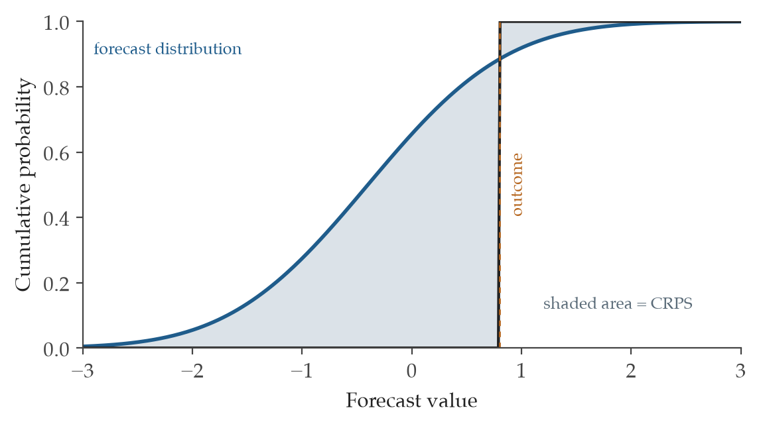
Figure 12. CRPS as the area between two curves. The smooth curve is the forecast distribution stated as a cumulative probability. The step rises at the value that actually occurred. The score is the shaded area between them, so a sharp forecast centered on the truth earns a small number.
Where it is used
Nonprofit director and board | For a nonprofit director and board, this score is the honest way to grade a revenue or timeline forecast that was given as a range rather than a point. A finance office that scores its annual revenue distribution against the closed books learns whether its ranges were both well-aimed and the right width, not merely wide enough to be safe.
Company leadership and board | For company leadership and a board, the continuous ranked probability score fits exactly the forecasts that drive capital plans, where a delivery date or a revenue number arrives as a spread of outcomes. It rewards the planning team that drew a tight, well-placed distribution over the one that hedged with a range so wide it could never be wrong.

Q6 - Bregman Divergence

What it measures
The Bregman divergence is the parent shape from which many familiar scoring rules descend, including the Brier score and log-loss. Choose a convex generator function and you fix the exact way a forecast is penalized for drifting from the truth. Its value to a careful analyst is that it lets you design a proper score whose penalties bend the way a real decision does. When the cost of a false alarm differs sharply from the cost of a miss, the divergence can be tuned to honor that asymmetry while still rewarding honest belief.
How it is calculated
D_φ(p,q) = φ(p) − φ(q) − ∇φ(q)^T(p − q)
Reading: the divergence is the gap between the generator at p and its tangent-line estimate taken from q, D_phi(p, q) = phi(p) - phi(q) - grad(phi(q)) dot (p - q).
D_φ is the Bregman divergence under convex generator φ.
p is the assessed distribution.
q is the reference distribution.
∇φ(q) is the gradient at q.
T is the transpose.
Where it is used
Nonprofit director and board | For a nonprofit director and board, the Bregman divergence matters when the two ways of being wrong are not equally costly, such as missing a child at real risk versus a false flag. It gives a way to build a fair scoring rule that weights those errors the way the mission demands, while still rewarding forecasters for stating what they truly believe.
Company leadership and board | For company leadership and a board, this divergence is the toolkit for designing a custom scoring rule when one error dwarfs the other, as in a fraud screen or a stock-out decision. Leadership can shape the penalty to match the real economics of being wrong without giving up the guarantee that honesty remains the best forecasting strategy.

Q7 - Quadratic Loss / MSE of Probability

What it measures
The quadratic loss extends the Brier idea from a single yes-or-no event to a forecast spread across several mutually exclusive classes. It averages the squared error in the probability assigned to each class against what actually occurred. Suppose a hiring panel forecasts that a candidate is 60% likely to accept, 30% to decline, and 10% to vanish. When the candidate accepts, the loss accumulates the small misses across all three buckets into one number, where 0 marks a forecast that placed all its weight on the truth.
How it is calculated
MSE = (1/NK)∑_{i=1}^{N}∑_{k=1}^{K}(p_{ik} − o_{ik})²
Reading: the loss is the mean squared gap between forecast probability and observed indicator, taken over every class in every case, MSE = mean((p_class - o_class)^2).
MSE is the mean squared probability error.
N is the number of cases.
K is the number of classes.
p_{ik} is the probability for class k in case i.
o_{ik} is the one-hot observed class indicator.
Where it is used
Nonprofit director and board | For a nonprofit director and board, the quadratic loss gives one clean summary when an outcome has more than two doors, such as a client moving into housing, staying in shelter, or leaving the program. A case team that scores its multiclass forecasts this way gets a single honest number for how well it read paths that were never a simple yes or no.
Company leadership and board | For company leadership and a board, this loss collapses a multiclass forecast into one probability-error figure, useful for segmentation calls or multi-way market outcomes. It tells leadership at a glance whether a team's spread of probabilities across several outcomes was well placed or merely scattered.

Q8 - Local Proper Scoring Rules

What it measures
A local proper scoring rule grades a forecast using only the probability it placed on the outcome that actually happened, ignoring how it spread the remaining belief. This locality is a deliberate ethic. It says a forecaster should be judged on the truth alone, not on bookkeeping over events that never occurred. The logarithmic score is the famous member of this family, and any rule chosen here must be fixed before the outcome is known so that no one can tune the grading to flatter a result already in hand.
How it is calculated
S(y,p) = g(p_y)
Reading: the score is a fixed function of the probability the forecast assigned to the realized outcome, score = f(p_observed).
S is the local proper score.
y is the realized outcome.
p_y is the probability assigned to y.
g(·) is the locally proper scoring function selected before review.
Where it is used
Nonprofit director and board | For a nonprofit director and board, a local proper scoring rule keeps the grading honest by judging only the weight a forecaster put on what actually came to pass. Fixing the rule before outcomes are known protects the review from the human temptation to bend the standard once the result is already in view.
Company leadership and board | For company leadership and a board, a local proper rule suits settings where outcome-conditional honesty is the whole point, such as analyst forecasts that feed directly into compensation. By committing to the scoring function in advance, leadership removes any room to reshape the standard after the market has spoken.

Q9 - Expected Calibration Error

What it measures
Expected calibration error asks whether stated confidence means what it says. It sorts forecasts into bins by their stated probability, then measures the gap between how often the team said something would happen and how often it actually did, weighted by how many forecasts fall in each bin. If everything a manager called 80% likely came true only 60% of the time, that 20-point gap is the heart of the error. A well-calibrated record drives the figure toward 0.
How it is calculated
ECE = ∑_{b=1}^{B}(n_b/N)|acc_b − conf_b|
Reading: the error is the size-weighted average gap between empirical accuracy and stated confidence across all bins, ECE = sum((n_b / N) * abs(acc_b - conf_b)).
ECE is the expected calibration error.
B is the number of populated bins.
n_b is the count of cases in bin b.
N is the total number of cases.
acc_b is the empirical accuracy in bin b.
conf_b is the mean stated confidence in bin b.
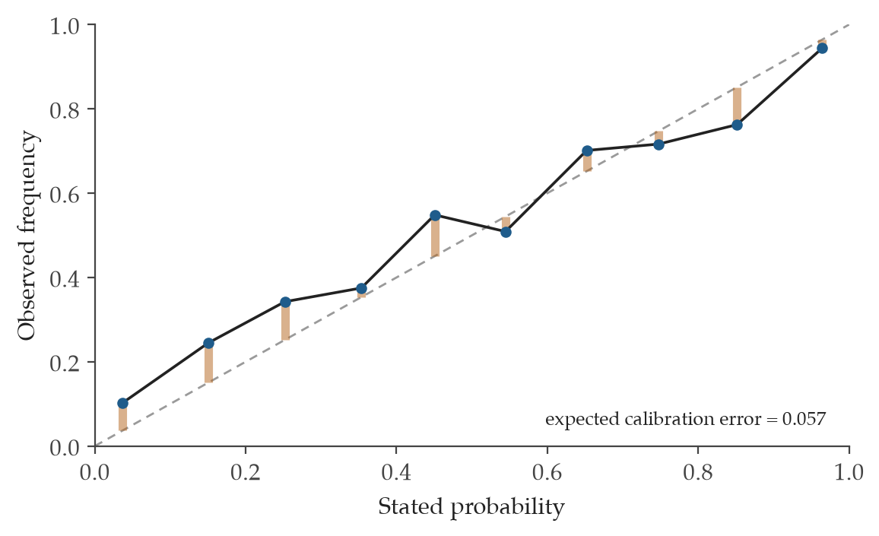
Figure 13. Calibration error as a weighted average of gaps. Each orange bar is the distance between a band's stated probability and how often the event then occurred. The expected calibration error averages those gaps, weighting each band by how many forecasts it holds.
Where it is used
Nonprofit director and board | For a nonprofit director and board, expected calibration error reveals whether the words confident and likely carry real weight in the organization's forecasts. Once a batch reaches roughly 20 entries, a board can see at a glance whether a team's 90% truly behaves like 90% or has quietly become wishful language.
Company leadership and board | For company leadership and a board, this measure checks whether the confidence attached to revenue or risk forecasts is trustworthy enough to act on. A persistent gap between stated and realized rates warns leadership that the numbers feeding capital decisions are systematically too bold or too timid.

Q10 - Maximum Calibration Error

What it measures
Maximum calibration error reports not the average miscalibration but the single worst bin, the confidence level where the team is most badly fooling itself. Where the expected version forgives a bad bin if most others are fine, this one refuses to look away from the worst case. Imagine a medical triage tool that is well calibrated everywhere except at the 95% confidence band, where it is right only 70% of the time. That 25-point gap is exactly the failure this measure puts in front of you.
How it is calculated
MCE = max_{b∈B}|acc_b − conf_b|
Reading: the error is the largest absolute gap between accuracy and confidence found in any populated bin, MCE = max(abs(acc_b - conf_b)).
MCE is the maximum calibration error.
b is a populated calibration bin.
acc_b is the empirical accuracy in bin b.
conf_b is the mean confidence in bin b.
max is the largest absolute bin gap.

Figure 14. The same gaps read at their worst. The maximum calibration error reports the single widest orange bar rather than the average. It guards against a forecaster who is calibrated on the whole but badly wrong in one band that may carry the costliest decisions.
Where it is used
Nonprofit director and board | For a nonprofit director and board, maximum calibration error is the right lens when one band of overconfidence could cause real harm, such as a risk screen that fails precisely where it claims near-certainty. It tells a board where the forecasts break worst, not merely how they do on average.
Company leadership and board | For company leadership and a board, this measure belongs in safety-critical reviews where the worst-calibrated band, not the typical one, is what threatens people or capital. It points leadership straight to the confidence level where the model or the team is most dangerously wrong.

Q11 - Hosmer-Lemeshow + Extensions

What it measures
The Hosmer-Lemeshow statistic tests whether a set of probability forecasts fits reality across the whole range of confidence, not just on average. It sorts forecasts into groups by predicted risk, then compares the outcomes that were expected in each group against those observed, summing the squared gaps into one statistic. A large value is the signal that the forecasts and the world have parted ways somewhere. Extensions carry the same idea into multinomial outcomes and into samples too small for the classic decile version.
How it is calculated
χ²_HL = ∑_{b=1}^{B}(O_b − E_b)²/V_b
Reading: the statistic sums the squared gap between observed and expected outcomes in each group, scaled by that group's variance, HL = sum((observed_b - expected_b)^2 / variance_b).
χ²_HL is the Hosmer-Lemeshow goodness-of-fit statistic.
O_b is the observed outcomes in bin b.
E_b is the expected outcomes in bin b.
V_b is the bin variance term.
B is the number of bins or groups.
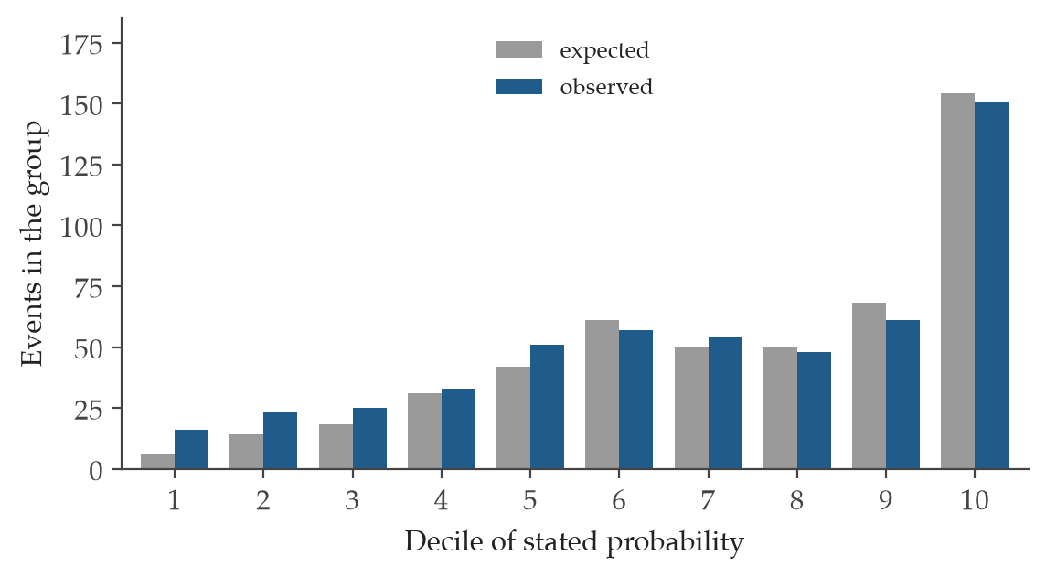
Figure 15. Observed against expected by decile. Forecasts are sorted into ten groups. For each group the chart compares how many events the forecasts expected with how many actually occurred. A close match across all groups is the sign of a well-calibrated model.
Where it is used
Nonprofit director and board | For a nonprofit director and board, the Hosmer-Lemeshow test is a formal way to ask whether a risk model holds up across every level of predicted risk, given a large enough sample. A board reviewing a screening tool can use it to confirm the model fits not just typical cases but the high-risk and low-risk groups it must get right.
Company leadership and board | For company leadership and a board, this test checks whether a scoring model, such as one for credit or churn, stays faithful across the full span of predicted risk. With a large sample, a high statistic warns leadership that the model misfits somewhere in the risk ladder before that drift turns into losses.

Q12 - Reliability-Resolution-Uncertainty Decomposition

What it measures
This decomposition splits the Brier score into the parts that explain why a forecaster did well or poorly. Reliability captures miscalibration, the penalty for stated odds that did not match outcomes. Resolution captures discrimination, the credit for separating events that happened from those that did not. The third part is the irreducible uncertainty of the outcome itself, which no forecaster can erase. Seeing these apart tells you whether a bad score comes from confidence that needs fixing or from a forecaster who cannot tell the cases apart.
How it is calculated
BS = REL − RES + UNC
Reading: the Brier score equals the reliability penalty minus the resolution credit plus the base uncertainty, BS = REL - RES + UNC.
REL is the reliability or miscalibration penalty.
RES is the resolution or discrimination benefit.
UNC is the outcome uncertainty or base-rate variance.
BS is the Brier score.
Where it is used
Nonprofit director and board | For a nonprofit director and board, this decomposition answers a practical question about a poor forecasting record. It shows whether the team needs calibration training, because its confidence is off, or sharper judgment, because it cannot yet tell likely outcomes from unlikely ones.
Company leadership and board | For company leadership and a board, breaking the Brier score into its parts turns a vague complaint about bad forecasts into a clear repair plan. Leadership learns whether to invest in calibration discipline or in the deeper analytical skill of telling winning bets from losing ones.

Q13 - Murphy Empirical-Var(y) Decomposition

What it measures
This is the Murphy decomposition fitted to outcomes that are not simple yes-or-no events but real-valued quantities. It replaces the base uncertainty term with the empirical variance of the observed values themselves, the natural spread that the data carried before any forecast was made. For a team forecasting continuous figures like donation totals, this matters because the binomial uncertainty of a coin-flip world is far too narrow to describe how much those totals naturally swing.
How it is calculated
UNC = Var(y) = (1/N)∑_{i=1}^{N}(y_i − ȳ)²
Reading: the uncertainty term is the empirical variance of the observed outcomes around their mean, UNC = empirical Var(y).
UNC is the empirical uncertainty.
Var(y) is the variance of outcomes.
y_i is the observed outcome or value.
ȳ is the sample mean.
N is the number of observations.
Where it is used
Nonprofit director and board | For a nonprofit director and board, this version of the decomposition is the honest choice when outcomes are continuous, such as dollars raised or clients served, rather than plain yes-or-no events. It measures the natural spread of those real numbers so the board does not mistake ordinary variation for a forecasting failure.
Company leadership and board | For company leadership and a board, the empirical variance term fits continuous business outcomes like revenue or volume, where binomial uncertainty would badly understate the real swing. It gives leadership a faithful baseline for how much the numbers move on their own before crediting or blaming the forecasters.

Q14 - Yates Diagnostics

What it measures
Yates diagnostics open up a forecasting record into a few plain readings of where it goes wrong. The first is calibration drift, the gap between the average forecast and the actual base rate, which reveals a team that runs habitually high or low. The others read the spread of the forecasts and how that spread tracks real outcomes. Together they expose the over-sharp forecaster who issues bold 90% and 10% calls when the evidence only justified something far closer to the middle.
How it is calculated
Δ_cal = f̄ − ȳ; Var(f); Cov(f,y)
Reading: the procedure computes calibration drift as mean forecast minus base rate, then the forecast variance and the forecast-outcome covariance, Procedure: mean_forecast - base_rate, Var(f), Cov(f, y).
Δ_cal is the calibration-in-the-large drift.
f̄ is the mean forecast.
ȳ is the mean outcome or base rate.
Var(f) is the forecast variance.
Cov(f,y) is the forecast-outcome covariance.
Where it is used
Nonprofit director and board | For a nonprofit director and board, Yates diagnostics show whether a team's forecasts run high or low as a whole and whether their confidence outpaces what the outcomes support. A board can spot a development office that is consistently too optimistic, or one that issues sharp odds it has not earned.
Company leadership and board | For company leadership and a board, these diagnostics catch two common faults at once: a forecasting function that drifts above or below the true base rate, and one that is too sharp for its own evidence. Leadership gets an early reading on whether bold quarterly calls reflect real insight or just overconfident habit.

Q15 - Platt Scaling

What it measures
Platt scaling takes the raw score a model spits out and bends it through a single logistic curve so that the number it reports can be read as an honest probability. It belongs to the family of calibration repair, the small set of methods that fix a forecaster who ranks cases well but states confidence poorly. Picture a loan model that loves to say 0.9 for borrowers who actually default a third of the time. Platt scaling learns two parameters from past cases and pulls that inflated 0.9 down toward 0.66, so a stated probability finally means what it says.
How it is calculated
p̂ = σ(As + B) = 1/(1 + e^{−(As+B)})
Reading: the calibrated probability is the sigmoid of A times the raw score plus B.
p̂ is the calibrated probability.
σ is the logistic sigmoid.
s is the raw model score.
A and B are the two fitted calibration parameters.
e is the base of the natural logarithm, roughly 2.71828.
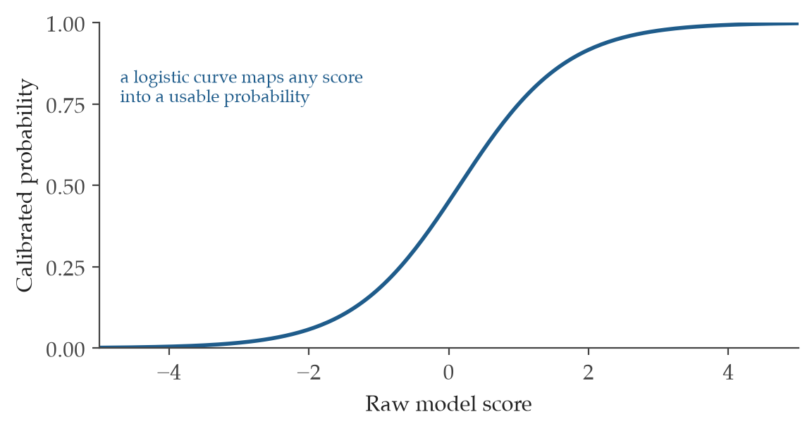
Figure 16. Platt scaling as a logistic map. Platt scaling fits a single logistic curve that turns a raw, uncalibrated score into a probability. It assumes the distortion is smooth, so it repairs gentle overconfidence with very few parameters.
Where it is used
Nonprofit director and board | A nonprofit director can use Platt scaling when a scoring model already ranks grant prospects or program risks sensibly but reports confidence that history does not support. It works best on a moderate set of past cases where the scores fall in a sensible order. The repaired number lets the board treat a stated 0.8 as a real 4-in-5 chance rather than wishful arithmetic.
Company leadership and board | For company leadership weighing capital allocation or pricing bets, Platt scaling turns a well-ordered but overconfident model into one whose probabilities can carry money. On a moderate calibration set the two fitted parameters quietly correct the inflation. A board can then read a 0.7 as a genuine 7-in-10 prospect instead of a salesman's round number.

Q16 - Isotonic Regression

What it measures
Isotonic regression repairs a model's probabilities without assuming any fixed shape for the correction, demanding only that higher raw scores keep mapping to higher probabilities. It sits in the family of calibration repair, and where Platt scaling forces a single smooth S-curve, this method follows whatever staircase the data describe. Imagine a hospital readmission model whose miscalibration is lumpy, fine in the middle and badly off at the extremes. Isotonic regression carves the scores into ordered steps and assigns each step the rate that actually occurred, so the staircase it builds matches reality rather than a tidy formula.
How it is calculated
p̂ = g(s), with g nondecreasing
Reading: the calibrated probability is a monotone fit applied to the raw score.
p̂ is the calibrated probability.
s is the raw score.
g is the isotonic monotone calibration function fitted on validation data.
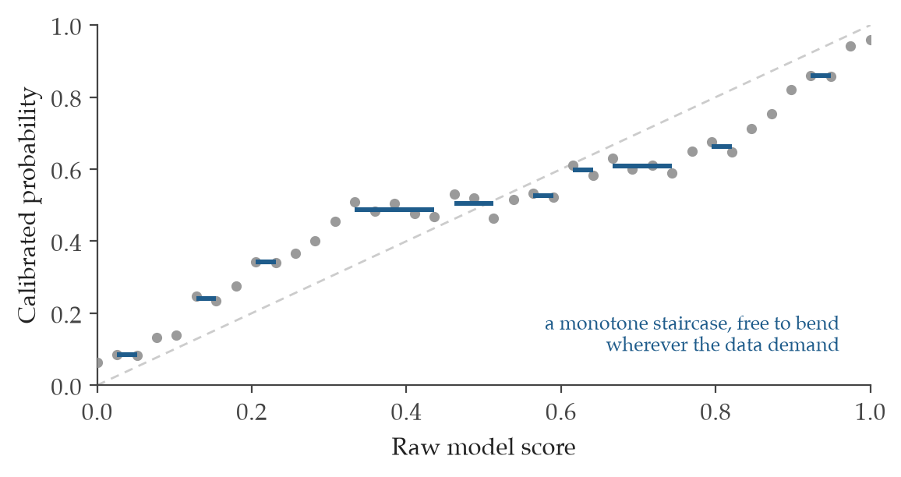
Figure 17. Isotonic regression as a monotone staircase. Isotonic regression fits the best non-decreasing step function to the raw scores. It makes no assumption about shape beyond order, so it can correct stranger distortions than a logistic curve, at the cost of needing more data.
Where it is used
Nonprofit director and board | A nonprofit director should reach for isotonic regression when there is a large pool of past cases and the gentle S-curve of simpler methods is too stiff to capture how a model really errs. The fitted staircase needs enough data to stand on, which is why volume matters. The payoff is a probability the board can trust even where the model used to drift worst.
Company leadership and board | For company leadership with a deep history of outcomes, isotonic regression corrects a forecast model flexibly when its errors do not follow any neat curve. It earns its keep on large calibration sets where a rigid sigmoid would leave money on the table. The board gains probabilities that hold up across the whole range, not just the comfortable middle.

Q17 - Beta Calibration

What it measures
Beta calibration fixes a model's probabilities with three fitted parameters, enough flexibility to bend an S-curve that leans harder on one tail than the other. It belongs to the family of calibration repair, and it answers a failure that simpler logistic correction cannot reach. Picture a fraud model that is roughly honest about likely-clean transactions but wildly overconfident about the rare suspicious ones. Platt scaling, with its symmetric curve, leaves that one tail uncorrected. Beta calibration adds the extra term that pulls the stubborn end back into line.
How it is calculated
p̂ = σ(a ln r + b ln(1 − r) + c)
Reading: the calibrated probability is the sigmoid of a weighted blend of the log of the raw score and the log of its complement, plus a constant.
p̂ is the beta-calibrated probability.
r is the raw probability score.
a, b, c are the three fitted parameters.
ln is the natural logarithm.
σ is the logistic sigmoid.
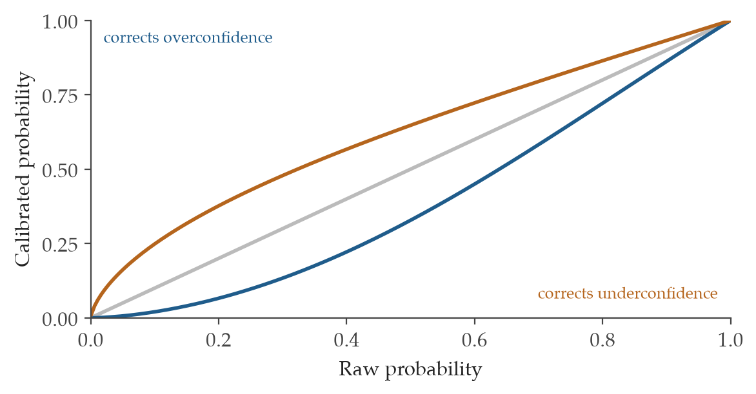
Figure 18. The beta family of calibration curves. Beta calibration extends the logistic map with a second shape parameter, so a single family can pull overconfident probabilities down or push underconfident ones up. The grey diagonal is the curve that leaves a forecast unchanged.
Where it is used
Nonprofit director and board | A nonprofit director should use beta calibration when a simpler logistic repair leaves one end of the probability range still misbehaving, often the high-stakes tail of rare outcomes. The third parameter buys the asymmetry that a plain sigmoid cannot express. The board then gets honest numbers even on the unusual cases that matter most.
Company leadership and board | For company leadership, beta calibration is the right tool when Platt scaling corrects most of a forecast but misses one probability tail, the very region where a pricing or risk decision can go badly wrong. Its three parameters let the curve lean where the data lean. The board reads confidence that holds at the extremes as well as the middle.

Q18 - Spline / Bayesian Calibration

What it measures
Spline and Bayesian calibration repair a model's probabilities with a smooth curve, either flexed freely by spline knots or steadied by a prior when data are thin. Both live in the family of calibration repair, and both shine when a hard staircase would overfit. Imagine a small charity with only 80 past grant outcomes trying to calibrate a risk score. A raw isotonic fit would chase noise. A spline draws a gentle line through the points, while a Bayesian version leans on a prior calibration curve from a sister program to keep the estimate sane.
How it is calculated
p̂ = g_spline(s) or p(θ|D) ∝ p(D|θ)p(θ)
Reading: the calibrated probability is either a smooth spline of the raw score or a posterior over calibration parameters given the data.
p̂ is the calibrated probability.
g_spline is the smooth calibration curve.
θ is the calibration parameters.
D is the calibration data.
∝ means proportional to.
Where it is used
Nonprofit director and board | A nonprofit director should choose spline or Bayesian calibration for small-sample repair, especially when a related program offers a usable prior curve to borrow from. The smoothness keeps the fit from chasing a handful of lucky or unlucky cases. The board gets a stable probability even when the record is short.
Company leadership and board | For company leadership facing a new product or market with few past outcomes, spline or Bayesian calibration repairs the forecast without overreacting to scarce data. A prior drawn from an adjacent line of business can anchor the curve where the evidence runs out. The board reads probabilities that bend with the data yet refuse to lurch on noise.

Q19 - Cost-Loss Rule

What it measures
The cost-loss rule sets the probability at which acting to prevent a harm becomes worth its price, by weighing the cost of action against the loss suffered if the harm strikes unmitigated. It belongs to the family of decision utility, where a forecast is finally turned into a choice. Suppose protective maintenance costs 2,000 dollars and a failure left unaddressed costs 50,000. The threshold falls to 0.04, meaning a failure probability above 4% already justifies the spend. Below that line the cheaper gamble is to wait.
How it is calculated
p* = C/L
Reading: the action threshold equals the cost of acting divided by the loss if the event occurs.
p* is the action threshold.
C is the cost of mitigation or action.
L is the loss if the adverse event occurs unmitigated.
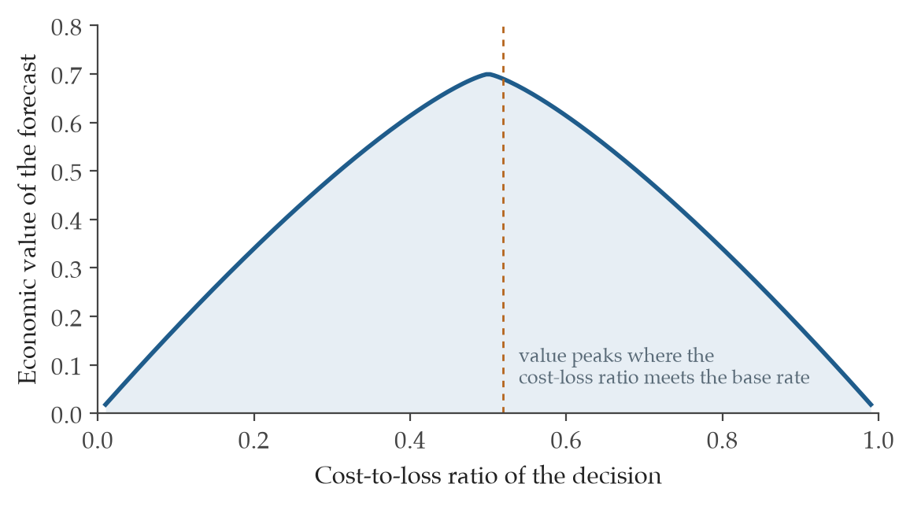
Figure 19. The economic value of a forecast across decisions. A forecast is worth more to some decisions than others. The curve traces its value as the ratio of the cost of acting to the loss of being caught unprepared. Value is highest when that ratio sits near the event's base rate.
Where it is used
Nonprofit director and board | A nonprofit director can use the cost-loss rule whenever a preventive action carries a known price and the avoided harm carries a known cost, such as repairing a roof before a feared leak. The ratio names the exact probability above which acting beats waiting. The board sees the spending decision reduced to one honest threshold.
Company leadership and board | For company leadership, the cost-loss rule turns a risk forecast into a clear spending line whenever the cost of acting and the loss from inaction are both visible. A recall, a hedge, or a maintenance program each has its own threshold. The board can then judge whether the stated failure probability clears the bar that justifies the outlay.

Q20 - Reference-Class Blending / Outside-View

What it measures
Reference-class blending tempers a case-specific estimate by mixing it with the base rate from comparable situations that came before. It belongs to the family of decision utility, and it exists to curb the optimism that grips us when we stare only at the project in front of us. A team swears its new clinic will open in nine months because their plan looks airtight. The outside view notes that the last dozen comparable clinics averaged 15 months. Blending the two pulls the forecast toward the sober record instead of the hopeful plan.
How it is calculated
p_adj = αp_inside + (1 − α)p_ref
Reading: the adjusted probability is the inside-view estimate weighted by alpha plus the reference-class estimate weighted by the remainder.
p_adj is the adjusted probability.
α ∈ [0,1] is the weight placed on the inside view.
p_inside is the case-specific estimate.
p_ref is the reference-class or base-rate probability.
Where it is used
Nonprofit director and board | A nonprofit director should blend in the outside view on any planning forecast backed by at least five comparable past cases, where the temptation to trust this time is different runs strong. The base rate of similar efforts anchors the estimate to lived history. The board gets a timeline or success rate that has already met reality once.
Company leadership and board | For company leadership, reference-class blending guards expansion and launch forecasts against inside-view optimism by folding in how comparable bets actually played out. Five or more analogous cases give the base rate enough weight to matter. The board reads a number disciplined by the company's own track record rather than the latest pitch.

Q21 - Posterior Predictive p-values

What it measures
A posterior predictive p-value asks how often a model that you believe would generate data as extreme as the data you actually saw. It belongs to the family of decision utility as a check on whether a fitted model deserves trust. Imagine a donation model that predicts smooth monthly giving, yet the real year held two wild spikes. You simulate many years from the model and count how many show spikes that large. If almost none do, the small p-value warns that the model is missing something real.
How it is calculated
p_ppc = Pr[T(y_rep) ≥ T(y_obs) | y_obs]
Reading: the value is the probability that a replicated statistic is at least as extreme as the observed statistic, given the observed data.
p_ppc is the posterior predictive p-value.
T(·) is the discrepancy statistic.
y_rep is the replicated outcome drawn under the posterior model.
y_obs is the observed outcome.
Pr is probability.
Where it is used
Nonprofit director and board | A nonprofit director can use a posterior predictive p-value to test whether a calibration repair or a fitted model truly matches the program's history before leaning on it. A value near 0 or 1 signals that the model fails to reproduce what actually happened. The board learns whether the tool is sound before betting decisions on it.
Company leadership and board | For company leadership, the posterior predictive p-value validates whether a forecasting model can recreate the patterns already seen in the business. An extreme value flags a model that quietly omits a real driver of revenue or risk. The board gains a warning light before a flawed model shapes capital choices.

Q22 - Zone Classification

What it measures
Zone classification reads a system's recent trajectory and sorts its current state into a named regime, from stable through transition to critical. It belongs to the family of dynamics and anomaly detection, and it exists to catch the moment when a small nudge could trigger an outsized swing. Think of a reservoir whose water quality has drifted for months. A classifier watching the trend can label it as still stable or as entering a transition where one hot week tips it over. That label tells operators when caution must replace routine.
How it is calculated
z_t = f(θ_t,x_t) ∈ {stable, transition, critical}
Reading: the zone at time t is a pre-specified classifier applied to the parameter trajectory and the current state.
z_t is the zone label at time t.
θ_t is the parameter trajectory.
x_t is the observed system state.
f is the pre-specified classifier.
∈ means membership in the set of possible states.
Where it is used
Nonprofit director and board | A nonprofit director can use zone classification to watch a program or system whose small shifts sometimes cause large swings, such as a service whose demand can suddenly overwhelm capacity. The label marks when the system has left its calm regime. The board gets early notice to act before a transition becomes a crisis.
Company leadership and board | For company leadership, zone classification flags when an operation or market sits near a state where minor changes can produce major output shifts. A move from stable to transition is a signal to tighten oversight. The board reads a clear regime label rather than a wall of raw telemetry.

Q23 - Tipping Points + AR(1) Early-Warning

What it measures
This early-warning method watches a time series for two quiet symptoms that often precede a regime shift, rising correlation from one moment to the next and a swelling variance. It belongs to the family of dynamics and anomaly detection. As a system loses its resilience it recovers more slowly from each small jolt, so today's value clings closer to yesterday's and the swings grow wider. Picture a lake easing toward sudden algal collapse. Months ahead, its weekly readings start tracking each other more tightly and bouncing more violently, a warning visible before the water turns.
How it is calculated
φ₁ = corr(x_t,x_{t−1}); flag if Δφ₁ > 0 and ΔVar(x) > 0
Reading: estimate the lag-one autocorrelation as the correlation between each value and the one before it, then raise a flag when both that autocorrelation and the variance are climbing.
φ₁ is the lag-one autocorrelation.
x_t is the value at time t.
Δ is the change over the monitoring window.
Var(x) is the variance.
corr is the correlation.
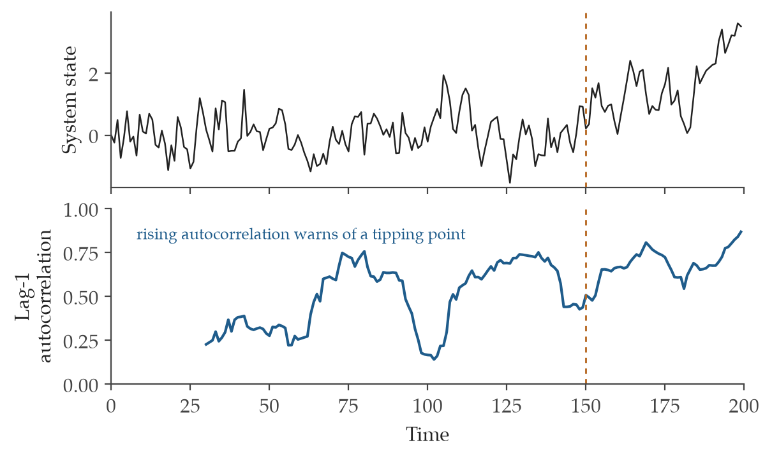
Figure 20. An early-warning signal before a tipping point. As a system loses resilience it recovers from small shocks more slowly, so each value resembles the one before it more closely. The lower panel tracks that lag-1 autocorrelation. Its climb begins before the visible shift at the dashed line.
Where it is used
Nonprofit director and board | A nonprofit director can use this early-warning signal on any system with a long run of historical readings, watching for the twin rise in autocorrelation and variance that hints at an approaching break. Both must climb together for the flag to mean much. The board gains lead time before a slow drift becomes an abrupt shift.
Company leadership and board | For company leadership, the AR(1) early-warning watches a monitored time series for the loss of resilience that precedes a sharp turn in a market or operation. A joint rise in lag-one correlation and variance is the tell. The board reads a forecast of fragility while there is still room to respond.

Q24 - Influence Gini

What it measures
The influence Gini measures how unevenly weight is spread across the people in a group review, running from 0 when everyone counts equally to near 1 when one voice dominates. It belongs to the family of dynamics and anomaly detection, here applied to the politics of a panel rather than a physical system. Picture a grant committee of eight where one senior figure quietly drives every verdict. A Gini of 0.6 exposes that lopsided authority, where a value near 0.1 would show a panel that truly shares the floor. The number turns a vague sense of capture into something the board can see.
How it is calculated
G = [∑_{i=1}^{n}∑_{j=1}^{n}|w_i − w_j|] / [2n∑_{i=1}^{n}w_i]
Reading: the coefficient is the average absolute difference between every pair of influence weights, scaled by twice the number of reviewers times the total weight.
G is the influence Gini coefficient.
w_i and w_j are the influence weights of two reviewers.
n is the number of reviewers.
|·| is the absolute value.
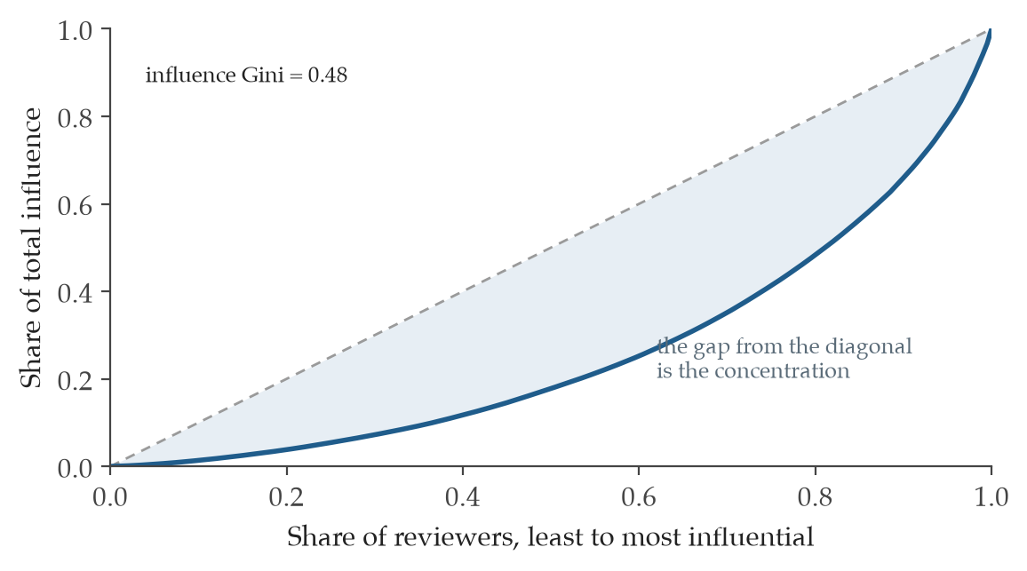
Figure 21. How concentrated influence is in a review body. Reviewers are ranked from least to most influential along the horizontal axis. The curve shows the share of total influence they hold. A straight diagonal would mean every reviewer counts equally. The bowed curve here means a few voices carry most of the weight.
Where it is used
Nonprofit director and board | A nonprofit director can use the influence Gini to audit whether a review committee genuinely deliberates or quietly bends to one authority or a bandwagon. A high value reveals that a few voices carry most of the weight. The board learns whether its panels need rebalancing before their verdicts harden into policy.
Company leadership and board | For company leadership, the influence Gini checks whether an investment or hiring committee shares judgment or defers to a dominant figure. A coefficient drifting toward 1 warns of authority capture that can steer capital badly. The board gets a concrete reading of how evenly decision power is actually distributed.

Q25 - Bias Cascade vs Snowball

What it measures
This pair of measures separates two ways a bias spreads, a cascade that jumps from one actor to many and a snowball that compounds inside a single actor over time. It belongs to the family of dynamics and anomaly detection. The distinction matters because the cures differ. Suppose an early reviewer's harsh framing infects six colleagues who each repeat it. That is a cascade across people. Now suppose one analyst's first error nudges every later judgment of his own in the same direction. That is a snowball within one mind, and rotating reviewers will not touch it.
How it is calculated
κ_cascade = |E_adoption|; ℓ_snowball = max path length
Reading: count the cascade as the number of cross-actor adoption edges, and measure the snowball as the longest within-actor amplification chain.
κ_cascade is the cross-actor adoption count.
E_adoption is the set of directed adoption edges.
ℓ_snowball is the longest within-actor amplification chain.
Where it is used
Nonprofit director and board | A nonprofit director can use this distinction when deciding whether to rotate reviewers or to recalibrate an individual. A wide cascade across people argues for fresh panels. A long snowball inside one reviewer argues for coaching that one person. The board chooses the remedy that fits the actual spread.
Company leadership and board | For company leadership, separating cascade from snowball clarifies whether a bias problem lives between people or within one decision-maker. A high cross-actor count points to rotation, while a long within-actor chain points to individual recalibration. The board directs the fix where the contagion actually runs.

Q26 - Coordination Tax

What it measures
The coordination tax measures how much individual judgment must be flattened to reach a single agreed number, taken as the average distance between each person's estimate and the consensus. It belongs to the family of dynamics and anomaly detection, and it treats disagreement as information rather than noise. Imagine five analysts forecasting demand at values ranging from 60 to 140, settling on a consensus of 100. The average gap is 24 units. That tax is the silent cost of agreement, the spread of honest views that the single headline number quietly erased.
How it is calculated
τ_coord = (1/N)∑_{i=1}^{N}|x_i − c|
Reading: the tax is the average absolute distance between each individual estimate and the consensus estimate.
τ_coord is the coordination tax.
x_i is an individual estimate.
c is the consensus estimate.
N is the number of reviewers or estimates.
|·| is the absolute compression required.
Where it is used
Nonprofit director and board | A nonprofit director can use the coordination tax in group decisions where wide disagreement may itself be the signal worth heeding. A large tax means the consensus hides real division rather than reflecting genuine accord. The board learns when a tidy single number deserves a second look.
Company leadership and board | For company leadership, the coordination tax reveals how much dissent was compressed to manufacture a unified forecast for a market or product call. A high value warns that the headline figure masks a divided room. The board can then probe the disagreement before committing capital on a false calm.

Q27 - Copula-Based Dependence

What it measures
Copula-based dependence captures how variables move together beyond the straight-line link that Pearson correlation can see, including the way some pairs cling hardest in their extreme tails. It belongs to the family of dependence and uncertainty. Two assets may look mildly correlated in calm markets yet crash in lockstep during a panic. A copula isolates that tail dependence, the probability they fail together precisely when it hurts most. Picture two funding streams that seem independent until a recession dries up both at once, a joint collapse a single correlation number would have missed.
How it is calculated
ρ_s, τ_K, λ_L, λ_U, C(u,v)
Reading: summarize dependence through rank correlations and tail measures, or through a fitted copula or vine that joins the marginal distributions.
ρ_s is the Spearman rank correlation.
τ_K is the Kendall rank correlation.
λ_L is the lower tail dependence and λ_U is the upper tail dependence.
C(u,v) is the copula joining the marginal distributions.
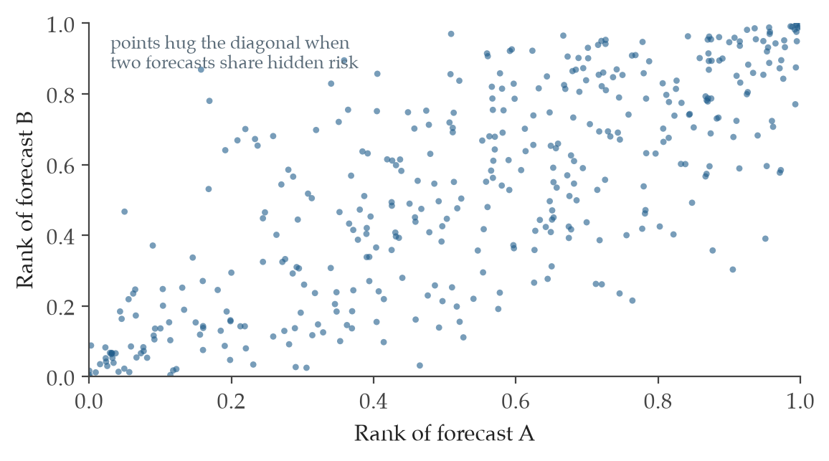
Figure 22. Dependence shown on the rank scale. A copula strips away each forecast's own distribution and shows only how the two move together. When points crowd the diagonal, the forecasts tend to fail at the same time, which is exactly the hidden link that turns separate risks into one large one.
Where it is used
Nonprofit director and board | A nonprofit director can use copula-based dependence to model the risk that several funding sources or programs fail together, where a plain correlation would understate the danger. Tail dependence shows whether they collapse in unison just when reserves run thin. The board sees joint-failure risk that Gaussian assumptions tend to hide.
Company leadership and board | For company leadership, copula methods expose how products and counterparties move together in the tails, where a normal-distribution model dangerously assumes calm. The tail-dependence figures reveal who sinks alongside whom in a crisis. The board gains a clearer picture of joint failure before it concentrates exposure.

Q28 - Conformal Prediction

What it measures
Conformal prediction builds a forecast interval that comes with a coverage guarantee, promising to contain the true outcome at least a stated share of the time without trusting any particular distribution. It belongs to the family of dependence and uncertainty. The method studies how large the model's past errors were on held-out cases and widens its intervals accordingly. A demand model might report not just 1,000 units but a band of 850 to 1,150 that will hold the real figure in 90% of cases. That honest band is worth more to a planner than a single confident point.
How it is calculated
Pr{Y ∈ C_{1−α}(X)} ≥ 1 − α
Reading: the probability that the true outcome falls inside the conformal set is at least 1 minus the allowed error rate.
Y is the future outcome.
X is the predictors or context.
C_{1−α}(X) is the conformal prediction set.
α is the allowed error rate.
Pr is the marginal coverage probability.
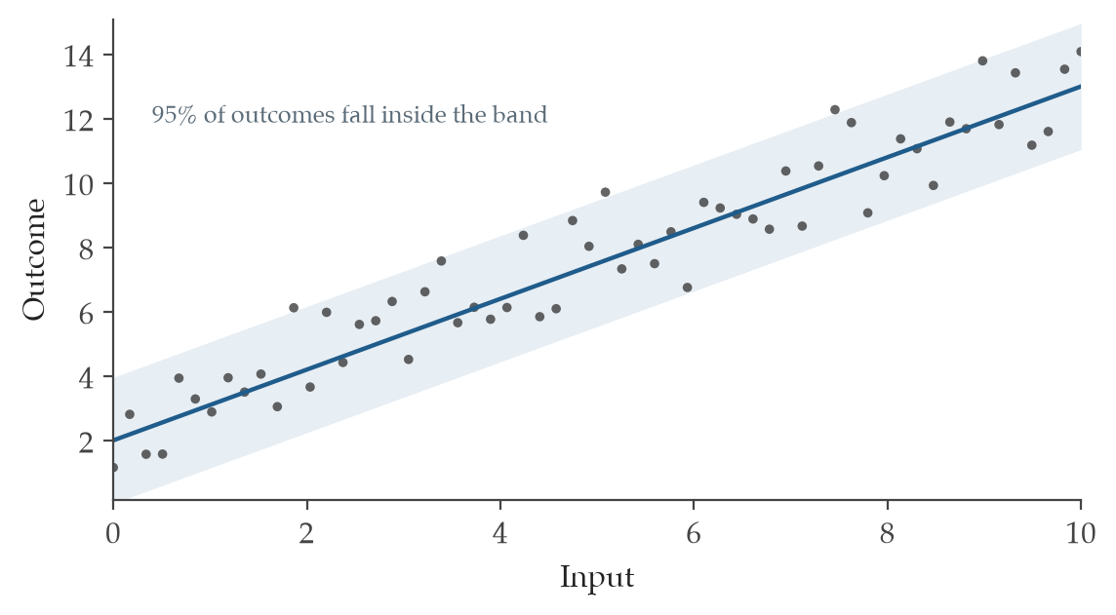
Figure 23. A prediction band with a guaranteed coverage rate. Conformal prediction turns any model into one that outputs an interval rather than a point. The band is built so that, over many cases, the true outcome lands inside it at the promised rate, here about 95%, without assuming the data follow any particular distribution.
Where it is used
Nonprofit director and board | A nonprofit director can use conformal prediction when a forecast needs an honest uncertainty band and the data refuse to fit a clean parametric model. The guaranteed coverage means the interval will hold the truth about as often as it claims. The board plans against a realistic range rather than a single fragile estimate.
Company leadership and board | For company leadership, conformal prediction supplies distribution-free intervals for revenue or demand forecasts that arrive with a coverage promise. The band is built from real past errors rather than convenient assumptions. The board can size inventory or capital against a range it can actually trust.

Combo Records (15)
Biases rarely arrive alone. These 15 records describe the combinations that do the most damage, where one distortion feeds another until a group talks itself into a decision no member would have made alone. Each record names the pattern and the control that interrupts it.

C1 - Planning Fallacy

What it measures
The planning fallacy is the mind's habit of estimating a project from the inside, by imagining the smooth path from here to done, while forgetting how every similar project actually unfolded. A program director maps out a new shelter expansion and sees 8 months of clean work, because she is picturing her own plan rather than the dozen comparable builds that each ran past a year. The correction is to weigh that hopeful inside estimate against the reference-class rate of how such efforts really went.
How it is calculated
p_adj = αp_inside + (1 − α)p_ref
The adjusted forecast blends the focal plan with the historical base rate, so a low weight on the inside view pulls the number toward what actually happened to similar efforts.
p_adj is the reference-adjusted forecast.
α is the inside-view weight.
p_inside is the focal plan estimate.
p_ref is the reference-class rate.
Where it is used
Nonprofit director and board | For a nonprofit director and board weighing a capital build or a fundraising commitment before they commit, this pairing replaces a single optimistic timeline with a number anchored in how past projects of the same kind actually ran. It tells the board whether the plan in front of them has been checked against history or only against hope.
Company leadership and board | For company leadership and a board deciding on a product launch or a major investment before commit, the reference-class adjustment exposes the gap between the team's inside estimate and the record of comparable bets. It gives the board one disciplined number to challenge instead of an internal forecast that no outside experience has tested.

C2 - Overconfidence / Dunning-Kruger

What it measures
Overconfidence is the mind stating more certainty than its track record can support, and the Dunning-Kruger pattern is the version where the least skilled are the surest. An analyst who says he is 90% sure of nine straight calls, then gets only six right, is living inside this gap between felt confidence and measured accuracy. Read after outcomes are known, the bias shows up as a persistent distance between how confident the forecaster sounded and how often events actually broke the predicted way.
How it is calculated
BS = (1/N)∑(p_i − o_i)²; ECE = ∑(n_b/N)|acc_b − conf_b|
The Brier score is the average squared miss across all forecasts, and the expected calibration error groups forecasts into confidence bins and measures how far stated confidence drifts from observed accuracy in each.
BS is the Brier score.
ECE is the expected calibration error.
p_i is the forecast probability.
o_i is the outcome.
n_b is the count in a bin.
acc_b is the accuracy within a bin, and conf_b is the stated confidence within that bin.
Where it is used
Nonprofit director and board | For a nonprofit director and board reviewing decisions after the outcome is in, these two numbers turn a vague sense of how well the team forecasts into a measured record. They tell the board, within a single cycle, whether the confidence voiced in the room was earned or merely felt.
Company leadership and board | For company leadership and a board looking back on strategy or investment calls, the Brier score and calibration error reveal whether the executives who sounded most certain were also most right. They give the board a way to price the reliability of its own forecasters rather than trusting the loudest voice.

C3 - Noisy expert override

What it measures
A noisy expert override is the moment a person sets aside a sound rule or model and substitutes a hunch that leaves no durable reason behind it. A senior underwriter overrules the pricing model on a gut feeling about one client, and a year later no one can reconstruct why the exception was made or whether it paid off. The cost-loss rule offers a fixed line for when action is worth taking, so an override can be checked against a threshold rather than a mood.
How it is calculated
p* = C/L
The action threshold is the cost of acting divided by the loss avoided, so any forecast probability above that line justifies the mitigation and any below it does not.
p* is the action threshold.
C is the cost of action or mitigation.
L is the loss if the event is not mitigated.
Where it is used
Nonprofit director and board | For a nonprofit director and board facing a partnership risk or a capacity commitment before they commit, the cost-loss threshold sets a clear bar for when caution is worth its price. When a staff expert wants to override the rule, the board can ask what changed in the cost or the loss rather than deferring to seniority.
Company leadership and board | For company leadership and a board weighing an operational risk before commit, the threshold makes the trade between the price of acting and the price of inaction explicit. An executive who overrides it must then justify the move against a stated number, which keeps a single confident voice from quietly steering capital.

C4 - Authority / Bandwagon / Groupthink

What it measures
This cluster names the way a room's judgment collapses toward one source, whether a senior voice, a growing majority, or the simple wish to agree. A grant panel hears the executive director speak first, and the four reviewers who follow shade their scores toward hers without quite noticing they have stopped thinking independently. The influence Gini measures how unequally weight was spread across reviewers, so a number near 1 reveals that one person effectively decided what looked like a panel.
How it is calculated
G = [∑∑|w_i − w_j|]/[2n∑w_i]
The influence Gini sums the differences between every pair of reviewer weights and scales them, returning 0 when influence is perfectly even and approaching 1 when it concentrates in one person.
G is the influence Gini.
w_i and w_j are reviewer influence weights.
n is the number of reviewers.
Where it is used
Nonprofit director and board | For a nonprofit director and board designing a blind review panel, the influence Gini shows whether a decision that looked collective was actually carried by one dominant voice. It tells the board when to restructure a panel so that authority and quiet conformity stop standing in for evidence.
Company leadership and board | For company leadership and a board setting up a review of an investment or a strategy, this measure reveals how evenly judgment was distributed before the vote. A concentrated score warns the board that consensus in the room may be the shadow of one person rather than independent agreement.

C5 - False Consensus / Halo

What it measures
False consensus is the assumption that others see a question as you do, and the halo effect is letting one strong impression color every other judgment about a person or plan. A board reads warm nods around the table as agreement on a risky merger, never measuring how widely the private estimates actually scatter. Auditing the spread of individual judgments before any discussion reveals whether the apparent consensus was real or a story the room told itself.
How it is calculated
σ_j = stdev(x_i); ECE = ∑(n_b/N)|acc_b − conf_b|
The judgment spread is the standard deviation of independent estimates, and the calibration error checks whether the confidence attached to those estimates matched how often they proved right.
σ_j is the judgment spread.
x_i is an individual judgment.
ECE is the calibration gap measured over bins.
n_b/N is the weight of a bin.
Where it is used
Nonprofit director and board | For a nonprofit director and board designing a blind panel, measuring the spread of estimates before anyone speaks shows whether real agreement exists or whether one confident impression has been mistaken for many. It protects the board from approving a plan that only seemed to have broad support.
Company leadership and board | For company leadership and a board structuring a blind review, the spread of independent judgments exposes false consensus before it hardens into a decision. It tells the board whether the team genuinely converged or whether a single strong impression carried the day.

C6 - Commission Bias / Optimism

What it measures
Commission bias is the pull toward doing something rather than waiting, and optimism is the quiet faith that the something will work, even when no one has counted the ways it could fail. A leadership team rushes to launch a new service line and never writes down what might break, because acting feels braver than pausing. A premortem with a risk register forces each failure mode onto paper, where likelihood and severity can be multiplied into an honest exposure.
How it is calculated
R_i = ℓ_i × s_i
The exposure for each failure mode is its likelihood multiplied by its severity, so a rare but ruinous event and a common but minor one can be compared on the same scale.
R_i is the exposure for failure mode i.
ℓ_i is the likelihood.
s_i is the severity.
× is the multiplicative composition of likelihood and severity.
Where it is used
Nonprofit director and board | For a nonprofit director and board running a premortem before a new program or a capital spend, the risk register turns the urge to act into a list of named failures with sizes attached. It gives the board a sober count of what could go wrong rather than a confident plan with the dangers left unsaid.
Company leadership and board | For company leadership and a board weighing a product or market move, scoring each failure mode by likelihood times severity converts optimism into a ranked map of real exposure. It lets the board see which risks deserve mitigation before capital is committed to action.

C7 - Anchoring

What it measures
Anchoring is the way a first number quietly holds the mind in place, so that later evidence nudges the estimate only slightly when it should move it a great deal. A foundation officer hears an opening ask of $2 million and ends up settling near $1.8 million, even after learning facts that should have pushed the figure far lower. Tracking the revision delta, the distance between the first guess and the final one, shows whether new evidence actually moved the judgment or merely decorated the anchor.
How it is calculated
RD = |p_final − p_initial|
The revision delta is the absolute distance between the final forecast and the first estimate made before the evidence arrived, so a number near 0 signals that fresh facts barely moved the view.
RD is the revision delta.
p_final is the final forecast.
p_initial is the initial pre-evidence forecast.
|·| marks the absolute change.
Where it is used
Nonprofit director and board | For a nonprofit director and board during evidence review, the revision delta shows whether the team's estimate genuinely responded to what was learned or stayed tethered to its first number. A delta near 0 after strong new evidence is a signal that an anchor, not the facts, is driving the decision.
Company leadership and board | For company leadership and a board reviewing evidence on a deal or a forecast, the revision delta measures how far judgment actually traveled as facts came in. It warns the board when a starting price or an early projection has quietly fixed the answer that should have changed.

C8 - Base Rate Neglect / Sample-size insensitivity

What it measures
Base rate neglect is treating a vivid specific case as if the broad background frequency did not exist, and sample-size insensitivity is trusting a percentage drawn from far too few cases. A board sees that four of five pilot sites succeeded and reads 80% as a stable rate, forgetting that five sites can swing wildly by chance alone. A posterior predictive check asks how often data this extreme would appear under the assumed model, which exposes a small sample posing as solid ground.
How it is calculated
p_ppc = (1/N_rep)∑𝟙{T_rep ≥ T_obs}
The posterior predictive p-value counts how often a replicated test statistic matches or exceeds the observed one across many simulated draws, so a value near 0 or 1 flags data the model struggles to reproduce.
p_ppc is the posterior predictive p-value.
N_rep is the number of replicated draws.
T_rep is the replicated test statistic, and T_obs is the observed test statistic.
𝟙{·} is the indicator that counts each qualifying draw.
Where it is used
Nonprofit director and board | For a nonprofit director and board before they commit to scaling a pilot, this check tests whether an encouraging early percentage rests on enough cases to trust. It keeps the board from betting living-support capacity on a number that a handful of lucky sites produced.
Company leadership and board | For company leadership and a board before commit on a product or market call, the posterior predictive check reveals whether a promising early result reflects a real signal or a small sample's noise. It protects capital from being deployed against a percentage that cannot bear the weight placed on it.

C9 - Dunning-Kruger

What it measures
Here the Dunning-Kruger pattern hides inside a single tidy Brier number, where a forecaster's poor judgment is masked because one summary score can look acceptable for the wrong reasons. A team reports a middling Brier score and calls its forecasting adequate, never noticing that the score is propped up by easy questions rather than real skill. The Murphy decomposition splits that one number into its parts, separating how well calibrated the forecasts were from how much they actually distinguished events.
How it is calculated
BS = REL − RES + UNC
The Murphy decomposition breaks the Brier score into a reliability penalty, a resolution benefit, and the base uncertainty of the events, so a decent total can be traced to genuine skill or to easy questions.
REL is the reliability penalty.
RES is the resolution benefit.
UNC is the base uncertainty.
BS is the Brier score.
Where it is used
Nonprofit director and board | For a nonprofit director and board reviewing forecasts after the outcome, the decomposition shows whether a respectable score came from real discernment or from questions that were never hard. It keeps the board from crediting skill where only easy calls were made.
Company leadership and board | For company leadership and a board assessing forecasting after the fact, splitting the Brier score into calibration and resolution reveals whether the team genuinely distinguished outcomes. It stops a comfortable headline number from disguising weak judgment about the decisions that mattered.

C10 - Generalized overconfidence

What it measures
Generalized overconfidence is the habit of reporting a single point probability as if it settled the matter, while the weak assumptions about noise behind it stay out of view. An executive states a 0.30 chance of failure with no range around it, and the board treats that lone figure as firm ground. A conformal prediction interval wraps the point estimate in an honest band of uncertainty, and the cost-loss rule then asks whether action is warranted across that whole band.
How it is calculated
C_{1−α}(x) = [ŷ − q̂_{1−α}, ŷ + q̂_{1−α}]; p* = C/L
The conformal interval surrounds the point prediction with a residual-based band that holds at the chosen error rate, and the cost-loss threshold then marks the probability above which acting is worthwhile.
C_{1−α}(x) is the conformal interval.
ŷ is the point prediction.
q̂ is the residual quantile.
α is the error rate.
C/L is the cost-loss threshold.
Where it is used
Nonprofit director and board | For a nonprofit director and board before they commit, pairing an honest uncertainty band with a cost-loss line shows whether a decision holds up across the plausible range, not just at one convenient point. It keeps the board from acting on a single confident number that hides how wide the real uncertainty runs.
Company leadership and board | For company leadership and a board before commit on capital or product, the interval plus threshold tests whether the case for acting survives across the full span of likely outcomes. It guards against an overconfident point estimate steering a major decision past risks it never priced.

C11 - Confirmation Bias / Framing Effect

What it measures
Confirmation bias is the search for evidence that supports what one already believes, and the framing effect is giving different answers to the same question dressed in different words. A program team gathers only the studies that back its favored approach, then rates the plan more highly when it is framed as a 70% success rather than a 30% failure. Setting a quota for disconfirming evidence and measuring the gap between answers under two frames drags both habits into the light.
How it is calculated
β = d/(s+d+n); Δφ = |p_frameA − p_frameB|
The disconfirming balance is the share of gathered evidence that cuts against the favored view, and the frame delta is the distance between the same judgment under two wordings.
β is the disconfirming-evidence balance.
d is the disconfirming count or weight.
s is the supporting count or weight.
n is the neutral count or weight.
Δφ is the frame sensitivity.
Where it is used
Nonprofit director and board | For a nonprofit director and board during evidence review, the disconfirming quota forces the team to seek out what argues against its plan, and the frame delta checks whether the same proposal would survive a different wording. Together they tell the board whether a decision rests on a fair reading of the evidence.
Company leadership and board | For company leadership and a board reviewing evidence on a strategy, requiring disconfirming evidence and testing two framings reveals whether a recommendation reflects the facts or only the team's preference. It protects capital from a case built to confirm what someone already wanted.

C12 - Planning Fallacy / Groupthink

What it measures
When the planning fallacy meets groupthink, hopeful inside-view estimates are first formed in isolation and then quietly squeezed toward a shared number the group can comfortably endorse. Each engineer privately fears a 14-month timeline, yet the meeting converges on the 9 months leadership clearly prefers, and the private doubts vanish into consensus. The coordination tax measures how far individual estimates were bent to reach agreement, exposing the cost of that compression.
How it is calculated
τ_coord = (1/N)∑|x_i − c|
The coordination tax is the average distance between each person's private estimate and the consensus figure, so a large value shows how much individual judgment was bent to reach agreement.
τ_coord is the coordination tax.
x_i is an individual estimate.
c is the consensus estimate.
N is the number of estimates.
Where it is used
Nonprofit director and board | For a nonprofit director and board designing a blind panel, the coordination tax reveals how far private estimates were pulled to manufacture agreement on a plan. A high value tells the board that consensus came at the cost of honest individual judgment.
Company leadership and board | For company leadership and a board structuring a blind review, this measure shows whether a unified timeline or forecast reflects real agreement or compressed dissent. It warns the board when comfortable consensus has buried the private doubts that should inform the decision.

C13 - Narrative Fallacy

What it measures
The narrative fallacy is the mind's rush to wrap events in a clean story, especially a story of why a regime shifted that only becomes obvious once the shift has already happened. After a donor base collapses, the board constructs a tidy account of the warning signs, though no one read them as a pattern at the time. Watching lag-one autocorrelation rise gives an early, numerical warning of a system losing its stability, before the story is available to tell.
How it is calculated
φ₁ = corr(x_t,x_{t−1})
The lag-one autocorrelation measures how strongly each value tracks the one just before it, and a steady climb toward 1 is a recognized early sign that a system is slowing and may be near a tipping point.
φ₁ is the lag-one autocorrelation.
x_t is the current value.
x_{t−1} is the prior value.
corr is the correlation.
Where it is used
Nonprofit director and board | For a nonprofit director and board monitoring an ongoing program or revenue stream, rising autocorrelation offers a quiet early warning that conditions are drifting toward a break. It lets the board act on a measured signal rather than waiting for the after-the-fact story.
Company leadership and board | For company leadership and a board monitoring a market or operational metric, a climbing autocorrelation flags a system losing resilience before any narrative explains it. It gives the board time to respond to instability while it is still a number rather than a crisis.

C14 - Authority / Bandwagon

What it measures
Authority and bandwagon biases describe how a single skewed judgment spreads, either jumping from one actor to many as a cascade or looping back to amplify itself within one decision chain. One respected director endorses a vendor, and within weeks every department has adopted the same choice, each pointing to the others as proof. Tracking the size of the adoption cascade alongside the longest self-reinforcing chain shows how far one initial nudge actually traveled.
How it is calculated
κ_cascade = |E_adoption|; ℓ_snowball = max path length
The cascade size counts how many adoption links a single judgment set off, and the snowball length measures the longest chain in which the bias kept feeding itself.
κ_cascade is the cascade size.
E_adoption is the set of adoption edges.
ℓ_snowball is the longest self-amplifying chain.
Where it is used
Nonprofit director and board | For a nonprofit director and board monitoring how decisions spread across teams, these measures show whether a choice was independently reached or simply copied down a chain from one authority. They tell the board when apparent agreement is really a single judgment echoing through the organization.
Company leadership and board | For company leadership and a board monitoring how a decision propagates, the cascade size and chain length reveal whether a market or vendor consensus grew from independent reasoning or from one influential move repeating itself. They warn the board when a single early nudge has quietly shaped a company-wide commitment.

C15 - Calibration model overfit

What it measures
Calibration model overfit is the trap of a repair that flatters its own training data while failing on cases it has not seen. A team applies an isotonic adjustment, watches the in-sample calibration look perfect, and ships it, only to find it falls apart on next quarter's forecasts. A posterior predictive check run after the repair tests whether the fix actually reproduces held-out data or merely memorized the sample it was built on.
How it is calculated
p_ppc = (1/N_rep)∑𝟙{T_rep ≥ T_obs}
After a Platt or isotonic repair, the posterior predictive p-value counts how often replicated statistics match or exceed the observed one, so a value near 0 or 1 signals a calibration fix that does not generalize.
p_ppc is the posterior predictive p-value after calibration repair.
N_rep is the number of replicated draws.
T is the test statistic.
𝟙{·} is the indicator that counts each qualifying draw.
Where it is used
Nonprofit director and board | For a nonprofit director and board reviewing a calibration repair after the outcome, this check tests whether the fix holds on data it never saw or only looked good on its own training set. It keeps the board from trusting a correction that will quietly fail in the next cycle.
Company leadership and board | For company leadership and a board assessing a calibration adjustment after the fact, the posterior predictive check distinguishes a genuine improvement from one that merely memorized past data. It protects future decisions from a repair that flatters the sample but breaks on real forecasts.

Quant-Field Entries (9)
These 9 measures look not at a forecast but at the conditions under which a review was made. They count the things that decide whether a judgment can be trusted at all, such as how many independent voices weighed in and how widely their scores spread.

UQ1 - Blind sample size

What it measures
Blind sample size counts how many people wrote down a judgment on their own before anyone heard the room lean one way. Imagine a hiring panel where each of six reviewers submits a score before the meeting opens, rather than nodding along after the senior partner speaks first. A higher count means the final view rests on minds that thought alone, and a count of 1 or 2 means the record holds little more than a single opinion wearing the clothes of a group.
How it is calculated
n_blind = |{j_i : t_i < t_reveal ∧ I_i = 1}|
The measure counts only the judgments that were both filed before the reveal and made without leaning on anyone else. n_blind is the count of blind independent judgments. j_i is judgment i. t_i is the moment that judgment was submitted. t_reveal is the moment discussion or visible consensus began. I_i marks whether the reviewer worked independently. The bars |·| mean the size of the set.
Where it is used
Nonprofit director and board | For a nonprofit director and board, blind sample size shows whether a program or grant decision rested on real independent reading or on one early voice the rest deferred to. When the count is low, the board learns that what looked like agreement may never have been tested.
Company leadership and board | For company leadership and a board, this count reveals how many people actually formed a view on a capital or market commitment before the room aligned. A confident recommendation backed by only one or two blind judgments deserves a harder look before money moves.

UQ2 - Score spread

What it measures
Score spread measures how far reviewers drifted apart in their ratings once the scores are put on a common scale. Picture five evaluators rating a proposal from 1 to 10, where one says 3 and another says 9. That gap is information, because honest disagreement usually means the evidence genuinely points in more than one direction. A healthy spread sits in a normal band for the kind of decision at hand, while a spread far below normal can mean the reviewers were copying each other rather than judging.
How it is calculated
z_spread = (s_score − μ_s)/σ_s
The measure takes the observed disagreement and states it as a distance from what disagreement usually looks like for similar reviews. z_spread is the standardized score spread. s_score is the observed standard deviation of the review scores. μ_s is the average spread expected for comparable reviews. σ_s is how much that expected spread normally varies.
Where it is used
Nonprofit director and board | For a nonprofit director and board, score spread tells whether reviewers of a program or funding choice truly wrestled with it or quietly settled on the same number. A spread far tighter than comparable reviews is a quiet warning that real scrutiny may have been skipped.
Company leadership and board | For company leadership and a board, the spread shows how much genuine debate sat behind a product or investment score. Unusually tight scores on a hard, uncertain decision often signal pressure to agree rather than real consensus.

UQ3 - Uniformity pressure

What it measures
Uniformity pressure measures how much tighter the agreement turned out than the situation should have allowed. When evidence is thin and reviewers come from different roles, opinions ought to scatter. If instead everyone lands on nearly the same score, the gap between the spread you expected and the spread you got is the pressure to conform. A value near 0 means the agreement was earned, while a large value means the room may have closed ranks before the question was settled.
How it is calculated
υ = max(0, s_expected − s_observed)
The measure subtracts the disagreement actually seen from the disagreement that comparable reviews would predict, and reports only the shortfall. υ is the uniformity-pressure signal. s_expected is the score spread expected for comparable reviews. s_observed is the spread that actually occurred. The max(0,·) holds the value at zero whenever observed disagreement meets or beats what was expected.
Where it is used
Nonprofit director and board | For a nonprofit director and board, uniformity pressure flags moments when a program or staffing vote looked unanimous but the underlying evidence never justified such calm agreement. It points the board toward decisions that may need a second, more candid hearing.
Company leadership and board | For company leadership and a board, this signal catches the kind of false consensus that precedes costly market or talent bets. A high reading invites leadership to reopen a question the team appeared to have closed too neatly.

UQ4 - Reviewer independence

What it measures
Reviewer independence measures how far each reviewer stayed clear of the same starting numbers, the same authority, and the same social cues that pull judgments together. Think of three analysts who each see the deal team's preferred valuation before scoring, against three who never do. The first group will tend to echo the anchor, the second will think for themselves. The score runs from 0 to 1, where values near 1 mean reviewers reached their views on separate paths and values near 0 mean they were all reading from the same script.
How it is calculated
ι = 1 − norm(a_shared + v_prior + h_authority)
The measure adds up the shared influences on the reviewers, scales that sum into a 0-to-1 range, and subtracts it so that less shared influence yields more independence. ι is the reviewer independence score. a_shared is how much reviewers were exposed to the same anchor. v_prior is how visible earlier scores were to later reviewers. h_authority is how visible a senior or authoritative view was. The norm(·) bounds the combined exposure to the interval from 0 to 1.
Where it is used
Nonprofit director and board | For a nonprofit director and board, reviewer independence shows whether the people assessing a grant or program reached their views separately or simply absorbed one dominant opinion. A low score warns that an apparent consensus may be a single judgment repeated several times.
Company leadership and board | For company leadership and a board, this score reveals how much of a recommendation came from independent thinking rather than a shared anchor planted early. On large capital or risk decisions, independence near the low end means the supporting votes carry less weight than their number suggests.

UQ5 - Evidence balance

What it measures
Evidence balance measures how lopsided the case was between evidence that supported the decision and evidence that cut against it. A board paper that cites 20 reasons to proceed and almost nothing that might give pause is telling you about its authors as much as about the world. The measure runs from 0 to 1, where a value near 0 means supporting and disconfirming evidence carried roughly equal weight and a value near 1 means the file leaned almost entirely one way.
How it is calculated
β = |W_support − W_disconfirm| / max(ε,W_total)
The measure takes the gap between supporting and opposing evidence and divides it by all the evidence on the table, so a one-sided file scores high. β is the evidence-balance gap. W_support is the weighted supporting evidence. W_disconfirm is the weighted disconfirming evidence. W_total is the total weight of all evidence. ε is a small guard that keeps the denominator from reaching zero.
Where it is used
Nonprofit director and board | For a nonprofit director and board, evidence balance shows whether a proposal was argued fairly or built only from reasons to say yes. A high gap tells the board that the disconfirming side of the case was never seriously gathered.
Company leadership and board | For company leadership and a board, this gap reveals when a product or market case has been assembled to persuade rather than to test. A reading near 1 on a major commitment is a sign to ask what evidence against the plan was left out of the room.

UQ6 - Processing completeness

What it measures
Processing completeness measures the share of the evidence that was actually dated, sorted, checked for freshness, and tied to the claim it was meant to support. Raw material piled into a decision file is not the same as evidence that has been worked through. If 40 sources were submitted and only 10 were handled this way, the file is one-quarter processed. The measure runs from 0 to 1, and a value near 1 means little was left sitting unexamined.
How it is calculated
χ = n_processed / max(1,N_evidence)
The measure divides the evidence that was properly worked through by all the evidence gathered. χ is the processing completeness. n_processed is the number of evidence rows that were properly worked through and connected to the claim they support. N_evidence is the total number of evidence rows. The max(1,·) keeps the calculation safe when no evidence was logged.
Where it is used
Nonprofit director and board | For a nonprofit director and board, processing completeness shows whether the evidence behind a decision was genuinely examined or merely collected and filed. A low share warns that much of the supporting material was never checked for age or relevance.
Company leadership and board | For company leadership and a board, this share separates a decision built on worked-through evidence from one resting on an impressive but untouched stack. On a costly bet, a low value means the file deserves real processing before approval.

UQ7 - Phrase-family hits

What it measures
Phrase-family hits measures how thickly a written rationale is salted with language that signals false certainty, such as words of inevitability, sweeping cause, or absolute confidence. A memo that calls an outcome certain and then inevitable is leaning on tone where it should be leaning on evidence. The measure is reported per 1,000 words so that long and short documents can be compared, and a lower rate means the writing claimed only what it could show.
How it is calculated
φ = [∑_k w_kh_k] / max(1,W_words/1000)
The measure weighs each cluster of loaded phrases, adds them up, and divides by the length of the rationale in thousands of words. φ is the weighted phrase-family hit rate per 1,000 words. h_k is the number of hits in phrase family k. w_k is the weight given to phrase family k. W_words is the word count of the rationale. The max(1,·) keeps very short rationales from distorting the rate.
Where it is used
Nonprofit director and board | For a nonprofit director and board, this rate flags proposals that persuade through confident language rather than through what the evidence can bear. A high count invites the board to ask whether the certainty in the writing is matched by certainty in the facts.
Company leadership and board | For company leadership and a board, the phrase rate exposes pitches that lean on inevitability and absolute language to carry a weak case. On a large commitment, a high reading is a prompt to strip the tone away and read what remains.

UQ8 - Challenge record completeness

What it measures
Challenge record completeness measures how much of the dissent and pre-commitment was actually written down: the alternatives weighed, the owner named, the deadline set, and the condition that would call the whole thing off. A decision that records no kill criterion and no named skeptic has left no trace of having been challenged. The measure runs from 0 to 1, where a value near 1 means the hard questions were captured rather than waved through.
How it is calculated
γ = n_completed / N_required
The measure divides the challenge fields that were filled in by the fields the process required. γ is the challenge-record completeness. n_completed is the number of challenge fields actually completed. N_required is the number of challenge fields the process called for.
Where it is used
Nonprofit director and board | For a nonprofit director and board, this measure shows whether dissent and exit conditions were recorded before a program or funding commitment, not invented afterward. A low value tells the board that the decision was never seriously challenged on the record.
Company leadership and board | For company leadership and a board, completeness here reveals whether a major bet carried a written kill criterion and a named challenger from the start. When the record is thin, the organization has no honest way to know later whether it should stop.

UQ9 - Calibration error

What it measures
Calibration error measures the distance between how confident forecasts were and how often those forecasts came true. If a team calls a string of events 80% likely and only 50% of them happen, its confidence has run ahead of reality by 30 points. The measure compares average stated probability against the observed rate across comparable decisions, and a value near 0 means the team's confidence has been earned by results.
How it is calculated
ε_cal = |p̄ − ō|
The measure takes the absolute gap between the average probability the team forecast and how often the event actually occurred. ε_cal is the calibration error. p̄ is the mean forecast probability. ō is the observed frequency, meaning the rate at which the predicted outcomes happened. The bars |·| make the gap a plain distance regardless of direction.
Where it is used
Nonprofit director and board | For a nonprofit director and board, calibration error gives a fair record of whether the organization's confidence in its forecasts has matched what actually unfolded. A persistent gap tells the board to discount future predictions until the confidence is brought back in line with results.
Company leadership and board | For company leadership and a board, this gap shows whether the numbers attached to forecasts can be trusted when capital is at stake. A large and steady error means the team's stated probabilities should be treated as opinion, not measurement, until calibration improves.

Composite Combo Records (5)
The 5 composite records gather the larger failure patterns that take hold across a whole governing body over time. Each one is a slow drift rather than a single error, and each is named so that a board can recognize it while it is still reversible.

UC1 - Deferential Consensus Combo

What it measures
Deferential Consensus is the pattern that appears when a respected voice speaks first and the room quietly arranges itself behind that voice. The authority bias and the bandwagon effect feed each other, reviewers stop scoring on their own, and the spread of their ratings collapses toward a single agreed number. Picture a foundation board where the chair says the new program is excellent, and within minutes every reviewer has marked it a 9 out of 10 without naming a single risk. The danger is not that the chair is wrong. It is that the record now holds one borrowed opinion wearing the costume of five independent judgments.
How it is calculated
κ_UC1 = γ_auth + γ_crowd + (1 − ι) + υ
Reading: the composite rises with the authority signal, the crowd or bandwagon signal, the lack of reviewer independence, and the pressure toward uniform scores.
κ_UC1 is the deferential-consensus risk.
γ_auth is the authority signal.
γ_crowd is the crowd or bandwagon signal.
ι is the independence score, so (1 − ι) grows as independence falls.
υ is the uniformity pressure in the scores.
Where it is used
Nonprofit director and board | For a nonprofit director and board, reach for UC1 when a major decision drew unusual agreement very fast and no one on the record dissented. A grant or hiring choice that every reviewer scored alike, right after a senior figure stated a view, is a sign to ask each reviewer for an independent judgment before the board commits.
Company leadership and board | For company leadership and a board, UC1 flags the investment or acquisition vote that closed with suspicious harmony in the room. When the deal memo shows uniform enthusiasm following a founder or chief executive endorsement, require at least one named owner to argue the opposing case in writing before capital moves.

UC2 - Evidence Echo Combo

What it measures
Evidence Echo is what happens when a group keeps hearing the same claim and slowly mistakes its familiarity for proof. Confirmation bias filters out the contradicting facts, repetition makes the surviving claim feel true, and a thin set of sources begins to look like a chorus. Imagine a leadership team that reads four memos all citing the same consultant, notices the consultant's name everywhere that week, and concludes the market has spoken. In truth one voice has simply been played back to them four times, and the group has counted the echo as new evidence.
How it is calculated
κ_UC2 = β + r_repeat + a_attention + (1 − d_source)
Reading: the composite rises with the imbalance in the evidence, the rate at which the same claim repeats, the recurrence of attention to it, and the lack of variety in the sources.
κ_UC2 is the evidence-echo risk.
β is the evidence-balance gap.
r_repeat is the repetition rate.
a_attention is the attention recurrence.
d_source is the source diversity, so (1 − d_source) grows as the sources narrow.
Where it is used
Nonprofit director and board | For a nonprofit director and board, use UC2 when the case for a decision rests on the same handful of voices repeated across many documents. If a program looks proven mainly because the claim keeps recurring, ask the staff to bring an independent source that could have shown the opposite before the board relies on it.
Company leadership and board | For company leadership and a board, UC2 catches the market thesis that feels obvious only because the same analyst note has circulated under many covers. Before funding a product or entering a market on that thesis, require evidence from a source with no tie to the original claim.

UC3 - Narrative Lock-In Combo

What it measures
Narrative Lock-In is the grip of a story so tidy that a group can no longer imagine abandoning it. An early figure anchors the discussion, a clean narrative closes around it, and the fear of admitting loss binds everyone to the money and effort already spent. Think of an executive team that set a 5 million dollar product bet two years ago, still describes it as the company's signature move, and treats every overrun as one more reason to continue rather than to stop. The story has become the reason, and the longer it runs the more expensive it feels to question.
How it is calculated
κ_UC3 = α_anchor + ν_story + λ_loss + σ_sunk
Reading: the composite rises with the strength of the anchor, the pressure toward narrative closure, the intensity of the loss frame, and the amount of sunk-cost language in the record.
κ_UC3 is the narrative-lock-in risk.
α_anchor is the anchor strength.
ν_story is the narrative-closure pressure.
λ_loss is the loss-frame intensity.
σ_sunk is the sunk-cost language intensity.
Where it is used
Nonprofit director and board | For a nonprofit director and board, UC3 is the warning that a beloved program is being defended by its history rather than its results. When the discussion leans on how much has already been invested, ask what the board would choose if it were starting fresh today, with no prior commitment.
Company leadership and board | For company leadership and a board, UC3 flags the project that survives on its founding story and the dread of writing off past spending. Before approving the next round of capital, force a decision framed only on future returns, with the money already spent treated as gone.

UC4 - Governance Drift Combo

What it measures
Governance Drift is the slow erosion of real oversight, where a board spends its energy on small comforts and waves through the things that matter. The members do not see their own blind spot, they linger on trivial items, they accept the first adequate answer, and no one is left to object. Picture a board that debates the wording of a press release for 40 minutes, then approves a 2 million dollar contract in 4 with no dissent recorded. The meeting felt productive, yet the one decision that carried weight received the least scrutiny.
How it is calculated
κ_UC4 = m_self + τ_low + s_first + m_dissent
Reading: the composite rises when self-checking is missing, when low-stakes items consume the time, when the group stops at the first adequate source, and when dissent is absent.
κ_UC4 is the governance-drift risk.
m_self is the missing self-check.
τ_low is the share of time spent on low-stakes items.
s_first is the first-adequate-source indicator.
m_dissent is the missing dissent.
Where it is used
Nonprofit director and board | For a nonprofit director and board, use UC4 when the minutes show long debate on minor matters and quick assent on major ones. If a significant approval passed with no recorded objection, assign someone to prepare the opposing view before the next vote of that size.
Company leadership and board | For company leadership and a board, UC4 catches the governance meeting that polishes the trivial and rubber-stamps the consequential. When a large commitment clears without a single challenge on the record, require a named dissent owner and a documented reason the alternative was rejected.

UC5 - Learning Washout Combo

What it measures
Learning Washout is the failure to learn from a decision because hindsight has rewritten how it was made. Once the result is known, the group judges the choice by that result, claims it saw the outcome coming, and recalls its own past confidence as firmer than it was. Imagine a team reviewing a campaign that happened to succeed, now certain the win was obvious and that everyone backed it from the start, though the original notes recorded real doubt. The record of how the team actually reasoned dissolves, and the next decision inherits no genuine lesson.
How it is calculated
κ_UC5 = ω_outcome + η_hindsight + η_choice + r_cert
Reading: the composite rises with the weight placed on the outcome, the amount of hindsight language, the amount of choice-supportive language, and the retrospective certainty in the account.
κ_UC5 is the learning-washout risk.
ω_outcome is the outcome-weighting pressure.
η_hindsight is the hindsight language.
η_choice is the choice-supportive language.
r_cert is the retrospective certainty.
Where it is used
Nonprofit director and board | For a nonprofit director and board, UC5 is the sign that a review is grading the result instead of the reasoning. When a post-mortem says the outcome was always clear, return to what the staff actually wrote beforehand and judge the decision against the uncertainty that existed at the time.
Company leadership and board | For company leadership and a board, UC5 flags the retrospective that launders a lucky win into proof of skill. Before carrying that lesson into the next bet, compare the confident hindsight account with the contemporaneous record of what the team really expected.

Review Dynamics
Review Dynamics covers the noise and social pressure that move a panel away from the evidence in front of it. The entries describe how the same case can draw different scores depending on who speaks first and how the room is feeling that day.

Level Noise

What it measures
Level noise is the steady gap in severity between reviewers who are looking at the very same kind of proposal. One panelist routinely scores a 7 where another routinely scores a 4, and the difference says more about the two people than about the work in front of them. Imagine two staff members reading the same housing grant. One has spent a decade saying no to protect the budget. The other came up believing most applicants deserve a chance, and the proposal lands at 8.1 or 5.3 depending only on whose queue it falls into. When that gap drives the outcome, the panel is measuring its own reviewers more than the proposal.
How it is calculated
r_RD = w_n𝟙(n_blind < n*) + w_sz_spread + w_υυ + w_γγ_social − w_ιι
Operational reading: Score BQC = 0.25*z(score spread) + 0.20*z(uniformity pressure) + 0.20*z(confidence minus support) + 0.20*z(1 - reviewer independence) + 0.15*z(1 - blind sample size normalized). Flag Level Noise when the score exceeds the local control limit and review metadata, confidence fields, or round order fit the pattern. The score rises as reviewers disagree more, lean on each other more, or claim more confidence than their evidence carries.
r_RD is the review-dynamics risk score. n_blind is the count of blind judgments. n* is the minimum acceptable blind sample. z_spread is the standardized spread across reviewer scores. υ is the uniformity pressure pushing reviewers toward one answer. γ_social is the pull of authority and the wish to look agreeable. ι is the independence score. w_* are the pre-set weights.
Where it is used
Nonprofit director and board | For a PCC director and board, this matters most when blind reviewers score an inclusive enterprise plan or a fundraising bid. If level noise shows up, hold approval until you have collected scores gathered independently, so a habitually harsh or generous reviewer cannot decide the result alone. That protects the commitment to presume competence from being quietly overruled by one person's calibration.
Company leadership and board | For company leadership and a board, level noise bites when the same reviewers keep rating market entries and executive hires. A deal that clears at one reviewer's table and dies at another's is being judged by temperament rather than merit, and real capital follows that accident. Require independent scoring and an anonymized read of the rationale before the number is trusted.

Stable Pattern Noise

What it measures
Stable pattern noise is a reviewer's durable personal habit of weighting one thing too much and another too little, round after round. It is not random, which is what makes it hard to see. Picture a panelist who always rewards a polished budget and always discounts a strong community letter. Over 20 reviews this reviewer hands the well-formatted proposal an extra point and quietly costs the grassroots applicant one, and because the tilt is so consistent everyone reads it as judgment rather than a fixed lean. When a single reviewer's signature pattern decides close calls, the panel inherits that person's blind spot.
How it is calculated
r_RD = w_n𝟙(n_blind < n*) + w_sz_spread + w_υυ + w_γγ_social − w_ιι
Operational reading: Score BQC = 0.25*z(score spread) + 0.20*z(uniformity pressure) + 0.20*z(confidence minus support) + 0.20*z(1 - reviewer independence) + 0.15*z(1 - blind sample size normalized). Flag Stable Pattern Noise when the score exceeds the local control limit and review metadata, confidence fields, or round order fit the pattern. The score rises as reviewers disagree more, lean on each other more, or claim more confidence than their evidence carries.
r_RD is the review-dynamics risk score. n_blind is the count of blind judgments. n* is the minimum acceptable blind sample. z_spread is the standardized spread across reviewer scores. υ is the uniformity pressure pushing reviewers toward one answer. γ_social is the pull of authority and the wish to look agreeable. ι is the independence score. w_* are the pre-set weights.
Where it is used
Nonprofit director and board | For a PCC director and board, watch for this when the same reviewers score an inclusive enterprise plan or a fundraising bid across many cycles. If stable pattern noise appears, gather independent scores before approval so one reviewer's fixed lean does not silently set the bar. That keeps the presume-competence commitment from being undercut by a habit nobody named.
Company leadership and board | For company leadership and a board, this shows up when a recurring reviewer always favors the same kind of plan and always dings another, whether the question is a pricing change or a hire. The pattern feels like wisdom because it never wavers, yet it can steer capital toward one shape of bet for years. Use independent scoring and an anonymized rationale review to test whether the preference is earned or merely habitual.

Occasion Noise

What it measures
Occasion noise is the swing in a single reviewer's judgment caused by the moment rather than the merits, by passing fatigue or by the order in which files arrive. The same person can score the same proposal differently on a Monday morning and a Friday afternoon. Picture a reviewer reading the 12th application of the day, right before lunch, after three weak submissions in a row. The strong proposal that follows gets a 6 now and would have earned an 8 at 9 a.m. with a clear desk. Nothing about the work changed, only the hour and the appetite of the person reading it.
How it is calculated
r_RD = w_n𝟙(n_blind < n*) + w_sz_spread + w_υυ + w_γγ_social − w_ιι
Operational reading: Score BQC = 0.25*z(score spread) + 0.20*z(uniformity pressure) + 0.20*z(confidence minus support) + 0.20*z(1 - reviewer independence) + 0.15*z(1 - blind sample size normalized). Flag Occasion Noise when the score exceeds the local control limit and review metadata, confidence fields, or round order fit the pattern. The score rises as reviewers disagree more, lean on each other more, or claim more confidence than their evidence carries.
r_RD is the review-dynamics risk score. n_blind is the count of blind judgments. n* is the minimum acceptable blind sample. z_spread is the standardized spread across reviewer scores. υ is the uniformity pressure pushing reviewers toward one answer. γ_social is the pull of authority and the wish to look agreeable. ι is the independence score. w_* are the pre-set weights.
Where it is used
Nonprofit director and board | For a PCC director and board, this matters when a single reviewer scores an inclusive enterprise plan or a fundraising bid in long sittings. If occasion noise appears, slow down and collect independent scores taken at different times, so an applicant's fate does not hinge on what slot they drew. A genuinely good plan deserves a fair reading whether it arrives first or 15th.
Company leadership and board | For company leadership and a board, occasion noise is the reason a market entry or hire can clear after a good morning and stall after a bad one. The judgment moved while the proposal did not, and millions can ride on that drift. Spread the reads across sittings and require independent scoring so the timing of the meeting does not stand in for analysis.

Bandwagon Effect

What it measures
The bandwagon effect is the pull toward a view simply because it looks like it is winning the room. As soon as a position seems to be gaining support, agreeing with it feels safer and smarter than questioning it. Picture a review meeting where the first two speakers praise a proposal warmly. The third reviewer, who arrived with real doubts, hears the momentum and trims an intended 4 up to a 7, telling herself the others must see something she missed. The proposal did not improve in those four minutes. The count of visible supporters did, and that count quietly did the persuading.
How it is calculated
r_RD = w_n𝟙(n_blind < n*) + w_sz_spread + w_υυ + w_γγ_social − w_ιι
Operational reading: Score BQC = 0.25*z(score spread) + 0.20*z(uniformity pressure) + 0.20*z(confidence minus support) + 0.20*z(1 - reviewer independence) + 0.15*z(1 - blind sample size normalized). Flag Bandwagon Effect when the score exceeds the local control limit and review metadata, confidence fields, or round order fit the pattern. The score rises as reviewers disagree more, lean on each other more, or claim more confidence than their evidence carries.
r_RD is the review-dynamics risk score. n_blind is the count of blind judgments. n* is the minimum acceptable blind sample. z_spread is the standardized spread across reviewer scores. υ is the uniformity pressure pushing reviewers toward one answer. γ_social is the pull of authority and the wish to look agreeable. ι is the independence score. w_* are the pre-set weights.
Where it is used
Nonprofit director and board | For a PCC director and board, this is the risk when reviewers score an an inclusive enterprise plan or a fundraising bid together in one room. If the bandwagon effect appears, collect each reviewer's score privately before any discussion, so an early surge of agreement cannot manufacture the rest. The presume-competence commitment is safest when each judgment is its own.
Company leadership and board | For company leadership and a board, the bandwagon effect turns an early show of enthusiasm into a consensus that was never really tested, whether the call is an acquisition or a launch. By the time the room feels unanimous, the dissent that might have saved capital has gone quiet. Gather independent scores before debate and keep the rationale anonymized so the tally cannot do the arguing.

Authority Bias

What it measures
Authority bias is the extra weight a judgment gathers simply because it came from someone powerful, a senior leader or a major funder. The status of the speaker stands in for the strength of the argument. Picture a panel that has read a proposal carefully and is leaning toward no, until the executive director says she likes it. Several reviewers revise upward within the hour, not because new evidence arrived but because disagreeing with the boss feels costly. The proposal carries the same facts it carried before she spoke. What changed is who is now attached to it.
How it is calculated
r_RD = w_n𝟙(n_blind < n*) + w_sz_spread + w_υυ + w_γγ_social − w_ιι
Operational reading: Score BQC = 0.25*z(score spread) + 0.20*z(uniformity pressure) + 0.20*z(confidence minus support) + 0.20*z(1 - reviewer independence) + 0.15*z(1 - blind sample size normalized). Flag Authority Bias when the score exceeds the local control limit and review metadata, confidence fields, or round order fit the pattern. The score rises as reviewers disagree more, lean on each other more, or claim more confidence than their evidence carries.
r_RD is the review-dynamics risk score. n_blind is the count of blind judgments. n* is the minimum acceptable blind sample. z_spread is the standardized spread across reviewer scores. υ is the uniformity pressure pushing reviewers toward one answer. γ_social is the pull of authority and the wish to look agreeable. ι is the independence score. w_* are the pre-set weights.
Where it is used
Nonprofit director and board | For a PCC director and board, this is the danger when a senior voice weighs in while reviewers score an inclusive enterprise plan or a fundraising bid. If authority bias appears, separate the senior voice from the evidence and collect scores before leadership states a preference. That keeps the presume-competence commitment from quietly bending to rank.
Company leadership and board | For company leadership and a board, authority bias lets a founder's or a large investor's preference substitute for analysis on a market entry or a major capital allocation. The deal that the most powerful person favors can sail through review that a quieter sponsor's identical proposal would never survive. Require a pre-read that keeps the rationale separate from who is backing it, and score independently before anyone with rank speaks.

Social Desirability Bias

What it measures
Social desirability bias is the bending of a stated judgment so it looks compassionate or loyal to the people in the room. The reviewer reports the answer that will play well rather than the one the evidence supports. Picture a panelist who privately thinks a beloved legacy program should be wound down, then writes a warm endorsement because voting against it would look cold to colleagues who founded it. The honest assessment never reaches the record. What reaches it is the version that protects the reviewer's standing, and the program survives on a verdict nobody actually believed.
How it is calculated
r_RD = w_n𝟙(n_blind < n*) + w_sz_spread + w_υυ + w_γγ_social − w_ιι
Operational reading: Score BQC = 0.25*z(score spread) + 0.20*z(uniformity pressure) + 0.20*z(confidence minus support) + 0.20*z(1 - reviewer independence) + 0.15*z(1 - blind sample size normalized). Flag Social Desirability Bias when the score exceeds the local control limit and review metadata, confidence fields, or round order fit the pattern. The score rises as reviewers disagree more, lean on each other more, or claim more confidence than their evidence carries.
r_RD is the review-dynamics risk score. n_blind is the count of blind judgments. n* is the minimum acceptable blind sample. z_spread is the standardized spread across reviewer scores. υ is the uniformity pressure pushing reviewers toward one answer. γ_social is the pull of authority and the wish to look agreeable. ι is the independence score. w_* are the pre-set weights.
Where it is used
Nonprofit director and board | For a PCC director and board, this bias hides in reviews of an inclusive enterprise plan or a fundraising bid where a candid no would feel unkind. If social desirability bias appears, collect scores privately so a reviewer's honest read is not edited for the room. The presume-competence commitment depends on reviewers saying what they actually think.
Company leadership and board | For company leadership and a board, social desirability bias produces approvals that everyone can live with and nobody quite endorses, on launches and capital calls alike. The pet project of a respected colleague gets a kind score that costs the company later. Take scores independently and review the rationale anonymized, so the safe answer cannot crowd out the true one.

False Consensus Effect

What it measures
The false consensus effect is the quiet assumption that most people see a question the way you do, when the actual support is far thinner. The reviewer mistakes a personal conviction for common ground. Picture a program officer certain that donors will love a bold new direction, who states in review that the base is clearly behind it. In truth perhaps 35% of donors share that enthusiasm, and the officer never tested the figure because it felt self-evident. The proposal advances on an imagined majority. When the real numbers arrive, the consensus that justified the decision turns out to have lived mostly in one head.
How it is calculated
r_RD = w_n𝟙(n_blind < n*) + w_sz_spread + w_υυ + w_γγ_social − w_ιι
Operational reading: Score BQC = 0.25*z(score spread) + 0.20*z(uniformity pressure) + 0.20*z(confidence minus support) + 0.20*z(1 - reviewer independence) + 0.15*z(1 - blind sample size normalized). Flag False Consensus Effect when the score exceeds the local control limit and review metadata, confidence fields, or round order fit the pattern. The score rises as reviewers disagree more, lean on each other more, or claim more confidence than their evidence carries.
r_RD is the review-dynamics risk score. n_blind is the count of blind judgments. n* is the minimum acceptable blind sample. z_spread is the standardized spread across reviewer scores. υ is the uniformity pressure pushing reviewers toward one answer. γ_social is the pull of authority and the wish to look agreeable. ι is the independence score. w_* are the pre-set weights.
Where it is used
Nonprofit director and board | For a PCC director and board, this appears when a reviewer scores an an inclusive enterprise plan or a fundraising bid on the belief that staff or donors plainly agree. If the false consensus effect shows, ask for the evidence behind the claimed agreement before approval, rather than treating one person's certainty as the room's. That keeps the presume-competence commitment grounded in what people actually said.
Company leadership and board | For company leadership and a board, the false consensus effect lets a leader's read of the market pass as the market's own view on a pricing change or entry. The assumption that customers obviously want this can commit capital before anyone checks. Require independent scoring and a pre-read that asks for the measured support behind any claim of broad agreement.

Third-Person Effect

What it measures
The third-person effect is the belief that persuasion and pressure work on other people but not on oneself. The reviewer grants that the crowd can be swayed while quietly exempting his own judgment. Picture a panelist who dismisses a slick funder presentation as marketing that might fool the junior staff, then approves the proposal anyway, sure that he saw through it. The same polish that he assumed only moved others moved him too. The danger of this bias is precisely that it disarms the guard, because the person most certain of his immunity is the one taking no precautions.
How it is calculated
r_RD = w_n𝟙(n_blind < n*) + w_sz_spread + w_υυ + w_γγ_social − w_ιι
Operational reading: Score BQC = 0.25*z(score spread) + 0.20*z(uniformity pressure) + 0.20*z(confidence minus support) + 0.20*z(1 - reviewer independence) + 0.15*z(1 - blind sample size normalized). Flag Third-Person Effect when the score exceeds the local control limit and review metadata, confidence fields, or round order fit the pattern. The score rises as reviewers disagree more, lean on each other more, or claim more confidence than their evidence carries.
r_RD is the review-dynamics risk score. n_blind is the count of blind judgments. n* is the minimum acceptable blind sample. z_spread is the standardized spread across reviewer scores. υ is the uniformity pressure pushing reviewers toward one answer. γ_social is the pull of authority and the wish to look agreeable. ι is the independence score. w_* are the pre-set weights.
Where it is used
Nonprofit director and board | For a PCC director and board, this matters when reviewers face a persuasive pitch for an an inclusive enterprise plan or a fundraising bid. If the third-person effect appears, build in independent scoring rather than trusting a reviewer's sense that he alone is unmoved. The presume-competence commitment is safer when no one is assumed immune to the room.
Company leadership and board | For company leadership and a board, the third-person effect is why a confident executive waves off a vendor's polish as something that only sways the less experienced, then signs the deal himself. The certainty of immunity is what removes the check. Require independent scoring and an anonymized rationale so the persuasion that supposedly works only on others has somewhere to be caught.

Overconfidence Effect

What it measures
The overconfidence effect is the gap between how sure a reviewer feels and how accurate that reviewer has actually been. Confidence outruns the track record that should anchor it. Picture a panelist who says he is 90% certain a venture will succeed, while reviewers with his past calls have been right closer to 60% of the time. He has not earned the last 30 points of that certainty, yet the panel treats his conviction as if it were calibrated. When felt confidence stands in for demonstrated accuracy, the strongest voice in the room can also be the least warranted.
How it is calculated
r_RD = w_n𝟙(n_blind < n*) + w_sz_spread + w_υυ + w_γγ_social − w_ιι
Operational reading: Score BQC = 0.25*z(score spread) + 0.20*z(uniformity pressure) + 0.20*z(confidence minus support) + 0.20*z(1 - reviewer independence) + 0.15*z(1 - blind sample size normalized). Flag Overconfidence Effect when the score exceeds the local control limit and review metadata, confidence fields, or round order fit the pattern. The score rises as reviewers disagree more, lean on each other more, or claim more confidence than their evidence carries.
r_RD is the review-dynamics risk score. n_blind is the count of blind judgments. n* is the minimum acceptable blind sample. z_spread is the standardized spread across reviewer scores. υ is the uniformity pressure pushing reviewers toward one answer. γ_social is the pull of authority and the wish to look agreeable. ι is the independence score. w_* are the pre-set weights.
Where it is used
Nonprofit director and board | For a PCC director and board, this appears when a reviewer voices strong certainty about an an inclusive enterprise plan or a fundraising bid. If the overconfidence effect shows, weigh the confidence against the reviewer's past accuracy before approval, not against how firmly it is stated. The presume-competence commitment is better served by calibrated judgment than by loud conviction.
Company leadership and board | For company leadership and a board, overconfidence is why a forecast stated with 95% certainty can sink a market entry that honest odds put closer to a coin flip. The conviction sells the decision and the calibration would have caught it. Score independently and check stated confidence against the forecaster's real hit rate before committing capital.

Dunning-Kruger Effect

What it measures
The Dunning-Kruger effect is the trap in which limited skill comes paired with inflated self-assessment, because the very knowledge needed to see one's gaps is the knowledge one lacks. The less someone knows, the harder it is to know how little that is. Picture a reviewer new to public health who rates a clinical proposal with breezy certainty, missing the design flaws an experienced epidemiologist would catch in minutes. He scores it a confident 9, unaware that his confidence and his competence point in opposite directions. The result is not arrogance so much as a blind spot that hides its own edges.
How it is calculated
r_RD = w_n𝟙(n_blind < n*) + w_sz_spread + w_υυ + w_γγ_social − w_ιι
Operational reading: Score BQC = 0.25*z(score spread) + 0.20*z(uniformity pressure) + 0.20*z(confidence minus support) + 0.20*z(1 - reviewer independence) + 0.15*z(1 - blind sample size normalized). Flag Dunning-Kruger Effect when the score exceeds the local control limit and review metadata, confidence fields, or round order fit the pattern. The score rises as reviewers disagree more, lean on each other more, or claim more confidence than their evidence carries.
r_RD is the review-dynamics risk score. n_blind is the count of blind judgments. n* is the minimum acceptable blind sample. z_spread is the standardized spread across reviewer scores. υ is the uniformity pressure pushing reviewers toward one answer. γ_social is the pull of authority and the wish to look agreeable. ι is the independence score. w_* are the pre-set weights.
Where it is used
Nonprofit director and board | For a PCC director and board, this matters when a reviewer outside their field scores an an inclusive enterprise plan or a fundraising bid with easy certainty. If the Dunning-Kruger effect appears, route the proposal to someone with the relevant depth before approval rather than trusting a confident outsider. The presume-competence commitment needs reviewers who can see what they do not know.
Company leadership and board | For company leadership and a board, this effect is why a confident generalist can wave through a technical acquisition whose real risks only a specialist would spot. The certainty is loudest exactly where the competence is thinnest. Match reviewers to the domain and require independent scoring so unearned confidence does not stand in for expertise on capital decisions.

Hard-Easy Effect

What it measures
The hard-easy effect is a tilt in calibration set by task difficulty, with confidence running too high on genuinely hard judgments and too low on easy ones. The mind misjudges its own footing depending on the terrain. Picture a panel forecasting a complex multi-year program, where reviewers feel 80% sure of an outcome that history would put nearer 55%. On a simple, familiar renewal the same panel hedges at 70% when the honest figure is closer to 95%. The errors point in opposite directions, so a panel can look well calibrated on average while being wrong in a patterned way on both the hardest and the easiest calls.
How it is calculated
r_RD = w_n𝟙(n_blind < n*) + w_sz_spread + w_υυ + w_γγ_social − w_ιι
Operational reading: Score BQC = 0.25*z(score spread) + 0.20*z(uniformity pressure) + 0.20*z(confidence minus support) + 0.20*z(1 - reviewer independence) + 0.15*z(1 - blind sample size normalized). Flag Hard-Easy Effect when the score exceeds the local control limit and review metadata, confidence fields, or round order fit the pattern. The score rises as reviewers disagree more, lean on each other more, or claim more confidence than their evidence carries.
r_RD is the review-dynamics risk score. n_blind is the count of blind judgments. n* is the minimum acceptable blind sample. z_spread is the standardized spread across reviewer scores. υ is the uniformity pressure pushing reviewers toward one answer. γ_social is the pull of authority and the wish to look agreeable. ι is the independence score. w_* are the pre-set weights.
Where it is used
Nonprofit director and board | For a PCC director and board, this matters when reviewers rate an inclusive enterprise plan or a fundraising bid that range from routine to genuinely novel. If the hard-easy effect appears, treat confidence on the hardest proposals with extra caution and revisit the easy ones that drew oddly low marks. The presume-competence commitment is steadier when difficulty is named rather than left to skew the scores.
Company leadership and board | For company leadership and a board, this effect inflates certainty on the hardest bets, a first-of-its-kind market entry, while deflating it on familiar ones a team should own with ease. Capital then chases overrated long shots and underrates safe ground. Calibrate stated confidence against the difficulty of the call and score independently before committing.

Illusory Superiority

What it measures
Illusory superiority is a person's or group's habit of rating its own ability or diligence as above average without the evidence to back it. Most people place themselves in the better half, which is a statistical impossibility once enough of them do it. Picture a board convinced it screens proposals more rigorously than peer organizations, when its actual approval errors run about the same as everyone else's. That belief makes the board slower to add outside review, because it feels unnecessary. The conviction of being better than average is itself the thing that lets the average go unexamined.
How it is calculated
r_RD = w_n𝟙(n_blind < n*) + w_sz_spread + w_υυ + w_γγ_social − w_ιι
Operational reading: Score BQC = 0.25*z(score spread) + 0.20*z(uniformity pressure) + 0.20*z(confidence minus support) + 0.20*z(1 - reviewer independence) + 0.15*z(1 - blind sample size normalized). Flag Illusory Superiority when the score exceeds the local control limit and review metadata, confidence fields, or round order fit the pattern. The score rises as reviewers disagree more, lean on each other more, or claim more confidence than their evidence carries.
r_RD is the review-dynamics risk score. n_blind is the count of blind judgments. n* is the minimum acceptable blind sample. z_spread is the standardized spread across reviewer scores. υ is the uniformity pressure pushing reviewers toward one answer. γ_social is the pull of authority and the wish to look agreeable. ι is the independence score. w_* are the pre-set weights.
Where it is used
Nonprofit director and board | For a PCC director and board, this matters when the team assumes its own scoring of an inclusive enterprise plan or a fundraising bid is sharper than it has shown itself to be. If illusory superiority appears, bring in independent review precisely where the team feels it is least needed. The presume-competence commitment extends to honesty about the panel's own limits, not only the applicant's strengths.
Company leadership and board | For company leadership and a board, illusory superiority is why a team sure of its edge skips the outside check on an acquisition or launch that its track record does not actually justify. The felt advantage discourages the very scrutiny that would test it. Require independent scoring and an anonymized rationale review so confidence in the team's judgment is earned against results, not assumed.

Egocentric Bias

What it measures
Egocentric bias is the tendency to weight one's own role and effort more heavily than everyone else's when judging a shared question. The view from inside one's own contribution looks larger than the others'. Picture a department head reviewing a joint proposal who, asked what share of the work each unit drove, puts her own team at 60% while every other lead privately claims a similar slice. The shares cannot all be right, since they add past 100%. Her score for the proposal quietly favors the part she sees most clearly, which is the part she had a hand in.
How it is calculated
r_RD = w_n𝟙(n_blind < n*) + w_sz_spread + w_υυ + w_γγ_social − w_ιι
Operational reading: Score BQC = 0.25*z(score spread) + 0.20*z(uniformity pressure) + 0.20*z(confidence minus support) + 0.20*z(1 - reviewer independence) + 0.15*z(1 - blind sample size normalized). Flag Egocentric Bias when the score exceeds the local control limit and review metadata, confidence fields, or round order fit the pattern. The score rises as reviewers disagree more, lean on each other more, or claim more confidence than their evidence carries.
r_RD is the review-dynamics risk score. n_blind is the count of blind judgments. n* is the minimum acceptable blind sample. z_spread is the standardized spread across reviewer scores. υ is the uniformity pressure pushing reviewers toward one answer. γ_social is the pull of authority and the wish to look agreeable. ι is the independence score. w_* are the pre-set weights.
Where it is used
Nonprofit director and board | For a PCC director and board, this matters when reviewers who helped shape an an inclusive enterprise plan or a fundraising bid also score it. If egocentric bias appears, separate authorship from review so a reviewer's own contribution does not inflate the verdict. The presume-competence commitment is cleanest when the people judging a plan are not silently scoring their own work.
Company leadership and board | For company leadership and a board, egocentric bias is why a sponsor who built a market-entry case rates it higher than a neutral reviewer would, overvaluing the part they own. Several such sponsors at one table can push a weak plan through. Keep authorship separate from scoring and require independent review before capital follows the loudest claim of credit.

Evidence Quality
Evidence Quality gathers the biases that corrupt the record a decision rests on, long before anyone reasons about it. Each entry shows how a particular habit of attention quietly filters what counts as evidence at all.

Confirmation Bias

What it measures
Confirmation bias is the mind's habit of hunting for evidence that fits what it already believes while quietly setting aside whatever does not. Imagine a program director who is sure a new tutoring model works. She reads the three glowing parent notes closely and skims past the attendance log that shows half the children stopped coming. The belief did not lie to her. It told her where to look, and she looked only there. The bias bites hardest exactly when the stakes feel settled, because that is when the search for contrary facts goes quiet.
How it is calculated
r_EQ = w_ββ + w_m(1 − d_disconfirm) + w_ω(1 − ω_outside) + w_q(1 − q_quant) + w_ττ_stale + w_s(1 − d_source) + w_χ(1 − χ)
Operational reading: Score BQC = 0.20*z(evidence imbalance) + 0.18*z(1 - disconfirming evidence) + 0.16*z(1 - outside-view coverage) + 0.16*z(1 - quantitative support) + 0.12*z(evidence staleness) + 0.10*z(1 - source diversity) + 0.08*z(1 - processing completeness). The bias is flagged when the evidence ledger shows the named imbalance.
The equation adds up the ways a record can lean toward what someone already believed, with each weight set in advance. r_EQ is the evidence-quality risk score. β is the evidence-balance gap. d_disconfirm is the disconfirming-evidence indicator. ω_outside is the outside-view coverage. q_quant is the quantitative support. τ_stale is the freshness penalty for stale evidence. d_source is the source diversity. χ is the processing completeness. Each w_ is a pre-set weight.
Where it is used
Nonprofit director and board | For a nonprofit director and board, run this check before you rest a grant case or a program-outcome claim on evidence that was gathered by the people who already believed it. When the flag appears, ask for the cases that cut the other way, the current numbers rather than last year's, and the view of an outside reader. The point is to learn whether the favorable picture survived an honest look for its opposite.
Company leadership and board | For company leadership and a board, treat this flag as a pause before capital follows a market-size or retention claim built only from the wins. Ask for the base rate, fresh figures, and at least one adverse case that the original author had reason to ignore. A claim that holds up after a real search for its weaknesses is worth far more than one that was only ever defended.

Ostrich Effect

What it measures
The ostrich effect is the choice to look away from information that is unwelcome but plainly relevant. The mind treats the bad news as if not reading it keeps it from being true. Picture a finance officer who lets the variance report sit unopened for three weeks because she suspects the program is running over budget. The number does not change while the envelope stays closed. It only grows. The bias bites when a person most needs to know something and least wants to.
How it is calculated
r_EQ = w_ββ + w_m(1 − d_disconfirm) + w_ω(1 − ω_outside) + w_q(1 − q_quant) + w_ττ_stale + w_s(1 − d_source) + w_χ(1 − χ)
Operational reading: Score BQC = 0.20*z(evidence imbalance) + 0.18*z(1 - disconfirming evidence) + 0.16*z(1 - outside-view coverage) + 0.16*z(1 - quantitative support) + 0.12*z(evidence staleness) + 0.10*z(1 - source diversity) + 0.08*z(1 - processing completeness). The bias is flagged when the evidence ledger shows the named imbalance.
The equation adds up the ways a record can lean toward what someone already believed, with each weight set in advance. r_EQ is the evidence-quality risk score. β is the evidence-balance gap. d_disconfirm is the disconfirming-evidence indicator. ω_outside is the outside-view coverage. q_quant is the quantitative support. τ_stale is the freshness penalty for stale evidence. d_source is the source diversity. χ is the processing completeness. Each w_ is a pre-set weight.
Where it is used
Nonprofit director and board | For a nonprofit director and board, use this before a capacity forecast or expansion plan that conveniently omits the data nobody wanted to gather. When it fires, the missing piece is usually the threatening one, so ask for the current figures and the disconfirming examples by name. A plan that has faced its own bad news is far steadier than one that has avoided it.
Company leadership and board | For company leadership and a board, this flag often marks a deal where an inconvenient risk went unmeasured rather than unseen. Before approving capital, require the adverse cases and the fresh quantitative support that the original case skipped. The cost of opening the bad report now is almost always smaller than the cost of meeting it later.

Selective Perception

What it measures
Selective perception is the way expectations and preferences quietly sort ambiguous evidence, making some facts vivid and others nearly invisible. Two people read the same client survey and come away certain of opposite things, each having truly noticed only the lines that matched what they hoped to find. Think of a board that wants a program to succeed reading a mixed evaluation and remembering the warm quotes far better than the flat outcome data. Nobody lied. The filter sat between the evidence and the eye.
How it is calculated
r_EQ = w_ββ + w_m(1 − d_disconfirm) + w_ω(1 − ω_outside) + w_q(1 − q_quant) + w_ττ_stale + w_s(1 − d_source) + w_χ(1 − χ)
Operational reading: Score BQC = 0.20*z(evidence imbalance) + 0.18*z(1 - disconfirming evidence) + 0.16*z(1 - outside-view coverage) + 0.16*z(1 - quantitative support) + 0.12*z(evidence staleness) + 0.10*z(1 - source diversity) + 0.08*z(1 - processing completeness). The bias is flagged when the evidence ledger shows the named imbalance.
The equation adds up the ways a record can lean toward what someone already believed, with each weight set in advance. r_EQ is the evidence-quality risk score. β is the evidence-balance gap. d_disconfirm is the disconfirming-evidence indicator. ω_outside is the outside-view coverage. q_quant is the quantitative support. τ_stale is the freshness penalty for stale evidence. d_source is the source diversity. χ is the processing completeness. Each w_ is a pre-set weight.
Where it is used
Nonprofit director and board | For a nonprofit director and board, use this before you trust a single reading of an outcome claim, because the same record can support more than one story. Bring in an outside reader and the views of the adults served, whose account may differ from staff impressions. Two honest interpretations placed side by side reveal which facts were really there and which were supplied by hope.
Company leadership and board | For company leadership and a board, this flag warns that the read on a market signal may have been shaped by what the team wanted it to mean. Ask for the same evidence interpreted by someone with no stake in the outcome, alongside the base rate. The discipline is to separate what the data says from what the reader hoped it would say.

Conservatism Bias

What it measures
Conservatism bias is the failure to move a belief far enough when solid new evidence says it should change. The mind treats its prior view as an anchor and tugs only slightly toward the fresh fact. Consider a director who has long believed a flagship program serves 400 families well, then receives clean data showing real engagement has fallen to 240. She nudges her estimate to 380 and calls it caution. The evidence asked for a large step and received a small one. The bias bites when the world moves faster than the mind allows.
How it is calculated
r_EQ = w_ββ + w_m(1 − d_disconfirm) + w_ω(1 − ω_outside) + w_q(1 − q_quant) + w_ττ_stale + w_s(1 − d_source) + w_χ(1 − χ)
Operational reading: Score BQC = 0.20*z(evidence imbalance) + 0.18*z(1 - disconfirming evidence) + 0.16*z(1 - outside-view coverage) + 0.16*z(1 - quantitative support) + 0.12*z(evidence staleness) + 0.10*z(1 - source diversity) + 0.08*z(1 - processing completeness). The bias is flagged when the evidence ledger shows the named imbalance.
The equation adds up the ways a record can lean toward what someone already believed, with each weight set in advance. r_EQ is the evidence-quality risk score. β is the evidence-balance gap. d_disconfirm is the disconfirming-evidence indicator. ω_outside is the outside-view coverage. q_quant is the quantitative support. τ_stale is the freshness penalty for stale evidence. d_source is the source diversity. χ is the processing completeness. Each w_ is a pre-set weight.
Where it is used
Nonprofit director and board | For a nonprofit director and board, use this when current data clashes with a long-held picture of a program and the update on offer feels too small to match the gap. Ask explicitly how much the new evidence should move the estimate, then check whether it actually did. A belief that barely shifts in the face of strong data is a belief that has stopped listening.
Company leadership and board | For company leadership and a board, this flag marks the moment when fresh numbers contradict an established view and the revision is suspiciously gentle. Require the outside-view benchmark and the quantitative support, then ask whether the conclusion truly absorbed them. Capital committed to yesterday's belief, lightly adjusted, is capital exposed to a world that already changed.

Base Rate Fallacy

What it measures
The base rate fallacy is the mind's habit of fixing on the vivid details of a single case while ignoring how often such things actually happen. The story in front of you crowds out the history behind it. A funder hears a stirring account of one youth who turned his life around and funds the program as if that outcome were typical, when the base rate of similar programs shows perhaps 15% reach it. The case was real. It was simply not representative. The bias bites whenever a particular story is more available than the general rate.
How it is calculated
r_EQ = w_ββ + w_m(1 − d_disconfirm) + w_ω(1 − ω_outside) + w_q(1 − q_quant) + w_ττ_stale + w_s(1 − d_source) + w_χ(1 − χ)
Operational reading: Score BQC = 0.20*z(evidence imbalance) + 0.18*z(1 - disconfirming evidence) + 0.16*z(1 - outside-view coverage) + 0.16*z(1 - quantitative support) + 0.12*z(evidence staleness) + 0.10*z(1 - source diversity) + 0.08*z(1 - processing completeness). The bias is flagged when the evidence ledger shows the named imbalance.
The equation adds up the ways a record can lean toward what someone already believed, with each weight set in advance. r_EQ is the evidence-quality risk score. β is the evidence-balance gap. d_disconfirm is the disconfirming-evidence indicator. ω_outside is the outside-view coverage. q_quant is the quantitative support. τ_stale is the freshness penalty for stale evidence. d_source is the source diversity. χ is the processing completeness. Each w_ is a pre-set weight.
Where it is used
Nonprofit director and board | For a nonprofit director and board, use this before a single success story stands in for an entire program's likely results. Ask for the historical rate across comparable efforts and place the one case beside it. The story can stay, but it should illustrate the rate rather than replace it.
Company leadership and board | For company leadership and a board, this flag warns that a compelling individual account is being mistaken for the typical case. Before capital follows it, require the base rate and an outside-view benchmark drawn from how such ventures usually fare. The vivid example tells you what is possible, not what is probable.

Attentional Bias

What it measures
Attentional bias is the pull that vivid or emotionally charged evidence exerts on the mind, drawing notice away from quieter facts that matter just as much. What grips us is not always what informs us. A leadership team that watched one angry client confrontation last week may weigh it above six months of steady satisfaction scores when judging a service. The dramatic event did not become more common. It became more present. The bias bites when the loudest piece of evidence is mistaken for the most important one.
How it is calculated
r_EQ = w_ββ + w_m(1 − d_disconfirm) + w_ω(1 − ω_outside) + w_q(1 − q_quant) + w_ττ_stale + w_s(1 − d_source) + w_χ(1 − χ)
Operational reading: Score BQC = 0.20*z(evidence imbalance) + 0.18*z(1 - disconfirming evidence) + 0.16*z(1 - outside-view coverage) + 0.16*z(1 - quantitative support) + 0.12*z(evidence staleness) + 0.10*z(1 - source diversity) + 0.08*z(1 - processing completeness). The bias is flagged when the evidence ledger shows the named imbalance.
The equation adds up the ways a record can lean toward what someone already believed, with each weight set in advance. r_EQ is the evidence-quality risk score. β is the evidence-balance gap. d_disconfirm is the disconfirming-evidence indicator. ω_outside is the outside-view coverage. q_quant is the quantitative support. τ_stale is the freshness penalty for stale evidence. d_source is the source diversity. χ is the processing completeness. Each w_ is a pre-set weight.
Where it is used
Nonprofit director and board | For a nonprofit director and board, use this when one striking incident threatens to outweigh the full record behind a program or service. Set the memorable event against the current data and ask whether its weight matches its frequency. A single vivid moment deserves attention, not the whole vote.
Company leadership and board | For company leadership and a board, this flag marks a decision tilting toward the most recent or dramatic signal rather than the steady evidence. Before capital moves, require the quantitative support and a fresh look at the wider record. What seized the room's attention is rarely the same as what should decide the matter.

Context Effect

What it measures
The context effect is the way a judgment shifts because of its surroundings rather than its substance. The same fact reads differently depending on what sits beside it, how it is worded, or where it falls in a sequence. A budget request for 50,000 dollars feels modest right after a 2 million dollar item and extravagant right after a 5,000 dollar one, though the request never changed. Picture a board approving a program because it was presented just after a far weaker one. The bias bites whenever the frame around the evidence does work that the evidence itself has not earned.
How it is calculated
r_EQ = w_ββ + w_m(1 − d_disconfirm) + w_ω(1 − ω_outside) + w_q(1 − q_quant) + w_ττ_stale + w_s(1 − d_source) + w_χ(1 − χ)
Operational reading: Score BQC = 0.20*z(evidence imbalance) + 0.18*z(1 - disconfirming evidence) + 0.16*z(1 - outside-view coverage) + 0.16*z(1 - quantitative support) + 0.12*z(evidence staleness) + 0.10*z(1 - source diversity) + 0.08*z(1 - processing completeness). The bias is flagged when the evidence ledger shows the named imbalance.
The equation adds up the ways a record can lean toward what someone already believed, with each weight set in advance. r_EQ is the evidence-quality risk score. β is the evidence-balance gap. d_disconfirm is the disconfirming-evidence indicator. ω_outside is the outside-view coverage. q_quant is the quantitative support. τ_stale is the freshness penalty for stale evidence. d_source is the source diversity. χ is the processing completeness. Each w_ is a pre-set weight.
Where it is used
Nonprofit director and board | For a nonprofit director and board, use this when the order or framing of a presentation may be carrying a proposal that its own merits would not. Ask to see the case on its own, with a neutral benchmark, free of the comparison that made it shine. A program worth funding should still look worth funding once the surrounding scenery is removed.
Company leadership and board | For company leadership and a board, this flag warns that wording or sequence may be flattering a deal beyond what its numbers support. Require the figures judged against an outside benchmark rather than against whatever was shown just before. Capital should follow the substance of an option, not the staging of it.

Bizarreness Effect

What it measures
The bizarreness effect is the mind's tendency to remember the odd and unusual far better than the ordinary, and then to treat that vividness as if it were importance. Strangeness sticks, and we mistake what sticks for what matters. A reviewer recalls the one truly unusual failure in a program's history and weighs it heavily, while a hundred routine successes blur together and fade. The peculiar case was memorable precisely because it was rare. The bias bites when ease of recall is confused with weight of evidence.
How it is calculated
r_EQ = w_ββ + w_m(1 − d_disconfirm) + w_ω(1 − ω_outside) + w_q(1 − q_quant) + w_ττ_stale + w_s(1 − d_source) + w_χ(1 − χ)
Operational reading: Score BQC = 0.20*z(evidence imbalance) + 0.18*z(1 - disconfirming evidence) + 0.16*z(1 - outside-view coverage) + 0.16*z(1 - quantitative support) + 0.12*z(evidence staleness) + 0.10*z(1 - source diversity) + 0.08*z(1 - processing completeness). The bias is flagged when the evidence ledger shows the named imbalance.
The equation adds up the ways a record can lean toward what someone already believed, with each weight set in advance. r_EQ is the evidence-quality risk score. β is the evidence-balance gap. d_disconfirm is the disconfirming-evidence indicator. ω_outside is the outside-view coverage. q_quant is the quantitative support. τ_stale is the freshness penalty for stale evidence. d_source is the source diversity. χ is the processing completeness. Each w_ is a pre-set weight.
Where it is used
Nonprofit director and board | For a nonprofit director and board, use this when an unusual case looms large in a discussion about a program's worth. Ask how often it actually occurs and set it against the routine record that is easy to forget. A rare event can teach a real lesson without deserving to govern the decision.
Company leadership and board | For company leadership and a board, this flag warns that a memorably strange outcome may be steering judgment past the ordinary data. Before capital responds, require the base rate and the quantitative support that show how typical the case really is. What is unforgettable is not always what is representative.

Experimenter's Bias

What it measures
Experimenter's bias is the way an observer's expectations seep into how evidence is gathered and recorded, so the result tilts toward what was anticipated. The hand that measures is not neutral. A program evaluator who expects good outcomes may, without any dishonesty, record borderline cases as successes and phrase questions in ways that invite the answer she awaits. The data look clean. The thumb on the scale was invisible even to the one pressing it. The bias bites whenever the people producing the evidence already know what they hope to find.
How it is calculated
r_EQ = w_ββ + w_m(1 − d_disconfirm) + w_ω(1 − ω_outside) + w_q(1 − q_quant) + w_ττ_stale + w_s(1 − d_source) + w_χ(1 − χ)
Operational reading: Score BQC = 0.20*z(evidence imbalance) + 0.18*z(1 - disconfirming evidence) + 0.16*z(1 - outside-view coverage) + 0.16*z(1 - quantitative support) + 0.12*z(evidence staleness) + 0.10*z(1 - source diversity) + 0.08*z(1 - processing completeness). The bias is flagged when the evidence ledger shows the named imbalance.
The equation adds up the ways a record can lean toward what someone already believed, with each weight set in advance. r_EQ is the evidence-quality risk score. β is the evidence-balance gap. d_disconfirm is the disconfirming-evidence indicator. ω_outside is the outside-view coverage. q_quant is the quantitative support. τ_stale is the freshness penalty for stale evidence. d_source is the source diversity. χ is the processing completeness. Each w_ is a pre-set weight.
Where it is used
Nonprofit director and board | For a nonprofit director and board, use this when the people who collected an outcome claim had a stake in how it turned out. Ask for an independent reviewer and for the raw method behind the numbers, not only the summary. Evidence gains trust when the hand that gathered it had no reason to wish it one way or the other.
Company leadership and board | For company leadership and a board, this flag warns that a favorable result may carry the expectations of whoever produced it. Before capital relies on it, require independent verification and a look at how the data were coded. The cleaner a self-collected number looks, the more it is worth checking against a disinterested source.

Semmelweis Reflex

What it measures
The Semmelweis reflex is the reflexive rejection of new evidence simply because it collides with established practice or authority. The mind defends the familiar before it weighs the fact. The name recalls a physician whose data on handwashing were dismissed for years because they offended accepted medical opinion, while patients kept dying. Picture a long-serving team waving away an evaluation that questions a beloved method, not because the evidence is weak but because the method is theirs. The bias bites when the strength of a finding is judged by how comfortably it fits what everyone already does.
How it is calculated
r_EQ = w_ββ + w_m(1 − d_disconfirm) + w_ω(1 − ω_outside) + w_q(1 − q_quant) + w_ττ_stale + w_s(1 − d_source) + w_χ(1 − χ)
Operational reading: Score BQC = 0.20*z(evidence imbalance) + 0.18*z(1 - disconfirming evidence) + 0.16*z(1 - outside-view coverage) + 0.16*z(1 - quantitative support) + 0.12*z(evidence staleness) + 0.10*z(1 - source diversity) + 0.08*z(1 - processing completeness). The bias is flagged when the evidence ledger shows the named imbalance.
The equation adds up the ways a record can lean toward what someone already believed, with each weight set in advance. r_EQ is the evidence-quality risk score. β is the evidence-balance gap. d_disconfirm is the disconfirming-evidence indicator. ω_outside is the outside-view coverage. q_quant is the quantitative support. τ_stale is the freshness penalty for stale evidence. d_source is the source diversity. χ is the processing completeness. Each w_ is a pre-set weight.
Where it is used
Nonprofit director and board | For a nonprofit director and board, use this when a finding that challenges a settled practice is being dismissed faster than it is being examined. Ask the team to argue the evidence on its merits and to invite an outside reviewer who carries no loyalty to the old way. A practice worth keeping can survive an honest test of the data against it.
Company leadership and board | For company leadership and a board, this flag marks evidence rejected for clashing with how things have always been done. Before that reflex shapes capital, require the disconfirming case to be heard and an outside-view benchmark applied. The most expensive mistakes often begin with a true fact that was waved away for being inconvenient.

Illusory Truth Effect

What it measures
The illusory truth effect is the strange comfort that repetition lends to a claim, making it feel more true each time it is heard even though hearing it again adds nothing to the evidence. Familiarity masquerades as proof. A figure cited in every board deck for three years comes to feel established simply because it keeps appearing, though no one has checked it since it was first written down. The repetition built confidence without building support. The bias bites when how often a claim is repeated is mistaken for how well it is grounded.
How it is calculated
r_EQ = w_ββ + w_m(1 − d_disconfirm) + w_ω(1 − ω_outside) + w_q(1 − q_quant) + w_ττ_stale + w_s(1 − d_source) + w_χ(1 − χ)
Operational reading: Score BQC = 0.20*z(evidence imbalance) + 0.18*z(1 - disconfirming evidence) + 0.16*z(1 - outside-view coverage) + 0.16*z(1 - quantitative support) + 0.12*z(evidence staleness) + 0.10*z(1 - source diversity) + 0.08*z(1 - processing completeness). The bias is flagged when the evidence ledger shows the named imbalance.
The equation adds up the ways a record can lean toward what someone already believed, with each weight set in advance. r_EQ is the evidence-quality risk score. β is the evidence-balance gap. d_disconfirm is the disconfirming-evidence indicator. ω_outside is the outside-view coverage. q_quant is the quantitative support. τ_stale is the freshness penalty for stale evidence. d_source is the source diversity. χ is the processing completeness. Each w_ is a pre-set weight.
Where it is used
Nonprofit director and board | For a nonprofit director and board, use this when a long-repeated claim about a program has come to feel certain by habit alone. Trace it back to its original source and check whether the current data still bear it out. A statement repeated for years is not the same as a statement verified this year.
Company leadership and board | For company leadership and a board, this flag warns that a much-repeated figure may owe its credibility to familiarity rather than fresh support. Before capital rests on it, require current quantitative backing and a return to the primary source. A number does not become true by being said often.

Frequency Illusion (Baader-Meinhof)

What it measures
The frequency illusion is the sense that something starts happening everywhere the moment you begin noticing it, when in truth only your attention has changed. The world held steady. Your filter sharpened. A director who just learned a new term for a funding model suddenly sees it in every proposal and concludes a trend is sweeping the field, though the rate never moved. What rose was her sensitivity to it. The bias bites when a freshly noticed pattern is mistaken for a genuinely growing one.
How it is calculated
r_EQ = w_ββ + w_m(1 − d_disconfirm) + w_ω(1 − ω_outside) + w_q(1 − q_quant) + w_ττ_stale + w_s(1 − d_source) + w_χ(1 − χ)
Operational reading: Score BQC = 0.20*z(evidence imbalance) + 0.18*z(1 - disconfirming evidence) + 0.16*z(1 - outside-view coverage) + 0.16*z(1 - quantitative support) + 0.12*z(evidence staleness) + 0.10*z(1 - source diversity) + 0.08*z(1 - processing completeness). The bias is flagged when the evidence ledger shows the named imbalance.
The equation adds up the ways a record can lean toward what someone already believed, with each weight set in advance. r_EQ is the evidence-quality risk score. β is the evidence-balance gap. d_disconfirm is the disconfirming-evidence indicator. ω_outside is the outside-view coverage. q_quant is the quantitative support. τ_stale is the freshness penalty for stale evidence. d_source is the source diversity. χ is the processing completeness. Each w_ is a pre-set weight.
Where it is used
Nonprofit director and board | For a nonprofit director and board, use this when a pattern you have only just begun to notice starts to feel like a wave worth chasing. Ask for the actual counts over time before and after you started looking. A real trend shows up in the numbers, not only in your heightened awareness of it.
Company leadership and board | For company leadership and a board, this flag warns that a newly salient pattern may feel like a market shift that the data do not confirm. Before capital follows it, require the measured rate over a fixed period rather than the impression of sudden prevalence. Noticing something more often is not the same as it happening more often.

Survivorship Bias

What it measures
Survivorship bias is the error of studying only the cases that made it through while the failures and closures sit silently outside the data. The record is written by what survived, and the absent cases never get a vote. A foundation reviews its thriving grantees to learn what works and misses that the ones who closed shared the same traits, because they are simply gone from the file. The lesson drawn from survivors alone can be exactly backward. The bias bites whenever the missing cases would have told a different story.
How it is calculated
r_EQ = w_ββ + w_m(1 − d_disconfirm) + w_ω(1 − ω_outside) + w_q(1 − q_quant) + w_ττ_stale + w_s(1 − d_source) + w_χ(1 − χ)
Operational reading: Score BQC = 0.20*z(evidence imbalance) + 0.18*z(1 - disconfirming evidence) + 0.16*z(1 - outside-view coverage) + 0.16*z(1 - quantitative support) + 0.12*z(evidence staleness) + 0.10*z(1 - source diversity) + 0.08*z(1 - processing completeness). The bias is flagged when the evidence ledger shows the named imbalance.
The equation adds up the ways a record can lean toward what someone already believed, with each weight set in advance. r_EQ is the evidence-quality risk score. β is the evidence-balance gap. d_disconfirm is the disconfirming-evidence indicator. ω_outside is the outside-view coverage. q_quant is the quantitative support. τ_stale is the freshness penalty for stale evidence. d_source is the source diversity. χ is the processing completeness. Each w_ is a pre-set weight.
Where it is used
Nonprofit director and board | For a nonprofit director and board, use this when conclusions about what works rest only on the programs still standing. Ask deliberately about the ones that closed or dropped out and what they shared. The cases that did not survive often hold the very warning the survivors cannot give.
Company leadership and board | For company leadership and a board, this flag warns that a strategy drawn from winners alone may ignore the identical bets that failed and vanished. Before capital follows the pattern, require the full set including the losses and an outside-view benchmark. A picture built only from survivors hides the true odds of joining them.

Insensitivity to Sample Size

What it measures
Insensitivity to sample size is the mind's habit of trusting a small batch of cases as if it were as steady as a large one. A handful of results feels like a verdict when it is barely a hint. A board sees that 4 of 5 pilot participants improved, reads 80%, and treats it as proof, though five people can swing wildly by chance. The same 80% across 500 people would mean something entirely firmer. The bias bites when the size of the evidence is ignored and only its direction is read.
How it is calculated
r_EQ = w_ββ + w_m(1 − d_disconfirm) + w_ω(1 − ω_outside) + w_q(1 − q_quant) + w_ττ_stale + w_s(1 − d_source) + w_χ(1 − χ)
Operational reading: Score BQC = 0.20*z(evidence imbalance) + 0.18*z(1 - disconfirming evidence) + 0.16*z(1 - outside-view coverage) + 0.16*z(1 - quantitative support) + 0.12*z(evidence staleness) + 0.10*z(1 - source diversity) + 0.08*z(1 - processing completeness). The bias is flagged when the evidence ledger shows the named imbalance.
The equation adds up the ways a record can lean toward what someone already believed, with each weight set in advance. r_EQ is the evidence-quality risk score. β is the evidence-balance gap. d_disconfirm is the disconfirming-evidence indicator. ω_outside is the outside-view coverage. q_quant is the quantitative support. τ_stale is the freshness penalty for stale evidence. d_source is the source diversity. χ is the processing completeness. Each w_ is a pre-set weight.
Where it is used
Nonprofit director and board | For a nonprofit director and board, use this before a small pilot's results are read as a settled answer about a program. Ask how many cases stand behind the percentage and whether that number could turn on luck. A promising rate from a handful of people earns a larger test, not yet a commitment.
Company leadership and board | For company leadership and a board, this flag warns that a striking rate may rest on too few cases to trust. Before capital follows it, require the sample size and the quantitative support that show whether the result would hold at scale. A small sample can point a direction, but it cannot yet carry the decision.

Anecdotal Fallacy

What it measures
The anecdotal fallacy is the habit of letting one vivid story outweigh the systematic evidence that should govern a judgment. A single tale, well told, feels more real than a table of numbers. A board hears one moving account of a client failed by a new intake process and moves to scrap it, even though the data across hundreds of cases show the process working well. The story was true and the harm was real, yet it was one case among many. The bias bites when a single example is asked to do the work of a whole dataset.
How it is calculated
r_EQ = w_ββ + w_m(1 − d_disconfirm) + w_ω(1 − ω_outside) + w_q(1 − q_quant) + w_ττ_stale + w_s(1 − d_source) + w_χ(1 − χ)
Operational reading: Score BQC = 0.20*z(evidence imbalance) + 0.18*z(1 - disconfirming evidence) + 0.16*z(1 - outside-view coverage) + 0.16*z(1 - quantitative support) + 0.12*z(evidence staleness) + 0.10*z(1 - source diversity) + 0.08*z(1 - processing completeness). The bias is flagged when the evidence ledger shows the named imbalance.
The equation adds up the ways a record can lean toward what someone already believed, with each weight set in advance. r_EQ is the evidence-quality risk score. β is the evidence-balance gap. d_disconfirm is the disconfirming-evidence indicator. ω_outside is the outside-view coverage. q_quant is the quantitative support. τ_stale is the freshness penalty for stale evidence. d_source is the source diversity. χ is the processing completeness. Each w_ is a pre-set weight.
Where it is used
Nonprofit director and board | For a nonprofit director and board, use this when one powerful story is about to overturn what the wider record shows. Honor the account, then set it beside the current data on how the program performs overall. A story can reveal a real problem worth fixing without proving the whole effort is broken.
Company leadership and board | For company leadership and a board, this flag warns that a single memorable case is being weighed above the systematic evidence. Before capital responds, require the quantitative support and an outside-view benchmark to show how the one story fits the larger pattern. Vivid does not mean representative.

Clustering Illusion

What it measures
The clustering illusion is the mind's insistence on seeing meaningful patterns in what is merely random scatter. Chance naturally produces streaks and clumps, and the eye reads design into them. A director notices that three large gifts arrived in the same week and builds a theory about donor timing, though random arrivals routinely bunch like that. The streak felt like a signal. It was the ordinary lumpiness of luck. The bias bites when a run of events is treated as a pattern before any test confirms it is more than coincidence.
How it is calculated
r_EQ = w_ββ + w_m(1 − d_disconfirm) + w_ω(1 − ω_outside) + w_q(1 − q_quant) + w_ττ_stale + w_s(1 − d_source) + w_χ(1 − χ)
Operational reading: Score BQC = 0.20*z(evidence imbalance) + 0.18*z(1 - disconfirming evidence) + 0.16*z(1 - outside-view coverage) + 0.16*z(1 - quantitative support) + 0.12*z(evidence staleness) + 0.10*z(1 - source diversity) + 0.08*z(1 - processing completeness). The bias is flagged when the evidence ledger shows the named imbalance.
The equation adds up the ways a record can lean toward what someone already believed, with each weight set in advance. r_EQ is the evidence-quality risk score. β is the evidence-balance gap. d_disconfirm is the disconfirming-evidence indicator. ω_outside is the outside-view coverage. q_quant is the quantitative support. τ_stale is the freshness penalty for stale evidence. d_source is the source diversity. χ is the processing completeness. Each w_ is a pre-set weight.
Where it is used
Nonprofit director and board | For a nonprofit director and board, use this before a short run of events becomes the basis for a new theory about a program or its donors. Ask whether the cluster exceeds what chance alone would produce over the same period. A streak deserves a statistical check before it earns a strategy.
Company leadership and board | For company leadership and a board, this flag warns that a run of results may be random noise dressed as a trend. Before capital follows it, require the quantitative support that distinguishes a real pattern from ordinary scatter. Chance produces clusters on its own, and acting on them as signals is a costly habit.

Illusory Correlation

What it measures
Illusory correlation is the perception of a relationship between two things when the data hold no such link. The mind pairs them, often because both stand out, and then remembers every match while forgetting the mismatches. A team comes to believe that grants written in spring succeed more often, recalling the spring wins vividly and overlooking the spring losses and the autumn successes. The connection felt obvious. The full table shows no tie at all. The bias bites when a felt association is trusted before the counts are checked.
How it is calculated
r_EQ = w_ββ + w_m(1 − d_disconfirm) + w_ω(1 − ω_outside) + w_q(1 − q_quant) + w_ττ_stale + w_s(1 − d_source) + w_χ(1 − χ)
Operational reading: Score BQC = 0.20*z(evidence imbalance) + 0.18*z(1 - disconfirming evidence) + 0.16*z(1 - outside-view coverage) + 0.16*z(1 - quantitative support) + 0.12*z(evidence staleness) + 0.10*z(1 - source diversity) + 0.08*z(1 - processing completeness). The bias is flagged when the evidence ledger shows the named imbalance.
The equation adds up the ways a record can lean toward what someone already believed, with each weight set in advance. r_EQ is the evidence-quality risk score. β is the evidence-balance gap. d_disconfirm is the disconfirming-evidence indicator. ω_outside is the outside-view coverage. q_quant is the quantitative support. τ_stale is the freshness penalty for stale evidence. d_source is the source diversity. χ is the processing completeness. Each w_ is a pre-set weight.
Where it is used
Nonprofit director and board | For a nonprofit director and board, use this when two factors feel linked in a program's story without a number behind the link. Ask for the full count of cases where they appear together and apart. A relationship that holds up in the complete data is worth acting on, but a felt one is not.
Company leadership and board | For company leadership and a board, this flag warns that a believed connection between two variables may not exist in the data. Before capital rests on it, require the quantitative support that tests the link across all cases, not only the memorable matches. A pattern that lives in impression and not in the numbers will not pay out.

Pareidolia

What it measures
Pareidolia is the mind's reflex to find meaning in noise, reading a clear shape into data or images that hold none. The brain is built to detect pattern, and it would rather see one too many than one too few. An analyst studying a jagged month of donation data sees a definite cycle and plans around it, though the line is closer to static than to signal. The shape was compelling and entirely imagined. The bias bites when ambiguous or random material is read as a clear message.
How it is calculated
r_EQ = w_ββ + w_m(1 − d_disconfirm) + w_ω(1 − ω_outside) + w_q(1 − q_quant) + w_ττ_stale + w_s(1 − d_source) + w_χ(1 − χ)
Operational reading: Score BQC = 0.20*z(evidence imbalance) + 0.18*z(1 - disconfirming evidence) + 0.16*z(1 - outside-view coverage) + 0.16*z(1 - quantitative support) + 0.12*z(evidence staleness) + 0.10*z(1 - source diversity) + 0.08*z(1 - processing completeness). The bias is flagged when the evidence ledger shows the named imbalance.
The equation adds up the ways a record can lean toward what someone already believed, with each weight set in advance. r_EQ is the evidence-quality risk score. β is the evidence-balance gap. d_disconfirm is the disconfirming-evidence indicator. ω_outside is the outside-view coverage. q_quant is the quantitative support. τ_stale is the freshness penalty for stale evidence. d_source is the source diversity. χ is the processing completeness. Each w_ is a pre-set weight.
Where it is used
Nonprofit director and board | For a nonprofit director and board, use this before a shape seen in noisy data becomes the reason for a plan. Ask whether the pattern survives a proper test or dissolves into randomness on closer look. Reading a clear message into static leads to plans built on nothing.
Company leadership and board | For company leadership and a board, this flag warns that a vivid pattern in ambiguous data may be invented by the eye rather than present in the numbers. Before capital follows it, require the quantitative support that separates real structure from noise. The brain offers patterns freely, and acting on the false ones is expensive.

Anthropomorphism

What it measures
Anthropomorphism, as an evidence problem, is the habit of assigning human motives and feelings to systems or markets that have none. The story of intention is satisfying, and it quietly replaces the harder search for real causes. A board says the market punished us or the funder lost faith in us, as if these were persons with grudges, when the truth lay in interest rates or a shifted strategy. The human framing felt explanatory and explained nothing. The bias bites when imagined intent stands in for evidence about how a system actually behaves.
How it is calculated
r_EQ = w_ββ + w_m(1 − d_disconfirm) + w_ω(1 − ω_outside) + w_q(1 − q_quant) + w_ττ_stale + w_s(1 − d_source) + w_χ(1 − χ)
Operational reading: Score BQC = 0.20*z(evidence imbalance) + 0.18*z(1 - disconfirming evidence) + 0.16*z(1 - outside-view coverage) + 0.16*z(1 - quantitative support) + 0.12*z(evidence staleness) + 0.10*z(1 - source diversity) + 0.08*z(1 - processing completeness). The bias is flagged when the evidence ledger shows the named imbalance.
The equation adds up the ways a record can lean toward what someone already believed, with each weight set in advance. r_EQ is the evidence-quality risk score. β is the evidence-balance gap. d_disconfirm is the disconfirming-evidence indicator. ω_outside is the outside-view coverage. q_quant is the quantitative support. τ_stale is the freshness penalty for stale evidence. d_source is the source diversity. χ is the processing completeness. Each w_ is a pre-set weight.
Where it is used
Nonprofit director and board | For a nonprofit director and board, use this when an explanation leans on what a funder or a system wanted rather than on what actually drove the result. Ask for the mechanism behind the outcome and the data that support it. Naming an intention can feel like understanding while leaving the real cause untouched.
Company leadership and board | For company leadership and a board, this flag warns that talk of what the market or a competitor intended may be standing in for analysis of how it works. Before capital responds, require the quantitative support and the actual mechanism rather than a tale of motive. Systems do not hold grudges, and treating them as if they do hides the levers that matter.

Picture Superiority Effect

What it measures
The picture superiority effect is the way images lodge in memory more firmly than words and then sway judgment beyond what their evidence deserves. A photograph outlasts a paragraph, and that staying power can be mistaken for weight. A board remembers one striking image from a site visit long after the evaluation report has faded, and gives the picture the deciding vote. The image carried feeling, not data. The bias bites when something is believed more strongly because it was seen rather than because it was shown to be true.
How it is calculated
r_EQ = w_ββ + w_m(1 − d_disconfirm) + w_ω(1 − ω_outside) + w_q(1 − q_quant) + w_ττ_stale + w_s(1 − d_source) + w_χ(1 − χ)
Operational reading: Score BQC = 0.20*z(evidence imbalance) + 0.18*z(1 - disconfirming evidence) + 0.16*z(1 - outside-view coverage) + 0.16*z(1 - quantitative support) + 0.12*z(evidence staleness) + 0.10*z(1 - source diversity) + 0.08*z(1 - processing completeness). The bias is flagged when the evidence ledger shows the named imbalance.
The equation adds up the ways a record can lean toward what someone already believed, with each weight set in advance. r_EQ is the evidence-quality risk score. β is the evidence-balance gap. d_disconfirm is the disconfirming-evidence indicator. ω_outside is the outside-view coverage. q_quant is the quantitative support. τ_stale is the freshness penalty for stale evidence. d_source is the source diversity. χ is the processing completeness. Each w_ is a pre-set weight.
Where it is used
Nonprofit director and board | For a nonprofit director and board, use this when a memorable image is carrying more weight in a decision than the written evidence behind it. Set the picture beside the current data and ask which one actually measures the outcome. A photograph can move the heart without proving the case.
Company leadership and board | For company leadership and a board, this flag warns that a vivid visual may be steering judgment past the figures. Before capital follows it, require the quantitative support and weigh the image as illustration rather than proof. What was seen lingers longest, but it is not always what should decide.

Humor Effect

What it measures
The humor effect is the extra grip that amusing material holds on memory and favor, so a funny point is recalled and trusted more than a dull one of equal substance. Laughter makes a claim stick, and stickiness gets mistaken for merit. A board remembers the consultant's witty line about a program far better than the sober analysis beside it, and leans toward the position that made them smile. The joke earned attention, not accuracy. The bias bites when how entertaining a claim is shapes how persuasive it feels.
How it is calculated
r_EQ = w_ββ + w_m(1 − d_disconfirm) + w_ω(1 − ω_outside) + w_q(1 − q_quant) + w_ττ_stale + w_s(1 − d_source) + w_χ(1 − χ)
Operational reading: Score BQC = 0.20*z(evidence imbalance) + 0.18*z(1 - disconfirming evidence) + 0.16*z(1 - outside-view coverage) + 0.16*z(1 - quantitative support) + 0.12*z(evidence staleness) + 0.10*z(1 - source diversity) + 0.08*z(1 - processing completeness). The bias is flagged when the evidence ledger shows the named imbalance.
The equation adds up the ways a record can lean toward what someone already believed, with each weight set in advance. r_EQ is the evidence-quality risk score. β is the evidence-balance gap. d_disconfirm is the disconfirming-evidence indicator. ω_outside is the outside-view coverage. q_quant is the quantitative support. τ_stale is the freshness penalty for stale evidence. d_source is the source diversity. χ is the processing completeness. Each w_ is a pre-set weight.
Where it is used
Nonprofit director and board | For a nonprofit director and board, use this when a memorable, amusing pitch is winning a decision that the quieter evidence does not support. Ask for the same case stated plainly and judged on its data. A point that only persuades when it is funny has not yet earned the vote.
Company leadership and board | For company leadership and a board, this flag warns that a charming presentation may be carrying a claim past its actual support. Before capital follows it, require the quantitative backing stripped of the performance. Wit makes a message stick, but it does not make it correct.

Von Restorff Effect

What it measures
The Von Restorff effect is the way a distinctive item stands out from its neighbors and then claims more weight in later judgment than its content warrants. What differs is what we remember, and memory lends it undue authority. Among twenty even line items in a budget review, the one printed in bold or phrased oddly is the one the board recalls and debates, while the larger ordinary figures pass unexamined. Its prominence was visual, not substantive. The bias bites when standing out is confused with mattering most.
How it is calculated
r_EQ = w_ββ + w_m(1 − d_disconfirm) + w_ω(1 − ω_outside) + w_q(1 − q_quant) + w_ττ_stale + w_s(1 − d_source) + w_χ(1 − χ)
Operational reading: Score BQC = 0.20*z(evidence imbalance) + 0.18*z(1 - disconfirming evidence) + 0.16*z(1 - outside-view coverage) + 0.16*z(1 - quantitative support) + 0.12*z(evidence staleness) + 0.10*z(1 - source diversity) + 0.08*z(1 - processing completeness). The bias is flagged when the evidence ledger shows the named imbalance.
The equation adds up the ways a record can lean toward what someone already believed, with each weight set in advance. r_EQ is the evidence-quality risk score. β is the evidence-balance gap. d_disconfirm is the disconfirming-evidence indicator. ω_outside is the outside-view coverage. q_quant is the quantitative support. τ_stale is the freshness penalty for stale evidence. d_source is the source diversity. χ is the processing completeness. Each w_ is a pre-set weight.
Where it is used
Nonprofit director and board | For a nonprofit director and board, use this when one item stands out in a review for how it looks rather than for how much it matters. Ask whether the attention it draws matches its real weight in the program or budget. The figures that decide an organization's health are often the plain ones that never caught the eye.
Company leadership and board | For company leadership and a board, this flag warns that a distinctive item may be commanding scrutiny out of proportion to its importance. Before capital follows that focus, weigh each element by its actual magnitude rather than its prominence. The most consequential numbers are frequently the unremarkable ones that no one paused on.

Rationale-Language Heuristics
These entries read the words of a written rationale for the fingerprints of bias. Each one names a pattern of language, such as flat certainty or borrowed authority, that tends to mark a judgment built on something other than evidence. The shared score counts those marks against the credit a document earns for naming its own uncertainty.

Anchoring Bias

What it measures
Anchoring bias is the pull of the first number or label a writer meets, which quietly drags every later estimate toward itself. You see it in the words of a rationale when an early figure becomes the gravitational center of the argument and the prose keeps circling back to it. A program officer who opens a memo by stating that last year's renewal came in at 92% will tend to write the rest of the case as if 92% were the natural truth, even when the new evidence points lower. The bias bites hardest when that opening anchor is stated as settled fact and never reopened.
How it is calculated
r_RLH = [∑_k w_kh_k/(W_words/1000)] + μ_modal + a_affect + |Δφ_frame| − (u_uncertain + c_counter + e_cited)
The score counts weighted phrase-family hits for every 1,000 words of rationale, adds deterministic modal language, affective intensity, and frame repetition, then subtracts credit for documented uncertainty and cited evidence. Flag anchoring bias when a rationale leans on the named pattern without enough qualifying evidence to support it.
r_RLH is the rationale-language heuristic risk.
h_k is the count of phrase-family hits.
w_k is the weight on each phrase family.
W_words is the rationale word count.
μ_modal is the intensity of deterministic modal language.
a_affect is the affective intensity.
Δφ_frame is the frame repetition and sensitivity.
u_uncertain is the documented uncertainty.
c_counter is the count of counterfactuals.
e_cited is the cited evidence.
Where it is used
Nonprofit director and board | For a nonprofit director and board, reach for this when a board packet or staff memo describes risk or the people served in flat, certain language built around one early number. When the anchoring pattern shows up, ask the writer to set the opening figure aside and rebuild the claim from current measured evidence and plainer wording.
Company leadership and board | For company leadership and a board, use this when a strategy memo or investor narrative carries strong conviction yet little that can be tested, especially when the whole case orbits a single founding number. When the pattern appears, ask for the underlying assumptions, a forecast range, and a named owner who will check the claim against what actually happens.

Availability Heuristic

What it measures
The availability heuristic is the habit of judging how likely or how important something is by how easily an example springs to mind. In a written rationale it shows up as vivid recent stories standing in for the wider record. After one donor publicly walks away, a development memo may declare that major gifts are collapsing, drawing the whole conclusion from the single case that is freshest in memory. The bias bites when the easy-to-recall instance is treated as representative of a pattern it does not actually measure.
How it is calculated
r_RLH = [∑_k w_kh_k/(W_words/1000)] + μ_modal + a_affect + |Δφ_frame| − (u_uncertain + c_counter + e_cited)
The score counts weighted phrase-family hits for every 1,000 words of rationale, adds deterministic modal language, affective intensity, and frame repetition, then subtracts credit for documented uncertainty and cited evidence. Flag the availability heuristic when a rationale leans on the named pattern without enough qualifying evidence to support it.
r_RLH is the rationale-language heuristic risk.
h_k is the count of phrase-family hits.
w_k is the weight on each phrase family.
W_words is the rationale word count.
μ_modal is the intensity of deterministic modal language.
a_affect is the affective intensity.
Δφ_frame is the frame repetition and sensitivity.
u_uncertain is the documented uncertainty.
c_counter is the count of counterfactuals.
e_cited is the cited evidence.
Where it is used
Nonprofit director and board | For a nonprofit director and board, use this when a packet or memo argues from one memorable episode rather than the full run of cases. When the availability pattern appears, ask for the base rate across all comparable events and for plainer, measured wording about the people served.
Company leadership and board | For company leadership and a board, use this when a memo or investor update reasons from a single recent win or loss that happens to be top of mind. When the pattern shows, ask for the full distribution behind the story, a forecast range, and a named owner who will test the claim against the record.

Mere Exposure Effect

What it measures
The mere exposure effect is the way repetition alone breeds liking, so a claim feels more valid simply because we have read it many times. In a rationale it surfaces as a phrase that has hardened into received wisdom through sheer repetition rather than fresh proof. A board that has heard for five straight years that a flagship program is the heart of the mission may keep writing it that way long after the evidence stopped supporting it. The bias bites when familiarity is mistaken for confirmation and no new evidence is asked for.
How it is calculated
r_RLH = [∑_k w_kh_k/(W_words/1000)] + μ_modal + a_affect + |Δφ_frame| − (u_uncertain + c_counter + e_cited)
The score counts weighted phrase-family hits for every 1,000 words of rationale, adds deterministic modal language, affective intensity, and frame repetition, then subtracts credit for documented uncertainty and cited evidence. Flag the mere exposure effect when a rationale leans on the named pattern without enough qualifying evidence to support it.
r_RLH is the rationale-language heuristic risk.
h_k is the count of phrase-family hits.
w_k is the weight on each phrase family.
W_words is the rationale word count.
μ_modal is the intensity of deterministic modal language.
a_affect is the affective intensity.
Δφ_frame is the frame repetition and sensitivity.
u_uncertain is the documented uncertainty.
c_counter is the count of counterfactuals.
e_cited is the cited evidence.
Where it is used
Nonprofit director and board | For a nonprofit director and board, use this when a long-repeated belief about a program or population is stated as fact without recent supporting evidence. When the pattern appears, ask for current measured results and for plainer wording that respects the people described.
Company leadership and board | For company leadership and a board, use this when a familiar internal slogan stands in for analysis in a strategy memo or investor narrative. When the pattern shows, ask for fresh assumptions, a forecast range, and a named owner who will retest the worn claim against new data.

Negativity Bias

What it measures
Negativity bias is the mind's tendency to give bad news more weight and memory than good or neutral news of equal size. In a rationale it appears as prose where a single setback colors the entire assessment while comparable successes barely register. A quarterly review that spends four paragraphs on one failed pilot and one sentence on three programs that met their targets is reading the record through this tilt. The bias bites when the alarming detail crowds out an honest accounting of what went right.
How it is calculated
r_RLH = [∑_k w_kh_k/(W_words/1000)] + μ_modal + a_affect + |Δφ_frame| − (u_uncertain + c_counter + e_cited)
The score counts weighted phrase-family hits for every 1,000 words of rationale, adds deterministic modal language, affective intensity, and frame repetition, then subtracts credit for documented uncertainty and cited evidence. Flag negativity bias when a rationale leans on the named pattern without enough qualifying evidence to support it.
r_RLH is the rationale-language heuristic risk.
h_k is the count of phrase-family hits.
w_k is the weight on each phrase family.
W_words is the rationale word count.
μ_modal is the intensity of deterministic modal language.
a_affect is the affective intensity.
Δφ_frame is the frame repetition and sensitivity.
u_uncertain is the documented uncertainty.
c_counter is the count of counterfactuals.
e_cited is the cited evidence.
Where it is used
Nonprofit director and board | For a nonprofit director and board, use this when a memo dwells on one failure while passing over results of equal importance. When the pattern appears, ask for a balanced ledger of outcomes and for plainer, measured language about the people served.
Company leadership and board | For company leadership and a board, use this when a strategy memo or investor update lets a single bad quarter overwhelm the wider trend. When the pattern shows, ask for the full set of results weighted fairly, a forecast range, and a named owner to keep score over time.

Framing Effect

What it measures
The framing effect is the shift in judgment that comes from how the same facts are dressed, as a gain or a loss, a risk or an opportunity. In a rationale it betrays itself when one presentation of a number is chosen and the equivalent one is quietly left out. A grant memo that calls a program a 90% success reads very differently from one that calls it a 10% failure, though both describe the identical result. The bias bites when the chosen frame does the persuading that the evidence alone could not.
How it is calculated
r_RLH = [∑_k w_kh_k/(W_words/1000)] + μ_modal + a_affect + |Δφ_frame| − (u_uncertain + c_counter + e_cited)
The score counts weighted phrase-family hits for every 1,000 words of rationale, adds deterministic modal language, affective intensity, and frame repetition, then subtracts credit for documented uncertainty and cited evidence. Flag the framing effect when a rationale leans on the named pattern without enough qualifying evidence to support it.
r_RLH is the rationale-language heuristic risk.
h_k is the count of phrase-family hits.
w_k is the weight on each phrase family.
W_words is the rationale word count.
μ_modal is the intensity of deterministic modal language.
a_affect is the affective intensity.
Δφ_frame is the frame repetition and sensitivity.
u_uncertain is the documented uncertainty.
c_counter is the count of counterfactuals.
e_cited is the cited evidence.
Where it is used
Nonprofit director and board | For a nonprofit director and board, use this when a packet states a result in only its flattering form. When the pattern appears, ask to see the same number framed both ways and to settle on plainer wording about the people served.
Company leadership and board | For company leadership and a board, use this when an investor narrative or strategy memo leans on a favorable framing to carry a weak claim. When the pattern shows, ask for the neutral statement of the same facts, a forecast range, and a named owner who will test it.

Contrast Effect

What it measures
The contrast effect is the way an option looks better or worse depending on whatever sat beside it, rather than on its own merits. In a rationale it shows up when an argument leans on comparison to a nearby alternative instead of a fixed standard. A vendor proposal can be praised as the strong choice only because it followed a weaker one in the review, with the prose never measuring it against an absolute bar. The bias bites when the neighbor, not the criteria, sets the verdict.
How it is calculated
r_RLH = [∑_k w_kh_k/(W_words/1000)] + μ_modal + a_affect + |Δφ_frame| − (u_uncertain + c_counter + e_cited)
The score counts weighted phrase-family hits for every 1,000 words of rationale, adds deterministic modal language, affective intensity, and frame repetition, then subtracts credit for documented uncertainty and cited evidence. Flag the contrast effect when a rationale leans on the named pattern without enough qualifying evidence to support it.
r_RLH is the rationale-language heuristic risk.
h_k is the count of phrase-family hits.
w_k is the weight on each phrase family.
W_words is the rationale word count.
μ_modal is the intensity of deterministic modal language.
a_affect is the affective intensity.
Δφ_frame is the frame repetition and sensitivity.
u_uncertain is the documented uncertainty.
c_counter is the count of counterfactuals.
e_cited is the cited evidence.
Where it is used
Nonprofit director and board | For a nonprofit director and board, use this when a choice is justified mainly by how it compares to a weaker option placed next to it. When the pattern appears, ask for the fixed criteria the option must meet on its own and for plainer wording about the people served.
Company leadership and board | For company leadership and a board, use this when a memo sells a deal or product by contrast with a poor alternative rather than against a real bar. When the pattern shows, ask for the absolute standard, a forecast range, and a named owner who will judge it on its own.

Distinction Bias

What it measures
Distinction bias is the trap of side-by-side comparison, where small differences loom large in the moment of choosing yet fade once the choice is lived with. In a rationale it appears as prose that magnifies a gap between two options that will barely matter in daily use. A memo comparing two case-management systems may dwell on a minor feature difference that no caseworker will notice after the first week. The bias bites when the comparison itself inflates a distinction the real world will flatten.
How it is calculated
r_RLH = [∑_k w_kh_k/(W_words/1000)] + μ_modal + a_affect + |Δφ_frame| − (u_uncertain + c_counter + e_cited)
The score counts weighted phrase-family hits for every 1,000 words of rationale, adds deterministic modal language, affective intensity, and frame repetition, then subtracts credit for documented uncertainty and cited evidence. Flag distinction bias when a rationale leans on the named pattern without enough qualifying evidence to support it.
r_RLH is the rationale-language heuristic risk.
h_k is the count of phrase-family hits.
w_k is the weight on each phrase family.
W_words is the rationale word count.
μ_modal is the intensity of deterministic modal language.
a_affect is the affective intensity.
Δφ_frame is the frame repetition and sensitivity.
u_uncertain is the documented uncertainty.
c_counter is the count of counterfactuals.
e_cited is the cited evidence.
Where it is used
Nonprofit director and board | For a nonprofit director and board, use this when a comparison memo treats a small feature gap as decisive. When the pattern appears, ask whether the difference will still matter in everyday operation and request plainer wording about the people served.
Company leadership and board | For company leadership and a board, use this when a product or vendor comparison inflates a minor distinction into a strategic one. When the pattern shows, ask how the gap behaves in real use, request a forecast range, and name an owner to verify it.

Narrative Fallacy

What it measures
The narrative fallacy is our hunger to read a clean story into events and then mistake that story for proof. A rationale falls into it when a smooth chain of cause and effect is offered as if the very smoothness were evidence. A memo may explain a successful campaign as the inevitable result of one bold decision, when chance and a dozen unmentioned factors did much of the work. The bias bites when the coherence of the telling stands in for any test of whether the story is true.
How it is calculated
r_RLH = [∑_k w_kh_k/(W_words/1000)] + μ_modal + a_affect + |Δφ_frame| − (u_uncertain + c_counter + e_cited)
The score counts weighted phrase-family hits for every 1,000 words of rationale, adds deterministic modal language, affective intensity, and frame repetition, then subtracts credit for documented uncertainty and cited evidence. Flag the narrative fallacy when a rationale leans on the named pattern without enough qualifying evidence to support it.
r_RLH is the rationale-language heuristic risk.
h_k is the count of phrase-family hits.
w_k is the weight on each phrase family.
W_words is the rationale word count.
μ_modal is the intensity of deterministic modal language.
a_affect is the affective intensity.
Δφ_frame is the frame repetition and sensitivity.
u_uncertain is the documented uncertainty.
c_counter is the count of counterfactuals.
e_cited is the cited evidence.
Where it is used
Nonprofit director and board | For a nonprofit director and board, use this when a memo offers a tidy cause-and-effect story as if the neatness proved the case. When the pattern appears, ask what evidence would break the story and request plainer wording about the people served.
Company leadership and board | For company leadership and a board, use this when a strategy memo or investor narrative explains success through one clean storyline. When the pattern shows, ask for the alternative explanations, a forecast range, and a named owner who will test the account against data.

Fundamental Attribution Error

What it measures
The fundamental attribution error is the habit of blaming a person's character for an outcome while ignoring the situation that shaped it. In a rationale it shows up when failure is pinned on someone's disposition and the surrounding constraints go unmentioned. A review that says a program manager missed the target because she lacks discipline, while saying nothing about the budget cut she absorbed, is reading character into circumstance. The bias bites when the words reach for a personal flaw before they reach for the conditions of the work.
How it is calculated
r_RLH = [∑_k w_kh_k/(W_words/1000)] + μ_modal + a_affect + |Δφ_frame| − (u_uncertain + c_counter + e_cited)
The score counts weighted phrase-family hits for every 1,000 words of rationale, adds deterministic modal language, affective intensity, and frame repetition, then subtracts credit for documented uncertainty and cited evidence. Flag the fundamental attribution error when a rationale leans on the named pattern without enough qualifying evidence to support it.
r_RLH is the rationale-language heuristic risk.
h_k is the count of phrase-family hits.
w_k is the weight on each phrase family.
W_words is the rationale word count.
μ_modal is the intensity of deterministic modal language.
a_affect is the affective intensity.
Δφ_frame is the frame repetition and sensitivity.
u_uncertain is the documented uncertainty.
c_counter is the count of counterfactuals.
e_cited is the cited evidence.
Where it is used
Nonprofit director and board | For a nonprofit director and board, use this when a memo explains a shortfall by naming a person's character rather than the conditions they faced. When the pattern appears, ask what situational pressures were present and request plainer, fairer wording about the people involved.
Company leadership and board | For company leadership and a board, use this when a review blames an individual's traits for a result that the market or budget largely set. When the pattern shows, ask for the situational factors, a forecast range, and a named owner who will weigh both fairly.

Halo Effect

What it measures
The halo effect is the glow that one good quality casts over judgments it has nothing to do with, so a strength in one area makes everything else look strong too. In a rationale it appears when a person or organization is trusted on a new question simply because they impressed us elsewhere. A board may approve a partner's budget plan with little scrutiny because that partner ran a brilliant gala last year. The bias bites when a reputation earned in one place is spent as evidence in another.
How it is calculated
r_RLH = [∑_k w_kh_k/(W_words/1000)] + μ_modal + a_affect + |Δφ_frame| − (u_uncertain + c_counter + e_cited)
The score counts weighted phrase-family hits for every 1,000 words of rationale, adds deterministic modal language, affective intensity, and frame repetition, then subtracts credit for documented uncertainty and cited evidence. Flag the halo effect when a rationale leans on the named pattern without enough qualifying evidence to support it.
r_RLH is the rationale-language heuristic risk.
h_k is the count of phrase-family hits.
w_k is the weight on each phrase family.
W_words is the rationale word count.
μ_modal is the intensity of deterministic modal language.
a_affect is the affective intensity.
Δφ_frame is the frame repetition and sensitivity.
u_uncertain is the documented uncertainty.
c_counter is the count of counterfactuals.
e_cited is the cited evidence.
Where it is used
Nonprofit director and board | For a nonprofit director and board, use this when a strong reputation in one area is used to wave through a judgment in another. When the pattern appears, ask for evidence specific to the question at hand and request plainer wording about the people served.
Company leadership and board | For company leadership and a board, use this when a leader's past success buys an untested plan an easy pass. When the pattern shows, ask for evidence tied to this decision, a forecast range, and a named owner who will judge it on its own merits.

Gambler's Fallacy

What it measures
The gambler's fallacy is the belief that chance keeps a ledger and owes us a correction, so a run of one result makes the opposite feel overdue. In a rationale it shows up when a writer treats independent events as if they were balancing each other out. A development memo might argue that after three lean years a strong fundraising year is due, as though the calendar were settling a debt. The bias bites when the words assume that randomness has a memory it does not have.
How it is calculated
r_RLH = [∑_k w_kh_k/(W_words/1000)] + μ_modal + a_affect + |Δφ_frame| − (u_uncertain + c_counter + e_cited)
The score counts weighted phrase-family hits for every 1,000 words of rationale, adds deterministic modal language, affective intensity, and frame repetition, then subtracts credit for documented uncertainty and cited evidence. Flag the gambler's fallacy when a rationale leans on the named pattern without enough qualifying evidence to support it.
r_RLH is the rationale-language heuristic risk.
h_k is the count of phrase-family hits.
w_k is the weight on each phrase family.
W_words is the rationale word count.
μ_modal is the intensity of deterministic modal language.
a_affect is the affective intensity.
Δφ_frame is the frame repetition and sensitivity.
u_uncertain is the documented uncertainty.
c_counter is the count of counterfactuals.
e_cited is the cited evidence.
Where it is used
Nonprofit director and board | For a nonprofit director and board, use this when a memo argues that a good year is owed after a string of poor ones. When the pattern appears, ask what real driver would change the odds and request plainer wording about the people served.
Company leadership and board | For company leadership and a board, use this when a forecast assumes that chance must even out after a streak. When the pattern shows, ask for the actual mechanism behind any expected change, a forecast range, and a named owner to track it.

Stereotyping

What it measures
Stereotyping is judging a person by the category they belong to instead of the evidence in front of you. In a rationale it surfaces when a sweeping group generalization stands in for individual facts. A memo that assumes a younger applicant will not stay long, or that a large funder will always be slow, is letting the label decide before the record is read. The bias bites when the category does the reasoning that only the individual case can honestly support.
How it is calculated
r_RLH = [∑_k w_kh_k/(W_words/1000)] + μ_modal + a_affect + |Δφ_frame| − (u_uncertain + c_counter + e_cited)
The score counts weighted phrase-family hits for every 1,000 words of rationale, adds deterministic modal language, affective intensity, and frame repetition, then subtracts credit for documented uncertainty and cited evidence. Flag stereotyping when a rationale leans on the named pattern without enough qualifying evidence to support it.
r_RLH is the rationale-language heuristic risk.
h_k is the count of phrase-family hits.
w_k is the weight on each phrase family.
W_words is the rationale word count.
μ_modal is the intensity of deterministic modal language.
a_affect is the affective intensity.
Δφ_frame is the frame repetition and sensitivity.
u_uncertain is the documented uncertainty.
c_counter is the count of counterfactuals.
e_cited is the cited evidence.
Where it is used
Nonprofit director and board | For a nonprofit director and board, use this when a memo judges a person or group by a category rather than their own record. When the pattern appears, ask for the individual evidence and insist on plainer, more respectful wording about the people served.
Company leadership and board | For company leadership and a board, use this when a hiring or customer judgment rests on a group generalization. When the pattern shows, ask for the case-specific evidence, a forecast range where a number is claimed, and a named owner to verify it.

Curse of Knowledge

What it measures
The curse of knowledge is the expert's blind spot, the inability to imagine not knowing what you already know. In a rationale it shows up as prose that assumes the reader shares context or terms that were never spelled out. A finance lead may write that the reserve ratio is obviously fine, forgetting that most board members have never been told what ratio counts as fine or why. The bias bites when the writer's fluency leaves the reader unable to check the claim.
How it is calculated
r_RLH = [∑_k w_kh_k/(W_words/1000)] + μ_modal + a_affect + |Δφ_frame| − (u_uncertain + c_counter + e_cited)
The score counts weighted phrase-family hits for every 1,000 words of rationale, adds deterministic modal language, affective intensity, and frame repetition, then subtracts credit for documented uncertainty and cited evidence. Flag the curse of knowledge when a rationale leans on the named pattern without enough qualifying evidence to support it.
r_RLH is the rationale-language heuristic risk.
h_k is the count of phrase-family hits.
w_k is the weight on each phrase family.
W_words is the rationale word count.
μ_modal is the intensity of deterministic modal language.
a_affect is the affective intensity.
Δφ_frame is the frame repetition and sensitivity.
u_uncertain is the documented uncertainty.
c_counter is the count of counterfactuals.
e_cited is the cited evidence.
Where it is used
Nonprofit director and board | For a nonprofit director and board, use this when a memo assumes knowledge the board has not been given. When the pattern appears, ask the writer to state the missing context plainly so the people served and the numbers can be understood by everyone at the table.
Company leadership and board | For company leadership and a board, use this when a technical memo skips the context a board needs to test it. When the pattern shows, ask for the unstated assumptions written out, a forecast range, and a named owner who can answer questions in plain terms.

Placebo Effect

What it measures
The placebo effect is improvement that flows from the expectation of help rather than from the help itself. In a rationale it appears when gains are credited to an intervention without separating what the intervention actually did from what hope and attention did. A memo may report that a new coaching program lifted morale, when the simple fact of being noticed could have produced the same lift. The bias bites when the words claim a cause that no comparison has yet isolated.
How it is calculated
r_RLH = [∑_k w_kh_k/(W_words/1000)] + μ_modal + a_affect + |Δφ_frame| − (u_uncertain + c_counter + e_cited)
The score counts weighted phrase-family hits for every 1,000 words of rationale, adds deterministic modal language, affective intensity, and frame repetition, then subtracts credit for documented uncertainty and cited evidence. Flag the placebo effect when a rationale leans on the named pattern without enough qualifying evidence to support it.
r_RLH is the rationale-language heuristic risk.
h_k is the count of phrase-family hits.
w_k is the weight on each phrase family.
W_words is the rationale word count.
μ_modal is the intensity of deterministic modal language.
a_affect is the affective intensity.
Δφ_frame is the frame repetition and sensitivity.
u_uncertain is the documented uncertainty.
c_counter is the count of counterfactuals.
e_cited is the cited evidence.
Where it is used
Nonprofit director and board | For a nonprofit director and board, use this when a memo credits a program for a gain that attention alone might explain. When the pattern appears, ask for a comparison group or baseline and request plainer wording about the people served.
Company leadership and board | For company leadership and a board, use this when a memo attributes improvement to a new initiative without isolating its real effect. When the pattern shows, ask for a control or baseline, a forecast range, and a named owner who will separate signal from expectation.

Mood-Congruent Memory Bias

What it measures
Mood-congruent memory bias is the way our present feelings tint the past, making memories that match the mood easier to recall and heavier in the weighing. In a rationale it shows up when the emotional temperature of the moment shapes which history the writer reaches for. A leader writing after a hard week may recall only the failures of a program and write its whole history as a struggle. The bias bites when today's mood, not the full record, selects the evidence on the page.
How it is calculated
r_RLH = [∑_k w_kh_k/(W_words/1000)] + μ_modal + a_affect + |Δφ_frame| − (u_uncertain + c_counter + e_cited)
The score counts weighted phrase-family hits for every 1,000 words of rationale, adds deterministic modal language, affective intensity, and frame repetition, then subtracts credit for documented uncertainty and cited evidence. Flag mood-congruent memory bias when a rationale leans on the named pattern without enough qualifying evidence to support it.
r_RLH is the rationale-language heuristic risk.
h_k is the count of phrase-family hits.
w_k is the weight on each phrase family.
W_words is the rationale word count.
μ_modal is the intensity of deterministic modal language.
a_affect is the affective intensity.
Δφ_frame is the frame repetition and sensitivity.
u_uncertain is the documented uncertainty.
c_counter is the count of counterfactuals.
e_cited is the cited evidence.
Where it is used
Nonprofit director and board | For a nonprofit director and board, use this when a memo's tone seems to be choosing its memories, recalling only what matches the writer's current mood. When the pattern appears, ask for the full record across good and hard periods and request plainer wording about the people served.
Company leadership and board | For company leadership and a board, use this when a memo written in a low or high moment recalls a one-sided history. When the pattern shows, ask for the complete record, a forecast range, and a named owner who will assemble the evidence apart from the day's mood.

Empathy Gap

What it measures
The empathy gap is our poor reach across emotional states, the difficulty of feeling now how we or others will want things in a different state. In a rationale it shows up when a calm planner sets policy for people who will be in crisis, or a comfortable board decides for those under strain. A memo written in a quiet office may set a help-line wait time that feels reasonable on paper and unbearable to a caller in distress. The bias bites when the writer's present state stands in for the very different state of the people the decision will touch.
How it is calculated
r_RLH = [∑_k w_kh_k/(W_words/1000)] + μ_modal + a_affect + |Δφ_frame| − (u_uncertain + c_counter + e_cited)
The score counts weighted phrase-family hits for every 1,000 words of rationale, adds deterministic modal language, affective intensity, and frame repetition, then subtracts credit for documented uncertainty and cited evidence. Flag the empathy gap when a rationale leans on the named pattern without enough qualifying evidence to support it.
r_RLH is the rationale-language heuristic risk.
h_k is the count of phrase-family hits.
w_k is the weight on each phrase family.
W_words is the rationale word count.
μ_modal is the intensity of deterministic modal language.
a_affect is the affective intensity.
Δφ_frame is the frame repetition and sensitivity.
u_uncertain is the documented uncertainty.
c_counter is the count of counterfactuals.
e_cited is the cited evidence.
Where it is used
Nonprofit director and board | For a nonprofit director and board, use this when a calm-state decision sets terms for people who will meet them under stress. When the pattern appears, ask how the choice feels from the other state and request plainer, more humane wording about the people served.
Company leadership and board | For company leadership and a board, use this when a policy set in comfort governs customers or staff under pressure. When the pattern shows, ask for evidence from the affected state, a forecast range, and a named owner who will check the decision against real experience.

Normalcy Bias

What it measures
Normalcy bias is the quiet assumption that tomorrow will look like yesterday, which dulls our reading of warning signs. In a rationale it appears when prose waves off early signals of trouble because the recent past has been steady. A memo may note a sudden drop in a major grant and then conclude that funding remains stable, because stability is all the writer has lately known. The bias bites when the comfort of routine is mistaken for a forecast.
How it is calculated
r_RLH = [∑_k w_kh_k/(W_words/1000)] + μ_modal + a_affect + |Δφ_frame| − (u_uncertain + c_counter + e_cited)
The score counts weighted phrase-family hits for every 1,000 words of rationale, adds deterministic modal language, affective intensity, and frame repetition, then subtracts credit for documented uncertainty and cited evidence. Flag normalcy bias when a rationale leans on the named pattern without enough qualifying evidence to support it.
r_RLH is the rationale-language heuristic risk.
h_k is the count of phrase-family hits.
w_k is the weight on each phrase family.
W_words is the rationale word count.
μ_modal is the intensity of deterministic modal language.
a_affect is the affective intensity.
Δφ_frame is the frame repetition and sensitivity.
u_uncertain is the documented uncertainty.
c_counter is the count of counterfactuals.
e_cited is the cited evidence.
Where it is used
Nonprofit director and board | For a nonprofit director and board, use this when a memo dismisses a warning sign because conditions have been calm. When the pattern appears, ask what would have to be true for the danger to be real and request plainer wording about the people served.
Company leadership and board | For company leadership and a board, use this when a memo assumes market or funding stability in the face of an early shock. When the pattern shows, ask for a stress case, a forecast range, and a named owner who will watch the signal rather than the routine.

Declinism

What it measures
Declinism is the warm glow we cast on the past paired with a harsh light on the present, so that today's conditions read as a falling-off from a better age. In a rationale it shows up when current results are framed as decay and an idealized earlier era is treated as the true baseline. A memo may lament that the organization has lost the spirit it had a decade ago, measuring now against a golden version of then that may never have existed. The bias bites when nostalgia, not the record, sets the standard the present is judged against.
How it is calculated
r_RLH = [∑_k w_kh_k/(W_words/1000)] + μ_modal + a_affect + |Δφ_frame| − (u_uncertain + c_counter + e_cited)
The score counts weighted phrase-family hits for every 1,000 words of rationale, adds deterministic modal language, affective intensity, and frame repetition, then subtracts credit for documented uncertainty and cited evidence. Flag declinism when a rationale leans on the named pattern without enough qualifying evidence to support it.
r_RLH is the rationale-language heuristic risk.
h_k is the count of phrase-family hits.
w_k is the weight on each phrase family.
W_words is the rationale word count.
μ_modal is the intensity of deterministic modal language.
a_affect is the affective intensity.
Δφ_frame is the frame repetition and sensitivity.
u_uncertain is the documented uncertainty.
c_counter is the count of counterfactuals.
e_cited is the cited evidence.
Where it is used
Nonprofit director and board | For a nonprofit director and board, use this when a memo frames the present as decline measured against an idealized past. When the pattern appears, ask for the actual figures from both periods and request plainer wording about the people served.
Company leadership and board | For company leadership and a board, use this when a narrative treats current performance as decay against a rosy memory of earlier years. When the pattern shows, ask for the comparable numbers across both periods, a forecast range, and a named owner who will check the trend against the record.

Planning Fallacy

What it measures
The planning fallacy is the steady optimism that makes us underestimate how long a task will take and how much it will cost, even when our own history says otherwise. In a rationale it shows up when a timeline or budget is stated with confidence and no nod to the last project that ran over. A memo may promise a new database in three months, though the last two such efforts took nine. The bias bites when the plan describes the best case and quietly calls it the expected one.
How it is calculated
r_RLH = [∑_k w_kh_k/(W_words/1000)] + μ_modal + a_affect + |Δφ_frame| − (u_uncertain + c_counter + e_cited)
The score counts weighted phrase-family hits for every 1,000 words of rationale, adds deterministic modal language, affective intensity, and frame repetition, then subtracts credit for documented uncertainty and cited evidence. Flag the planning fallacy when a rationale leans on the named pattern without enough qualifying evidence to support it.
r_RLH is the rationale-language heuristic risk.
h_k is the count of phrase-family hits.
w_k is the weight on each phrase family.
W_words is the rationale word count.
μ_modal is the intensity of deterministic modal language.
a_affect is the affective intensity.
Δφ_frame is the frame repetition and sensitivity.
u_uncertain is the documented uncertainty.
c_counter is the count of counterfactuals.
e_cited is the cited evidence.
Where it is used
Nonprofit director and board | For a nonprofit director and board, use this when a plan states a confident schedule or budget with no reference to past overruns. When the pattern appears, ask for the record of similar projects and request plainer wording about what the people served can actually expect.
Company leadership and board | For company leadership and a board, use this when a memo presents a best-case timeline or cost as the expected one. When the pattern shows, ask for the history of comparable efforts, a forecast range, and a named owner who will hold the estimate to that record.

Illusion of Validity

What it measures
The illusion of validity is the confidence a writer feels in a judgment simply because the story behind it hangs together, even when that story predicts almost nothing. The clue lives in the words. A rationale that says a program "will clearly succeed" because every detail fits a familiar pattern, yet offers no record of how similar bets actually turned out, is leaning on coherence in place of evidence. The mind mistakes a tidy narrative for a tested one, and the prose reads as certain long before the facts have earned it.
How it is calculated
r_RLH = [∑_k w_kh_k/(W_words/1000)] + μ_modal + a_affect + |Δφ_frame| − (u_uncertain + c_counter + e_cited)
The score adds up the weighted phrase-family hits per 1,000 words, the force of deterministic words, the heat of the language, and the repetition of one frame, then subtracts the credit a writer earns for naming uncertainty and citing real evidence. A high score flags the illusion of validity when a rationale uses confident phrasing without the qualifying evidence to back it.
r_RLH is the rationale-language heuristic risk. h_k is the count of phrase-family hits. w_k is the weight given to each phrase family. W_words is the rationale word count. μ_modal is the intensity of deterministic modal language. a_affect is the affective intensity. Δφ_frame is the frame repetition or sensitivity. u_uncertain is the documented uncertainty. c_counter is the count of counterfactuals. e_cited is the cited evidence.
Where it is used
Nonprofit director and board | For the executive director and board, read this when a board packet or staff rationale describes a program's odds in the language of certainty while the file holds little measurable evidence. When the illusion of validity shows up, ask the author to restate the claim in plainer words and to point to the past cases that actually support it.
Company leadership and board | For company leadership and the board, watch for this in a strategy memo or investor narrative that sounds sure of itself yet offers nothing a skeptic could test. When the illusion of validity shows up, turn the confident sentence into a stated assumption with a forecast range and a clear test that could prove it wrong.

Confabulation

What it measures
Confabulation is the mind quietly building a reasonable-sounding explanation after the fact to cover a gap in memory or evidence, then presenting it as the real reason. In a written rationale it appears as a smooth, complete account that no one could have actually held at the moment of decision. A memo that explains a hire by reciting a clean chain of reasons, none of which were written down before the choice was made, is filling a hole with story. The danger is that the account feels honest to its author, because the mind does not flag the seam where memory ended and invention began.
How it is calculated
r_RLH = [∑_k w_kh_k/(W_words/1000)] + μ_modal + a_affect + |Δφ_frame| − (u_uncertain + c_counter + e_cited)
The score adds up the weighted phrase-family hits per 1,000 words, the force of deterministic words, the heat of the language, and the repetition of one frame, then subtracts the credit a writer earns for naming uncertainty and citing real evidence. A high score flags confabulation when a rationale reads as a smooth after-the-fact account with no contemporaneous record behind it.
r_RLH is the rationale-language heuristic risk. h_k is the count of phrase-family hits. w_k is the weight given to each phrase family. W_words is the rationale word count. μ_modal is the intensity of deterministic modal language. a_affect is the affective intensity. Δφ_frame is the frame repetition or sensitivity. u_uncertain is the documented uncertainty. c_counter is the count of counterfactuals. e_cited is the cited evidence.
Where it is used
Nonprofit director and board | For the executive director and board, read this when a rationale tells a complete and confident story about why a decision was made but no notes from the time of the decision exist to match it. When confabulation shows up, ask for the record that was written before the choice rather than the explanation assembled afterward.
Company leadership and board | For company leadership and the board, watch for this when a post-mortem or board narrative reconstructs a clean reason for a market move that no document foresaw. When confabulation shows up, separate what was genuinely known at the time from the tidy account written later, and weigh the decision on the first.

Masked Man Fallacy

What it measures
The masked man fallacy is the slip of treating two names for the same thing as if they must be two different things. In a rationale it appears when one description carries weight that another, equally true, would not. A board note that approves "a strategic regional partner" while a separate paragraph warns against "the unproven vendor in that region" may be describing one company twice, with the wording alone deciding the verdict. The mind responds to the label rather than the object, and the prose hides the fact that the two are one.
How it is calculated
r_RLH = [∑_k w_kh_k/(W_words/1000)] + μ_modal + a_affect + |Δφ_frame| − (u_uncertain + c_counter + e_cited)
The score adds up the weighted phrase-family hits per 1,000 words, the force of deterministic words, the heat of the language, and the repetition of one frame, then subtracts the credit a writer earns for naming uncertainty and citing real evidence. A high score flags the masked man fallacy when a rationale lets two labels for one thing pull in opposite directions.
r_RLH is the rationale-language heuristic risk. h_k is the count of phrase-family hits. w_k is the weight given to each phrase family. W_words is the rationale word count. μ_modal is the intensity of deterministic modal language. a_affect is the affective intensity. Δφ_frame is the frame repetition or sensitivity. u_uncertain is the documented uncertainty. c_counter is the count of counterfactuals. e_cited is the cited evidence.
Where it is used
Nonprofit director and board | For the executive director and board, read this when a packet praises one description of a partner or program while a different paragraph distrusts what is quietly the same thing under another name. When the masked man fallacy shows up, ask the author to use one consistent name and judge the object itself.
Company leadership and board | For company leadership and the board, watch for this when a memo treats "our incumbent supplier" and "the high-risk single source" as two separate matters that are in fact identical. When the masked man fallacy shows up, collapse the descriptions into one and reassess the claim against the actual entity.

Hot-Hand Fallacy

What it measures
The hot-hand fallacy is the belief that a recent run of success makes more success likely, as if luck or momentum had a memory. In a rationale it reads as a streak doing the work of evidence. A memo that recommends doubling a campaign because "the last three quarters all beat target" treats a short, recent run as proof of a durable rate. The mind feels the warmth of the streak and forgets to ask whether the underlying odds ever changed.
How it is calculated
r_RLH = [∑_k w_kh_k/(W_words/1000)] + μ_modal + a_affect + |Δφ_frame| − (u_uncertain + c_counter + e_cited)
The score adds up the weighted phrase-family hits per 1,000 words, the force of deterministic words, the heat of the language, and the repetition of one frame, then subtracts the credit a writer earns for naming uncertainty and citing real evidence. A high score flags the hot-hand fallacy when a rationale leans on a recent streak in place of a stable base rate.
r_RLH is the rationale-language heuristic risk. h_k is the count of phrase-family hits. w_k is the weight given to each phrase family. W_words is the rationale word count. μ_modal is the intensity of deterministic modal language. a_affect is the affective intensity. Δφ_frame is the frame repetition or sensitivity. u_uncertain is the documented uncertainty. c_counter is the count of counterfactuals. e_cited is the cited evidence.
Where it is used
Nonprofit director and board | For the executive director and board, read this when a rationale predicts continued success from a recent string of good results without checking the longer record. When the hot-hand fallacy shows up, ask for the base rate across many cycles rather than the warmth of the last few.
Company leadership and board | For company leadership and the board, watch for this when a memo scales a bet because the most recent quarters ran hot, with no test of whether the underlying odds have shifted. When the hot-hand fallacy shows up, ask whether anything real changed beneath the streak before committing more capital.

Group Attribution Error

What it measures
The group attribution error is the move that treats a few members of a group as the whole, or treats a group's decision as the choice of every member inside it. In a rationale it appears whenever a single trait stands in for a population. A note that says "that department always resists change" because two people pushed back is letting a pair speak for many. The mind reaches for a clean group label, and the prose erases the variety that actually sits inside the group.
How it is calculated
r_RLH = [∑_k w_kh_k/(W_words/1000)] + μ_modal + a_affect + |Δφ_frame| − (u_uncertain + c_counter + e_cited)
The score adds up the weighted phrase-family hits per 1,000 words, the force of deterministic words, the heat of the language, and the repetition of one frame, then subtracts the credit a writer earns for naming uncertainty and citing real evidence. A high score flags the group attribution error when a rationale generalizes from a few members to an entire group.
r_RLH is the rationale-language heuristic risk. h_k is the count of phrase-family hits. w_k is the weight given to each phrase family. W_words is the rationale word count. μ_modal is the intensity of deterministic modal language. a_affect is the affective intensity. Δφ_frame is the frame repetition or sensitivity. u_uncertain is the documented uncertainty. c_counter is the count of counterfactuals. e_cited is the cited evidence.
Where it is used
Nonprofit director and board | For the executive director and board, read this when a rationale assigns one attitude to a whole team or population of people served based on a handful of cases. When the group attribution error shows up, ask for the spread within the group and a count of how many cases actually support the claim.
Company leadership and board | For company leadership and the board, watch for this when a memo treats a market segment or a division as a single mind, judging all of it by a few loud examples. When the group attribution error shows up, ask the author to show the variation inside the group before acting on the generalization.

Essentialism

What it measures
Essentialism is the habit of treating a category as if it carried a fixed inner nature, so that members are judged by what they supposedly are rather than how they behave in context. In a rationale it shows up as language of permanence around a label. A memo that dismisses a proposal because "that kind of program never works here" treats a category as having a built-in destiny. The mind prefers a stable essence to a shifting set of conditions, and the words quietly close off the chance that context could change the result.
How it is calculated
r_RLH = [∑_k w_kh_k/(W_words/1000)] + μ_modal + a_affect + |Δφ_frame| − (u_uncertain + c_counter + e_cited)
The score adds up the weighted phrase-family hits per 1,000 words, the force of deterministic words, the heat of the language, and the repetition of one frame, then subtracts the credit a writer earns for naming uncertainty and citing real evidence. A high score flags essentialism when a rationale fixes a category's fate in permanent language without weighing context.
r_RLH is the rationale-language heuristic risk. h_k is the count of phrase-family hits. w_k is the weight given to each phrase family. W_words is the rationale word count. μ_modal is the intensity of deterministic modal language. a_affect is the affective intensity. Δφ_frame is the frame repetition or sensitivity. u_uncertain is the documented uncertainty. c_counter is the count of counterfactuals. e_cited is the cited evidence.
Where it is used
Nonprofit director and board | For the executive director and board, read this when a rationale treats a population or a program type as having a fixed character that decides the outcome in advance. When essentialism shows up, ask what conditions would have to change the result, and require respectful wording about the people involved.
Company leadership and board | For company leadership and the board, watch for this when a memo writes off a market, a technology, or a customer type as simply being a certain way. When essentialism shows up, ask the author to name the specific conditions behind the claim rather than resting on a fixed label.

Just-World Hypothesis

What it measures
The just-world hypothesis is the comforting belief that outcomes are deserved, which leads a writer to credit success to virtue and failure to fault while the role of luck and circumstance fades from view. In a rationale it reads as moral language attached to results. A note that explains a grantee's struggle by saying they "simply didn't want it enough" skips past the funding gaps and access barriers that shaped the outcome. The mind would rather live in a fair world than a partly random one, and the prose rewards the winners and blames the losers without checking what they were given to start with.
How it is calculated
r_RLH = [∑_k w_kh_k/(W_words/1000)] + μ_modal + a_affect + |Δφ_frame| − (u_uncertain + c_counter + e_cited)
The score adds up the weighted phrase-family hits per 1,000 words, the force of deterministic words, the heat of the language, and the repetition of one frame, then subtracts the credit a writer earns for naming uncertainty and citing real evidence. A high score flags the just-world hypothesis when a rationale reads outcomes as deserved and underweights luck and structure.
r_RLH is the rationale-language heuristic risk. h_k is the count of phrase-family hits. w_k is the weight given to each phrase family. W_words is the rationale word count. μ_modal is the intensity of deterministic modal language. a_affect is the affective intensity. Δφ_frame is the frame repetition or sensitivity. u_uncertain is the documented uncertainty. c_counter is the count of counterfactuals. e_cited is the cited evidence.
Where it is used
Nonprofit director and board | For the executive director and board, read this when a rationale treats a person's or program's result as plainly earned and skips the access and funding behind it. When the just-world hypothesis shows up, ask for the conditions each party started from and require fair wording about the people served.
Company leadership and board | For company leadership and the board, watch for this when a memo credits a win purely to skill or blames a loss purely on weak execution, ignoring market timing and starting position. When the just-world hypothesis shows up, ask the author to account for luck and circumstance alongside merit.

Loss Aversion

What it measures
Loss aversion is the way a possible loss weighs heavier on the mind than an equal possible gain, so the fear of giving something up can freeze a decision that the numbers would otherwise favor. In a rationale it shows up as language that dwells on what might be lost while the matching upside goes nearly unmentioned. A memo that warns at length about "the risk of losing our current donors" but barely names the larger base a change could win is feeling a 100-dollar loss as if it hurt twice as much as a 100-dollar gain. The mind guards what it holds, and the prose tilts toward staying put.
How it is calculated
r_RLH = [∑_k w_kh_k/(W_words/1000)] + μ_modal + a_affect + |Δφ_frame| − (u_uncertain + c_counter + e_cited)
The score adds up the weighted phrase-family hits per 1,000 words, the force of deterministic words, the heat of the language, and the repetition of one frame, then subtracts the credit a writer earns for naming uncertainty and citing real evidence. A high score flags loss aversion when a rationale magnifies a possible loss while leaving the matching gain almost unspoken.
r_RLH is the rationale-language heuristic risk. h_k is the count of phrase-family hits. w_k is the weight given to each phrase family. W_words is the rationale word count. μ_modal is the intensity of deterministic modal language. a_affect is the affective intensity. Δφ_frame is the frame repetition or sensitivity. u_uncertain is the documented uncertainty. c_counter is the count of counterfactuals. e_cited is the cited evidence.
Where it is used
Nonprofit director and board | For the executive director and board, read this when a rationale dwells on what a change might cost while saying little about what it could win. When loss aversion shows up, ask for the gains and the losses on the same scale so the choice rests on the full picture.
Company leadership and board | For company leadership and the board, watch for this when a memo resists a pivot mainly out of fear of losing current revenue, with the larger possible upside left vague. When loss aversion shows up, ask the author to size the gain and the loss in the same units before deciding.

Sunk Cost Fallacy

What it measures
The sunk cost fallacy is the pull to keep going on a failing course because so much money and effort has already gone into it, as if past spending could be recovered by spending more. In a rationale it reads as the past justifying the future. A memo that argues to continue a project because "we have already put two years and 400,000 dollars into it" is letting money that is already gone decide what comes next. The mind hates to admit a loss, and the prose treats the past investment as a reason rather than the irrelevance it has become.
How it is calculated
r_RLH = [∑_k w_kh_k/(W_words/1000)] + μ_modal + a_affect + |Δφ_frame| − (u_uncertain + c_counter + e_cited)
The score adds up the weighted phrase-family hits per 1,000 words, the force of deterministic words, the heat of the language, and the repetition of one frame, then subtracts the credit a writer earns for naming uncertainty and citing real evidence. A high score flags the sunk cost fallacy when a rationale uses past investment to justify continuing rather than judging the choice forward.
r_RLH is the rationale-language heuristic risk. h_k is the count of phrase-family hits. w_k is the weight given to each phrase family. W_words is the rationale word count. μ_modal is the intensity of deterministic modal language. a_affect is the affective intensity. Δφ_frame is the frame repetition or sensitivity. u_uncertain is the documented uncertainty. c_counter is the count of counterfactuals. e_cited is the cited evidence.
Where it is used
Nonprofit director and board | For the executive director and board, read this when a rationale defends staying the course mainly by pointing to the time and money already spent. When the sunk cost fallacy shows up, ask the author to judge the decision only on the future costs and benefits from today onward.
Company leadership and board | For company leadership and the board, watch for this when a memo argues to keep funding a program because of how much capital is already in it. When the sunk cost fallacy shows up, ask whether the same investment would be made fresh today, knowing what is now known.

Endowment Effect

What it measures
The endowment effect is the extra value a thing takes on simply because it already belongs to the organization, so a held asset feels worth more than the same asset would if someone were offered it new. In a rationale it shows up as ownership doing the arguing. A memo that defends keeping an aging program because "it has been part of who we are for 15 years" is pricing identity into a decision that should turn on present worth. The mind clings to what it owns, and the prose dresses attachment up as judgment.
How it is calculated
r_RLH = [∑_k w_kh_k/(W_words/1000)] + μ_modal + a_affect + |Δφ_frame| − (u_uncertain + c_counter + e_cited)
The score adds up the weighted phrase-family hits per 1,000 words, the force of deterministic words, the heat of the language, and the repetition of one frame, then subtracts the credit a writer earns for naming uncertainty and citing real evidence. A high score flags the endowment effect when a rationale values something more highly only because the organization already owns it.
r_RLH is the rationale-language heuristic risk. h_k is the count of phrase-family hits. w_k is the weight given to each phrase family. W_words is the rationale word count. μ_modal is the intensity of deterministic modal language. a_affect is the affective intensity. Δφ_frame is the frame repetition or sensitivity. u_uncertain is the documented uncertainty. c_counter is the count of counterfactuals. e_cited is the cited evidence.
Where it is used
Nonprofit director and board | For the executive director and board, read this when a rationale defends a program or asset mainly because it is already part of the organization's holdings or identity. When the endowment effect shows up, ask what the same thing would be worth if it were being acquired today.
Company leadership and board | For company leadership and the board, watch for this when a memo holds onto a product line or business unit because it has always been ours rather than for its present value. When the endowment effect shows up, ask the author to value it as an outside buyer would.

Zero-Risk Bias

What it measures
Zero-risk bias is the strong pull to wipe out one small risk completely, even when the same effort spent elsewhere would cut far more total danger. In a rationale it reads as the comfort of a clean zero. A memo that spends heavily to remove the last 2% of risk from one minor process, while a larger hazard nearby goes unaddressed, is buying the feeling of certainty rather than the most safety. The mind loves the tidy zero, and the prose celebrates eliminating a risk without asking whether it was the risk most worth eliminating.
How it is calculated
r_RLH = [∑_k w_kh_k/(W_words/1000)] + μ_modal + a_affect + |Δφ_frame| − (u_uncertain + c_counter + e_cited)
The score adds up the weighted phrase-family hits per 1,000 words, the force of deterministic words, the heat of the language, and the repetition of one frame, then subtracts the credit a writer earns for naming uncertainty and citing real evidence. A high score flags zero-risk bias when a rationale prizes eliminating one small risk over reducing the larger total.
r_RLH is the rationale-language heuristic risk. h_k is the count of phrase-family hits. w_k is the weight given to each phrase family. W_words is the rationale word count. μ_modal is the intensity of deterministic modal language. a_affect is the affective intensity. Δφ_frame is the frame repetition or sensitivity. u_uncertain is the documented uncertainty. c_counter is the count of counterfactuals. e_cited is the cited evidence.
Where it is used
Nonprofit director and board | For the executive director and board, read this when a rationale prizes driving one minor risk to zero while a bigger hazard goes unaddressed. When zero-risk bias shows up, ask which choice cuts the most total risk for the people served, not which one feels cleanest.
Company leadership and board | For company leadership and the board, watch for this when a memo spends to perfect the safety of a small exposure while a larger one sits open. When zero-risk bias shows up, ask the author to rank spending by how much total risk each dollar removes.

Status Quo Bias

What it measures
Status quo bias is the quiet preference for things as they are, because the current arrangement is familiar, already approved, and easier to keep than to change. In a rationale it shows up as the present being treated as the safe default that needs no defense. A memo that keeps a vendor because "this is how we have always done it" puts the burden of proof entirely on change while the existing choice escapes the same scrutiny. The mind treats the known as safer than the unknown, and the prose lets inertia pass for a decision.
How it is calculated
r_RLH = [∑_k w_kh_k/(W_words/1000)] + μ_modal + a_affect + |Δφ_frame| − (u_uncertain + c_counter + e_cited)
The score adds up the weighted phrase-family hits per 1,000 words, the force of deterministic words, the heat of the language, and the repetition of one frame, then subtracts the credit a writer earns for naming uncertainty and citing real evidence. A high score flags status quo bias when a rationale defends the current state mainly because it is familiar or already authorized.
r_RLH is the rationale-language heuristic risk. h_k is the count of phrase-family hits. w_k is the weight given to each phrase family. W_words is the rationale word count. μ_modal is the intensity of deterministic modal language. a_affect is the affective intensity. Δφ_frame is the frame repetition or sensitivity. u_uncertain is the documented uncertainty. c_counter is the count of counterfactuals. e_cited is the cited evidence.
Where it is used
Nonprofit director and board | For the executive director and board, read this when a rationale keeps a current arrangement chiefly because it is familiar and already in place. When status quo bias shows up, ask the author to hold the existing choice to the same test as any proposed change.
Company leadership and board | For company leadership and the board, watch for this when a memo defends an incumbent supplier or process simply because it is the way things run now. When status quo bias shows up, ask for the same evidence from the status quo that a new option would have to provide.

Pro-Innovation Bias

What it measures
Pro-innovation bias is the glow that surrounds a new idea or program because it is new, with the costs and harms of adopting it quietly discounted. In a rationale it reads as novelty doing the persuading. A memo that urges buying a fresh platform because it is "cutting-edge" while skipping the training time, switching costs, and chance of failure is letting newness stand in for worth. The mind is drawn to the next thing, and the prose sells the promise while passing over the bill that comes with it.
How it is calculated
r_RLH = [∑_k w_kh_k/(W_words/1000)] + μ_modal + a_affect + |Δφ_frame| − (u_uncertain + c_counter + e_cited)
The score adds up the weighted phrase-family hits per 1,000 words, the force of deterministic words, the heat of the language, and the repetition of one frame, then subtracts the credit a writer earns for naming uncertainty and citing real evidence. A high score flags pro-innovation bias when a rationale favors something for its novelty while underweighting its costs.
r_RLH is the rationale-language heuristic risk. h_k is the count of phrase-family hits. w_k is the weight given to each phrase family. W_words is the rationale word count. μ_modal is the intensity of deterministic modal language. a_affect is the affective intensity. Δφ_frame is the frame repetition or sensitivity. u_uncertain is the documented uncertainty. c_counter is the count of counterfactuals. e_cited is the cited evidence.
Where it is used
Nonprofit director and board | For the executive director and board, read this when a rationale champions a new program or tool largely because it is new, with adoption costs barely named. When pro-innovation bias shows up, ask for the full cost of switching and the risk of failure beside the promised benefit.
Company leadership and board | For company leadership and the board, watch for this when a memo pushes a novel technology or product on the strength of its novelty while the harms and switching costs stay vague. When pro-innovation bias shows up, ask the author to price the downside as carefully as the upside.

Commission Bias

What it measures
Commission bias is the urge to act rather than wait, because doing something looks more responsible and decisive than holding still, even when holding still is wiser. In a rationale it shows up as language that treats action itself as the proof of leadership. A memo that urges "we must do something now" about a slow decline, without weighing whether the move helps, is mistaking motion for progress. The mind would rather be seen acting than seen waiting, and the prose rewards the visible step over the patient one.
How it is calculated
r_RLH = [∑_k w_kh_k/(W_words/1000)] + μ_modal + a_affect + |Δφ_frame| − (u_uncertain + c_counter + e_cited)
The score adds up the weighted phrase-family hits per 1,000 words, the force of deterministic words, the heat of the language, and the repetition of one frame, then subtracts the credit a writer earns for naming uncertainty and citing real evidence. A high score flags commission bias when a rationale treats acting as inherently better than waiting without testing whether the action helps.
r_RLH is the rationale-language heuristic risk. h_k is the count of phrase-family hits. w_k is the weight given to each phrase family. W_words is the rationale word count. μ_modal is the intensity of deterministic modal language. a_affect is the affective intensity. Δφ_frame is the frame repetition or sensitivity. u_uncertain is the documented uncertainty. c_counter is the count of counterfactuals. e_cited is the cited evidence.
Where it is used
Nonprofit director and board | For the executive director and board, read this when a rationale presses for immediate action mainly because doing something feels responsible. When commission bias shows up, ask whether the proposed move actually improves the outcome compared with waiting and watching.
Company leadership and board | For company leadership and the board, watch for this when a memo demands a decisive move under pressure without showing that action beats patience. When commission bias shows up, ask the author to weigh the cost of acting against the cost of holding before committing.

Omission Bias

What it measures
Omission bias is the mirror of the urge to act. It is the preference for doing nothing, because harm that follows from a deliberate move feels more blameworthy than the same harm that follows from standing aside. In a rationale it reads as inaction framed as the safe and innocent path. A memo that avoids a needed change because "if we act and it goes wrong, that is on us" treats the damage of inaction as if it carried no blame at all. The mind fears being the visible cause of harm, and the prose lets a costly silence pass as caution.
How it is calculated
r_RLH = [∑_k w_kh_k/(W_words/1000)] + μ_modal + a_affect + |Δφ_frame| − (u_uncertain + c_counter + e_cited)
The score adds up the weighted phrase-family hits per 1,000 words, the force of deterministic words, the heat of the language, and the repetition of one frame, then subtracts the credit a writer earns for naming uncertainty and citing real evidence. A high score flags omission bias when a rationale treats inaction as safer or less blameworthy than action without weighing the harm of doing nothing.
r_RLH is the rationale-language heuristic risk. h_k is the count of phrase-family hits. w_k is the weight given to each phrase family. W_words is the rationale word count. μ_modal is the intensity of deterministic modal language. a_affect is the affective intensity. Δφ_frame is the frame repetition or sensitivity. u_uncertain is the documented uncertainty. c_counter is the count of counterfactuals. e_cited is the cited evidence.
Where it is used
Nonprofit director and board | For the executive director and board, read this when a rationale favors doing nothing because action would feel more blameworthy if it went wrong. When omission bias shows up, ask the author to weigh the harm of inaction on the people served as seriously as the harm of acting.
Company leadership and board | For company leadership and the board, watch for this when a memo defends standing still because a failed move would draw blame, while the cost of doing nothing goes uncounted. When omission bias shows up, ask the author to put the price of inaction beside the price of action.

Optimism Bias

What it measures
Optimism bias is the habit of expecting the future to turn out better than base rates and past experience would warrant. It shows up in the words of a rationale as flat certainty, a memo that says a launch will succeed rather than that it is likely to. A development plan that pencils in best-case revenue for 3 years running, while every prior year fell short, is optimism bias written down.
How it is calculated
r_RLH = [∑_k w_kh_k/(W_words/1000)] + μ_modal + a_affect + |Δφ_frame| − (u_uncertain + c_counter + e_cited)
Read plainly, the score counts weighted bias-language hits per 1,000 words and adds deterministic and emotional language, then subtracts the credit a rationale earns for naming its own uncertainty and citing evidence.
w_k is the weight of phrase family k. h_k is the count of hits in that family. W_words is the document length in words. μ_modal is the level of deterministic modal language. a_affect is the affective intensity. Δφ_frame is the amount of frame repetition. u_uncertain and c_counter and e_cited are the offsetting credits for stated uncertainty and cited evidence.
Where it is used
Nonprofit director and board | For a nonprofit director and board, watch for this when a board packet describes a risky plan in language that leaves no room for failure. The flag asks the author to state plainly what would have to go right and how likely that really is.
Company leadership and board | For company leadership and a board, the flag rises when a strategy memo carries strong language but weak testability. It turns a confident narrative back into a checkable claim before capital follows it.

Decoy Effect

What it measures
The decoy effect is what happens when adding a clearly worse option changes which of the remaining options people prefer. A budget paper that presents a deliberately weak third choice is steering the reader toward a target, not informing the decision. The tell in the language is an option that exists only to make another one look reasonable.
How it is calculated
r_RLH = [∑_k w_kh_k/(W_words/1000)] + μ_modal + a_affect + |Δφ_frame| − (u_uncertain + c_counter + e_cited)
Read plainly, the score counts weighted bias-language hits per 1,000 words and adds deterministic and emotional language, then subtracts the credit a rationale earns for naming its own uncertainty and citing evidence.
w_k is the weight of phrase family k. h_k is the count of hits in that family. W_words is the document length in words. μ_modal is the level of deterministic modal language. a_affect is the affective intensity. Δφ_frame is the amount of frame repetition. u_uncertain and c_counter and e_cited are the offsetting credits for stated uncertainty and cited evidence.
Where it is used
Nonprofit director and board | For a nonprofit director and board, look for this when a recommendation arrives flanked by an option no one would seriously pick. The flag asks whether each choice on the page is real or there to tilt the room.
Company leadership and board | For company leadership and a board, the flag rises in pricing and vendor papers where one alternative seems planted. It restores a fair comparison before the preferred option is waved through.

IKEA Effect

What it measures
The IKEA effect is the way people overvalue what they helped build, because their own labor is bound up in it. A team that spent a year on a tool will defend it past the point the evidence allows. In a written rationale it reads as pride standing in for proof, warm language about the work itself rather than cold language about its results.
How it is calculated
r_RLH = [∑_k w_kh_k/(W_words/1000)] + μ_modal + a_affect + |Δφ_frame| − (u_uncertain + c_counter + e_cited)
Read plainly, the score counts weighted bias-language hits per 1,000 words and adds deterministic and emotional language, then subtracts the credit a rationale earns for naming its own uncertainty and citing evidence.
w_k is the weight of phrase family k. h_k is the count of hits in that family. W_words is the document length in words. μ_modal is the level of deterministic modal language. a_affect is the affective intensity. Δφ_frame is the amount of frame repetition. u_uncertain and c_counter and e_cited are the offsetting credits for stated uncertainty and cited evidence.
Where it is used
Nonprofit director and board | For a nonprofit director and board, raise this when a proposal to keep a homegrown program leans on the effort already spent rather than on what it delivers. The flag returns the question to outcomes.
Company leadership and board | For company leadership and a board, the flag rises when a build-versus-buy memo defends an internal tool by the work invested in it. It separates sunk effort from present value.

Actor-Observer Bias

What it measures
Actor-observer bias is the double standard we apply when explaining behavior. We explain our own missteps by pointing to the circumstances we faced, while we explain the same missteps in others by pointing to their character. In a rationale it shows up as that split in the wording. A review note that excuses an internal delay as "the timeline was impossible" but reads a partner's identical delay as "they are simply unreliable" is judging one situation and one soul. The mind sees its own context but only the other person's nature, and the prose quietly grades on two scales.
How it is calculated
r_RLH = [∑_k w_kh_k/(W_words/1000)] + μ_modal + a_affect + |Δφ_frame| − (u_uncertain + c_counter + e_cited)
The score adds up the weighted phrase-family hits per 1,000 words, the force of deterministic words, the heat of the language, and the repetition of one frame, then subtracts the credit a writer earns for naming uncertainty and citing real evidence. A high score flags actor-observer bias when a rationale explains its own conduct by circumstance and others' conduct by character.
r_RLH is the rationale-language heuristic risk. h_k is the count of phrase-family hits. w_k is the weight given to each phrase family. W_words is the rationale word count. μ_modal is the intensity of deterministic modal language. a_affect is the affective intensity. Δφ_frame is the frame repetition or sensitivity. u_uncertain is the documented uncertainty. c_counter is the count of counterfactuals. e_cited is the cited evidence.
Where it is used
Nonprofit director and board | For the executive director and board, read this when a rationale forgives the organization's own slip as bad circumstances but reads the same slip in a partner or person served as a flaw of character. When actor-observer bias shows up, ask the author to apply one standard and to use fair wording about people.
Company leadership and board | For company leadership and the board, watch for this when a memo blames internal misses on conditions but blames a competitor's or vendor's misses on who they are. When actor-observer bias shows up, ask the author to judge both by the same rule, weighing circumstance and conduct alike.

Risk Compensation

What it measures
Risk compensation is the way a stated safeguard quietly licenses bolder action in the words that follow it. The bias shows up in a rationale when a protection is named and then treated as if it has erased the danger rather than reduced it. A program memo that says "because we carry liability insurance, we can run the overnight event without extra staffing" has let the safeguard do the arguing. The insurance is real, but the sentence leans on it to skip the question of whether the event is actually safe.
How it is calculated
r_RLH = [∑_k w_kh_k/(W_words/1000)] + μ_modal + a_affect + |Δφ_frame| − (u_uncertain + c_counter + e_cited)
The score adds up weighted hits from risk-language phrase families per 1,000 words, then adds the intensity of certain-sounding modal words, the affective heat of the writing, and the repetition of a single frame. It then subtracts the credit a rationale earns for documented uncertainty and cited evidence. Flag risk compensation when a rationale leans on a named protection without enough qualifying evidence.
r_RLH is the rationale-language heuristic risk. h_k is the count of phrase-family hits. w_k is the weight given to each phrase family. W_words is the rationale word count. μ_modal is the intensity of deterministic modal language. a_affect is the affective intensity. Δφ_frame is the degree of frame repetition. u_uncertain is the documented uncertainty. c_counter is the counterfactuals offered. e_cited is the cited evidence.
Where it is used
Nonprofit director and board | For a nonprofit director and board, read this flag when a packet justifies a riskier choice by pointing to a control or a reserve fund as if the risk were now gone. Ask the writer to state how much the safeguard actually lowers the exposure and what remains uncovered. The honest answer is usually a range, not a clean all-clear.
Company leadership and board | For company leadership and a board, watch for the move where a hedge or a compliance review is cited to wave through a larger bet. The discipline is to name the residual risk in plain numbers and say who owns it if the safeguard underperforms. A protection that lowers exposure by 30% is not a reason to act as though it fell to zero.

Hyperbolic Discounting

What it measures
Hyperbolic discounting is the pull toward what pays off now, written into a rationale as language that shrinks the future. The bias appears when near-term gains or costs are described in vivid, urgent terms while the larger long-run consequence is mentioned briefly or not at all. A budget note that reads "we must cut the training line this quarter to hit the number, we can rebuild capacity later" has put a sharp present against a vague "later." The later, left undefined, almost never arrives on the terms the sentence promised.
How it is calculated
r_RLH = [∑_k w_kh_k/(W_words/1000)] + μ_modal + a_affect + |Δφ_frame| − (u_uncertain + c_counter + e_cited)
The score adds up weighted hits from urgency phrase families per 1,000 words, then adds the intensity of certain-sounding modal words, the affective heat of the writing, and the repetition of a single frame. It then subtracts the credit a rationale earns for documented uncertainty and cited evidence. Flag hyperbolic discounting when a rationale presses a present payoff and leaves the long-run cost thin.
r_RLH is the rationale-language heuristic risk. h_k is the count of phrase-family hits. w_k is the weight given to each phrase family. W_words is the rationale word count. μ_modal is the intensity of deterministic modal language. a_affect is the affective intensity. Δφ_frame is the degree of frame repetition. u_uncertain is the documented uncertainty. c_counter is the counterfactuals offered. e_cited is the cited evidence.
Where it is used
Nonprofit director and board | For a nonprofit director and board, this flag fits the moment a proposal trades a lasting capacity for an immediate relief. Ask for the long-run figure to be stated as plainly as the short-run one, with a date attached to any promised recovery. A cut described as temporary deserves a written test for when it will actually be reversed.
Company leadership and board | For company leadership and a board, the pattern hides in memos that protect a quarter at the expense of a year. The fix is to put the deferred cost in the same units and on the same page as the present saving. If the later rebuild has no owner and no date, treat it as a cost already incurred.

Identifiable Victim Effect

What it measures
The identifiable victim effect is the way a single vivid case can outweigh a much larger number in the language of a rationale. The bias shows when one named person or story carries the argument while the broader population it should be weighed against stays abstract. A grant rationale that spends three paragraphs on one family and a single line on the 4,000 people the same money could otherwise reach has let the story set the priority. The family is real, but the sentence has quietly demoted the larger group to a statistic.
How it is calculated
r_RLH = [∑_k w_kh_k/(W_words/1000)] + μ_modal + a_affect + |Δφ_frame| − (u_uncertain + c_counter + e_cited)
The score adds up weighted hits from vivid-case phrase families per 1,000 words, then adds the intensity of certain-sounding modal words, the affective heat of the writing, and the repetition of a single frame. It then subtracts the credit a rationale earns for documented uncertainty and cited evidence. Flag the identifiable victim effect when a single story carries weight that the wider numbers do not support.
r_RLH is the rationale-language heuristic risk. h_k is the count of phrase-family hits. w_k is the weight given to each phrase family. W_words is the rationale word count. μ_modal is the intensity of deterministic modal language. a_affect is the affective intensity. Δφ_frame is the degree of frame repetition. u_uncertain is the documented uncertainty. c_counter is the counterfactuals offered. e_cited is the cited evidence.
Where it is used
Nonprofit director and board | For a nonprofit director and board, this flag belongs in the room when one compelling beneficiary story is steering a funding choice. Honor the story, then ask how the same resources would serve the larger group the rationale barely mentioned. A vivid case is a reason to look closer, not a reason to stop counting.
Company leadership and board | For company leadership and a board, the same effect appears when one customer anecdote drives a product or market call. Ask for the size of the segment the anecdote represents before the single example becomes the strategy. A memorable account of one user should sit beside the number of users it actually stands for.

Forer Effect (Barnum Effect)

What it measures
The Forer effect, also called the Barnum effect, is the readiness to accept a vague description as if it were precise and tailored. In a rationale it shows up as sweeping statements that could apply to almost any organization yet are read as a sharp diagnosis of this one. A strategy note that says "our culture values excellence and is ready for the next phase of growth" has said almost nothing testable while sounding specific. The words feel like insight because they flatter, not because they describe.
How it is calculated
r_RLH = [∑_k w_kh_k/(W_words/1000)] + μ_modal + a_affect + |Δφ_frame| − (u_uncertain + c_counter + e_cited)
The score adds up weighted hits from vague-description phrase families per 1,000 words, then adds the intensity of certain-sounding modal words, the affective heat of the writing, and the repetition of a single frame. It then subtracts the credit a rationale earns for documented uncertainty and cited evidence. Flag the Forer effect when general language is read as a specific finding without evidence to anchor it.
r_RLH is the rationale-language heuristic risk. h_k is the count of phrase-family hits. w_k is the weight given to each phrase family. W_words is the rationale word count. μ_modal is the intensity of deterministic modal language. a_affect is the affective intensity. Δφ_frame is the degree of frame repetition. u_uncertain is the documented uncertainty. c_counter is the counterfactuals offered. e_cited is the cited evidence.
Where it is used
Nonprofit director and board | For a nonprofit director and board, this flag fits a report that praises the organization in terms that would fit any organization. Ask what specific fact would be false if the flattering sentence were wrong. If nothing would change, the sentence is decoration rather than a claim.
Company leadership and board | For company leadership and a board, beware investor language and self-assessments that sound bespoke but say almost nothing measurable. Push each glowing phrase toward a number or a falsifiable claim. A description that fits every competitor describes none of them, including you.

System Justification

What it measures
System justification is the habit of defending the current arrangement simply because it exists, written into a rationale as if longevity were proof. The bias shows when the case for keeping things rests on tradition or familiarity rather than on whether the arrangement still works. A board memo that argues "this is how we have always allocated the budget and it has served us well" has used the past as the whole argument. That a thing endured tells you it survived, not that it was ever the best choice.
How it is calculated
r_RLH = [∑_k w_kh_k/(W_words/1000)] + μ_modal + a_affect + |Δφ_frame| − (u_uncertain + c_counter + e_cited)
The score adds up weighted hits from status-quo phrase families per 1,000 words, then adds the intensity of certain-sounding modal words, the affective heat of the writing, and the repetition of a single frame. It then subtracts the credit a rationale earns for documented uncertainty and cited evidence. Flag system justification when the defense of an arrangement rests on its familiarity rather than its results.
r_RLH is the rationale-language heuristic risk. h_k is the count of phrase-family hits. w_k is the weight given to each phrase family. W_words is the rationale word count. μ_modal is the intensity of deterministic modal language. a_affect is the affective intensity. Δφ_frame is the degree of frame repetition. u_uncertain is the documented uncertainty. c_counter is the counterfactuals offered. e_cited is the cited evidence.
Where it is used
Nonprofit director and board | For a nonprofit director and board, raise this flag when "we have always done it this way" stands in for a reason. Ask what evidence would justify the arrangement if it were proposed fresh today. A practice worth keeping can survive that question without leaning on its own age.
Company leadership and board | For company leadership and a board, watch for strategy that protects an existing model because it is incumbent rather than because it still wins. Ask what a new entrant unburdened by the past would do instead. The honest comparison is to the best alternative, not to the comfort of continuity.

Reactance

What it measures
Reactance is the impulse to push back against a recommendation because it feels like a limit on one's own discretion, and it leaves a mark in the language of a rationale. The bias shows when an objection focuses on who is doing the telling or on lost autonomy rather than on the merits of the proposal. A reviewer note that says "we should not let an outside model dictate how we run our own programs" has answered the messenger instead of the evidence. The resistance may be sincere, but the sentence never engaged the actual claim on the table.
How it is calculated
r_RLH = [∑_k w_kh_k/(W_words/1000)] + μ_modal + a_affect + |Δφ_frame| − (u_uncertain + c_counter + e_cited)
The score adds up weighted hits from resistance phrase families per 1,000 words, then adds the intensity of certain-sounding modal words, the affective heat of the writing, and the repetition of a single frame. It then subtracts the credit a rationale earns for documented uncertainty and cited evidence. Flag reactance when a rejection answers the constraint on autonomy rather than the substance of the recommendation.
r_RLH is the rationale-language heuristic risk. h_k is the count of phrase-family hits. w_k is the weight given to each phrase family. W_words is the rationale word count. μ_modal is the intensity of deterministic modal language. a_affect is the affective intensity. Δφ_frame is the degree of frame repetition. u_uncertain is the documented uncertainty. c_counter is the counterfactuals offered. e_cited is the cited evidence.
Where it is used
Nonprofit director and board | For a nonprofit director and board, this flag fits a comment that bristles at being told what to do without addressing whether the advice is right. Separate the question of who decides from the question of what the evidence says. A team can keep its authority and still weigh the recommendation on its merits.
Company leadership and board | For company leadership and a board, reactance surfaces when a sound proposal is dismissed because it came from a tool or a rival function. Ask the objector to grant the point of authorship and respond to the substance. The decision can stay in-house while the argument gets a fair hearing.

Belief Bias

What it measures
Belief bias is the tendency to judge an argument by whether you like its conclusion rather than by whether the reasoning holds. In a rationale it shows when a shaky line of logic passes without challenge because it lands where the writer already wanted to be. A memo that concludes "the new site will obviously succeed, so the weak attendance projections must be too conservative" has bent the evidence to fit the verdict. The pleasing conclusion has been used to grade the reasoning, which is exactly backward.
How it is calculated
r_RLH = [∑_k w_kh_k/(W_words/1000)] + μ_modal + a_affect + |Δφ_frame| − (u_uncertain + c_counter + e_cited)
The score adds up weighted hits from conclusion-first phrase families per 1,000 words, then adds the intensity of certain-sounding modal words, the affective heat of the writing, and the repetition of a single frame. It then subtracts the credit a rationale earns for documented uncertainty and cited evidence. Flag belief bias when a welcome conclusion is used to excuse weak reasoning.
r_RLH is the rationale-language heuristic risk. h_k is the count of phrase-family hits. w_k is the weight given to each phrase family. W_words is the rationale word count. μ_modal is the intensity of deterministic modal language. a_affect is the affective intensity. Δφ_frame is the degree of frame repetition. u_uncertain is the documented uncertainty. c_counter is the counterfactuals offered. e_cited is the cited evidence.
Where it is used
Nonprofit director and board | For a nonprofit director and board, raise this flag when an agreeable conclusion seems to carry an argument that would not survive on its own. Ask whether the same logic would be accepted if it pointed the other way. Reasoning that only convinces when you like the answer is not yet reasoning.
Company leadership and board | For company leadership and a board, belief bias lets a favored strategy slide past scrutiny its evidence cannot support. Test the argument by imagining it led to a conclusion you dislike. If you would reject it then, the conclusion is doing the work the evidence should be doing.

Misinformation Effect

What it measures
The misinformation effect is the way a later, misleading account can reshape what someone remembers and then reports. In a rationale it shows when a recollection has clearly absorbed a detail that was introduced after the fact. A review note that says "as we all agreed in the spring, the program was already underperforming" may be importing a judgment that only formed later. The memory feels firsthand, but a piece of it was planted by what came afterward.
How it is calculated
r_RLH = [∑_k w_kh_k/(W_words/1000)] + μ_modal + a_affect + |Δφ_frame| − (u_uncertain + c_counter + e_cited)
The score adds up weighted hits from recollection phrase families per 1,000 words, then adds the intensity of certain-sounding modal words, the affective heat of the writing, and the repetition of a single frame. It then subtracts the credit a rationale earns for documented uncertainty and cited evidence. Flag the misinformation effect when a remembered account appears to carry detail that was introduced after the event.
r_RLH is the rationale-language heuristic risk. h_k is the count of phrase-family hits. w_k is the weight given to each phrase family. W_words is the rationale word count. μ_modal is the intensity of deterministic modal language. a_affect is the affective intensity. Δφ_frame is the degree of frame repetition. u_uncertain is the documented uncertainty. c_counter is the counterfactuals offered. e_cited is the cited evidence.
Where it is used
Nonprofit director and board | For a nonprofit director and board, this flag fits a confident recollection of past consensus that the contemporaneous record may not support. Ask for the minutes or the email from the time rather than the memory of it. What people recall agreeing to often drifts toward what later turned out to be true.
Company leadership and board | For company leadership and a board, the effect rewrites the history of a decision once its outcome is known. Anchor postmortems to documents written before the result was clear. A clean memory of having seen the risk all along is the warning sign, not the proof.

Suggestibility

What it measures
Suggestibility is the way a leading question or a senior voice can shape what someone reports believing. In a rationale it shows when an account closely mirrors the wording of the prompt or the boss who asked. A staff response that echoes the executive's phrasing almost exactly, "yes, the rollout went smoothly and the team is confident," may be reflecting the question more than the reality. The answer was available to be given before the asking was even finished.
How it is calculated
r_RLH = [∑_k w_kh_k/(W_words/1000)] + μ_modal + a_affect + |Δφ_frame| − (u_uncertain + c_counter + e_cited)
The score adds up weighted hits from prompt-echo phrase families per 1,000 words, then adds the intensity of certain-sounding modal words, the affective heat of the writing, and the repetition of a single frame. It then subtracts the credit a rationale earns for documented uncertainty and cited evidence. Flag suggestibility when a reported view mirrors the question or the authority that prompted it.
r_RLH is the rationale-language heuristic risk. h_k is the count of phrase-family hits. w_k is the weight given to each phrase family. W_words is the rationale word count. μ_modal is the intensity of deterministic modal language. a_affect is the affective intensity. Δφ_frame is the degree of frame repetition. u_uncertain is the documented uncertainty. c_counter is the counterfactuals offered. e_cited is the cited evidence.
Where it is used
Nonprofit director and board | For a nonprofit director and board, raise this flag when staff feedback arrives phrased almost as the question was phrased. Gather views in writing and out of the leader's earshot before they harden. A confirmation that only repeats the prompt has told you little you did not already supply.
Company leadership and board | For company leadership and a board, suggestibility lets a confident executive unknowingly script the answers they receive. Ask open questions and collect responses before discussion converges. The most useful report is the one that does not sound like the person who requested it.

Cryptomnesia

What it measures
Cryptomnesia is the moment a borrowed idea returns feeling brand new because its origin has slipped from memory. In a rationale it shows when a proposal is presented as original while plainly tracing an earlier source. A planning note that offers "a fresh idea, a sliding-scale fee" when the same approach was piloted and dropped two years earlier has forgotten its own history. The idea is not new, and the forgetting hides what was already learned about it.
How it is calculated
r_RLH = [∑_k w_kh_k/(W_words/1000)] + μ_modal + a_affect + |Δφ_frame| − (u_uncertain + c_counter + e_cited)
The score adds up weighted hits from originality-claim phrase families per 1,000 words, then adds the intensity of certain-sounding modal words, the affective heat of the writing, and the repetition of a single frame. It then subtracts the credit a rationale earns for documented uncertainty and cited evidence. Flag cryptomnesia when an idea is claimed as new without the history that would place it.
r_RLH is the rationale-language heuristic risk. h_k is the count of phrase-family hits. w_k is the weight given to each phrase family. W_words is the rationale word count. μ_modal is the intensity of deterministic modal language. a_affect is the affective intensity. Δφ_frame is the degree of frame repetition. u_uncertain is the documented uncertainty. c_counter is the counterfactuals offered. e_cited is the cited evidence.
Where it is used
Nonprofit director and board | For a nonprofit director and board, this flag fits a proposal billed as fresh that the organization has in fact tried before. Ask whether anything like it has been attempted and what happened. Recovering the source also recovers the lessons the first attempt already paid for.
Company leadership and board | For company leadership and a board, an idea pitched as novel may be a rerun of a prior effort whose results have been forgotten. Check the archive before funding the rediscovery. Knowing where an idea came from often tells you why it was set aside.

Primacy Effect

What it measures
The primacy effect is the outsized hold that whatever comes first keeps over a judgment. In a rationale it shows when the opening framing governs the conclusion even after later facts should have moved it. A board packet that leads with one alarming figure and then reads every later detail through that alarm has let the first impression set the verdict. What arrived first was not necessarily what mattered most, yet it shaped how everything after it was read.
How it is calculated
r_RLH = [∑_k w_kh_k/(W_words/1000)] + μ_modal + a_affect + |Δφ_frame| − (u_uncertain + c_counter + e_cited)
The score adds up weighted hits from first-impression phrase families per 1,000 words, then adds the intensity of certain-sounding modal words, the affective heat of the writing, and the repetition of a single frame. It then subtracts the credit a rationale earns for documented uncertainty and cited evidence. Flag the primacy effect when the opening framing carries more weight than later evidence warrants.
r_RLH is the rationale-language heuristic risk. h_k is the count of phrase-family hits. w_k is the weight given to each phrase family. W_words is the rationale word count. μ_modal is the intensity of deterministic modal language. a_affect is the affective intensity. Δφ_frame is the degree of frame repetition. u_uncertain is the documented uncertainty. c_counter is the counterfactuals offered. e_cited is the cited evidence.
Where it is used
Nonprofit director and board | For a nonprofit director and board, raise this flag when the first item in a packet seems to color everything after it. Try reordering the evidence and ask whether the conclusion still holds. A judgment that depends on what was read first depends on the order, not the facts.
Company leadership and board | For company leadership and a board, primacy lets an opening narrative anchor a decision before the full picture lands. Read the strongest counter-evidence first in at least one pass. If the order of presentation can flip the call, the call was never resting on the substance.

Recency Effect

What it measures
The recency effect is the outsized hold that whatever came last keeps over a judgment. In a rationale it shows when the most recent event dominates the conclusion while the longer record fades. A quarterly review that pivots its whole assessment on last month's dip, brushing past two strong years, has let the latest data crowd out the trend. The most recent number is rarely the most representative one, yet it tends to speak loudest.
How it is calculated
r_RLH = [∑_k w_kh_k/(W_words/1000)] + μ_modal + a_affect + |Δφ_frame| − (u_uncertain + c_counter + e_cited)
The score adds up weighted hits from latest-event phrase families per 1,000 words, then adds the intensity of certain-sounding modal words, the affective heat of the writing, and the repetition of a single frame. It then subtracts the credit a rationale earns for documented uncertainty and cited evidence. Flag the recency effect when the most recent event carries more weight than the longer record warrants.
r_RLH is the rationale-language heuristic risk. h_k is the count of phrase-family hits. w_k is the weight given to each phrase family. W_words is the rationale word count. μ_modal is the intensity of deterministic modal language. a_affect is the affective intensity. Δφ_frame is the degree of frame repetition. u_uncertain is the documented uncertainty. c_counter is the counterfactuals offered. e_cited is the cited evidence.
Where it is used
Nonprofit director and board | For a nonprofit director and board, this flag fits a review that swings on the latest month and forgets the years behind it. Ask for the full trend line beside the recent point. One quarter is a data point, not the story.
Company leadership and board | For company leadership and a board, recency lets a single recent result, good or bad, reset a judgment it should only adjust. Weigh the latest figure against the longer baseline before acting. A trend earns more trust than the most recent reading taken alone.

Implicit Stereotypes

What it measures
Implicit stereotypes are automatic associations that steer a judgment without the writer ever endorsing them on purpose. In a rationale they show in word choices that quietly assign traits by group rather than by the case at hand. A hiring note that calls one candidate "polished and a natural fit" and another "surprisingly articulate" has let an association do work the evidence did not. The writer may intend no such thing, yet the language has already tilted the scale.
How it is calculated
r_RLH = [∑_k w_kh_k/(W_words/1000)] + μ_modal + a_affect + |Δφ_frame| − (u_uncertain + c_counter + e_cited)
The score adds up weighted hits from group-association phrase families per 1,000 words, then adds the intensity of certain-sounding modal words, the affective heat of the writing, and the repetition of a single frame. It then subtracts the credit a rationale earns for documented uncertainty and cited evidence. Flag implicit stereotypes when language assigns traits by group rather than by the specific evidence.
r_RLH is the rationale-language heuristic risk. h_k is the count of phrase-family hits. w_k is the weight given to each phrase family. W_words is the rationale word count. μ_modal is the intensity of deterministic modal language. a_affect is the affective intensity. Δφ_frame is the degree of frame repetition. u_uncertain is the documented uncertainty. c_counter is the counterfactuals offered. e_cited is the cited evidence.
Where it is used
Nonprofit director and board | For a nonprofit director and board, raise this flag when evaluations of people use loaded or uneven language that the facts do not justify. Ask for each judgment to rest on a specific, observable behavior. Descriptions of people deserve the same evidence we demand of any other claim.
Company leadership and board | For company leadership and a board, implicit stereotypes shape talent and partnership decisions through wording no one would defend out loud. Hold each characterization to a concrete example before it counts. A word like "fit" should name a behavior, not stand in for an assumption.

Leveling and Sharpening

What it measures
Leveling and sharpening is the way a retold account loses its quiet details while a few features grow louder. In a rationale it shows when a story has clearly been smoothed into a sharper, simpler version than the events deserved. A summary that reduces a tangled program failure to "the vendor let us down" has flattened the caveats and amplified one cause. The retelling is cleaner than the truth, and the cleanliness is the distortion.
How it is calculated
r_RLH = [∑_k w_kh_k/(W_words/1000)] + μ_modal + a_affect + |Δφ_frame| − (u_uncertain + c_counter + e_cited)
The score adds up weighted hits from simplification phrase families per 1,000 words, then adds the intensity of certain-sounding modal words, the affective heat of the writing, and the repetition of a single frame. It then subtracts the credit a rationale earns for documented uncertainty and cited evidence. Flag leveling and sharpening when a retold account has been smoothed into a sharper, simpler version than the facts support.
r_RLH is the rationale-language heuristic risk. h_k is the count of phrase-family hits. w_k is the weight given to each phrase family. W_words is the rationale word count. μ_modal is the intensity of deterministic modal language. a_affect is the affective intensity. Δφ_frame is the degree of frame repetition. u_uncertain is the documented uncertainty. c_counter is the counterfactuals offered. e_cited is the cited evidence.
Where it is used
Nonprofit director and board | For a nonprofit director and board, this flag fits a clean narrative that has shed the complications of what actually happened. Ask for the details that the tidy version dropped. The caveats that fall away in retelling are often the ones a decision most needs.
Company leadership and board | For company leadership and a board, leveling and sharpening turns a messy outcome into a single memorable cause that invites the wrong fix. Go back to the contemporaneous record before accepting the simplified story. A failure with one neat villain usually had several quieter contributors.

Source Confusion

What it measures
Source confusion is the error of remembering a claim clearly while misremembering where it came from or how solid it was. In a rationale it shows when an assertion is stated with confidence and an authority that the real source cannot support. A memo that reports "the research shows our approach is best practice" when the basis was a single conference remark has upgraded a passing comment into evidence. The claim survived in memory, but the part that should govern its weight did not.
How it is calculated
r_RLH = [∑_k w_kh_k/(W_words/1000)] + μ_modal + a_affect + |Δφ_frame| − (u_uncertain + c_counter + e_cited)
The score adds up weighted hits from attribution phrase families per 1,000 words, then adds the intensity of certain-sounding modal words, the affective heat of the writing, and the repetition of a single frame. It then subtracts the credit a rationale earns for documented uncertainty and cited evidence. Flag source confusion when a claim is reported with more authority than its actual source can support.
r_RLH is the rationale-language heuristic risk. h_k is the count of phrase-family hits. w_k is the weight given to each phrase family. W_words is the rationale word count. μ_modal is the intensity of deterministic modal language. a_affect is the affective intensity. Δφ_frame is the degree of frame repetition. u_uncertain is the documented uncertainty. c_counter is the counterfactuals offered. e_cited is the cited evidence.
Where it is used
Nonprofit director and board | For a nonprofit director and board, raise this flag when a confident claim cites "the research" or "the experts" without a traceable source. Ask for the actual reference and check what it really says. A claim is only as strong as the source it can name, not the certainty in its voice.
Company leadership and board | For company leadership and a board, source confusion lets a half-remembered figure or study harden into the basis for a decision. Require the citation before the claim carries weight. Where an assertion came from determines how much it should move you, so the source has to be findable.

False Memory

What it measures
False memory is the recollection of an event or detail that did not happen as remembered, held with full confidence. In a rationale it shows when a writer recounts a decision or a promise that the record does not support. A note that insists "the board approved this expansion last year" when the minutes show only a discussion has built an argument on something that never occurred. The memory is sincere and vivid, which is exactly what makes it dangerous.
How it is calculated
r_RLH = [∑_k w_kh_k/(W_words/1000)] + μ_modal + a_affect + |Δφ_frame| − (u_uncertain + c_counter + e_cited)
The score adds up weighted hits from recollection phrase families per 1,000 words, then adds the intensity of certain-sounding modal words, the affective heat of the writing, and the repetition of a single frame. It then subtracts the credit a rationale earns for documented uncertainty and cited evidence. Flag false memory when a recounted event or detail is not supported by the record.
r_RLH is the rationale-language heuristic risk. h_k is the count of phrase-family hits. w_k is the weight given to each phrase family. W_words is the rationale word count. μ_modal is the intensity of deterministic modal language. a_affect is the affective intensity. Δφ_frame is the degree of frame repetition. u_uncertain is the documented uncertainty. c_counter is the counterfactuals offered. e_cited is the cited evidence.
Where it is used
Nonprofit director and board | For a nonprofit director and board, this flag fits a confident claim about a past decision that the minutes do not confirm. Check the written record before acting on the recollection. The more certain a memory of approval feels, the more worth it is to verify.
Company leadership and board | For company leadership and a board, false memory can manufacture a commitment or a result that never existed and then drive real spending. Tie consequential claims about the past to documents, not recall. A vivid, certain memory is a reason to check the record, not a substitute for it.

Serial Recall Effect

What it measures
The serial recall effect is the way the position of an item in a list shapes whether it is remembered, with the first and last items holding fast and the middle fading. A summary that quotes only the opening and closing points of a long review has let order, not importance, choose the evidence. The pattern hides whatever sat in the middle.
How it is calculated
r_RLH = [∑_k w_kh_k/(W_words/1000)] + μ_modal + a_affect + |Δφ_frame| − (u_uncertain + c_counter + e_cited)
Read plainly, the score counts weighted bias-language hits per 1,000 words and adds deterministic and emotional language, then subtracts the credit a rationale earns for naming its own uncertainty and citing evidence.
w_k is the weight of phrase family k. h_k is the count of hits in that family. W_words is the document length in words. μ_modal is the level of deterministic modal language. a_affect is the affective intensity. Δφ_frame is the amount of frame repetition. u_uncertain and c_counter and e_cited are the offsetting credits for stated uncertainty and cited evidence.
Where it is used
Nonprofit director and board | For a nonprofit director and board, watch for this when a meeting summary echoes the first and last speakers and loses the rest. The flag asks whether the middle of the discussion was weighed at all.
Company leadership and board | For company leadership and a board, the flag rises when a long diligence file is compressed to its bookends. It prompts a deliberate pass through the overlooked middle.

Stereotypical Bias

What it measures
Stereotypical bias is the substitution of a learned group expectation for the evidence of the case in front of you. A hiring note that leans on what people like this candidate usually do has stopped reading the candidate. In language it surfaces as group nouns standing where specific facts should be.
How it is calculated
r_RLH = [∑_k w_kh_k/(W_words/1000)] + μ_modal + a_affect + |Δφ_frame| − (u_uncertain + c_counter + e_cited)
Read plainly, the score counts weighted bias-language hits per 1,000 words and adds deterministic and emotional language, then subtracts the credit a rationale earns for naming its own uncertainty and citing evidence.
w_k is the weight of phrase family k. h_k is the count of hits in that family. W_words is the document length in words. μ_modal is the level of deterministic modal language. a_affect is the affective intensity. Δφ_frame is the amount of frame repetition. u_uncertain and c_counter and e_cited are the offsetting credits for stated uncertainty and cited evidence.
Where it is used
Nonprofit director and board | For a nonprofit director and board, raise this when a judgment about a person or a partner rests on a group label rather than on what that person or partner has actually done. The flag calls for case-specific evidence.
Company leadership and board | For company leadership and a board, the flag rises in hiring and customer judgments that lean on a group expectation. It returns the decision to the record of the individual case.

Memory Inhibition

What it measures
Memory inhibition is the way recalling one thing can push a related thing out of reach, so remembering the headline fact quietly buries the qualifying one. A review that fixes on the single number everyone repeats may have lost the caveat that came with it. The effect is invisible from the inside, which is what makes it dangerous.
How it is calculated
r_RLH = [∑_k w_kh_k/(W_words/1000)] + μ_modal + a_affect + |Δφ_frame| − (u_uncertain + c_counter + e_cited)
Read plainly, the score counts weighted bias-language hits per 1,000 words and adds deterministic and emotional language, then subtracts the credit a rationale earns for naming its own uncertainty and citing evidence.
w_k is the weight of phrase family k. h_k is the count of hits in that family. W_words is the document length in words. μ_modal is the level of deterministic modal language. a_affect is the affective intensity. Δφ_frame is the amount of frame repetition. u_uncertain and c_counter and e_cited are the offsetting credits for stated uncertainty and cited evidence.
Where it is used
Nonprofit director and board | For a nonprofit director and board, watch for this when a much-repeated figure crowds out the condition attached to it. The flag asks the author to restore the qualifier next to the headline.
Company leadership and board | For company leadership and a board, the flag rises when a memorable metric travels without its caveat. It reunites the number with the condition that makes it true.

Governance Discipline
Governance Discipline covers the ways a board or review body fails to govern itself. The entries describe blind spots in the very process meant to catch blind spots, and the records that reveal them.

Bias Blind Spot

What it measures
The bias blind spot is the habit of spotting distortion in everyone else's thinking while feeling clear-eyed about one's own. A board reads a rival nonprofit's failed merger and shakes its head at the obvious wishful thinking, then approves its own merger on the same kind of thin evidence an hour later. The mind grants itself an exemption it grants no one else. This is a risk to the quality of a decision and not a charge against anyone's character, and it bites hardest in the very rooms that pride themselves on being rigorous.
How it is calculated
r_GD = m_challenge + m_dissent + u_owner_date + a_unbounded + p_closure
The governance-discipline score adds up the marks of missing rigor in a decision record. A record with no written challenge, no recorded dissent, an unfilled owner or date, an open-ended analysis, and an early close earns the highest score and the loudest flag. Read it as a request to tidy the record before the decision is treated as final, not as a claim about anyone's intent.
r_GD is the governance-discipline risk.
m_challenge is the missing challenge record.
m_dissent is the missing dissent record.
u_owner_date is the unresolved owner or date field.
a_unbounded is the unbounded-analysis indicator.
p_closure is the premature-closure or search-satisfying marker.
Where it is used
Nonprofit director and board | For a nonprofit director and board, this flag is worth raising on consent agendas and program-risk reviews, the moments when a group is most tempted to wave its own judgment through. When it appears, name a person to argue the other side and set a real deadline and an evidence bar before the organization commits money or its good name.
Company leadership and board | For company leadership and a board, this belongs in audit and strategy and the review of any acquisition, where confidence in one's own analysis runs high. When it appears, ask the minutes to record the dissent and the alternatives weighed, and write down what would have to be true to walk away.

Law of Triviality (Bike-Shedding)

What it measures
The law of triviality is the pull toward the small and familiar question when a large and hard one sits on the same agenda. A board will spend 40 minutes on the wording of a press release and 4 minutes approving a 2 million dollar reserve drawdown, because everyone has an opinion about words and almost no one feels equipped to weigh the reserves. The easy item is comfortable and the hard item is frightening, so attention drifts to the safe ground. The cost is that the decision that truly moves the future gets the least scrutiny.
How it is calculated
r_GD = m_challenge + m_dissent + u_owner_date + a_unbounded + p_closure
The governance-discipline score adds up the marks of missing rigor in a decision record. A record with no written challenge, no recorded dissent, an unfilled owner or date, an open-ended analysis, and an early close earns the highest score and the loudest flag. Read it as a request to tidy the record before the decision is treated as final, not as a claim about anyone's intent.
r_GD is the governance-discipline risk.
m_challenge is the missing challenge record.
m_dissent is the missing dissent record.
u_owner_date is the unresolved owner or date field.
a_unbounded is the unbounded-analysis indicator.
p_closure is the premature-closure or search-satisfying marker.
Where it is used
Nonprofit director and board | For a nonprofit director and board, watch for this when the minutes show long debate on a logo or a small line item while a major program risk passes with a nod. When it appears, give the heavy item a named owner and a deadline so it cannot be crowded out by easier talk.
Company leadership and board | For company leadership and a board, this shows up when a committee polishes a familiar detail and rushes the capital allocation that actually shapes the year. When it appears, set the agenda so the large decision gets the time and the written challenge it deserves.

Information Bias

What it measures
Information bias is the urge to gather more before deciding, even when the new facts cannot change what one will do. A board defers a clear hiring choice to commission a third reference check, though it has already agreed it would hire the candidate under any plausible result. The waiting feels responsible, yet it buys nothing but delay and the comfort of seeming thorough. The honest test is whether a finding could actually flip the decision, and if it cannot, the search is costing time it does not earn.
How it is calculated
r_GD = m_challenge + m_dissent + u_owner_date + a_unbounded + p_closure
The governance-discipline score adds up the marks of missing rigor in a decision record. A record with no written challenge, no recorded dissent, an unfilled owner or date, an open-ended analysis, and an early close earns the highest score and the loudest flag. Read it as a request to tidy the record before the decision is treated as final, not as a claim about anyone's intent.
r_GD is the governance-discipline risk.
m_challenge is the missing challenge record.
m_dissent is the missing dissent record.
u_owner_date is the unresolved owner or date field.
a_unbounded is the unbounded-analysis indicator.
p_closure is the premature-closure or search-satisfying marker.
Where it is used
Nonprofit director and board | For a nonprofit director and board, this appears as a study or a survey requested before a decision that the group has, in truth, already made. When it appears, ask plainly what result would change the choice, and if nothing would, set a deadline and proceed.
Company leadership and board | For company leadership and a board, this is the extra diligence stage that delays a launch or a deal without the power to alter it. When it appears, weigh the expected value of the added analysis against the cost of waiting and act once that value falls to near zero.

Ambiguity Bias

What it measures
Ambiguity bias is the reflex to back away from an option whose odds are unclear, even when it may be the wiser bet than the familiar one. A board renews a known vendor whose results have quietly stalled rather than try a newer partner whose track record is thinner but whose promise is greater, because a vague unknown feels worse than a measured disappointment. The mind treats the absence of a clean probability as a danger in itself. Sometimes that caution is sound, and sometimes it quietly forecloses the better path.
How it is calculated
r_GD = m_challenge + m_dissent + u_owner_date + a_unbounded + p_closure
The governance-discipline score adds up the marks of missing rigor in a decision record. A record with no written challenge, no recorded dissent, an unfilled owner or date, an open-ended analysis, and an early close earns the highest score and the loudest flag. Read it as a request to tidy the record before the decision is treated as final, not as a claim about anyone's intent.
r_GD is the governance-discipline risk.
m_challenge is the missing challenge record.
m_dissent is the missing dissent record.
u_owner_date is the unresolved owner or date field.
a_unbounded is the unbounded-analysis indicator.
p_closure is the premature-closure or search-satisfying marker.
Where it is used
Nonprofit director and board | For a nonprofit director and board, this shows up when a promising but unproven program loses to a tired but familiar one only because its outcomes are harder to predict. When it appears, ask someone to argue the unfamiliar option's case and set an evidence bar that judges it on merit rather than on comfort.
Company leadership and board | For company leadership and a board, this is the safe incumbent chosen over the new market simply because the new market resists a tidy forecast. When it appears, record the alternatives weighed so an unknown is not mistaken for a loss before the analysis is done.

List-Length Effect

What it measures
The list-length effect is the way the sheer number of items on a page bends attention and memory, apart from what any single item is worth. A board packet that lists 18 risks can leave each one feeling minor, while a packet naming only the 2 that matter makes both land with weight. Length itself becomes a kind of argument, drowning the few things that should hold the room. The danger is that the most important item gets the same passing glance as the least.
How it is calculated
r_GD = m_challenge + m_dissent + u_owner_date + a_unbounded + p_closure
The governance-discipline score adds up the marks of missing rigor in a decision record. A record with no written challenge, no recorded dissent, an unfilled owner or date, an open-ended analysis, and an early close earns the highest score and the loudest flag. Read it as a request to tidy the record before the decision is treated as final, not as a claim about anyone's intent.
r_GD is the governance-discipline risk.
m_challenge is the missing challenge record.
m_dissent is the missing dissent record.
u_owner_date is the unresolved owner or date field.
a_unbounded is the unbounded-analysis indicator.
p_closure is the premature-closure or search-satisfying marker.
Where it is used
Nonprofit director and board | For a nonprofit director and board, watch for the long risk register or the crowded consent agenda that flattens every item into the same low importance. When it appears, pull the decisions that truly matter onto their own page with a named owner and a deadline so length does not bury them.
Company leadership and board | For company leadership and a board, this is the dense dashboard where a serious threat reads the same as a routine note. When it appears, separate the few decisions that move capital or product and give each its own written challenge.

Spacing Effect

What it measures
The spacing effect is the way ideas met again and again across weeks stick in the mind more firmly than ideas heard once, whatever their real merit. A proposal raised at four straight board meetings starts to feel settled and wise simply because it has been around, while a sharper idea mentioned once fades. Repetition over time does the quiet work of persuasion that evidence should be doing. The risk is that the board mistakes familiarity for proof.
How it is calculated
r_GD = m_challenge + m_dissent + u_owner_date + a_unbounded + p_closure
The governance-discipline score adds up the marks of missing rigor in a decision record. A record with no written challenge, no recorded dissent, an unfilled owner or date, an open-ended analysis, and an early close earns the highest score and the loudest flag. Read it as a request to tidy the record before the decision is treated as final, not as a claim about anyone's intent.
r_GD is the governance-discipline risk.
m_challenge is the missing challenge record.
m_dissent is the missing dissent record.
u_owner_date is the unresolved owner or date field.
a_unbounded is the unbounded-analysis indicator.
p_closure is the premature-closure or search-satisfying marker.
Where it is used
Nonprofit director and board | For a nonprofit director and board, this appears when a recurring agenda item gains support through sheer repetition rather than new evidence. When it appears, ask what fresh facts have arrived since the last hearing and set an evidence bar that repetition alone cannot clear.
Company leadership and board | For company leadership and a board, this is the pet initiative that survives quarter after quarter because it keeps reappearing, not because it keeps performing. When it appears, record the disconfirming evidence and a named challenger so familiarity is not read as merit.

Modality Effect

What it measures
The modality effect is the way the channel of a message, whether spoken aloud or shown on a slide or buried in a written packet, shifts how much weight it carries and how well it is remembered. A risk delivered as a confident verbal aside in the meeting can eclipse a graver risk left in a dense appendix no one opened. The medium, not the substance, decides what the board recalls when it votes. The result is that the loudest channel wins, even when the quiet one held the more important truth.
How it is calculated
r_GD = m_challenge + m_dissent + u_owner_date + a_unbounded + p_closure
The governance-discipline score adds up the marks of missing rigor in a decision record. A record with no written challenge, no recorded dissent, an unfilled owner or date, an open-ended analysis, and an early close earns the highest score and the loudest flag. Read it as a request to tidy the record before the decision is treated as final, not as a claim about anyone's intent.
r_GD is the governance-discipline risk.
m_challenge is the missing challenge record.
m_dissent is the missing dissent record.
u_owner_date is the unresolved owner or date field.
a_unbounded is the unbounded-analysis indicator.
p_closure is the premature-closure or search-satisfying marker.
Where it is used
Nonprofit director and board | For a nonprofit director and board, watch for the critical fact that lived only in a slide or only in a spoken remark and so was weighed by how it arrived rather than what it said. When it appears, make sure the material risks reach the board in writing with a named owner before the vote.
Company leadership and board | For company leadership and a board, this is the verbal reassurance that outweighs a written warning tucked into an appendix. When it appears, ask that the decisive evidence be set down in the minutes in the same form so the channel stops doing the deciding.

Testing Effect

What it measures
The testing effect is the simple truth that a fact one has to recall and state aloud lodges in memory far better than a fact merely read over. A board that is asked to restate last quarter's biggest risk in its own words will carry that risk into the next decision, while a board that only skimmed it will not. Active retrieval turns a passive packet into something the room actually owns. The lesson for governance is that a board remembers what it is made to work for.
How it is calculated
r_GD = m_challenge + m_dissent + u_owner_date + a_unbounded + p_closure
The governance-discipline score adds up the marks of missing rigor in a decision record. A record with no written challenge, no recorded dissent, an unfilled owner or date, an open-ended analysis, and an early close earns the highest score and the loudest flag. Read it as a request to tidy the record before the decision is treated as final, not as a claim about anyone's intent.
r_GD is the governance-discipline risk.
m_challenge is the missing challenge record.
m_dissent is the missing dissent record.
u_owner_date is the unresolved owner or date field.
a_unbounded is the unbounded-analysis indicator.
p_closure is the premature-closure or search-satisfying marker.
Where it is used
Nonprofit director and board | For a nonprofit director and board, use this in reverse as a tool, by asking members to restate the key risk or assumption before a vote rather than nodding along to the packet. A board that has to say the threat in its own words will hold it when the money is on the line.
Company leadership and board | For company leadership and a board, build the review so directors must recall and challenge the core assumptions aloud rather than passively absorb the deck. The decision that the board has had to defend in the room is the one it will govern well afterward.

Cue-Dependent Forgetting

What it measures
Cue-dependent forgetting is the way knowledge a board truly possesses can vanish at the moment of choice because nothing in the room calls it back. A director who learned of a donor's quiet conflict of interest in a hallway months ago may never recall it during the vote, simply because the boardroom holds no reminder of that conversation. The knowledge was there, but the trigger was absent. The decision then proceeds as if the missing fact had never existed.
How it is calculated
r_GD = m_challenge + m_dissent + u_owner_date + a_unbounded + p_closure
The governance-discipline score adds up the marks of missing rigor in a decision record. A record with no written challenge, no recorded dissent, an unfilled owner or date, an open-ended analysis, and an early close earns the highest score and the loudest flag. Read it as a request to tidy the record before the decision is treated as final, not as a claim about anyone's intent.
r_GD is the governance-discipline risk.
m_challenge is the missing challenge record.
m_dissent is the missing dissent record.
u_owner_date is the unresolved owner or date field.
a_unbounded is the unbounded-analysis indicator.
p_closure is the premature-closure or search-satisfying marker.
Where it is used
Nonprofit director and board | For a nonprofit director and board, this shows up when a relevant fact known to someone in the room never surfaces because the agenda gave no prompt to retrieve it. When it appears, build the standing reminders, such as a conflicts check, that pull buried knowledge into the open before the vote.
Company leadership and board | For company leadership and a board, this is the prior warning or past commitment that no one recalls because the meeting carried no cue to summon it. When it appears, attach the relevant history to the decision record so the board decides with what it already knows.

Google Effect (Digital Amnesia)

What it measures
The Google effect is the way people remember where a fact is stored rather than the fact itself, so a board can feel informed while the actual knowledge sits unopened in a shared drive. Directors nod along to a financial assumption because they know the model exists somewhere, yet no one has opened it in this meeting or the last. The sense of knowing outruns the knowing. Live deliberation thins out when the room trusts the archive to remember on its behalf.
How it is calculated
r_GD = m_challenge + m_dissent + u_owner_date + a_unbounded + p_closure
The governance-discipline score adds up the marks of missing rigor in a decision record. A record with no written challenge, no recorded dissent, an unfilled owner or date, an open-ended analysis, and an early close earns the highest score and the loudest flag. Read it as a request to tidy the record before the decision is treated as final, not as a claim about anyone's intent.
r_GD is the governance-discipline risk.
m_challenge is the missing challenge record.
m_dissent is the missing dissent record.
u_owner_date is the unresolved owner or date field.
a_unbounded is the unbounded-analysis indicator.
p_closure is the premature-closure or search-satisfying marker.
Where it is used
Nonprofit director and board | For a nonprofit director and board, this appears when the board assumes a stored document settles a question that no one has actually reopened and read. When it appears, ask that the key record be opened and walked through in the room before the decision rests on it.
Company leadership and board | For company leadership and a board, this is the model or memo everyone references and no one rereads, so a stale figure governs a live decision. When it appears, require that the source be opened and checked against the present facts before the vote.

Premature Closure

What it measures
Premature closure is the moment a board stops thinking the instant a plausible answer appears, before the obvious alternatives have been tested. A director offers a tidy explanation for a sudden drop in revenue, the room exhales, and the agenda moves on, though a second cause may sit just behind the first. The relief of having an answer ends the search that should have continued. What looked like resolution was only the comfort of closing the question early.
How it is calculated
r_GD = m_challenge + m_dissent + u_owner_date + a_unbounded + p_closure
The governance-discipline score adds up the marks of missing rigor in a decision record. A record with no written challenge, no recorded dissent, an unfilled owner or date, an open-ended analysis, and an early close earns the highest score and the loudest flag. Read it as a request to tidy the record before the decision is treated as final, not as a claim about anyone's intent.
r_GD is the governance-discipline risk.
m_challenge is the missing challenge record.
m_dissent is the missing dissent record.
u_owner_date is the unresolved owner or date field.
a_unbounded is the unbounded-analysis indicator.
p_closure is the premature-closure or search-satisfying marker.
Where it is used
Nonprofit director and board | For a nonprofit director and board, this is the first comfortable explanation accepted as final while a more troubling cause goes untested. When it appears, name someone to argue the alternative and hold the question open until that case has had a fair hearing.
Company leadership and board | For company leadership and a board, this is the early diagnosis of a market shift taken as settled before rival explanations are weighed. When it appears, record the alternatives considered and the evidence that would reopen the question before the matter is closed.

Search Satisfying

What it measures
Search satisficing is the habit of stopping at the first adequate answer, content that something fits, while better or contradictory evidence still sits within reach. A board reviewing a troubled program finds one reasonable cause for the trouble and ends the inquiry, leaving a second and larger problem in the same report unread. The first satisfactory finding quiets the urge to keep looking. The danger is not that the answer is wrong but that it is incomplete, and the rest goes unseen.
How it is calculated
r_GD = m_challenge + m_dissent + u_owner_date + a_unbounded + p_closure
The governance-discipline score adds up the marks of missing rigor in a decision record. A record with no written challenge, no recorded dissent, an unfilled owner or date, an open-ended analysis, and an early close earns the highest score and the loudest flag. Read it as a request to tidy the record before the decision is treated as final, not as a claim about anyone's intent.
r_GD is the governance-discipline risk.
m_challenge is the missing challenge record.
m_dissent is the missing dissent record.
u_owner_date is the unresolved owner or date field.
a_unbounded is the unbounded-analysis indicator.
p_closure is the premature-closure or search-satisfying marker.
Where it is used
Nonprofit director and board | For a nonprofit director and board, this shows up when the first plausible cause of a problem ends the review and a second issue in the same file stays buried. When it appears, ask whether anything nearby was left unexamined and set the bar for what counts as a complete look.
Company leadership and board | For company leadership and a board, this is the audit or post-mortem that stops at the first finding and misses a larger fault in the same data. When it appears, require a written challenge confirming the search continued past the first acceptable answer.

Organizational Learning
Organizational Learning covers the patterns that stop an institution from learning from its own past. Each entry describes how a true record of what was predicted and what occurred gets rewritten into a more comforting story.

Hindsight Bias

What it measures
Hindsight bias is the mind's quiet habit of treating an outcome, once known, as something that was always going to happen. Before the result, the future looked like a fog of competing possibilities. After it, the fog clears and memory rewrites the past so the answer seems to have been visible all along. Picture a board reading the closing report on a service expansion that failed. The room nods that the warning signs were obvious, yet the original minutes show a careful split decision made with real uncertainty. This pattern blocks learning because an organization that believes it already knew the answer feels no need to study how it actually reasoned, and so it carries the same blind spots into the next decision.
How it is calculated
r_OL = |p_pre − y| + ε_cal + r_cert + m_bias + g_note
The score reads as the gap between the forecast and the outcome, plus calibration error, plus the weight of certainty language added after the fact, plus any mismatch between which biases were confirmed or disproved, plus how incomplete the outcome notes are. A high score flags a record that has rewritten its own decision quality once the result was in, or that failed to revise its priors for next time.
r_OL is the organizational-learning risk.
p_pre is the pre-outcome forecast.
y is the realized outcome.
ε_cal is the calibration error.
r_cert is the retrospective certainty language.
m_bias is the confirmed or disproved bias-list mismatch.
g_note is the outcome-note completeness gap.
Where it is used
Nonprofit director and board | For the PCC executive director and board, reach for this after a campaign, an enterprise launch, or a community partnership has run its course. Lay the original forecast beside what actually happened, and notice whether the story in the room has quietly shifted toward we saw this coming. The honest comparison, written into the next board packet without blame to staff or participants, is what lets the organization read its own record clearly.
Company leadership and board | For a for-profit C-suite and board, hindsight bias bites hardest in post-investment reviews and M&A integration retrospectives, where a known result tempts everyone to call the original call obvious. Judge the decision against the evidence that sat on the table at approval time, not against the answer that arrived later. Only then will the recalibrated forecasts and thresholds you carry into the next deal rest on what the company truly knew.

Outcome Bias

What it measures
Outcome bias is the error of grading a decision by how it turned out rather than by how sound it was when it was made. A good process can meet bad luck, and a reckless one can stumble into a win. The mind, seeing only the result, hands out praise and blame accordingly. Imagine a hiring choice that followed a thorough review yet ended in an early departure. If the board condemns the process purely because the person left, it has confused a single outcome with the quality of the reasoning. An organization that learns this way punishes good judgment that drew a bad card and rewards luck dressed as skill, so its people quietly learn to chase results instead of sound thinking.
How it is calculated
r_OL = |p_pre − y| + ε_cal + r_cert + m_bias + g_note
The score reads as the gap between the forecast and the outcome, plus calibration error, plus the weight of certainty language added after the fact, plus any mismatch between which biases were confirmed or disproved, plus how incomplete the outcome notes are. A high score flags a record that has rewritten its own decision quality once the result was in, or that failed to revise its priors for next time.
r_OL is the organizational-learning risk.
p_pre is the pre-outcome forecast.
y is the realized outcome.
ε_cal is the calibration error.
r_cert is the retrospective certainty language.
m_bias is the confirmed or disproved bias-list mismatch.
g_note is the outcome-note completeness gap.
Where it is used
Nonprofit director and board | For the PCC executive director and board, use this after a campaign, a hiring decision, or a service expansion, especially when the result was disappointing. Ask whether the choice was reasonable given what was known at the time, separate from how it landed. Revising the next board packet on that basis, without blaming staff or participants, keeps the organization from teaching itself to fear sound decisions that happened to fail.
Company leadership and board | For a for-profit C-suite and board, outcome bias distorts post-investment reviews and risk-event reviews whenever a loss invites a hunt for someone to blame. Weigh the decision against the evidence available at approval time, and let a bad result prompt inquiry rather than automatic condemnation. Incentives and thresholds tuned to process quality, not to the roll of the dice, are what keep capable judgment in the room.

Choice-Supportive Bias

What it measures
Choice-supportive bias is the way memory flatters the option we chose and tarnishes the ones we passed over. The path taken grows more attractive in recollection than it was on the day, and the rejected paths grow worse. Consider a director recalling a vendor selected two years ago, now remembering the winner as the clear front-runner and the runners-up as obviously weaker, though the scoring sheet had them nearly tied. This pattern blocks learning because it erases the closeness of the original call. An organization that remembers every past choice as obviously correct never examines the moments when it nearly went another way, and so it cannot tell luck from wisdom.
How it is calculated
r_OL = |p_pre − y| + ε_cal + r_cert + m_bias + g_note
The score reads as the gap between the forecast and the outcome, plus calibration error, plus the weight of certainty language added after the fact, plus any mismatch between which biases were confirmed or disproved, plus how incomplete the outcome notes are. A high score flags a record that has rewritten its own decision quality once the result was in, or that failed to revise its priors for next time.
r_OL is the organizational-learning risk.
p_pre is the pre-outcome forecast.
y is the realized outcome.
ε_cal is the calibration error.
r_cert is the retrospective certainty language.
m_bias is the confirmed or disproved bias-list mismatch.
g_note is the outcome-note completeness gap.
Where it is used
Nonprofit director and board | For the PCC executive director and board, use this after a partnership or a service expansion where one option was picked over close alternatives. Pull the original comparison and check whether memory has since widened the gap between the winner and the rest. Recording the true closeness in the next board packet, without blame, keeps the organization honest about how near its choices really were.
Company leadership and board | For a for-profit C-suite and board, choice-supportive bias colors product retrospectives and M&A integration reviews, where the chosen acquisition or feature gets remembered as the obvious winner. Return to the original scoring and preserve how close the contest actually was. Forecasts and thresholds built on an honest memory of the decision, rather than a flattering one, give the next choice a fair footing.

Post-Purchase Rationalization

What it measures
Post-purchase rationalization is the mind's work of manufacturing reasons that make a commitment already made feel wiser than the evidence warranted. Once the money is spent or the contract signed, discomfort pushes us to build a case for the choice rather than to test it. Picture a leadership team that approved a costly platform, then, as problems mount, assembles fresh justifications for why it was always the right buy. This pattern blocks learning because the reasons arrive after the decision and serve to defend it, not to understand it. An organization busy justifying its commitments stops asking whether they were sound, and so it repeats the same purchases with the same false confidence.
How it is calculated
r_OL = |p_pre − y| + ε_cal + r_cert + m_bias + g_note
The score reads as the gap between the forecast and the outcome, plus calibration error, plus the weight of certainty language added after the fact, plus any mismatch between which biases were confirmed or disproved, plus how incomplete the outcome notes are. A high score flags a record that has rewritten its own decision quality once the result was in, or that failed to revise its priors for next time.
r_OL is the organizational-learning risk.
p_pre is the pre-outcome forecast.
y is the realized outcome.
ε_cal is the calibration error.
r_cert is the retrospective certainty language.
m_bias is the confirmed or disproved bias-list mismatch.
g_note is the outcome-note completeness gap.
Where it is used
Nonprofit director and board | For the PCC executive director and board, use this after a campaign or an enterprise launch that drew significant resources. Watch for new reasons that appear only to defend the spend, and set them beside the rationale recorded at approval. A board packet that distinguishes the original case from later justification, written without blame, helps the organization spend its next dollar on evidence rather than on comfort.
Company leadership and board | For a for-profit C-suite and board, post-purchase rationalization shapes post-investment reviews after a large commitment, where mounting trouble invites ever-better reasons for the original choice. Compare the case made at approval with the case being made now, and treat any widening gap as a signal. Recalibrating forecasts and incentives on the early evidence, not the later defense, protects the next capital decision from inherited self-justification.

Fading Affect Bias

What it measures
Fading affect bias is the tendency for the sting of bad experiences to fade faster than the warmth of good ones, gradually shifting how the past is judged. Time sands down the sharp edges of trouble while leaving pleasant memories largely intact. A board looking back on a turbulent merger may recall mostly the eventual relief, the long stretch of strain having quietly dimmed. This pattern blocks learning because the emotional record that should warn an organization away from painful mistakes grows fainter with each passing quarter. The hard lessons lose their force, and the institution drifts back toward the very choices that once cost it dearly.
How it is calculated
r_OL = |p_pre − y| + ε_cal + r_cert + m_bias + g_note
The score reads as the gap between the forecast and the outcome, plus calibration error, plus the weight of certainty language added after the fact, plus any mismatch between which biases were confirmed or disproved, plus how incomplete the outcome notes are. A high score flags a record that has rewritten its own decision quality once the result was in, or that failed to revise its priors for next time.
r_OL is the organizational-learning risk.
p_pre is the pre-outcome forecast.
y is the realized outcome.
ε_cal is the calibration error.
r_cert is the retrospective certainty language.
m_bias is the confirmed or disproved bias-list mismatch.
g_note is the outcome-note completeness gap.
Where it is used
Nonprofit director and board | For the PCC executive director and board, use this when revisiting a difficult past episode, such as a strained partnership or a hard funding year. Check the contemporaneous notes against present memory, which may have softened the worst of it. Carrying the original difficulty faithfully into the next board packet, without blame, keeps the organization from repeating a painful choice it has half forgotten.
Company leadership and board | For a for-profit C-suite and board, fading affect bias dulls risk-event reviews and integration retrospectives as the memory of distress recedes. Anchor the review to records written while the trouble was live, not to the calmer recollection of today. Forecasts and thresholds that preserve the true cost of past pain keep the company from sliding back into the decisions that caused it.

Peak-End Rule

What it measures
The peak-end rule is the mind's habit of summing up a long experience by two moments alone, its most intense point and its ending, while the rest fades. The full arc of effort and difficulty is compressed into a feeling shaped mainly by the climax and the finish. Think of a year-long program judged almost entirely by a triumphant closing event, the months of uneven progress before it barely registering. This pattern blocks learning because the record an organization keeps of its own work becomes a caricature of two scenes. Decisions about whether to repeat an effort rest on how it peaked and how it ended, not on what the whole journey actually demanded.
How it is calculated
r_OL = |p_pre − y| + ε_cal + r_cert + m_bias + g_note
The score reads as the gap between the forecast and the outcome, plus calibration error, plus the weight of certainty language added after the fact, plus any mismatch between which biases were confirmed or disproved, plus how incomplete the outcome notes are. A high score flags a record that has rewritten its own decision quality once the result was in, or that failed to revise its priors for next time.
r_OL is the organizational-learning risk.
p_pre is the pre-outcome forecast.
y is the realized outcome.
ε_cal is the calibration error.
r_cert is the retrospective certainty language.
m_bias is the confirmed or disproved bias-list mismatch.
g_note is the outcome-note completeness gap.
Where it is used
Nonprofit director and board | For the PCC executive director and board, use this when judging a long campaign or service effort by its closing moment. Walk back through the full timeline rather than the high point and the finale alone. A board packet that weighs the whole stretch, written without blame, keeps the organization from repeating an effort that ended well but cost far more along the way than memory admits.
Company leadership and board | For a for-profit C-suite and board, the peak-end rule skews product retrospectives toward a strong launch or a clean wind-down, eclipsing the long middle. Reconstruct the entire course of the project before deciding whether to do it again. Forecasts that account for the full duration of effort, not just its brightest and final moments, keep capital aimed at work that pays across its whole life.

Duration Neglect

What it measures
Duration neglect is the mind's tendency to ignore how long an experience lasted and to judge it instead by its intensity or its ending. Two weeks of strain and two months of the same strain can leave nearly the same imprint in memory. A board may recall a prolonged staffing crisis and a brief one as roughly equal ordeals, the difference in length having dropped out of the account. This pattern blocks learning because the true weight of a sustained problem is the time it consumed, and that is exactly what fades. An organization blind to duration underestimates the real cost of long troubles and keeps walking into them.
How it is calculated
r_OL = |p_pre − y| + ε_cal + r_cert + m_bias + g_note
The score reads as the gap between the forecast and the outcome, plus calibration error, plus the weight of certainty language added after the fact, plus any mismatch between which biases were confirmed or disproved, plus how incomplete the outcome notes are. A high score flags a record that has rewritten its own decision quality once the result was in, or that failed to revise its priors for next time.
r_OL is the organizational-learning risk.
p_pre is the pre-outcome forecast.
y is the realized outcome.
ε_cal is the calibration error.
r_cert is the retrospective certainty language.
m_bias is the confirmed or disproved bias-list mismatch.
g_note is the outcome-note completeness gap.
Where it is used
Nonprofit director and board | For the PCC executive director and board, use this when reviewing a problem that stretched over many months, such as a long break in service. Put the actual length on the record rather than the feeling it left behind. A board packet that counts the time a difficulty consumed, written without blame, keeps the organization from underrating how costly its long troubles truly were.
Company leadership and board | For a for-profit C-suite and board, duration neglect understates the toll of drawn-out risk events and slow integrations, since the clock fades from memory. Bring the real elapsed time back into the review and weigh it plainly. Forecasts and thresholds that price the full length of a problem, not just its peak, keep the company from repeatedly committing to ordeals it remembers as shorter than they were.

Posterior Probability Error

What it measures
Posterior probability error is the mistake of folding a new outcome into an old belief the wrong way, so the lesson an organization draws is not the lesson the evidence supports. A board learns that a campaign missed its target and quietly concludes the whole strategy was doomed, when the honest reading is that one assumption was off by 15%. The error matters because it is how a single bad quarter hardens into a permanent and false rule.
How it is calculated
r_OL = |p_pre − y| + ε_cal + r_cert + m_bias + g_note
Read plainly, the score adds the gap between the forecast and the outcome to the calibration error, the amount of after-the-fact certainty in the language, the mismatch between flagged and confirmed bias, and any gap in the outcome notes.
p_pre is the probability stated before the outcome was known. y is the realized outcome. ε_cal is the calibration error. r_cert is the strength of retrospective certainty in the write-up. m_bias is the mismatch between bias flagged beforehand and bias confirmed after. g_note is the completeness gap in the outcome record.
Where it is used
Nonprofit director and board | For a nonprofit director and board, run this check after a campaign or a service expansion closes. It asks whether the after-the-fact story matches what the organization actually predicted beforehand, so a single disappointment does not rewrite a sound plan into a cautionary tale.
Company leadership and board | For company leadership and a board, use this in post-investment and product reviews. It compares the retrospective verdict against the forecast on record, which keeps one loss from teaching a lesson the numbers never taught.

