Week2

Data set generation:
Characteristic of initial data set:
Single zipped files can be unzipped into 180G data, which contains the 5 type gray image videos shot from different directions, and one full - color videos(what we want to get). Other audio data are not we need.

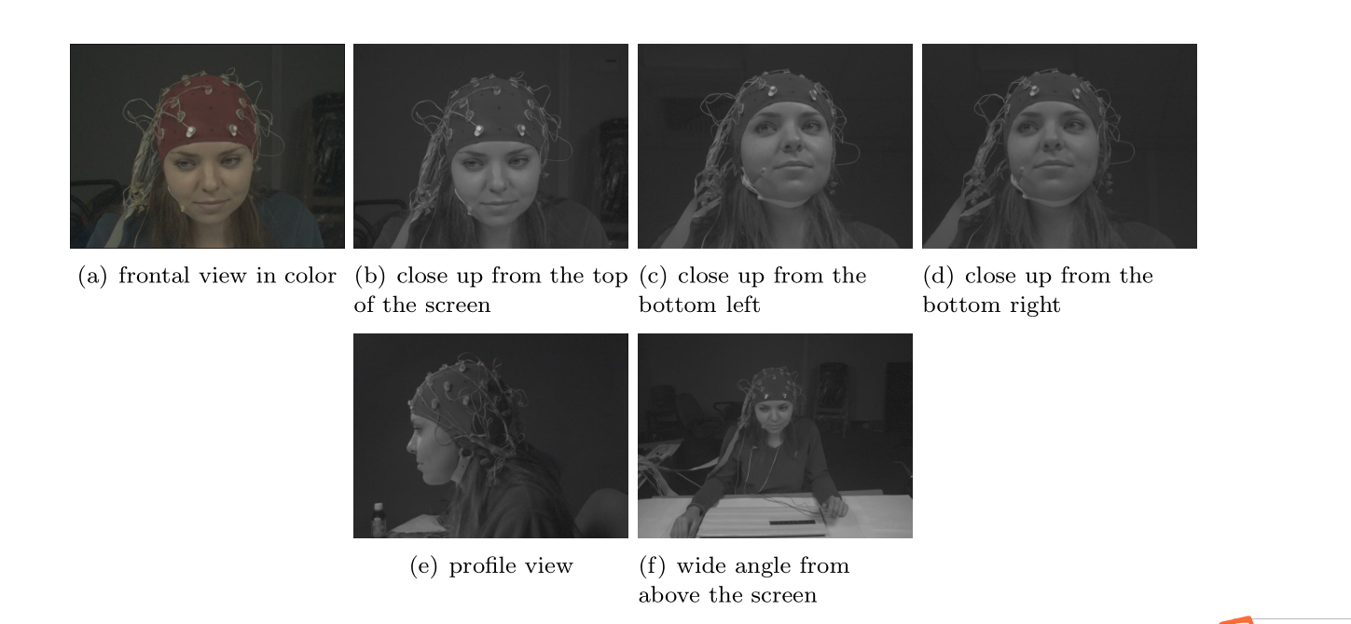

zipped files contains 562 records and 30 subjects.
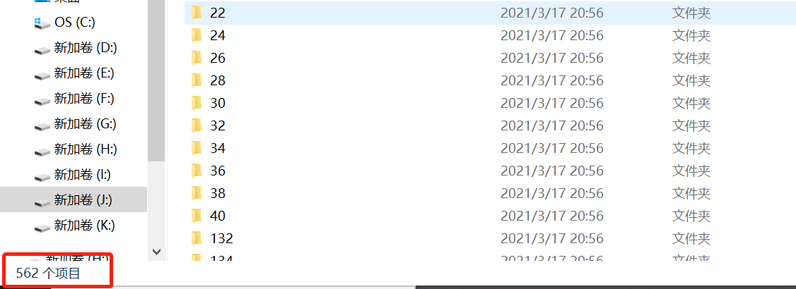

What is more, some data are missing in this file, for example, No.26 subject information:
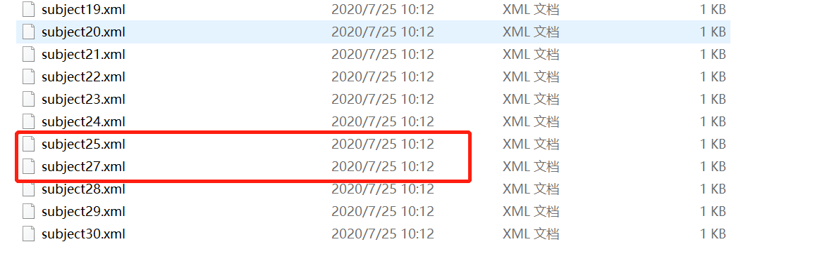

In iPPG technology, we need the full-colour videos. So I write a batch file operation code to grab the video which name including ‘trigger’, whole 562 video are 30G.
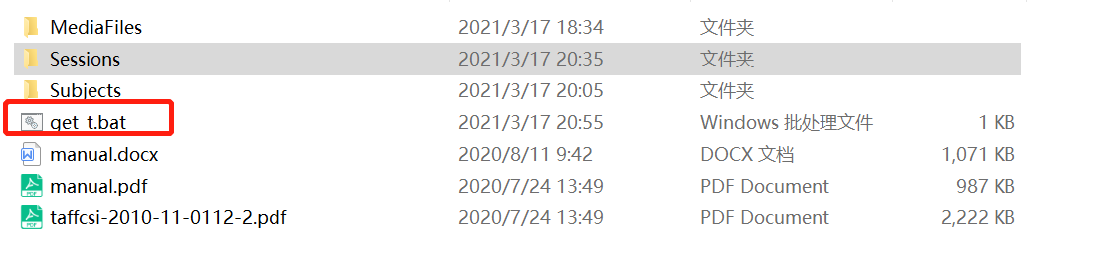
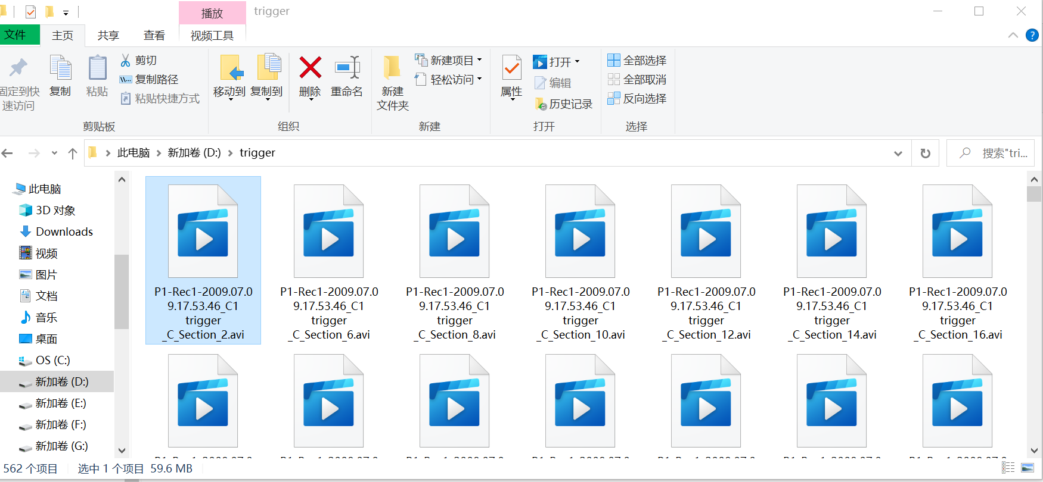

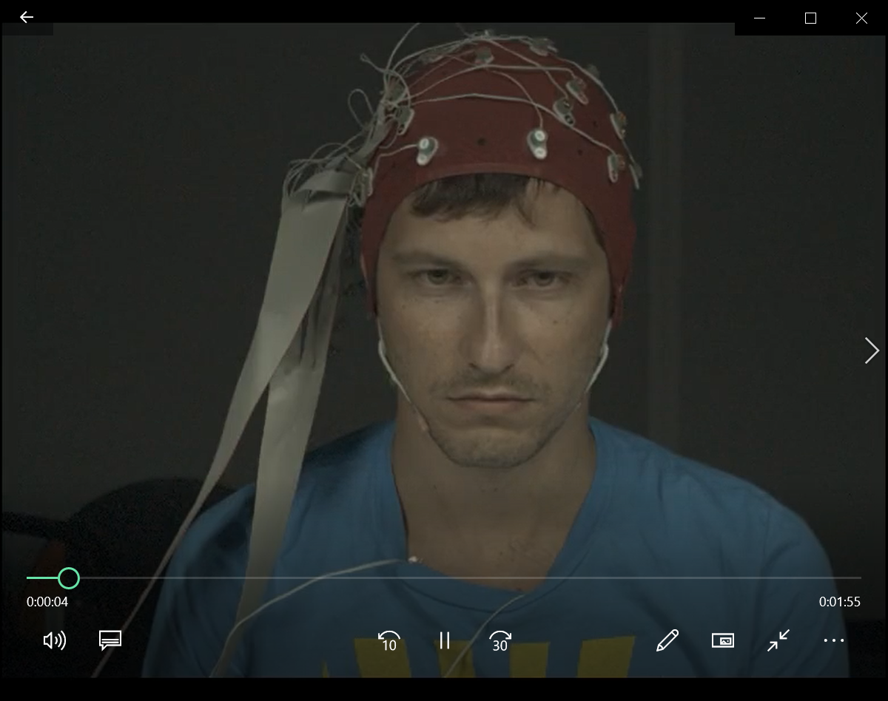

Code test and implement:
The code test the 5-35s video of one single video file.

I test the code supported by WUHAN teams;
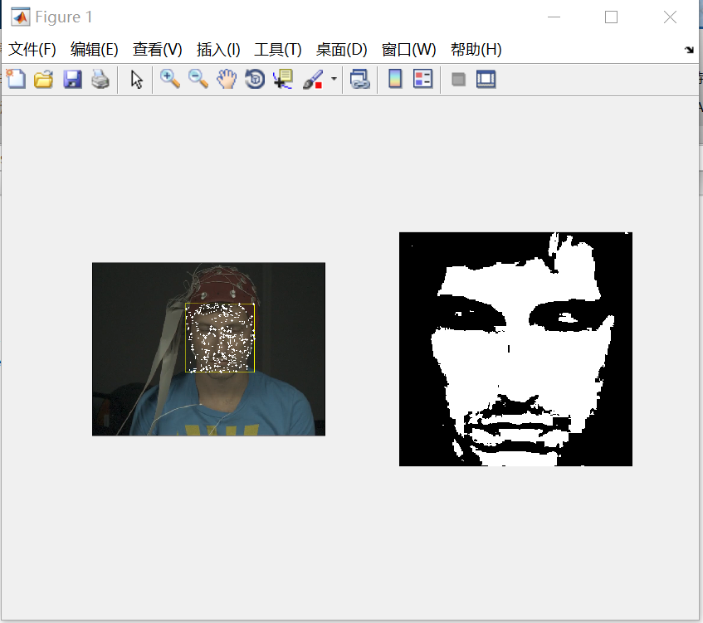

I picked out 24 videos as the initial dataset which come from the different subjects. We test the initial algorithm of iPPG to the results of ECG, and the MAE is 8.0, we can use this as baseline.
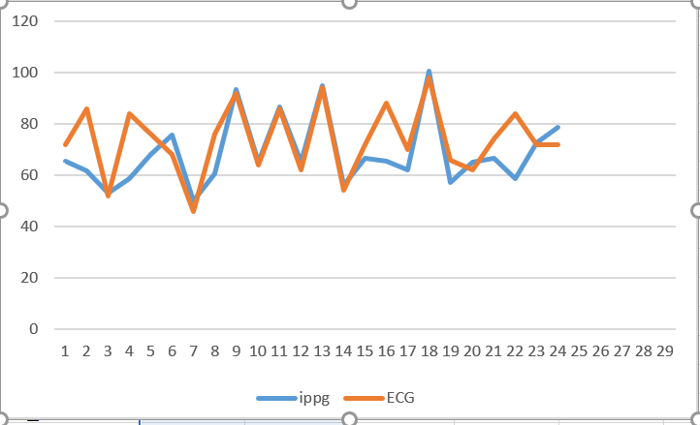

This file(P11-Rec1-2009.07.24.10.27.36_C1 trigger _C_Section_2.avi) can not be detected, because the wide range move:
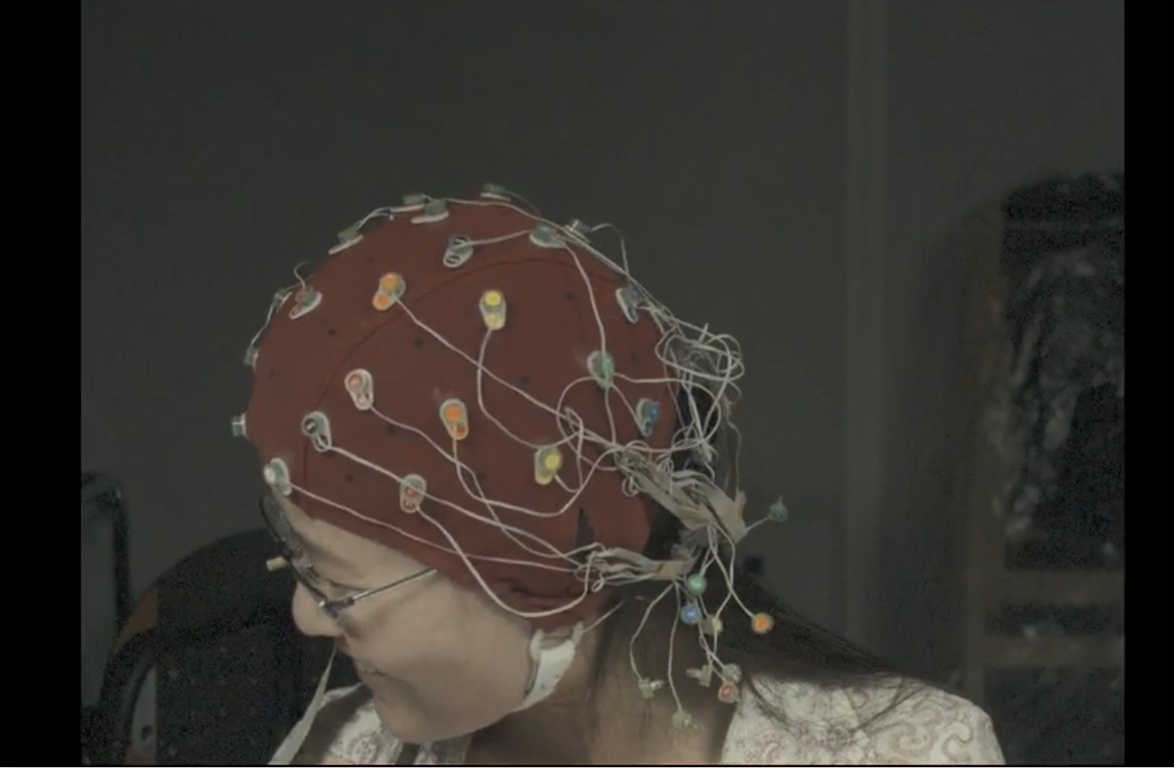

Implement the method perform best ever (2020)
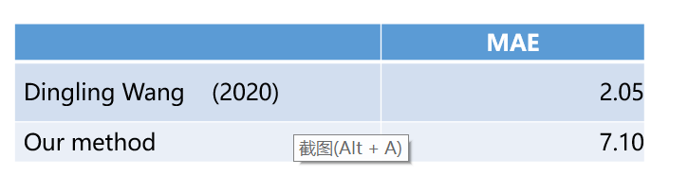

Preprocessing part:
1Baseline cancelation
2 Spike smoothing
3 Five-point cubic smoothing

Processing:
4 rajectory matrix construction
5 Singular value decomposition
6 Self-adaptive components selection
7 Signal reconstruction

I have implement the most part of this algorithm，and the preprocessing part is close to the
Wavelet method. However the processing part still need some changes.
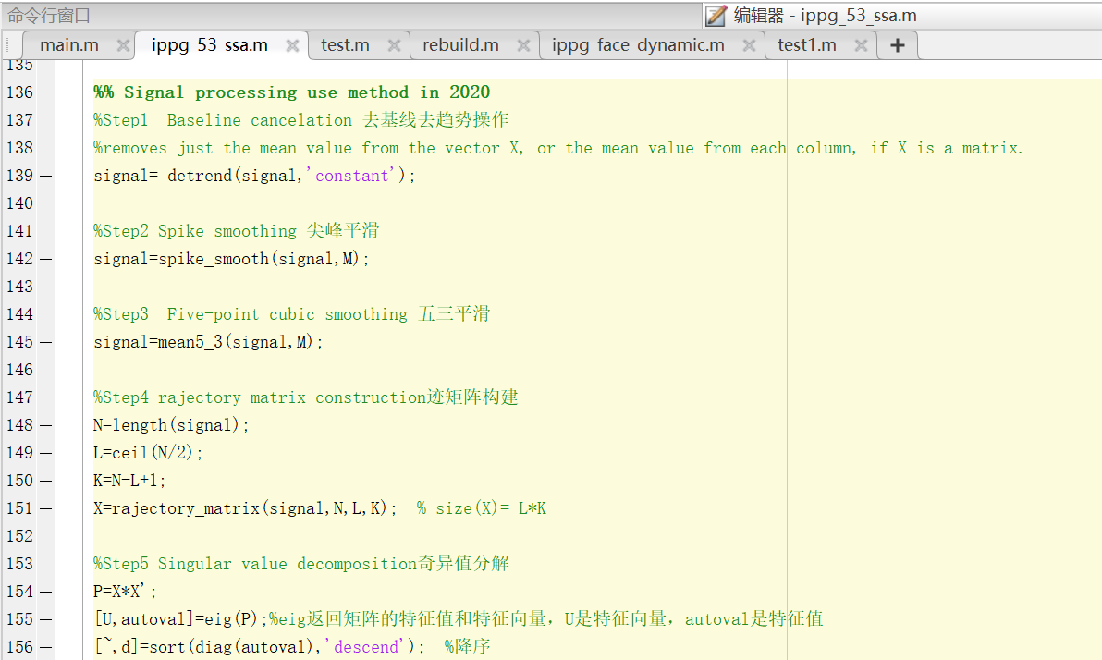
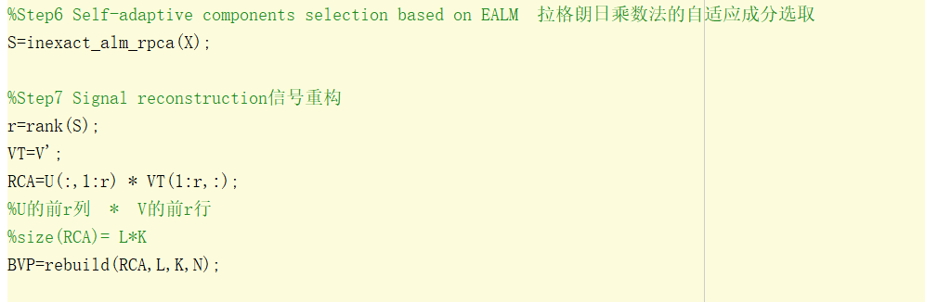
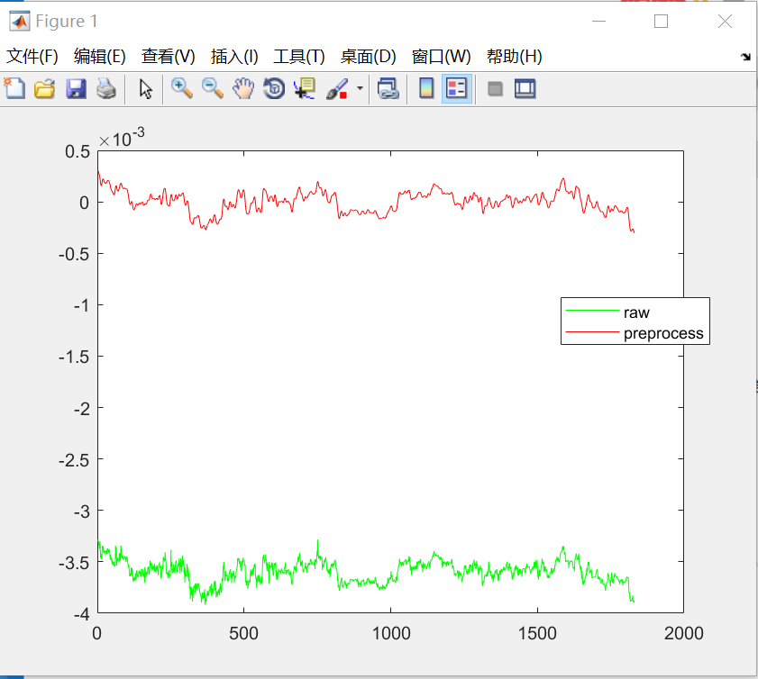

Further work and plan:
1 Finish the implement of Self-adaptive singular spectrum analysis(2020), try to get the best performance right now.

2 try to use the CNN or LSTM model to develop or reuse the method to deal with signal, details can be discussed in meeting.

3 Android application development should be considered?

