Week3

1 Failure of last week
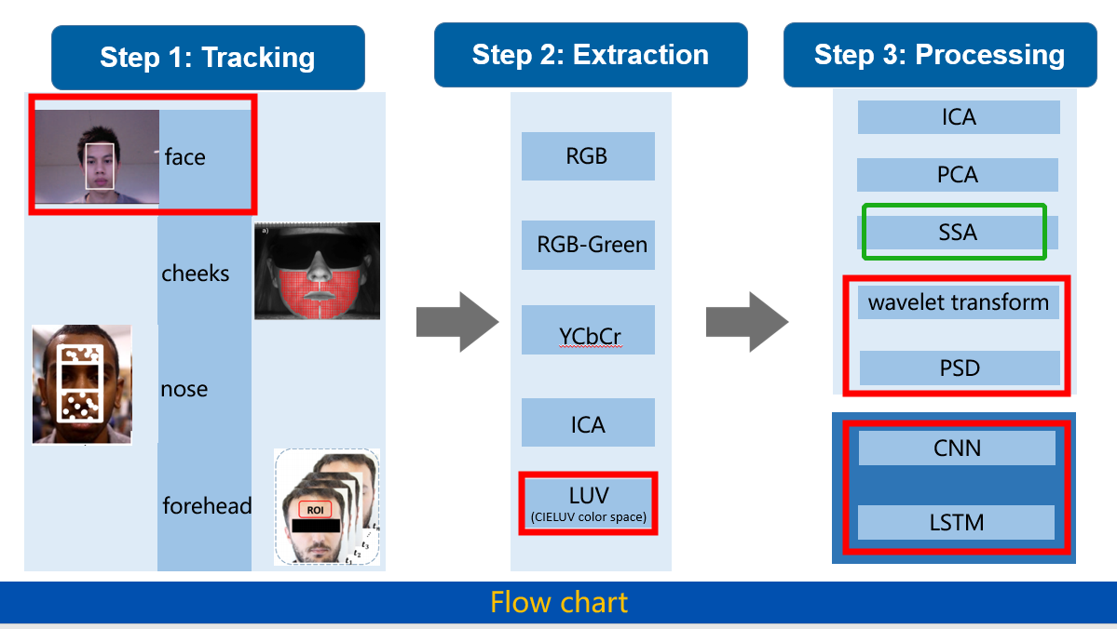

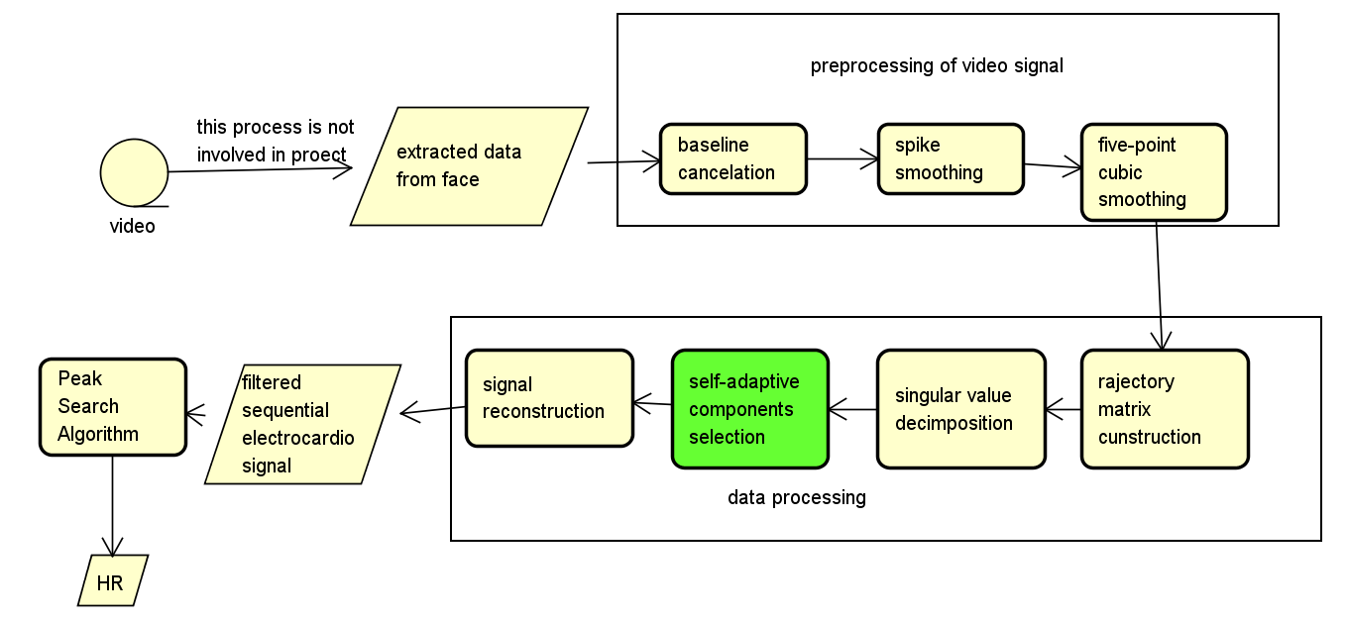
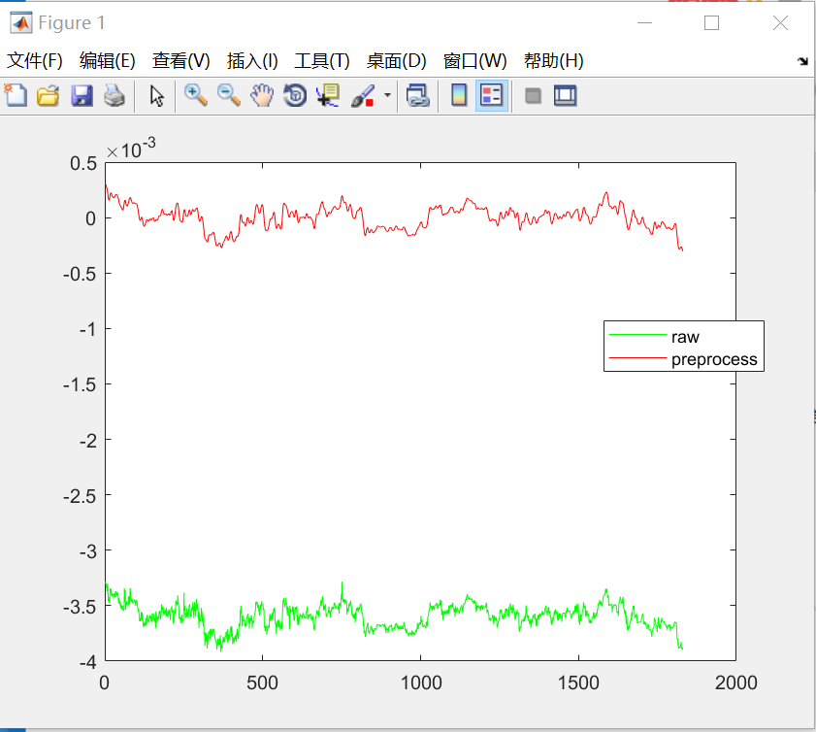

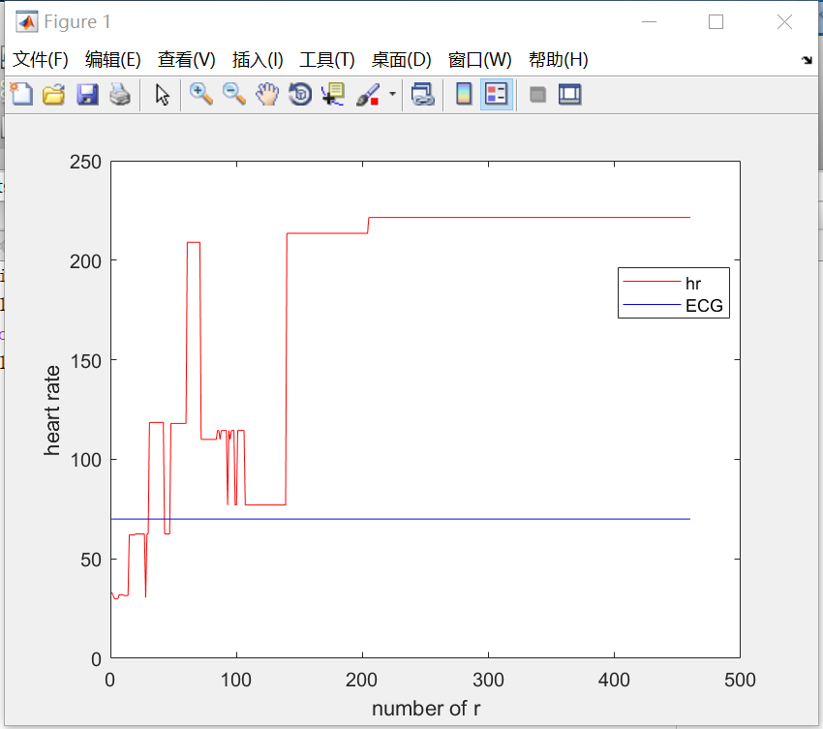
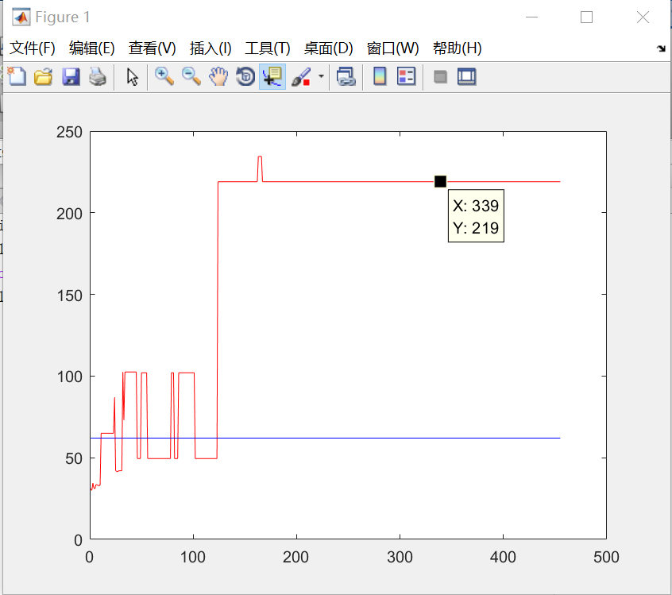

It seems that this algorithm is not stable enough，which means that we cannot find a suitable r to get stable heart rate.

2Work of this week
Reference:
“CorNET: Deep Learning framework for PPG based Heart Rate Estimation and Biometric Identification in Ambulant Environment”

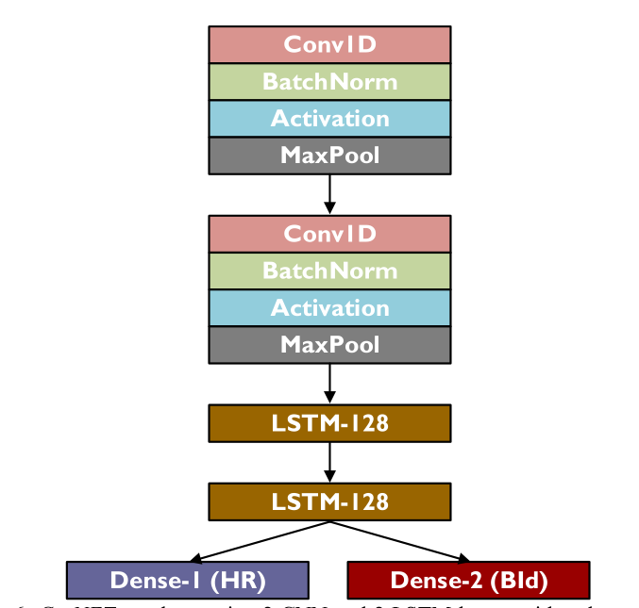
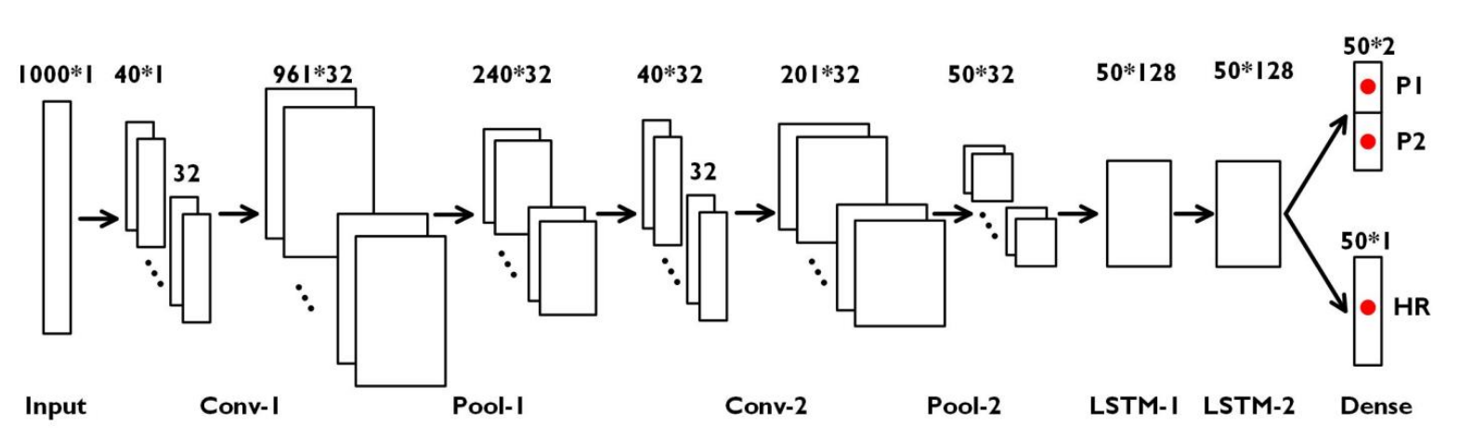

3.Further work and plan:
1. run the Cornet algorithm with a larger algorithm
2. try another aproach

