Week4

1work of this week
We test the different net architecture.
Model 1.
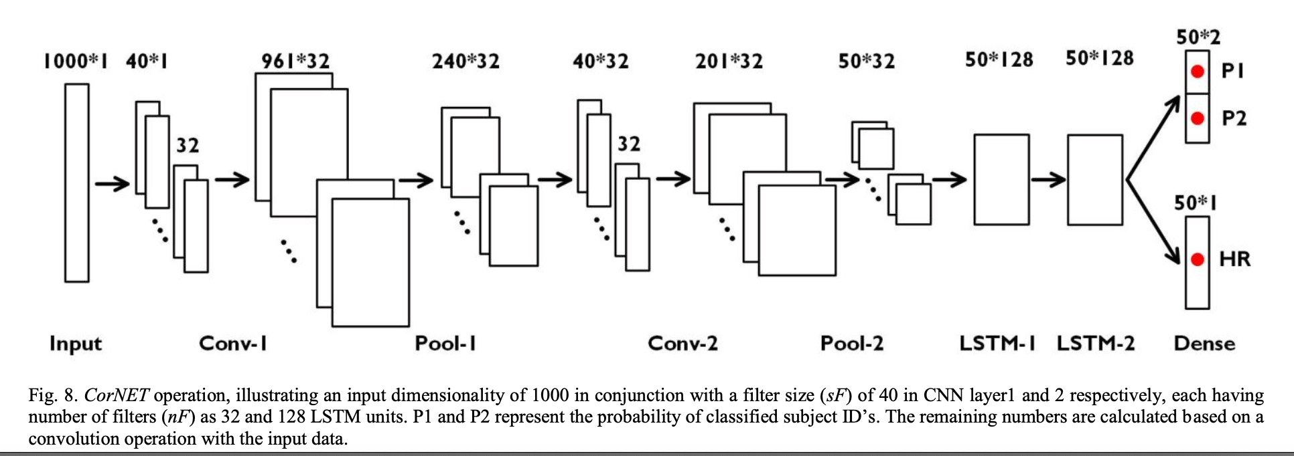
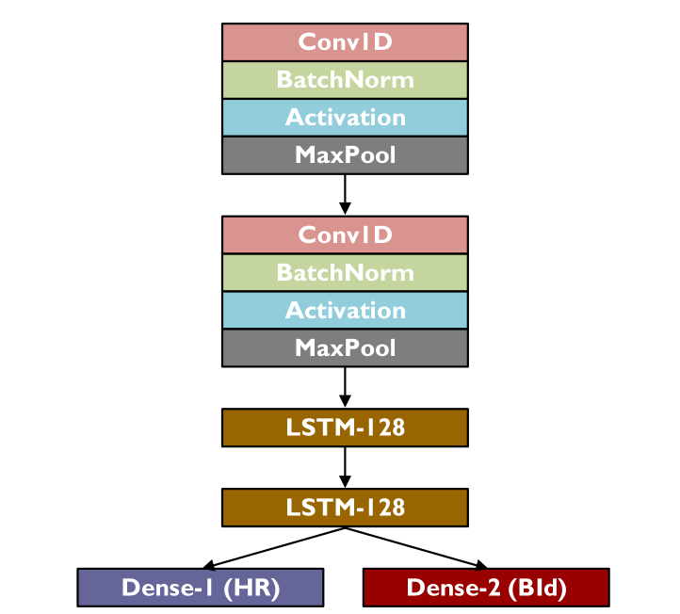
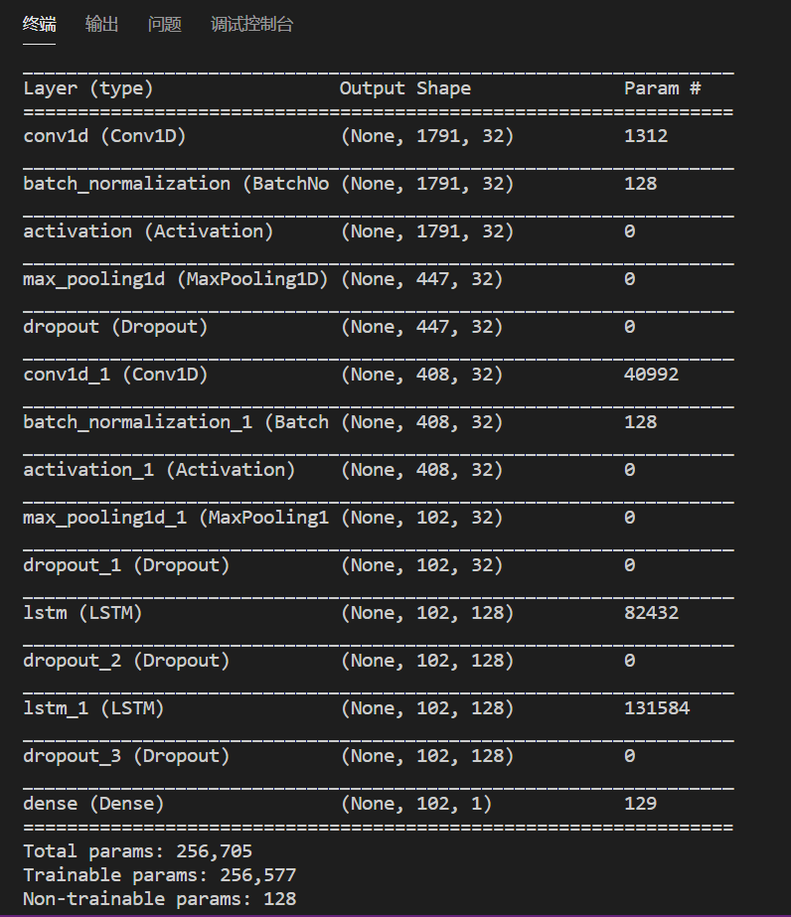

model2.
four convolution layers

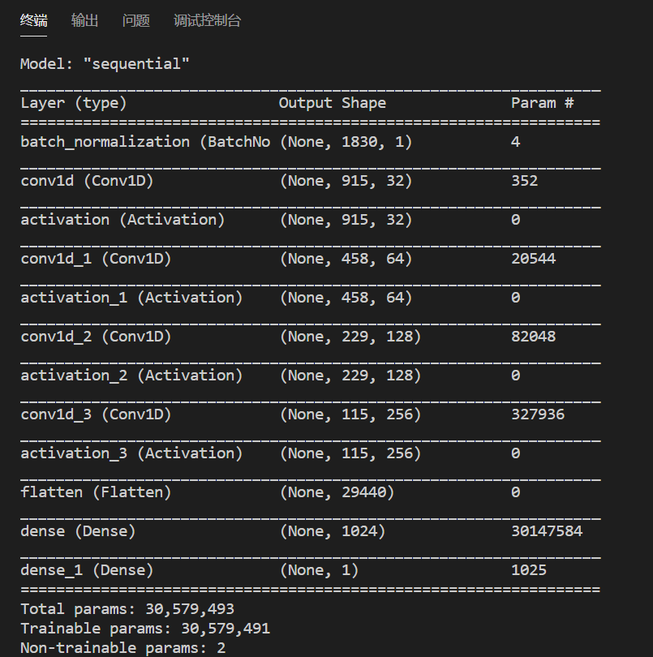

Model 3:
Four full connection layers
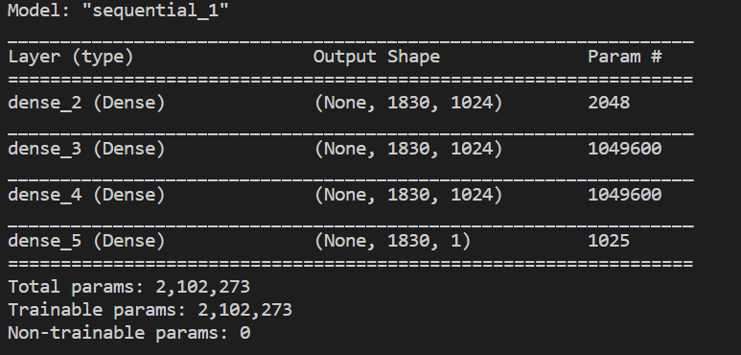

Results are same:
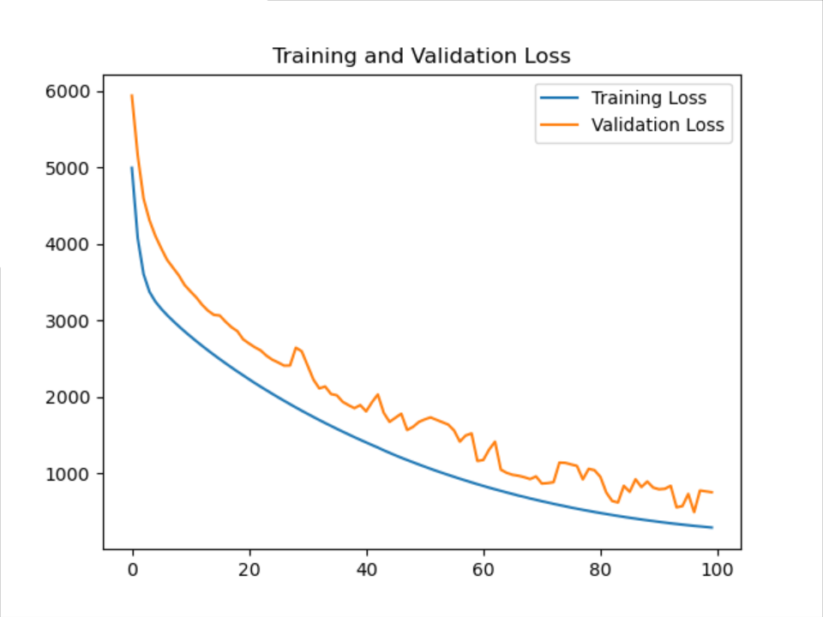
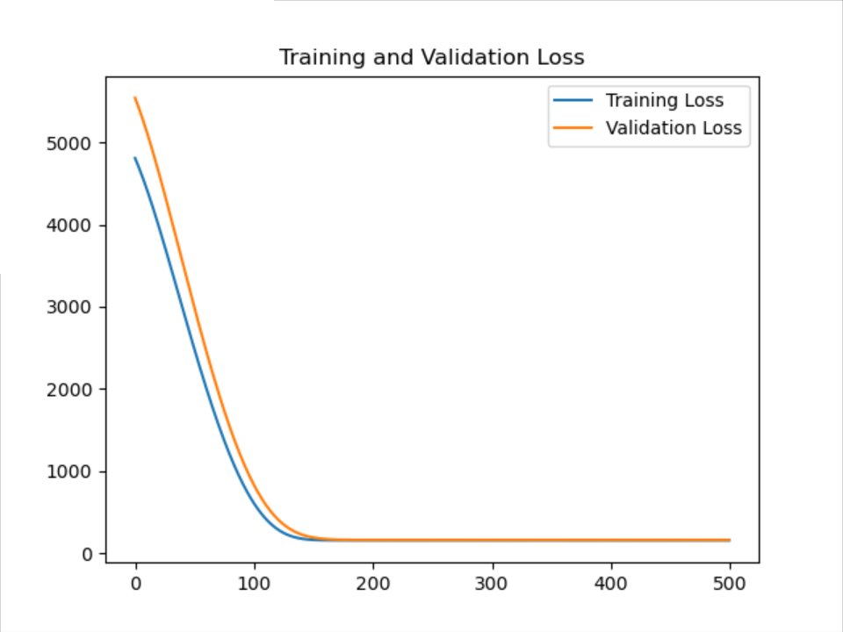
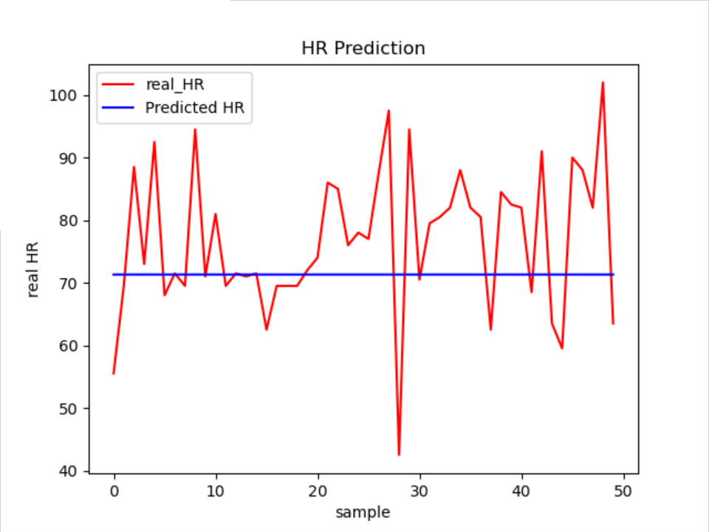

So we suspect the input data in time domain is not enough.
The essence of the model task is to simulate the peaking-search algorithm in matlab.
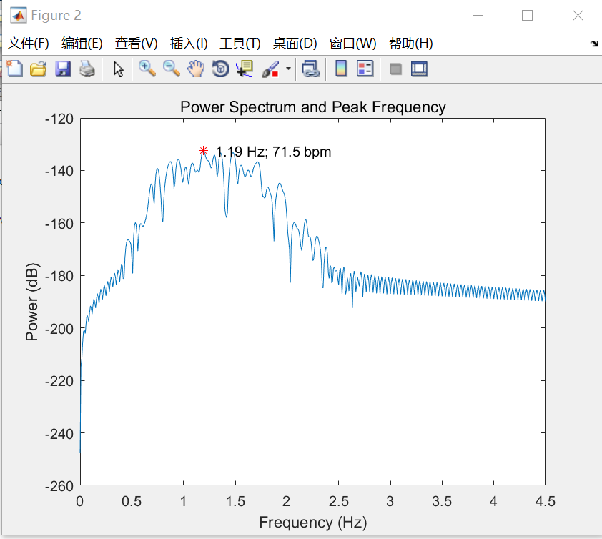
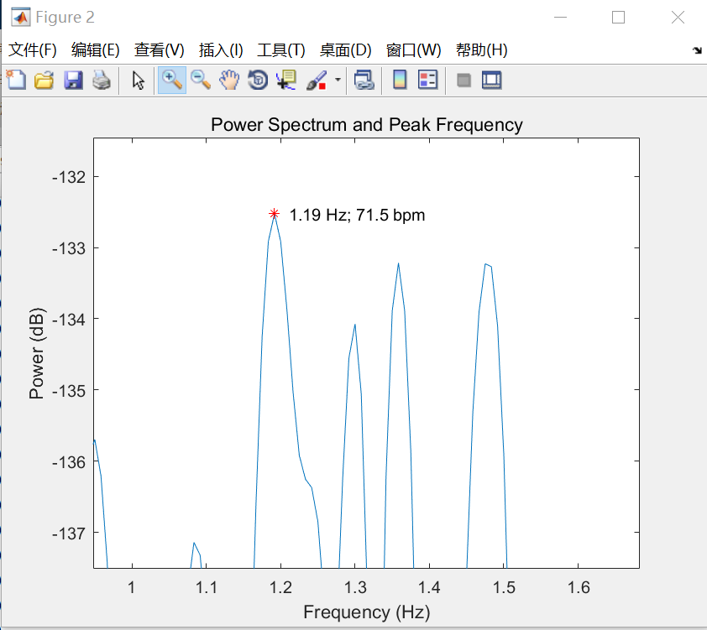

Actually, the peaking-search algorithm just select the highest frequency component of the signal.
Then we consider to add the frequency domain feature into deep learning model;

This time we used two features, and use the 8s window to cut every video into 8s slides. What is more, we use the same heart rates in a video sample.
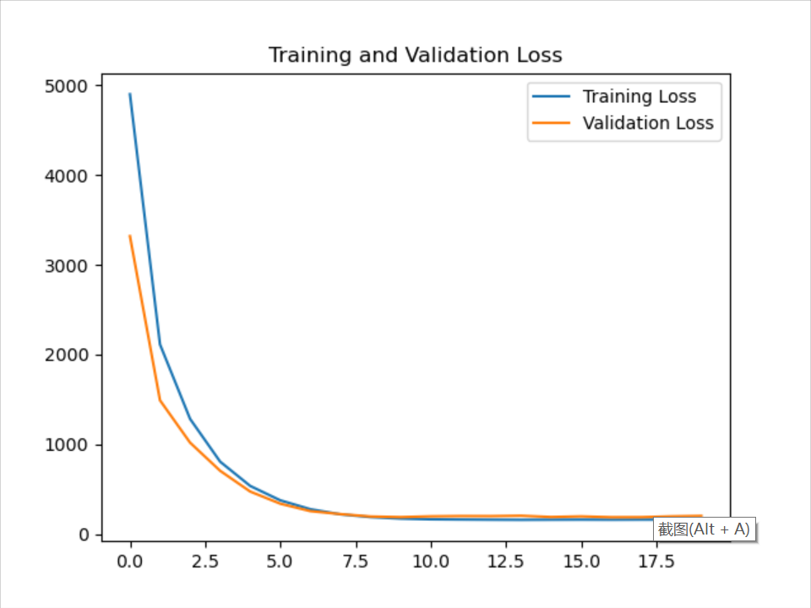

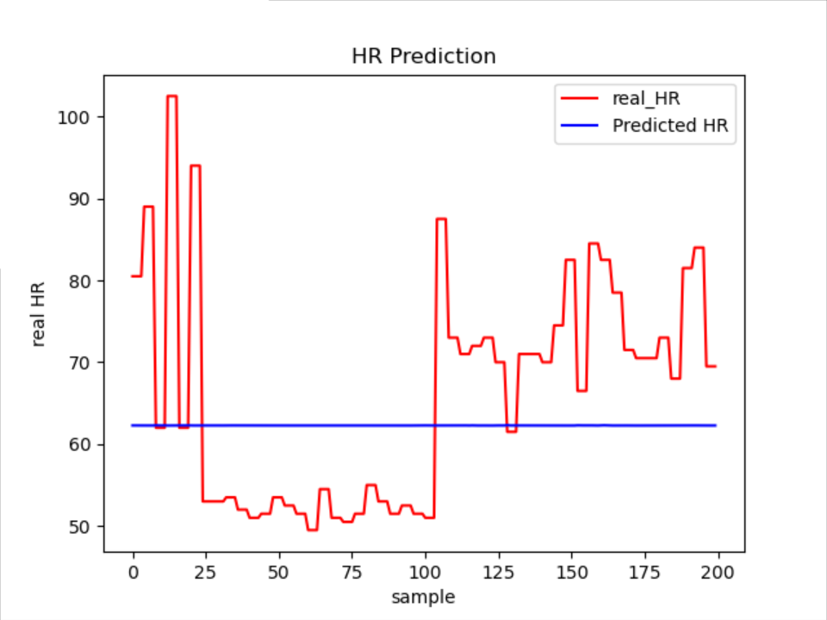

Further work and plan:
1 why all sample perform the same in the model?

