Week 1 report
17206018 Chenglitao

1 Python：
Interpretation解释 of code: https://www.cnblogs.com/my-love-is-python/p/10463352.html

README
packages required installed:
pip install PyWavelet
说明：import pywt ，是一个小波分析的包 。
API：https://pywavelets.readthedocs.io/en/latest/ref/index.html

pip install wfdb
wfdb包，读写处理波形数据的包。
API：https://wfdb.readthedocs.io/en/latest/

pip install biosppy
biosppy包，生物信号处理的工具包。
API：https://biosppy.readthedocs.io/en/stable/biosppy.html

pip install gatspy

pip install CMake 一个处理包的包
pip install dlib 人脸识别的包 需要先安装CMake
安装教程：https://blog.csdn.net/weixin_43627723/article/details/108939475

Environment：
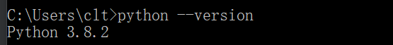
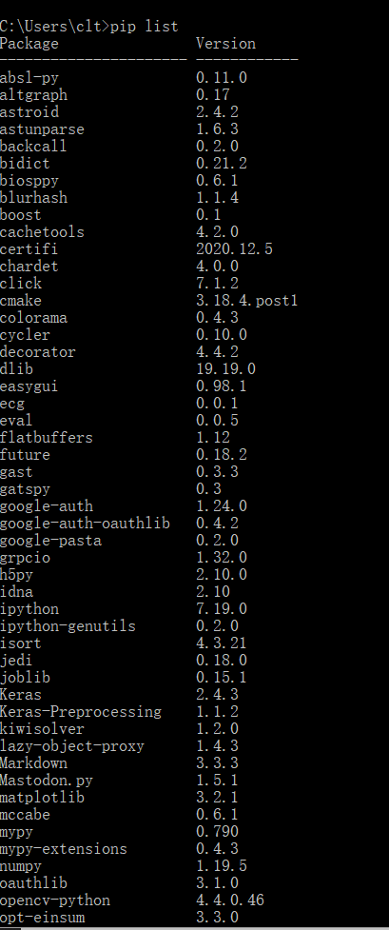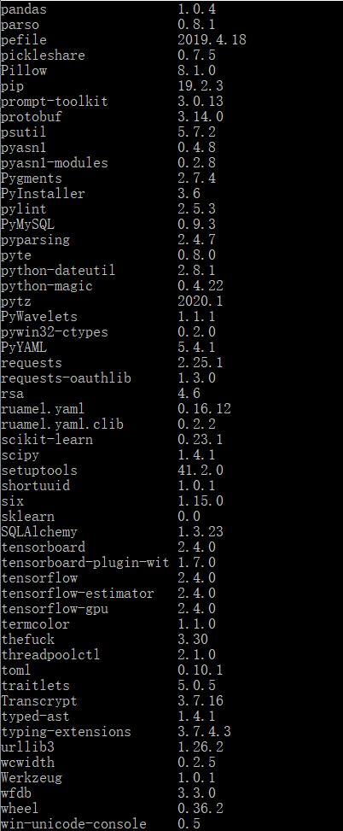

Path configure:
Click this file folder
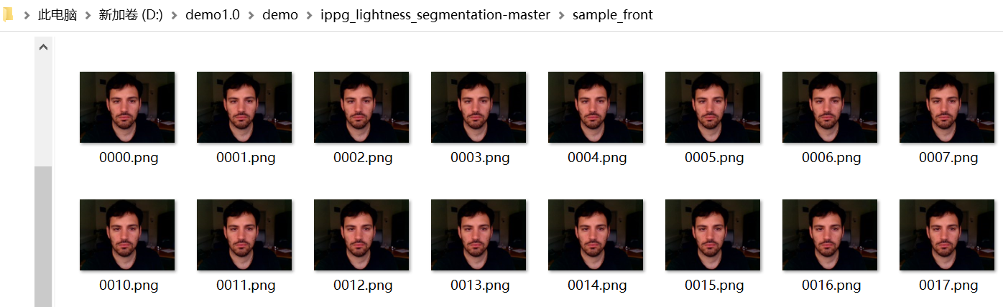

Running result of ippg_lightness_segmentation.py
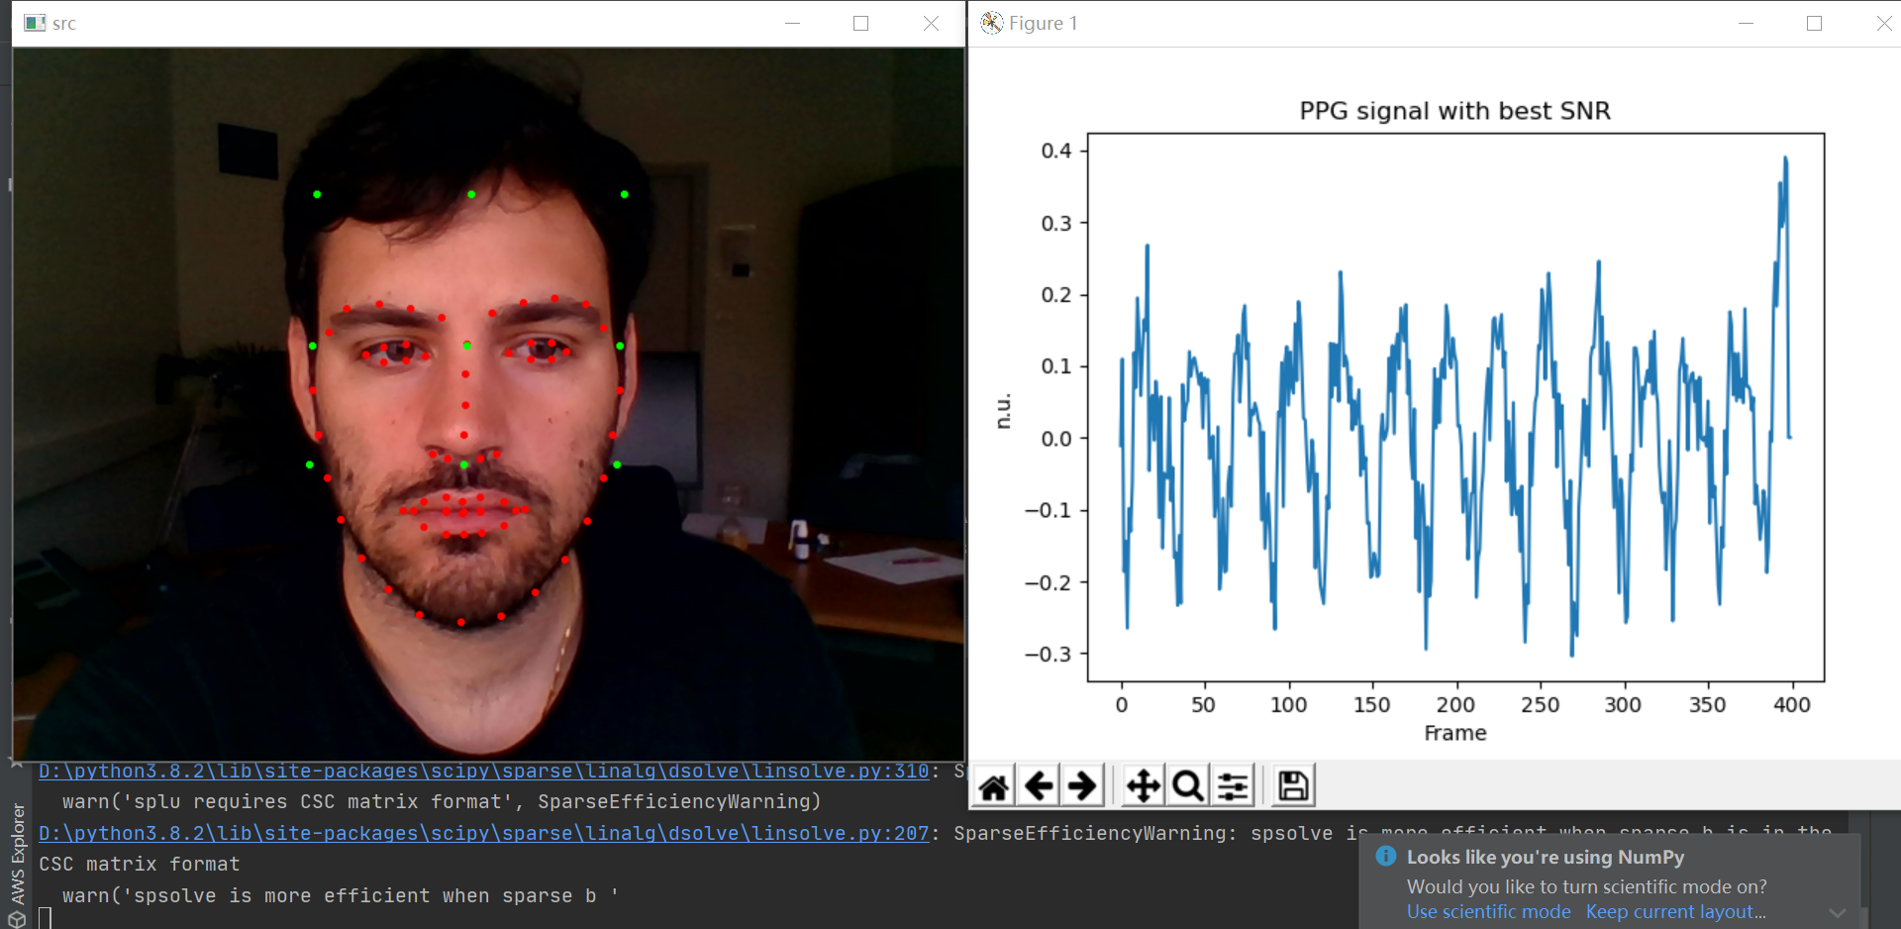

Warning: do not use Chinese as path.

2 Matlab：
README
Toolbox required installed：
Computer Vision System Toolbox 计算机视觉工具箱
Wavelet Toolbox 小波分析工具箱

Path configure and debug:
Change the input file folder path, and this folder can contains a list of .avi files.
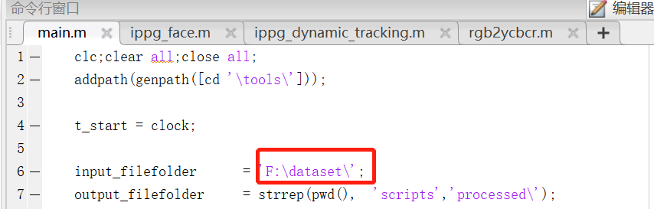

Img_grey() change to img()
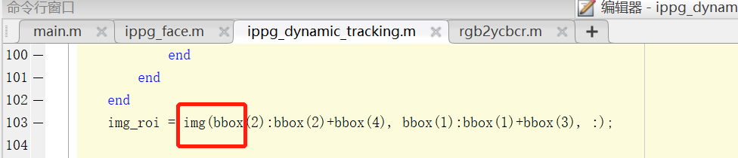

Environment：
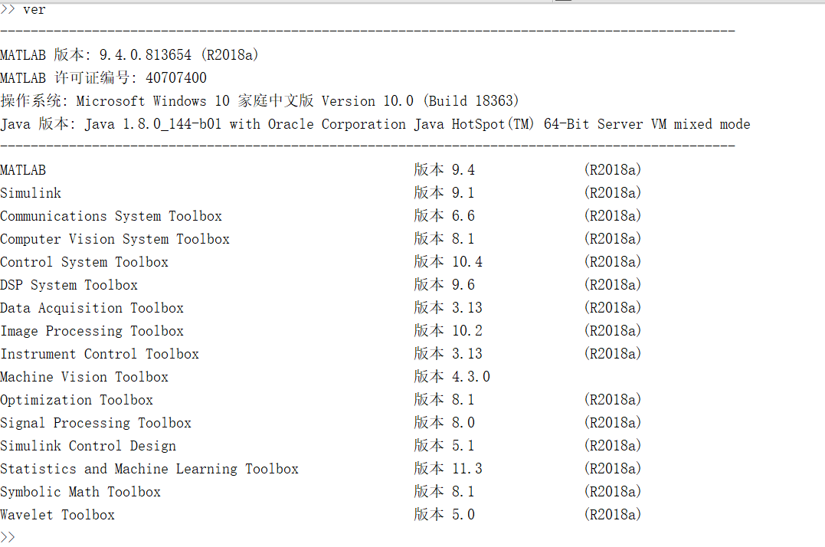

Running results of main.m
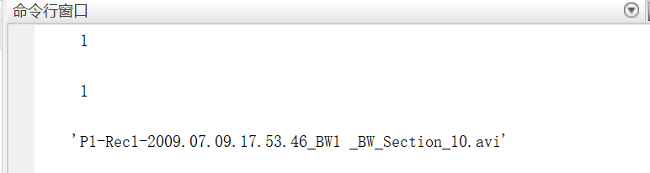

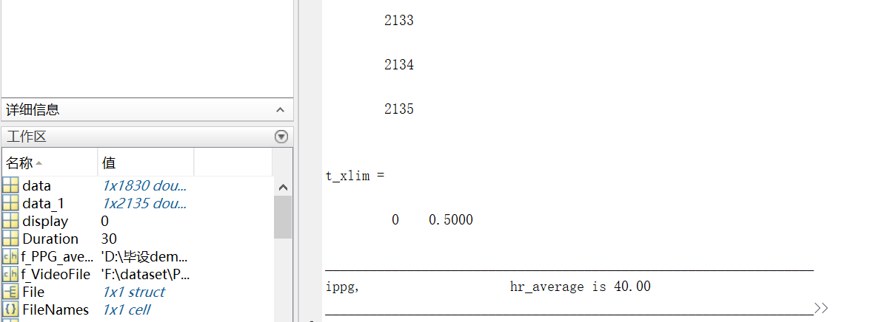

3 work plans
- We noticed that it is very huge(177G) for data, and the running time is quite long for a single demo, it seems impossible to run the program in local laptop. So should we consider the solution of cloud server?

- EGG part got the initial results, but we have not yet known the meaning of the corresponding operation.

- Paper reading is significant, next week we can look through the corresponding papers, we will try to know procedures they did.

526个视频，一个30s左右

30s心率均值，mse，
目前误差还比较大（选区或滤波算法有待调整）

面部识别
固定选（目前7左右），人脸识别（待调整），

带通滤波对结果影响较大（调频率范围）

接下来工作
1 Matlab如何选区域比较合理
可能会用到python opencv rsnet
（额头）
熟悉流程，跑单个视频，断点调试

2CNN LSTM
加入深度学习的算法观察效果

