KafAnnotator Manual
Version 0.1
August 2010

KYOTO Working paper: nr TR008, WP3 Capture

Knowledge-Yielding Ontologies for Transition-Based Organization
KYOTO (project nr. 211423)
FP7-ICT-2007-1



website: http://www.kyoto-project.eu

Authors:
Piek Vossen, Vrije Universiteit Amsterdam, p.vossen@let.vu.nl

Funded under project number 211423 in the 7th Frame work project in the area of Digital Libraries: FP7-ICT-2007-1, Objective ICT-2007.4.2: Intelligent Content and Semantics
Table of Contents
1. Introduction 3
2. Getting started 5
2.1 Installation 5
2.2. Start the application 6
2.3. Quick overview 6
3. The tag file 15
4. The tag set file 15
5. The lexicon file 17
6. Annotating synsets 17
7. Converting annotations to training data 23
8. Converting annotations to event triplets 24

1. Introduction

KafAnnotator is a generic standalone program for the annotation of text represented in the Kyoto Annotation Format. The Kyoto Annotation Format (KAF) is a layered representation of natural language text that was developed in the Asian-European project KYOTO: http:www.kyoto-project.eu. In KAF different types of text analysis are stored as separate layers where each layer is anchored to a previous layer. Standard layers in KAF are: the token layer, the term layer and the chunk layer. An example of KAF is given below:

<?xml version="1.0" encoding="UTF-8" standalone="yes"?>
<text>
<wf page="1" sent="1" wid="w1">The</wf>
<wf page="1" sent="1" wid="w2">annual</wf>
<wf page="1" sent="1" wid="w3">report</wf>
</text>
<terms>
<term lemma="the" pos="D" tid="t1" type="close">
<span>
<target id="w1"/>
</span>
</term>
<term lemma="annual_report" pos="N" tid="t2" type="open">
<span>
<target id="w2"/><target id="w3"/>
</span>
</term>
</terms>
<chunks>
<chunk cid="c1" head="t2" phrase="NP">
<span>
<target tid="t1"/><target tid="t2"/>
</span>
</chunk>
</chunks>

The token layer (<text>) consists of a list of word tokens (<wf>) with identifiers in the linear order of the text. The term layer is a list of word types (<term>) with separate identifiers for each term, where each term refers to one or more tokens (using the token identifier). For example, the term “annual_report” refers to twp tokens. Chunks are constituents that consists of one or more terms. Chunks have their own identifiers and point to the identifiers of their terms and of the head term. More details on KAF can be found at:
http://www2.let.vu.nl/twiki/pub/Kyoto/TechnicalPapers/WP002_TR009_KAF_Framework.pdf

Annotations in KAF are stand-off annotations, i.e. any tags can be added in a new KAF layer with pointers to other elements in other layers. This offers large freedom in assigning tags to structures in text. The KafAnnotator makes use of this feature. When you read a KAF file, the tokens are listed in a column in the order of the original text together with their token identifiers. Any set of tags can then be assigned to any set of tokens (possibly disjoint) in the tag columns of the annotator. The tags are stored in a tag file that can be loaded with the original KAF file. In addition to tagging tokens, you can also tag word types (terms), constituents (terms) and sentences. Furthermore, it is possible to assign (different) tags to 3 levels. The same tokens can thus be tagged in 3 different ways.

Through the table interface it is possible to manipulate the text in many ways. You can sort all word forms or their lemmas in alphabetic order. You can also group them by part-of-speech, by tag and by tag identifier. You can at any point restore the order of the text by sorting on the order. In this way, you can choose to tag sequentially in text order or tag groups of tokens with the same form or properties in one tag action. The former way of tagging lets you focus on contextual sequences of words and structures, the latter way of tagging focuses on the types rather than the tokens and lets you focus on consistent and fast tagging of all tokens regardless of the context.

Another important feature of the KafAnnotator is that tags assigned to words are stored in a tag lexicon with the frequency of the tag for each word. Likewise, the annotator can assign the most frequent or dominant tag to any token. In some cases of tagging, for example, when assigning part-of-speech or word-senses, the most frequent tag applies in 80% to 90% of the cases. When the lexicon is sufficiently rich, you can assign the most frequent or dominant tag as the default tag and only change the tag when needed.

This manual is further structured as follows. In the next section, we give you a quick start on the annotator. In the subsequent sections, we explain the structures of the tag file, the tag set file and the lexicon file.

The KafAnnotator is licensed as open source software under license GNU General Public License version 3: http://www.opensource.org/licenses/gpl-3.0.html

2. Getting started

2.1 Installation
KafAnnotator requires Java JDK1.6 to be installed on a local machine. We assume that Java is installed and is added to the path settings of the machine. Ask your system manager for details.
To install the software unpack the archive file on any location. After unpacking the application, you will see the following directory structure:

kafannotator_v.0.1
doc
KafAnnotatorManual.pdf (this manual)
examples
11614.kaf
images
lib
kaf.jar
kafannotator.jar
resources
locations.xml
tagSetLevel.txt
kafannotator.sh
kafannotator.bat

Path settings are relative to this directory structure. You should therefore leave the structure of the installation as it is. To remove the installation, you can simply delete the complete directory.

2.2. Start the application
The distribution includes a shell-script to launch the application from Linux/Unix and a bat file to launch the application on Windows.

Linux/Unix
Run the kafannotator.sh from the command line.

Windows
Double click the kafannotator.bat file or call it from the command line

2.3. Quick overview
After starting the application, you will see window with an empty table with columns and a menu bar. The columns are explained in the table below.
Column label | Explanation
Id | For storing the word token id
Word token | The word token read from the KAF file
Word type | The lemmatized word token or set of word tokens that makes up a word type
Pos | The part of speech of the word type as stored in the KAF file
Synset | Synset if the word type if present and if disambiguated
Tag1 | First level tag for a word token
Tag 1 id | Identifier for the tagging event at level 1
Tag 2 | Second level tag for a word token
Tag 2 id | Identifier for the tagging event at level 2
Tag 3 | Third level tag for a word token
Tag 3 id | Identifier for the tagging event at level 3
Tag 4 | Fourth level tag for a word token
Tag 4 id | Identifier for the tagging event at level 4
Tag 5 | Fifth level tag for a word token
Tag 5 id | Identifier for the tagging event at level 5
Tag 6 | Sixth level tag for a word token
Tag 6 id | Identifier for the tagging event at level 6
Order | Sequence number of the token
Status | Status of the word token

The first thing to do is to load a KAF file. Open the File menu and select the menu Open KAF File. An example of a KAF file is provided in the examples folder in the distribution. Select the file: examples/11767.mw.wsd.ne.kaf. The KAF file is loaded and the table is filled with the word tokens and their types, as shown in the next screen dump.
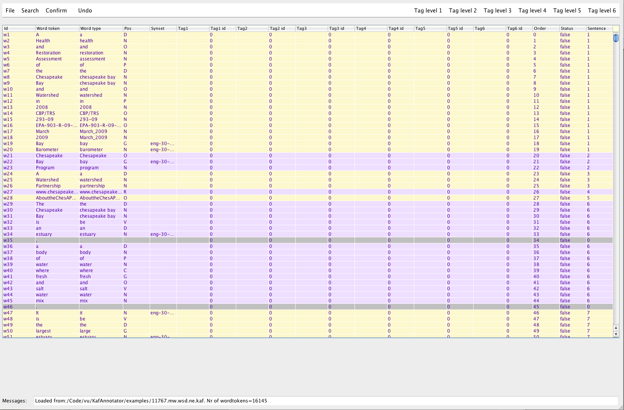
In the message field at the bottom of the screen, you will see the message:

Loaded from:/Code/vu/KybotEvaluation/data/11767.mw.wsd.ne.kaf. Nr of wordtokens=16145

It shows the path to the KAF file and the number of word tokens that are loaded.
The text can be read in the second column top down. The KAF identifiers for the word tokens are in the first column. These identifiers are used to connect the tag output to the original KAF file. You can click on the column headers to sort the table according to any column. Try sorting the table in different ways to see the effect for grouping word tokens. To restore the reading order of the words, use the Order column for sorting the words.
Only the Tag columns and the Status column can be edited. You can type in tags manually in the Tag columns and tick and untick the status column immediately. For each work token you can specify at most 6 tags. However, it is better to use a predefined tag set to do the tagging. Tag sets can be created and modified through the interface or stored in any text file. Once a tag set file is created you can load the tag set at any time.
We start by creating tags for level 1. Open the Tag level 1 menu. Below this you see the following submenus:

- Add tag
- Tag Tokens4
- Tag types4
- Tag constituent4
- Tag sentence4
- UNTAG
- Dominant tag
Tag tokens, types, constituent and sentence are used to assign tags from a tag set to any of these structures in the Tag1 column. However the first time you start, there are no submenus to select a tag. Therefore, we select the Add tag menu to add a tag. We fill in the tag PARTICIPANT and press OK.

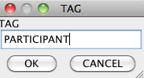
We select the Add tag menu again to add the tags ROLE-DONE-BY, ROLE-PATIENT, LOCATION and TIME.

Next select some rows in the table. In this example, we select the rows for “in” and for “2008” and we will tag them as TIME. After selecting the rows, we open the Tag level 1 menu again and open the submenu Tag tokens.

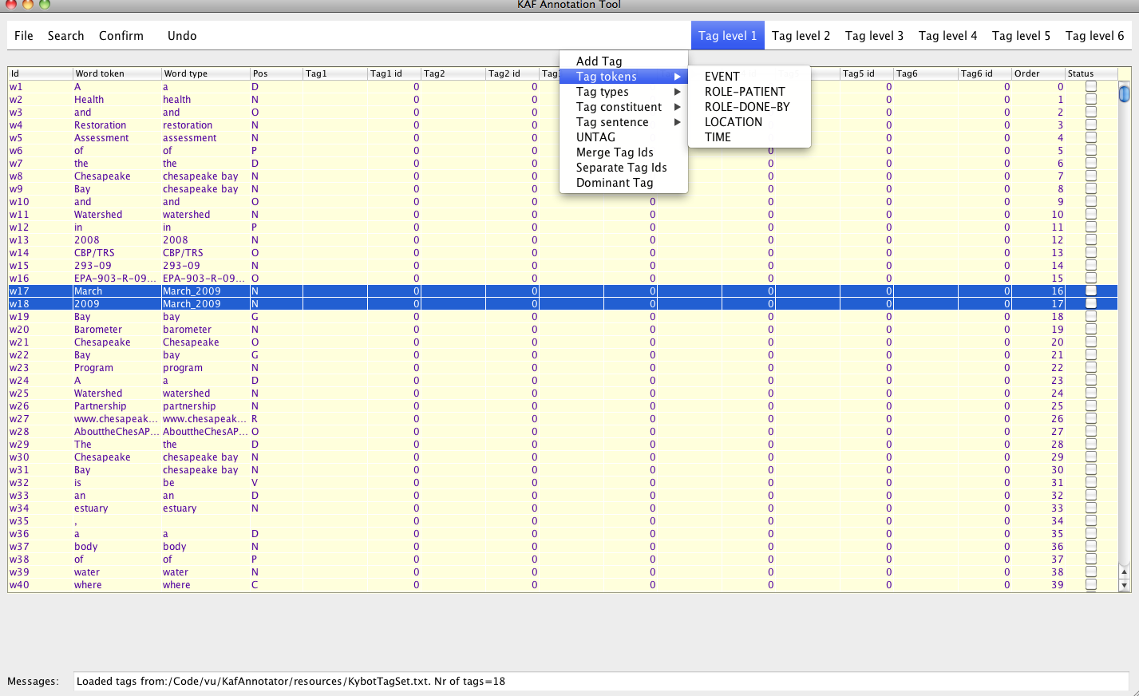Tag level 1 at the word token level
We select the TIME submenu to tag the two rows. After selecting the submenu TIME, the result looks as follows:
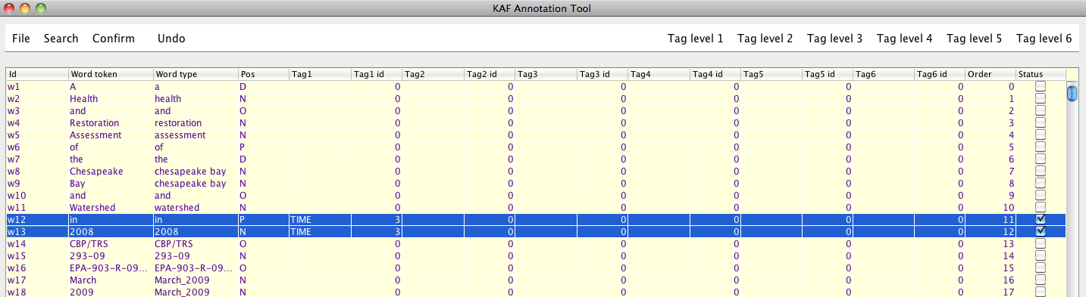Tag level 1 at the word token level
We see that both “in” and “2008” have the tag TIME and share the same Tag1 tag id (column 6). A tag id is created for each tagging action that you perform. This way you can indicate that a sequence of tokens share a single tag. Using the submenus Merge Tag Ids and Separate Tag Ids, you can adapt the tag ids at any moment to joint them or make them unique for a selected set of tokens. Also note that the status of the rows is now ticked through the tagging action. You can also un-tick the status if are not sure about the status. The tags are kept but the status is not confirmed.
Just above “in 2008”, we the tokens Chesapeake and Bay that belong to a single word type chesapeake bay. Select just the row for Chesapeake and select from the Tag level 1 menu the Tag types submenu. Here you see the same set of tags from the tag set created. Select the LOCATION tag. If you selected the Tag types menu you will now see that both Chesapeake and Bay got the same tag. The tag has been assigned to the word type level and thus is assigned to all word tokens belonging to the same type.

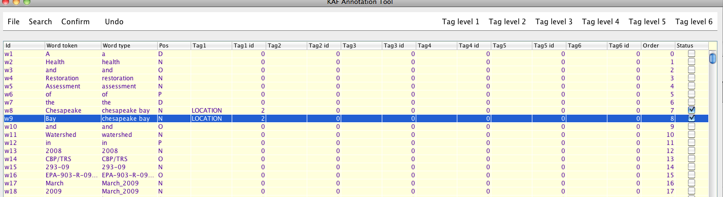Tag level 1 at the word type level
We can do the same for the constituent level. We scroll down to the rows body of water and select the row body. We do the same as before but now select the ROLE-PATIENT tag below the submenu Tag constituent. The result looks as follows:
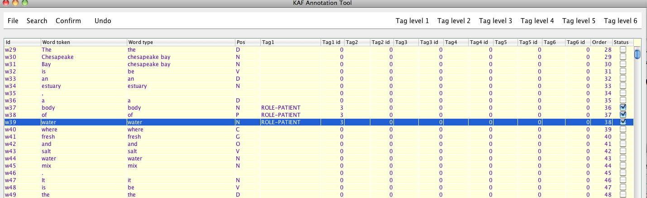Tag level 1 at the constituent level
We now see that three tokens that make up a single constituent all received the same tag and tag identifier.
In the same way, you can also assign a tag to a complete sentence. Select a row for a single word token and choose a tag from the submenu Tag sentence. You will see that all the tokens from the same sentence receive the same tag and identifier.
Make different selections of rows and assign tags to tokens, types, constituents and sentences. If you want to remove tags, select the rows and choose the UNTAG menu.
So far, we added tags to the Tag1 column. In order to assign tags to the Tag2, Tag3 up to Tag6 columns, we need to follow the same procedure are above. The KafAnnotator keeps separate tag sets for each level. You are free to define the tags for each level and it is also possible to use the same tag set for different levels.
Instead of making the tag sets manually, we are going to load the tag set from a file. Any tag added to a tag menu is stored in a tag file (default file name is: tagSet.txt stored in the resources folder). Open the File menu and select the Load TAG set submenu. You are asked to select a file and the popup opens in the resources folder of the installation. In this folder, there is already a file stored with the name KybotTagSet.txt. Select the file. The message box at the bottom of the screen now says:
Load tags level 2 from:/Code/vu/KafAnnotator/releases/kafannotator_v.0.1/resources/KybotTagSet.txt. Nr of tags=18
If we go now to the Tag Level 2, Tag Level 4 and Tag Level 6 submenus, we see a sub-submenu for EVENT-SCOPE, if we go to the Tag Level 3 and Tag Level 5 submenus, we see the same tags as for Tag Level 1.
We now assign the tag EVENT to the sentence with Chesapeake Bay. The result is shown in the next screen dump. The previous tags have been overwritten by the new tag. Instead of assigning to a sentence, you can remove the tag and assign them to any selection of tokens. We scroll down and assign the third level tag EVENT to a series of tokens in the next sentence. The result looks as follows.
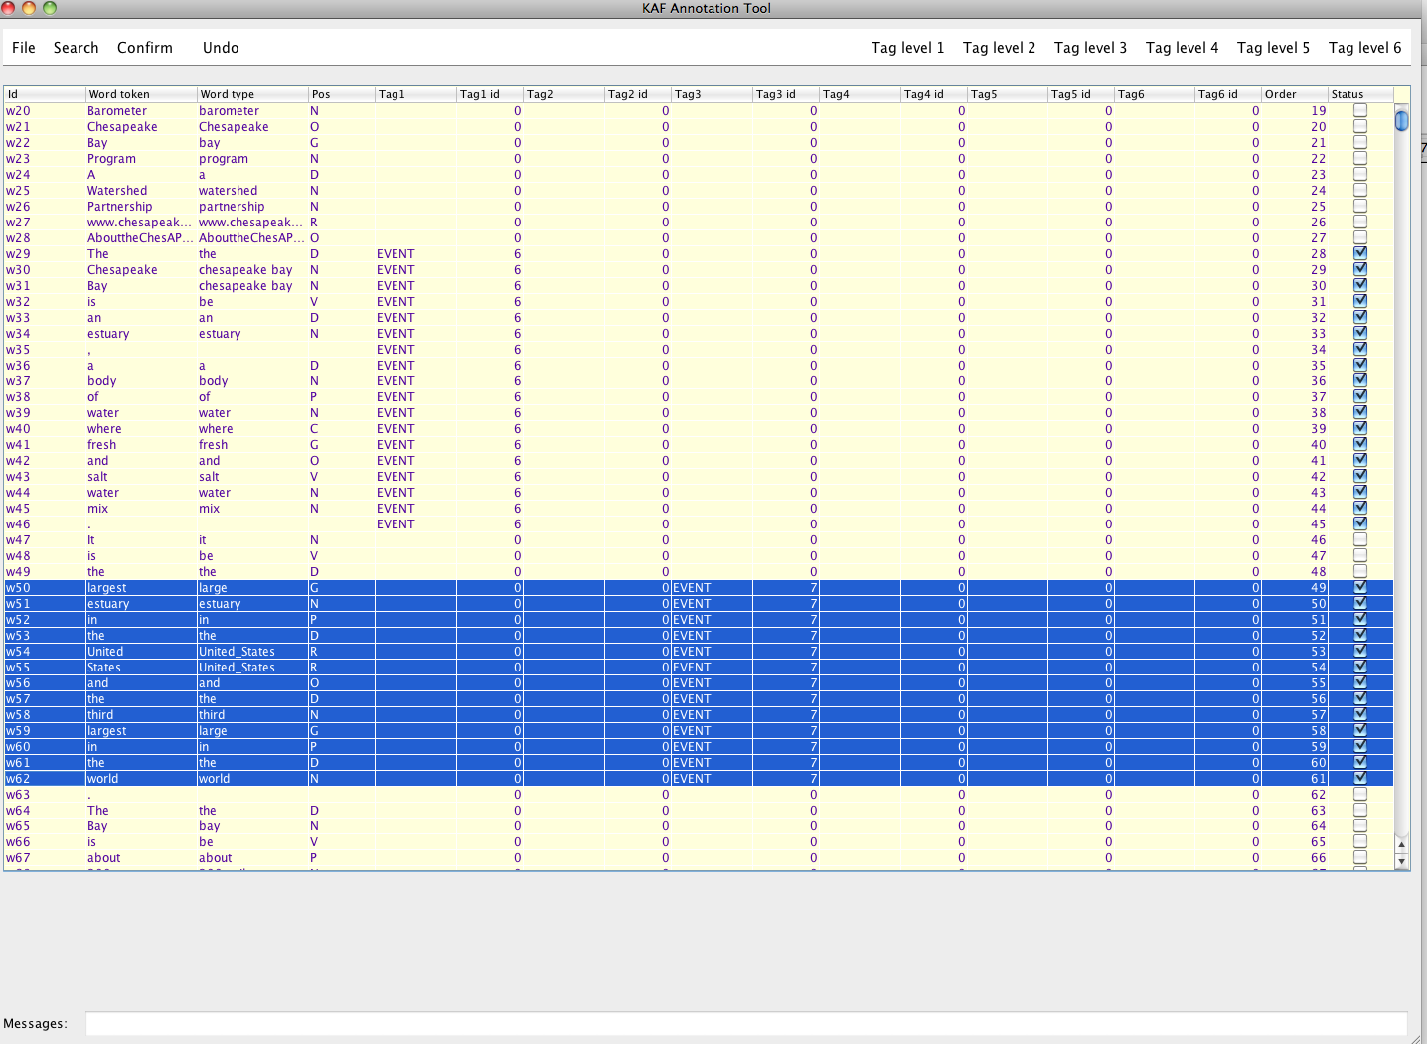Sentence level tagging
Tagging is not automatically saved, just as with a text editor. You need to save your tags using the save Save tagging submenu under the File menu. The tags are by default saved in the same location as the KAF file, where the extension “.kaf” is replaced by the extension “.tag”. When a KAF file is loaded, the program always looks for a tag file with the KAF file. If you want to use another TAG file you can use the load TAG file menu. If you want to save the tags in another location you can use the Save tagging as menu. The program always uses the most-recent location for saving the tags until the program is terminated.

Now we have saved the tags, we re-load the KAF files. You can see the original KAF file without the tags. From the File menu, we select the submenu Load TAG file. We select the TAG file that we just saved and the tags re-appear.
When you use the Save tagging menu, the tags are saved in the tag file for the KAF but also the lexicon is saved to a lexicon file. Once the lexicon file is built, you can use the submenu Dominant Tag below the Tag level 1 menu. To see the effect, select all rows in the table and select the Dominant Tag submenu. You can see now that tokens that were tagged before got a tag based on the most frequent tag in the lexicon.
Try to experiment with the various options to tag and save the results while you are working just as with a regular text editor. The tag file and the lexicon are updated every time you save. At any point, you can also choose to save the tags and the lexicon file to another file or location using the Save as submenu below File. Note that saving to another file, means that the location of the tag file and the lexicon are also changed to the new file and regular saves will be stored there.
Tip: try using the ALT key to operate the menus with the keyboard and use arrows, TAB and ENTER to navigate through the table. The space bar can be used to toggle the status after selecting the Status column.
When you tag more than one file, you probably work with fixed tagsets and lexicons. The following steps should be done to tag these files in a consistent way:

- Load the tagset: File/Load TAG set
- Load the lexicon file: File/Load lexicon file
- Load the KAF file: File/Open KAF file
- Load the TAG file: File/Load TAG file (your previous work if any)
- Assign tags
- Save tagging: File/Save tagging

Other menus:
File/Export tags to train format exports the annotation to a simple list format that can be used for machine learning
Export tags to triplets exports the annotation to triplets for evaluating text mining
Confirm confirm or unconfirm any set of annotations
Search search for words or tags in the table
Undo undo the last tagging action and restores the previous values

3. The tag file
A tag file is a tab separated file containing all tokens that have been tagged on separate rows. Each row contains the full set of columns from the table:
w1615 The the D ROLE-PATIENT 49 EVENT-SCOPE 52 0 0 0 0 1338 true w1616 Chesapeake chesapeake bay N ROLE-PATIENT 49 EVENT-SCOPE 52 0 0 0 0 1339 true
w1617 Bay chesapeake bay N ROLE-PATIENT 49 EVENT-SCOPE 52 0 0 0 0 1340 true w1618 and and O ROLE-PATIENT 49 EVENT-SCOPE 52 0 0 0 0 1341 true
w1619 its its D ROLE-PATIENT 49 EVENT-SCOPE 52 0 0 0 0 1342 true w1620 tributaries tributary N ROLE-PATIENT 49 EVENT-SCOPE 52 0 0 0 0 1343 true

4. The tag set file

The tag set file is a list of tags prefixed with the tag level:

1;EVENT
1;ROLE-PATIENT
1;ROLE-DONE-BY
1;LOCATION
1;TIME
2;EVENT-SCOPE
3;EVENT
3;TIME
3;LOCATION
3;ROLE-DONE-BY
3;ROLE-PATIENT
4;EVENT-SCOPE
5;EVENT
5;TIME
5;LOCATION
5;ROLE-DONE-BY
5;ROLE-PATIENT
6;EVENT-SCOPE

You can manually create the file and load it for tagging.

It is possible to create a hierarchical tag menu. You can manually edit the tag set file and prefix intermediate levels using a prefix string separated with “#”. Below is an example of a tagset file used in KYOTO that differentiates between tags that apply to endurants (objects and substances) only and tags that apply to perdurants (processes and states). The tags for endurants have a further subdivision for tags related to motion events:

1;EVENT
1;endurant#patient
1;endurant#done-by
1;endurant#instrument
1;endurant#use-of
1;endurant#participant
1;endurant#has-state
1;endurant#motion#path-of
1;endurant#motion#destination-of
1;endurant#motion#source-of
1;endurant#generic-location
1;endurant#product-of
1;perdurant#simple-cause-of
1;perdurant#result-of
1;perdurant#state-of
1;perdurant#purpose-of
1;perdurant#goal-of
1;LOCATION
1;TIME

Any number of levels can be added to the tags. Note that only the leaf-items can be assigned to text. If you want to be able to assign intermediate levels as undifferentiated tags, you can repeat the intermediate level at the lowest level, e.g.:

1;NAMED-ENTITY#NAMED-ENTITY
1;NAMED-ENTITY#LOCATION
1;NAMED-ENTITY#TIME

If you add a new tag manually using the interface, you can also specify the level. For example, typing endurant#experiencer when adding a tag will insert experiencer below the endurant submenu.

5. The lexicon file

The lexicon file stores the tags used for a token. It has the following format:
<?xml version="1.0" encoding="UTF-8" standalone="no"?>
<lexicon>
<entry>
<form>Humber</form>
<tagData><tag>LOCATION</tag> <freq>1</freq></tagData>
</entry>
<entry>
<form>2006</form>
<tagData><tag>TIME</tag> <freq>1</freq></tagData>
</entry>
<entry>
<form>tangible</form>
<tagData><tag>PARTICIPANT</tag> <freq>1</freq></tagData>
<tagData><tag>STATE</tag> <freq>6</freq></tagData>
</entry>
</lexicon>

The is used to assign the dominant tag to a token and to collect statistics on the tagging.

6. Annotating synsets
The synset column shows synset identifiers for word types that have a single synset associated with them in KAF. This can be the result of word-sense-disambiguation. It is possible to assign synsets to other word types or to choose another synset for word types with a single synset. To do that, you select a row with a word token and click with the right-mouse. As shown below, a pop-up menu with a list of wordnets from which you can select.. Selecting a menu will make a call to the online wordnet in the Kyoto project.
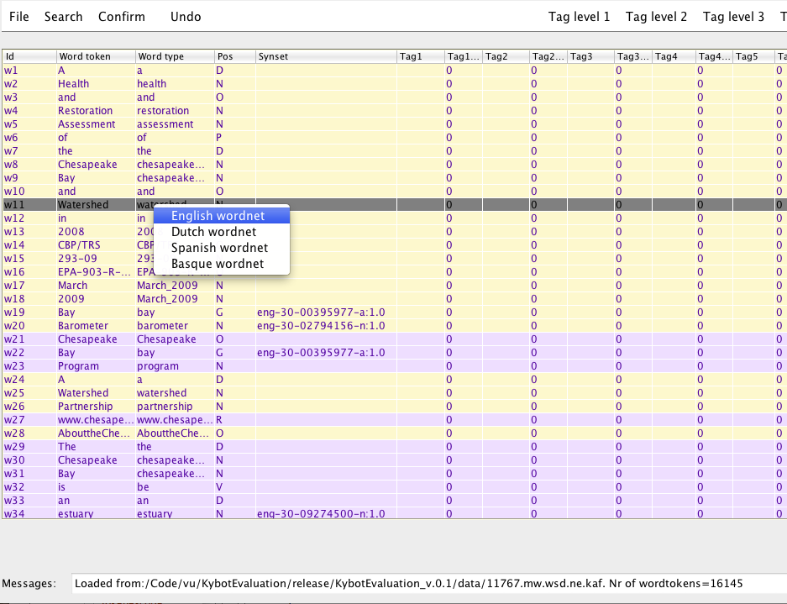
The next window shows the different synsets associated with the senses of the word type. You can select a sense by the tick boxes and pressing OK.
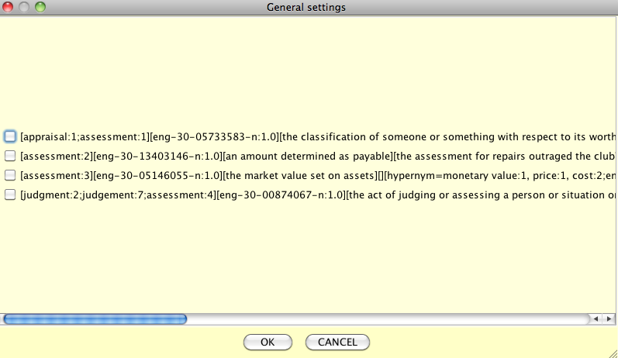
The selected synset is inserted into the synset column as shown in the next screen dump. You can also tag single synsets that were selected. In some cases, the wrong part-of-speech is assigned and the wrong synset may be assigned as well. Making a call to the wordnet database, lets you correct this.

Note that the assigned senses are stored in the tag file and not in the original KAF file. When you load a KAF file, you need to load the tag file to see the assigned senses.
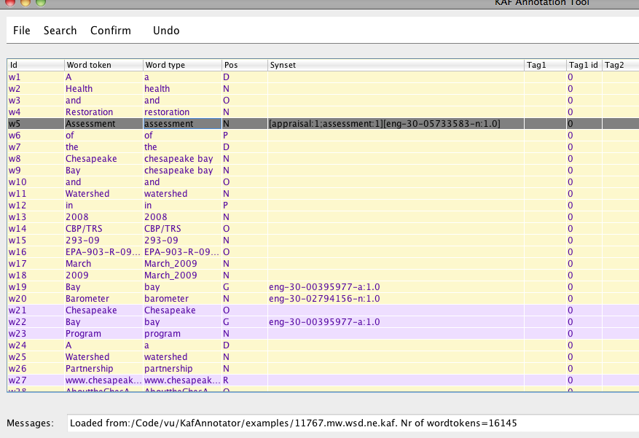

It is possible to tag senses out of context. This is convenient if you have good reasons to believe that a word is used in the same meaning throughout the document. First you sort the text on the word type by clicking on the word type column. In the example shown below, you see now all occurrences of waterway out of context. You can select a synset for one occurrence as was explained above. Next, you select all rows for the same word type and do Select sense by right-clicking the mouse.
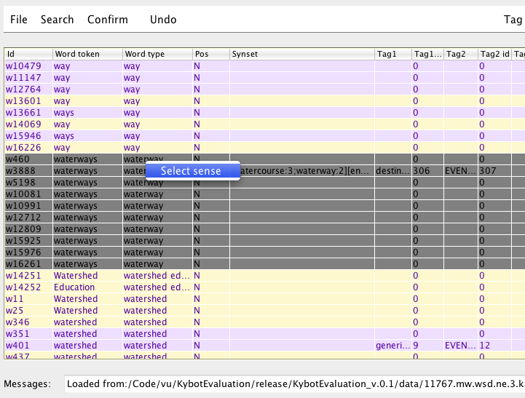

The program will now take the first synset in the selection and apply it to all selected rows with the same word type. This is shown in the next screen dump. Note that you can next sort the text in the original order and re-evaluate each occurrence in context and where necessary correct the assignment that is made out-of-context.
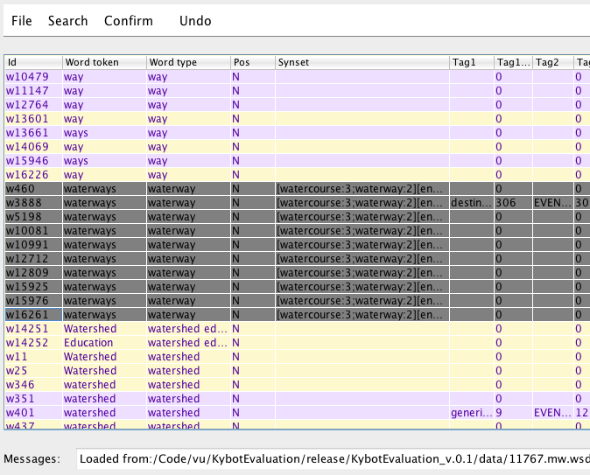

7. Converting annotations to training data
Many Machine Learning modules use a simple format for training data, where each token is presented on a separate line followed by the annotation separated by a tab:

the ROLE-PATIENT EVENT-SCOPE
overall ROLE-PATIENT EVENT-SCOPE
health ROLE-PATIENT EVENT-SCOPE
of ROLE-PATIENT EVENT-SCOPE
the ROLE-PATIENT EVENT-SCOPE
Chesapeake ROLE-PATIENT EVENT-SCOPE
Bay ROLE-PATIENT EVENT-SCOPE
did
not EVENT EVENT-SCOPE
improve EVENT EVENT-SCOPE
in TIME EVENT-SCOPE
2008 TIME EVENT-SCOPE
.

The ROLE-PATIENT EVENT-SCOPE ROLE-PATIENT EVENT-SCOPE ROLE-PATIENT EVENT-SCOPE
Bay ROLE-PATIENT EVENT-SCOPE ROLE-PATIENT EVENT-SCOPE ROLE-PATIENT EVENT-SCOPE
continues
to
have
poor EVENT EVENT-SCOPE
water EVENT EVENT-SCOPE
quality EVENT EVENT-SCOPE
,
degraded EVENT EVENT-SCOPE
habitats EVENT EVENT-SCOPE
and
low EVENT EVENT-SCOPE
populations EVENT EVENT-SCOPE
of EVENT EVENT-SCOPE
many EVENT EVENT-SCOPE
species EVENT EVENT-SCOPE
of EVENT EVENT-SCOPE
fish EVENT EVENT-SCOPE
and EVENT EVENT-SCOPE
shellfish EVENT EVENT-SCOPE
.

8. Converting annotations to event triplets
A special function is provided to convert KAF annotations to event triplet format: File/Export to triplets. The function reads the annotation tag file and generates a file with triplets. Such an annotation triplet file can be used as a gold standard for evaluating system output for event mining.
A triplet consists of:
  - a relation
  - a list of token ids that represent the event
  - a list of token ids that represent a participant

Here is an example of a triplet:

<triplet id="16" relation="ROLE-PATIENT">
<eventids>
<event id="w12250"/>
</eventids>
<participantids>
<participant id="w12253"/>
<participant id="w12254"/>
<participant id="w12255"/>
</participantids>
</triplet>
If an event has multiple participants, a separate triplet is created for each event-participant pair. The triplet identifier is used to mark which triplets relate to the same event.

For the annotation of triplets the following requirements should be met:
- At level 1, 3, and 5, one of the tags should be “EVENT”, other tags are free to choose (typical tags are roles of participants, time and location).
- At level 2, 4, and 6, the tags should be “EVENT-SCOPE”
The annotators can tag any sequence of tokens using the tags at level 1, 3 and 5. In order to group annotations to the same event, they need to assign the EVEN-SCOPE tag to the set of tokens that belong to a single event. If participants (roles, time, location) belong to more than one event, they need to annotated separately at another level (e.g. 3 or 5) and bound by separate EVENT-SCOPE. The next screen dump shows an example of tagging a KAF file in this way.
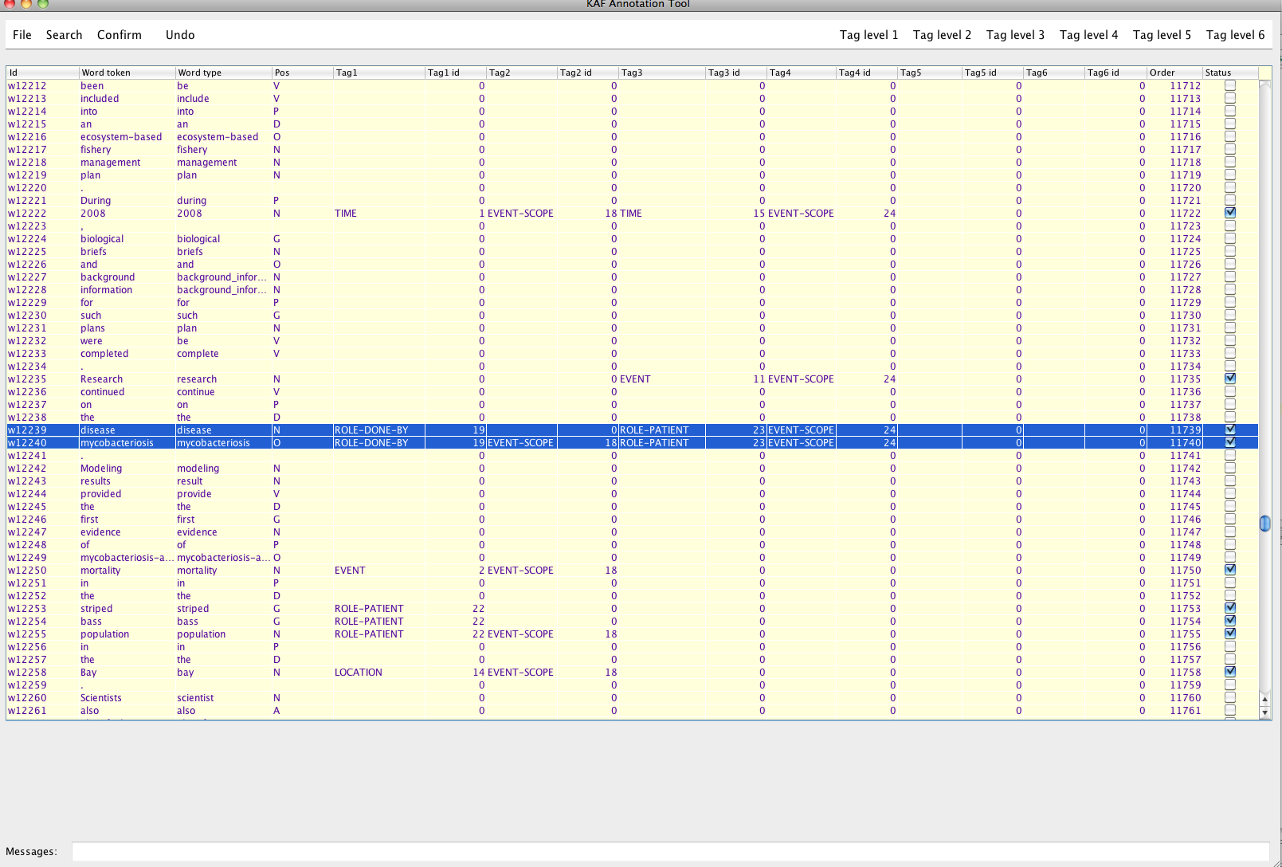Using the annotation layers to annotate triplets for KYOTO evaluation
In this screen dump, disease mycobacteriosis is playing two different roles in two events.

Note that the tags EVENT and EVENT-SCOPE are obligatory to be able to derive triplets. The other tags are optional and any tag can be chosen.

