Module6_Assignment1

trucks <- read_csv("trucks.csv")

### Task 1

ggplot(trucks, aes(Distance, Speeding)) +  
 geom_point(alpha = 0.4) + theme_bw()

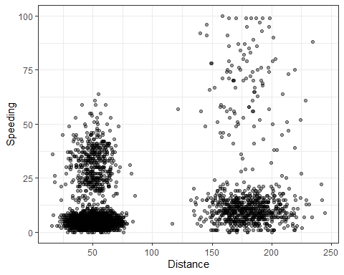 There are 2 distinct clusterings at distances around 50 and 175.

### Task 2

trucks = trucks %>%  
 select(-Driver_ID)  
  
kmeans_recipe = recipe(~ Distance + Speeding, trucks)   
  
trucks_dummy = kmeans_recipe %>%   
 step_scale(all_numeric()) %>%  
 step_center(all_numeric())   
  
trucks_dummy = prep(trucks_dummy, trucks)   
trucks_cleaned = bake(trucks_dummy, trucks)

### Task 3

set.seed(64)  
clusts =   
 tibble(k = 1:2) %>%  
 mutate(  
 kclust = map(k, ~kmeans(trucks_cleaned, .x)),  
 tidied = map(kclust, tidy),  
 glanced = map(kclust, glance),  
 augmented = map(kclust, augment, trucks_cleaned)  
 )  
  
clusts

## # A tibble: 2 x 5  
## k kclust tidied glanced augmented   
## <int> <list> <list> <list> <list>   
## 1 1 <kmeans> <tibble [1 x 5]> <tibble [1 x 4]> <tibble [4,000 x 3]>  
## 2 2 <kmeans> <tibble [2 x 5]> <tibble [1 x 4]> <tibble [4,000 x 3]>

clusters =   
 clusts %>%  
 unnest(cols = c(tidied))  
  
assignments =   
 clusts %>%   
 unnest(cols = c(augmented))  
  
clusterings =   
 clusts %>%  
 unnest(cols = c(glanced))

p1 =   
 ggplot(assignments, aes(x = Distance, y = Speeding)) +  
 geom_point(aes(color = .cluster), alpha = 0.8) +   
 facet_wrap(~ k)  
p1

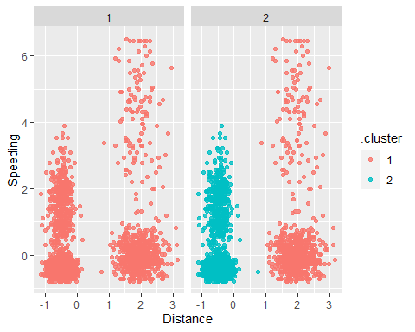 The clusters above are very similar to the clusters in task one, confirming the 2 distinct clusters.

clusters = kmeans(trucks_cleaned, centers = 2)  
trucks = augment(clusters, trucks)

### Task 4

set.seed(412)  
clusts =   
 tibble(k = 1:8) %>%  
 mutate(  
 kclust = map(k, ~kmeans(trucks_cleaned, .x)),  
 tidied = map(kclust, tidy),  
 glanced = map(kclust, glance),  
 augmented = map(kclust, augment, trucks_cleaned)  
 )  
  
clusts

## # A tibble: 8 x 5  
## k kclust tidied glanced augmented   
## <int> <list> <list> <list> <list>   
## 1 1 <kmeans> <tibble [1 x 5]> <tibble [1 x 4]> <tibble [4,000 x 3]>  
## 2 2 <kmeans> <tibble [2 x 5]> <tibble [1 x 4]> <tibble [4,000 x 3]>  
## 3 3 <kmeans> <tibble [3 x 5]> <tibble [1 x 4]> <tibble [4,000 x 3]>  
## 4 4 <kmeans> <tibble [4 x 5]> <tibble [1 x 4]> <tibble [4,000 x 3]>  
## 5 5 <kmeans> <tibble [5 x 5]> <tibble [1 x 4]> <tibble [4,000 x 3]>  
## 6 6 <kmeans> <tibble [6 x 5]> <tibble [1 x 4]> <tibble [4,000 x 3]>  
## 7 7 <kmeans> <tibble [7 x 5]> <tibble [1 x 4]> <tibble [4,000 x 3]>  
## 8 8 <kmeans> <tibble [8 x 5]> <tibble [1 x 4]> <tibble [4,000 x 3]>

clusters =   
 clusts %>%  
 unnest(cols = c(tidied))  
  
assignments =   
 clusts %>%   
 unnest(cols = c(augmented))  
  
clusterings =   
 clusts %>%  
 unnest(cols = c(glanced))

p1 =   
 ggplot(assignments, aes(x = Distance, y = Speeding)) +  
 geom_point(aes(color = .cluster), alpha = 0.8) +   
 facet_wrap(~ k)  
p1

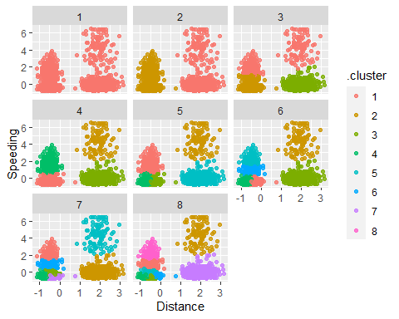

Cluster set at 4 seems to be the most appropriate as the other clusters seem to be splitting the data too fine.

### Task 5

ggplot(clusterings, aes(k, tot.withinss)) +  
 geom_line() +  
 geom_point() + theme_bw()

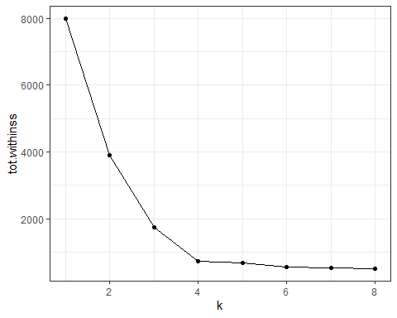

the value of K that appears to be best is 4 where the graph stops descending and forms a “hockey puck.”

### Task 6

set.seed(64)  
clusts =   
 tibble(k = 1:4) %>%  
 mutate(  
 kclust = map(k, ~kmeans(trucks_cleaned, .x)),  
 tidied = map(kclust, tidy),  
 glanced = map(kclust, glance),  
 augmented = map(kclust, augment, trucks_cleaned)  
 )  
  
clusts

## # A tibble: 4 x 5  
## k kclust tidied glanced augmented   
## <int> <list> <list> <list> <list>   
## 1 1 <kmeans> <tibble [1 x 5]> <tibble [1 x 4]> <tibble [4,000 x 3]>  
## 2 2 <kmeans> <tibble [2 x 5]> <tibble [1 x 4]> <tibble [4,000 x 3]>  
## 3 3 <kmeans> <tibble [3 x 5]> <tibble [1 x 4]> <tibble [4,000 x 3]>  
## 4 4 <kmeans> <tibble [4 x 5]> <tibble [1 x 4]> <tibble [4,000 x 3]>

clusters =   
 clusts %>%  
 unnest(cols = c(tidied))  
  
assignments =   
 clusts %>%   
 unnest(cols = c(augmented))  
  
clusterings =   
 clusts %>%  
 unnest(cols = c(glanced))

p1 =   
 ggplot(assignments, aes(x = Distance, y = Speeding)) +  
 geom_point(aes(color = .cluster), alpha = 0.8) +   
 facet_wrap(~ k)  
p1

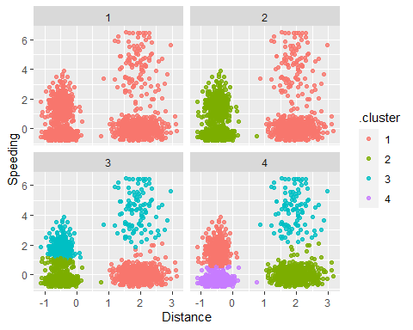

Cluster number 4 seems to be appropriate in this scenario as it seems to clearly show differentiation between the various sets.