Woody_Module2_Assign1_final

## Task 1

library(tidyverse)

## -- Attaching packages --------------------------------------- tidyverse 1.3.0 --

## v ggplot2 3.3.3 v purrr 0.3.4  
## v tibble 3.0.5 v dplyr 1.0.3  
## v tidyr 1.1.2 v stringr 1.4.0  
## v readr 1.4.0 v forcats 0.5.0

## -- Conflicts ------------------------------------------ tidyverse_conflicts() --  
## x dplyr::filter() masks stats::filter()  
## x dplyr::lag() masks stats::lag()

library(tidymodels)

## -- Attaching packages -------------------------------------- tidymodels 0.1.2 --

## v broom 0.7.3 v recipes 0.1.15  
## v dials 0.0.9 v rsample 0.0.8   
## v infer 0.5.4 v tune 0.1.2   
## v modeldata 0.1.0 v workflows 0.2.1   
## v parsnip 0.1.5 v yardstick 0.0.7

## -- Conflicts ----------------------------------------- tidymodels_conflicts() --  
## x scales::discard() masks purrr::discard()  
## x dplyr::filter() masks stats::filter()  
## x recipes::fixed() masks stringr::fixed()  
## x dplyr::lag() masks stats::lag()  
## x yardstick::spec() masks readr::spec()  
## x recipes::step() masks stats::step()

library(GGally)

## Registered S3 method overwritten by 'GGally':  
## method from   
## +.gg ggplot2

library(lmtest)

## Loading required package: zoo

##   
## Attaching package: 'zoo'

## The following objects are masked from 'package:base':  
##   
## as.Date, as.Date.numeric

air=airquality  
summary(air)

## Ozone Solar.R Wind Temp   
## Min. : 1.00 Min. : 7.0 Min. : 1.700 Min. :56.00   
## 1st Qu.: 18.00 1st Qu.:115.8 1st Qu.: 7.400 1st Qu.:72.00   
## Median : 31.50 Median :205.0 Median : 9.700 Median :79.00   
## Mean : 42.13 Mean :185.9 Mean : 9.958 Mean :77.88   
## 3rd Qu.: 63.25 3rd Qu.:258.8 3rd Qu.:11.500 3rd Qu.:85.00   
## Max. :168.00 Max. :334.0 Max. :20.700 Max. :97.00   
## NA's :37 NA's :7   
## Month Day   
## Min. :5.000 Min. : 1.0   
## 1st Qu.:6.000 1st Qu.: 8.0   
## Median :7.000 Median :16.0   
## Mean :6.993 Mean :15.8   
## 3rd Qu.:8.000 3rd Qu.:23.0   
## Max. :9.000 Max. :31.0   
##

Ozone is the likely “Y” variable

## Task 2

air2<- drop_na(air, Ozone, Solar.R)

## Task 3

ggpairs(air2)

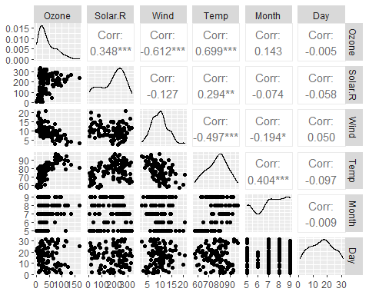

ggcorr(air2, label = TRUE)

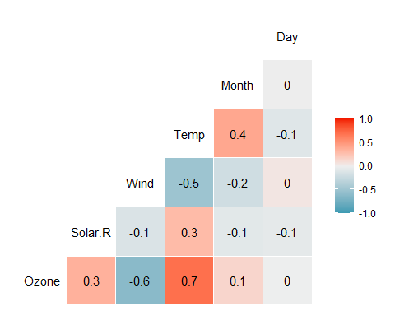 Day is the least associated with the Ozone variable Temp is the most strongly associated with the Ozone variable.