# Selenium + AutoIt: How to Automate Non-Browser Based Functionality

# The Selenium Problem – AutoIt to the Rescue

My team is currently working on a project using [Behavior Driven Development](https://www.joecolantonio.com/2016/04/19/wow-customers-tdd-bdd/) (BDD) and Java. Our main application is browser-based, so we’re also using the Selenium WebDriver with Java; however, our application also has other thick client applications integrated into it.

Most of our automation efforts are fine when using Selenium with BDD, but issues arise whenever we need to perform actions against the thick client applications when testing certain workflows. What to do?  
  
  
The best solution I’ve found around these issues is to use AutoIt which is a freeware application that is designed to help automate Windows-based UIs. The normal procedure is to create AutoIt scripts using the built-in BASIC-like programming language, but that isn’t an optimal solution for my team.

Instead, to still be able to develop in Java in our normal IDE we are accessing AutoIt through COM using [Jacob](http://sourceforge.net/projects/jacob-project/), which is a Java COM bridge.  
  
Also — rather than have everyone that needs to run the tests install another product — AutoIt– we can get around it simply by registering the [AutoItX3](https://code.google.com/p/autoitx4java/downloads/list) DLL.  
  
This might sound complicated, but following the steps below should get you up and running in no time.

## The Selenium AutoIt Solution

First you need to configure your machine:

* Fire up Eclipse and **Create a new Java Project** named **AutoIT**

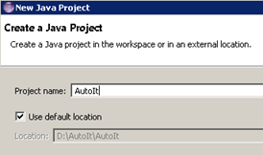

* In the Windows directory where the AutoIT project is saved, create a new directory named **lib**

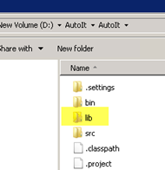‘

* Download the JACOB Java COM bridge:

<http://sourceforge.net/projects/jacob-project/>

* Download the AutoIt Zip file option:

<http://www.autoitscript.com/site/autoit/downloads/>

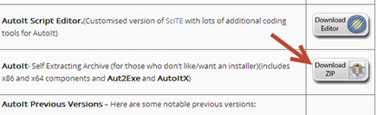

* Download the AutoItXJava.jar file:

<https://code.google.com/p/autoitx4java/downloads/list>

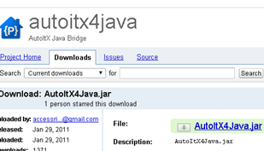

* Navigate to where you placed the Jacob zip file and extract it.
* Copy the **jacob.jar**, **jacob-1.18-M2-x64.dll** and **jacob-1.18-M2-x64.dll** filed and place them in the **AutoIT>Lib** folder we created earlier.

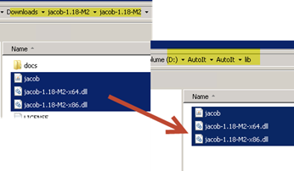

* Navigate to where you downloaded the **AutoItX4java.jar** file and copy it into the **AutoIt>Lib** directory.
* Your **AutoIT >lib** directory should now have these four files:
  + AutoItX4Java.jar
  + Jacob.jar
  + Jacob-1.18-M2-x64.dll
  + Jacob-1.18-M2-x86.dll

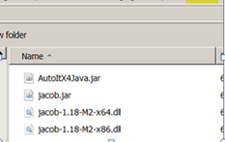

* + Create another folder under your project named **tools/autoit**
  + Navigate to the folder where you extracted **AutoIT**and copy the **AutoItX3.dll** and the **AutoItX3_x64.dll** into the tools/autoit directory.

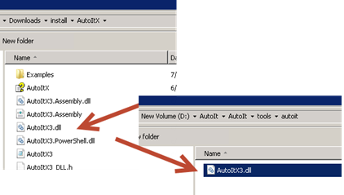

* + In Eclipse, right click on the **AutoIt** project and click **Refresh**
  + Right click on the **AutoIt** project again and select **Properties**
  + Under the **Java Build Path,** click on the **Libraries** tab.
  + Click on the **Add JARS..** button.
  + Navigate to the lib folder we created and add:
    - **AutoItX4Java.jar**
    - **Jacob.jar**

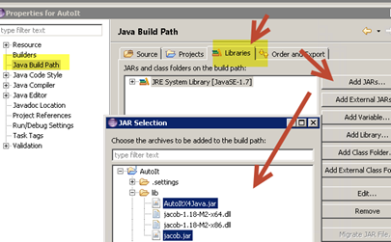

Now — so that we can use AutoIt without installing Autoit we need to register the AutoIT dll that we placed in our tools/autoit directory:

If you are using Java 32bit:

* Click on the Windows start button and enter regsvr32 yourpath/**AutoItX3.dll**

If you are using Java 64bit (if you don’t do this, you will get the error Can’t co-create object):

* Click on the Windows start button and enter regsvr32 yourpath/**AutoItX3_x64.dll**

http://www.joecolantonio.com/wp-content/uploads/2014/07/070314_2306_SeleniumAut10.png

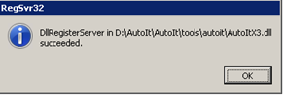

* You should now be able to call AutoItX methods directly from Java. Let’s look at how this is done:

**Use the Calculator to add two numbers**

For a quick sanity check to verify that you can use ActiveIT in Java, let’s create a small test that calls the Windows calculator and adds two numbers:

* In Eclipse, right click on the **AutoIt** project and click **Class**
* In the New Java Class window, name the class **CalcTest** and select the **public static void main** option.

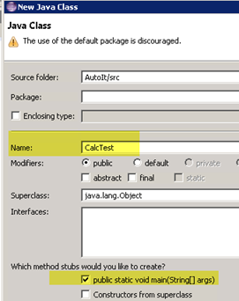

* Click **finish**
* At the very top of the class, add the following imports:

import java.io.File;

import autoitx4java.AutoItX;

import com.jacob.com.LibraryLoader;

* In the **CalcTest** class, under the main section, add the following code:

First, you’ll need to determine whether the machine you’re running this on has **Java32 bit** or **64bit** installed. (If you know this already you won’t need this code, but if you want to run on multiple machines it might make sense for you to programmatically determine the Java bit version and load up the corresponding Jacob.dll version.)

To do this, add a method under the **static void main** section:

/**

*

* Returns if the JVM is 32 or 64 bit version

*/

public

static String jvmBitVersion(){

return System.getProperty("sun.arch.data.model");

}

* Under **static void main**, enter:

public static void main(String[] args) throws InterruptedException {

String jacobDllVersionToUse;

if (jvmBitVersion().contains("32")){

jacobDllVersionToUse = "jacob-1.18-M2-x86.dll"

}

else {

jacobDllVersionToUse = "jacob-1.18-M2-x64.dll";

}

File file = new File("lib", jacobDllVersionToUse);

System.setProperty(LibraryLoader.JACOB_DLL_PATH, file.getAbsolutePath());

AutoItX x = new AutoItX();

x.run("calc.exe");

x.winActivate("Calculator");

x.winWaitActive("Calculator");

//Enter 3

x.controlClick("Calculator", "", "133") ;

Thread.sleep(1000);

//Enter +

x.controlClick("Calculator", "", "93") ;

Thread.sleep(1000);

//Enter 3

x.controlClick("Calculator", "", "133") ;

Thread.sleep(1000);

//Enter =

x.controlClick("Calculator", "", "121") ;

}

* To get the Calculator button ids for the number **3** and **=** I used the **Au3info** application that is in the install directory of **autoit-v3** that we downloaded and extracted in a previous step.

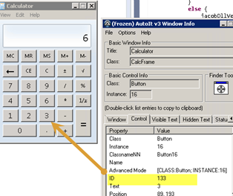

* For a list of AutoIt function’s available and how to use them, check out [the AutoIt online documentation](http://www.autoitscript.com/autoit3/docs/functions.htm).
* Right click on the AutoIt project and select **Run As** > **Java Application**
* The Windows calculator should start and enter the values 3 + 3 = 6

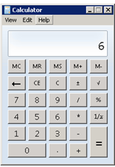

## More Automation Awesomeness with AutoIt

How cool is that?! Stay tuned for my next post where I will show you how to use this same technique to handle non-browser based dialogs that occasionally occur when testing web applications.  
  
Another option to check it besides AutoIt to help with these types of issues is [SikuliX](https://www.joecolantonio.com/2015/02/17/sikulix-java-video-example/). Check out my post on [How to Get Started with SikuliX](https://www.joecolantonio.com/2015/02/17/sikulix-java-video-example/) to learn more.