# Bunny Wars – Data Structures Exam

**Bunny Wars** is an interactive game. The rules are as follows:

* There are **several rooms** in the game, each with a **unique id**. Rooms are situated according to their **id** in ascending order.
* Each room can hold **several bunnies**.
* A bunny has a **unique** **name**, **health**, **score** and **team**. All bunnies have **health = 100** and **score = 0**   
  by default.
* Bunnies can jump to the **next** or **previous** room.
* Bunnies can **detonate**, causing damage to all bunnies of other teams in the room (**detonating** does not delete the detonated bunny – it’s still in the room after the command).

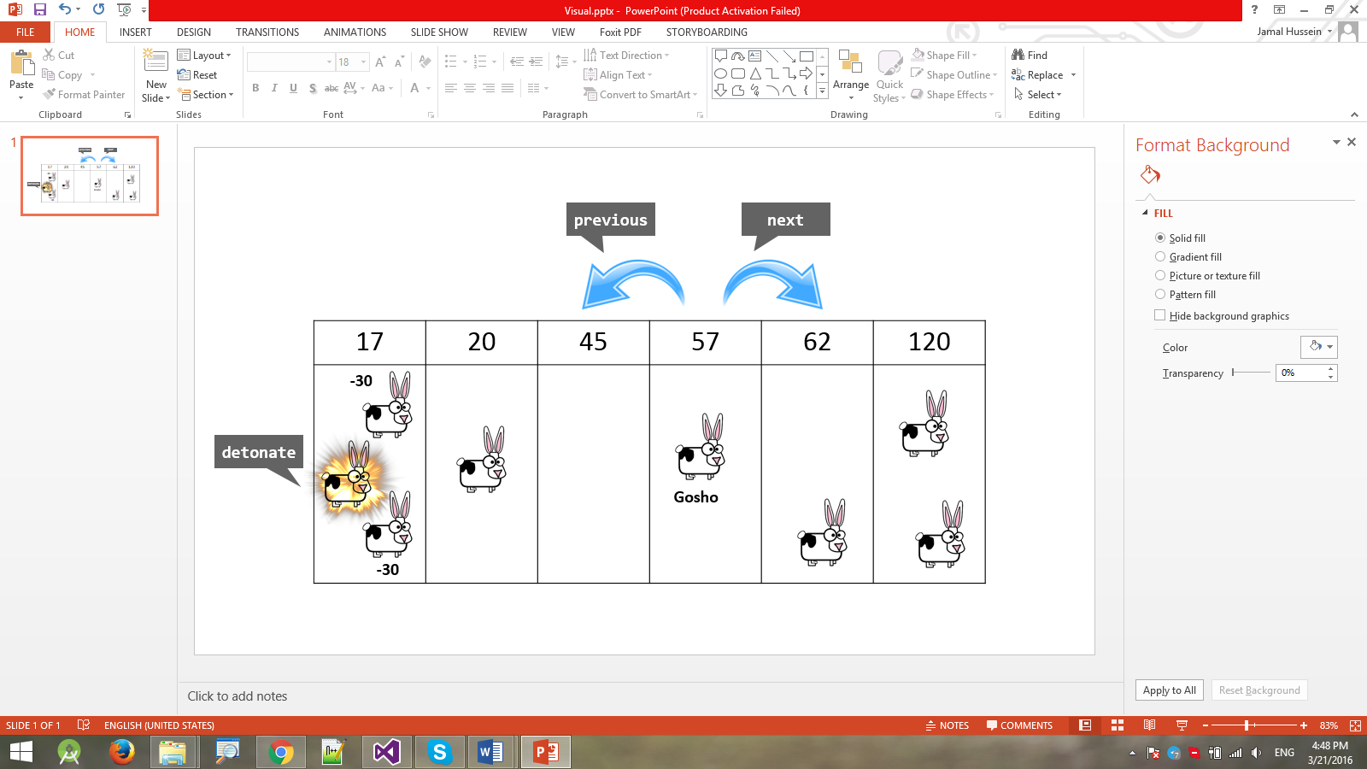

Your task is to design a data structure in C# or Java that supports the commands listed below in a **fast and efficient way**.

* Add roomId– adds a room to the structure. Rooms have unique ids. Rooms should be situated according to **their id in ascending order**.
  + If a room with the given Id exists the command should throw an exception.
* Add bunnyName teamId roomId– creates a new bunny with the given **name** and **team id** and adds it to the **specified room**.
  + There can be a maximum of 5 teams in the game, teamId will always be in the range [0..4]**.**
  + If a bunny with the given name already exists or a room with the given Id does not exist, the command should throw an exception.
* BunnyCount – returns the total amount of bunnies in the structure.
* RoomCount – returns the total amount of rooms in the structure.
* Remove roomId– removes the given **room** from the game. **All bunnies in the room** are also removed from the game.
  + If a room with the given **Id** does not exist, the command should throw an exception.
* Next bunnyName– moves the specified bunny in the **next room** (to the right of the current room). If a bunny is in the last room (the room with the biggest Id) and receives this command he will move to the first room (the room with the lowest Id).
  + If a bunny with the given name does not exist, the command should throw an exception.
* Previous bunnyName – moves the specified bunny in the **previous room** (to the left of the current room). If a bunny is in the first room (the room with the lowest Id) and receives this command he will move to the last room.
  + If a bunny with the given name does not exist, the command should throw an exception.
* Detonate bunnyName– detonates the bunny, causing all bunnies from other teams in the same room to suffer 30 damage to their health (their health is reduced by 30).
  + If a bunny with the given name does not exist, the command should throw an exception.
  + If a bunny falls to 0 or less health as a result of the detonation, it should be removed from the game.
  + For each removed enemy bunny, the detonated bunny should gain +1 score.
* ListBunniesByTeam teamId - returns all bunnies from the specified team in (sorted by name in descending order).
* ListBunniesBySuffix suffix - returns all bunnies ending with the **specified suffix** (sorted by the ASCII code of the reversed name in ascending order as a first criteria and by length in ascending order as a second criteria)**.** Example **Tpen < apen < aapen < bapen < bpen.**

### Input

The input data should be read from the console. The input data consists of several commands, each on separate line, ending with the command "End". Empty lines in the input should be ignored.

The input data will consist of valid commands in the above described format. There is no need to check its validity.

### Output

The output should be printed on the console. It should hold the output from each command from the input.

### Constraints

* All names:
  + Consist of **Latin letters and digits**.
  + Have length in the range [1...100].
* Room IDs will be integer values in the range [-231..231].
* All string matching operations are **case-sensitive**.

### Submissions

Submit an archive (.zip) of the source code + external libraries.

# Scoring

Each implemented method brings you a specific amount of points, some of the points are awarded for correct behavior, others for performance. If you cover only a part of the tests for a category, you’ll receive a percentage of the points for the category based on the percentage of covered tests. Bellow is a breakdown of all points by methods:

|  |  |  |  |
| --- | --- | --- | --- |
| Method | Correct Behaviour | Performance | Total |
| Add Room | 2 | 4 | 6 |
| Add Bunny | 3 | 6 | 9 |
| BunnyCount | 1 |  | 1 |
| RoomCount | 1 |  | 1 |
| Remove | 4 | 10 | 14 |
| Next | 3 | 8 | 11 |
| Previous | 3 | 8 | 11 |
| Detonate | 4 | 10 | 14 |
| ListBunniesByTeam | 4 | 10 | 14 |
| ListBunniesBySuffix | 5 | 14 | 19 |
| Overall: | 30 | 70 | 100 |