RMD Html Word Combined - 1

Project Name - Description

Table of Contents

Header 1 4

Subheader 1 4

Header 2 5

Analyses 1 5

Analyses 2 5

Analyses 3 5

Reference Material 6

About this Document 6

Methods 6

Outliers 6

Reviewer Credits 6

# 

**Report Layout:** The *Reference Material* section of this report contains more detailed information regarding how to use this report in the About Document tab, data analysis details in the Methods and details about the contributors on the Reviewer Credits tab.

# Header 1

## Subheader 1

# Header 2

## Analyses 1

Here is a good area to put a summary table of the data set:

## mpg cyl wt gear  
## 1 20.09062 6.1875 3.21725 3.6875

## Analyses 2

Here is a picture of SPARTY for you:

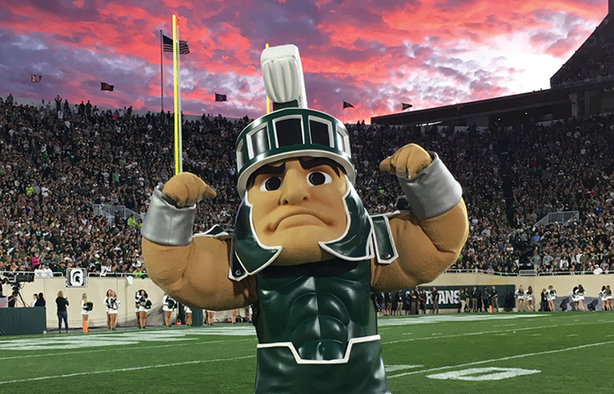

SPARTY; the great mascot of the best school

## Analyses 3

GO GREEN

# Reference Material

## About this Document

Users of this document can interact with any of the data visualizations provided in this supplement. Below is a list of the primary ways that each of the data displays can be used:

## Methods

Repeat this section as many times as needed.

## Outliers

Repeat this section as many times as needed.

## Reviewer Credits

This analysis has benefited from the collaboration, dedication and review of various members of the **INSERT ORG. HERE**. Special thanks to:

* *SPARTY*, for being awesome
* *Jason*, for loving SPARTY too
* *Josh*, for hiring me and paying me to talk about sparty in order to make a template
* *Jenna*, for liking hockey; an awesome sport that was not covered in this paper

# 

End of document