* Pins A6 and A7 are read only due to how the chip muxes the 2 pins through ADC (see <https://forum.arduino.cc/t/nano-a4-and-a5/538697/2> ). I encountered problems with this on 11/11/21. Had to change pins.
* If you try to make pin A7 an output, when you try to write HIGH to this pin it does not send current to pin A7, instead it actually sends current to D8 and D10.

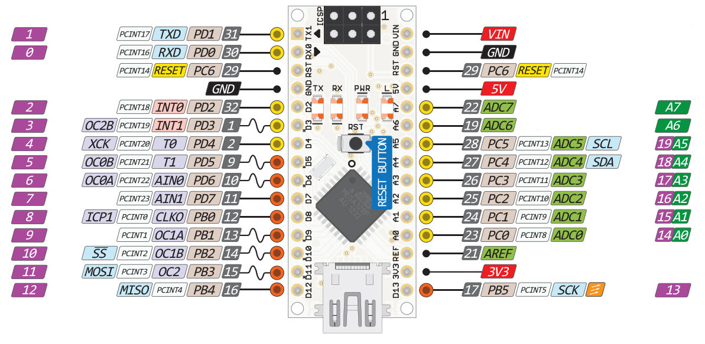

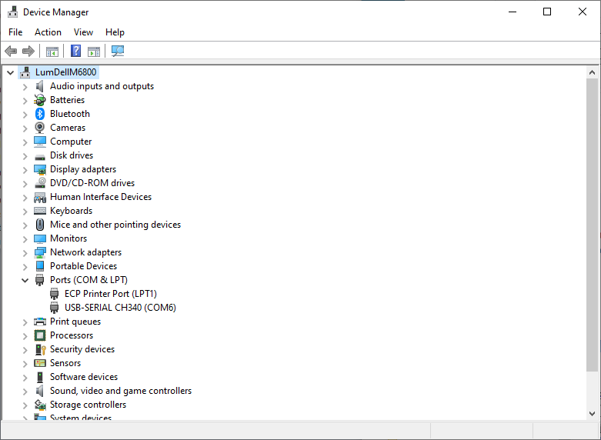

Figure : Device Manager after installed CH340 driver (see Ports > USB-SERIAL CH340 (COM6))

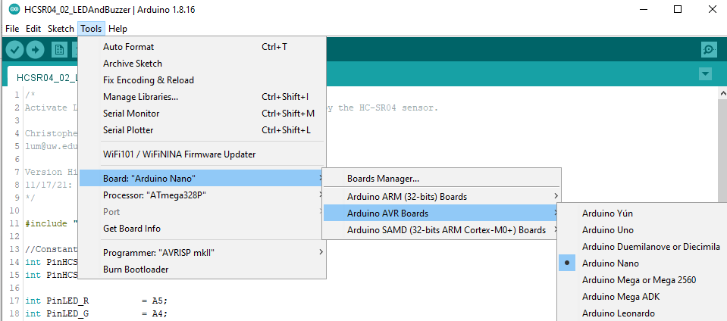

Figure : Selecting Board.

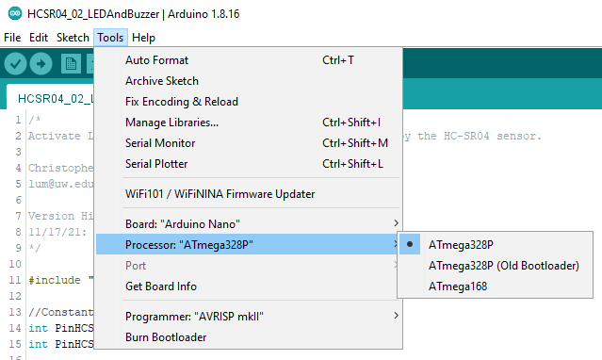

Figure : Selecting Processor.