 | U W A L  University of Washington  Aeronautical Laboratory  Kirsten Wind Tunnel, Box 352400, Seattle WA 98195-2400 | 

General Information

Please complete the attached Test Letter and return to UWAL. Keep this page for your records.

Test Number:

Tentative Test Date(s):

The UWAL staff is glad to assist you in your wind tunnel testing. Please feel free to contact the following staff members to answer your concerns and questions:

Business Manager Jack Ross
E-mail: jwross@u.washington.edu
Phone: (206) 543-0439

Operations Manager Steven Isley
E-mail: sci@aa.washington.edu
Phone: (206) 543-0439

Standard UWAL business hours are between 7:30 a.m. and 4:30 p.m. Monday - Friday.
More information about the facility can be found on the Internet at our website: www.uwal.org

UWAL BUSINESS (206) 543-0439
OPERATIONS (206) 543-0337
FAX NUMBER (206) 616-2150
CUSTOMER LINE (206) 616-5981

Note: Information on local lodging and parking is available upon request.

UWAL TEST LETTER

I. CUSTOMER INFORMATION

A. Primary Test Engineer

Name:

Email Address:

Company Name:

Company Address:

Company Phone:

Company fax:

B. Company Representatives

Please list other company representatives who will be given admittance to the test, their affiliation with the test and phone number (if other than above):

Name | Affiliation | Phone Number
Name | Affiliation | Phone Number
Name | Affiliation | Phone Number
Name | Affiliation | Phone Number
Name | Affiliation | Phone Number

II. GENERAL TEST INFORMATION

UWAL Test Number

Customer Name

Model Designation

Model Number

Model Scale

Model Tentative Dates

Test Classification q Company Proprietary q Confidential
(Check one) q Unclassified q Secret
q Research q Top Secret

Work Authorization/P.O. Number

Date:

Any changes to the test letter must be submitted in writing and signed by the test engineer.

SECURITY
Since we are part of the University of Washington, we occasionally provide tours of our facility to the public. At the same time we respect the test classification specified above.
Please specify whether tours should be allowed:

q Yes, tours are okay with the following restrictions:
q No, tours are not allowed.
Other Restrictions:

The interior building doors can be locked to restrict access to the main testing area from the shop and faculty offices. This may, however, slow down access to these areas during high traffic.

q Lock interior doors for security. q Leave doors unlocked for convenience.

Test Engineer Date
III. OPERATIONS PREPARATION INFORMATION

A. Mounting (See Technical Guide to the Kirsten Wind Tunnel for drawings.)

Pitch Arm Number

Pitch Arm Pin provided by: | q UWAL q Customer q Customer

Strut or Fork Number

Fork or Strut Pins provided by: | q UWAL q Customer q Customer

Fairing Cap Number

Other comments about mounting:

B. On-Line Plotting Information

Each plot set should list the variables and scales to be plotted during a run. Please complete a grid definition form for plots that you would like to see on-line.

The on-line plotting system is a PC Windows-based software package that allows the customer to view up to 25 plots of data for a set of runs. The plots can be classified into five groups, referred to as a “plot set.” All plots are easily viewed on a 17” high resolution monitor and can be printed out in either 8½” x 11” or 11” x 17” formats at any point in time.

Available variables for on-line plots:
α, β, Ψ, CL, CD, CM, CN, CR, CY on either the wind, body, or stability axis.

C. Ground Plane Positions

For the standard ground plane:
Maximum height: 43 1/8 in. Minimum height: 25 5/8 in.
Measured from the tunnel floor to the top of the ground plane.
Desired positions:
in.
in.

- Dynamic Pressure

lbs. / ft.²
lbs. / ft.²
lbs. / ft.²

E. Flow Visualization (Check those desired, if any)

q Smoke q Oil q Tufts (specify type)

q China clay q Other:

F. Photography

Standard photo-documentation is provided for the test by use of a digital camera to record model configurations, flow visualization, and other important images. Also available are 35mm black and white photos, 35mm color photos, and VHS and digital video. Indicate the approximate number and type of photographs desired, as well as hours of video:

Please indicate what compression to use for digital video:
q MPEG-1 – 720x480
q MPEG-1 – 352x240
IV. DATA REDUCTION PREPARATION INFORMATION

A. Six Component Force/Moment Data (standard data)

Primary indicated angle of attack (α_{i}):
q UWAL encoder
q UWAL accelerometer (requires internal mounting within the model)
q Customer-provided accelerometer
Refer to the yaw angle of the model in reduced data as:
q ψ (Note: model positioning is always referred to in terms of ψ)
q β; (β = - ψ)
Wall corrections (Complete Section IV. D. 2. a.):
q Do not apply
q Approximate
q Classical
Blockage corrections:
q Do not apply
q Apply Shindo’s Simplified Tunnel Correction Method - same as used by the on-line plotting reduction program. (Complete Section IV. D. 2. a. even if you aren’t applying wall corrections.)
q Apply Maskell’s Blockage Corrections (Complete Section IV. D. 2. b.)

Coefficient data presented in the:
q Wind axis q Stability axis q Body axis
Fork or strut tare and interference corrections:
q Do not apply
q Apply UWAL generic fork tare (Check with UWAL for details.)
q Determine during the test

B. Non-Standard Requests

If data reduction other than the UWAL main balance data, such as pressures, hinge moments, is necessary, enclose all the pertinent information (including equations, output formats, reduction constants, etc.) on a separate sheet.

C. Auxiliary Data

The UWAL data system will accept up to 6 additional channels of output voltages from pressure transducers, strain gauges, or other measuring devices. The additional data channels will be measured like the UWAL balance channels (average of 100 samples per second over five seconds of on-condition time). Contact UWAL for further details.

Please provide the following information for each auxiliary data channel:
- Raw data channel name
- Full scale range of voltage output
- Constants for conversion from voltage to engineering units
- Equations to apply for final calculation/reduction
- Final data variable name

D. Model Dimensions

1. Geometry Constants
(Please complete one page for each wing-body configuration.)
CONFIGURATION DESCRIPTION:

a. Dimensions for Moment Transfers and Coefficients
SW = |  |  |  | ft.²
bref = |  |  |  | in.
MAC = |  |  |  | in.
x = |  |  |  | in.
z = |  |  |  | in.
 | α measured from

MMC location
(% MAC)
x_{MMC} (in.)
z_{MMC} (in.)
a (in.)
γ (deg.)
l_{h} (in.)
Please enter either x_{MMC} and z_{MMC} OR a and γ (see pg. 8)
*NOTE: Moment arm lengths necessary if calculation of C_{L, TRIM} is desired.

D. Model Dimensions

2. Wall and Blockage Correction Constants
(Please complete one page for each wing-body configuration.)
CONFIGURATION DESCRIPTION:

- Dimensions for Wall Corrections
bactual = |  | in.
croot = |  | in.
ctip = |  | in.
acwx = |  | in.
acwz = |  | in.
lto = |  | in.
tto = |  | in.

b. Constants for Maskell's Blockage Corrections (See Section 6.11, Low Speed Wind Tunnel Testing, by Rae and Pope, Wiley, 1984.)
UWAL can calculate these constants upon request if 3-view drawings are provided:

A1 =

A2 =
 | For flaps up or off configurations, A2 = 0

KA =

KB =
KW = | (assigned by UWAL)
VA = |  | ft.³
VB = |  | ft.³

c. An estimated numerical value for stabilizer effectiveness is needed for the on-line plotting system:

dCm/d∂s =
δ_{W} = | (assigned by UWAL)
δ_{AS} = | (assigned by UWAL)

3. Nomenclature Diagram (Positive Directions Shown)

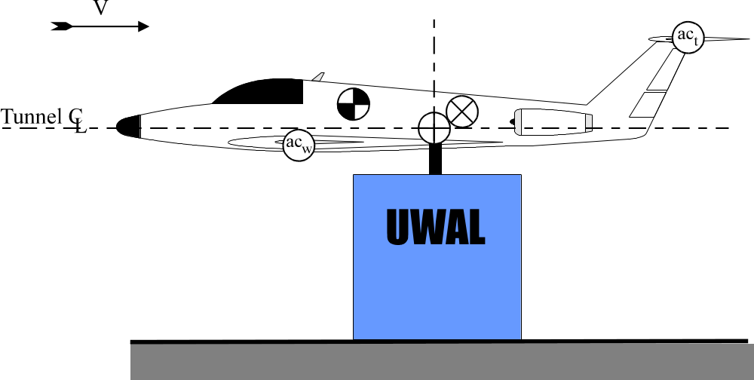

Exaggerated Enlargement (Positive Directions Shown)
l_{h}
ac_{t}
Wind
Tunnel Centerline

x_{MMC}


t_{to}
γ
a
Angle of Attack Ref Line
z_{MMC}
z
x
ac_{wz}
ac_{w}
ac_{wx}

l_{to}

The MMC is shown at zero alpha.

Configuration for a canard-equipped aircraft has not been included. For information on canard-specific geometry variables, contact UWAL.

4. Nomenclature Definitions (for the scale model)
Balance moment center
Model moment center (MMC)
Trunnion; model pivot center
 Aerodynamic center of the tail
 Aerodynamic center of the wing
a Distance from to ; inches
A1, A2 Functions of the flap span to wing span ratio, flap cutout in the
wing, and the wing aspect ratio
acwx Horizontal distance from to , at α = 0°, ψ = 0°; inches
acwz Vertical distance from to , at α = 0°, ψ = 0°; inches
bref Reference wing span; inches
bactual Actual wing span; inches
croot Wing root chord; inches
ctip Wing tip chord; inches
KA Shape factor for airfoil surfaces
KB Shape factor for bodies of revolution
KW Wing separation factor
lh Horizontal distance from to , at α = 0°, ψ = 0°; inches
lto Horizontal distance from to , at α = 0°, ψ = 0°; inches
MAC Mean aerodynamic chord; inches
SW Reference wing area; square feet
VA Volume of major airfoil surfaces, cubic feet
VB Volume of major bodies of revolution; cubic feet
x Horizontal transfer distance from to ; inches
xMMC Horizontal transfer distance from to ; inches
z Vertical transfer distance from to ; inches
through and at α = 0°, ψ = 0°; degrees
zMMC Vertical transfer distance from to ; inches
γ Angle between angle of attack reference line and a
V. DATA OUTPUT OPTIONS

The standard data set includes the final reduced data in coefficient form saved to ASCII files and placed on a PC-formatted CD-ROM. The binary data files containing all of the data parameters are also provided along with a copy of the UWAL Customer Plotting software so that any parameter can be plotted by the customer. The plotting package also allows the customer to produce tabulated data files from the binary data. The tabulated data files import into Excel with ease.

In addition, the UWAL Wind Tunnel Data Organizer software is provided on the CD, which enables the customer to view the run log, print out data in various formats, view the digital images and their notes.

Standard ASCII data output includes the following variables: Run, test point, test number, α_{c}, ψ, q_{c}, Mach, Reynolds number per foot, and corrected coefficients for the six force and moment components of the external balance in the axis of choice for all model moment centers.

If additional variables are desired in the output files, please specify the variable names in the space below:

ASCII data file structure: q All runs in one file q One run per file
Delimiter in the ASCII data file: q Comma q Space

UWAL Report Input Form

Test Number: Test Dates: to

Would you like a UWAL test report: q YES q NO

If you would like a special report/request, please attach a description on a separate page.

UWAL provides up to four report copies at no additional charge. Unless otherwise specified, test reports will be on paper and in electronic form on the final data disk. All test data and information is archived to a CD-ROM and stored in the UWAL vault.

1. | Total number of test report copies:
2. | Document number (if desired):
3. | Report title:
4. | Test purpose:
5. | Complementary data for cross reference (if applicable)
 |  | Report number:
 |  | Document number:
 |  | Title:
 |  |  |  | (if more than one reference, attach additional sheets)
6. | Photographs (circle one): |  | not desired include
If photographs are desired, attach a list with image numbers, run numbers, and titles.

Please also provide:
a. A complete run log (original)
b. A description of all model components (i.e. configuration summary)
c. A statement noting the disposition of all photographic material
d. A description of all types of data taken
e. A description of all types of runs made

Signed:

Date:
*If a final approval of the test report is desired, please contact the Operations Manager
 | U W A L  University of Washington  Aeronautical Laboratory  Kirsten Wind Tunnel, Box 352400, Seattle WA 98195-2400 | embed MSDraw \* mergeformat

Photo Release Form

Name (Print) |  | Title

Signature |  | Date

The above individual consented to the release of certain photo images to the public domain regarding University of Washington Aeronautical Laboratory (UWAL) test, number UW , conducted from to , 20 .

UWAL occasionally uses photos for educational purposes and promotional material. Releasing the photo images to the public domain allows public access to the images. UWAL will handle all requests for access to the information.

UWAL will not release any photos if this form has not been completed.

Please initial next to the photo(s) that you release for public access:

UWAL TEST PHOTOS:
ALL
SPECIFIC PHOTOS(please list):

UWAL GLAMOUR PHOTOS
ALL
SPECIFIC PHOTOS(please list):

OTHER
CUSTOMER SUPPLIED IMAGES
MODEL SKETCHES

Please state any additional restrictions:
If desired, you may specify a date after which the photos may be released:

