# Notes

* 12/07/21 – initial fork of Trackduino
* 03/21/22 – Tried to build/compile. Ran into error.
* 03/22/22 – Got radio transmitting
* 03/23/22 – Got Direwolf decoding position measurements. Temperature and Vin seem fishy.

**sensors_avr.cpp**

int sensors_ext_lm60()

{

return sensors_lm60(EXTERNAL_LM60_VS_PIN, EXTERNAL_LM60_VOUT_PIN);

}

int sensors_int_lm60()

{

return sensors_lm60(INTERNAL_LM60_VS_PIN, INTERNAL_LM60_VOUT_PIN);

}

**config.h**

// Pin mappings for the internal / external temperature sensors. VS refers

// to (arduino) digital pins, whereas VOUT refers to (arduino) analog pins.

#define INTERNAL_LM60_VS_PIN 6

#define INTERNAL_LM60_VOUT_PIN 0

#define EXTERNAL_LM60_VS_PIN 7

#define EXTERNAL_LM60_VOUT_PIN 1

// Units for temperature sensors (Added by: Kyle Crockett)

// 1 = Celsius, 2 = Kelvin, 3 = Fahrenheit

#define TEMP_UNIT 1

// Calibration value in the units selected. Use integer only.

#define CALIBRATION_VAL 0

// Resistors divider for the voltage meter (ohms)

#define VMETER_R1 10000

#define VMETER_R2 3300

// Voltage meter analog pin

#define VMETER_PIN 2

# Troubleshooting

* BODS was not declared in this scope

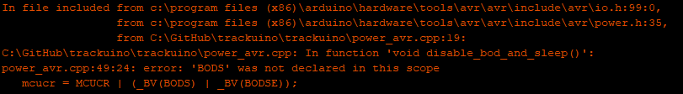

Might be an issue with the Board = Arduino Mega. Compiles OK with Board = Arduino Nano.