HACKATHON PROJECT DOCUMENT | PROBLEM STATEMENT EL-01
ReproLens
AI-Powered ML Paper Reproducibility Platform
Proposed Solution, Architecture, MVP, Demonstration Plan and Evaluation
Version 1.0 | 1 October 2026
"ReproLens" is the team's working name. The official problem title is unchanged.
Document conventions
Requirements from the official problem statement are labelled "PS". Design choices by the team are labelled "assumption". Sources marked "To be verified" must be checked before final submission. The example report is hypothetical.

Table of Contents
2. Abstract 6
3. Problem Statement 7
Problem title 7
What the official problem statement says 7
Requirements extracted from the PS 8
Distinguishing official requirements from our assumptions 9
Scope boundary 9
4. Background 10
Reproducibility and replicability 10
Evidence that reproducibility is a real problem 10
Why ML experiments are hard to reproduce 11
Why “the code exists on GitHub” is not enough 11
Implications for design 11
5. Motivation 13
6. Objectives 14
7. Existing Solutions 15
Tools and systems reviewed 15
Comparison table 16
8. Research Gap 17
Research gap 17
What we reuse versus build 17
9. Proposed Solution 18
Core idea 18
System overview 18
Modules and responsibilities 18
User workflow 19
Experiment execution strategy 19
Result comparison strategy 19
Evidence model: three tiers 19
Reproducibility scoring (explainable, not a single opaque number) 20
Why this design 20
10. System Architecture 21
High-level architecture 21
Technology choices and rationale 21
Component interaction (sequence) 22
Deployment architecture 23
Data and artifact layout 23
Failure containment 23
11. Detailed Workflow 24
Step table 24
Cross-cutting rules 26
12. Core Modules 27
13. Experiment Mapping 28
Paper-side extraction 28
Repository-side indexing 28
Candidate generation and scoring 28
Confidence and thresholds 29
Execution command derivation 29
Mapping flow diagram 30
Structured representation 30
Evidence linking 31
14. Execution Environment 32
15. Result Comparison 33
Outcome categories 33
Comparison logic 34
16. Discrepancy Analysis 35
Cause investigation 35
Controlled ablation checks (optional, MVP “should have”) 35
Handling missing, ambiguous and inconsistent information 36
17. Reproducibility Assessment 37
Report structure 37
Example report 37
Report content rules 39
18. Database Design 40
ER diagram 40
Entity notes 40
SQL schema (SQLite/PostgreSQL compatible, simplified) 41
Design notes 42
19. API Design 43
Details 43
20. UI/UX 46
Navigation 46
Screens 46
Shared UI elements 47
Accessibility and responsiveness 47
21. Security 48
Threats 48
Safeguards 48
Orchestrator hardening 49
Demo policy 49
Residual risks (honest list) 49
22. Evaluation 50
Evaluation set 50
Metrics 50
Procedures 50
Success criteria (targets chosen by the team, adjustable) 51
Threats to validity 51
23. MVP 52
MUST HAVE (demo cannot work without these) 52
SHOULD HAVE 52
NICE TO HAVE 52
FUTURE WORK 52
Explicit non-goals for the MVP 52
Suggested team split (assumption) 52
24. Demo Plan 54
Honesty guidance for the presenter 54
Backup plan 55
Candidate Papers for Rehearsal 55
Candidate 1 (recommended): Fashion-MNIST benchmark 55
Candidate 2: fastText text classification 55
Candidate 3: Revisiting Deep Learning Models for Tabular Data 56
Candidate 4: UMAP 56
Selection guidance 56
Reference benchmarks for automated reproduction 57
25. Limitations 58
26. Future Scope 59
27. References 60
Notes 62

2. Abstract
Reproducing published machine-learning results is difficult because the information needed is spread across a paper, its repository, configuration files and the execution environment. Hackathon problem statement EL-01 asks for a web-based platform that takes an ML paper and its code repository, executes appropriate experiments in a controlled CPU-only environment, compares reproduced outputs with reported results, and produces an evidence-backed assessment that highlights discrepancies, missing information and implementation differences.
This document proposes ReproLens, a working name for such a platform. ReproLens extracts experimental claims from a paper with page-and-table provenance, maps each claim to repository code and configuration using explainable signals with human confirmation, runs the mapped experiments in a resource-limited Docker sandbox, compares results under an explicit tolerance policy, and classifies each experiment into one of five outcomes. A discrepancy engine investigates potential causes using deterministic checks, and every finding carries evidence labelled as hard evidence (E1), automatically inferred (E2) or LLM interpretation (E3). The document covers the research background, a review of existing tools, the architecture, pipeline, data model, API, user interface, security model, evaluation plan, limitations and future scope. It deliberately separates requirements stated in the official problem statement from assumptions made by the team, and it marks any source or detail that has not been verified.
Keywords: machine learning reproducibility, computational reproduction, experiment-to-code mapping, discrepancy analysis, sandboxed execution, evidence-based assessment.

3. Problem Statement
Source of truth: the two screenshots of the official hackathon problem statement EL-01 — AI-Powered ML Paper Reproducibility Platform. Everything in Section 2 is taken from those screenshots. Everything in Section 3 onward that is not in Section 2 is a team assumption and is labelled as such.

Problem title
EL-01 — AI-Powered ML Paper Reproducibility Platform
Working name for our solution (a team choice, not part of the PS): ReproLens.

What the official problem statement says

Background (PS)
- ML research is advancing rapidly, but reproducing published results remains a significant challenge.
- A paper may describe its methodology while important implementation details are scattered across supplementary material, source code, configuration files and documentation.
- Variations in preprocessing, dataset splits, hyperparameters, dependencies or execution environments can lead to results that differ from those reported by the authors.
- A practical system is needed to bridge the gap between what a paper claims and what can actually be reproduced from its available implementation and resources.

Main problem statement (PS)
- Design a web-based platform that takes an ML research paper along with its associated code repository and assesses the reproducibility of its reported experiments.
- The platform should understand the experimental methodology in the paper, identify the relevant implementation and configuration in the repository, execute appropriate experiments in a controlled environment, and compare resulting outputs with the results reported in the paper.
- The system should go beyond checking whether code exists or generating a paper summary. It should provide an evidence-backed assessment of individual experiments and highlight discrepancies, missing information, or implementation differences that may explain why reproduced results differ.
- For the hackathon, participants work with a curated set of lightweight ML papers and repositories selected to support execution using CPU-only resources.

Objectives (PS)
- Develop an end-to-end workflow connecting research claims with their corresponding implementations and experimental results.
- Automatically extract relevant experimental information such as datasets, configurations, metrics, procedures and reported results.
- Identify and execute the appropriate experiments from the associated repository.
- Compare reproduced results with the results reported in the paper.
- Identify missing, ambiguous or inconsistent information that may affect reproducibility.
- Present the findings in a clear and interpretable manner, with evidence supporting the assessment.

Expected deliverables (PS)
- Proposed solution and end-to-end system architecture.
- Working prototype or UI demonstrating the reproducibility workflow.
- Demonstration of experiment execution, result comparison and discrepancy analysis.
- Sample reproducibility assessment/report with supporting evidence.

Requirements extracted from the PS

Explicit functional requirements (derived directly from Section 2)
ID | Requirement | PS basis
F1 | Accept an ML research paper and its code repository as input | Main problem statement
F2 | Extract experimental methodology: datasets, configurations, metrics, procedures, reported results | Objective 2
F3 | Identify relevant implementation and configuration in the repository | Main problem statement; Objective 1
F4 | Execute appropriate experiments in a controlled environment | Main problem statement; Objective 3
F5 | Compare reproduced outputs with paper-reported results | Objective 4
F6 | Produce an evidence-backed assessment per experiment | Main problem statement
F7 | Highlight discrepancies, missing information and implementation differences | Main problem statement; Objective 5
F8 | Present findings clearly and interpretably | Objective 6
F9 | Be web-based | Main problem statement

Explicit constraints (PS)
- CPU-only resources for execution (hackathon papers are curated to support this).
- Papers and repositories are lightweight and curated by the organisers.
- The system must not reduce to “does code exist?” or “paper summary”.

Expected inputs and outputs
 | Explicit in PS | Our interpretation (assumption)
Inputs | An ML paper; its associated code repository | Paper as PDF (or arXiv ID); repository as Git URL or ZIP
Outputs | Reproducibility assessment/report with supporting evidence; results comparison; discrepancy analysis | Interactive dashboard plus exportable report (HTML/PDF/JSON)

Non-functional requirements
The PS states no explicit non-functional requirements beyond “controlled environment”, “CPU-only” and “clear and interpretable”. The following are team assumptions, adopted because the platform executes untrusted code and must be demonstrable live:
ID | Assumption | Rationale
N1 | Executed code runs in an isolated sandbox with CPU, memory, time and network limits | Repository code is untrusted (see 15-security.md)
N2 | Every conclusion links to inspectable evidence | PS requires “evidence-backed”
N3 | Runs are re-runnable and logged (commands, versions, hashes) | Needed for a reproducibility tool to be itself reproducible
N4 | A demo experiment finishes in minutes, not hours | Live hackathon demonstration
N5 | LLM outputs are labelled as interpretation and are validated against source text where possible | Avoids unsupported claims

Evaluation criteria that can reasonably be inferred (assumption)
The PS does not publish a rubric. From its deliverables, judges plausibly look at: (a) soundness of the architecture, (b) a working end-to-end demo, (c) real experiment execution with real result comparison, (d) quality of discrepancy analysis and evidence, (e) a usable, honest report, and (f) respect for the CPU-only constraint. This is our inference, not an official criterion.

Distinguishing official requirements from our assumptions
Item | Status
Web-based platform, paper + repo in, assessment out | Official
CPU-only, curated lightweight papers | Official
Evidence-backed per-experiment assessment | Official
Five outcome categories (reproduced / partial / deviated / not executable / insufficient evidence) | Team assumption
Reproducibility scoring methodology | Team assumption
Docker sandbox, FastAPI, React, SQLite | Team assumption
Specific tolerance thresholds | Team assumption (configurable)

Scope boundary
In scope: assessing whether reported experimental results can be re-obtained from the paper and repository on CPU. Out of scope: judging scientific novelty, correctness of the research idea, peer review quality, or reproducing GPU-scale training.

4. Background
Source status: every claim marked [Ref N] maps to 19-references.md. References whose pages were opened and checked while preparing this package are marked Verified there; others are marked To be verified and should be re-checked before the final submission.

Reproducibility and replicability
Terminology is not uniform across fields. The U.S. National Academies report Reproducibility and Replicability in Science defines reproducibility as obtaining consistent results using the same input data, computational steps, methods and code, and conditions of analysis, and replicability as obtaining consistent results across studies that aim to answer the same question with new data [Ref 3]. Pineau et al. discuss the same distinction for ML, noting that terminology is used inconsistently across communities [Ref 4].
ACM artifact badging uses different words (repeatability, reproducibility, replicability depending on who runs the experiment and with which setup) [Ref 12]. To avoid confusion, this project fixes its own meaning:
Term used in this project | Meaning
Computational reproduction | Re-running the authors’ released code/configuration on the authors’ (or equivalent) data and comparing outputs to the paper
Replication | New data or independent reimplementation. Out of scope for the MVP
The platform assesses computational reproduction only. A paper that passes is consistent with its reported numbers under our environment; this is not proof that the scientific claim is true.

Evidence that reproducibility is a real problem
- Science broadly. In a Nature survey of 1,576 researchers, more than 70% had tried and failed to reproduce another scientist’s experiments and more than half had failed to reproduce their own [Ref 1].
- AI research. Gundersen and Kjensmo surveyed 400 papers from IJCAI and AAAI and examined which documentation variables (for example method, data, experiment) were reported, finding the share of papers documenting these low [Ref 5]. (Exact percentages: To be verified against the paper before quoting.)
- Deep reinforcement learning. Henderson et al. showed that results vary with random seeds, hyperparameters, implementation differences and codebases, and that reporting practice makes fair comparison difficult [Ref 6].
- Community response. The NeurIPS 2019 reproducibility program introduced a code-submission policy, a reproducibility checklist and a community reproducibility challenge [Ref 4]. The ML Reproducibility Challenge continues this effort [Ref 14].
- Data leakage. Kapoor and Narayanan surveyed ML-based science and found leakage-related errors across many fields, a failure that code availability alone does not reveal [Ref 7].
- Statistical rigour. Bouthillier et al. argue that comparisons need to account for sources of variation such as data sampling, initialisation and hyperparameter choice [Ref 8].
- Benchmarks for automated reproduction. CORE-Bench (270 tasks from 90 papers) and PaperBench (20 ICML 2024 papers, 8,316 gradable tasks) show that even frontier agents perform far from reliably on reproduction tasks, which is a useful warning for our own LLM components [Ref 9, Ref 10].

Why ML experiments are hard to reproduce
Each factor below is a possible root cause the discrepancy engine (08-discrepancy-analysis.md) can look for.
Factor | How it breaks reproduction | What the platform can check
Dataset version differences | Dataset re-releases, cleaning, or different mirrors change the numbers | Dataset hash/size/row counts vs. paper statistics
Train/validation/test splits | Random splits, undocumented split files, or tuning on the test set | Presence of split files or seeds; paper-stated split sizes vs. observed
Random seeds | Initialisation and shuffling change results; variance is often large [Ref 6, Ref 11] | Seed set in code? Multiple-seed rerun to estimate variance
Hardware | Different CPUs/BLAS, thread counts or floating-point order change low-order digits | Record CPU model, thread count
Python/package versions | Library defaults change between versions (for example estimator defaults) | Compare pinned vs. installed versions; flag unpinned packages
CUDA/GPU differences | GPU kernels can be non-deterministic and differ from CPU [Ref 11] | Detect GPU-only code paths; mark experiment CPU-infeasible
Preprocessing | Normalisation, tokenisation, augmentation not fully specified | Compare paper text vs. code preprocessing calls
Hyperparameters | Paper reports some; code defaults to others; search space unreported | Diff paper-stated vs. config/code values
Missing configuration | No config for a specific table or figure | Map each paper table to config/script; flag orphans
Incomplete repositories | Missing data loaders, checkpoints, scripts | Static check of imports, referenced paths
Undocumented procedures | Manual steps, run order, post-processing in notebooks | README/script analysis; notebook cell order
Paper-code mismatch | Code does something different from the text | Cross-check hyperparameters, metrics, loss definitions
Variance deserves emphasis: Pham et al. measured run-to-run variability in deep learning training even under controlled settings and attribute part of it to non-determinism in software and hardware [Ref 11]. Therefore a single run that differs from the paper is weak evidence of an error, and the platform should state so.

Why “the code exists on GitHub” is not enough
- Code can exist yet not run (missing dependencies, removed data URLs, API changes).
- Code can run yet not produce the paper’s configuration (default hyperparameters differ from reported ones).
- Code can run and produce numbers that differ from the paper with no documented explanation.
- Documentation checklists record what the authors declare, not what happens when the code runs [Ref 4].
- A paper summary says what the paper claims; it does not test any claim.
The PS makes the same point explicitly (code existence checks and summaries are insufficient). The platform therefore treats execution plus comparison as the core evidence and everything else as context.

Implications for design
- Treat the paper’s tables as claims with provenance (page, table, cell).
- Separate hard evidence (observed execution) from inference and LLM interpretation.
- Estimate variance where affordable (multiple seeds) before calling a difference “significant”.
- Never claim causality; report potential causes supported by evidence.
- Be explicit about what could not be tested (GPU-only, proprietary data, time-limit).

5. Motivation
Reproducibility failures waste researcher time and weaken trust in published results. A Nature survey found that more than 70% of the 1,576 responding researchers had failed to reproduce another scientist’s experiments [Ref 1]. Within AI, studies of deep reinforcement learning showed that seeds, hyperparameters and implementation choices can change conclusions [Ref 6], and conference programs introduced code submission and reproducibility checklists in response [Ref 4].
Checklists record what authors declare; artifact evaluation relies on human reviewers; tracking tools record an author’s own runs. None of these, by themselves, answers the practical question a reader or reviewer has: if I take this paper and this repository and run them, do I get the reported numbers, and if not, why not? Recent agent benchmarks show how hard automating this is [Ref 9, Ref 10], which motivates an approach that keeps humans in the loop, grounds conclusions in execution evidence, and is honest about uncertainty.
Participants in this hackathon receive a curated set of lightweight papers that can run on CPU only (official PS), so the problem is tractable at demo scale while still exercising the full chain from claim to evidence.

6. Objectives
Objectives stated in the official problem statement
- Develop an end-to-end workflow connecting research claims with implementations and experimental results.
- Automatically extract datasets, configurations, metrics, procedures and reported results.
- Identify and execute the appropriate experiments from the repository.
- Compare reproduced results with reported results.
- Identify missing, ambiguous or inconsistent information that may affect reproducibility.
- Present findings clearly, with supporting evidence.
Additional project objectives (team assumptions)
- Keep every conclusion traceable to inspectable evidence, with LLM output clearly labelled.
- Execute untrusted repository code safely enough for a controlled demonstration.
- Define explainable comparison tolerances and a decomposable score instead of an opaque headline number.
- Deliver a realistic MVP that a small team can build and demonstrate in a hackathon.

7. Existing Solutions
Method: capabilities below are stated from each tool’s purpose as documented by its maintainers (see 19-references.md). Where a capability was not confirmed against current documentation it is marked (to be verified). We make no claim that ReproLens is “better”; we identify a gap in the workflow coverage.

Tools and systems reviewed

MLflow
- What it does: open-source platform for the ML lifecycle: tracking of parameters, metrics and artifacts; model packaging; project packaging [Ref 15].
- Inputs: run parameters/metrics logged by user code. Outputs: run history, comparison UI, registered models.
- Helps reproducibility by: recording what was run, with which parameters and code version, so the author’s own runs can be repeated.
- Does not: read a paper, link a paper table to code, or compare against paper-reported numbers. It records runs; it does not decide which run corresponds to a claim.
- Executes experiments: MLflow Projects can run packaged code; it does not choose experiments for you.

DVC (Data Version Control)
- What it does: Git-based versioning of data and models, reproducible pipelines declared in dvc.yaml, experiment management, metrics/params diff between revisions [Ref 16].
- Helps reproducibility by: pinning data and pipeline stages so dvc repro can re-execute them.
- Does not: parse papers or compare against published numbers. It requires the repository to already use DVC.

Weights & Biases (W&B)
- What it does: hosted experiment tracking, sweeps, artifacts and reports [Ref 17].
- Helps reproducibility by: centralised logging and shareable reports of the author’s runs.
- Does not: reproduce someone else’s repository or validate paper claims. Primarily SaaS (self-hosting options exist, to be verified).

Papers with Code (archived)
- What it did: linked papers to code, datasets, methods and leaderboards. It was shut down by Meta in July 2025; the domain now redirects to Hugging Face Trending Papers and a static data snapshot remains on GitHub [Ref 18].
- Relevance: useful for discovering paper-code pairs and reported benchmark numbers (archived data), not for execution or verification. It showed that a link between a paper and a repo exists, not that the code reproduces the claim.

Containerisation: Docker, repo2docker/Binder, ReproZip
- Docker packages an environment [Ref 19]. repo2docker builds a container image from a repository’s dependency files [Ref 20]. ReproZip traces an experiment’s execution and packs files and dependencies for re-running elsewhere [Ref 21].
- Helps by: capturing environments. Does not: know which command corresponds to which paper claim or compare outputs.
- For us: these are building blocks, not competitors; we reuse Docker for sandboxing.

Code Ocean
- What it does: a commercial “compute capsule” platform that bundles code, data and environment for reproducible runs [Ref 22].
- Does not (as far as documented): extract claims from a paper and auto-assess them (to be verified).

Reproducibility checklists and artifact evaluation
- ML Reproducibility Checklist / NeurIPS program [Ref 4, Ref 13]: authors self-declare items (data, code, hyperparameters, compute).
- ACM artifact review and badging [Ref 12] and conference artifact-evaluation tracks: human reviewers run artifacts and award badges.
- ML Reproducibility Challenge [Ref 14]: volunteers reproduce papers and write reports.
- Strength: high-quality human judgement. Limitation: manual, slow, not scalable; checklists are self-reported.

Research on automated reproduction agents
- CORE-Bench [Ref 9]: benchmark of 270 tasks from 90 papers where agents must install, run and extract results from repositories.
- PaperBench [Ref 10]: benchmark where agents replicate 20 ICML 2024 papers from scratch, graded by rubrics.
- Relevance: these are evaluation benchmarks for agents, not deployable assessment platforms. They show the task is hard and give us a way to think about grading (hierarchical rubrics, partial credit). They are not products a user can upload a paper to and receive an evidence-backed report.

Comparison table
Legend: Yes = documented capability; No = not a purpose of the tool; Partial = limited; N/A = not applicable. Entries reflect each tool’s stated purpose, not an exhaustive audit.
Capability | MLflow | DVC | W&B | Papers with Code (archived) | Docker / repo2docker | Code Ocean | Checklists / Artifact eval | CORE-Bench / PaperBench
Executes experiments | Partial (Projects) | Yes (pipelines) | Partial (launch/sweeps) | No | Yes (runs env) | Yes | Humans do | Agents do (benchmark)
Understands the paper | No | No | No | Metadata only | No | No | Humans | Task input
Maps paper claim to code | No | No | No | Paper-to-repo link only | No | No | Humans | Rubric-based
Compares to paper-reported numbers | No | Between own revisions | Between own runs | Leaderboard values (not re-run) | No | No | Humans | Yes (graded)
Discrepancy analysis | No | No | No | No | No | No | Human report | Rubric diagnosis
Evidence-backed explanation | Logs only | Logs only | Logs only | No | No | No | Human prose | Judge output
Deployable assessment product | Tracking tool | Tracking tool | SaaS | Discontinued | Infra | Commercial | Process | Benchmark
Key technologies | Python, REST, UI | Git, YAML | SaaS, SDK | Web, archive | Containers | Containers | Process | LLM agents, VMs/Docker

8. Research Gap

Research gap
Tracking and packaging tools (MLflow, DVC, W&B, Docker) are designed so that authors can record and repeat their own work. Checklists and artifact evaluation judge reproducibility with human effort. Agent benchmarks measure how well agents can reproduce papers. Based on this review, we did not identify a widely available tool that, given a third-party paper and repository, connects the following chain end to end. (Absence claim: to be verified by a broader literature search before presenting it as fact.)
Research Paper -> Experimental Claims -> Repository -> Relevant Implementation
-> Controlled Execution -> Reproduced Results -> Comparison
-> Discrepancy Analysis -> Evidence-backed Reproducibility Report
The specific gap ReproLens targets is the claim-level linkage: tying individual reported results (a table cell) to the code that should produce them, executing it in a controlled CPU sandbox, and explaining differences with linked evidence. Tracking tools can be consumed by ReproLens (for example reading dvc.yaml or MLflow logs as evidence of the intended procedure), so we position them as complements.

What we reuse versus build
Component | Reuse | Build
Environment isolation | Docker | Sandbox policy, resource profile
Dependency discovery | pip, requirements.txt, pyproject.toml, conda files | Missing/unpinned dependency analysis
Pipeline hints | dvc.yaml, MLflow MLproject if present | Paper-claim mapping
Paper parsing | PDF libraries | Claim and table extraction, provenance
Comparison | numpy/pandas | Tolerance policy, discrepancy taxonomy, evidence graph

9. Proposed Solution
ReproLens is a working name chosen by the team. The official problem title remains AI-Powered ML Paper Reproducibility Platform.

Core idea
Treat every numeric result in the paper as a claim with provenance, find the code that is supposed to produce it, run that code in a sandbox, and compare observed numbers to the claim. Every statement in the final report links to an evidence item. LLMs help with reading messy text and proposing mappings, but they never act as the judge of numbers: numbers come from execution and arithmetic.

System overview
Layer | Responsibility
Ingestion | Receive paper (PDF/arXiv ID) and repository (Git URL/ZIP); validate size and type
Paper understanding | Extract text, tables, sections; build Claim records with page/table/cell provenance
Repository understanding | Index files, parse configs/README/code (AST); build a code inventory
Mapping | Link each Claim to candidate scripts, configs, datasets and a proposed command
Execution | Build an environment and run the command in a resource-limited container
Comparison | Parse produced metrics and compare with the reported value under a tolerance policy
Discrepancy analysis | Classify outcome; collect evidence for potential causes
Reporting | Generate dashboard and exportable report with an evidence appendix

Modules and responsibilities
Module | Responsibility | Deterministic or LLM-assisted
paper_parser | PDF to text/tables with page coordinates | Deterministic (LLM only to tidy tables, then re-validated)
claim_extractor | Candidate experiments: dataset, model, metric, value, procedure | LLM-assisted with schema, then verbatim-quote check
repo_indexer | File tree, entry points, requirements, configs, README commands | Deterministic
code_analyzer | AST: argparse flags, config keys, seeds, dataset loaders, metric calls | Deterministic
mapper | Rank candidate (claim, code) pairs by lexical, structural and optional embedding similarity, with LLM re-ranking | Hybrid
env_builder | Derive dependencies; build image; record versions | Deterministic
runner | Execute with limits; capture stdout/stderr, exit code, timing, resource use, artifacts | Deterministic
metric_extractor | Parse metrics from logs/files (regex, JSON, CSV) | Deterministic first; LLM fallback flagged
comparator | Deviation arithmetic, tolerance policy, classification | Deterministic
discrepancy_engine | Rule-based checks that produce evidence items per candidate cause | Deterministic checks; LLM only for wording
report_generator | Assemble report with confidence labels | Templates; LLM only for narrative, constrained to cited evidence

User workflow
- Create a project; upload paper; paste repository URL.
- Review extracted experiments (user can edit or deselect claims).
- Review mapping proposals (accept, change, or supply a command).
- Choose experiments to run and the time budget.
- Watch execution; inspect logs.
- View comparison dashboard and discrepancy analysis.
- Export report.
A human-in-the-loop step at 2 and 3 is deliberate: it reduces the damage from LLM extraction errors and is realistic for a first version.

Experiment execution strategy
- Prefer entry points the repository documents (README commands, Makefile, scripts). Only synthesise a command when a documented one is absent, and mark it as inferred.
- Run in two phases: setup (install dependencies, download allowed data) and run (no network).
- Budget: per-experiment wall-clock cap and memory cap; if the full experiment exceeds the cap, run a declared reduced variant (for example fewer epochs or a data subset) and label the result partial by design. Never silently shrink an experiment.
- For stochastic experiments, run N seeds (default 3 where time allows) to estimate variance.

Result comparison strategy
For each claim with reported value r and reproduced value(s) x:
- Absolute difference d = x - r.
- Relative deviation delta = (x - r) / |r|, computed only when r != 0 and the metric is on a ratio scale. For bounded metrics in [0, 1] we also report percentage-point difference.
- If the paper reports a mean with standard deviation or confidence interval, check whether x lies inside that interval.
- Apply the tolerance policy in 08-discrepancy-analysis.md.

Evidence model: three tiers
Tier | Meaning | Examples | How shown
E1 Hard evidence | Directly observed or verbatim | Exit code, log lines, parsed metric value, file hash, exact paper text span with page, installed package versions | Solid badge
E2 Automatically inferred | Produced by deterministic analysis of artifacts, with a confidence | AST finding that random_state is not set; config key matches paper hyperparameter name; fuzzy dataset name match | Outlined badge with confidence
E3 LLM interpretation | Model-generated reading or explanation | Proposed claim-to-script mapping; natural-language explanation | Dashed badge; must cite E1/E2 ids; excluded from scoring unless confirmed by user or E1/E2
Rule: a conclusion that rests only on E3 is reported as “Insufficient evidence”.

Reproducibility scoring (explainable, not a single opaque number)
We report two separate, decomposable scores plus a categorical verdict. Weights are team defaults, configurable, and not empirically calibrated; the report always shows the per-dimension values so reviewers can disagree with the weights.

Readiness score (static, no execution)
Each dimension is scored 0 to 1 from checklist items evaluated with E1/E2 evidence.
Dimension | Example checks | Default weight
Code availability | Repo accessible; license present; entry points found | 0.10
Environment reproducibility | Dependency file present; versions pinned; Python version stated | 0.20
Dataset availability | Dataset reachable or loader present; split defined | 0.20
Configuration completeness | Hyperparameters in paper found in config/code; seeds set | 0.20
Documentation completeness | README gives run commands; mentions expected outputs | 0.15
Claim-to-code traceability | Each claim maps to a script/config with confidence above threshold | 0.15
Readiness = sum(weight_i * score_i), with missing dimensions excluded and weights renormalised (and the exclusion shown).

Execution score (per experiment, then aggregated)
Component | Definition
Execution success | 1 if completed with parseable metric; 0 otherwise
Metric agreement | 1 within tolerance, partial credit (linear) between tolerance and 2x tolerance, 0 beyond
Variance support | Share of seeds that fall within tolerance (when multiple seeds run)
ExperimentScore = ExecutionSuccess * (0.7 * MetricAgreement + 0.3 * VarianceSupport); if only one seed ran, MetricAgreement carries full weight and the report notes “single run”.
Aggregate across experiments with equal weights by default (optionally weighted by the user for “main result” tables).

Verdict (rule-based, shown instead of a headline score)
Each experiment receives one of five categories (defined in 08-discrepancy-analysis.md). The overall assessment is a count by category plus a one-paragraph, evidence-linked summary. We deliberately avoid a single “reproducibility percentage” as the headline.

Why this design
- It satisfies the PS chain: claims, mapping, execution, comparison, discrepancy, evidence.
- It keeps LLMs in roles where errors are detectable (extraction with quote checks, ranking with human confirmation).
- It fits a CPU-only hackathon: a small number of curated, lightweight experiments, run in containers.

10. System Architecture
All technology choices are proposals. Each is chosen against a concrete requirement; alternatives are noted.

High-level architecture
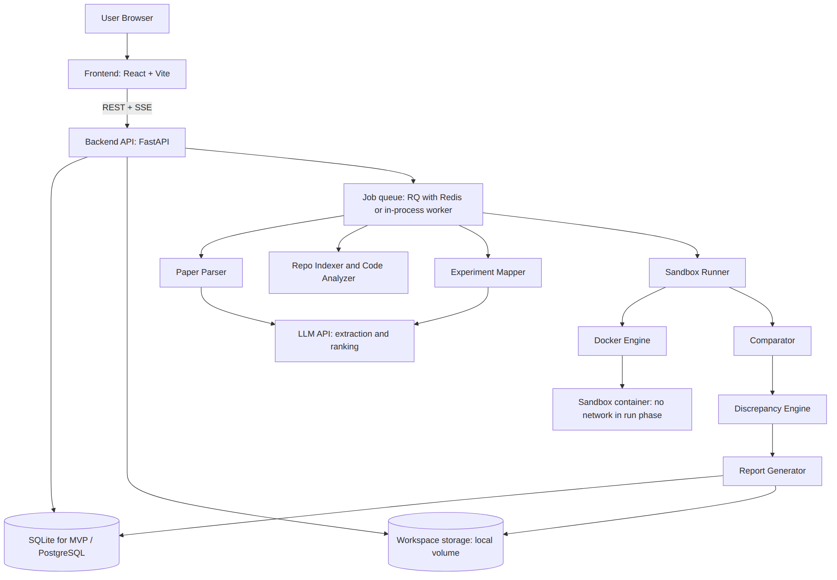

Technology choices and rationale
Area | Choice | Why | Alternative considered
Frontend | React with Vite and a component library; Recharts for charts | Fast to build dashboards, tables and diff views; no server-side rendering needed for a demo | Next.js (more setup than needed for MVP)
Backend | Python 3.11 with FastAPI | Same language as ML tooling and repository analysis; typed request models; automatic OpenAPI docs | Flask, Django
Background jobs | RQ with Redis, or a simple in-process worker thread for the MVP | Executions take minutes; API must stay responsive | Celery (heavier), plain threads
Live progress | Server-Sent Events | One-way progress stream is enough; simpler than WebSockets | WebSockets, polling
Database | SQLite for MVP, PostgreSQL for deployment (via SQLAlchemy) | Zero-setup demo; same schema migrates | Postgres only
File storage | Local volume per project (workspaces/{project_id}) | Hackathon scale; no cloud dependency | S3-compatible object storage later
PDF extraction | PyMuPDF for text with coordinates; pdfplumber for tables | Page and bounding-box provenance is required for evidence | GROBID (more structured but heavier service; optional extension)
LLM extraction | Hosted LLM API with JSON-schema outputs | Papers are heterogeneous; rules alone are brittle | Local small model (weaker on this task; CPU-bound)
Semantic matching | Lexical (BM25/TF-IDF) first; optional small sentence-embedding model on CPU | Cheap and explainable; embeddings only as booster | LLM-only matching (opaque, costly)
Repo access | git clone --depth 1 with size limits; GitHub API only for metadata | Shallow clone is fast; API unnecessary for most data | Full clone
Static analysis | Python ast module; tomllib, YAML and JSON parsers; nbformat for notebooks | Deterministic and explainable for Python repositories | tree-sitter for multi-language (future)
Execution | Docker containers via Docker SDK for Python | Mature isolation primitives, resource flags, reproducible images | Plain subprocess (weaker isolation), Firecracker/gVisor (stronger, more setup)
Numerics | numpy, pandas, scipy | Deviation and interval calculations | None needed
Report | Jinja2 to HTML; WeasyPrint for PDF; JSON as canonical export | Machine-readable plus human-readable | LaTeX (heavier)
Not selected for MVP, on purpose: Kubernetes, vector database, GPU orchestration, multi-agent frameworks. They add complexity without helping the demonstrated chain.

Component interaction (sequence)
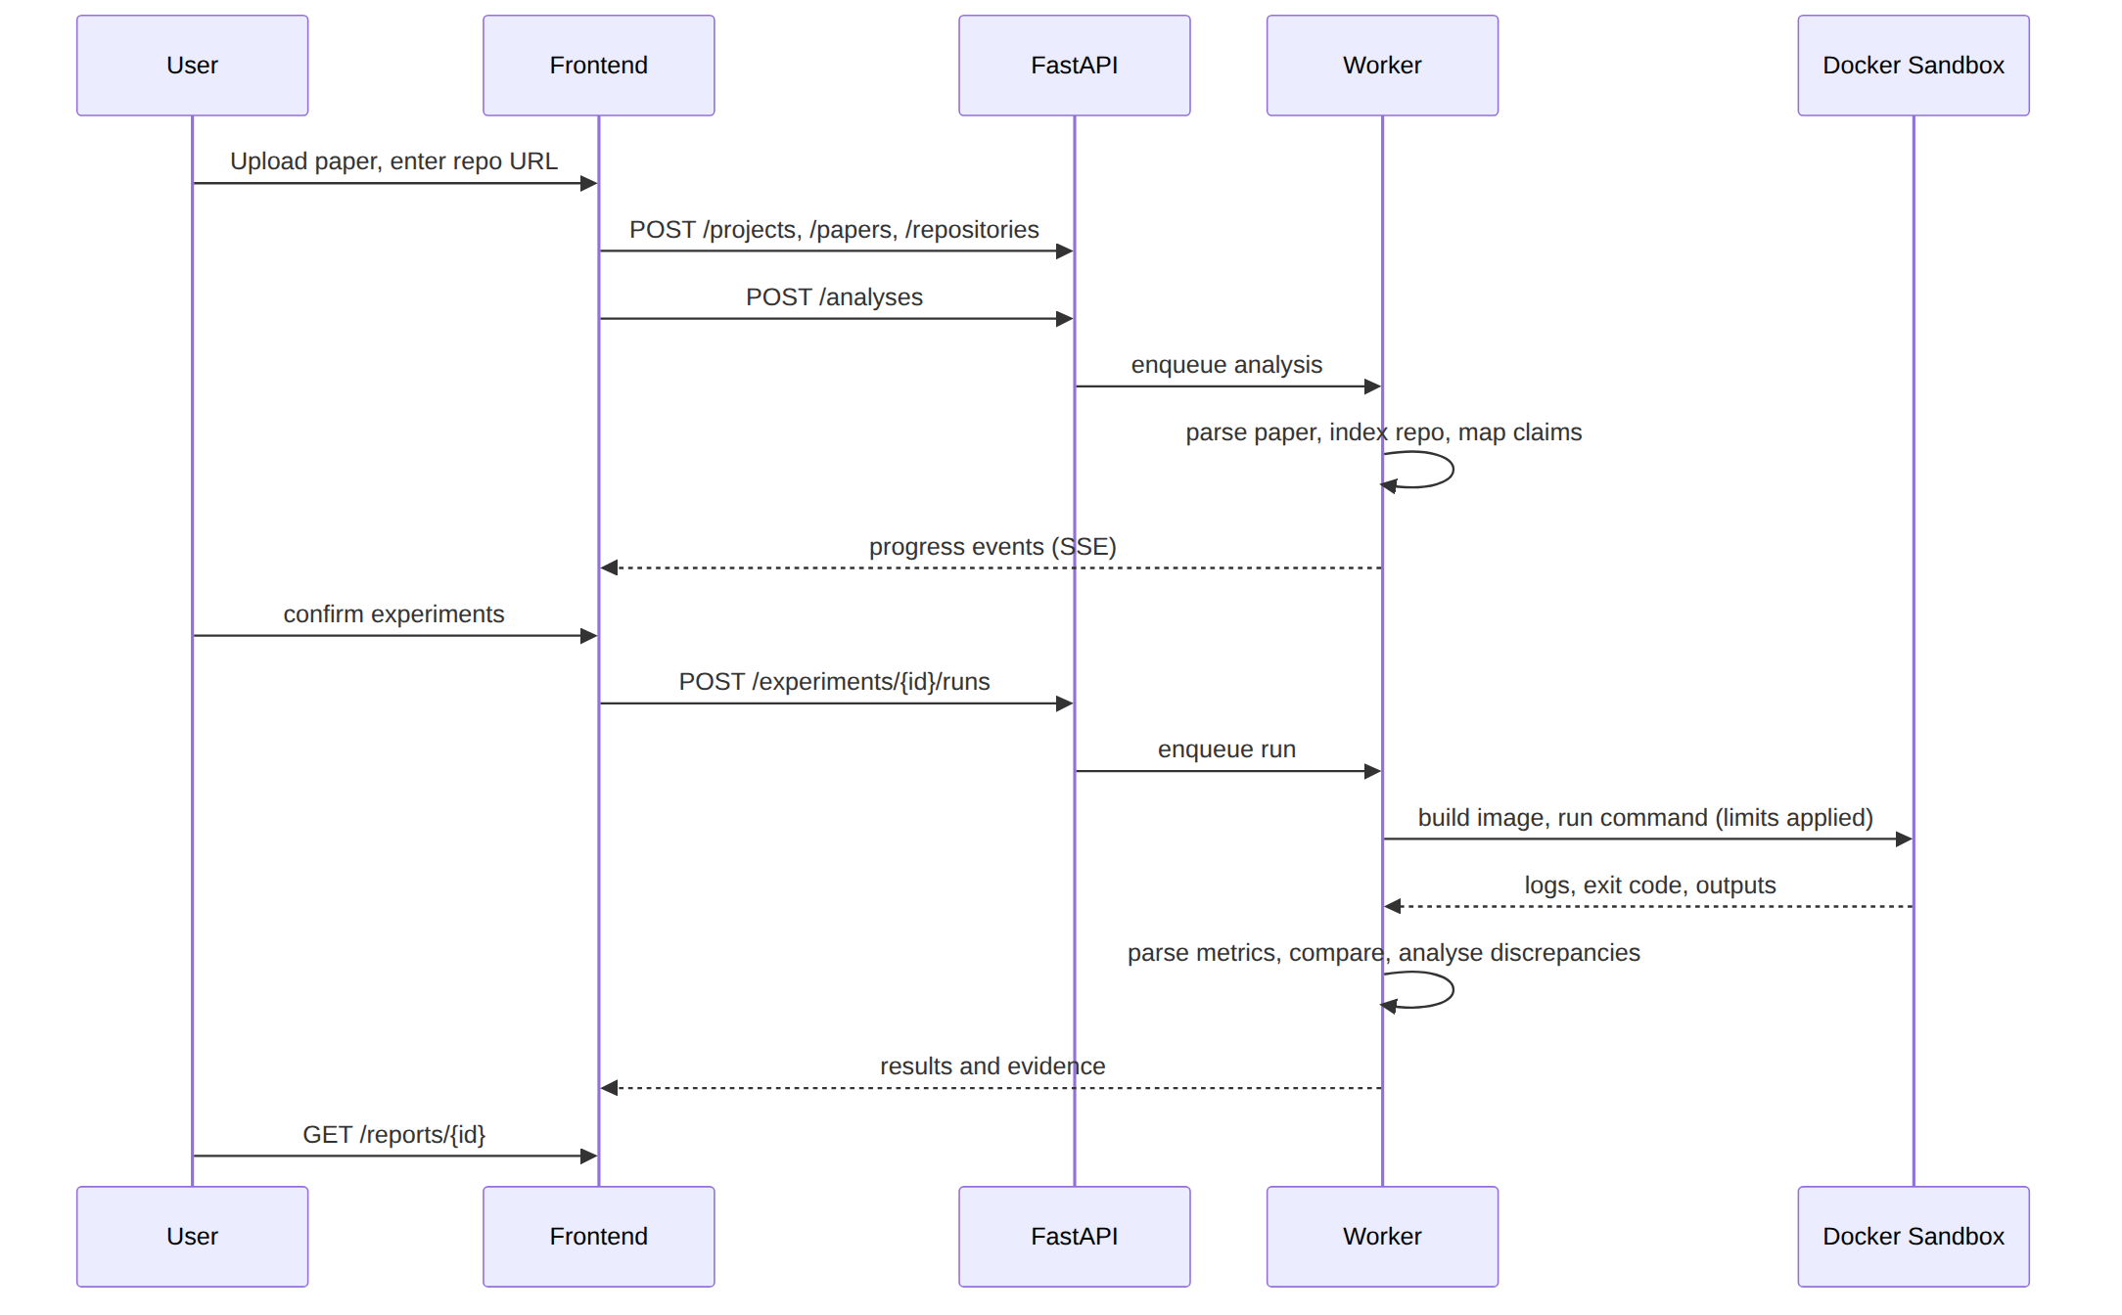

Deployment architecture
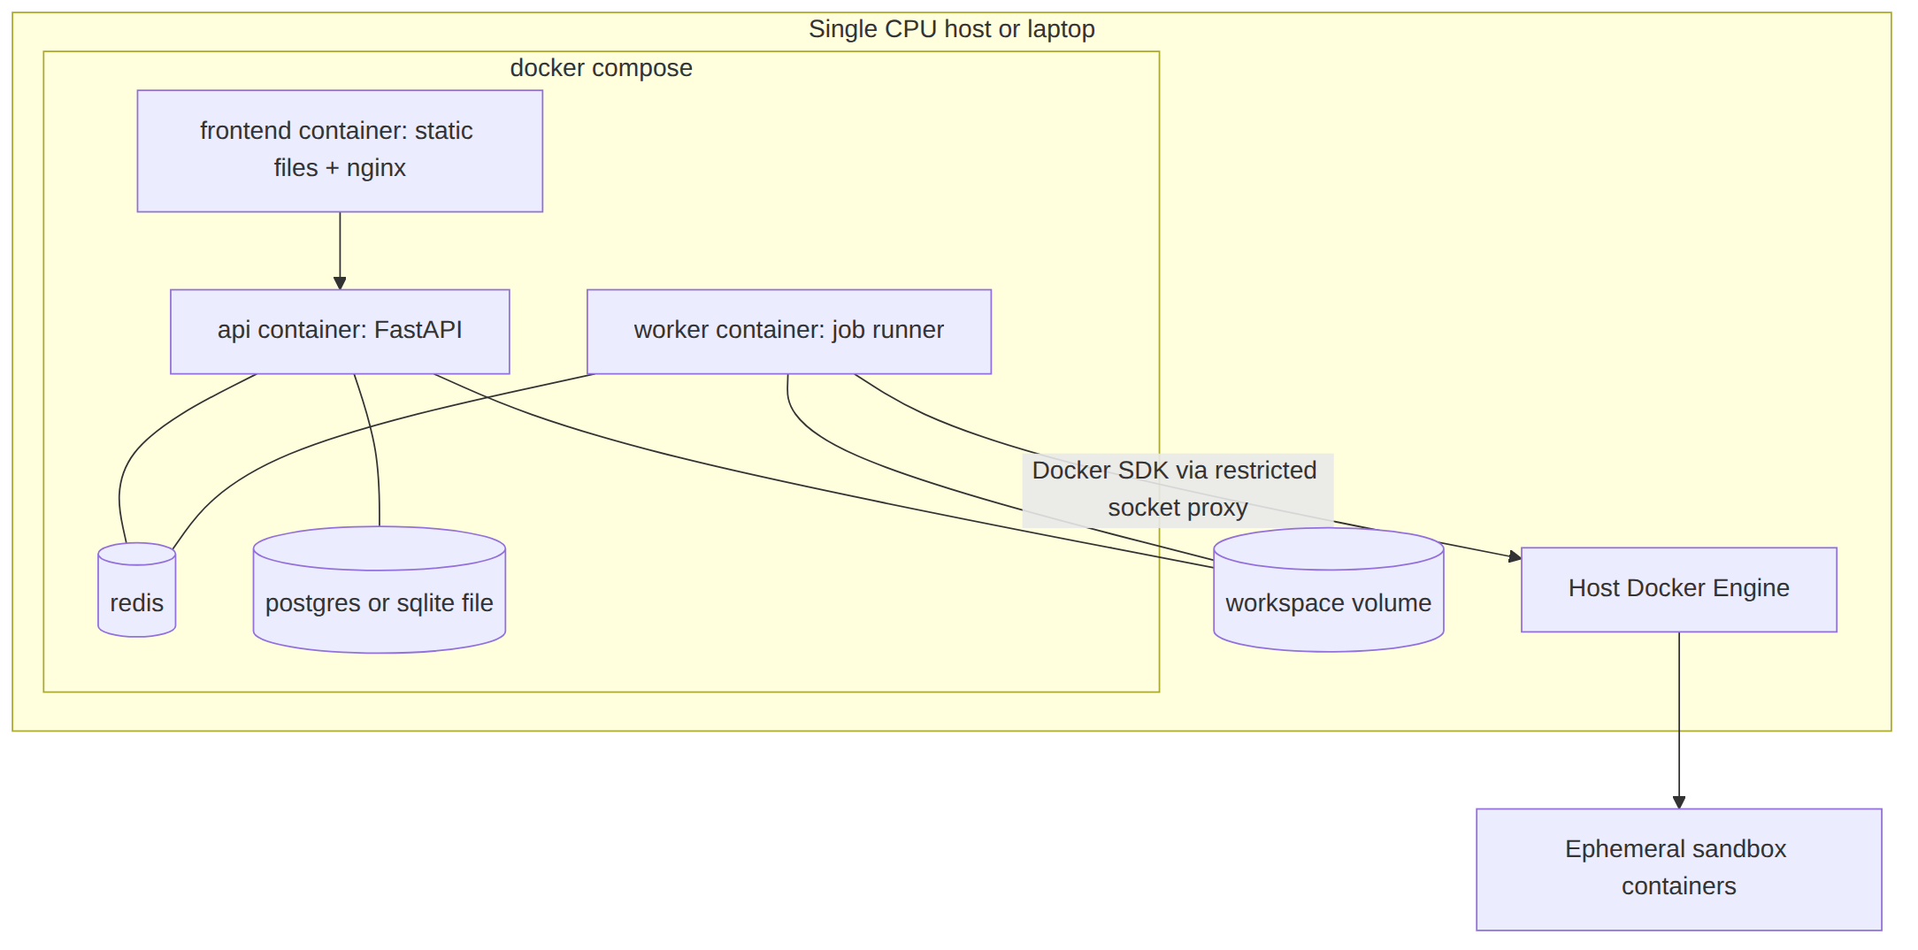
Note on the Docker socket: giving the worker access to the Docker socket is equivalent to root on the host. For the MVP, run on a dedicated machine or VM, expose Docker through a restricted proxy, and treat this as a known risk (see 15-security.md).

Data and artifact layout
workspaces/{project_id}/
paper/paper.pdf
paper/extracted/{text.json, tables.json}
repo/ # shallow clone, read-only mount into sandbox
runs/{run_id}/
command.json # exact command and environment
stdout.log, stderr.log
resource.json # CPU time, peak memory, wall clock
outputs/ # files produced by the experiment
env/{pip_freeze.txt, system.json}
report/{report.json, report.html, report.pdf}

Failure containment
- Each pipeline stage records status and a machine-readable failure reason.
- A failed stage never aborts the whole analysis: downstream stages mark affected experiments as “not executable” or “insufficient evidence” with the reason.
- All LLM calls are logged (prompt hash, model name, output) so interpretations can be audited.

11. Detailed Workflow
The PS-aligned 15 steps are kept and improved: we add Step 0 (validation) and split mapping and environment checks so failures are attributable.
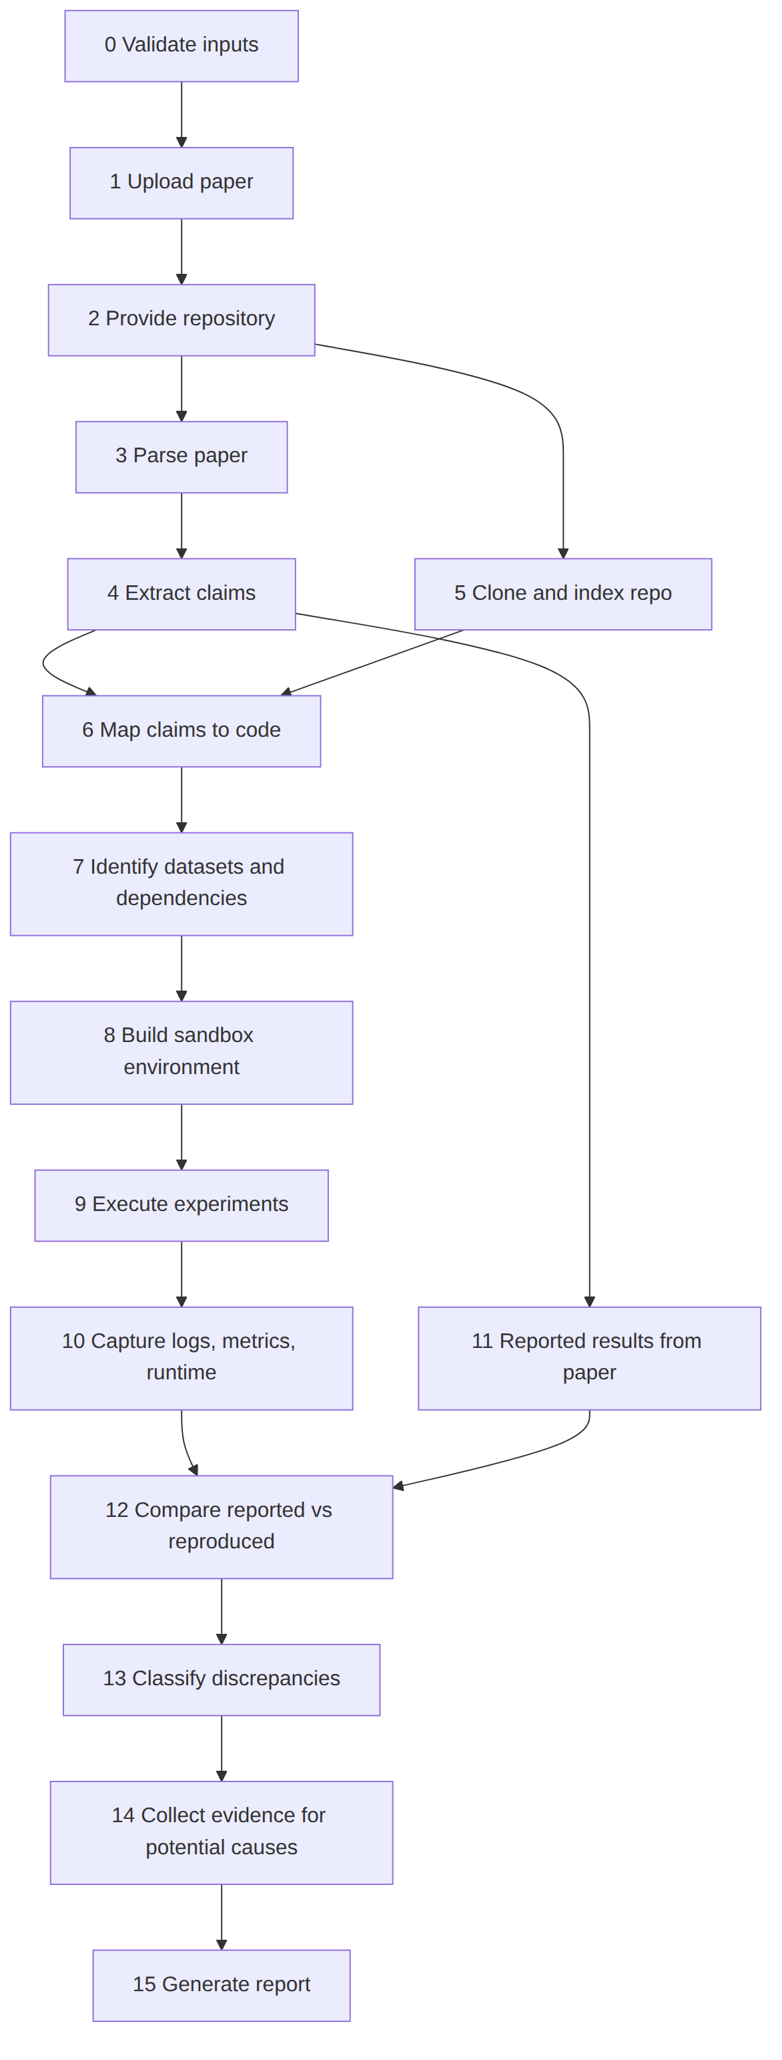

Step table
# | Step | Input | Processing | Output | Technologies | Possible failures
0 | Validate inputs | PDF, repo URL | Check file type/size, URL scheme and host allow-list, repo size via shallow clone | Accepted job or rejection reason | FastAPI validators | Encrypted/huge PDF; private repo; oversized repo
1 | Upload paper | PDF or arXiv ID | Store file, hash it | Paper record with SHA-256 | FastAPI, local storage | Corrupt PDF
2 | Provide repository | Git URL or ZIP | Record URL and commit SHA for pinning | Repository record | git | Repo deleted, rate limits
3 | Parse paper | PDF | Text with page/bbox, section tree, tables | text.json, tables.json | PyMuPDF, pdfplumber | Scanned PDF (no text layer), mangled tables, two-column order errors
4 | Extract claims | Parsed paper | LLM extracts structured claims; each field must include a quoted source span; verbatim check against text | Draft Experiment records | LLM with JSON schema | Hallucinated fields; missed tables; unit/metric ambiguity
5 | Clone and index repo | Repo URL, SHA | Shallow clone; file inventory; parse README, configs, requirements, Makefile, notebooks | Code inventory | git, ast, YAML/TOML parsers | Non-Python repo; submodules; LFS data
6 | Map claims to code | Claims, inventory | Candidate generation then ranking (see 07-experiment-mapping.md) | Ranked mappings with confidence | BM25, optional embeddings, LLM re-rank | No candidate; several plausible scripts
7 | Datasets and dependencies | Mapped code | Detect dataset loaders, download URLs, local paths; resolve dependency files | Dataset and dependency report | ast, regex, pip resolver | Dead URLs; unpinned deps; system libraries needed
8 | Build environment | Dependency list, base image | Build image; install in setup phase; save pip freeze | Image digest, version manifest | Docker SDK | Build failure; incompatible versions; GPU-only wheels
9 | Execute experiments | Command, image | Run with CPU/mem/time/pid limits, no network in run phase; N seeds when feasible | Run records | Docker | Timeout; OOM; missing data; interactive prompts
10 | Capture outputs | Run record | Store logs, resource use, produced files; parse metrics (JSON/CSV/regex) | Reproduced results | Python parsers | Metric not printed; ambiguous multiple values
11 | Reported results | Claims | Normalise numbers, units, bounds, std/CI | ReportedResult rows | pandas | Percent vs fraction confusion
12 | Compare | Reported, reproduced | Deviation arithmetic; tolerance policy | Comparison rows | numpy | Different metric definitions
13 | Classify discrepancies | Comparisons, run status | Assign one of five outcomes | Outcome per experiment | Rules engine | Insufficient information
14 | Collect evidence | Everything above | Run rule checks per candidate cause; attach E1/E2 items | Evidence graph, potential causes with strength | Rules, diff tools | False leads; coincidental mismatches
15 | Report | All records | Assemble report; narrative restricted to cited evidence | HTML/PDF/JSON | Jinja2, WeasyPrint | Report too long; unsupported narrative (blocked by citation check)

Cross-cutting rules
- Pinning: store paper hash, repo commit SHA, image digest. Re-running the same analysis must be possible.
- Idempotent stages: each stage can be re-run without redoing earlier ones.
- Human checkpoints: after Step 4 (claims) and Step 6 (mappings).
- Time budget: the user sets total budget; the scheduler runs experiments in priority order (main-table claims first).

12. Core Modules
The platform is organised into the modules below. Responsibilities, determinism and failure behaviour are defined in Sections 9 to 11.
Module | Responsibility | Deterministic or LLM-assisted
Paper parser | PDF to text, sections and tables with page coordinates | Deterministic
Claim extractor | Structured experimental claims with verbatim-verified spans | LLM-assisted, validated
Repository indexer | File inventory, entry points, requirements, configs, README commands | Deterministic
Code analyzer | AST findings: CLI arguments, config keys, seeds, loaders, metrics | Deterministic
Experiment mapper | Ranked claim-to-code mappings with sub-scores and confidence | Hybrid; human-confirmed
Environment builder | Dependency resolution, image build, version manifest | Deterministic
Sandbox runner | Resource-limited execution, log and resource capture | Deterministic
Metric extractor | Parsing reproduced metrics from logs and outputs | Deterministic first
Comparator | Deviation arithmetic and outcome classification | Deterministic
Discrepancy engine | Rule-based checks producing evidence for potential causes | Deterministic checks
Report generator | Evidence-linked report in HTML/PDF/JSON | Template-based; narrative constrained to cited evidence

13. Experiment Mapping
This is the most important and least solved module. The design therefore favours explainable signals and a human confirmation step over a fully autonomous mapping.

Paper-side extraction
Source | Technique | Output
Experiment sections (“Experiments”, “Evaluation”, appendices) | Section-tree segmentation from PDF headings and font sizes | Text blocks with page numbers
Result tables | pdfplumber table detection; LLM-assisted header repair; verify every number appears in the extracted text | Cells with row/column labels and bounding boxes
Setup details | LLM extraction restricted to a JSON schema; every field requires a quoted span | Dataset, preprocessing, model, hyperparameters, metric
Supplementary material | Optional second PDF/appendix upload | More hyperparameters
Validation rule: a field is accepted as E2 only if its quoted span occurs verbatim (after whitespace normalisation) in the parsed text. Otherwise it is kept as E3 and highlighted for user review.

Repository-side indexing
Signal | Technique
Entry points | Files with if __name__ == "__main__", scripts under scripts/, Makefile targets, README code blocks, dvc.yaml stages, MLproject entries
CLI parameters | AST detection of argparse/click/typer arguments and defaults
Config files | YAML/JSON/TOML/INI parsing; flatten keys
Datasets | Loader calls (torchvision.datasets, sklearn.datasets, pd.read_csv), download URLs, local paths
Models | Class definitions and constructor arguments; estimator names
Metrics | Calls such as accuracy_score, f1_score, custom evaluate functions; printed metric names
Seeds | random.seed, np.random.seed, torch.manual_seed, random_state=
Notebooks | nbformat cell order, outputs

Candidate generation and scoring
For each claim, score every entry-point candidate with an explainable weighted sum of sub-signals in [0, 1]:
Signal | Description | Default weight (assumption)
Dataset-name match | Claim dataset appears in loader/config/path (normalised, alias list) | 0.25
Model-name match | Model/estimator/class names match | 0.20
Metric match | Metric function or printed key matches | 0.15
Hyperparameter overlap | Fraction of paper hyperparameters found with equal values in config/code/CLI | 0.20
Textual similarity | BM25 between claim text and README/docstrings/script names | 0.10
Structural hint | README or Makefile explicitly cites the table/figure/section | 0.10
An optional embedding similarity may replace the textual similarity term. Every sub-score is stored, so the UI can show why a mapping was proposed.
An LLM then re-ranks the top k (for example 5) candidates, but must cite which sub-signals or code lines it relies on. If its choice contradicts the top-scored candidate, both are shown and the mapping is flagged “needs confirmation”.

Confidence and thresholds
Confidence | Rule (assumption)
High | Score >= 0.7 and runner-up margin >= 0.15
Medium | 0.4 to 0.7 or small margin
Low | < 0.4; the UI asks the user to choose or give a command
Thresholds are initial guesses and must be tuned on the labelled demo set (see 16-evaluation.md).

Execution command derivation
- Prefer a command shown in README/Makefile/CI config that targets the mapped script.
- Otherwise build python <script> --arg value from detected CLI arguments, setting values from the claim’s hyperparameters where names match; mark as inferred (E2).
- If values cannot be set (hard-coded in code), run with defaults and record a hyperparameter mismatch finding when defaults differ from the paper.
- Never modify repository source in the MVP. Overrides happen via CLI/config only, and every override is logged.

Mapping flow diagram
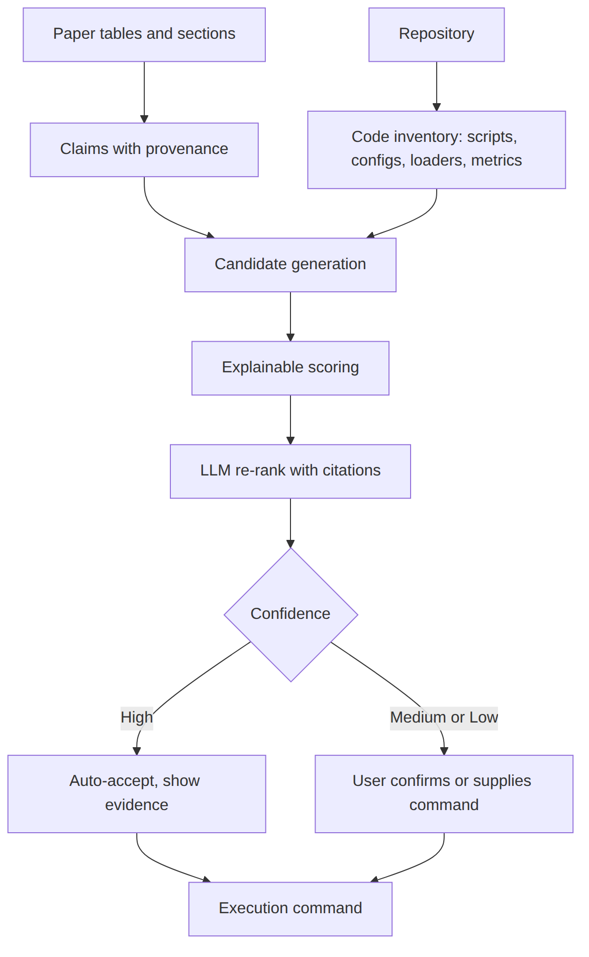

Structured representation
Improved over the PS-suggested skeleton: separate claims, mappings, runs and comparisons, because one claim can have several candidate mappings and several runs.
{
"experiment_id": "EXP-003",
"claim": {
"text": "Random Forest reaches 0.873 test accuracy on <dataset>",
"source": {"paper_sha256": "...", "page": 6, "table": "Table 3", "row": "RandomForest", "col": "Accuracy", "bbox": [72, 310, 410, 326]},
"quoted_span_verified": true
},
"setup": {
"dataset": {"name": "...", "split": "train/test as released", "evidence": ["EV-11"]},
"preprocessing": ["..."],
"model": {"name": "RandomForestClassifier", "hyperparameters": {"n_estimators": 100, "max_depth": 10}},
"training_procedure": "...",
"metric": {"name": "accuracy", "higher_is_better": true},
"seeds_reported": null
},
"reported_result": {"value": 0.873, "unit": "fraction", "std": null, "n_runs_reported": null},
"mappings": [
{"mapping_id": "MAP-1", "files": ["benchmark/runner.py"], "functions": ["run_experiment"],
"configs": [], "command": "python ...", "command_origin": "readme|inferred|user",
"score": 0.78, "subscores": {"dataset": 1.0, "model": 1.0, "metric": 1.0, "hyper": 0.5},
"confidence": "high", "confirmed_by_user": false}
],
"runs": [
{"run_id": "RUN-1", "seed": 0, "status": "completed", "exit_code": 0, "wall_s": 41.2,
"image_digest": "sha256:...", "metric_value": 0.869, "log_evidence": "EV-31"}
],
"comparison": {"abs_diff": -0.004, "rel_dev_pct": -0.46, "within_reported_interval": null,
"outcome": "near_exact"},
"discrepancies": [],
"missing_information": ["random seed not stated in paper"],
"evidence": [{"id": "EV-31", "tier": "E1", "kind": "log_line", "ref": "runs/RUN-1/stdout.log:118"}]
}

Evidence linking
Every extracted field, mapping and finding carries one or more evidence_ids. Evidence kinds: paper_span, table_cell, file_range, ast_finding, config_key, log_line, package_version, hash, resource_stat, llm_note (always E3).

14. Execution Environment
Repository code is untrusted, so execution happens inside Docker containers created per run. The run is split into two phases.
Phase | Purpose | Network | Writable locations
Setup | Install dependencies and fetch allowed datasets | Allow-list through a proxy (package index and approved data hosts only) | Image layers, build cache
Run | Execute the mapped command | None | tmpfs for temporary files and one output volume; repository mounted read-only
Default resource profile (team assumption, configurable): 2 CPUs, 4 GB memory with swap equal to memory, 256 processes, a per-experiment wall-clock limit (default 15 minutes), non-root user, all Linux capabilities dropped, no-new-privileges. The environment record stores the image digest, operating system, CPU model, Python version, the full pip freeze, limits, and the exact command, so that each result can be re-run and so that environment differences can be reported as evidence.
If a full experiment cannot fit the budget, a reduced variant may be run only with explicit user consent, and the result is labelled partial by design. Detailed threats and controls are in Section 21.

15. Result Comparison

Outcome categories
Outcome | Definition (team assumption, thresholds configurable)
Exact / near-exact reproduction | Run completed; reproduced value within tolerance tau_near of reported value, or inside the paper’s reported interval
Partial reproduction | Run completed but only part of the claim is matched: deviation between tau_near and tau_partial; or some rows/metrics of a table matched and others did not; or an agreed reduced variant was run
Significant deviation | Run completed; deviation beyond tau_partial, and variance evidence (if any) does not explain it
Not executable | No valid result: build failure, missing data/code, timeout, GPU-only, crash
Insufficient evidence | Cannot decide: mapping low-confidence, metric ambiguous, single run on a high-variance method, or reported value unparseable
Default tolerances (our assumption, not a standard): tau_near = 1% relative deviation, tau_partial = 5%; for bounded metrics also report percentage points. For metrics where relative deviation is misleading (reported value near 0, signed metrics, rank metrics) the system uses absolute difference and says so. These defaults must be tuned per metric on the demo set.

Comparison logic
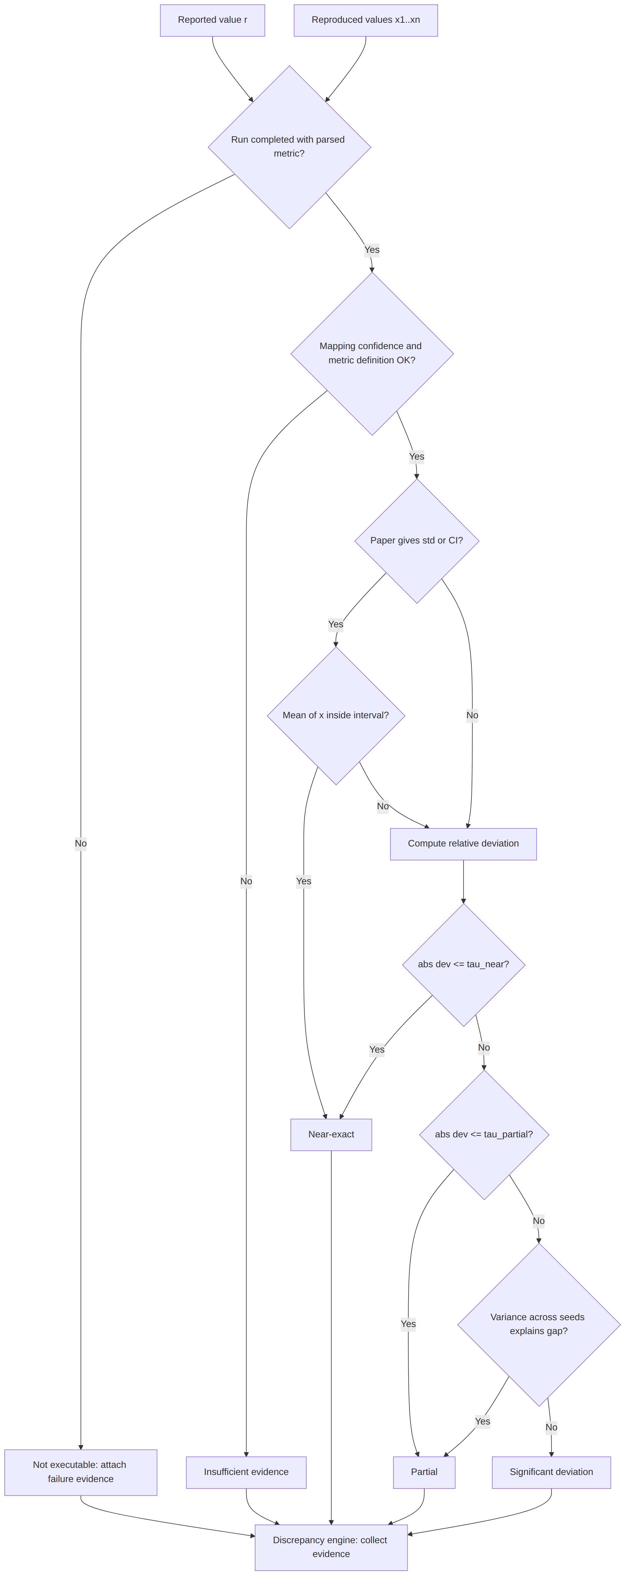
Calculations:
- delta_pct = 100 * (x_mean - r) / |r|, defined only for r != 0.
- With n >= 3 seeds: report x_mean, sample standard deviation s, and whether r lies within x_mean +/- 2*s/sqrt(n) (a rough check, not a formal hypothesis test; the report must say “rough”). If the paper reports its own std, also report overlap of intervals.
- With n = 1: no variance claim is made.

16. Discrepancy Analysis

Cause investigation
The engine runs checks, each returning zero or more evidence items. A cause is listed only if at least one check produced E1 or E2 evidence. Wording is always “Potential cause supported by evidence”, with a strength label.
Candidate cause | Checks (examples) | Typical evidence
Different dataset | Dataset hash/size/row count vs. paper-stated size; class counts | hash, config_key, paper_span
Dataset unavailable | Download URL status in setup phase; missing local path | log_line (HTTP error), file_range
Different preprocessing | Paper preprocessing terms vs. calls in code (normalisation, resizing, tokenisation) | ast_finding vs paper_span
Missing hyperparameters | Paper-stated hyperparameters absent in config/CLI; values hard-coded | config_key, ast_finding
Different random seed | Seed unset, or paper seeds absent; variance across our seeds | ast_finding, multi-run stats
Dependency/version mismatch | Paper/README versions vs. installed; unpinned packages; library default changes | package_version, file_range
Hardware limitations | CPU-only reduced run; thread count; GPU-specific code | resource_stat, ast_finding (.cuda(), device="cuda")
Repository-code mismatch | README commands that fail; scripts not producing the reported metric | log_line, file_range
Paper-repository inconsistency | Paper value for a hyperparameter differs from repo default | paper_span + config_key
Missing files | Imports/paths that do not exist at the pinned commit | ast_finding, log_line
Broken implementation | Stack traces originating in repo code | log_line
Computational limitations | Timeout, OOM, reduced epochs/subset | resource_stat, command.json
Ambiguous methodology | Claim fields lacking verified spans; several equally plausible mappings | low mapping confidence
Non-deterministic behaviour | Variance across seeds large relative to the gap; multi-threaded or GPU ops | multi-run stats

Strength labels
Strength | Meaning
Strong | At least one E1 evidence item directly shows the factor (for example a failing download in the log, or a measured seed variance larger than the gap)
Moderate | E2 evidence shows the factor exists, but a link to the size of the deviation is not demonstrated
Weak | Only E3 interpretation or circumstantial
The engine never states causality. It ranks potential causes and lists what would settle the matter (for example “rerun with the paper’s stated seed list”, “provide the original split file”).

Controlled ablation checks (optional, MVP “should have”)
Where a candidate cause can be tested cheaply on CPU, the engine can run a one-factor-at-a-time check, for example running with a different seed set to estimate variance, or setting a hyperparameter to the paper’s value when the code default differs. Results are labelled as follow-up experiments, with their own run records.

Handling missing, ambiguous and inconsistent information
Class | Detection | Report wording
Missing | Required field (seed, split, preprocessing) not found in paper or repo | “Not stated in paper or repository”
Ambiguous | Multiple values/mappings; vague phrases | “Ambiguous: candidates are …”
Inconsistent | Paper and code values differ | “Paper states A (p. N); code uses B (file:line)”
Implementation-specific | Behaviour depends on library defaults or hardware | “Depends on library default in version X”

17. Reproducibility Assessment

Report structure
- Paper information
- Repository information (URL, commit SHA)
- Environment information (image digest, OS, CPU, Python and package versions, limits)
- Experiments identified
- Experiments reproduced (near-exact)
- Experiments partially reproduced
- Experiments not reproducible (not executable / significant deviation)
- Paper-reported metrics
- Reproduced metrics
- Differences (absolute; percentage where mathematically appropriate)
- Evidence (with tier badges)
- Missing information
- Potential explanations (strength-labelled)
- Confidence / strength of evidence
- Overall reproducibility assessment (verdict counts plus narrative; readiness and execution scores with breakdown)
A machine-readable report.json mirrors this structure; HTML/PDF are rendered from it.

Example report
HYPOTHETICAL EXAMPLE. The paper, repository, numbers, logs and file names below are invented to illustrate the format. They do not describe any real research.

Reproducibility Assessment: “TinyTab: A Small Gradient-Boosted Baseline for Tabular Classification” (hypothetical paper)

Paper information
Field | Value
Title | TinyTab (hypothetical)
Authors | Example Authors (hypothetical)
Paper SHA-256 | 3f1a...e9 (illustrative)
Experiments identified | 4 (Table 2 rows A to D)

Repository information
Field | Value
URL | https://example.invalid/tinytab (hypothetical, does not exist)
Commit | a1b2c3d (illustrative)
License | MIT (hypothetical)

Environment
Python 3.11, scikit-learn 1.4.2 (illustrative); paper does not state versions (E1: no version string found in paper text). 2 vCPU, 4 GB RAM, 20 min per experiment, network disabled during run.

4-7. Experiments and outcomes
ID | Claim (paper Table 2) | Reported | Reproduced (3 seeds, mean +/- sd) | Abs. diff | Rel. dev. | Outcome
EXP-A | Accuracy, dataset X, TinyTab | 0.872 | 0.869 +/- 0.003 | -0.003 | -0.34% | Near-exact
EXP-B | Accuracy, dataset X, baseline LR | 0.801 | 0.790 +/- 0.001 | -0.011 | -1.37% | Partial
EXP-C | Accuracy, dataset Y, TinyTab | 0.915 | 0.861 +/- 0.004 | -0.054 | -5.90% | Significant deviation
EXP-D | Accuracy, dataset Z, TinyTab | 0.934 | no result | n/a | n/a | Not executable
Verdict counts: 1 near-exact, 1 partial, 1 significant deviation, 1 not executable, 0 insufficient evidence.

11-13. Evidence and potential explanations
EXP-B (Partial) - Potential cause, Moderate: logistic regression default max_iter and solver differ between library versions (E2: version pinned in our image is 1.4.2; paper gives no version [E1: absence in text]). Settling check: rerun with versions from requirements.txt if the authors provide one. - Evidence: EV-07 (config.yaml has no C value; paper p.5 states C = 1.0, E1 text span).
EXP-C (Significant deviation) - Potential cause, Strong: hyperparameter inconsistency. Paper p.5 states n_estimators = 500 (E1 span); configs/dataset_y.yaml:12 sets n_estimators: 100 (E1 file range). Running the paper value in a follow-up check changed the result to 0.904 +/- 0.003 (E1, run RUN-C2), which narrows but does not close the gap. - Potential cause, Weak: undocumented preprocessing for dataset Y (E3: the paper mentions “standard scaling”; no scaler found in the code path, E2 negative finding with low coverage). - Not claimed: that the paper is wrong. Remaining gap (-1.1 points) is unexplained.
EXP-D (Not executable) - E1: download URL for dataset Z returned HTTP 404 in setup phase (log setup.log:44). - Potential cause, Strong: dataset unavailable at the documented location. We could not test the claim.

Missing information
- No random seeds stated (paper, README).
- No package versions in paper.
- Dataset Z location outdated.

Confidence
Experiment | Evidence strength | Note
EXP-A | High | 3 seeds, mapping confirmed
EXP-B | Medium | Version effect inferred, not tested
EXP-C | Medium | Follow-up run supports cause partially
EXP-D | High (not executable) | Direct 404 evidence

Overall assessment
Readiness score (static): 0.62 (dimension breakdown: code 1.0, environment 0.4, data 0.67, configuration 0.5, documentation 0.6, traceability 0.75) (illustrative numbers). Execution score over executed experiments: 0.54 (illustrative). One of four headline results is reproduced within tolerance, two deviate to different degrees with identified potential causes, and one could not be tested. These results indicate limited computational reproducibility under our CPU environment; they do not establish that the original claims are incorrect.

Report content rules
- Numbers come only from E1 sources (logs, parsed outputs, paper text).
- Narrative sentences must carry evidence ids; a build-time check rejects uncited causal sentences.
- Language: “potential cause supported by evidence”, “not tested”, “unexplained gap”.
- Always print environment and limits so readers can judge comparability.

18. Database Design

ER diagram
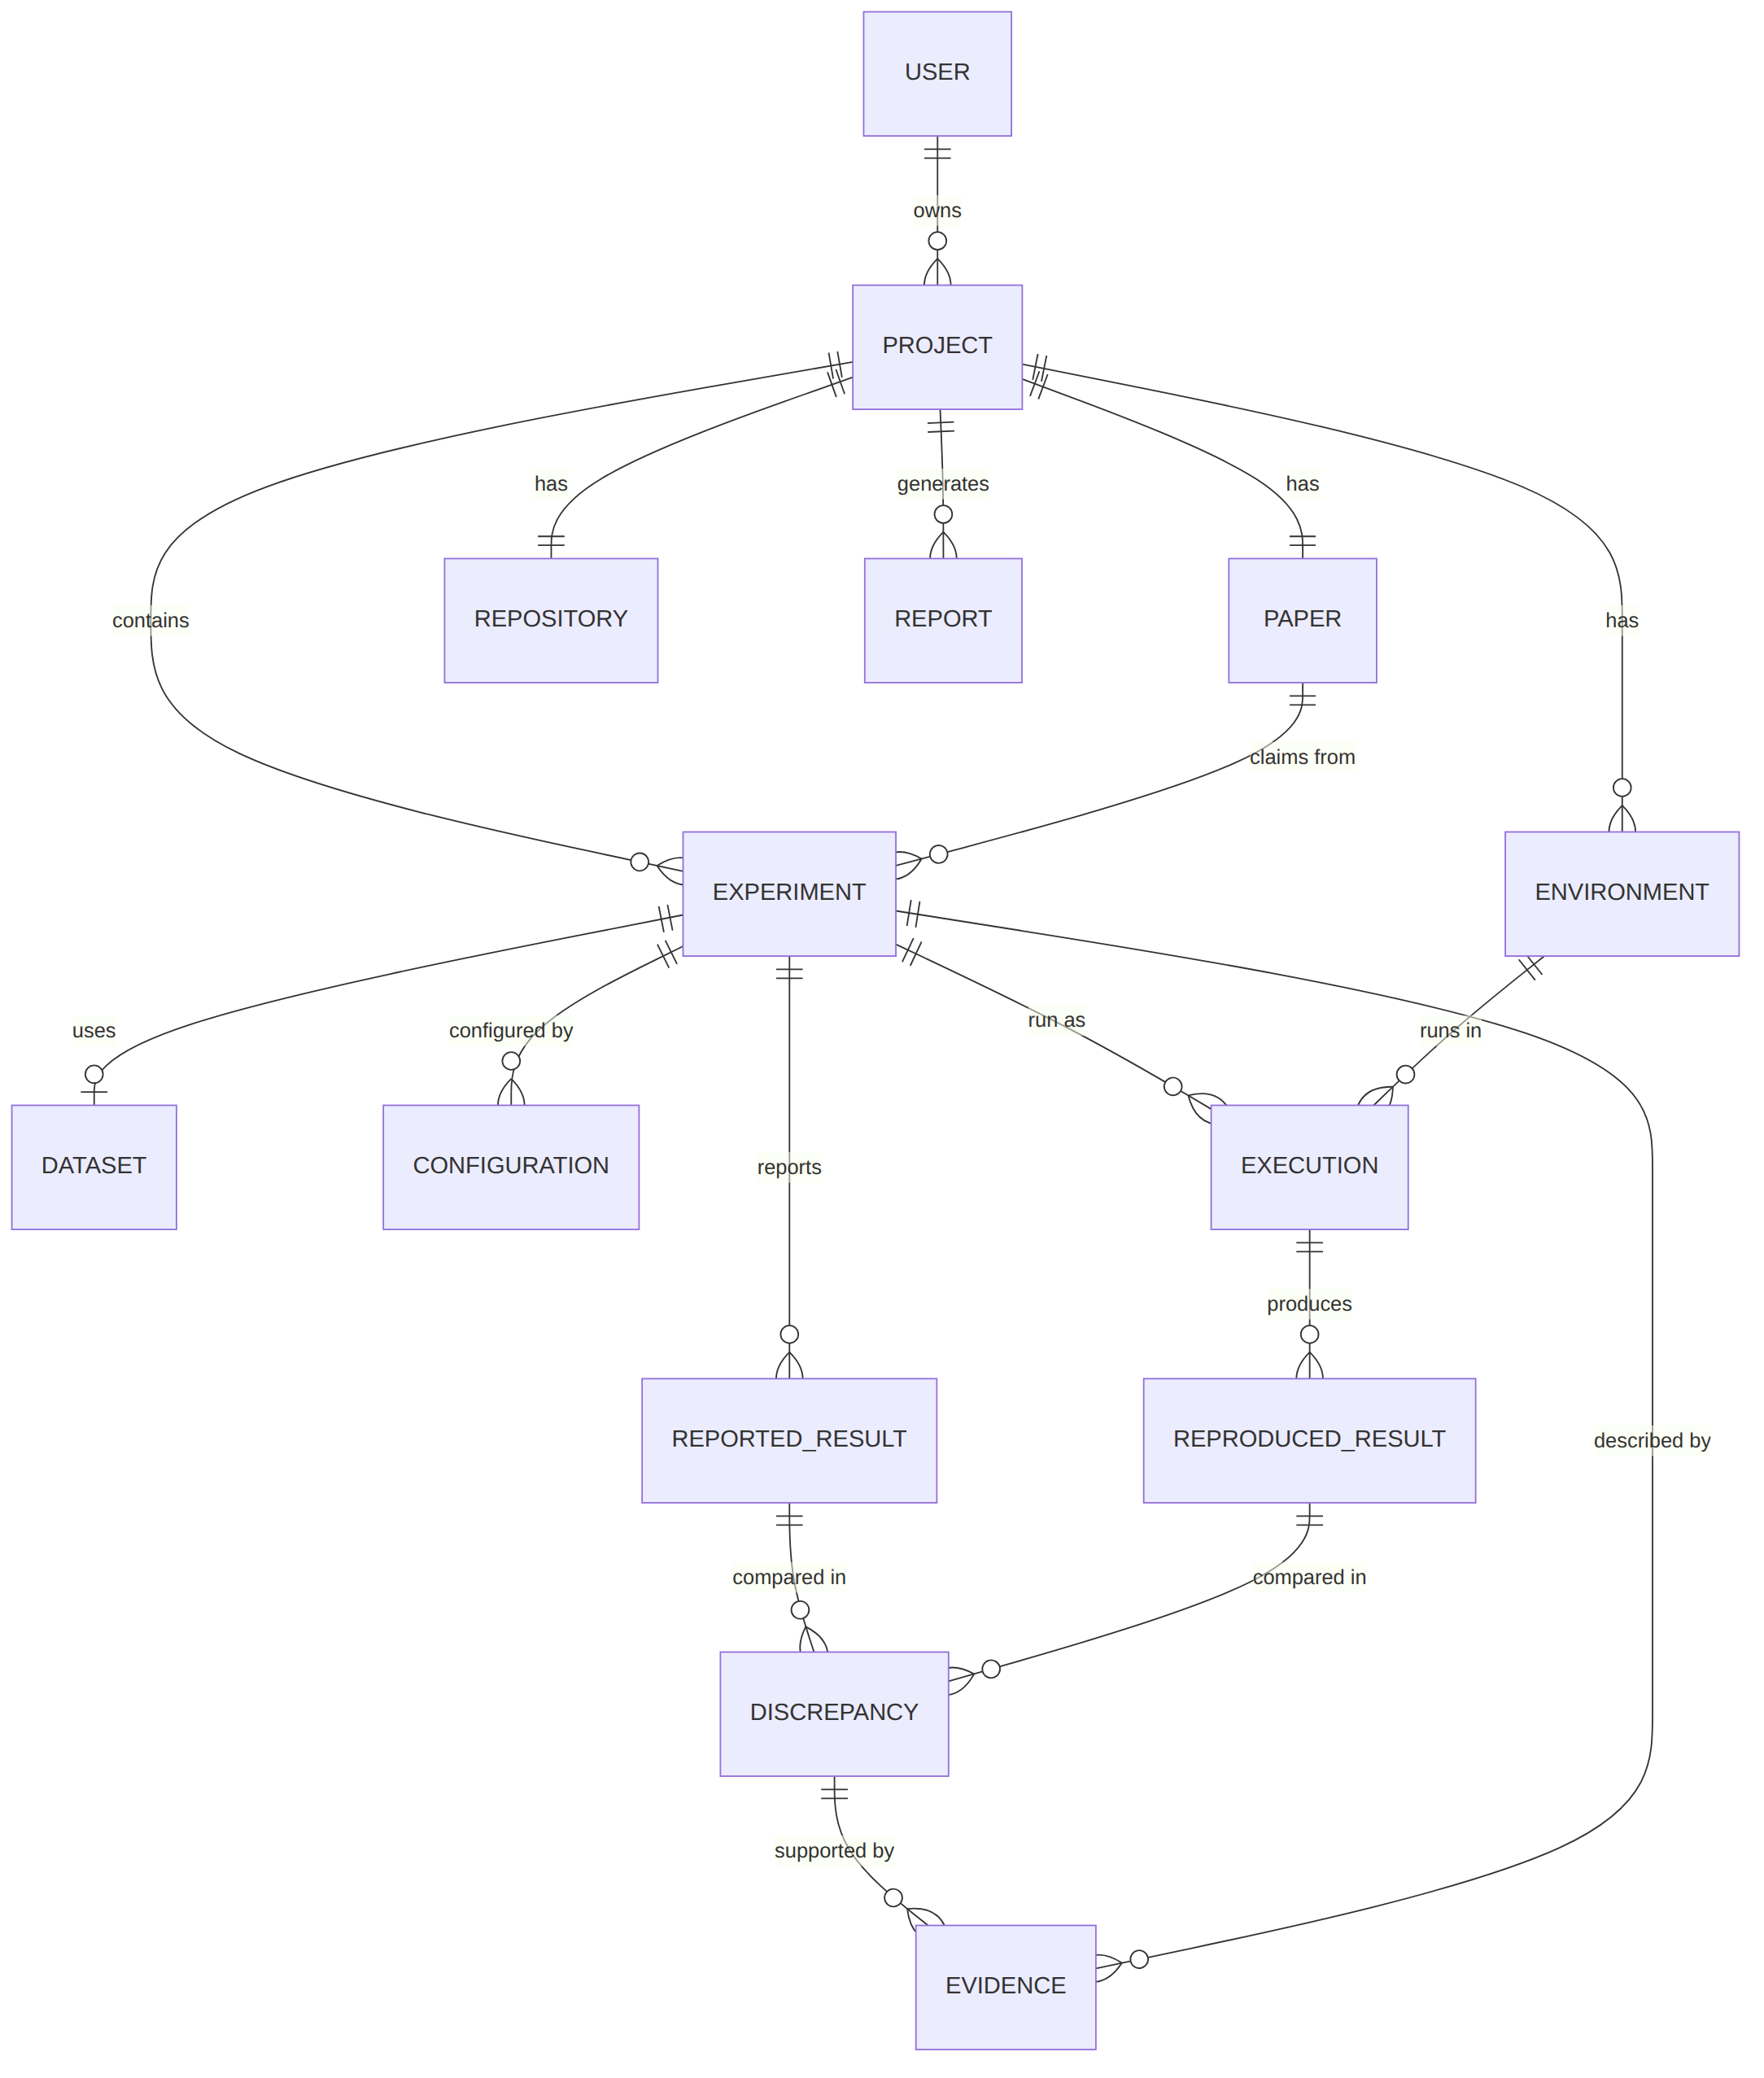

Entity notes
Entity | Purpose
User | Account (optional in MVP; single local user is acceptable)
Project | One paper plus one repository assessment
Paper | PDF metadata, hash, parsed text location
Repository | URL, commit SHA, size, license, inventory JSON
Experiment | One claim with its mapping, status and outcome
Dataset | Name, source, hash, availability status
Configuration | Key-value hyperparameters with origin (paper, config file, CLI, code default)
Environment | Image digest, OS, CPU, Python and package manifest, limits
Execution | One run: command, seed, status, timings, resource use
Metric | Dictionary of metric names and directions
ReportedResult / ReproducedResult | Values with provenance
Discrepancy | Comparison outcome and numeric differences
Evidence | Tiered evidence item referencing artifacts
Report | Rendered report versions

SQL schema (SQLite/PostgreSQL compatible, simplified)
CREATE TABLE users (
id INTEGER PRIMARY KEY, email TEXT UNIQUE NOT NULL, created_at TIMESTAMP NOT NULL
);
CREATE TABLE projects (
id INTEGER PRIMARY KEY, user_id INTEGER REFERENCES users(id),
name TEXT NOT NULL, status TEXT NOT NULL, time_budget_s INTEGER,
created_at TIMESTAMP NOT NULL
);
CREATE TABLE papers (
id INTEGER PRIMARY KEY, project_id INTEGER UNIQUE NOT NULL REFERENCES projects(id),
title TEXT, sha256 TEXT NOT NULL, page_count INTEGER, storage_path TEXT NOT NULL,
parse_status TEXT NOT NULL
);
CREATE TABLE repositories (
id INTEGER PRIMARY KEY, project_id INTEGER UNIQUE NOT NULL REFERENCES projects(id),
url TEXT NOT NULL, commit_sha TEXT NOT NULL, size_bytes INTEGER, license TEXT,
inventory_json TEXT, index_status TEXT NOT NULL
);
CREATE TABLE datasets (
id INTEGER PRIMARY KEY, project_id INTEGER NOT NULL REFERENCES projects(id),
name TEXT NOT NULL, source_url TEXT, sha256 TEXT, availability TEXT NOT NULL
);
CREATE TABLE experiments (
id INTEGER PRIMARY KEY, project_id INTEGER NOT NULL REFERENCES projects(id),
paper_id INTEGER NOT NULL REFERENCES papers(id),
dataset_id INTEGER REFERENCES datasets(id),
claim_text TEXT NOT NULL, page INTEGER, table_ref TEXT, bbox_json TEXT,
model_name TEXT, metric_name TEXT, higher_is_better INTEGER,
preprocessing_json TEXT, training_procedure TEXT,
mapping_json TEXT, mapping_confidence TEXT, command TEXT, command_origin TEXT,
user_confirmed INTEGER NOT NULL DEFAULT 0,
outcome TEXT, selected INTEGER NOT NULL DEFAULT 1
);
CREATE TABLE configurations (
id INTEGER PRIMARY KEY, experiment_id INTEGER NOT NULL REFERENCES experiments(id),
key TEXT NOT NULL, paper_value TEXT, repo_value TEXT, used_value TEXT,
origin TEXT NOT NULL, matches INTEGER
);
CREATE TABLE environments (
id INTEGER PRIMARY KEY, project_id INTEGER NOT NULL REFERENCES projects(id),
image_digest TEXT, os TEXT, cpu_model TEXT, python_version TEXT,
packages_json TEXT, cpu_limit REAL, mem_limit_mb INTEGER, timeout_s INTEGER,
network_policy TEXT
);
CREATE TABLE executions (
id INTEGER PRIMARY KEY, experiment_id INTEGER NOT NULL REFERENCES experiments(id),
environment_id INTEGER NOT NULL REFERENCES environments(id),
seed INTEGER, command_json TEXT NOT NULL, status TEXT NOT NULL,
exit_code INTEGER, wall_s REAL, peak_mem_mb REAL,
stdout_path TEXT, stderr_path TEXT, started_at TIMESTAMP, finished_at TIMESTAMP,
kind TEXT NOT NULL DEFAULT 'primary' -- primary | followup
);
CREATE TABLE reported_results (
id INTEGER PRIMARY KEY, experiment_id INTEGER NOT NULL REFERENCES experiments(id),
metric_name TEXT NOT NULL, value REAL NOT NULL, std REAL, ci_low REAL, ci_high REAL,
unit TEXT, evidence_id INTEGER
);
CREATE TABLE reproduced_results (
id INTEGER PRIMARY KEY, execution_id INTEGER NOT NULL REFERENCES executions(id),
metric_name TEXT NOT NULL, value REAL NOT NULL, evidence_id INTEGER
);
CREATE TABLE discrepancies (
id INTEGER PRIMARY KEY, experiment_id INTEGER NOT NULL REFERENCES experiments(id),
reported_result_id INTEGER REFERENCES reported_results(id),
outcome TEXT NOT NULL, -- near_exact|partial|significant|not_executable|insufficient
abs_diff REAL, rel_dev_pct REAL, n_runs INTEGER, within_interval INTEGER,
tolerance_json TEXT
);
CREATE TABLE evidence (
id INTEGER PRIMARY KEY, project_id INTEGER NOT NULL REFERENCES projects(id),
experiment_id INTEGER REFERENCES experiments(id),
discrepancy_id INTEGER REFERENCES discrepancies(id),
tier TEXT NOT NULL CHECK (tier IN ('E1','E2','E3')),
kind TEXT NOT NULL, ref TEXT NOT NULL, excerpt TEXT, confidence REAL,
cause TEXT, strength TEXT, created_by TEXT NOT NULL -- rule name or model name
);
CREATE TABLE reports (
id INTEGER PRIMARY KEY, project_id INTEGER NOT NULL REFERENCES projects(id),
version INTEGER NOT NULL, json_path TEXT, html_path TEXT, pdf_path TEXT,
readiness_score REAL, execution_score REAL, created_at TIMESTAMP NOT NULL
);
CREATE INDEX idx_exec_exp ON executions(experiment_id);
CREATE INDEX idx_evid_disc ON evidence(discrepancy_id);

Design notes
- evidence.tier is constrained so every evidence row is explicitly typed.
- configurations stores paper, repository and used values side by side: the basis for paper-code inconsistency checks.
- executions.kind separates primary runs from follow-up checks so follow-ups never silently replace primary results.
- Heavy payloads (logs, outputs) live on disk; the database holds paths and hashes.

19. API Design
Base path /api/v1. JSON unless noted. Long operations return 202 Accepted with a resource to poll or an SSE stream. Changes versus the sketch in the brief: analysis and runs are modelled as resources (/analyses, /runs) because they are asynchronous and re-runnable.
Common error body: {"error": {"code": "string", "message": "string", "details": {}}}. Common errors: 400 validation, 401/403 auth (if enabled), 404 not found, 409 conflict (state), 413 too large, 422 schema, 429 rate limit, 500 internal.
# | Method | Endpoint | Purpose
1 | POST | /projects | Create a project
2 | GET | /projects/{id} | Project summary and stage status
3 | POST | /projects/{id}/paper | Upload paper (multipart) or give arXiv ID
4 | POST | /projects/{id}/repository | Register repository URL and ref
5 | POST | /projects/{id}/analyses | Start analysis (parse, claims, index, map)
6 | GET | /analyses/{id} | Status and stage results
7 | GET | /analyses/{id}/events | SSE progress stream
8 | GET | /projects/{id}/experiments | List experiments (claims plus mappings)
9 | PATCH | /experiments/{id} | Edit claim fields, confirm mapping, set command, select/deselect
10 | POST | /experiments/{id}/runs | Start run(s) (seeds, budget, kind)
11 | GET | /runs/{id} | Run status, resource use, results
12 | GET | /runs/{id}/logs | Logs (supports ?follow=true SSE)
13 | GET | /projects/{id}/results | Reported vs reproduced comparison
14 | GET | /experiments/{id}/discrepancy | Outcome, causes, evidence
15 | GET | /evidence/{id} | Evidence item with source excerpt
16 | POST | /projects/{id}/reports | Generate report
17 | GET | /reports/{id} | Report JSON; ?format=html|pdf for rendered
18 | PUT | /projects/{id}/tolerance | Set tolerance policy (recomputes outcomes)

Details

POST /projects
Request: {"name": "Fashion-MNIST check"} Response 201: {"id": 12, "name": "...", "status": "created"} Errors: 422 missing name.

POST /projects/{id}/paper
Request: multipart file (PDF, max configurable size) or JSON {"arxiv_id": "1708.07747"} (example). Response 201: {"paper_id": 5, "sha256": "...", "page_count": 14, "parse_status": "pending"} Errors: 400 not a PDF, 413 too large, 409 paper already set.

POST /projects/{id}/repository
Request: {"url": "https://github.com/org/repo", "ref": "main"} Response 201: {"repository_id": 3, "commit_sha": "...", "size_bytes": 1234567, "license": "MIT"} Errors: 400 URL host not allowed, 404 repo not found/private, 413 over size limit.

POST /projects/{id}/analyses
Request: {"time_budget_s": 1800, "allow_reduced": true} Response 202: {"analysis_id": 7, "status": "queued"} Errors: 409 paper or repository missing.

GET /analyses/{id}
Response 200: {"id": 7, "status": "waiting_confirmation", "stages": [{"name": "parse_paper", "status": "done"}, {"name": "extract_claims", "status": "done", "warnings": 2}, {"name": "map_claims", "status": "done"}]} Errors: 404.

GET /projects/{id}/experiments
Response 200: list of experiment objects following the schema in 07-experiment-mapping.md (claim, setup, reported_result, mappings, status).

PATCH /experiments/{id}
Request: {"confirm_mapping": "MAP-1", "command": "python ...", "selected": true, "fields": {"metric": {"name": "accuracy"}}} Response 200: updated experiment. Errors: 409 while a run is active, 422.

POST /experiments/{id}/runs
Request: {"seeds": [0,1,2], "timeout_s": 900, "kind": "primary", "overrides": {"n_estimators": 500}} (overrides only with kind = "followup"). Response 202: {"run_ids": [31,32,33]} Errors: 409 mapping unconfirmed or environment build failed; 422 override not allowed for primary runs.

GET /runs/{id}
Response 200: {"id": 31, "status": "completed", "exit_code": 0, "wall_s": 41.2, "peak_mem_mb": 512, "image_digest": "sha256:...", "metrics": [{"name": "accuracy", "value": 0.869, "evidence_id": 90}]} Errors: 404.

GET /projects/{id}/results
Response 200: {"summary": {"near_exact": 1, "partial": 1, "significant": 1, "not_executable": 1, "insufficient": 0}, "rows": [{"experiment_id": 1, "reported": 0.872, "reproduced_mean": 0.869, "n": 3, "abs_diff": -0.003, "rel_dev_pct": -0.34, "outcome": "near_exact"}]} (example values)

GET /experiments/{id}/discrepancy
Response 200: {"outcome": "significant", "causes": [{"cause": "hyperparameter_mismatch", "strength": "strong", "evidence_ids": [41, 42, 77], "settling_checks": ["rerun with paper value"]}], "missing_information": ["seed"]}

POST /projects/{id}/reports
Response 202: {"report_id": 4}; poll GET /reports/4. Errors: 409 no completed comparisons; 422 uncited causal statement blocked (details list offending sentences).

Security notes
- Add authentication (token) if exposed beyond localhost.
- Validate all repository URLs against an allow-list of hosts; never accept file:// or local paths.
- Rate-limit analysis and run creation.

20. UI/UX
Design principles: show provenance everywhere, show uncertainty explicitly, never hide that something is an interpretation. Style is functional, not decorative.

Navigation
Stepper across the top: Input, Experiments, Mapping, Execution, Results, Discrepancies, Report. A persistent right-hand Evidence drawer opens from any evidence chip.

Screens

Landing page
- Components: headline, three-step explainer, “Start analysis” button, link to sample report.
- Info: what the tool checks and what it does not (no claim of scientific validity).
- Actions: start; open sample report.
- Errors: none significant.

Project creation / upload
- Components: project name field, PDF drop zone (or arXiv ID), optional supplementary PDF.
- Info: file size/page limits.
- Actions: upload, remove, continue.
- Errors: non-PDF, encrypted PDF, too large, scanned PDF without text layer (offer OCR as future work).

Paper and repository input
- Components: repository URL field, branch/commit selector, time-budget slider, “reduced run allowed” toggle.
- Info: resolved commit SHA, size, license, detected languages.
- Actions: validate, start analysis.
- Errors: repo not found/private, over size limit, non-Python repo (warning), rate limit.

Analysis progress
- Components: vertical timeline of stages with status icons; log tail; elapsed time.
- Visualisations: stage progress bar.
- Actions: cancel; continue when a human checkpoint is reached.
- Errors: stage failure card with reason and “retry stage”.

Experiment extraction
- Components: claims table; PDF viewer with highlighted spans; edit drawer.
- Info per claim: dataset, model, metric, reported value, std if any, page/table/cell, extraction verification badge (span verified or not).
- Actions: edit field, merge/split claims, deselect, add claim manually.
- Errors: “no results tables found”, “N claims have unverified fields”.

Repository mapping
- Components: split view: claim card left, ranked candidate list right; code viewer for the selected file range.
- Visualisations: horizontal bars for sub-scores; confidence badge.
- Actions: accept, choose another candidate, edit command, mark “not reproducible by design”.
- Errors: no candidate found; conflicting LLM and score ranking (flagged).

Experiment execution
- Components: run queue table; selected run panel with streaming logs; resource meters.
- Info: command, image digest, limits, seed, status, exit code.
- Actions: run selected, stop, rerun with seeds, view artifacts.
- Errors: build failure, timeout, OOM, missing data, network-blocked download (explained).

Results comparison dashboard
- Components: summary cards (counts by outcome); comparison table; dot plot with reported value line and reproduced mean with whiskers; per-experiment drill-down.
- Info: reported, reproduced, abs diff, % deviation (where defined), seeds, outcome.
- Actions: filter by outcome; open evidence; change tolerance (recomputes outcomes and logs the change).
- Errors: “metric ambiguous” cards.

Discrepancy analysis
- Components: per-experiment accordion of potential causes with strength badges; side-by-side paper span vs code/config; “what would settle this” list; optional follow-up run button.
- Visualisations: evidence tier chips (E1 solid, E2 outlined, E3 dashed).
- Actions: run follow-up check; mark cause as accepted/rejected by reviewer.
- Errors: “no evidence-supported cause found” (a valid result).

Final report
- Components: report preview following 09-reproducibility-report.md; score breakdown table; download buttons.
- Actions: export HTML/PDF/JSON; copy shareable link (local only in MVP).
- Errors: report blocked if uncited causal statements exist (shows which).

Shared UI elements
Element | Behaviour
Evidence chip | Click opens drawer with source (PDF crop, code snippet, log lines)
Tier badge | E1/E2/E3 with legend
Outcome badge | Five fixed colours plus text (colour is never the only cue)
Disclaimer banner | “Computational reproduction under CPU-only environment; not a judgment of scientific validity”

Accessibility and responsiveness
Keyboard-navigable tables, sufficient contrast, text labels with colours. Desktop-first; tablet-usable.

21. Security
The platform runs code from arbitrary repositories. This is the single largest risk. The measures below are realistic for a hackathon; they reduce but do not eliminate risk. Docker containers are not a perfect security boundary.

Threats
Threat | Example
Arbitrary code execution | Repository runs a payload on import, in setup.py, or in a notebook
Malicious repositories | Cryptominer, data theft, reverse shell
Infinite loops / fork bombs | Never-ending training loop, process spawning
Resource exhaustion | Memory bombs, filling disk, saturating CPU
Network abuse | Scanning, spam, exfiltration, DDoS participation
Dependency attacks | Typosquatted or malicious packages; install-time scripts
File-system access | Reading host files, writing outside workspace, symlink tricks
Secrets exposure | API keys in environment variables, mounted credentials, Docker socket
Malicious PDFs | Parser exploits
LLM prompt injection | Paper or README text instructing the LLM to ignore rules or run commands

Safeguards
Control | Implementation (Docker flags / practice)
Container sandbox | Fresh container per run; image built from a minimal base
CPU limit | --cpus=2 (configurable)
Memory limit | --memory=4g --memory-swap=4g
Process limit | --pids-limit=256
Timeout | Orchestrator kills container after timeout_s; also timeout inside
Disk limit | tmpfs or size-limited volume for outputs; stop on quota
Network | Setup phase: only package index/dataset allow-list via proxy. Run phase: --network none
Filesystem | --read-only, writable tmpfs for /tmp and a single output volume; repository mounted read-only
Non-root | --user 10001:10001
Capabilities | --cap-drop=ALL --security-opt no-new-privileges
No host credentials | No env passthrough; no mounts of ~/.ssh, cloud credentials; never mount the Docker socket into the sandbox
Dependency isolation | Per-project image; install into a virtualenv in the image; prefer wheels (--only-binary when feasible); hash-pin where possible
Repository limits | Max clone size, max file count, ignore Git LFS beyond limit, no submodule fetch by default
Input validation | Host allow-list for repo URLs; PDF size/page limits; sanitise file names
PDF parsing | Parse in a separate low-privilege process; keep libraries updated
LLM safety | Treat paper/README text as data; the LLM has no tool access; commands it proposes are validated against allowed patterns and shown to the user before running
Logging and audit | Record command, image digest, limits, exit status for each run
Cleanup | Destroy containers and volumes after retention window

Orchestrator hardening
- The worker needs Docker access: use a dedicated machine/VM for the MVP, expose Docker through a restricted proxy where possible, and never expose the worker publicly.
- Consider rootless Docker or Podman as a low-effort improvement.
- Stronger isolation (gVisor, Kata Containers, Firecracker microVMs) is future work (18-future-scope.md).

Demo policy
For the hackathon, execute only organiser-curated repositories or repositories the team has reviewed. Accepting arbitrary public URLs in a live demo is not recommended.

Residual risks (honest list)
- Container escape vulnerabilities in the Docker/kernel stack.
- Install-time scripts in dependencies running during the (network-enabled) setup phase.
- Side-channel and resource-contention effects between concurrent runs.
- Incomplete detection of malicious intent; execution is blocked by policy, not by understanding the code.

22. Evaluation
How do we know ReproLens itself is correct? We define metrics, a labelled evaluation set, and measurement procedures. No result numbers exist yet; the targets below are goals, not achieved figures.

Evaluation set
- Build a small gold set from the curated hackathon papers plus a few extra lightweight papers (see 20-candidate-papers.md).
- Team members manually annotate: claims (table cells), correct code mapping, correct run command, expected outcome class, and known causes of discrepancy (where determinable).
- Include a few seeded faults (for example changing a hyperparameter, removing a dataset file, pinning a different library version). Faults are labelled as synthetic when reported.

Metrics
Component | Metric | How measured
Claim extraction | Precision, recall, F1 of claims vs gold; field-level accuracy (dataset, metric, value) | Match by table cell identity; value exact after normalisation
Span verification | Share of extracted fields with verbatim-verified spans | Automatic
Mapping | Top-1 and top-3 accuracy of file/command vs gold; calibration of confidence labels (accuracy per confidence bin) | Compare to annotations
Execution | Successful execution rate = completed runs with parseable metric / attempted | Logs
Metric extraction | Accuracy of parsed metric value vs manually read value | Manual spot check
Comparison | Agreement of outcome class with human-assigned class (Cohen’s kappa or simple accuracy) | Two annotators plus adjudication
Discrepancy detection | Precision and recall of detected causes vs seeded faults; false positive rate on clean runs; false negative rate on seeded faults | Seeded-fault experiments
Evidence quality | Share of report sentences with valid evidence links; human rating of usefulness (1 to 5) | Automatic plus survey
Performance | End-to-end time per experiment; peak memory; parse time | Resource logs
Safety | Sandbox policy tests: network blocked, fork bomb contained, memory bomb killed, write outside volume denied | Automated test suite

Procedures
- Freeze versions (platform commit, prompts, LLM model name).
- Run the pipeline on the gold set 3 times; report mean and spread (LLM variability).
- Compare against gold; compute metrics above.
- Report errors by category (extraction, mapping, execution, comparison, discrepancy).
- Ablations worth reporting: with and without span verification; with and without LLM re-ranking.

Success criteria (targets chosen by the team, adjustable)
Item | Target
Demo experiments execute end-to-end | All selected demo experiments
Mapping top-1 on demo set | At least a majority correct, confirmed manually
False “near-exact” claims | Zero tolerated in demo set
Sandbox tests | All pass

Threats to validity
Small gold set, annotator bias, overfitting prompts to the demo papers, and LLM nondeterminism. Results must be reported with these caveats.

23. MVP
Target: a team of roughly 3 to 5 people over a hackathon weekend, working on 1 to 2 curated papers.

MUST HAVE (demo cannot work without these)
Feature | Notes
Upload paper PDF and enter repository URL | Basic validation
Paper parsing and claim extraction for results tables | LLM with schema plus verbatim-span check
Repository indexing (README, requirements, entry points, argparse/config) | Python repositories only
Claim-to-code mapping proposal with visible sub-scores and user confirmation | Human-in-the-loop
Docker sandbox execution with CPU, memory, time limits; network off in run phase | Single container per run
Log capture and metric parsing | Regex/JSON for the demo repos
Comparison with tolerance policy and five outcome classes | Deterministic
Basic discrepancy checks: hyperparameter mismatch, unpinned deps, dataset availability, seed absence | Rule-based, evidence-linked
Report page (HTML) with evidence list | Export JSON/HTML

SHOULD HAVE
Feature | Notes
Multi-seed runs (default 3) and variance display | Strengthens the deviation story
One follow-up “paper-value override” run to test a hyperparameter cause | Shows evidence-backed analysis
Live progress (SSE) and log streaming | Better demo
PDF export | WeasyPrint
Readiness score with per-dimension breakdown | Defined in 04-proposed-solution.md

NICE TO HAVE
Feature | Notes
Embedding-based matching | Small CPU model
Notebook-based repositories | nbformat execution
Project history and comparison across runs | Needs persistence UI
GitHub metadata (stars, last commit) | Context only

FUTURE WORK
See 18-future-scope.md: GPU/cloud execution, automatic environment reconstruction, multi-language support, stronger sandboxing, benchmarking across many papers.

Explicit non-goals for the MVP
- Autonomous reimplementation of papers from scratch.
- Reproducing large-scale or GPU-bound experiments.
- Judging scientific validity.
- Multi-tenant production security.

Suggested team split (assumption)
Role | Work
Paper/LLM | Parser, claim extraction, validation
Repo/analysis | Indexer, AST analysis, mapper
Execution | Docker runner, metric parsing, comparator
Frontend | Screens in 12-ui-ux.md
Integration/report | API, discrepancy rules, report, demo script

24. Demo Plan
Recommended demo subject: the Fashion-MNIST paper and repository (see candidate list in 20-candidate-papers.md), because the paper reports a table of scikit-learn classifier accuracies and the repository documents a benchmark runner script. Both were confirmed to exist while preparing this package. Before the demo, rehearse on the exact commit and record actual runtimes; if a classifier is too slow on the demo machine, select a subset of rows in Step 5 and state this on stage. If the organisers supply their own curated set, use that instead.
Prepare in advance (not live): pre-built Docker base image, a pre-warmed dependency cache, a fallback recorded run, and a pinned repository commit.
# | Step | What the presenter does | What must be visible on screen
1 | Open platform | Landing page, click New analysis | One-line value statement; the pipeline strip (Paper, Claims, Code, Run, Compare, Report)
2 | Upload paper | Drop the PDF | Filename, page count, SHA-256, parse status
3 | Enter repository | Paste GitHub URL | Resolved commit SHA, repo size, license, language breakdown
4 | Start analysis | Click Analyze | Progress timeline with live stage names (parse, claims, index, map)
5 | Extracted experiments | Open Experiments | Table of claims: dataset, model, metric, reported value, page/table link; click a row to highlight the source span in the PDF viewer; edited/deselected rows possible
6 | Repository mapping | Open Mapping | For each claim: candidate script, sub-score bars (dataset, model, metric, hyperparameters), confidence badge, proposed command. Presenter confirms one low/medium item to show human-in-the-loop
7 | Environment and dependencies | Open Environment | Detected dependencies, pinned versus unpinned, Python version, CPU/memory limits, network policy (setup: allow-list, run: none)
8 | Execute | Click Run selected | Container state, elapsed time, CPU/memory meters
9 | Logs | Expand log panel | Streaming stdout/stderr; exit code on completion
10 | Reproduced result | Open Results | Parsed metric per run (3 seeds where applicable) with link to the exact log line
11 | Compare with paper | Same screen | Reported vs reproduced bar/dot plot; absolute and percentage difference; outcome badge per experiment
12 | Discrepancy | Select a non-exact row (or a deliberately perturbed case, labelled as such) | Outcome class; list of checks run
13 | Evidence and reasoning | Open evidence panel | Potential causes with strength labels; each cause lists E1/E2/E3 evidence chips; paper span and code line side by side
14 | Final report | Click Generate report | Report preview with sections from 09-reproducibility-report.md; download HTML/JSON

Honesty guidance for the presenter
- If every experiment reproduces, say so; do not manufacture discrepancies. To demonstrate discrepancy analysis, use a clearly labelled perturbation (for example run with a package version or a changed hyperparameter) or a second repository with a known gap.
- State the CPU-only limits and any reduced variants openly.
- Say once: “numbers come from execution; the LLM only helps read the paper and propose mappings.”

Backup plan
If live execution fails: switch to the pre-recorded run (the same UI in “replay” mode loaded from stored run records), and say so.

Candidate Papers for Rehearsal
The PS says the organisers provide a curated set. This list is a fallback and rehearsal set. Status key: Verified = the paper page and repository were confirmed to exist during preparation of this package; To be verified = recalled from authoring knowledge, confirm the link, licence, data access and runtime before relying on it. Expected compute figures are estimates and must be measured.

Candidate 1 (recommended): Fashion-MNIST benchmark
Item | Detail
Paper | Fashion-MNIST: a Novel Image Dataset for Benchmarking Machine Learning Algorithms
Authors | Han Xiao, Kashif Rasul, Roland Vollgraf
Year | 2017 (arXiv v2, 15 Sep 2017)
Paper link | https://arxiv.org/abs/1708.07747
Repository | https://github.com/zalandoresearch/fashion-mnist
Dataset | 70,000 grayscale 28x28 images, 10 classes; stored in the repository under data/fashion
Model(s) | scikit-learn classifiers (the repository describes an automatic benchmarking system covering 125 classifiers with different parameters)
Main experiment | Table 3 benchmark of classifier accuracies on Fashion-MNIST and MNIST; repository states results can be reproduced with benchmark/runner.py
Compute (estimate) | Dataset is small; individual classical classifiers are CPU-feasible; some of the 125 configurations may be slow. Measure per classifier and select a subset
Status | Verified (paper, repo, dataset location, benchmark runner statement)
Why suitable | Tabular-style results table, public data inside the repo, clear metric (accuracy), no GPU
Reproducibility challenges | scikit-learn version differences in defaults; unseeded stochastic classifiers; time for full sweep; MNIST data download for side-by-side rows; paper reports a subset of the repo’s larger table

Candidate 2: fastText text classification
Item | Detail
Paper | Bag of Tricks for Efficient Text Classification
Authors | Armand Joulin, Edouard Grave, Piotr Bojanowski, Tomas Mikolov
Year | 2016 (arXiv); EACL 2017
Paper link | https://arxiv.org/abs/1607.01759
Repository | https://github.com/facebookresearch/fastText
Dataset | Public text classification datasets such as AG News and sentiment sets (download scripts and exact versions: To be verified)
Model | Linear classifier with n-gram features (fastText)
Main experiment | Text classification accuracy tables; training-time comparisons
Compute (estimate) | Designed for CPU training; small datasets train quickly. To be measured
Status | To be verified (links and dataset scripts)
Why suitable | CPU-oriented method, small configurations, clear accuracy metric
Challenges | Compiled C++ binary or Python wheel versions; dataset preprocessing conventions; the paper’s timing results depend on hardware (hardware limitation example)

Candidate 3: Revisiting Deep Learning Models for Tabular Data
Item | Detail
Paper | Revisiting Deep Learning Models for Tabular Data
Authors | Yury Gorishniy, Ivan Rubachev, Valentin Khrulkov, Artem Babenko
Year | 2021 (NeurIPS)
Paper link | https://arxiv.org/abs/2106.11959
Repository | Official code under the yandex-research GitHub organisation (exact repository name: To be verified)
Dataset | Several public tabular datasets (sizes vary; some are large)
Model | MLP, ResNet-like, FT-Transformer, gradient-boosted trees baselines
Main experiment | Test-metric comparison across datasets
Compute (estimate) | Small datasets plausible on CPU; hyperparameter tuning in the paper is expensive and likely infeasible on CPU
Status | To be verified
Why suitable | Realistic example where tuning budgets and seeds are central to reproducibility
Challenges | Extensive hyperparameter search not reproducible within a hackathon; dataset versions; deliberately a “partial reproduction by design” example

Candidate 4: UMAP
Item | Detail
Paper | UMAP: Uniform Manifold Approximation and Projection for Dimension Reduction
Authors | Leland McInnes, John Healy, James Melville
Year | 2018 (arXiv)
Paper link | https://arxiv.org/abs/1802.03426
Repository | https://github.com/lmcinnes/umap
Dataset | MNIST, Fashion-MNIST, and others used in examples
Main experiment | Embedding quality and runtime comparisons
Compute (estimate) | CPU-feasible on moderate data; runtime comparisons are hardware-sensitive
Status | To be verified
Why suitable | Illustrates hardware-dependent and qualitative claims
Challenges | Many results are visual or runtime-based, so numeric comparison is limited; the library evolved beyond the paper’s code; non-determinism with multi-threading

Selection guidance
Prefer papers whose key claims are numeric table cells on small data (Candidate 1). Use Candidates 3 and 4 only to demonstrate honest “partial” or “insufficient evidence” outcomes.

Reference benchmarks for automated reproduction
Not demo targets, but relevant context: CORE-Bench (https://arxiv.org/abs/2409.11363) and PaperBench (https://arxiv.org/abs/2504.01848); see 19-references.md.

25. Limitations
We state these plainly; the system should not be oversold.
Limitation | Explanation | Mitigation in design
LLM interpretation errors | Models can misread tables, invent fields or confuse metrics. Benchmarks such as CORE-Bench and PaperBench show automated reproduction is still hard [Ref 9, Ref 10] | Schema output, verbatim-span checks, E3 labelling, human confirmation
Ambiguous papers | Methodology may be underspecified | Report “ambiguous/missing” rather than guessing
Proprietary or unavailable datasets | Cannot be downloaded or licensed | Outcome “not executable” with evidence
GPU-dependent experiments | CPU-only environment cannot run them in reasonable time | Detect and mark; optionally reduced variant, clearly labelled
Non-deterministic experiments | Seeds, threading and hardware change results [Ref 11] | Multi-seed runs; do not call a single-run difference an error
Large repositories | Indexing and builds are slow; size limits apply | Limits, shallow clone, ignore large artifacts
Complex multi-stage pipelines | Pretraining, then fine-tuning, then evaluation may exceed budget | Focus on single-stage claims first
Missing implementation details | Cannot be recovered by the tool | Flag as missing; list what would settle it
Dynamic code generation, external services/APIs | Hard to analyse statically; services may be unavailable | Dynamic traces only for what runs; mark external dependency
Time constraints | Hackathon scope; limited tuning of thresholds | Configurable tolerances; honest scoring
CPU-only limits | Results from reduced settings differ from full-scale training | “Partial by design” label
Language coverage | MVP targets Python repositories | Future work
Tolerance and weights are not calibrated | Defaults are our assumptions | Expose and show breakdown
Sandbox is not a perfect boundary | Docker escapes exist | 15-security.md residual risks
Scope of claim | A match shows consistency with the reported number under our environment, not scientific validity | Disclaimer in every report
Absence-of-competitor claim | Our gap statement is from a limited review | Marked “to be verified” in 03-existing-solutions.md

26. Future Scope
Area | Idea | Why it matters
GPU/cloud execution | Optional GPU workers; budgeted cloud runs | Reproduce larger experiments
Larger experiment support | Checkpoint reuse, staged pipelines, distributed runs | Multi-stage training
Automated environment reconstruction | Infer versions from commit dates, lock files, CI configs; search for a working dependency set | Dependency drift is a leading failure
More languages | R, Julia, C++ via tree-sitter | Broader coverage
Multi-repository experiments | Paper depends on several repos | Realistic research stacks
Artifact provenance | Record data lineage and hashes; signed run attestations | Trustworthy reports
Advanced analysis | Dataflow analysis, dynamic tracing, taint tracking of hyperparameters from config to model | Stronger paper-code mismatch detection
Better experiment graphs | Graph of claims, runs, datasets, dependencies | Explain complex papers
Benchmarking across papers | Aggregate reproducibility statistics, with CORE-Bench-style tasks as external validation [Ref 9] | Measure the platform and the field
Integration with paper-code indexes | Use archived Papers with Code data and successors (for example Hugging Face papers) to discover paper-repo pairs [Ref 18] | Scale discovery
Continuous reproducibility monitoring | Re-run on a schedule or on new commits | Detect drift
Reproducibility badges | Machine-generated badge aligned with ACM terminology [Ref 12], after community review | Incentives for authors
Research artifact verification | Plug into artifact-evaluation workflows as an assistant for human reviewers | Scale human review
Stronger isolation | gVisor, Kata, Firecracker; rootless runtimes | Safer arbitrary-code execution
Calibration studies | Fit tolerances and weights against human judgement | Evidence-based scoring

27. References
Verification status key - Verified: the source was located and its key facts confirmed via web search while preparing this package. - To be verified: cited from authoring knowledge; confirm authors, title, URL and any numbers before final submission. No statistic from a “To be verified” source is quoted in this package unless flagged.
Ref | Citation | URL | Status
1 | Baker, M. (2016). 1,500 scientists lift the lid on reproducibility. Nature, 533, 452-454. (Survey of 1,576 researchers: >70% failed to reproduce another’s experiments; >50% failed to reproduce their own.) | https://www.nature.com/news/1-500-scientists-lift-the-lid-on-reproducibility-1.19970 | Verified (figures); article URL as cited in secondary sources
2 | Hackathon organisers. EL-01: AI-Powered ML Paper Reproducibility Platform (problem statement, screenshots supplied by the team). | n/a (screenshots) | Verified (primary source for this project)
3 | National Academies of Sciences, Engineering, and Medicine (2019). Reproducibility and Replicability in Science. National Academies Press. doi:10.17226/25303 | https://nap.nationalacademies.org/catalog/25303 | To be verified
4 | Pineau, J., Vincent-Lamarre, P., Sinha, K., Lariviere, V., Beygelzimer, A., d’Alche-Buc, F., Fox, E., Larochelle, H. (2021). Improving Reproducibility in Machine Learning Research (A Report from the NeurIPS 2019 Reproducibility Program). JMLR 22(164). | https://arxiv.org/abs/2003.12206 | To be verified
5 | Gundersen, O. E., Kjensmo, S. (2018). State of the Art: Reproducibility in Artificial Intelligence. AAAI-18. | https://ojs.aaai.org/index.php/AAAI/article/view/11503 | To be verified
6 | Henderson, P., Islam, R., Bachman, P., Pineau, J., Precup, D., Meger, D. (2018). Deep Reinforcement Learning that Matters. AAAI-18. | https://arxiv.org/abs/1709.06560 | To be verified
7 | Kapoor, S., Narayanan, A. (2023). Leakage and the reproducibility crisis in machine-learning-based science. Patterns, 4(9). | https://arxiv.org/abs/2207.07048 | To be verified
8 | Bouthillier, X., Laurent, C., Vincent, P. (2019). Unreproducible Research is Reproducible. ICML 2019, PMLR 97. | https://proceedings.mlr.press/v97/bouthillier19a.html | To be verified
9 | Siegel, Z. S., Kapoor, S., Nagdir, N., Stroebl, B., Narayanan, A. (2024). CORE-Bench: Fostering the Credibility of Published Research Through a Computational Reproducibility Agent Benchmark. Transactions on Machine Learning Research. (270 tasks, 90 papers.) | https://arxiv.org/abs/2409.11363 | Verified (title, task counts); author list To be verified
10 | Starace, G., et al. (OpenAI) (2025). PaperBench: Evaluating AI’s Ability to Replicate AI Research. (20 ICML 2024 papers; 8,316 gradable tasks.) | https://arxiv.org/abs/2504.01848 | Verified
11 | Pham, H. V., Qian, S., Wang, J., Lutellier, T., Rosenthal, J., Tan, L., Yu, Y., Nagappan, N. (2020). Problems and Opportunities in Training Deep Learning Software Systems: An Analysis of Variance. ASE 2020. | https://doi.org/10.1145/3324884.3416545 | To be verified
12 | ACM. Artifact Review and Badging (current version). | https://www.acm.org/publications/policies/artifact-review-and-badging-current | To be verified
13 | Pineau, J. The Machine Learning Reproducibility Checklist. | https://www.cs.mcgill.ca/~jpineau/ReproducibilityChecklist.pdf | To be verified
14 | ML Reproducibility Challenge. | https://reproml.org/ | To be verified (named as a venue in the CORE-Bench paper)
15 | MLflow documentation. | https://mlflow.org/docs/latest/index.html | To be verified
16 | DVC documentation. | https://dvc.org/doc | To be verified
17 | Weights & Biases documentation. | https://docs.wandb.ai/ | To be verified
18 | Papers with Code shutdown and successors (Meta sunset July 2025; redirects to Hugging Face Trending Papers; archived data at github.com/paperswithcode/paperswithcode-data). Secondary sources: Coursera article and CodeSOTA record. | https://huggingface.co/papers/trending ; https://github.com/paperswithcode/paperswithcode-data ; https://www.codesota.com/papers-with-code/shutdown | Verified via secondary sources; primary announcement To be verified
19 | Docker documentation. | https://docs.docker.com/ | To be verified
20 | repo2docker documentation (Project Jupyter). | https://repo2docker.readthedocs.io/ | To be verified
21 | ReproZip. | https://www.reprozip.org/ | To be verified
22 | Code Ocean. | https://codeocean.com/ | To be verified
23 | Xiao, H., Rasul, K., Vollgraf, R. (2017). Fashion-MNIST: a Novel Image Dataset for Benchmarking Machine Learning Algorithms. arXiv:1708.07747. | https://arxiv.org/abs/1708.07747 | Verified
24 | zalandoresearch/fashion-mnist (GitHub repository; benchmark described as reproducible via benchmark/runner.py). | https://github.com/zalandoresearch/fashion-mnist | Verified
25 | Joulin, A., Grave, E., Bojanowski, P., Mikolov, T. Bag of Tricks for Efficient Text Classification. arXiv:1607.01759. | https://arxiv.org/abs/1607.01759 | To be verified
26 | facebookresearch/fastText (GitHub). | https://github.com/facebookresearch/fastText | To be verified
27 | Gorishniy, Y., Rubachev, I., Khrulkov, V., Babenko, A. (2021). Revisiting Deep Learning Models for Tabular Data. arXiv:2106.11959. | https://arxiv.org/abs/2106.11959 | To be verified
28 | McInnes, L., Healy, J., Melville, J. (2018). UMAP: Uniform Manifold Approximation and Projection for Dimension Reduction. arXiv:1802.03426. | https://arxiv.org/abs/1802.03426 | To be verified
29 | lmcinnes/umap (GitHub). | https://github.com/lmcinnes/umap | To be verified

Notes
- Quoted numbers in this package come only from Refs 1, 9, 10, 18 and the Fashion-MNIST sources (23, 24), all checked. Numbers in the hypothetical report (09-reproducibility-report.md) are invented and labelled as such.
- A final pass should open every “To be verified” URL, confirm the bibliographic details, and update this table.

