1. **Does income differentiate customers who purchase wine?**

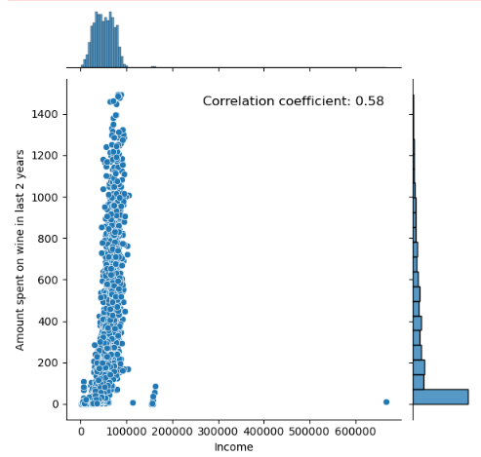

**Conclusion**: Income is moderately positively correlated with the amount spent on wine. As income increases, amount spent on wine too increases.

1. **What customers are more likely to participate in the last promotional campaign?**

The educated, higher income earners, have 0 to 1 kids or teens at home, use the web for purchases, have not complained in the last 2 years, as well as those that have accepted offers in earlier campaigns.

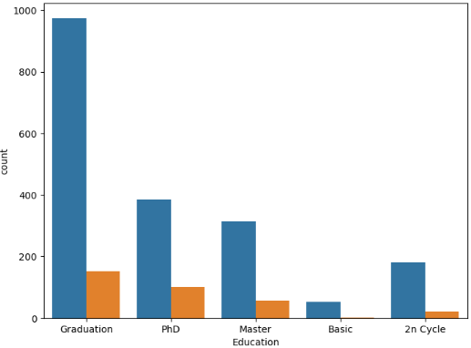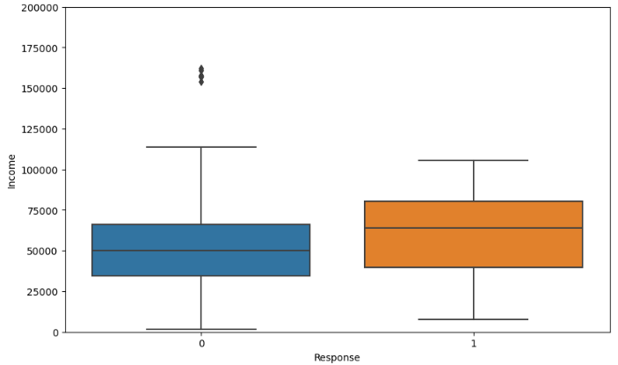

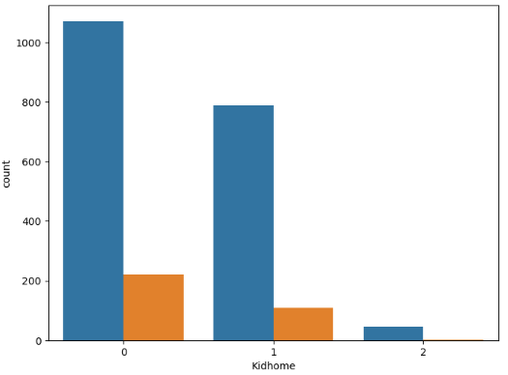 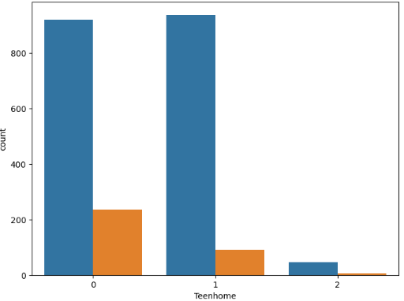

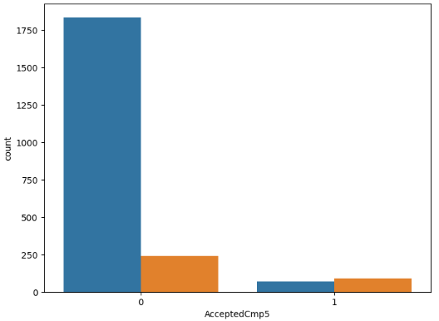 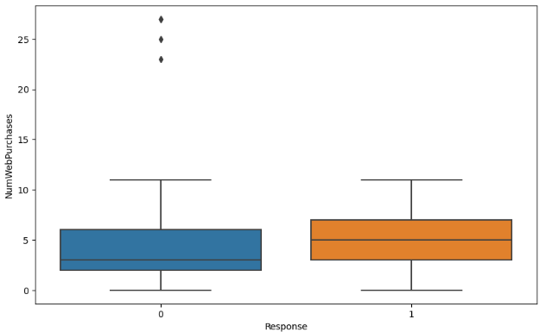

1. **Are customers with children more likely to purchase products online?**

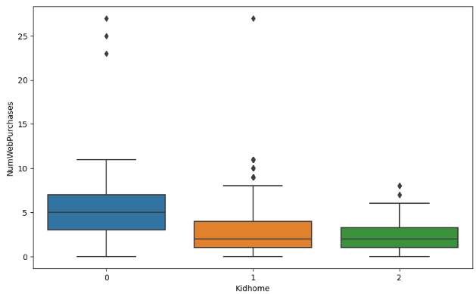

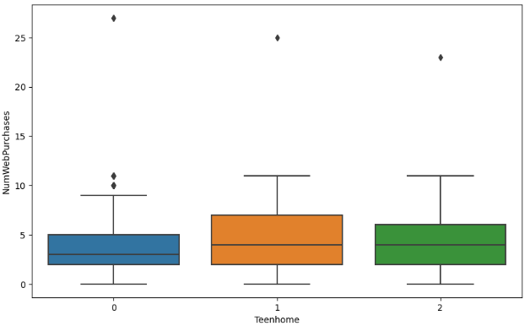

**Conclusion**: Customers with children are less likely to purchase products online compared to those with no children. However, having atleast 1 teen at home increases online purchases.

1. **Do married people purchase more wine?**

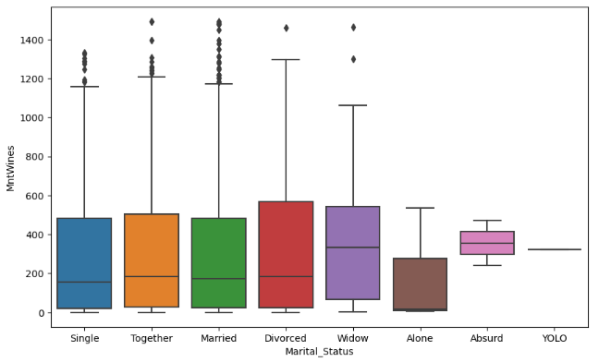

**Conclusion**: Married people don’t purchase more wine compared to the singles and those living together. The widowed and absurd seem to purchase more wine.

1. **What kinds of purchases led to customer complaints?**

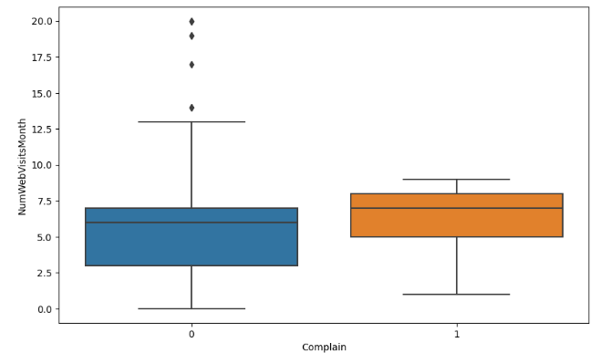

**Conclusion**: No particular purchases however complaints are associated with the higher number of visits to the company’s web site in the last month.