**Comparisons of Ridge regression, Recursive Feature Elimination (RFE) with Lasso, and Sequential Feature Selection (SFS) with Lasso modeling of red wine chemical compositions to predict its quality**

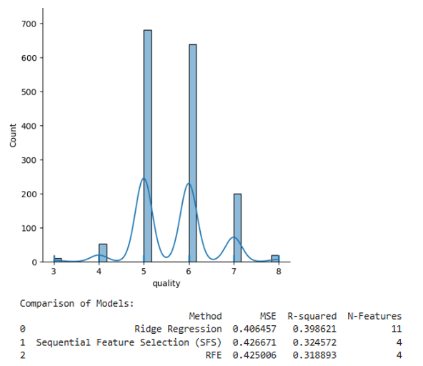 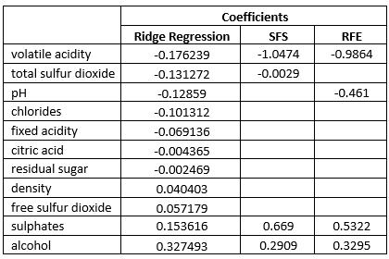

Lower MSE and higher R-squared indicate better model performance. However, Ridge regression has more variables whose VIF<10 indicating absence of multicollinearity, which problem ridge regression is trying to solve by shrinking the coefficients. RFE with Lasso eliminates the least important features while SFS with Lasso fits the model by adding or removing features based on performance improvement thereby selecting features that maximize model performance. I am choosing SFS with Lasso because it’s a parsimonious model and it is very easy to interpret.

R-squared: 0.3245718343171865 Adjusted R-squared: 0.32123638658541953

F-value: 97.3098247728325 F-test p-value: 1.2636296498304507e-67

Equation: y = 2.8532 + (-1.0474 * volatile acidity) + (-0.0029 * total sulfur dioxide) + (0.6690 * sulphates)

+ (0.2909 * alcohol)

Mean Squared Error (MSE) on Validation Set: 0.4750

Mean Squared Error (MSE) on Test Set: 0.4267

N = 1599

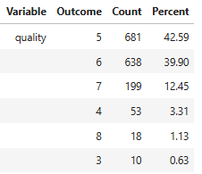

Y- variable is discrete and ordinal, not a continous random variable.