COP 2805C

Conner Luzier

Part1:

**import** java.lang.reflect.Array;

**public** **class** Algorithm {

**public** **static** **void** main(String[] args) {

**int** size = 8;

**int**[] a = **new** **int**[] {5,3,2,6,4,1,7,9};

System.***out***.println(*findposition*(a, size, 4));

}

**static** **int** findposition(**int** a[], **int** size, **int** find) {

**for**(**int** i = 0; i < a.length; i++) {

**if**(a[i] == find) {

**return** i;

}

}

**return** 0;

}

}

Output:

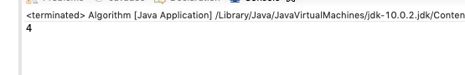

Part2:

**public** **class** Greaterthan {

**private** **static** Object *countGreaterThan*;

**public** **static** **void** main(String[] args) {

System.out.println(**int** count[], **int** countGreaterThan);

}

**public** **static** <T **extends** Comparable<T>> **int** countGreaterThan(T[] anArray, T elem) {

**int** count = 0;

**for** (T e : anArray)

**if** (e.compareTo(elem) > 0)

++count;

**return** count;

}

}

Output: (couldn’t get it to print anything

