MQSAR

User Manual

Matlab based Quantitative Structure Activity Modeling Toolbox



Ersin Bayram, PhD
ersinbayram@gmail.com
ebayram@wfubmc.edu
June 2005

TABLE OF CONTENTS
TABLE OF CONTENTS 2
What is MQSAR? 4
Requirements 4
Backward Compatibility 4
Executable Compilation 4
Starting MQSAR 5
JOBS 5
Build Model: 5
Predict: 5
Cluster Script, Cluster Run, & Run: 5
Mqsar operates in 3 different modes. 5
DATA 6
Training Data: 6
Test Data: 6
Partition File: 6
Model File: 6
Output File: 6
PREPROCESS 6
Protein: 6
Bioactivity: 7
Bins: 7
Exclude: 7
Cutoff: 7
Partition: 7
ANALYZE 7
Variable Selection: 7
Modeling: 7
Setup: 7

What is MQSAR?
MQSAR is the graphical user interface (gui) for the quantitative structure activity/property relationship (QSAR/QSPR) modeling. MQSAR is written in a commercial language, Matlab (Mathworks, Natick, MA). MQSAR has been implemented in Matlab 7.0, but backward compatibility to 5 and 6 can be achieved easily with no or minor modifications. Unfortunately, such platforms are not available at our instituition.

Requirements
MQSAR requires Matlab’s neural network (NNET) toolbox for NNET based QSAR/QSPR modeling. For self-organizing based modeling, freely available somtoolbox is needed (can be downloaded from http://www.cis.hut.fi/projects/somtoolbox/).

Backward Compatibility
Backward Compatibility can be achieved by modifying “createscript” function to save Matlab’s “mat” file format files in backward compatible mode.

Executable Compilation
Matlab provides a very nice mechanism to rapid development and quick testing. Unfortunately commercial nature of the language along with the overhead of Matlab Desktop might force users to seek alternatives. One approach is compiling mqsar as an executable by simply typing “mcc –m mqsar.m”. This will generate the Csource code as well as the executables to run mqsar without a license. The script will generate many files two of which were particularly important: mqsar.ctf and mqsar, both files are needed to run the executable mqsar.
Starting MQSAR

MQSAR can be started by typing mqsar in Matlab or double clicking the executable.  GUI is grouped into the logical subsets: Jobs, Data, PreProcess, and Methods | 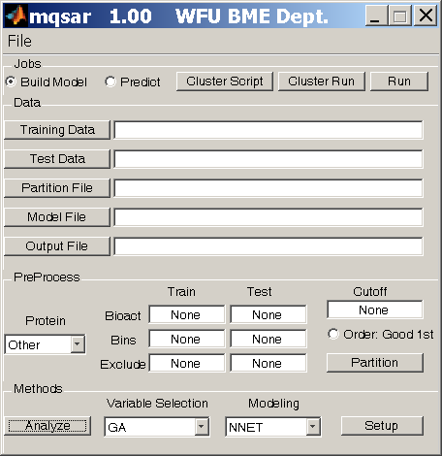
MQSAR GUI: Main GUI to drive the modeling and prediction

JOBS
Build Model:
The algorithms in MQSAR supervised in the sense that training is required, which can be achieved by “Build Model”. This option should be selected with a Training data. A Model file should be typed in to dump the trained model as the output.

Predict:
In this mode, mqsar uses the trained model and predict the bioactivities of Test data and writes the results to the Output File.

Cluster Script, Cluster Run, & Run:
Mqsar operates in 3 different modes.

1) Cluster Script: This button generates a job script that can be launched at the DEAC cluster as a job to utilize the readily available computer power. Please keep in mind that Matlab’s MPI (message passing interface) toolbox had not released when this software was written; hence the scripts are single threaded. However multiple models ( different modeling algorithms) can be run on different nodes at the same time

2) Cluster Run: This button can be used to launch jobs directly at a cluster without generating cluster scripts. I have never used this feature so please use at your own risk. Modifications might be needed to get it working.

3) Run: This option is to run the mqsar on the local machine. Simple jobs could be run quickly on the local machine to save time, but long simulations prohibit the utility of this option. Mostly cluster script should be used when dealing with relatively long simulations.

DATA

Training Data:
The training data that is needed to build the models. This data is needed in the Prediction phase as well, as the generated model file contains the names of the important features (descriptors) but not the model itself. Hence the model is rebuilt again in prediction; hence the need to have the training data.

Test Data:
The test data serves two purposes:
- In model building/training mode, it contains the test data of the training phase.
- In prediction mode, it contains the external dataset to which the models were blinded.

Partition File:
This file is a binary file that can have N columns indicating N columns of datasets that can generate N-fold training generating N different models. A value of 1 indicates that the data is used in training. Values of 0 indicate the data is used in the testing part of training.

Model File:
Model file contains the statistics on training and the descriptor set that generates the specific model. The descriptor set is chosen based on least square based error between the bioactivity of the training data and the predictions using the descriptors.

Output File:
Output file contains the prediction results from the prediction step. For Model building it should be left empty

PREPROCESS

Protein:
Protein pulldown menu has “pre-canned” setups for certain protein datasets that exist inhouse. This simplifies the workflow for in house testing. Further proteins or settings could be added by modifying the code.

Bioactivity:
Bioactivity filed contains the column number which has the “unknown” target values in the training data and test data. If it is in the test data, the filed is used only for statistics calculation and predictions are done blindly.

Bins:
Not all datasets have bioactivity field to fit a quantitative model. Actually more than occasionally, only the categories of the molecules are known such as active or in active. In such cases the problem becomes a classification problem and “Bins” field specify which column should be used in classification.

Shortly, Bioactivity and Bins columns represent the “Y” in a Y = AX.

Exclude:
Exclude filed contains the columns which should be ignored and not included in the modeling/prediction.

Cutoff:
Cutoff filed contains the cutoff values to classify the bioactivity based data into bins as well to calculate classification statistics as well.
For example [ 3.2 7] will generate three bins (-inf, 3.2), [3.2, 7), and [7, inf)
Good First check states that 1st bin is the best bin of (true positives bin)

Partition:
Partition button opens up the controls for creating Partion data that si listed under DATA task panel.

ANALYZE

Variable Selection:
This pull down menu has the variable selection methods. It is the feature reduction part of the process

Modeling:
Modeling filed has the modeling methods that fits the models to the bioactivity or target values.

Setup:
Once the variable selection and modeling methods are selected, pressin Setup button provides extra control fields to fine tune the methods.

