Supplementary Notes for ECE 2714: Signals and Systems

C.L. Wyatt

2025-08-04

Table of contents

# About the Notes

Version: c65ae945427fc7610829bb94a95ce731425d5c85

This is a set of supplementary notes and examples for ECE 2714 in the Bradley Department of Electrical and Computer Engineering at Virginia Tech.

See a mistake? [file an issue](https://github.com/clwyatt/notes-2714/issues). This helps improve the notes.

### License

This work is licensed under a Creative Commons Attribution 4.0 International License.

### Update History

This book is continually updated as new content becomes available and errata corrected.

* July 2025: Conversion of Chapters 2-5 complete.
* June 2025: Conversion of Chapter 1 complete.
* Feb 2025: Conversion from LaTeX pdf to accessible html started.

# Preface

## To the student:

This is a set of supplementary notes and examples for ECE 2714. It is not a replacement for the textbook, but can act as a reference and guide your reading. These notes are not comprehensive – often additional material and insights are covered during class.

This material is well covered in the official course text “Oppenheim, A. V., Willsky, A. S., and Nawab, S. H. Signals and Systems, Prentice Hall Pearson, 1996.” (abbreviated OW). This is an older, but very good book. However there are many, many texts that cover the same material. *Engaged* reading a textbook is one of the most important things you can do to learn this material. Again, these notes should **not** be considered a replacement for a textbook.

## To the instructor:

These notes are simply a way to provide some consistency in topic coverage and notation between and within semesters. Feel free to share these with your class but you are under no obligation to do so. There are many alternative ways to motivate and develop this material and you should use the way that you like best. This is just how I do it.

Each chapter corresponds to a “Topic Learning Objective” and would typically be covered in one class meeting on a Tuesday-Thursday or Monday-Wednesday schedule. Note CT and DT topics are taught interleaved rather than in separate blocks. This gets the student used to going back and forth between the two signal and system types. We introduce time-domain topics first, followed by (real) frequency domain topics, using complex frequency domain for sinusoidal analysis only and as a bridge. Detailed analysis and application of Laplace and Z-transforms is left to ECE 3704.

## Acknowledgements:

The development of this course has been, and continues to be, a team effort. Dr. Mike Buehrer was instrumental in the initial design and roll-out of the course. Dr. Mary Lanzerotti has helped enormously with the course organization and academic integrity. All the instructors thus far: Drs. Buehrer, Safaai-Jazi, Lanzerotti, Kekatos, Poon, Xu, and Talty, have shaped the course in some fashion.

C.L. Wyatt

May 7, 2024

# 1. Course Introduction

The concepts and techniques in this course are probably the most useful in engineering. A *signal* is a function of one or more independent variables conveying information about a physical (or virtual) phenomena. A *system* may respond to signals to produce other signals, or produce signals directly.

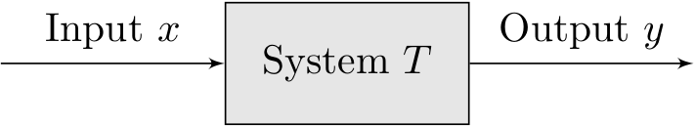

A block diagram representing a system.

This course is about the mathematical models and related techniques for the design and understanding of systems as signal transformations. We focus on a broadly useful class of systems, known as *linear, time-invariant systems*. You will learn about:

* the representation and analysis of signals as information carrying channels
* and how to analyze and implement linear, time-invariant systems to transform those signals.

## 1.1 Example Signals and Systems

Example

**Electrical Circuits.** This is a Sallen-Key filter, a second-order system commonly use to select frequencies from a signal:

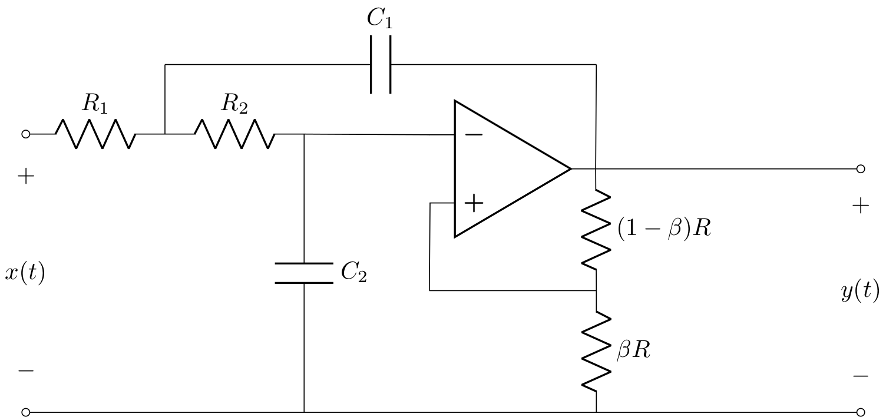

A circuit that implements a Sallen-Key filter.

There are two signals we can easily identify, the input signal as the voltage applied across $x\left(t\right)$, and the output voltage measured across $y\left(t\right)$. We build on your circuits course by viewing this circuit as an implementation of a more abstract linear system. We see how it can be viewed as a frequency selective filter. We will see how to answer questions such as: how do we choose the values of the resistors and capacitors to select the frequencies we are interested in? and how do we determine what those frequencies are?

Example

**Robotic Joint.** This is a Linear, Time-Invariant model of a DC motor, a mixture of electrical and mechanical components.

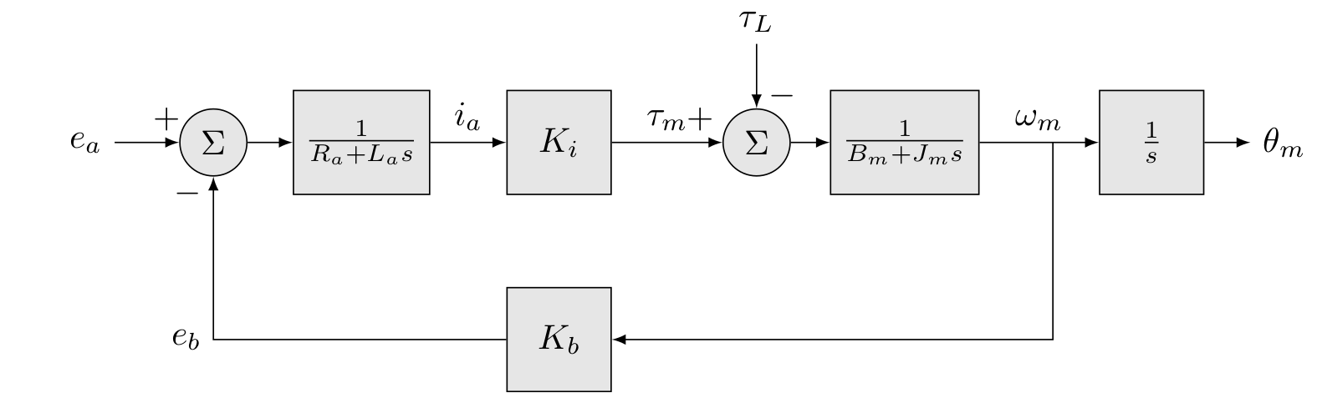

A model of a DC motor.

How do we convert the motor into a servo for use in a robotic joint? What are its characteristics (e.g. how fast can it move)?

Example

**Audio Processing.** Suppose you record an interview for a podcast, but during an important part of the discussion, the HVAC turns on and there is an annoying noise in the background.

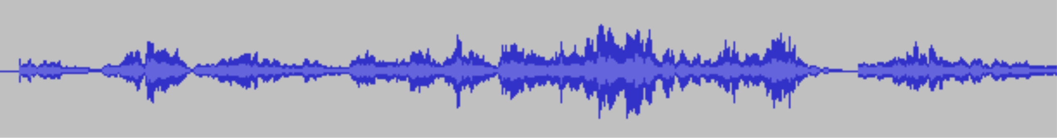

A plot of a noisy signal in the time domain.

How could you remove the noise minimizing distortion to the rest of the audio?

Example

**Communications.** Consider a wireless sensor, that needs to transmit to a base station, e.g. a wireless mic system.

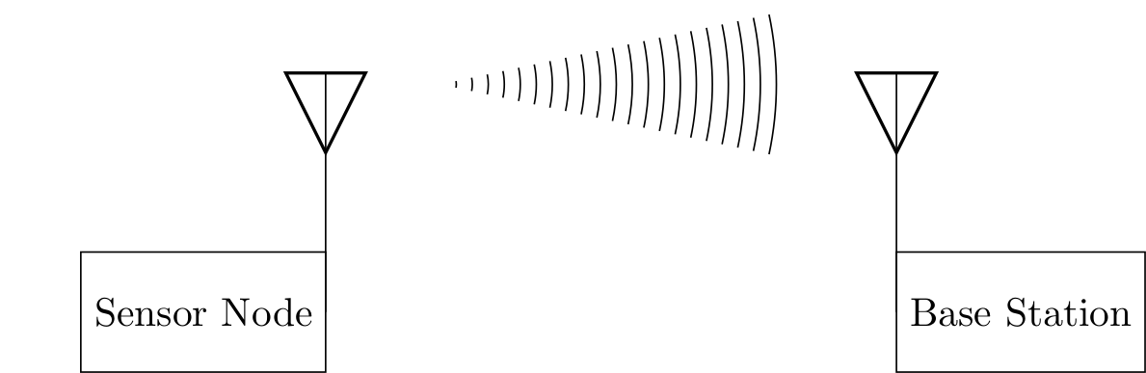

Diagram illustrating a wireless transmitter and reciever.

How should the signal be processed so it can be transmitted? How should the received signal be processed?

## 1.2 Types of Problems

Applications of this material occur in all areas of science and engineering. When we have a measured output but are unsure what combination of inputs and system components could have produced it, we have a *modeling* problem.

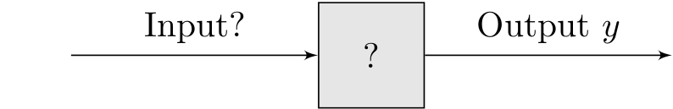

A Modeling Problem

Models are the bedrock of the scientific method and are required to apply the concepts of this course to engineering problems.

When we know the input and the system description and desire to know the output we have an *analysis* problem.

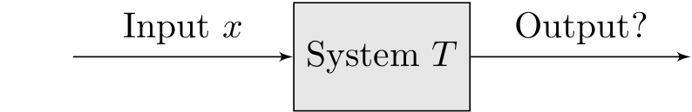

An Analysis Problem

Analysis problems are the kind you have encountered most often already. For example, given an electrical circuit and an applied voltage or current, what are the voltages and currents across and through the various components.

When we know either the input and desired output and seek the system to perform this transformation,

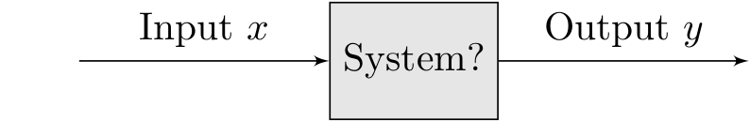

An System Identification Problem

or we know the system description and output and desire the input that would generate the output,

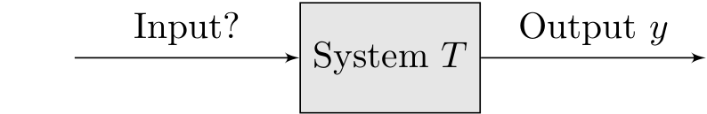

An Input Identification Problem

we have a *design problem* or *identification problem*.

This course focuses on modeling and analysis with applications to electrical circuits and devices for measurement and control of the physical world and is broadly applicable to all ECE majors. Some Examples:

* Controls, Robotics, & Autonomy: LTI systems theory forms the basis of perception and control of machines.
* Communications & Networking: LTI systems theory forms the basis of transmission and reception of signals, e.g. AM and FM radio.
* Machine Learning: LTI systems are often used to pre-process samples or to create basis functions to improve learning.
* Energy & Power Electronic Systems: linear circuits are often modeled as LTI systems.

Subsequent courses, e.g. ECE 3704, focus more on analysis and design.

## 1.3 Learning Objectives

The learning objectives (LOs) for the course are:

1. Describe a given system using a block-level description and identify the input/output signals.
2. Mathematically model continuous and discrete linear, time-invariant systems using differential and difference equations respectively.
3. Analyze the use of filters and their interpretation in the time and frequency domains and implement standard filters in hardware and/or software.
4. Apply computations of the four fundamental Fourier transforms to the analysis and design of linear systems.
5. Communicate solutions to problems and document projects within the domain of signals and systems through formal written documents.

These are broken down further into the following topic learning objectives (TLOs). The TLOs generally map onto one class meeting but are used extensively in later TLOs.

TLO 1: Course introduction (OW Forward and §1.0)

TLO 2: Continuous-time (CT) signals (OW §1.1 through 1.4 and 2.5): A continuous-time (CT) signal is a function of one or more independent variables conveying information about a physical phenomena. This lecture gives an introduction to continuous-time signals as functions. You learn how to characterize such signals in a number of ways and are introduced to two very important signals: the unit impulse and the complex exponential.

TLO 3: Discrete-time (DT) signals (OW §1.1 through 1.4)

TLO 4: CT systems as linear constant coefficient differential equations (OW §2.4.1)

TLO 5: DT systems as linear constant coefficient difference equations (OW §2.4.2)

TLO 6: Linear time invariant CT systems (OW §1.5, 1.6, 2.3)

TLO 7: Linear time invariant DT systems (OW §1.5, 1.6, 2.3)

TLO 8: CT convolution (OW §2.2)

TLO 9: DT convolution (OW §2.1)

TLO 10: CT block diagrams (OW §1.5.2 and 2.4.3)

TLO 11: DT block diagrams (OW §1.5.2 and 2.4.3)

TLO 12: Eigenfunctions of CT systems (OW §3.2 and 3.8)

TLO 13: Eigenfunctions of DT systems (OW §3.2 and 3.8)

TLO 14: CT Fourier Series representation of signals (OW §3.3 through 3.5)

TLO 15: DT Fourier Series representation of signals (OW §3.6 and 3.7)

TLO 16: CT Fourier Transform (OW §4.0 through 4.7)

TLO 17: DT Fourier Transform (OW §5.0 though 5.8)

TLO 18: CT Frequency Response (OW §6.1, 6.2, 6.5)

TLO 19: DT Frequency Response (OW §6.1, 6.2, 6.6)

TLO 20: Frequency Selective Filters in CT (OW §3.9, 3.10, 6.3, 6.4)

TLO 21: Frequency Selective Filters in DT (OW §3.11, 6.3, 6.4)

TLO 22: The Discrete Fourier Transform

TLO 23: Sampling (OW §7.1, 7.3, 7.4)

TLO 24: Reconstruction (OW §7.2)

## 1.4 Graphical Outline

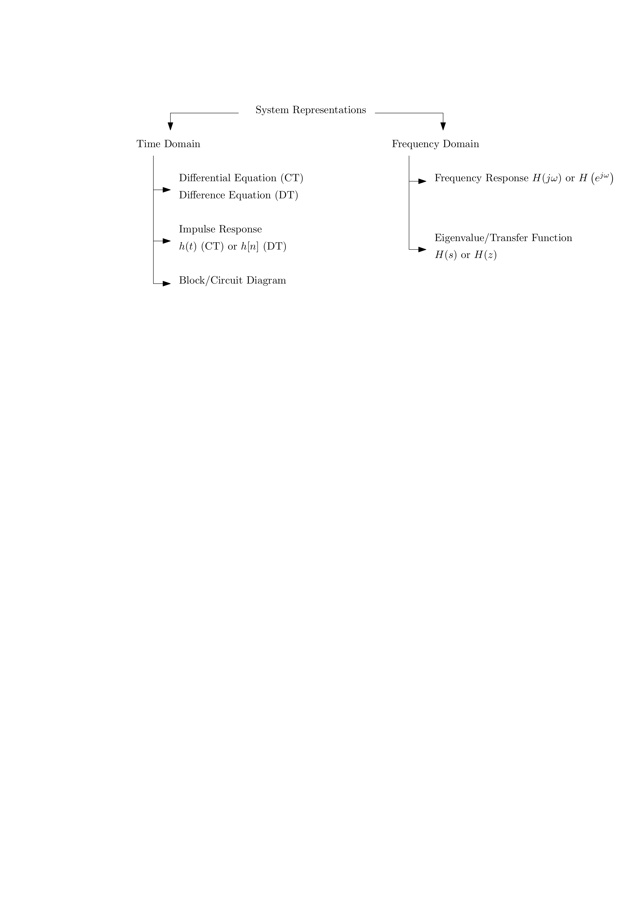

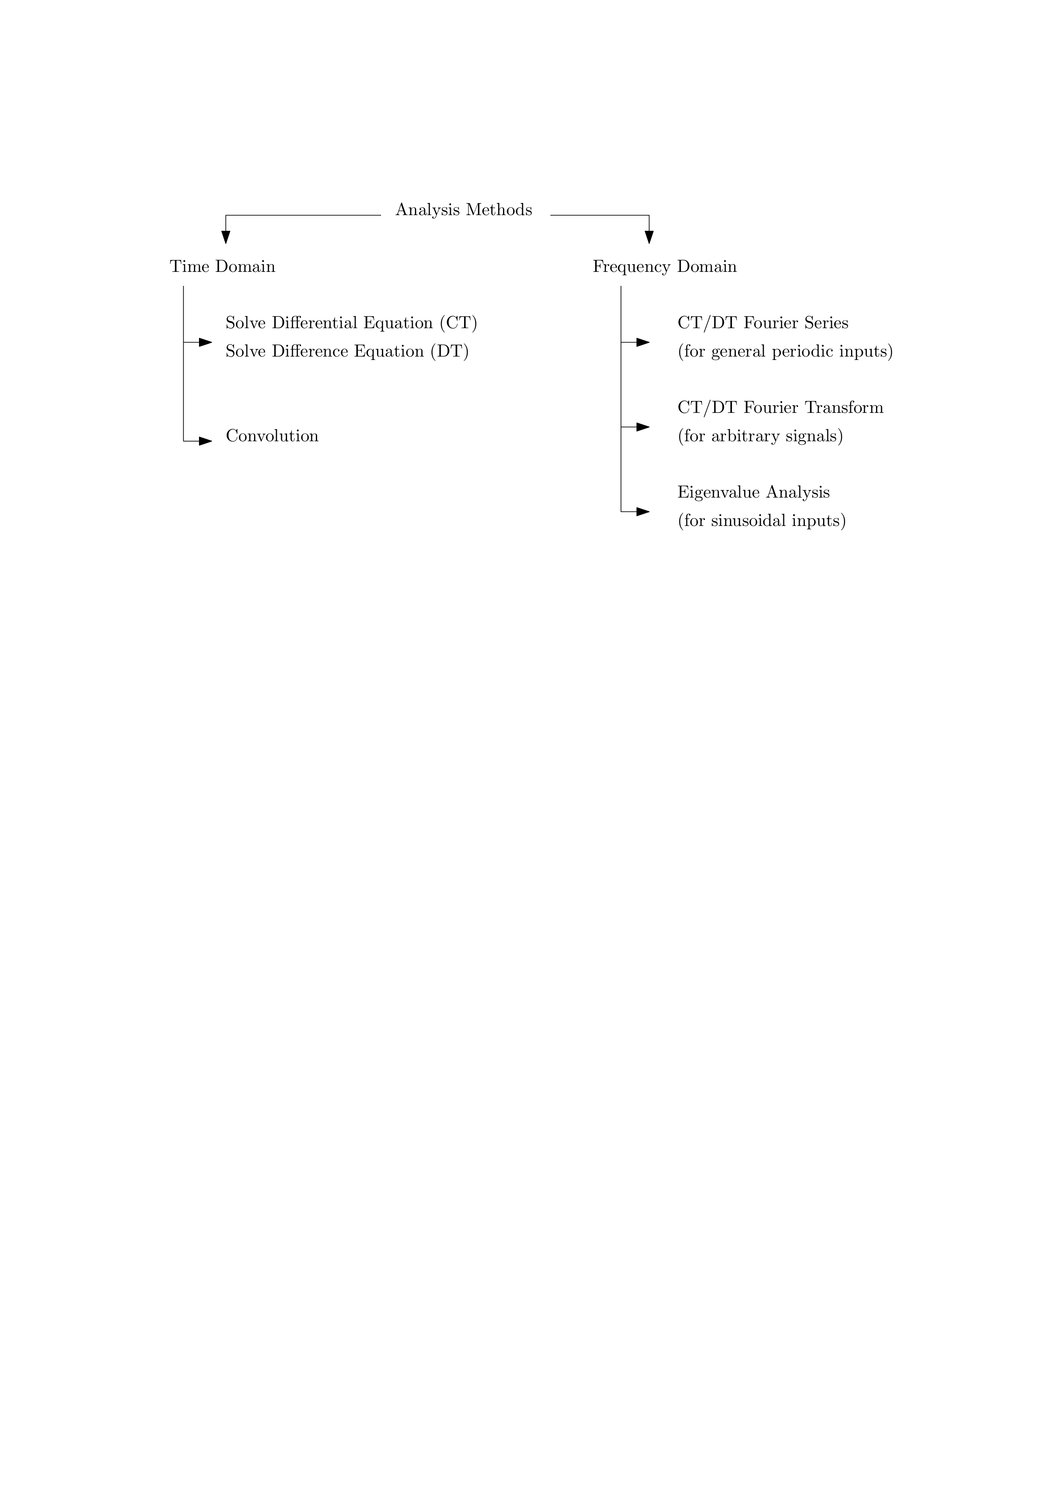

# 2. Continuous-Time Signals

A continuous-time (CT) signal is a function of one or more independent variables conveying information about a physical phenomena. This lecture gives an introduction to continuous-time signals as functions. You learn how to characterize such signals in a number of ways and are introduced to two very important signals: the unit impulse and the complex exponential.

## 2.1 Signals as Functions

In order to reason about signals mathematically we need a representation or *model*. Signals are modeled as functions, mappings between sets

$$f:A→B$$

where $A$ is a set called the *domain* and $B$ is a set called the *range*.

The most basic classification of signals depends on the sets that makeup the domain and co-domain. We will be interested in two versions of the domain, the reals denoted $R$ and the integers denoted $Z$. We will be interested in two versions of the co-domain, the reals $R$ and the set of complex numbers $C$.

Example

**Analog Signal:** If the function $f:R→R$, we call this an analog or real, continuous-time signal, e.g. a voltage at time $t∈R$, $v\left(t\right)$. We will write these as $x\left(t\right)$, $y\left(t\right)$, etc. The units of $t$ are seconds. Figure 2.1 shows some graphical representations, i.e. plots.

|  |
| --- |
| Figure 2.1: Example plots of analog signals. |

Example

**Real, Discrete-time Signal:** If the function $f:Z→R$, we call this a real, discrete-time signal, e.g. the temperature every day at noon. We will write these as $x\left[n\right]$, $y\left[n\right]$, etc. Note $n$ is dimensionless. Figure 2.2 shows some graphical representations.

|  |
| --- |
| Figure 2.2: Example plots of real-valued, discrete-time signals. |

Some other possibilities:

* $f:R→Z$, digital, continuous-time signals, e.g. the output of a general purpose pin on a microcontroller
* $f:Z→Z$, digital, discrete-time signals, e.g. the signal on a computer bus

The co-domain can also be complex.

* $f:R→C$, complex-valued, continuous-time signals, e.g.
$$x\left(t\right)=e^{jωt}=cos\left(ωt\right)+jsin\left(ωt\right)$$

* $f:Z→C$, complex-valued, discrete-time signals, e.g.

$$x\left[n\right]=e^{jωn}=cos\left(ωn\right)+jsin\left(ωn\right)$$

Since the domains $R$ and $Z$ are usually interpreted as time, we will call these *time-domain* signals. In the time-domain, when the co-domain is $R$ we call these real signals. All physical signals are real. However complex signals will become important when we discuss the frequency domain.

## 2.2 Primitive Models

We mathematically model signals by combining elementary/primitive functions, for example:

* polynomials: $x\left(t\right)=t$, $x\left(t\right)=t^{2}$, etc.
* transendental functions: $x\left(t\right)=e^{t}$, $x\left(t\right)=sin\left(t\right)$, $x\left(t\right)=cos\left(t\right)$, etc.
* piecewise functions, e.g.

$$x\left(t\right)=\left\{\begin{matrix}f_{1}\left(t\right) & t<0 \\ f_{2}\left(t\right) & t≥0 \\ \end{matrix}\right.$$

Example

**Modeling a Switch:** Consider a mathematical model of a switch, which moves positions at time $t=0$.

|  |
| --- |
| Figure 2.3: Single pole, single throw switch connected to a unit DC source. |

We use this model so much we give it it’s own name and symbol: Unit Step, $u\left(t\right)$

$$u\left(t\right)=\left\{\begin{matrix}0 & t<0 \\ 1 & t≥0 \\ \end{matrix}\right.$$

so a mathematical model of the switch circuit above would be $x\left(t\right)=Vu\left(t\right)$.

Note: some texts define the step function at $t=0$ to be $1$ or $\frac{1}{2}$. It is typically plotted like so:

|  |
| --- |
| Figure 2.4: Plot of the unit step function. It turns on at the time origin and stays on forever. |

Example

**Pure audio tone at “middle C”.** A signal modeling the air pressure of a specific tone might be

$$x\left(t\right)=sin\left(2π\left(261.6\right)t\right)$$

Example

**Chord.** The chord “G”, an additive mixture of tones at G, B, and D and might be modeled as

$$x\left(t\right)=sin\left(2π\left(392\right)t\right)+sin\left(2π\left(494\right)t\right)+sin\left(2π\left(293\right)t\right)$$

This example shows we can use addition to build-up signals to approximate real signals of interest.

## 2.3 Basic Transformations

We can also apply transformations to signals to increase their modeling flexibility.

* magnitude scaling
$$x_{2}\left(t\right)=ax_{1}\left(t\right)$$

* for $a∈R$.
* derivatives
$$x_{2}\left(t\right)=x_{1}^{′}\left(t\right)=\frac{dx_{1}}{dt}\left(t\right)$$

* integrals
$$x_{2}\left(t\right)=\int_{−∞}^{t}{x_{1}}\left(τ\right) dτ$$

* sums


* an important example we will see is the CT Fourier series.
* multiplication (modulation)
$$y\left(t\right)=x_{1}\left(t\right)x_{2}\left(t\right)$$

* For example amplitude modulation $y\left(t\right)=x\left(t\right)sin\left(ω_{0}t\right)$
* time shift
 $$x_{2}\left(t\right)=x_{1}\left(t+τ\right)$$

 + if $τ<0$ it is called a *delay*
  + if $τ>0$ it is called an *advance*
* time scaling
 $$x_{2}\left(t\right)=x_{1}\left(\frac{t}{τ}\right)$$

 + if $τ>1$ increasing $τ$ expands in time, slows down the signal
  + if $0<τ<1$ decreasing $τ$ contracts in time, speeds up the signal
  + if $−1<τ<0$ time reverses and increasing $τ$ contracts in time, speeding up the signal
  + if $τ<−1$ time reverses and decreasing $τ$ expands in time, slows down the signal
* Common uses are time reversal, $x_{2}\left(t\right)=x_{1}\left(−t\right)$, and changing the frequency of of sinusoids.

## 2.4 Characterization of Signals

There are a few basic ways of characterizing signals.

Definition

**Causal CT Signal.** A CT signal is if $x\left(t\right)=0$ $∀t<0$.

**Anti-Causal CT Signal.** A CT signal is or acausal if $x\left(t\right)=0$ $∀t≥0$.

A signal can be written as the sum of a causal and anti-causal signal.

Definition

**Periodic Signals.** A CT signal is if $x\left(t\right)=x\left(t+T\right)$ $∀t$ for a fixed parameter $T∈R$ called the .

The simplest periodic signals are those based on the sinusoidal functions.

Definition

**Even Signal.** A CT signal is if $x\left(t\right)=x\left(−t\right)$ $∀t$.

**Odd Signal.**  A CT signal is if $x\left(t\right)=−x\left(−t\right)$ $∀t$.

Any CT signal can be written in terms of an even and odd component

$$x\left(t\right)=x_{e}\left(t\right)+x_{o}\left(t\right)$$

where

$$\begin{matrix}x_{e}\left(t\right) & =\frac{1}{2}\left\{x\left(t\right)+x\left(−t\right)\right\} \\ & \\ x_{o}\left(t\right) & =\frac{1}{2}\left\{x\left(t\right)−x\left(−t\right)\right\}\end{matrix}$$

Definition

**Energy of a CT Signal.** The *energy* of a CT signal $x\left(t\right)$ is defined as a measure of the function

$$E_{x}=\lim_{T→∞}\int_{−T}^{T}{|}x\left(t\right)|^{2}dt .$$

Definition

**Power of a CT Signal.** The *power* of a CT signal is the energy averaged over an interval as that interval tends to infinity.

$$P_{x}=\lim_{T→∞}\frac{1}{2T}\int_{−T}^{T}{|}x\left(t\right)|^{2}dt .$$

Signals can be characterized based on their energy or power:

* Signals with finite, non-zero energy and zero power are called *energy signals*.
* Signals with finite, non-zero power (and by implication infinite energy) are called *power signals*.

Note, these categories are non-exclusive, some signals are neither energy or power signals.

## 2.5 Unit Impulse Function

An important CT signal is the unit impulse function, also called the “delta” $δ$ function for the symbol traditionally used to define it. Applying this signal to a system models a “kick” to that system. For example, consider striking a tuning fork. The reason this signal is so important is that it will turn out that the response of the system to this input tells us all we need to know about a linear, time-invariant system!

Example

**CT Impulse Function.** The CT impulse function is not really a function at all, but a mathematical object called a “distribution”. Some equivalent definitions:

$$δ\left(t\right)=\lim_{ϵ→0}\left\{\begin{matrix}\frac{1}{2ϵ} & \left|t\right|<ϵ \\ 0 & \text{else}\end{matrix}\right.$$

$$δ\left(t\right)=\lim_{ϵ→0}\frac{1}{\sqrt{2π}ϵ}e^{−\frac{t^{2}}{2ϵ^{2}}}$$

Note the area under each definition is always one.

In practice we can often use the following definition and some properties, without worrying about the distribution functions.

$$δ\left(t\right)=\left\{\begin{matrix}0 & t≠0 \\ ∞ & t=0\end{matrix}\right.$$

which we draw as a vertical arrow in plots:

|  |
| --- |
| Figure 2.5: Plot of the CT delta function. |

Note the height of the arrow is arbitrary. Often in the case of a non-unit impulse function the area is written in parenthesis near the arrow tip.

The following properties of the impulse function will be used often.

* The area under the unit impulse is unity since by definition
$$\int_{−∞}^{∞}{δ}\left(t\right) dt=1$$

* Sampling property: $x\left(t\right)δ\left(t−t_{0}\right)=x\left(t_{0}\right)δ\left(t−t_{0}\right)$
* Sifting Property:
$$\int_{a}^{b}{x}\left(t\right)δ\left(t−t_{0}\right) dt=x\left(t_{0}\right)$$

* for any $a<t_{0}<b$.

We previously defined the unit step function. The impulse can be defined in terms of the step:

$$δ\left(t\right)=\frac{du}{dt}$$

and vice-versa

$$u\left(t\right)=\int_{−∞}^{t}{δ}\left(τ\right) dτ$$

using the notion of distributions, e.g.

$$u\left(t\right)=\int_{−∞}^{t}{δ}\left(τ\right) dτ=\lim_{ϵ→0}\int_{−∞}^{t}{\frac{1}{\sqrt{2π}ϵ}}e^{−\frac{τ^{2}}{2ϵ^{2}}} dτ=\lim_{ϵ→0}\frac{1}{2}\left(1+\text{erf}\left(\frac{t}{\sqrt{2}ϵ}\right)\right)$$

The step and impulse function are related, but in many cases finding the response of a system to a step input is easier.

We can apply additional transformations to the impulse and step functions to get other useful signals, e.g.

* ramp
$$r\left(t\right)=\int_{−∞}^{t}{u}\left(τ\right) dτ=tu\left(t\right)$$

* causal pulse of width $ϵ$
$$p\left(t\right)=u\left(t\right)−u\left(t−ϵ\right)$$

* non-causal pulse of width $2ϵ$

$$p\left(t\right)=u\left(t+ϵ\right)−u\left(t−ϵ\right)$$

## 2.6 CT Complex Exponential

One of the most important signals in systems theory is the complex exponential:

$$x\left(t\right)=C e^{at}$$

where the parameters $C,a∈C$ in general.

When $C$ and $a$ are both real ($ℑ\left(C\right)=ℑ\left(a\right)=0$), we have the familiar exponential. When $a>0$ and $C>0$, $x\left(t\right)=Ce^{at}$ looks like:

|  |
| --- |
| Figure 2.6: Plot of the expoential function with real, positive parameter. |

When $a<0$ and $C>0$, $x\left(t\right)=Ce^{at}$ looks like:

|  |
| --- |
| Figure 2.7: Plot of the expoential function with real, negative parameter. |

If $C<0$ the signals reflect about the time axis.

To get the pure sinusoidal case, let $C∈R$ and $a$ be purely imaginary: $a=jω_{0}$:

$$x\left(t\right)=Ce^{jω_{0}t}$$

where $ω_{0}$ is the frequency (in radians/sec). This is called the complex sinusoid.

By Euler’s identity:

$$e^{jω_{0}t}=cos\left(ω_{0}t\right)+jsin\left(ω_{0}t\right)$$

and

$$ℜ\left(x\left(t\right)\right)=cos\left(ω_{0}t\right)=\frac{1}{2}\left(e^{jω_{0}t}+e^{−jω_{0}t}\right)$$

$$ℑ\left(x\left(t\right)\right)=sin\left(ω_{0}t\right)=\frac{1}{2j}\left(e^{jω_{0}t}−e^{−jω_{0}t}\right)$$

are both real sinusoids.

Note that the sinusoids are periodic. Recall a signal $x\left(t\right)$ is periodic with period $T$ if

$$x\left(t\right)=x\left(t+T\right) ∀t$$

In the case of the complex sinusoid

$$Ce^{jω_{0}t}=Ce^{jω_{0}\left(t+T\right)}=Ce^{jω_{0}t}\underset{\text{must be 1}}{\underset{⏟}{e^{jω_{0}T}}}$$

* if $ω_{0}=0$ this is true for all $T$
* if $ω_{0}≠0$, then to be periodic $ω_{0}T=2πm$ for $m=±1,±2,⋯$. The smallest $T$ for which this is true is the *fundamental period $T_{0}$*
$$T_{0}=\frac{2π}{\left|ω_{0}\right|}$$

* or equivalently $ω_{0}=\frac{2π}{T_{0}}$

Some useful properties of sinusoids:

* If $x\left(t\right)$ is periodic with period $T$ and $g$ is any function then $g\left(x\left(t\right)\right)$ is periodic with period $T$.
* If $x_{1}\left(t\right)$ is periodic with period $T_{1}$ and $x_{2}\left(t\right)$ is periodic with period $T_{2}$, and if there exists positive integers $a,b$ such that
$$aT_{1}=bT_{2}=P$$

* then $x_{1}\left(t\right)+x_{2}\left(t\right)$ and $x_{1}\left(t\right)x_{2}\left(t\right)$ are periodic with period $P$

The last property implies that both $T_{1}$ and $T_{2}$ must both be rational in $π$ or neither should be. For example

* $x\left(t\right)=sin\left(2πt\right)+cos\left(5πt\right)$ is periodic
* $x\left(t\right)=sin\left(2t\right)+cos\left(5t\right)$ is periodic
* $x\left(t\right)=sin\left(2πt\right)+cos\left(5t\right)$ is **not** periodic

When the parameter $C$ is complex we get a phase shift. Again let $a=jω_{0}$. When $C$ is complex we can write it as $C=Ae^{jϕ}$ where $A=\left|C\right|$ and $ϕ=∠C$. Then

$$x\left(t\right)=Ae^{jϕ}e^{jω_{0}t}=Ae^{j\left(ω_{0}t+ϕ\right)}$$

and

$$ℜ\left(x\left(t\right)\right)=Acos\left(ω_{0}t+ϕ\right)$$

$$ℑ\left(x\left(t\right)\right)=Asin\left(ω_{0}t+ϕ\right)$$

Since $sin$ is a special case of $cos$, i.e. $cos\left(θ\right)=sin\left(θ+\frac{π}{2}\right)$ , the general real sinusoid is

$$Acos\left(ω_{0}t+ϕ\right)$$

* $A$ is called the amplitude
* $ω_{0}$ is again the frequency in radians/sec.
* $ϕ$ is called the phase shift and is related to a time shift $T_{s}$ by

$$ϕ=ω_{0}T_{s}$$

For example the signal graphically represented as follows

|  |
| --- |
| Figure 2.8: Example plot of sinusoidal signal. |

has the functional representation

$$x\left(t\right)=2cos\left(\frac{π}{2}\left(t+1/2\right)\right)=2cos\left(\frac{π}{2}t+\frac{π}{4}\right)$$

### 2.6.1 Energy of CT complex sinusoid

Recall the energy of a CT signal $x\left(t\right)$ is

$$E_{x}=\lim_{T→∞}\int_{−T}^{T}{|}x\left(t\right)|^{2}dt .$$

Substituting $x\left(t\right)=e^{jω_{0}t}$ and letting $T=NT_{0}$

$$E_{x}=\lim_{N→∞}\int_{−NT_{0}}^{NT_{0}}{\underset{\text{always 1}}{\underset{⏟}{|e^{jω_{0}t}|^{2}}}} dt=\lim_{N→∞}2NT_{0}=∞$$

### 2.6.2 Power of CT complex sinusoid

Recall the power of a CT signal $x\left(t\right)$ is

$$P_{x}=\lim_{T→∞}\frac{1}{2T}\int_{−T}^{T}{|}x\left(t\right)|^{2}dt .$$

Again, substituting $x\left(t\right)=e^{jω_{0}t}$ and letting $T=NT_{0}$

$$P_{x}=\lim_{N→∞}\frac{1}{2NT_{0}}\int_{−NT_{0}}^{NT_{0}}{\underset{\text{always 1}}{\underset{⏟}{|e^{jω_{0}t}|^{2}}}} dt=\lim_{N→∞}\frac{1}{2NT_{0}}2NT_{0}=1$$

### 2.6.3 Harmonics

Two CT complex sinusoids are *harmonics* of one another is both are periodic in $T_{0}$. This occurs when

$$x_{k}\left(t\right)=e^{jkω_{0}t} \text{for} k=0,±1,±2,⋯$$

The term comes from music where the vibrations of a string instrument are modeled as a weighted combination of harmonic tones.

### 2.6.4 Geometric interpretation of the Complex Exponential

In the general case we get a sinusoid signal modulated by an exponential. Let $C=Ae^{jϕ}$ and $a=r+jω_{0}$, then

$$x\left(t\right)=Ce^{at}=Ae^{jϕ}e^{\left(r+jω_{0}\right)t}$$

Expanding the terms and using Euler’s identity gives:

$$x\left(t\right)=\underset{ℜ\text{part}}{\underset{⏟}{Ae^{rt}cos\left(ω_{0}t+ϕ\right)}}+j\underset{ℑ\text{part}}{\underset{⏟}{Ae^{rt}sin\left(ω_{0}t+ϕ\right)}}$$

Each part is a real sinusoid whose amplitude is modulated by a real exponential.

An important visualization of the general case is to view the signal $x\left(t\right)$ as a vector rotating counter-clockwise in the complex plane for positive $t$.

|  |
| --- |
| Figure 2.9: The CT complex sinusoid at a specific point in time. |

For $r<0$ the tip of the arrow traces out an inward spiral, whereas for $r>0$ it traces out an outward spiral. For $r=0$ it traces out the unit circle.

## 2.7 Example Problems

### 2.7.1

Consider a signal described by the function

$$x\left(t\right)=e^{−3t}sin\left(10πt\right)u\left(t\right)$$

1. Determine the magnitude and phase of $x\left(\frac{1}{20}\right)$

**Solution:**

Substituting $t=\frac{1}{20}$ gives

$$x\left(\frac{1}{20}\right)=e^{−3\frac{1}{20}}sin\left(10π\frac{1}{20}\right)u\left(\frac{1}{20}\right)=e^{−\frac{3}{20}}≈0.86$$

Since the signal is purely real and exponential is always positive, the magnitude is

$$\left|x\left(\frac{1}{20}\right)\right|=\left|e^{−\frac{3}{20}}\right|=e^{−\frac{3}{20}}≈0.86$$

and the phase is

$$∠x\left(\frac{1}{20}\right)=0$$

1. Using Matlab, plot the signal $\left|x\left(t\right)\right|$ between $\left[−2,2\right]$. Give your code and embed the plot.

**Solution:**

% Solution to Example Problem 2.7.1b  
t = -2:0.001:2;  
x = exp(-3*t).*sin(10*pi*t).*heaviside(t);  
hp = plot(t,abs(x));  
grid on;  
xh = xlabel('t');  
yh = ylabel('x(t)');  
th = title('Plot for Example Problem 2.7.1b');  
  
% make the plot more readable  
set(gca, 'FontSize', 12, 'Box', 'off', 'LineWidth', 2);  
set(hp, 'linewidth', 2);  
set([xh, yh, th], 'FontSize', 12);  
  
set(gcf, 'PaperPositionMode', 'auto');  
print -dpng example_2_7_1.png

Line 2

Create time slices from -2 seconds to 2 seconds in increments of 1 millisecond

Line 3

Compute the signal value at each time slice

Line 4

Plot the signal

### 2.7.2

Find a solution to the differential equation

$$\frac{dy}{dt}\left(t\right)+9y\left(t\right)=e^{−t}$$

for $t≥0$, when $y\left(0\right)=1$.

**Solution:** The homogeneous equation is

$$\frac{dy_{h}}{dt}\left(t\right)+9y_{h}\left(t\right)=0$$

with initial condition . Its solution is of the form

for constant . Using the initial condition

gives

The particular solution is of the form

$$y_{p}\left(t\right)=C_{1}e^{−t}+C_{2}e^{−9t}$$

Substitution and equating coefficients gives $C_{1}=\frac{1}{8}$ and $C_{2}=−\frac{1}{8}$. The total solution is the sum of the two solutions or

$$y\left(t\right)=\frac{1}{8}e^{−t}−\frac{1}{8}e^{−9t}+e^{−9t}=\frac{1}{8}e^{−t}+\frac{7}{8}e^{−9t}$$

### 2.7.3

Find a solution to the differential equation

$$\frac{dy}{dt}\left(t\right)+9y\left(t\right)=e^{−t}$$

for $t≥0$, when $y\left(0\right)=1$.

**Solution:** The homogeneous equation is

$$\frac{dy_{h}}{dt}\left(t\right)+9y_{h}\left(t\right)=0$$

with initial condition . Its solution is of the form

for constant . Using the initial condition

gives

The particular solution is of the form

$$y_{p}\left(t\right)=C_{1}e^{−t}+C_{2}e^{−9t}$$

Substitution and equating coefficients gives $C_{1}=\frac{1}{8}$ and $C_{2}=−\frac{1}{8}$. The total solution is the sum of the two solutions or

$$y\left(t\right)=\frac{1}{8}e^{−t}−\frac{1}{8}e^{−9t}+e^{−9t}=\frac{1}{8}e^{−t}+\frac{7}{8}e^{−9t}$$

### 2.7.4

Compute the integral

$$\int_{−∞}^{∞}{e^{−t^{2}}} δ\left(t−10\right) dt$$

where $δ\left(t\right)$ is the delta function.

**Solution:**

Using the sifting property of the delta function

$$\int_{a}^{b}{f}\left(t\right) δ\left(t−t_{0}\right) dt=f\left(t_{0}\right)$$

for $a<t_{0}<b$, we get

$$\int_{−∞}^{∞}{e^{−t^{2}}} δ\left(t−10\right) dt=e^{−100}≈0$$

# 3. Discrete-Time Signals

Recall from the previous chapter that a discrete-time (DT) signal is modeled as a function $f:Z→C$. We will write these as $x\left[n\right]$, $y\left[n\right]$, etc. Note $n$ is dimensionless. These are graphically plotted as stem or “lollipop” plots, as demonstrated in Chapter 2.

Since the domain $Z$ is usually interpreted as a time index, we will still call these *time-domain* signals. In the time-domain, when the co-domain is $R$ we call these real DT signals. Unlike with CT signals there are no physical limitations requiring DT signals to be real, since in discrete hardware, a value at a given index can be a complex number, i.e. just a pair of numbers. However it is computationally advantageous to restrict ourselves to real arithmetic and such signals are often converted to or from CT signals, which do have to be real. For this reason, real DT signals dominate in models.

## 3.1 Primitive Models

As with CT signals, we mathematically model DT signals by combining elementary/primitive functions, for example:

* polynomials: $x\left[n\right]=n$, $x\left[n\right]=n^{2}$, etc.
* transendental functions: $x\left[n\right]=e^{n}$, $x\left[n\right]=sin\left(n\right)$, $x\left[n\right]=cos\left(n\right)$, etc.
* piecewise functions, e.g.

$$x\left[n\right]=\left\{\begin{matrix}f_{1}\left[n\right] & n<0 \\ f_{2}\left[n\right] & n≥0 \\ \end{matrix}\right.$$

Definition

The DT counterpart of the CT step function is the *DT Unit Step*, $u\left[n\right]$:

$$u\left[n\right]=\left\{\begin{matrix}0 & n<0 \\ 1 & n≥0 \\ \end{matrix}\right.$$

Note, there are not continuity issues at $n=0$ as DT functions have discrete domains.

Example

A *sampled* signal modeling the air pressure of a specific tone, sampled at 8kHz, might be

$$x\left[n\right]=sin\left(2π\left(261.6\right)1/{8000}n\right)$$

Such DT signals are commonly used in digital music generation, storage, and playback.

Example

Similarly, the sampled chord "G", an additive mixture of tones at G, B, and D and might be modeled as

$$x\left[n\right]=sin\left(2π\left(392\right)1/{8000}n\right)+sin\left(2π\left(494\right)1/{8000}n\right)+sin\left(2π\left(293\right)1/{8000}n\right)$$

again sampled at 8kHz. This example shows we can use addition to build-up signals to approximate real signals of interest.

## 3.2 Basic Transformations

Similar to CT signals, we can also apply transformations to DT signals to increase their modeling flexibility.

* magnitude scaling
$$x_{2}\left[n\right]=ax_{1}\left[n\right]$$

* for $a∈R$.
* time differences
$$x_{2}\left[n\right]=x_{1}\left[n\right]−x_{1}\left[n−1\right]$$

* running sums
$$x_{2}\left[n\right]=\sum_{m=−∞}^{n}{x_{1}}\left[m\right]$$

* sums


* an important example we will see is the DT Fourier series.
* multiplication (modulation)
$$y\left[n\right]=x_{1}\left[n\right]x_{2}\left[n\right]$$

* time index shift
 $$x_{2}\left[n\right]=x_{1}\left[n+m\right]$$

 + if $m<0$ it is called a *delay*
  + if $m>0$ it is called an *advance*
* time reversal
$$x_{2}\left[n\right]=x_{1}\left[−n\right]$$

* decimation
$$y\left[n\right]=x\left[mn\right]$$

* for $m∈Z^{+}$.
  + e.g. for $m=2$ only keep every other sample
  + e.g. for $m=3$ only keep every third sample
  + etc.
* interpolation
$$y\left[n\right]=\left\{\begin{matrix}x\left[\frac{n}{m}\right] & n=0 , ±m,, ±2m⋯ \\ 0 & \text{else}\end{matrix}\right.$$

* When $m=2$ this inserts a zero sample between every sample of the signal.

## 3.3 Characterization of Signals

There are a few basic ways of characterizing DT signals.

Definition

A DT signal is *causal* if $x\left[n\right]=0$ $∀n<0$.

Definition

A DT signal is *anti-causal* or acausal if $x\left[n\right]=0$ $∀n≥0$.

A DT signal can be written as the sum of a causal and anti-causal signal.

A DT signal is periodic if $x\left[n\right]=x\left[n+N\right] ∀n$ for a fixed period $N∈Z$.

A DT signal is even if $x\left[n\right]=x\left[−n\right] ∀n$.

A DT signal is odd if $x\left[n\right]=−x\left[−n\right] ∀n$.

Any DT signal can be written in terms of an even and odd component

$$x\left[n\right]=x_{e}\left[n\right]+x_{o}\left[n\right]$$

where

$$\begin{matrix}x_{e}\left[n\right] & =\frac{1}{2}\left\{x\left[n\right]+x\left[−n\right]\right\} \\ & \\ x_{o}\left[n\right] & =\frac{1}{2}\left\{x\left[n\right]−x\left[−n\right]\right\}\end{matrix}$$

Analogous to CT signals, the energy of a DT signal is

$$E_{x}=\lim_{N→∞}\sum_{−N}^{N}{|}x\left[n\right]|^{2} .$$

And the power of a DT signal is the energy averaged over an interval as that interval tends to infinity.

$$P_{x}=\lim_{N→∞}\frac{1}{2N+1}\sum_{−N}^{N}{|}x\left[n\right]|^{2} .$$

DT Signals with finite, non-zero energy and zero power are called *energy signals*. DT Signals with finite, non-zero power (and by implication infinite energy) are called *power signals*. These categories are non-exclusive, some signals are neither energy or power signals.

## 3.4 DT Unit Impulse Function

In DT the unit impulse function, denoted $δ\left[n\right]$ is defined as

$$δ\left[n\right]=\left\{\begin{matrix}1 & n=0 \\ 0 & \text{else}\end{matrix}\right.$$

Note this definition is straightforward compared to the CT impulse as there are no continuity issues and it is not defined in terms of a distribution. It is typically drawn as

|  |
| --- |
| Figure 3.1: Plot of discrete-time delta function. |

Some useful properties of the DT impulse function are:

* Energy is 1: $\sum_{n=−∞}^{∞}{δ}\left[n\right]=1$
* Sampling: $x\left[n\right]δ\left[n−n_{0}\right]=x\left[n_{0}\right]δ\left[n−n_{0}\right]$
* Sifting: $\sum_{n=−∞}^{∞}{x}\left[n\right]δ\left[n−n_{0}\right]=x\left[n_{0}\right]$

The impulse can be defined in terms of the step:

$$δ\left[n\right]=u\left[n\right]−u\left[n−1\right]$$

and vice-versa

$$u\left[n\right]=\sum_{m=−∞}^{n}{δ}\left[m\right]$$

or

$$u\left[n\right]=\sum_{k=0}^{∞}{δ}\left[n−k\right]$$

## 3.5 DT Complex Exponential

The DT Complex Exponential is defined in a similar fashion the the CT version, but with some important differences. The general DT complex exponential is given by the expression:

$$x\left[n\right]=Ce^{βn}$$

where in general $C∈C$ and $β∈C$. It is sometimes convenient (for reasons we will see later) to write this as

$$x\left[n\right]=Cα^{n}$$

where $α=e^{jθ}$ is a complex number $α=cos\left(θ\right)+jsin\left(θ\right)$.

We now examine several special cases.

### 3.5.1 DT Complex Exponential: real case

Let $C$ and $α$ be real, then there are four intervals of interest:

$α>1$

$0<α<1$

$−1<α<0$

$α<−1$

Each of these are shown in Figure 3.2.

|  |
| --- |
| Figure 3.2: DT Complex Exponential: real case, four intervals of interest. |

### 3.5.2 DT Complex Exponential: sinusoidal case

Let $C=1$. When $β$ is purely imaginary, $β=jω_{0}$

$$x\left[n\right]=e^{jω_{0}n}$$

As in CT, by Euler’s identity:

$$e^{jω_{0}n}=cos\left(ω_{0}n\right)+jsin\left(ω_{0}n\right)$$

and

$$ℜ\left(x\left[n\right]\right)=cos\left(ω_{0}n\right)=\frac{1}{2}\left(e^{jω_{0}n}+e^{−jω_{0}n}\right)$$

$$ℑ\left(x\left[n\right]\right)=sin\left(ω_{0}n\right)=\frac{1}{2j}\left(e^{jω_{0}n}−e^{−jω_{0}n}\right)$$

The energy and power are the same as for the CT complex sinusoid: $E_{x}=∞$ and $P_{x}=1$.

### 3.5.3 DT Complex Exponential: sinusoidal case with phase shift

The general DT sinusoid is

$$x\left[n\right]=Acos\left(ω_{0}n+ϕ\right)$$

* $A$ is called the amplitude
* $ϕ$ is called the phase shift
* $ω_{0}$ is now in radians (assuming $n$ is dimensionless)

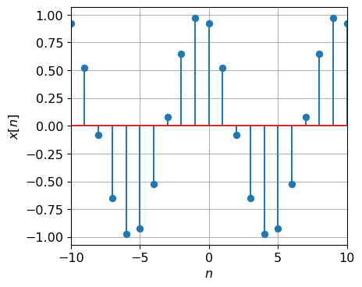

For CT sinusoids as $ω_{0}$ increases the signal oscillates faster and faster. However for DT sinusoids there is a "fastest" oscillation.

$$e^{jω_{0}n}|_{ω_{0}=π}=e^{jπn}={\left(−1\right)}^{n}$$

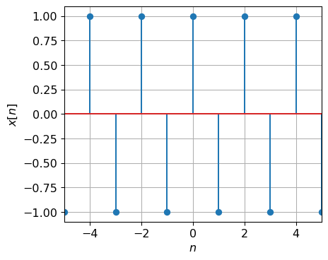

### 3.5.4 Properties of DT complex sinusoid

If we consider two frequencies: $ω_{0}$ and $ω_{0}+2π$. In the first case:

$$x\left[n\right]=e^{jω_{0}n}$$

In the second case:

$$\begin{matrix}x\left[n\right] & =e^{j\left(ω_{0}+2π\right)n} \\ & =\underset{\text{always 1}}{\underset{⏟}{e^{j2πn}}} e^{jω_{0}n} \\ & =e^{jω_{0}n}\end{matrix}$$

Thus the two are the same signal. This has important implications later in the course.

Another difference between CT and DT complex sinusoids is periodicity. Recall for a DT signal to be periodic with period $N$

$$x\left[n\right]=x\left[n+N\right] ∀n$$

Substituting the complex sinusoid

$$e^{jω_{0}n}=e^{jω_{0}\left(n+N\right)}=e^{jω_{0}n}e^{jω_{0}N}$$

requires $e^{jω_{0}N}=1$, which implies $ω_{0}N$ is a multiple of $2π$:

$$ω_{0}N=2πm m=±1,±2,⋯$$

or equivalently

$$\frac{\left|ω_{0}\right|}{2π}=\frac{m}{N}$$

thus $ω_{0}$ must be a rational multiple of $π$.

Two DT complex sinusoids are harmonics of one another is both are periodic in $N$, i.e when

$$x_{k}\left(t\right)=e^{jk\frac{2π}{N}n} \text{for} k=0,±1,±2,⋯$$

This implies there are only $N$ distinct harmonics in DT.

### 3.5.5 DT Complex Exponential: general case

In the general case we get a sinusoid signal modulated by an exponential. Let $C=Ae^{jϕ}$ and $β=r+jω_{0}$, then

$$x\left[n\right]=Ce^{βn}=Ae^{jϕ}e^{\left(r+jω_{0}\right)n}$$

Expanding the terms and using Euler’s identity gives:

$$x\left[n\right]=\underset{ℜ\text{part}}{\underset{⏟}{Ae^{rn}cos\left(ω_{0}n+ϕ\right)}}+j\underset{ℑ\text{part}}{\underset{⏟}{Ae^{rn}sin\left(ω_{0}n+ϕ\right)}}$$

Each part is a real sinusoid whose amplitude is modulated by a real exponential.

The visualization of the general case is to view the signal $x\left[n\right]$ as a vector rotating through fixed angles in the complex plane.

|  |
| --- |
| Figure 3.3: The DT complex sinusoid at a specific point in time. |

# 4. CT Systems as Linear Constant Coefficient Differential Equations

Recall a system is a transformation of signals, turning the input signal into the output signal. While this might seem like a new concept to you, you already know something about them from your differential equations course, i.e. MATH 2214 and your circuits course.

For example, consider the following circuit:

|  |
| --- |
| Figure 4.1: A series RC circuit connected to a battery by a switch. |

where the switch moves position at $t=0$. The governing equation for the circuit when $t<0$ is

$$\frac{dV_{c}}{dt}\left(t\right)+\frac{1}{RC}V_{c}\left(t\right)=0$$

a *homogeneous* differential equation of first-order. From a DC analysis, the initial condition on the capacitor voltage is $V_{C}\left(0^{−}\right)=0$, so there is no current flowing prior to $t=0$ and the solution is $V_{C}\left(t\right)=0$ for $t<0$.

After the switch is thrown, the governing equation for the circuit when $t≥0$ is

$$\frac{dV_{c}}{dt}\left(t\right)+\frac{1}{RC}V_{c}\left(t\right)=\frac{1}{RC}$$

Since the voltage across the capacitor cannot change instantaneously $V_{C}\left(0^{−}\right)=V_{C}\left(0^{+}\right)=0$, giving the auxillary condition necessary to solve this equation, which has the form

$$V_{C}\left(t\right)=A+Be^{−\frac{1}{RC}t}$$

Using the auxillary condition we find

$$V_{C}\left(0\right)=A+Be^{−\frac{1}{RC}0}=A+B=0\text{ which implies }B=−A$$

Subsitution back into the differential equation and equating the coefficients gives $A=1$. Thus the voltage for $t≥0$ is

$$V_{C}\left(t\right)=1−e^{−\frac{1}{RC}t}$$

Suppose we consider the voltage after the switch as the input signal $x\left(t\right)$ to the system composed of the series RC. As we have seen previously a mathematical model of the switch is the unit step $x\left(t\right)=u\left(t\right)$. Suppose we consider the capacitor voltage at the output of the system, so that $y\left(t\right)=V_{C}\left(t\right)$. Then we can consider the system to be represented by the *linear, constant-coefficient differential equation*

$$\frac{dy}{dt}\left(t\right)+\frac{1}{RC}y\left(t\right)=\frac{1}{RC}x\left(t\right)$$

where $x\left(t\right)=u\left(t\right)$ and the solution $y\left(t\right)$ is the *step response*

$$y\left(t\right)=\left(1−e^{−\frac{1}{RC}t}\right)u\left(t\right)$$

As we will see later this representation of systems is central to the course, so we take some time here to review the solution of such equations.

## 4.1 Solving Linear, Constant Coefficient Differential Equations

A linear, constant coefficient (LCC) differential equation is of the form

$$a_{0} y+a_{1} \frac{dy}{dt}+a_{2} \frac{d^{2}y}{dt^{2}}+⋯+a_{N} \frac{d^{N}y}{dt^{N}}=b_{0} x+b_{1} \frac{dx}{dt}+b_{2} \frac{d^{2}x}{dt^{2}}+⋯+b_{M} \frac{d^{M}x}{dt^{M}}$$

which can be written compactly as

$$\sum_{k=0}^{N}{a_{k}} \frac{d^{k}y}{dt^{k}}=\sum_{k=0}^{M}{b_{k}} \frac{d^{k}x}{dt^{k}}$$

It is helpful to clean up this notation using the derivative operator $D^{n}=\frac{d^{n}}{dt^{n}}$. For example $D^{2}y=\frac{d^{2}y}{dt^{2}}$ and $D^{0}y=y$. To give for form as

$$\sum_{k=0}^{N}{a_{k}} D^{k}y=\sum_{k=0}^{M}{b_{k}} D^{k}x$$

We can factor out the derivative operators

$$a_{0}y+a_{1}Dy+a_{2}D^{2}y+⋯+a_{N}D^{N}y=b_{0} x+b_{1} Dx+b_{2} D^{2}x+⋯+b_{M} D^{M}x$$

$$\underset{\text{Polynomial in }D,Q\left(D\right)}{\underset{⏟}{\left(a_{0}+a_{1}D+a_{2}D^{2}+⋯+a_{N}D^{N}\right)}}y=\underset{\text{Polynomial in }D,P\left(D\right)}{\underset{⏟}{\left(b_{0}+b_{1}D+b_{2}D^{2}+⋯+b_{M}D^{M}\right)}}x$$

to give:

$$Q\left(D\right)y=P\left(D\right)x$$

You learned how to solve these in differential equations (Math 2214) as

$$y\left(t\right)=y_{\text{h}}\left(t\right)+y_{\text{p}}\left(t\right)$$

The term $y_{\text{h}}\left(t\right)$ is the solution of the homogeneous equation

$$Q\left(D\right)y=0$$

Given the $N−1$ auxillary conditions $y\left(t_{0}\right)=y_{0}$, $Dy\left(t_{0}\right)=y_{1}$, $D^{2}y\left(t_{0}\right)=y_{2}$, up to $D^{N−1}y\left(t_{0}\right)=y_{N−1}$.

The term $y_{\text{p}}\left(t\right)$ is the solution of the particular equation

$$Q\left(D\right)y=P\left(D\right)x$$

for a given $x\left(t\right)$.

Rather than recapitulate the solution to $y_{\text{h}}\left(t\right)$ and $y_{\text{p}}\left(t\right)$ in the general case we focus on the homogeneous solution $y_{\text{h}}\left(t\right)$ only. The reason is that we will use the homogeneous solution to find the impulse response below and take a different approach to solving the general case for an arbitrary input using the impulse response and convolution (next week).

To solve the homogenous system:

**Step 1:** Find the *characteristic equation* by replacing the derivative operators by powers of an arbitrary complex variable $s$.

$$Q\left(D\right)=a_{0}+a_{1}D+a_{2}D^{2}+⋯+a_{N}D^{N}$$

becomes

$$Q\left(s\right)=a_{0}+a_{1}s+a_{2}s^{2}+⋯+a_{N}s^{N}$$

a polynomial in $s$ with $N$ roots $s_{i}$ for $i=1,2,⋯,N$ such that

$$\left(s−s_{1}\right)\left(s−s_{2}\right)⋯\left(s−s_{N}\right)=0$$

**Step 2:** Select the form of the solution, a sum of terms corresponding to the roots of the characteristic equation.

* For a real root $s_{1}∈R$ the term is of the form
$$C_{1}e^{s_{1}t}.$$

* For a pair of complex roots (they will always be in pairs) $s_{1,2}=a±jb$ the term is of the form
$$C_{1}e^{s_{1}t}+C_{2}e^{s_{2}t}=e^{at}\left(C_{3}cos\left(bt\right)+C_{4}sin\left(bt\right)\right)=C_{5}e^{at}cos\left(bt+C_{6}\right).$$

* For a repeated root $s_{1}$, repeated $r$ times, the term is of the form

$$e^{s_{1}t}\left(C_{0}+C_{1}t+⋯+C_{r−1}t^{r−1}\right).$$

**Step 3:** Solve for the unknown constants in the solution using the auxillary conditions.

We now examine two common special cases, when $N=1$ (first-order) and when $N=2$ (second-order).

### 4.1.1 First-Order Homogeneous LCCDE

Consider the first order homogeneous differential equation

$$\frac{dy}{dt}\left(t\right)+ay\left(t\right)=0\text{ for }a∈R$$

The characteristic equation is given by

$$s+a=0$$

which has a single root $s_{1}=−a$. The solution is of the form

$$y\left(t\right)=Ce^{s_{1}t}=Ce^{−at}$$

where the constant $C$ is found using the auxillary condition $y\left(t_{0}\right)=y_{0}$.

Example

Consider the homogeneous equation

$$\frac{dy}{dt}\left(t\right)+3y\left(t\right)=0\text{ where }y\left(0\right)=10$$

The solution is

$$y\left(t\right)=Ce^{−3t}$$

To find $C$ we use the auxillary condition

$$y\left(0\right)=Ce^{−3⋅0}=C=10$$

and the final solution is

$$y\left(t\right)=10e^{−3t}$$

### 4.1.2 Second-Order Homogeneous LCCDE

Consider the second-order homogeneous differential equation

$$\frac{d^{2}y}{dt^{2}}\left(t\right)+a\frac{dy}{dt}\left(t\right)+by\left(t\right)=0\text{ for }a,b∈R$$

The characteristic equation is given by

$$s^{2}+as+b=0$$

Let’s look at several examples to illustrate the functional forms.

Example

$$\frac{d^{2}y}{dt^{2}}\left(t\right)+7\frac{dy}{dt}\left(t\right)+10y\left(t\right)=0$$

The characteristic equation is given by

$$s^{2}+7s+10=0$$

which has roots $s_{1}=−2$ and $s_{2}=−5$. Thus the form of the solution is

$$y\left(t\right)=C_{1}e^{−2t}+C_{2}e^{−5t}$$

Example

$$\frac{d^{2}y}{dt^{2}}\left(t\right)+2\frac{dy}{dt}\left(t\right)+5y\left(t\right)=0$$

The characteristic equation is given by

$$s^{2}+2s+5=0$$

which has complex roots $s_{1}=−1+j2$ and $s_{1}=−1−j2$. Thus the form of the solution is

$$y\left(t\right)=e^{−t}\left(C_{1}cos\left(2t\right)+C_{2}sin\left(2t\right)\right)$$

Example

$$\frac{d^{2}y}{dt^{2}}\left(t\right)+2\frac{dy}{dt}\left(t\right)+y\left(t\right)=0$$

The characteristic equation is given by

$$s^{2}+2s+1=0$$

which has a root $s_{1}=−1$ repeated $r=2$ times. Thus the form of the solution is

$$y\left(t\right)=e^{−t}\left(C_{1}+C_{2}t\right)$$

In each of the above cases the constants, $C_{1}$ and $C_{2}$, are found using the auxillary conditions $y\left(t_{0}\right)$ and $y′\left(t_{0}\right)$.

## 4.2 Finding the impulse response of a system described by a LCCDE

As we will see next week an important response of a system is the one that corresponds to an impulse input, i.e. the *impulse response $y\left(t\right)=h\left(t\right)$* when $x\left(t\right)=δ\left(t\right)$. Thus we focus here on a recipe for solving LCCDEs for this special case when $M≤N$. We will skip the derivation of why this works.

Our goal is to find the solution to $Q\left(D\right)y=P\left(D\right)x$ when $x\left(t\right)=δ\left(t\right)$.

**Step 1:** Rearrange the LCCDE so that $a_{N}=1$, i.e. divide through by $a_{N}$ to put it into a standard form.  
**Step 2:** Let $y_{h}\left(t\right)$ be the homogeneous solution to $Q\left(D\right)y_{h}=0$ for auxillary conditions

$$D^{N−1}y_{h}\left(0^{+}\right)=1 , D^{N−2}y_{h}\left(0^{+}\right)=0 , \text{etc.} y_{h}\left(0^{+}\right)=0$$

**Step 3:** Assume a form for $h\left(t\right)$ given by:

$$h\left(t\right)=\underset{=0\text{ unless }N=M}{\underset{⏟}{b_{N}δ\left(t\right)}}+\underset{\text{apply }P\left(D\right)\text{ to }y_{n}\left(t\right)}{\underset{⏟}{\left[P\left(D\right)y_{h}\right]}}u\left(t\right)$$

Recall from above the homogeneous solution depends on the roots of the characteristic equation $Q\left(D\right)=0$.

* roots are either real, or
* roots occur in complex conjugate pairs, or
* repeated roots.

Example

Find the impulse response of the LCCDE

$$2\frac{dy}{dt}\left(t\right)+2y\left(t\right)=2x\left(t\right)$$

In the standard for the LCCDE is

$$\frac{dy}{dt}\left(t\right)+y\left(t\right)=x\left(t\right)$$

The characteristic equation is given by

$$s+1=0$$

which has a single root $s_{1}=−1$. The solution is of the form

$$y_{h}\left(t\right)=Ce^{−t}$$

with the special auxillary condition $y\left(0\right)=1$, so that

$$y_{h}\left(t\right)=e^{−t}$$

Since $P\left(D\right)=1$ and $N=1≠M=0$ the impulse response is

$$h\left(t\right)=\underset{=0}{\underset{⏟}{b_{N}δ\left(t\right)}}+\left[\underset{1}{\underset{⏟}{P\left(D\right)}}y_{h}\left(t\right)\right]u\left(t\right)=e^{−t}u\left(t\right)$$

Example

Find the impulse response of the LCCDE

$$\frac{dy}{dt}\left(t\right)+y\left(t\right)=\frac{dx}{dt}\left(t\right)+x\left(t\right)$$

It is already in the standard form. The homogeneous solution is the same as in Example 1,

$$y_{h}\left(t\right)=e^{−t}$$

however now $M=N=1$ with $b_{1}=1$ and $P\left(D\right)=D+1$. Thus, the impulse response is

$$h\left(t\right)=\underset{=1}{\underset{⏟}{b_{N}}}δ\left(t\right)+\left[\underset{D+1}{\underset{⏟}{P\left(D\right)}}y_{h}\left(t\right)\right]u\left(t\right)=δ\left(t\right)+\left\{\left[D+1\right]e^{−t}\right\}u\left(t\right)=δ\left(t\right)+\left[−e^{−t}+e^{−t}\right]u\left(t\right)=δ\left(t\right)$$

Example

Find the impulse response of the LCCDE

$$\frac{d^{2}y}{dt^{2}}\left(t\right)+7\frac{dy}{dt}y\left(t\right)+10y\left(t\right)=x\left(t\right)$$

It is already in the standard form. The characteristic equation is given by

$$s^{2}+7s+10=0$$

which has roots $s_{1}=−2$ and $s_{2}=−5$. Thus the form of the solution is

$$y_{h}\left(t\right)=C_{1}e^{−2t}+C_{2}e^{−5t}$$

The special auxillary conditions are $y_{h}\left(0\right)=0$ and $y_{h}^{′}\left(0\right)=1$. Using these conditions

$$y_{h}\left(0\right)=C_{1}e^{−2t}+C_{2}e^{−5t}|_{t=0}=C_{1}+C_{2}=0$$

$$y_{h}^{′}\left(0\right)=−2C_{1}e^{−2t}−5C_{2}e^{−5t}|_{t=0}=−2C_{1}−5C_{2}=1$$

Solving for the constants gives $C_{1}=\frac{1}{3}$ and $C_{2}=−\frac{1}{3}$. Since $P\left(D\right)=1$ and $N=2≠M=0$ the impulse response is

$$h\left(t\right)=\underset{=0}{\underset{⏟}{b_{N}δ\left(t\right)}}+\left[\underset{1}{\underset{⏟}{P\left(D\right)}}y_{h}\left(t\right)\right]u\left(t\right)=\frac{1}{3}e^{−2t}u\left(t\right)−\frac{1}{3}e^{−5t}u\left(t\right)$$

# 5. DT systems as linear constant coefficient difference equations

A *difference equation* is a relation among combinations of two DT functions and shifted versions of them. Similar to differential equations where the solution is a CT function, the solution to a difference equation is a DT function. For example:

$$y\left[n+1\right]+\frac{1}{2}y\left[n\right]=x\left[n\right]$$

is a first order, linear, constant-coefficient difference equation. Given $x\left[n\right]$ the solution is a function $y\left[n\right]$. We can view this as a representation of a DT system, where $x\left[n\right]$ is the input signal and $y\left[n\right]$ is the output.

There is a parallel theory to differential equations for solving difference equations. However in this lecture we will focus specifically on the iterative solution of linear, constant-coefficient difference equations and the case when the input is a delta function, as this is all we need for this course.

## 5.1 Definition of linear constant coefficient difference equation

A *linear*, *constant-coefficient*, difference equation (LCCDE) comes in one of two forms.

* Delay form.
$$\sum_{k=0}^{N}{a_{k}}y\left[n−k\right]=\sum_{k=0}^{M}{b_{k}}x\left[n−k\right]$$

* or
$$a_{0}y\left[n\right]+a_{1}y\left[n−1\right]+⋯a_{N}y\left[n−N\right]=b_{0}x\left[n\right]+⋯b_{M}x\left[n−M\right]$$

* Advance form. Let $n→n+N$, then the delay form becomes
$$\sum_{k=0}^{N}{a_{k}}y\left[n+N−k\right]=\sum_{k=0}^{M}{b_{k}}x\left[n+N−k\right]$$

* or

$$a_{0}y\left[n+N\right]+a_{1}y\left[n+N−1\right]+⋯a_{N}y\left[n\right]=b_{0}x\left[n+N\right]+⋯b_{M}x\left[n+N−M\right]$$

The *order* of the system is given by $N$. The delay and advance forms are equivalent because the equation holds for any $n$, and we can move back and forth between them as needed by a constant index-shift.

Example

The delay form is

$$a_{0}y\left[n\right]+a_{1}y\left[n−1\right]+a_{2}y\left[n−2\right]=b_{0}x\left[n\right]+b_{1}x\left[n−1\right]$$

Replacing $n→n+2$, the advance form is

$$a_{0}y\left[n+2\right]+a_{1}y\left[n+1\right]+a_{2}y\left[n\right]=b_{0}x\left[n+2\right]+b_{1}x\left[n+1\right]$$

It will be convenient to define the operator $E^{m}$ as shifting a DT function by positive $m$, i.e. $E^{m}x\left[n\right]=x\left[n+m\right]$ , and the operator $D^{m}$ as shifting a DT function by negative $m$, i.e. $D^{m}x\left[n\right]=x\left[n−m\right]$. These are called the advance and delay operators respectively. Then, the advance form of the difference equation using this operator notation is

$$a_{0}y\left[n+N\right]+a_{1}y\left[n+N−1\right]+⋯a_{N}y\left[n\right]=b_{0}x\left[n+N\right]+⋯b_{M}x\left[n+N−M\right]$$

$$a_{0}E^{N}y+a_{1}E^{N−1}y+⋯a_{N}y=b_{0}E^{N}x+⋯b_{M}E^{N−M}x$$

Factoring out the advance operators gives

$$\underset{Q\left(E\right)}{\underset{⏟}{\left(a_{0}E^{N}+a_{1}E^{N−1}+⋯a_{N}\right)}}y=\underset{P\left(E\right)}{\underset{⏟}{\left(b_{0}E^{N}+⋯b_{M}E^{N−M}\right)}}x$$

or

$$Q\left(E\right)y\left[n\right]=P\left(E\right)x\left[n\right]$$

Similarly, the delay form of the difference equation using this operator notation is

$$a_{0}y\left[n\right]+a_{1}y\left[n−1\right]+⋯a_{N}y\left[n−N\right]=b_{0}x\left[n\right]+⋯b_{M}x\left[n−M\right]$$

$$a_{0}y\left[n\right]+a_{1}Dy+⋯a_{N}D^{N}y=b_{0}x+⋯b_{M}D^{M}x$$

Note: The DT delay operator $D$ is similar, but *not* identical to the derivative operator $D$ in CT.

Example

Consider the difference equation

$$3y\left[n+1\right]+4y\left[n\right]+5y\left[n−1\right]=2x\left[n+1\right]$$

The advance form would be:

$$3y\left[n+2\right]+4y\left[n+1\right]+5y\left[n\right]=2x\left[n+2\right]$$

or using the advance operator

$$\left(3E^{2}+4E+5\right)y=2E^{2}x$$

with $Q\left(E\right)=3E^{2}+4E+5$ and $P\left(E\right)=2E^{2}$.  
The delay form would be:

$$3y\left[n\right]+4y\left[n−1\right]+5y\left[n−2\right]=2x\left[n\right]$$

or using the delay operator

$$\left(5D^{2}+4D+3\right)y=2x$$

with $Q\left(D\right)=5D^{2}+4D+3$ and $P\left(D\right)=2$.

## 5.2 Iterative solution of LCCDEs

Difference equations are different (pun!) from differential equations in that they can be solved by manually running the equation forward using previous values of the output and current and previous values of the input, given some initial conditions. This is called an *iterative* solution for this reason.

To perform an iterative solution we need the difference equation in delay form

$$a_{0}y\left[n\right]+a_{1}y\left[n−1\right]+⋯a_{N}y\left[n−N\right]=b_{0}x\left[n\right]+⋯b_{M}x\left[n−M\right]$$

We then solve for the current output $y\left[n\right]$

$$y\left[n\right]=−\left(\frac{a_{1}}{a_{0}}y\left[n−1\right]+⋯\frac{a_{N}}{a_{0}}y\left[n−N\right]\right)+\frac{b_{0}}{a_{0}}x\left[n\right]+⋯\frac{b_{M}}{a_{0}}x\left[n−M\right]$$

Now lets examine what this expression says in words. To compute the current output $y\left[n\right]$ we need the value of the *previous $N−1$* outputs, the value of the *current* input $x\left[n\right]$ and $M−1$*previous* inputs (and the coefficients). Then we can compute the next output $y\left[n+1\right]$ by adding the previous computation result for $y\left[n\right]$ to our list of things to remember, and forgetting one previous value of $y$. This can continue as long as we like.

Example

Consider the first-order difference equation

$$y\left[n+1\right]+y\left[n\right]=x\left[n+1\right]$$

where $y\left[−1\right]=1$ and $x\left[n\right]=u\left[n\right]$. We first convert this to delay form

$$y\left[n\right]=−y\left[n−1\right]+x\left[n\right] .$$

Then we can compute $y\left[0\right]$ as

$$y\left[0\right]=−y\left[−1\right]+x\left[0\right]=−1+1=0$$

and continuing

We can see that this will continue to give the alternating sequence $1,0,1,0,1,⋯$.

## 5.3 Solution of the homogeneous LCCDE

Note the iterative solution does not give us (directly) and analytical expression for the output at arbitrary $n$. We have to start at the initial conditions and compute our way up to $n$. We now consider an analytical solution when the input is zero, the solution to the *homogeneous* difference equation

$$Q\left(E\right) y=a_{0}y\left[n+N\right]+a_{1}y\left[n+N−1\right]+⋯a_{N}y\left[n\right]=0 .$$

given $N$ sequential auxiliary conditions on $y$.

Similar to differential equations, the homogeneous solution depends on the roots of the characteristic equation $Q\left(E\right)=0$ whose roots are either real or occur in complex conjugate pairs. Let $λ_{i}$ be the $i$-th root of $Q\left(E\right)=0$, then the solution is of the form

$$y\left[n\right]=\sum_{i=1}^{N}{C_{i}}λ_{i}^{n}$$

where the parameters $C_{i}$ are determined from the auxiliary conditions.

For a real system (when the coefficients of the difference equation are real) and when the roots are complex $λ_{1,2}=\left|λ\right|e^{±jβ}$, it is cleaner to assume a form for those terms as

$$y\left[n\right]=C{\left|λ\right|}^{n}cos\left(βn+θ\right)$$

for constants $C$ and $θ$.

Example

Find the solution to the first-order homogeneous LCCDE

$$y\left[n+1\right]+\frac{1}{2}y\left[n\right]=0\text{ with }y\left[0\right]=5 .$$

Note $Q\left(E\right)=E+\frac{1}{2}$ has a single root $λ_{1}=−\frac{1}{2}$. Thus the solution is of the form

$$y\left[n\right]=C{\left(−\frac{1}{2}\right)}^{n}$$

where the parameter $C$ is found using

$$y\left[0\right]=C=5$$

to give the final solution

$$y\left[n\right]=5{\left(−\frac{1}{2}\right)}^{n}$$

Example

Find the solution to the second-order homogeneous LCCDE

$$y\left[n+2\right]+y\left[n+1\right]+\frac{1}{2}y\left[n\right]=0\text{ with }y\left[0\right]=1\text{ and }y\left[1\right]=0 .$$

Note $Q\left(E\right)=E^{2}+E+\frac{1}{2}$ has a pair of complex roots $λ_{1,2}=−\frac{1}{2}±j\frac{1}{2}$. Thus the solution is of the form

$$y\left[n\right]=C{\left|\frac{1}{\sqrt{2}}\right|}^{n}cos\left(\frac{3π}{4}n+θ\right)$$

where the parameters are found using

$$y\left[0\right]=Ccos\left(θ\right)=1$$

$$y\left[1\right]=C\frac{1}{\sqrt{2}}cos\left(\frac{3π}{4}+θ\right)=0$$

This is true when

$$C=\sqrt{2}\text{ and }θ=−\frac{π}{4}+2πm$$

for any $m∈Z$ since $cos$ is periodic in $2π$. A final solution is then

$$y\left[n\right]=\sqrt{2}{\left|\frac{1}{\sqrt{2}}\right|}^{n}cos\left(\frac{3π}{4}n−\frac{π}{4}\right)$$

See the appendix for a general technique to solve for these constants.

## 5.4 Impulse response from LCCDE

Today our goal is to find the solution to $Q\left(E\right)y=P\left(E\right)x$ when $x\left[n\right]=δ\left[n\right]$ assuming $y\left[n\right]=0$ for $n<0$, giving the *impulse response $y\left[n\right]=h\left[n\right]$* . We skip the derivation here and just give a procedure.

**Step 1:** Let $y_{h}$ be the homogeneous solution to $Q\left(E\right)y_{h}=0$ for $n>N$.

**Step 2:** Assume a form for $h\left[n\right]$ given by

$$h\left[n\right]=\frac{b_{N}}{a_{N}}δ\left[n\right]+y_{h}\left[n\right]u\left[n\right]$$

**Step 3:** Using the iterative procedure above find the $N$ auxiliary conditions we need by,

* first, rewrite the equation in delay form and solve for $y\left[n\right]$,
* then let $x\left[n\right]=δ\left[n\right]$ and manually compute $h\left[0\right]$ assuming $h\left[n\right]=0$ for $n<0$,
* repeating the previous step for $h\left[1\right]$, continuing up to $h\left[N−1\right]$.

**Step 4:** Using the auxillary conditions in step 3, solve for the constants in the solution $h\left[n\right]$ from step 2.

Example

Find the impulse response of the system given by

$$y\left[n+2\right]−\frac{1}{4}y\left[n+1\right]−\frac{1}{8}y\left[n\right]=2x\left[n+1\right]$$

For step 1 we solve the equation

$$y_{h}\left[n+2\right]−\frac{1}{4}y_{h}\left[n+1\right]−\frac{1}{8}y_{h}\left[n\right]=0$$

which is of the form

$$y_{h}\left[n\right]=C_{1}{\left(−\frac{1}{4}\right)}^{n}+C_{2}{\left(\frac{1}{2}\right)}^{n}$$

since the roots of $Q\left(E\right)=E^{2}−\frac{1}{4}E−\frac{1}{8}$ are $−\frac{1}{4}$ and $\frac{1}{2}$.

For step 3, we find the auxiliary conditions needed to find $C_{1}$ and $C_{2}$ by rewriting the original equation in delay form and solving for $y\left[0\right]$ and $y\left[1\right]$ when $x\left[n\right]=δ\left[n\right]$.

$$y\left[n\right]=\frac{1}{4}y\left[n−1\right]+\frac{1}{8}y\left[n−2\right]+2x\left[n−1\right]$$

Let $x\left[n\right]=δ\left[n\right]$ and manually compute $y\left[0\right]$ assuming $y\left[n\right]=0$ for $n<0$

$$y\left[0\right]=\frac{1}{4}\underset{0}{\underset{⏟}{y\left[0−1\right]}}+\frac{1}{8}\underset{0}{\underset{⏟}{y\left[0−2\right]}}+2\underset{0}{\underset{⏟}{δ\left[0−1\right]}}=0$$

Repeat for $y\left[1\right]$

$$y\left[1\right]=\frac{1}{4}\underset{0}{\underset{⏟}{y\left[1−1\right]}}+\frac{1}{8}\underset{0}{\underset{⏟}{y\left[1−2\right]}}+2\underset{1}{\underset{⏟}{δ\left[1−1\right]}}=2$$

Now we find the constants using step 4

$$h\left[0\right]=C_{1}+C_{2}=0$$

$$h\left[1\right]=C_{1}\left(−\frac{1}{4}\right)+C_{2}\left(\frac{1}{2}\right)=2$$

which gives $C_{1}=−\frac{8}{3}$ and $C_{2}=\frac{8}{3}$. Thus the final impulse response is

$$h\left[n\right]=\frac{b_{N}}{a_{N}}δ\left[n\right]+y_{h}\left[n\right]u\left[n\right]=−\frac{8}{3}{\left(−\frac{1}{4}\right)}^{n}u\left[n\right]+\frac{8}{3}{\left(\frac{1}{2}\right)}^{n}u\left[n\right]$$

since $b_{N}=0$.

Note we can confirm our closed-form result in the previous example, for a few values of $n$, by iteratively solving the difference equation

$$h\left[0\right]=\frac{1}{4}\underset{0}{\underset{⏟}{h\left[0−1\right]}}+\frac{1}{8}\underset{0}{\underset{⏟}{h\left[0−2\right]}}+2\underset{0}{\underset{⏟}{δ\left[0−1\right]}}=0$$

$$h\left[1\right]=\frac{1}{4}\underset{0}{\underset{⏟}{h\left[1−1\right]}}+\frac{1}{8}\underset{0}{\underset{⏟}{h\left[1−2\right]}}+2\underset{1}{\underset{⏟}{δ\left[1−1\right]}}=2$$

$$h\left[2\right]=\frac{1}{4}\underset{2}{\underset{⏟}{h\left[2−1\right]}}+\frac{1}{8}\underset{0}{\underset{⏟}{h\left[2−2\right]}}+2\underset{0}{\underset{⏟}{δ\left[2−1\right]}}=\frac{1}{2}$$

$$h\left[3\right]=\frac{1}{4}\underset{\frac{1}{2}}{\underset{⏟}{h\left[3−1\right]}}+\frac{1}{8}\underset{2}{\underset{⏟}{h\left[3−2\right]}}+2\underset{0}{\underset{⏟}{δ\left[2−1\right]}}=\frac{3}{8}$$

and comparing to our closed-form solution a the same values of $n$

$$h\left[0\right]=−\frac{8}{3}+\frac{8}{3}=0$$

$$h\left[1\right]=−\frac{8}{3}\left(−\frac{1}{4}\right)+\frac{8}{3}\left(\frac{1}{2}\right)=2$$

$$h\left[2\right]=−\frac{8}{3}{\left(−\frac{1}{4}\right)}^{2}+\frac{8}{3}{\left(\frac{1}{2}\right)}^{2}=\frac{1}{2}$$

$$h\left[3\right]=−\frac{8}{3}{\left(−\frac{1}{4}\right)}^{3}+\frac{8}{3}{\left(\frac{1}{2}\right)}^{3}=\frac{3}{8}$$

Example

Find the impulse response of the system given by

$$y\left[n+1\right]−\frac{1}{2}y\left[n\right]=x\left[n+1\right]+x\left[n\right]$$

In step 1 we note the solution to $Q\left(E\right)y\left[n\right]=0$ is of the form

$$y_{h}\left[n\right]=C{\left(\frac{1}{2}\right)}^{n}$$

From step 2 we note $b_{N}=1$ and $a_{N}=−\frac{1}{2}$, so that

$$h\left[n\right]=−2δ\left[n\right]+C{\left(\frac{1}{2}\right)}^{n} u\left[n\right]$$

In step 3 we manually find $h\left[0\right]$

And in step 4 we solve for $C$

$$h\left[0\right]=−2+C=1\text{ implies }C=3$$

to give

$$h\left[n\right]=−2δ\left[n\right]+3{\left(\frac{1}{2}\right)}^{n} u\left[n\right]$$

# 6. 6. Linear Time Invariant CT Systems

Today’s topic is our introduction to CT systems and the important case of CT Linear, Time-Invariant Systems.

## 6.1 System types

A system is an interconncted set of components or sub-systems. Mathematically a system is a transformation between one or more signals, a rule that maps functions to functions.

* single input - single output (SISO) system.
* 
* SISO Block Diagram
* single input - multiple output (SIMO) system
* 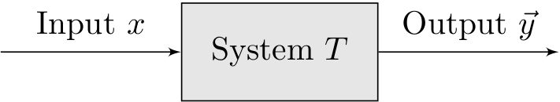
* SIMO Block Diagram
* general case, multiple input - multiple output (MIMO)
* 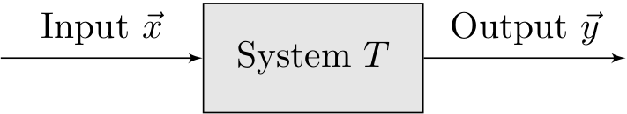
* MIMO Block Diagram

We will focus on single input - single output, CT and DT systems.

# References