BIMField is a model based application intended for mobile devices. It is provided “As is” as a technology preview. It was primarily developed with Chrome and Android. It provides for viewing asset data and creating work orders from the model.
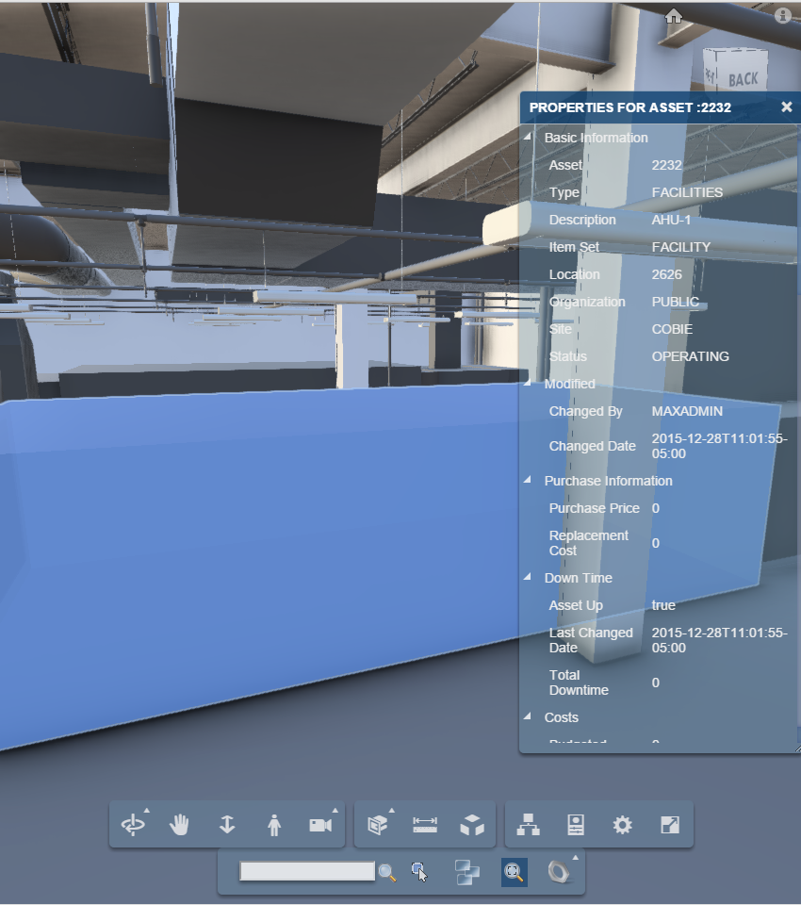

Installation
While installing the BIM, after coping the BIM solution files onto the expanded EAR and before rebuilding the EAR copy the BIMField files into the expanded EAR.
It may be added to an existing BIM installation by coping the BIMField subdirectory into the maximouiweb.war/webclient directory of the installed applications.
It is dependent on the current level of the BIM solution

Launch
BIMField may be launched from the following URL:
http://<hostname:port>/maximo/webclient/BIMField/viewer.jsp
It supports the following query parameters:
appservauth=true | This should be used if your Maximo installation uses appserver authentication for a slightly improved login experience.
j_username=<username> | Allows credentials to be passed on the URL. Must be used with j_password, and should only be used over and SSL connection
j_password=<password> | Allows credentials to be passed on the URL. Must be used with j_username, and should only be used over and SSL connection
assetuid=<Assetuid> | Bypasses the initial model list loads the model for the listed asset and selects and zooms to it.

Example:
http://maximo.mycompany.com/maximo/webclient/BIMField/viewer.jsp?appservauth=true&j_username=maxadmin&j_password=maxadmin&assetuid=1234

Known Limitations
- When Maximo uses App Server authentication, there are several places including on session timeout that the browser login prompt is displayed instead of the Maximo login screen
- The application uses the Maximo Integration Framework (MIF), and the MIF context root is hard coded as maxrest. If this is not the context root, viewer.jsp must be editied to specify the correct context root.

