
Manufacturing Brief

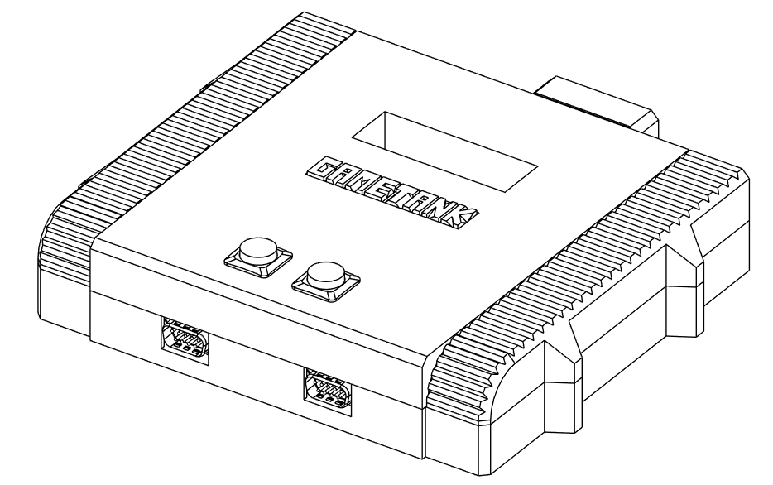

Prepared by Clydeware, LLC
Updated 16th September 2026
Table of Contents
Hardware Descriptions | 3
Bill of Materials
Motherboard | 4
Audio/Visual Board | 6
Console Assembly | 8
Controller | 9
Data Cartridge | 9
Cartridge Flasher Tool | 10
3D Printed Parts
Main Game Console Unit | 11
Controller | 12
Data Cartridge | 13
Cartridge Flasher Tool | 14
Assembly Procedure
Main Console PCB Stack | 15
Enclosure Top Half Preparation | 17
Console Assembly | 19
Controller Wiring | 22
Controller Assembly | 23
Data Cartridge | 24
Cartridge Flasher Tool | 27
Cartridge Flasher Firmware | 28
Cartridge Flasher Operation | 29
Parts Sourcing Notes | 30

Hardware Descriptions

Main Game Console Unit
A GameTank console consists of two PCBs inside a plastic enclosure. The two PCBs are connected electrically by a pair of flat flexible cables, and mechanically by four standoff fasteners. There is also a 3D-printed spacer placed in the center of the board stack. The enclosure consists of four printed parts, and two push-buttons. The buttons have a wire harness soldered on, which plugs into the motherboard in three places. The bottom half of the enclosure is one solid piece. The upper half of the enclosure has a printed decorative “badge” piece which is thermally bonded to the main upper part of the enclosure body. Lastly, a “vent” cover is placed at the rear of the console. The enclosure is held together by four screws which self-tap into the plastic.

Controller
The input device consists of an assembled PCB, a cable with an attached molded flangeless D-shape connector, four 3D printed parts, two screws, and two spacers. The printed parts include the main body of the controller in which the PCB rests, a faceplate with holes for buttons, a flexure holding four buttons and a plus-shaped directional pad, and an insert to be placed beneath the directional pad that prevents simultaneous opposite direction inputs. The cable is soldered directly to the PCB, and has a rubber strain relief boot that mates with a tab inside the controller body. The two screws are installed from the back of the controller through all other parts, and into the faceplate. The spacers support the center of the flexure, above the PCB. The faceplate is designed so that the screws self-tap.

Data Cartridge
The data cartridge consists of an assembled PCB, a 3D printed shell in two parts, and two screws. The PCB has plated finger contacts for use with the edge connector in the Console and the Flasher. The side of the PCB with mounted components is considered the front of the cartridge. The two halves of the shell have diagonal tabs to allow the cartridge to be stably held together by the two screws near the top. The screws should fit loosely through the back half of the shell, and self-tap into the front half. The cartridge may be affixed with a label bearing artwork for a particular game title. The front half of the shell has a gap to allow the label to be folded over for improved long term adhesion.

If being used as distribution media for software, the Cartridge Flasher Tool is used to load data into the flash memory of the cartridge.

Cartridge Flasher Tool
The cartridge flasher tool consists of an assembled PCB, a 3D printed base, and two screws. The AVR microcontroller on the PCB requires a bootloader and firmware. The programming header is exposed both as header pins and as Tag-Connect contacts. If the Tag-Connect header can be used for flashing at scale, the header pins may be omitted.

Bill of Materials

Main Game Console Unit – Motherboard (revised 13/8/26)
Qty | MPN | Description
1 | 5530843-3 | Card Edge Connector
2 | 62684-502100ALF | Connector, Flex Cable
2 | 74HC04PW,118 | Hex inverter
9 | 74HC257PW,118 | Quad 2-to-1 multiplexer
2 | 74HC40103D,653 | 8-bit synchronous binary down counter
1 | 74LVC2G07GW,125 | Dual buffer, open drain
1 | 860020273009 | Capacitor 220µF, Electrolytic
1 | AS6C4008-55TIN | SRAM, 512K x 8, 55ns
1 | AS7C256A-15TIN | SRAM, 32K x 8, 15ns
1 | CC0805KRX7R7BB104 | Capacitor 0.1µF, 16V, X7R, 0805
1 | CD74AC163M96 | Binary counter, synchronous, 4-bit
4 | CD74HC08PWR | Quad 2-input AND gate
1 | CD74HC30PWR | 8-input NAND gate
2 | CD74HCT238PWR | 3-to-8 line decoder/demultiplexer
1 | CDBW140-G | Power Diode
1 | CL32A106KAULNNE | CAP CER 10UF 25V X5R 1210
2 | CL32A226KOJNNNE | CAP CER 22UF 16V X5R 1210
1 | DCJ200-10-A-K1-K | DC power jack
3 | G800WC306018EU | 2-pin header, 2.54mm
1 | GRM1555C1H101JA01D | Capacitor 100pF 0402
94 | GRM155R62A104KE14J | Capacitor 0.1µF, 100V, X5R, 0402
1 | HDL26-SL-B | D-sub connector, 26-pin
2 | LD09P13A4GX00LF | D-sub connector, 9-pin female
1 | LFSPXO022134 | Oscillator / clock generator (Clydeware Provided)
1 | LPD5030-103MRC | Common Mode Choke
1 | MC74HC1GU04DFT1G | Single Logic Inverter
2 | MC74HC32ADTR2G | Quad 2-input OR gate
3 | MC74HC74ADTR2G | Dual D-type flip-flop
5 | MC74HC86ADTR2G | Quad 2-input XOR gate
1 | MCP130T-475I/TT | Voltage supervisor, reset IC, 4.75V
8 | MI0805K400R-10 | Ferrite Bead
1 | RC0805FR-07150RL | Resistor 150Ω, 1%, 0805
16 | RC0402JR-1310RL | 10 Ohm Resistor 0402
1 | RC0603FR-0710RL | 10 Ohm Resistor 0603
3 | RC0603FR-07100RL | 100 Ohm Resistor 0603
6 | RC0805FR-073K3L | Resistor 3.3kΩ, 1%, 0805
2 | YC158TJR-0710KL | Bussed Resistor Array 10k
1 | RC0805FR-07150RL | 150 Ohm Resistor 0805
11 | SN74HC573APWR | Octal latch, transparent, active-high
1 | SN74HC139PWR | Dual 2-to-4 line decoder
8 | SN74HC163PWR | 4-bit binary counter
1 | SN74HC640PWR | Octal bus transceiver, inverting
3 | SN74HCS00PWR | Quad 2-input NAND gate
1 | TPS22917DBVT | Load Switch
1 | AP63205WU-7 | DC-DC buck converter, 2A (Clydeware provided)
1 | CIGW252010GL4R7MNE | Inductor 4.7 µH
1 | W65C02S6TQG-14 | WDC 65C02 CPU, 14MHz, QFP (Clydeware provided)
1 | W65C22S6TQG-14 | WDC 65C22 VIA, 14MHz, QFP (Clydeware provided)
(Main Game Console Unit- Motherboard, cont’d)

Main Game Console Unit – Audio/Visual Board
2 | 62684-502100ALF | Flex Cable Connector
1 | 74HC04PW,118 | Hex inverter
2 | 74HC244PW,118 | 8-bit Buffer/Line Driver 3-state
2 | 74HC257PW,118 | Quad 2-input multiplexer
1 | 74HC40103D,653 | 4-bit synchronous up/down counter
4 | 74HC4040PW,118 | 12-stage binary ripple counter
3 | 74VHC373MTCX | 8-bit Latch, 3-state outputs
3 | 860020273009 | Capacitor 220µF, Electrolytic
2 | AS7C256A-10TIN | Parallel SRAM 10ns 32k X 8
1 | CC0805JPNPO9BN471 | 470pF Cap 0805
1 | CC0805JRNPO9BN101 | CAP CER 100PF 50V C0G/NPO 0805
1 | CC0805JRNPO9BN820 | CAP CER 82PF 50V C0G/NPO 0805
1 | CC0805KRX7R9BB472 | 4700pF Cap 0805
1 | CC0805KRX7R9BB681 | 0805 680pF Capacitor
1 | CC0805KRX7R9BB821 | 0805 820pF Capacitor
1 | CD74HC30PWR | 8-input NAND gate
1 | CY7C1342-35JCT | Dual ported SRAM 35ns 4k X 8 (Clydeware provides)
3 | GRM1555C1H101JA01D | CAP CER 100pF 0402
44 | GRM155R62A104KE14J | CAP CER 0.1UF 100V X5R 0402
1 | LM358APWR | Dual operational amplifier
2 | MC74HC08ADTR2G | Quad 2-input AND gate
2 | MC74HC32ADTR2G | Quad 2-input OR gate
3 | MC74HC74ADTR2G | Dual D-type flip-flop
1 | MC74HC86ADTR2G | Quad 2-input XOR gate
1 | MI0805K400R-10 | Ferrite Bead
8 | RC0402FR-07100RL | 0402 100 Ohm Resistor
8 | RC0402JR-1310RL | 0402 10 Ohm Resistor
1 | RC0603FR-07100RL | 0603 100 Ohm Resistor
1 | RC0805FR-0710KL | 0805 10kΩ resistor
1 | RC0805FR-07150RL | 0805 150Ω resistor
1 | RC0805FR-0716KL | 0805 16kΩ resistor
14 | RC0805FR-071KL | 0805 1kΩ resistor, 1%
4 | RC0805FR-073K3L | 0805 3.3kΩ resistor
1 | RC0805FR-07470RL | 0805 470Ω resistor
1 | RC0805FR-0768KL | 0805 68kΩ resistor
1 | RC0805FR-0775RL | 0805 75Ω resistor
1 | RCJ-014 | RCA Connector, Yellow (Video Out)
1 | RCJ-013 | RCA Connector, White (Audio Out)
1 | SN74ACT564PWR | Octal D-type flip-flop with tri-state outputs
2 | SN74HC573APWR | Octal D-type transparent latch
1 | SN74HC151PWR | 8-input multiplexer
2 | SN74HC161PWR | Synchronous 4-bit counter
2 | SN74HC164PWR | 8-bit serial-in parallel-out shift register
5 | SN74HCS00PWR | Quad 2-input NAND gate
1 | THS7374IPWR | Quad, 2-channel video switch
1 | TLC7524CDR | IC DAC 8BIT 16-SOIC
1 | W65C02S6TQG-14 | 65C02 CMOS microprocessor
(Main Game Console Unit- Audio/Visual Board, cont’d)

Main Console Unit – Combined Assembly

Qty | MPN | Description
2 | 05-50-D-0050-A-4-06-4-T | Ribbon Cable, 0.5mm pitch, 50 pos, 50mm lg, opposite side contacts
1 | RP3508ABLKYELYELNS | Pushbutton, Momentary, Yellow (Clydeware provided)
1 | RP3508BBLKREDREDNS | Pushbutton, Latching, Red (Clydeware provided)
3 | Custom | Red/black wire pair, 2pin XH 2.5mm crimp housing, 25cm
4 | R30-3011402 | Standoffs, 14mm, M3 thread
4 | 91292A112 | Cap screw, 8mm, M3 thread
4 | 91292A123 | Cap screw, 20mm, M3 thread
4 | 90591A121 | Hex Nut, M3 thread
1 | PSAC12R-060 | 6V DC Power Supply
1 | RPA-AB01B-H | US Clip for power supply
1 | RPE-AB01B-H | EU Clip for power supply
1 | https://www.alibaba.com/product-detail/RCA-TV-Composite-Video-Lead-1_1600507184687.html | RCA Cable pair Yellow/Red plugs

Controller
Qty | MPN | Description
1 | SN74HC157DR | Multiplexer IC
8 | RC0805FR-073K3L | Resistor
8 | KSC2 TE 01J LFS | Tactile Switch
1 | https://www.alibaba.com/product-detail/New-1-8M-6FT-9-Pin_1600240153607.html | 9-conductor cable with molded D-type flangeless connector
2 | 91292A115 | Cap screw, 16mm, M3 thread
2 | Bivar 905-125 | Nylon spacer, 1/8” Ln, ¼” OD, doesn’t have to be this specific brand, should have at least 3.2mm inner diameter

Data Cartridge
Qty | MPN | Description
4 | CC0805KRX7R9BB104 | Capacitor
1 | M29F160FT55N3E2 | NOR Flash, Parallel, 16Mbit
1 | 74HC595D,118 | Shift Register
1 | 74HC244D,653 | Non Inverting CMOS Buffer
1 | 74HC1G04GW,125 | NOT Gate
2 | 91292A112 | Cap screw, 8mm, M3 thread

Cartridge Flasher Tool
Qty | MPN | Description
7 | CC0805KRX7R9BB104 | Capacitor
2 | CC0805JRNPO9BN470 | Capacitor
1 | TAJR475K010RNJ | Capacitor
1 | CC0805KRX7R9BB103 | Capacitor
1 | CC0805JRNPO9BN220 | Capacitor
2 | LTST-C170KFKT | Orange LED
1 | LTST-C170GKT | Green LED
1 | MI0805K400R-10 | Ferrite
1 | USB4110-GF-A | USB-C Port
2 | RC0805JR-075K1L | Resistor
3 | RC0805JR-07270RL | Resistor
1 | RC0805FR-0710KL | Resistor
1 | EVP-BFAC1A000 | Button
1 | 5530843-3 | Card Edge Connector
1 | AVR64DA64-I/PT | Microcontroller
1 | FT232RNL-REEL | USB-UART Interface IC

3D Printed Parts

Main Game Console Unit
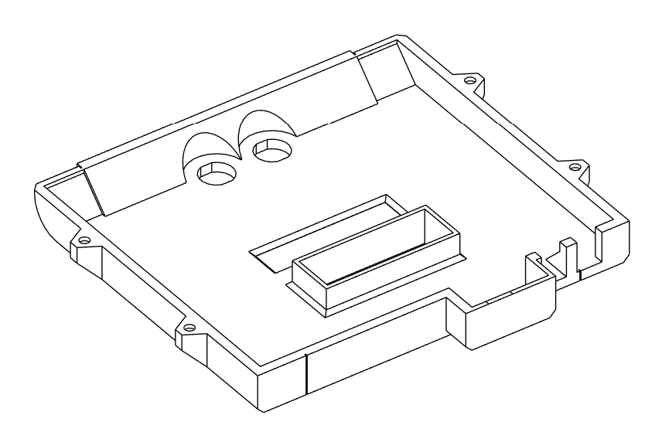Figure 2: Upper Enclosure Body (Underside view)
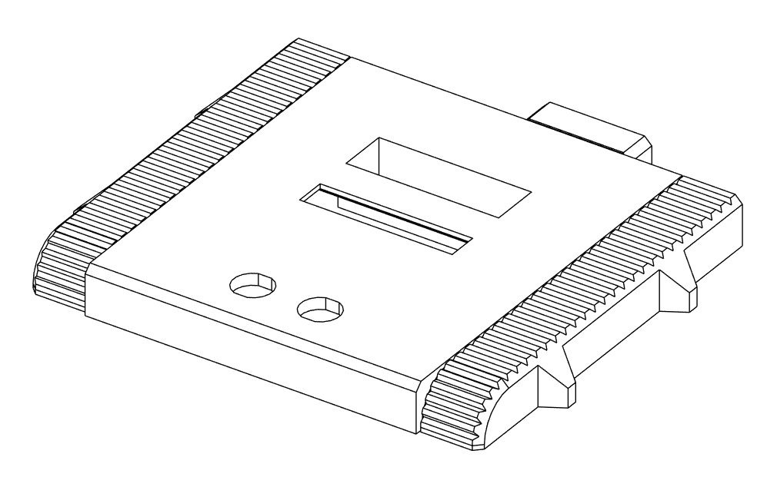Figure 1: Upper Enclosure Body (Top view)
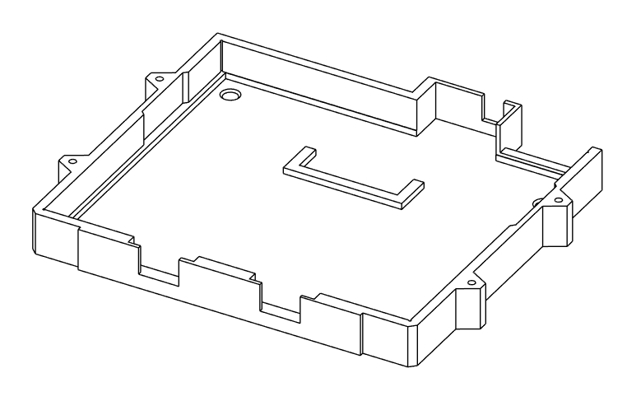Figure 3: Lower Enclosure Body
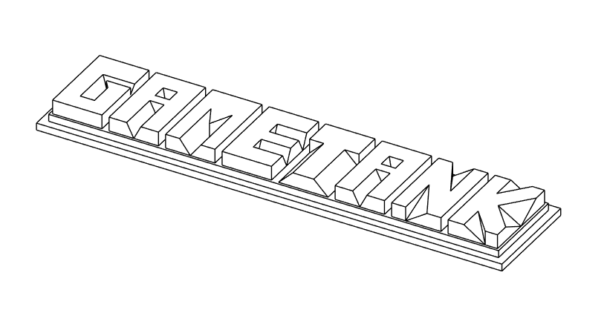Figure 4: Badge
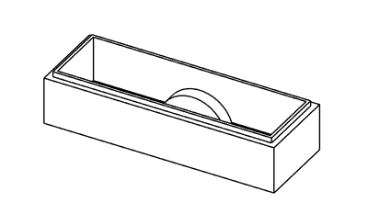Figure 5: Center Board Support

Controller
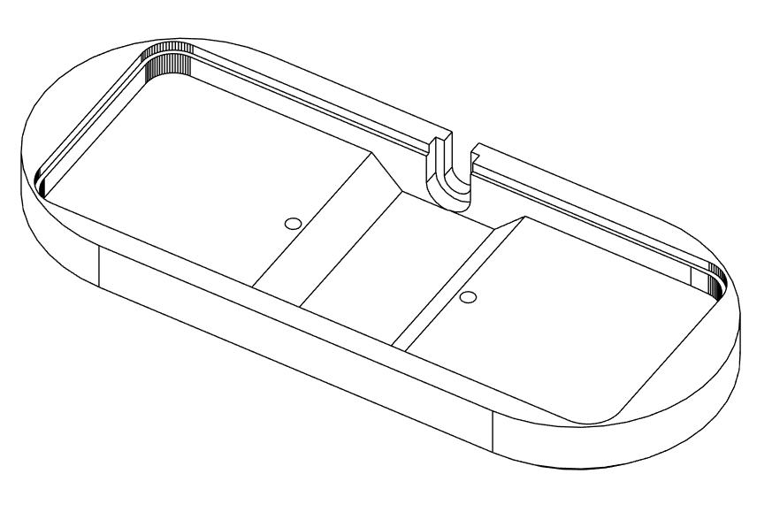Figure 7: Controller Body
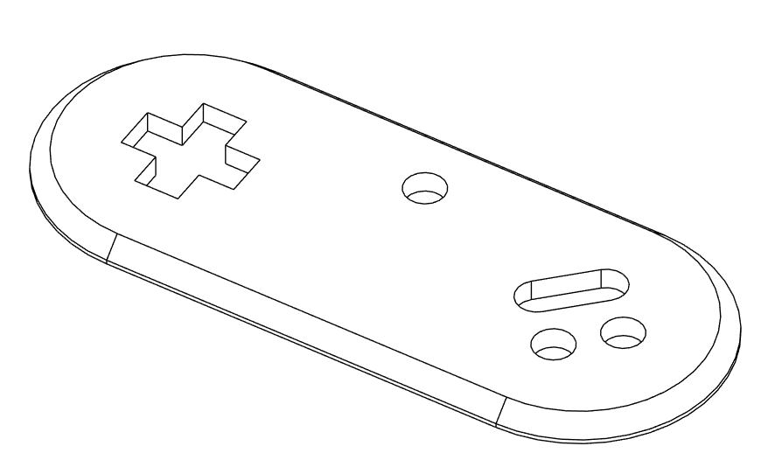Figure 6: Controller Faceplate

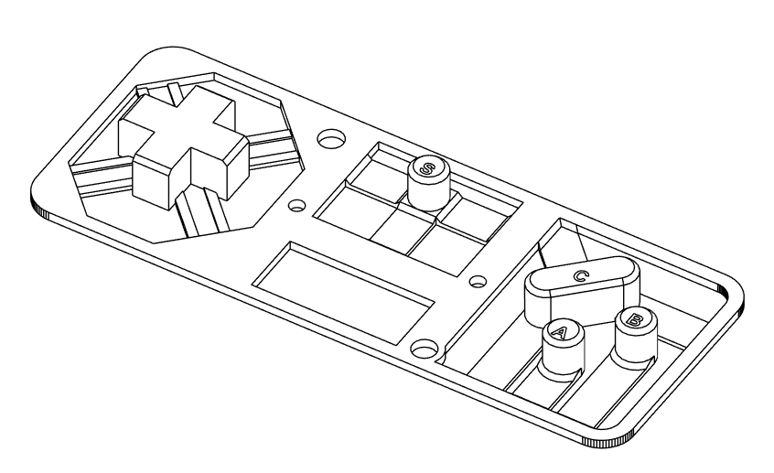Figure 8: Button Flexure, Multi Material Print Labels (Provided separately)
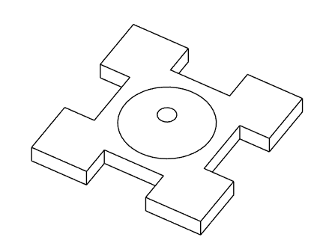Figure 9: Directional Pad Pivot
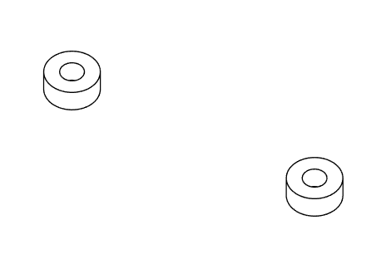Figure 10: Spacers (If printed)

Data Cartridge
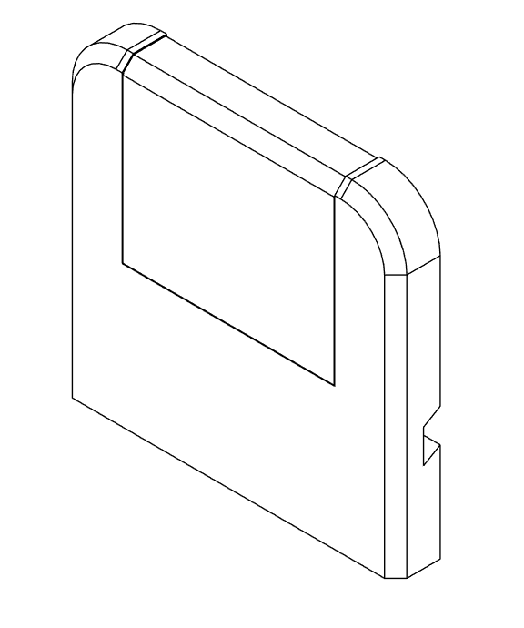Figure 11: Cartridge Front (Outside)
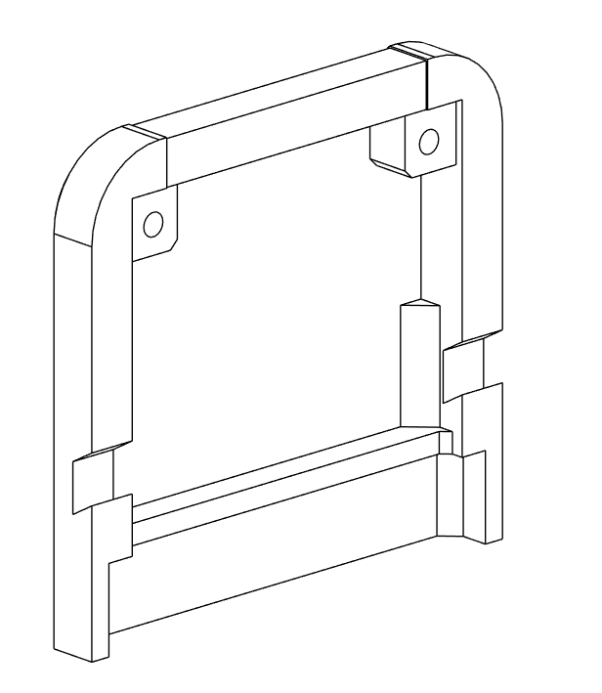Figure 12: Cartridge Front (Inside)
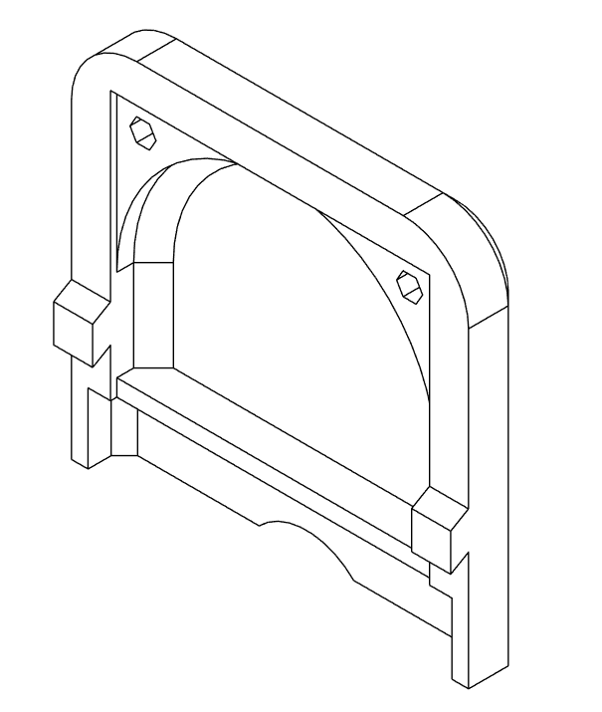Figure 14: Cartridge Back (Inside)
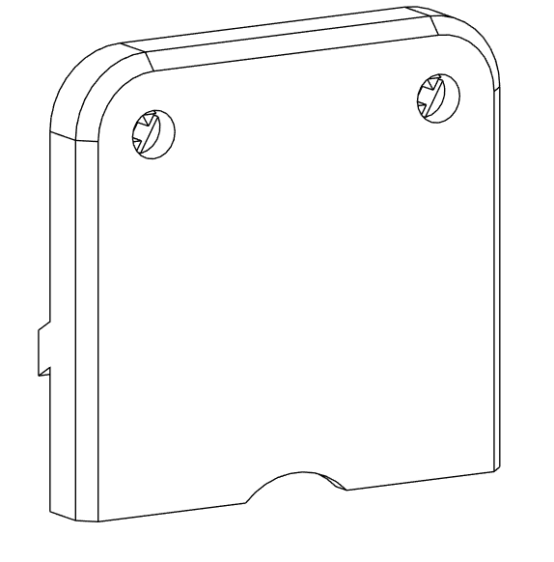Figure 13: Cartridge Back (Outside)

Cartridge Flasher Tool
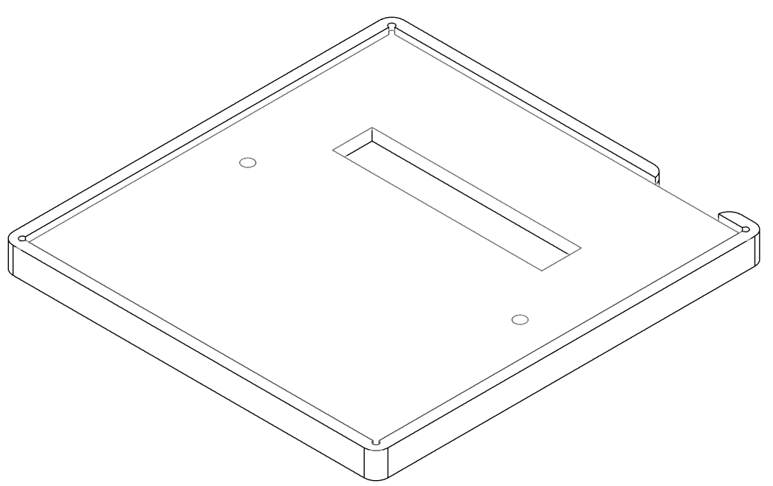Figure 15: Cartridge Flasher Base

Assembly Procedure

Main Console PCB Stack
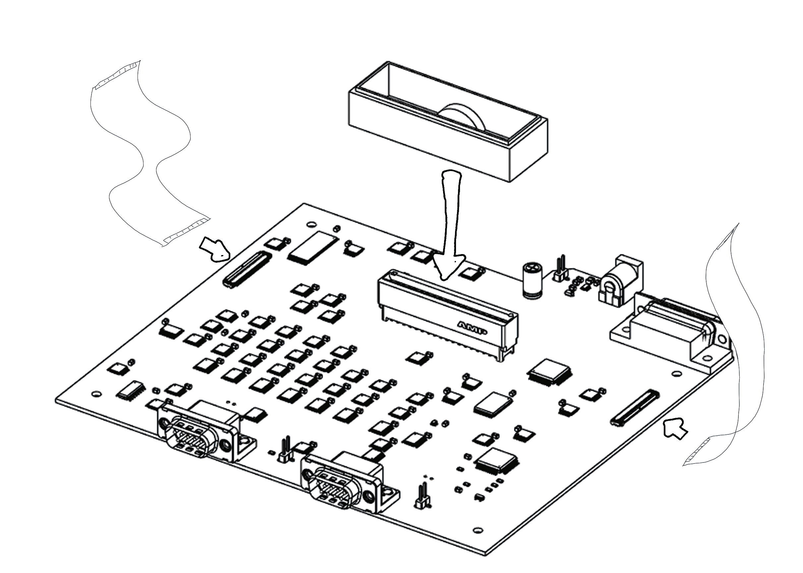Figure 16: Install FFCs and Cartridge Slot Spacer (Ensure Bump is towards rear)

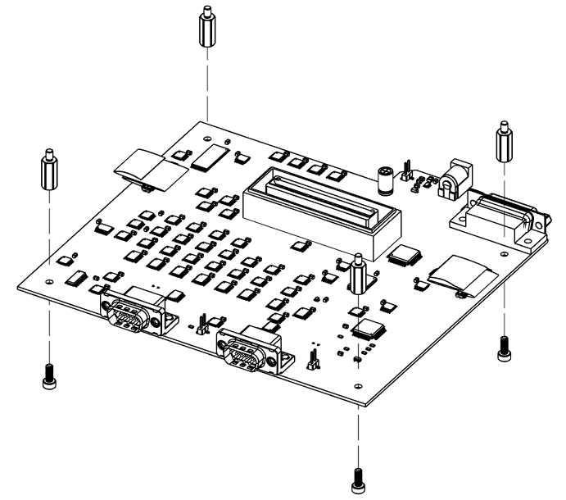Figure 17: Install standoffs at corners with 8mm screws
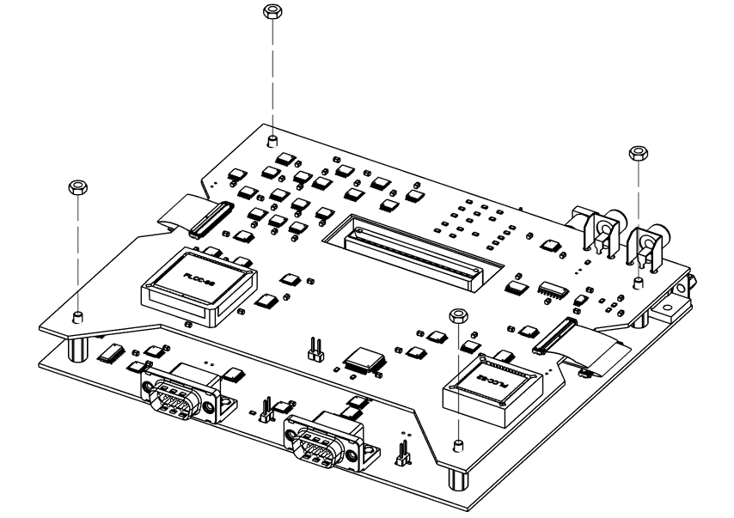Figure 18: Place video board on standoffs, connect FFCs, and fasten with nuts
NOTE: Illustration features previous version of board, large square chip on left will be absent in current version.

Enclosure Top Half Preparation

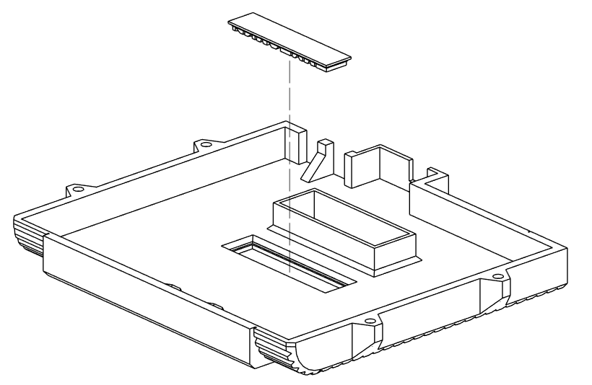Figure 19: Snap GAMETANK badge into place from inner side, making sure of correct orientation

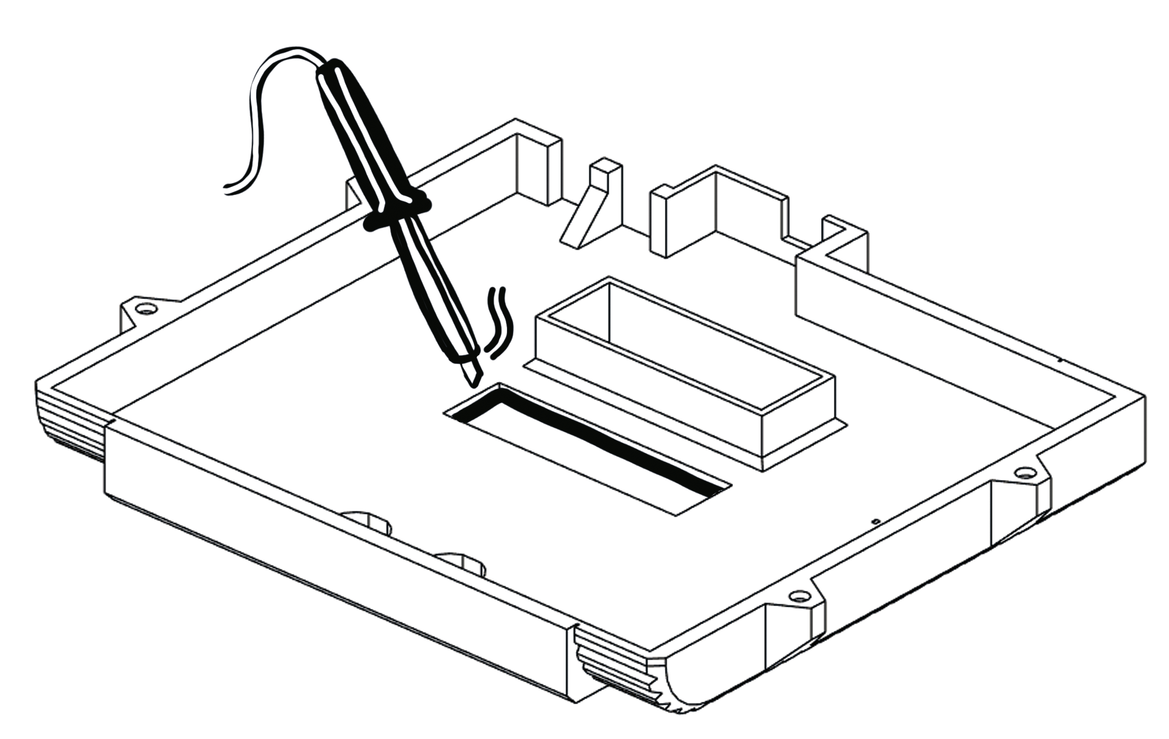Figure 20: Thermally bond at edges
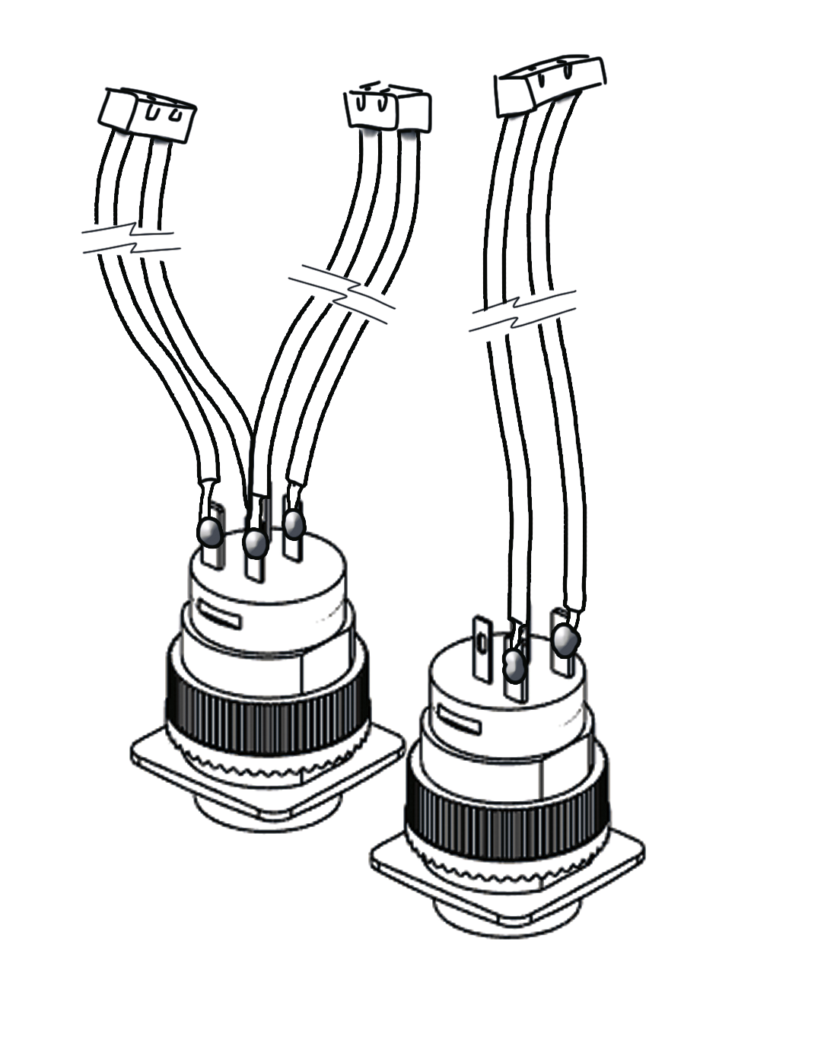Figure 21: Soldering button wires. Red button gets wires on all terminals. Yellow button gets wires on switched terminals only.

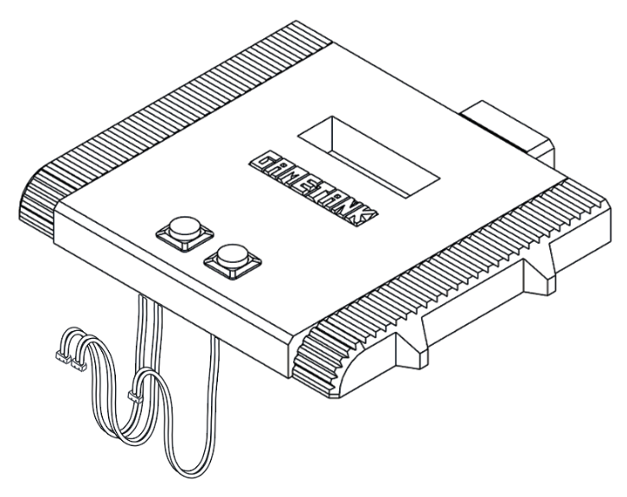Figure 22: Thread button wires through button holes, fasten buttons with threaded collars

Combining Top Shell, PCB Stack, and Bottom Shell
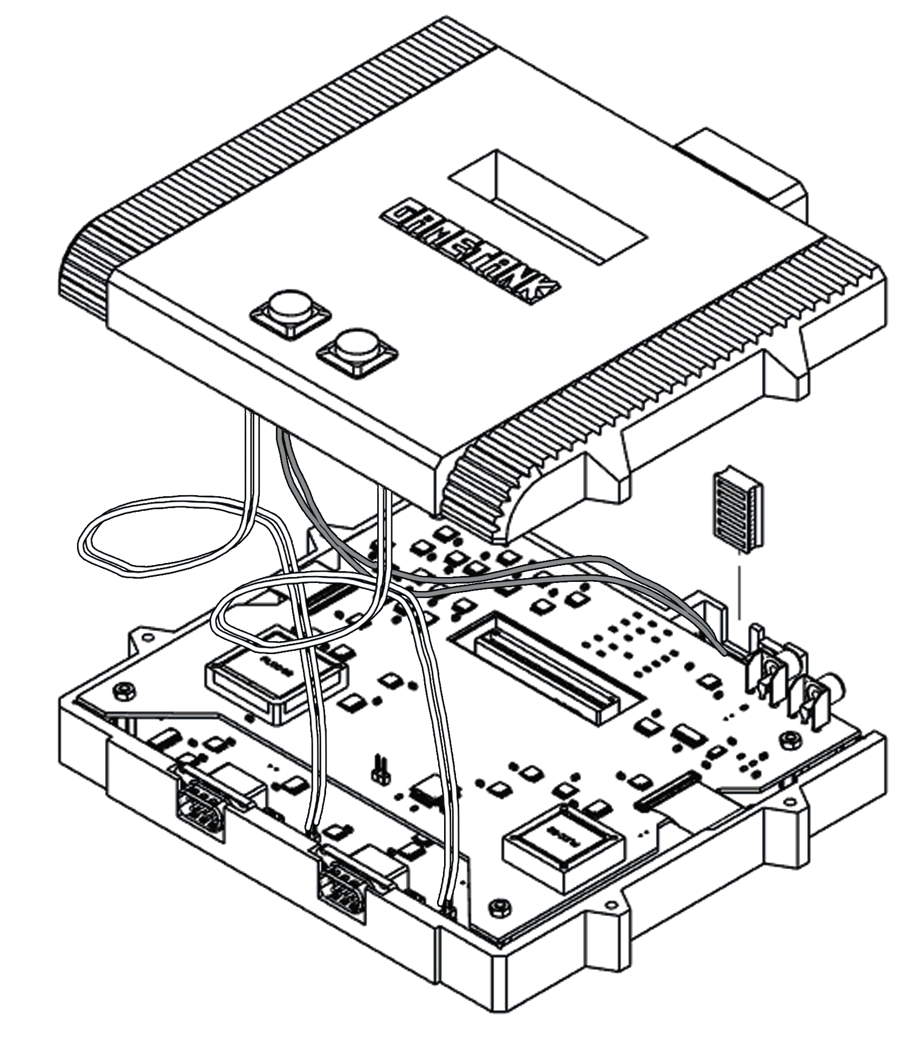Figure 23: Wires from buttons plug into headers on board. Ignore vent piece in diagram.

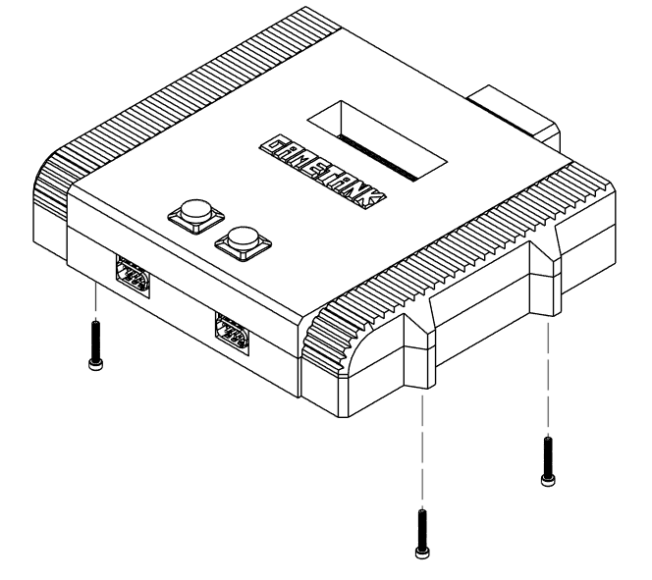Figure 24: Fasten enclosure together with M3x20mm screws

Product Information Label

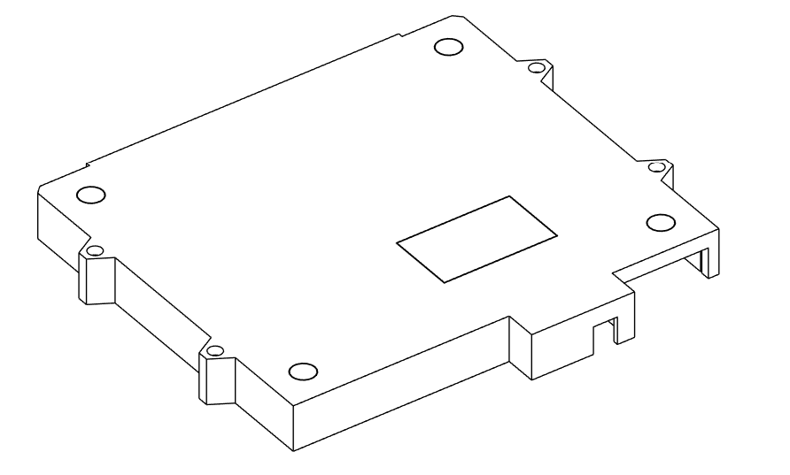
The bottom shell features a 50x30cm mark for placing a rectangular label that will include the product ID, compliance information, and the power requirements.

Controller Wiring

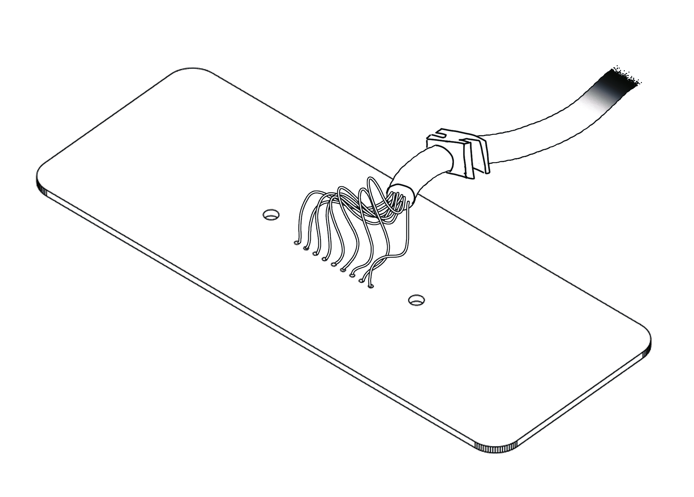

9 Wires soldered from cable, note the strain relief boot that seats into controller body

Wire Position | Wire Color
1 | Red
2 | Black
3 | Gray
4 | Orange
5 | Brown
6 | Green
7 | White
8 | Blue
9 | Yellow

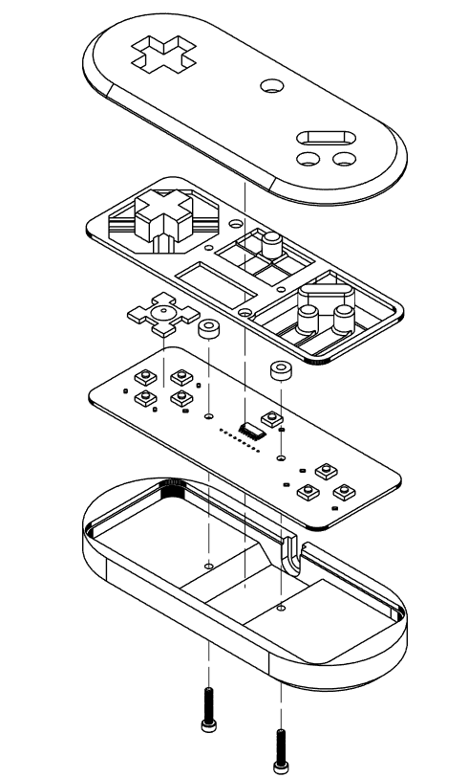
Controller Assembly

Data Cartridge
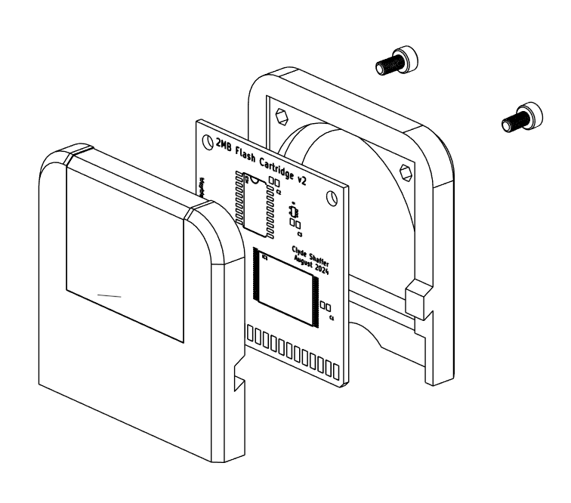
Two screws hold together the cartridge shell at the top, angled tabs stabilize the middle.

Data Cartridge, Labeled

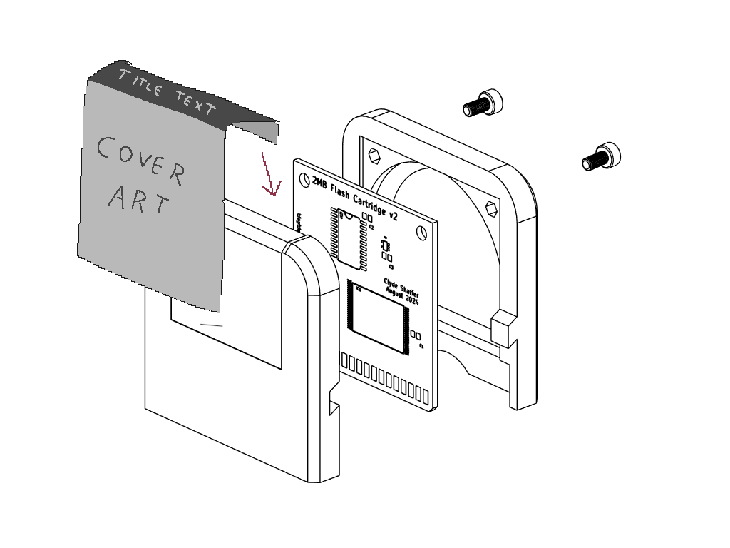
Sticker for labeled cartridge aligns with scribe line on front of cartridge.
Cartridge label is printed slightly taller to fold over top and be clamped by cartridge body.

Cartridge Flasher Tool
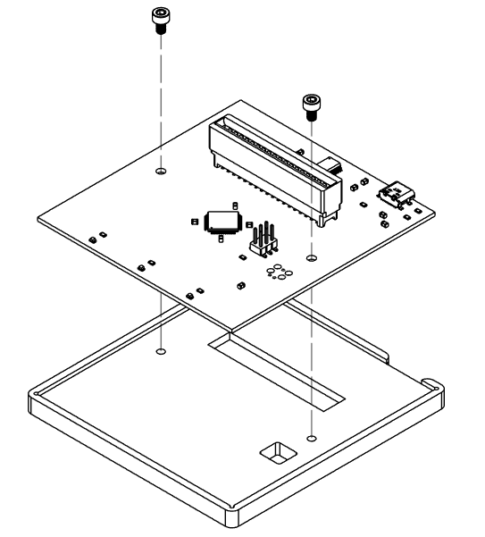
Flasher board drops into base plate and fastens with M3x5 screws

Cartridge Flasher Firmware
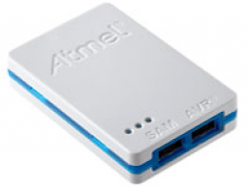
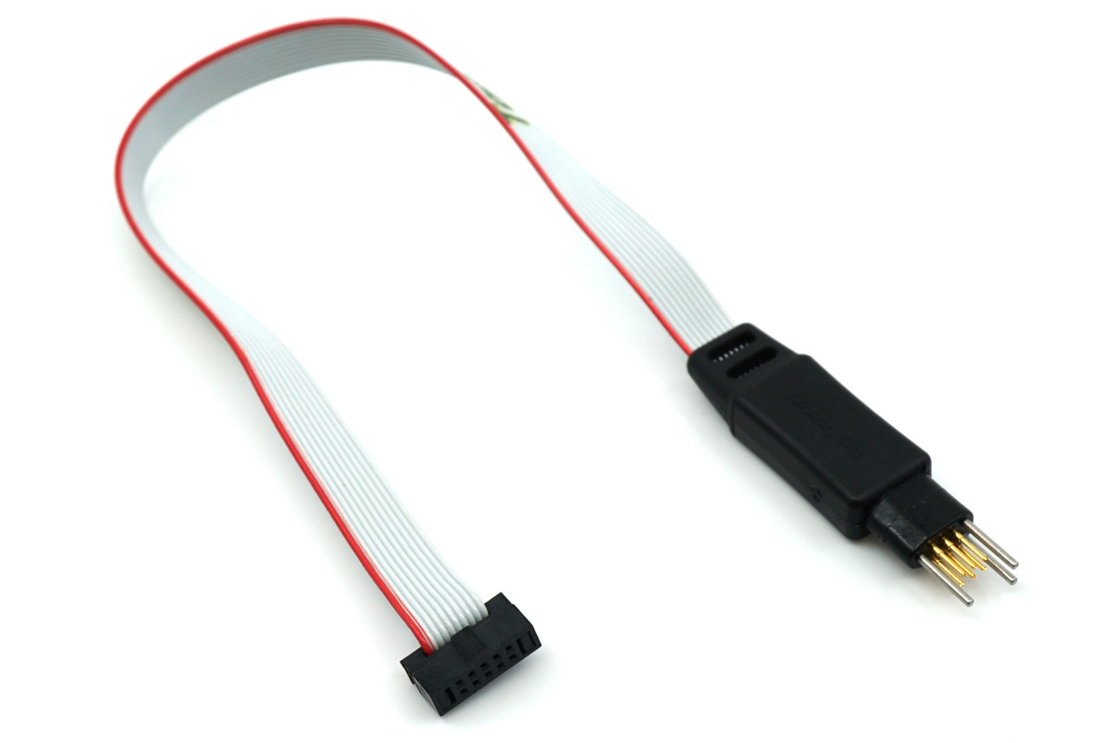

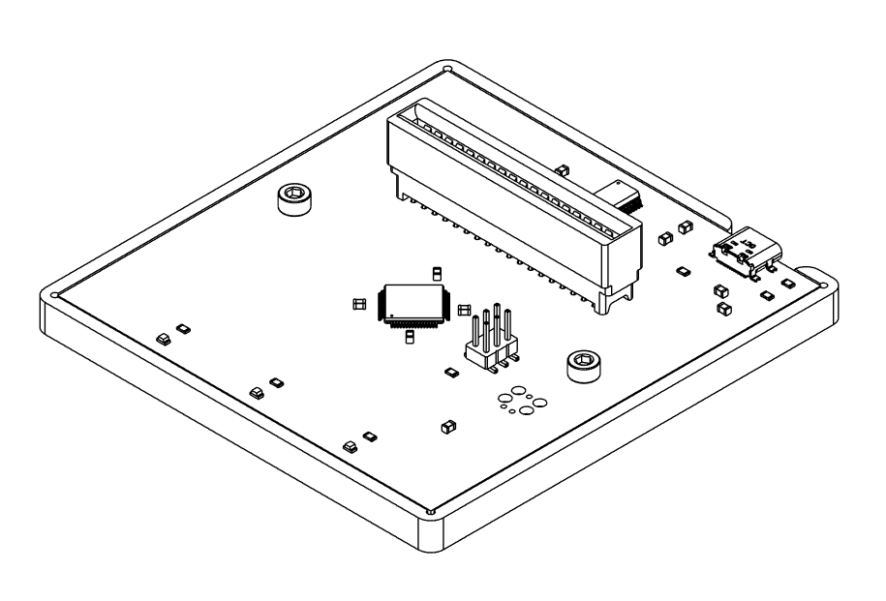
Tag Connect or generic header can be used for programming with Atmel-ICE. Optiboot firmware is flashed, then over USB-C avrdude is used to load the firmware. Afterward the cart flasher should respond to “help”command over serial.

Cartridge Flasher Operation
For cartridges to be labeled and shipped with data on them, the Cartridge Flasher should be used as follows:
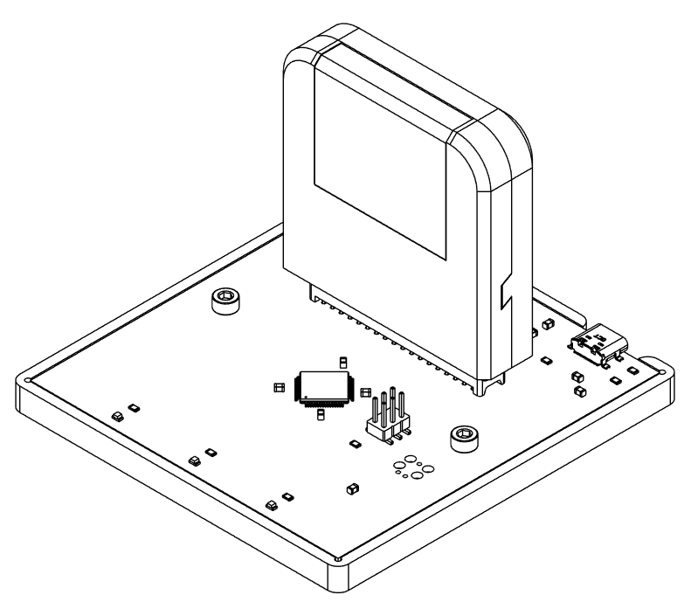
- Cartridge is placed on edge connector, front side towards status LEDs
- Flasher connects to PC with USB-C cable and enumerates as a serial device (COM port on Windows)
- PC program “gtld” is used to initiate loading of the cartridge data

Parts Sourcing Notes

Dual-Ported SRAM CY7C1342-35JCT
Clydeware LLC will provide these.

IQD 28.6363MHz Oscillator
Clydeware LLC will provide these.

Controller Cable
Alibaba link: https://www.alibaba.com/product-detail/New-1-8M-6FT-9-Pin_1600240153607.html

A/V Cable
Alibaba link: https://www.alibaba.com/product-detail/RCA-TV-Composite-Video-Lead-1_1600507184687.html

AP63205WU-7 DC Converter
Clydeware LLC will provide these.

Packing List

- GameTank “Developer Edition” Bundle
  - Printed product box bearing the “Developer Edition” mark
    - 1 Fully assembled GameTank console
    - 1 Fully assembled Controller
    - 1 Power Adapter, plus US and EU plugs
    - 1 A/V Cable
    - 1 Printed Manual
    - 1 Labeled+Flashed “Accursed Fiend” cartridge
    - 1 Blank cartridge
    - 1 assembled Cartridge Flasher with firmware installed
    - All box contents protected by standard shipping filler eg. bubble wrap or paper fill material
- GameTank Standard Set
  - Printed product box NOT bearing the “Developer Edition” mark
    - 1 Fully assembled GameTank console
    - 1 Fully assembled Controller
    - 1 Power Adapter, plus US and EU plugs
    - 1 A/V Cable
    - 1 Printed Manual
    - 1 Labeled+Flashed “Accursed Fiend” cartridge
    - All box contents protected by standard shipping filler eg. bubble wrap or paper fill material

